Name: Hii Nian Yu (WQD180038)

Github link: <https://github.com/hiinianyu/DataMining>

First, we load data into python. Then we check the shape and summary of the dataset.

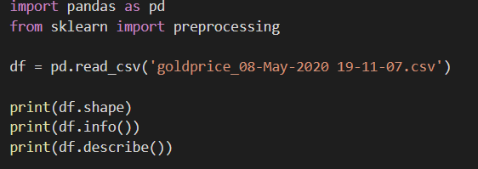

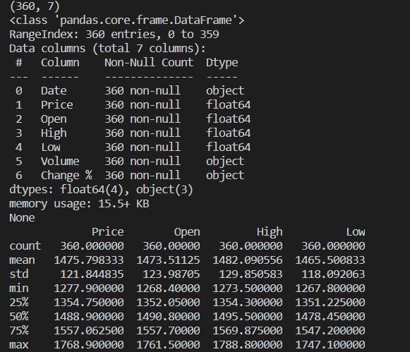

After that we check is there any of the missing values.



