Week 1 Internship Report
Python for Machine Learning & Data Preprocessing
Project: Student Performance Data Preprocessing

1. Introduction
This report describes a beginner-level data preprocessing project completed as part of Week 1. The main aim was to understand how Python libraries such as Pandas and NumPy are used to work with dataset information before applying machine learning. A small synthetic student-performance dataset was used so that the preprocessing steps could be practised safely without using personal student records.

2. Objectives
- Understand how a CSV dataset can be loaded and inspected using Pandas.
- Identify missing values and duplicate records.
- Clean numeric and categorical data.
- Select useful features for a simple student-result example.
- Convert categorical information into numeric form.
- Normalize numeric features and perform basic exploratory data analysis.

3. Tools and Libraries
Python was used as the programming language. Pandas was used for reading CSV files, creating and inspecting DataFrames, handling missing values and removing duplicate rows. NumPy supported numeric data operations. Scikit-learn was used for Min-Max normalization. Matplotlib was used to create a simple bar chart for exploratory data analysis.

4. Dataset Description
The sample dataset contains student-related fields such as age, study hours, attendance, previous score, internet access, learning mode and final result. The original file contains 21 rows and 9 columns. It intentionally includes missing values and a repeated record to demonstrate data-cleaning methods. This is a synthetic educational dataset, not a real institutional record.

5. Preprocessing Steps

Data loading and inspection
The CSV file was loaded with pandas.read_csv(). Commands such as head(), shape, info() and isnull().sum() were used to understand the dataset.

Duplicate removal
The dataset contained 1 duplicate row. The drop_duplicates() method was applied to remove repeated records.

Missing-value handling
Missing values in Study_Hours and Attendance were replaced with the median of their respective columns. Median was selected because it is less affected by unusually high or low values than the mean.

Feature selection
A smaller set of relevant columns was retained for the student-result example. The student name and ID were not used as model input features.

Categorical encoding
Internet_Access and Learning_Mode were converted into numeric indicator columns using one-hot encoding. The Pass/Fail result was mapped to 1/0.

Normalization
MinMaxScaler was applied to the numeric input features so their values were placed on a common 0-to-1 scale.

Exploratory data analysis
Basic descriptive statistics and a bar chart of Pass/Fail counts were generated to understand the sample data.

6. Results
After duplicate removal, the dataset contained 20 rows. The missing values in the selected numeric columns were filled, categorical columns were encoded, and numeric input features were normalized. The final preprocessed dataset contains 20 rows and 8 columns. The processed CSV and the EDA chart are saved in the output folder.

7. Conclusion and Learning
This task helped demonstrate why preprocessing is an important part of a machine-learning workflow. Raw data may contain missing entries, repeated records and text categories that need to be prepared before a model can use them. By completing this project, I practised loading data, checking its quality, cleaning it, encoding categories, scaling numeric features and summarising the dataset. Model training is not included in this Week 1 project because the next task focuses on supervised learning.

8. How to Run the Project
Install the libraries listed in requirements.txt using pip install -r requirements.txt. Keep preprocess.py and student_performance_raw.csv in the same folder, then run python preprocess.py. The output folder will contain the cleaned CSV file and the EDA chart.

9. The screenshots
1. the graphical representation
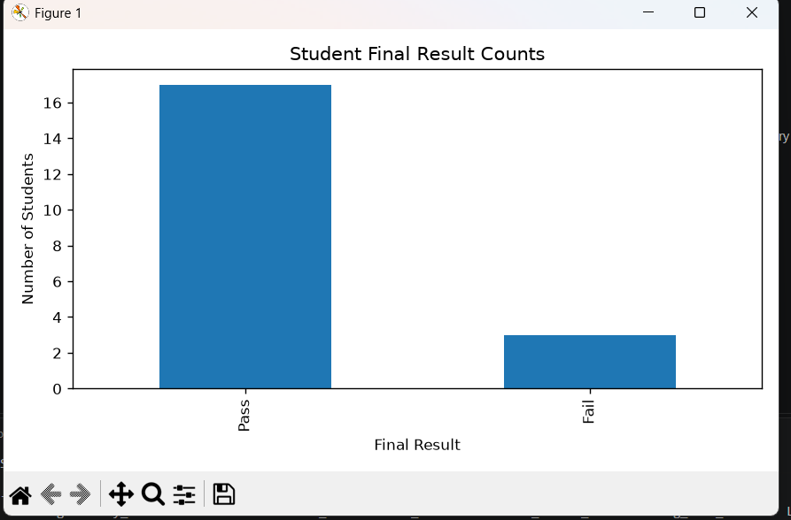
2.csv file of cleaned data.
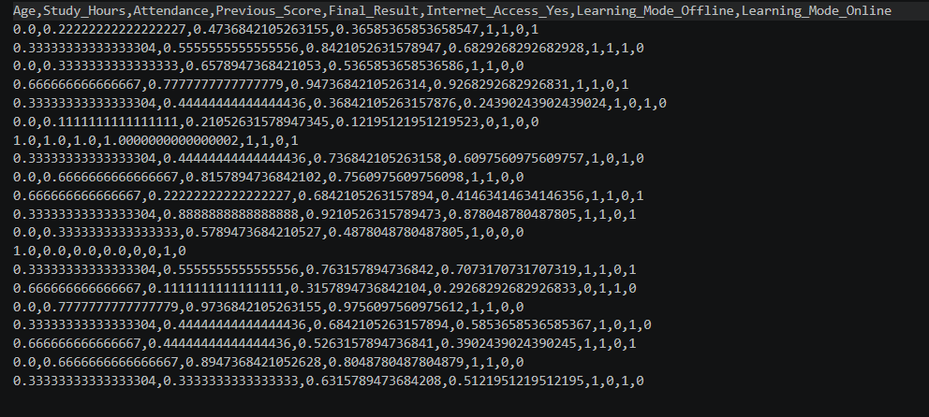
3. command and output.


