Week 2 Internship Project Report

Student Performance Prediction
Technologies: Python, Pandas, NumPy, Matplotlib and Scikit-learn.

1. Objective
Demonstrate supervised machine learning for student performance estimation through regression and pass/fail classification.

2. Dataset
A reproducible synthetic dataset of 600 records is used. Features include study hours, attendance, previous exam score, assignments completed, sleep hours, internet access and parental support. No real student personal data is used.

3. Preprocessing
Numeric values are median-imputed and standardized. Categorical values are imputed using the most frequent value and encoded with OneHotEncoder. Pipelines keep preprocessing with model training.

4. Models
Linear Regression and Random Forest Regressor predict final score. Logistic Regression and Random Forest Classifier predict pass/fail, using 60 as the demonstration threshold.

5. Evaluation
Regression metrics: MAE, RMSE and R-squared. Classification metrics: accuracy, precision, recall and F1-score. A confusion matrix and classification report are also saved.

6. Regression model comparison
model | MAE | RMSE | R2
Linear Regression | 4.9775 | 6.2156 | 0.6798
Random Forest Regressor | 5.9148 | 7.3563 | 0.5514

7. Classification model comparison
model | Accuracy | Precision | Recall | F1
Logistic Regression | 0.9750 | 0.9829 | 0.9914 | 0.9871
Random Forest Classifier | 0.9667 | 0.9667 | 1.0000 | 0.9831

8. How to run
Create a virtual environment, install requirements.txt, and run python train_models.py. See README.md for PowerShell commands.

9. Conclusion and limitations
The project demonstrates regression, classification, preprocessing and model comparison. The dataset is synthetic, so results are illustrative only and must not be used for real student decisions.

10. Supporting screenshots
1. vs code folder
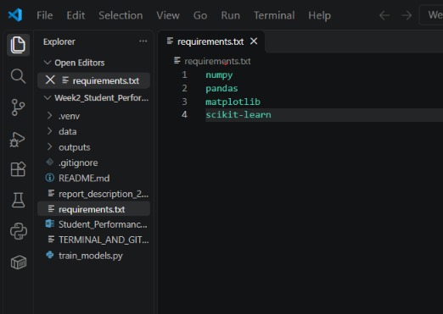
2. output


