STUDENT SEGMENTATION ANALYSIS
Week 3 — Unsupervised Learning & Model Evaluation

1. Project Overview
This project groups students with similar study and engagement patterns using unsupervised machine learning. It implements K-Means and Agglomerative Hierarchical Clustering, compares cluster quality and visualizes the groups. The dataset contains 600 synthetic/demo records and no real student personal information.

2. Objectives
- Prepare numerical activity features for clustering.
- Apply K-Means and Hierarchical Clustering.
- Select a cluster count using the Silhouette Score.
- Evaluate clusters using Silhouette, Davies-Bouldin and Calinski-Harabasz scores.
- Use PCA, a dendrogram and cluster profiles to explore patterns.

3. Dataset and Features
The CSV contains 600 artificially generated records with study hours per week, attendance percentage, assignment score, previous exam score, extracurricular hours and class participation. Student ID is an identifier only and is excluded from model inputs. A few missing values demonstrate preprocessing.

4. Methodology
- Load the CSV with Pandas and select six numerical features.
- Impute missing values using the median.
- Standardize features using StandardScaler.
- Test K-Means cluster counts from 2 to 6 and select the highest Silhouette Score.
- Fit K-Means and Agglomerative Clustering with Ward linkage using the selected count.
- Compare Silhouette, Davies-Bouldin and Calinski-Harabasz scores.
- Use PCA for a two-dimensional plot; create a dendrogram and average feature profiles.

5. Results
Model | Clusters | Silhouette | Davies-Bouldin | Calinski-Harabasz
KMeans | 2 | 0.4016 | 0.9375 | 607.98
Agglomerative | 2 | 0.3796 | 0.9310 | 500.90
The K-Means cluster-count check selected 2 clusters based on the highest Silhouette Score among the tested values. A higher Silhouette and Calinski-Harabasz score is generally preferred; a lower Davies-Bouldin score is generally preferred. These are internal clustering measures, not prediction accuracy.

6. Visualizations
The PCA scatter plot shows K-Means groups in two dimensions. The dendrogram illustrates hierarchical merging on a sample of up to 80 records.
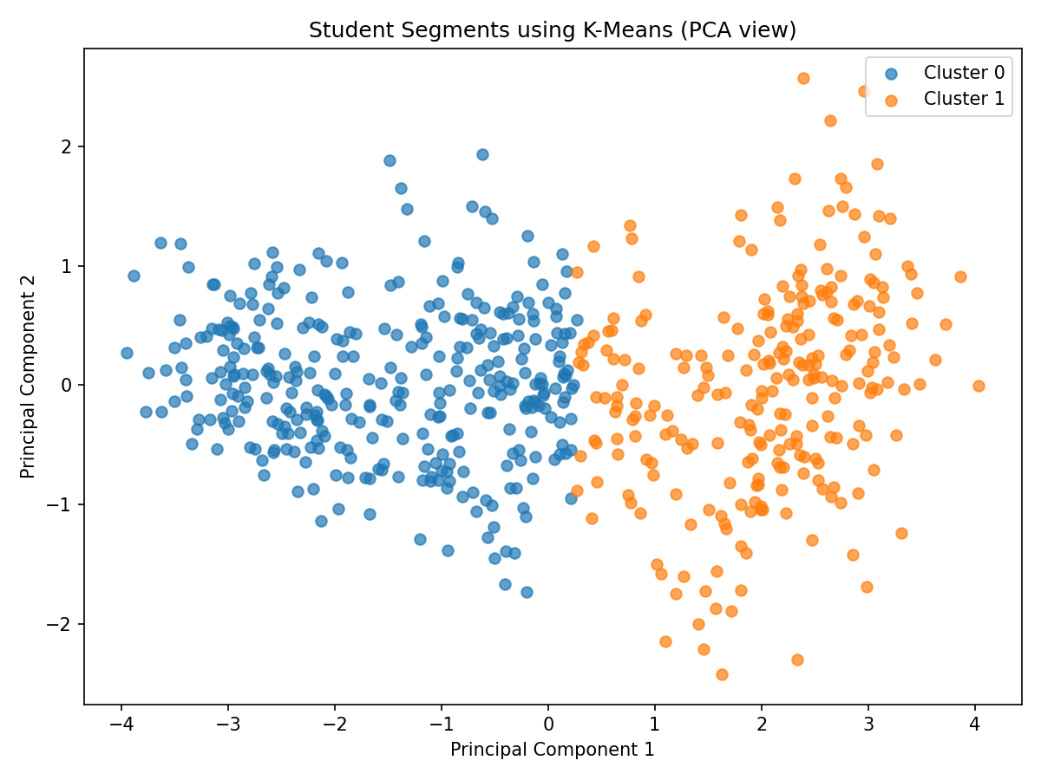
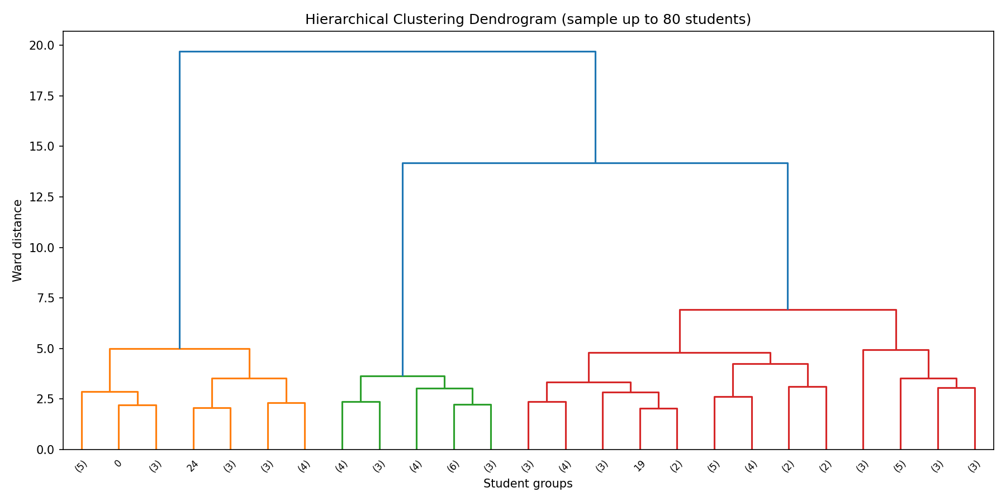

7. Conclusion
The project demonstrates an unsupervised workflow covering data preparation, scaling, clustering, evaluation, visualization and cluster profiling. It supports exploratory analysis of broad engagement patterns. Cluster IDs are arbitrary and should not be interpreted as grades, rankings or definitive judgements about individual students.

8. Tools and Libraries
Python, Pandas, NumPy, Scikit-learn, Matplotlib and SciPy.

9. How to Run
Create and activate a virtual environment, install requirements.txt, then run: python student_segmentation.py. Detailed PowerShell and GitHub commands are included in TERMINAL_AND_GITHUB_COMMANDS.txt.

10. Ethical Note
The dataset is synthetic and intended for practice. Do not upload identifiable student records or use unsupervised clusters alone for high-impact educational decisions.

