**HTTP Answers**

**Q1:** Name of website  
http://neverssl.com

**Q2:** First GET packet number  
Frame **188** (GET / HTTP/1.1)

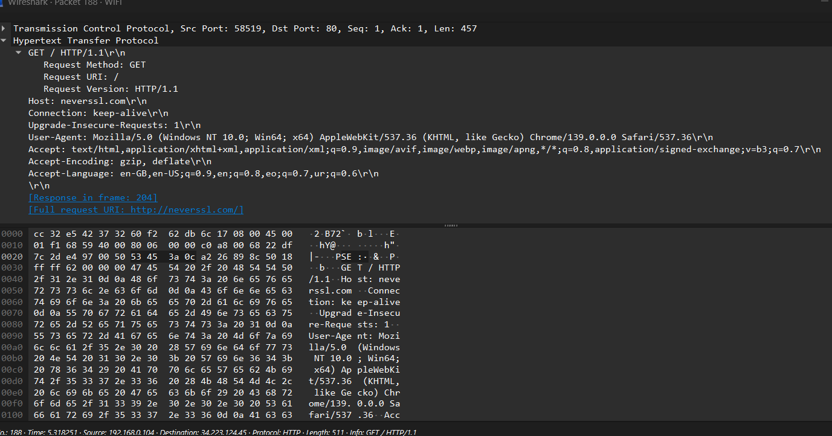

**Q3:** Headers (with meaning)

* + Host: neverssl.com → tells server which site you want
  + Connection: keep-alive → request persistent connection
  + Upgrade-Insecure-Requests: 1 → ask server to upgrade insecure requests
  + User-Agent: Mozilla/5.0 (Windows NT 10.0; …) → identifies browser/OS
  + Accept: text/html,… → what formats client can accept
  + Accept-Encoding: gzip, deflate → compression supported
  + Accept-Language: en-GB, en-US,… → preferred languages

**Q4:** First server response code  
 Frame **204** → HTTP/1.1 200 OK

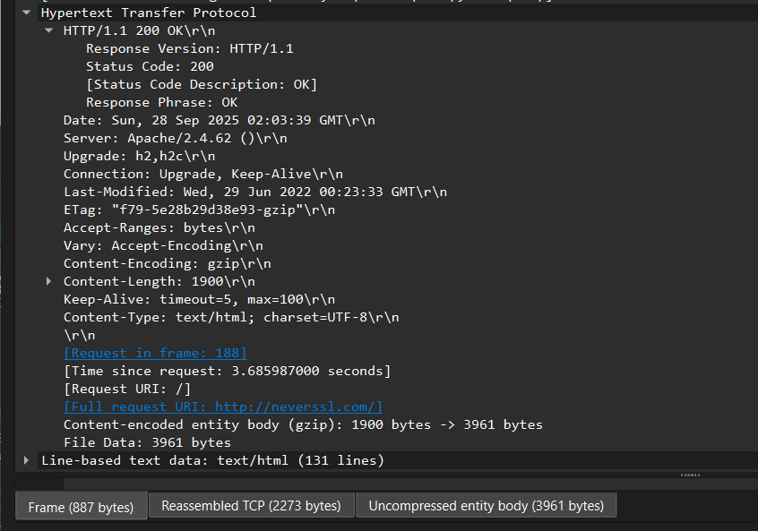

**Q5:** Total responses  
 1 (verified by applying filter http.response)

**Q6:** Persistent or not?  
Connection: keep-alive header shows it is persistent. Evidence: same TCP stream continues after first response.

