CS 499 Professional Self-Assessment

Jennifer Tabor

Southern New Hampshire University

CS 499 Professional Self-Assessment

Introduction

Collaboration & Communication

While completing the computer science program I have been able to gain experience in several areas while completing projects for each class. This has helped me to develop my technical skills as well as my interpersonal skills. Technical capabilities are important but perhaps equally as important or even more important are communication and collaboration skills. For example, in each class project issues arose that impeded progress, yet I was able to complete my projects successfully. In small part this was due to my researching skills but largely it was through collaboration with classmates. Being able to post questions in a clear manner allowed others to see where I was having issues and aid me. In turn, I was able to help others by reading and responding to their posted questions or even emails that were sent to me personally. We collaborated on platforms like BitBucket.org doing code reviews on our work. Code reviews helped me to further develop my own programming skills, teaching me the correct way to format code and notes so that it can be easily understood by other programmers.

Technical Skills

From the first programming class to the last I was able to develop technical skills that built on each other. Security was emphasized throughout all the courses and was a part of each project completed. Data structures and algorithms were taught and practiced across all levels allowing deeper understanding of reusable blocks of code, functions and methods and the usefulness of iterating through loops. This went along with software development by being able to see a project from the planning phase to completion by finishing the final projects for each programming class. This began in IT 145 Foundations in App Development using Java and wrapped up in CS 499 Computer Science Capstone. In IT 145 I made a Java program for zookeepers to keep track of the health and welfare of the animals. It would allow data to be entered on the animals that could then be searched for to find out who had been fed and what their overall health was, and it focused on the importance of object-oriented programming. We also practiced using mathematical functions to aid in searching for information. In between It 145 and CS 499 I was able to further my programming skills using Python in CS 200 Computer Science Role in Industry where I completed a project to demonstrate my understanding of data structures by building a dictionary of movies along with a menu of options for a user to search the dictionary. We had to practice using algorithms to sort the data efficiently along with making flowcharts using pseudocode for the planning of the program modules.

I also had classes that helped me to develop my database skills. Database was taught throughout the regular programming classes but was emphasized in classes like DAD 220 Introduction to SQL and expanded on in DAT 220 Fundamentals of Data Mining. In DAD 220 I was able to build a SQL database and then make queries of that database using various commands in the terminal. This included making primary & secondary keys, inserting data into the database, updating records, deleting data, altering tables, combining data in shared tables and locating information using queries.

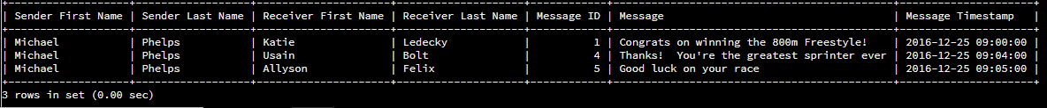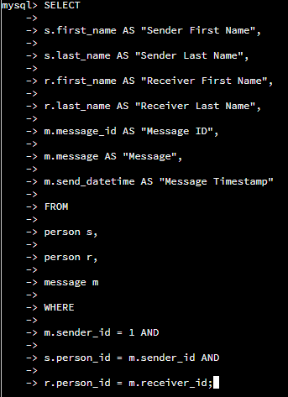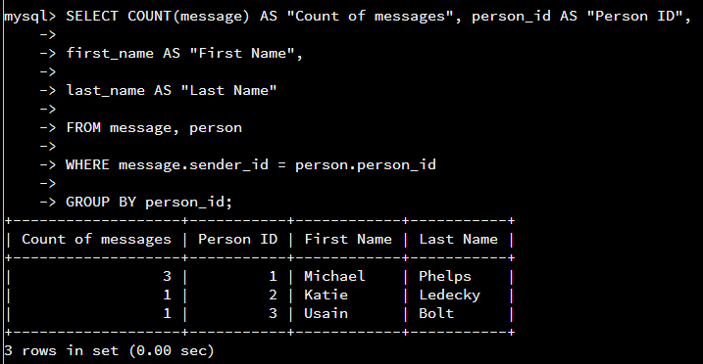

In DAD 200 I learned how to interpret large amounts of data for business purposes. This involved techniques like predictive analysis, descriptive analysis, Poisson regression and the stepwise approach using a linear regression plot to compare relationships between data like ages and the amount of money spent online. It was also important to learn about how to avoid inaccurate depictions of data when using data mining tools.

ePorfolio

For my final class and project, I selected an artifact to demonstrate my skills in software engineering, data structures and algorithms and database and security. My artifact was based on an app that I developed in CS 360 Mobile Architecture & Programming which used a SQLite database to store data. The new app I developed demonstrates all the skills discussed because I started from scratch and developed a plan using a wireframe of the processes, I wanted the app to include. Then I had to start by creating modules of code to handle the commands I wanted to employ like a login screen, adding notes, the actual note taking screen, being able to save data, retrieve data as well as add free form notes and connecting to Google maps. I learned about using authentication for username and passwords for security purposes as well to protect user data. I had to use algorithms and data structure to make the actions functional. For example, the user can click on the plus sign ‘+’ to add a new note which involves the look of the screen designed in an xml file and the functionality of the button in the main activity. I had to use the SQLite database to create a database for the notes as well as database for storing contact names, phone numbers and addresses. Along the way I needed to solve issues that arose which meant employing researching skills as well as communication skills to let my professor know where I was at in completing the project and where I needed some help. Overall, I was able to cement the technical skills I developed in the computer science program especially my problem-solving skills. All these components had to then be uploaded on a GitHub page for my ePortfolio. Using GitHub is a new skill that I am continuing to develop as well. It meant formatting data (using both a markdown and CSS file) and designing a pleasant webpage using Jekyll to display all the aspects of the final project. Not only was it a fun endeavor, through a lot of research I was able to learn about tools such as pandoc and git-lfs to add documents to the page. While I am still developing these skills, I found useful learning on GitHub that can help to expand my knowledge and hone these new skills. While I was able to install git-lfs I was not able to use it to add my video recorded code review, so I did add screenshots from that video to my GitHub page <https://hijackedunicorn.github.io/> .

