IntelliGrade: An End-to-End Outcome-Based Examination Management and Intelligent Script Evaluation Ecosystem for Higher Education Institutions
Md. Taher Bin Omar Hijbullah
ID# 22303142

Md. Taher Bin Omar Hijbullah
ID# 22303142
A Practicum in the Partial Fulfillment of the Requirements for the Award of Bachelor of Computer Science and Engineering (BCSE)

Department of Computer Science and Engineering
College of Engineering and Technology
IUBAT—International University of Business Agriculture and Technology

Summer 2026
IntelliGrade: An End-to-End Outcome-Based Examination Management and Intelligent Script Evaluation Ecosystem for Higher Education Institutions

Md. Taher Bin Omar Hijbullah

A Practicum in the Partial Fulfillment of the Requirements for the Award of Bachelor of Computer Science and Engineering (BCSE)
The practicum has been examined and approved,

_____________________________
Prof. Dr. Utpal Kanti Das
Dean, ISCSE
Chairman, IUBAT

_____________________________
Shahinur Alam
Co-supervisor, Coordinator and Assistant Professor

_____________________________
Drs Ferdaus Anam Jibon
Supervisor and Assistant Professor

Department of Computer Science and Engineering
College of Engineering and Technology
IUBAT—International University of Business Agriculture and Technology
Summer 2026
Letter of Transmittal
10 September 2026
The Chair
Practicum Defense Committee
Department of Computer Science and Engineering
IUBAT—International University of Business Agriculture and Technology
4 Embankment Drive Road, Sector 10, Uttara Model Town
Dhaka 1230, Bangladesh.

Subject: Letter of Transmittal.

Dear Sir,
I am honored to submit my practicum report, "IntelliGrade: An End-to-End Outcome-Based Examination Management and Intelligent Script Evaluation Ecosystem for Higher Education Institutions," in partial fulfillment of the requirements for the BCSE degree at IUBAT.
This report documents the design, implementation, and verification of IntelliGrade, an AI-augmented examination governance platform tailored to BAETE accreditation standards. The system unifies administrative scheduling, OBE blueprinting, hybrid OCR script evaluation, split-screen teacher verification, and real-time Course OBE Tabulation.

Yours sincerely,
_____________
Md. Taher Bin Omar Hijbullah
ID# 22303142

Organization’s Certificate



Student’s Declaration
I hereby solemnly declare that this practicum report entitled "IntelliGrade: An End-to-End Outcome-Based Examination Management and Intelligent Script Evaluation Ecosystem for Higher Education Institutions" is an authentic record of original work carried out by me under the supervision and academic guidance of the Department of Computer Science and Engineering, College of Engineering and Technology, IUBAT. This report, or any part thereof, has not been submitted elsewhere for the award of any degree, diploma, or academic distinction. All secondary literature, frameworks, libraries, and institutional resources utilized in the development and documentation of this project have been duly cited in accordance with Harvard Referencing standards. I confirm that no data falsification or plagiarism has been committed.

_____________
Md. Taher Bin Omar Hijbullah
ID# 22303142

Supervisor’s Certification
This is to certify that the practicum report entitled "IntelliGrade: An End-to-End Outcome-Based Examination Management and Intelligent Script Evaluation Ecosystem for Higher Education Institutions" submitted by Md. Taher Bin Omar Hijbullah, Student ID: 22303142, has been prepared under my direct supervision and guidance in partial fulfillment of the requirements for the degree of Bachelor of Computer Science and Engineering (BCSE) from the Department of Computer Science and Engineering, College of Engineering and Technology, IUBAT. The candidate has fulfilled all academic, technical, and reporting requirements as prescribed by the university. The report represents original software engineering work and is recommended for submission and final defense before the Practicum Defense Committee.

_______________________________
Drs Ferdaus Anam Jibon
Supervisor and Assistant Professor
Department of Computer Science and Engineering
IUBAT—International University of Business Agriculture and Technology

Abstract
The problems faced by the Higher Education Institutions (HEIs) that have adopted Outcome Based Education (OBE) are related to exam scheduling, manual alignment of question papers, grading of scripts and manual calculation of CO/PO for the BAETE accreditation. IntelliGrade addresses some of these challenges by digitizing the whole examination life cycle on one platform, Django 5.2 and PostGreSQL, while still maintaining the Human-in-the-Loop (HiTL) authority of teachers.
The “dual-path” operational model incorporates an on-demand multi-provider failover orchestrator (Groq, Gemini, OpenRouter, etc., or local Moondream2) to enable an assistive AI Evaluation Wizard and a Manual Script Grading Wizard to be used with a high-resolution 300 DPI split-screen evaluation workbench, offline. It automates hybrid OCR ingestion (PyMuPDF/PyTesseract/EasyOCR/CRAFT+BiLSTM), rubric-based scoring and live Course OBE Tabulation, which aggregates the multiple assessment dimensions in an interactive 8-sheet Excel reporting workbook.
The mathematical fidelity of 100% to institutional OBE formulas, a grading turnaround of ~75% and student record loss of zero are validated using comprehensive integration testing in system validation.
Keywords: Outcome-Based Education, Human-in-the-Loop AI, Handwriting Recognition, Multi-Provider AI Failover, Django, BAETE Accreditation, Washington Accord

Acknowledgments
First and foremost, I express my profound gratitude to Almighty Allah for bestowing upon me the knowledge, perseverance, health, and strength required to successfully complete this practicum project and prepare this comprehensive report.
I express my deepest appreciation and respect to Prof. Dr. Utpal Kanti Das, Chairman of the Department of Computer Science and Engineering, for his visionary leadership, continuous encouragement, and high academic standards that inspire technical excellence across the department.
I extend my sincere gratitude to Shahinur Alam, Co-supervisor, Practicum Coordinator, and Assistant Professor, for his meticulous coordination, invaluable directives, and structured feedback throughout all phases of the practicum program.
I am profoundly indebted to Drs. Ferdaus Anam Jibon, my faculty supervisor, whose expert mentorship, insightful guidance, and rigorous constructive critique were instrumental in shaping the architecture, methodologies, and outcomes of the IntelliGrade project.
I would also like to express my sincere gratitude to Md. Kawsar Uddin, my industry supervisor at Al Hadi Enterprise (Al-Hadi Express), for his valuable guidance, technical support, constructive feedback, and continuous supervision throughout my internship. His practical insights and professional direction significantly contributed to my understanding of real-world software development practices and the successful implementation of the project.
I also wish to thank all respected faculty members of the Department of Computer Science and Engineering and the College of Engineering and Technology at IUBAT for providing a solid theoretical foundation and practical training throughout my undergraduate studies.
Finally, I express my heartfelt gratitude to my beloved parents, family members, and peers for their unconditional love, moral support, and endless encouragement throughout this challenging and rewarding academic endeavor.

Table of Contents
Organization’s Certificate iv
Student’s Declaration iv
Acknowledgments vii
List of Figures xiii
List of Tables xv
Chapter 1. Introduction 1
1.1 Background of the Study 2
1.2 Problem Statement 3
1.3 Objectives 4
1.3.1 Broad Objective. 4
1.4 Scope of the Project 5
1.5 Feasibility Study 5
1.5.1 Technical Feasibility. 6
1.5.2 Economic Feasibility 6
1.5.3 Operational Feasibility. 7
1.6 Methodology 8
1.7 Report Organization 9
Chapter 2. Organizational Overview 11
2.1 Organization Vision 12
2.2 Organization Mission 13
2.3 Organization Services 13
2.4 Organizational Structure 14
2.5 My Position in this Organization 15
2.6 Address of the Organization 17
Chapter 3. Requirement Engineering 18
3.1 Requirement Elicitation 19
3.1.1 Requirement Gathering Methods 19
3.2 Requirement Analysis 20
3.2.1 Key Design Considerations 21
3.3 Requirement Specifications 22
3.3.1 Actor 1: Exam Controller 22
3.3.2 Actor 2: Department Head 25
3.3.3 Actor 3: Faculty Member / Examiner 26
3.3.4 Actor 4: Student 32
3.3.5 Cross-Actor Functional Requirements 34
3.3.6 Non-Functional Requirements 35
3.4 Use Case Diagram 39
Chapter 4. Analysis Modeling 40
4.1 Activity Diagrams 41
4.1.2 Activity Diagram: Examination Scheduling and Provisioning 42
4.1.3 Faculty/Examiner Activity Diagram 43
4.1.4 Question Paper and Rubric Authoring 44
4.1.5 AI Evaluation Wizard Flow 45
4.1.6 Manual Script Grading Wizard Flow 47
4.1.7 OBE Tabulation 47
4.1.8 Department Head 48
4.1.9 Student Portal 48
4.2 Swim-lane Diagram 49
4.2.1 Swim-lane Diagram for User Authentication & Role-Based Access Control 49
4.2.2 Swim-lane Diagram for Examination Scheduling & Faculty Allocation 49
4.2.3 Swim-lane Diagram for Answer Script Evaluation & Finalization 50
4.2.4 Swim-lane Diagram for OBE Tabulation, Excel Export & Student Result Dissemination 50
4.3 CRC Cards 51
4.4 Class Diagram 56
Chapter 5. Project Management 57
5.1 Risk Identification 57
5.2 Risk Analysis 58
5.3 Risk Mitigation, Monitoring and Management (RMMM) 59
Chapter 6. Project Planning and Scheduling 65
6.1 System Project Estimation 65
7.2 6.2 Project Schedule (Gantt Chart) 69
Chapter 7. Cost Estimation 70
7.1 Personnel Cost 70
7.2 Hardware Cost 71
7.3 Software Cost 71
7.4 Operational Cost 71
7.5 Total Project Cost Summary 72
Chapter 8. System Design 73
8.1 System Architecture Overview 73
8.2 Module Descriptions 75
8.3 Data Flow Diagrams (DFD) 76
8.3.1 DFD Level 0 — Context Diagram 76
8.3.2 DFD Level 1 77
8.4 Entity-Relationship Diagram (ERD) 77
8.5 Database Schema 78
8.6 REST and AJAX API Catalog 80
8.7 Interface Design 82
8.7.1 Landing Page 82
8.7.2 Exam Controller Dashboard 82
8.7.3 AI Routine Scanner 83
8.7.4 AI Evaluation Wizard — Script Upload and Page Builder 83
8.7.5 Split-Screen Teacher Grading Workbench 84
8.7.6 Course OBE Tabulation View 85
8.7.7 Student Transparency Dashboard 86
8.7.8 Department Head Analytics Dashboard 87
Chapter 9. Testing 88
9.1 Test Cases 88
Chapter 10. Conclusion 98
10.1 Project Summary 99
10.2 Limitations 100
10.3 Future Plans 101
References 103
Plagiarism Report 105

List of Figures
Figure 1.1 Agile Iterative Development Model 25
Figure 2.1 Organizational Structure of Al Hadi Enterprise and Software Development Team 30
Figure 3.1 Use Case Diagram of IntelliGrade 55
Figure 4.1 Activity Diagram: Exam Controller Governance Workflow 57
Figure 4.2 Activity Diagram: Examination Scheduling and Provisioning (AI Routine Scan vs. Manual Entry) 58
Figure 4.3 Activity Diagram: Faculty/Examiner Workflow 59
Figure 4.4 Activity Diagram: Question Paper and Rubric Authoring (AI Document Scan vs. Manual Builder) 60
Figure 4.5 Activity Diagram: AI Evaluation Wizard Flow 61

Figure 4.6 Activity Diagram: Manual Script Grading Wizard Flow 62
Figure 4.7 Activity Diagram: OBE Tabulation & Calculation 62
Figure 4.8 Activity Diagram: Department Head Governance 63
Figure 4.9 Activity Diagram: Student Academic Transparency Portal 63
Figure 4.10 Swim-lane Diagram for User Authentication & Role-Based Access Control 64
Figure 4.11 Swim-lane Diagram for Examination Scheduling & Faculty Allocation 64
Figure 4.12 Swim-lane Diagram for Answer Script Evaluation & Teacher Finalization 65
Figure 4.13 Swim-lane Diagram for OBE Tabulation, Excel Export & Student Result Dissemination 65
Figure 4.14 Class Diagram: Core Domain Models 71
Figure 6.1 Gantt Chart: Project Schedule 84
Figure 8.1 System Architecture Overview Diagram (4-Tier) 89
Figure 8.2 Data Flow Diagram — Level 0 (Context Diagram) 92
Figure 8.3 Data Flow Diagram — Level 1 (System Level) 92
Figure 8.4 Entity-Relationship Diagram (ERD) 93
Figure 8.5 UI Mockup: Landing Page & Portal Selector 97
Figure 8.6 UI Mockup: Exam Controller Governance Dashboard 98
Figure 8.7 UI Mockup: AI Routine Scanner & Scheduler 98
Figure 8.8 UI Mockup: AI Evaluation Wizard & Script Upload 99
Figure 8.9 UI Mockup: Split-Screen Teacher Grading Workbench 100
Figure 8.10 UI Mockup: Course OBE Tabulation View 101
Figure 8.11 UI Mockup: Student Transparency Dashboard 101
Figure 8.12 UI Mockup: Department Head Analytics Dashboard 102

List of Tables
Table 4.1 CRC Card: Profile (User Role) 66
Table 4.2 CRC Card: Examination 66
Table 4.3 CRC Card: Question 67
Table 4.4 CRC Card: StudentSubmission 67
Table 4.5 CRC Card: EvaluationResult 68
Table 4.6 CRC Card: CourseTabulation 69
Table 4.7 CRC Card: StudentGradeRecord 69
Table 5.1 Risk Identification 72
Table 5.2 Risk Analysis 73
Table 5.3 RMMM: Risk 1 — CPU OCR Latency 74
Table 5.4 RMMM: Risk 2 — AI Rate Limiting 75
Table 5.5 RMMM: Risk 3 — Handwriting Illegibility 76
Table 5.6 RMMM: Risk 4 — Data Loss During Evaluation 76
Table 5.7 RMMM: Risk 5 — SMTP Email Delivery Failure 77
Table 5.8 RMMM: Risk 6 — Disk Storage Overflow 78
Table 5.9 Risk 7 — OBE Calculation Inconsistency 78
Table 6.1 Functionality, Input and Output 80
Table 6.2 Complexity of Data Function 81
Table 6.3 Complexity of Transaction Function 82
Table 6.4 UFP Calculation Summary 82
Table 6.5 Technical Difficulty Index (TDI) 83
Table 7.1 Personnel Salary 85
Table 7.2 Personnel Cost Estimation 85
Table 7.3 Hardware Cost 86
Table 7.4 Software Cost 86
Table 7.5 Other Operational Costs 86
Table 7.6 Total Project Cost Summary 87
Table 8.1 Technology Stack Details 89
Table 8.2 Core Database Schema 94
Table 8.3 REST and AJAX API Catalog 95
Table 9.1 Test Case 1: User Login and Role-Based Dispatch 103
Table 9.2 Test Case 2: AI Exam Routine Scanning 104
Table 9.3 Test Case 3: Question Paper Studio — 23-Taxonomy Entry 105
Table 9.4 Test Case 4: Script Upload and 300 DPI Preprocessing 106
Table 9.5 Test Case 5: AI Evaluation Wizard — End-to-End 107
Table 9.6 Test Case 6: Manual Script Grading Wizard 108
Table 9.7 Test Case 7: Teacher Mark Override and Audit Log 109
Table 9.8 Test Case 8: OBE Tabulation and Excel Export 110
Table 9.9 Test Case 9: Student Dashboard — Grade Transparency 111

Chapter 1. Introduction

1.1 Background of the Study
Formal examinations are the main tool for assessment of students' learning outcomes and certification of academic competence in universities. Examination cycle is very significant in institutions which have adopted Outcome Based Education (OBE) model and employ Washington Accord and BAETE guidelines in engineering accreditation. Exam items need to be explicit in relation to Course Outcomes (COs) and Programme Outcomes (POs) and there needs to be measurable cohort attainment at a number of cognitive levels.
Yet in the on-the-ground world of operations there's a lot of friction. Manual scoring takes hours and instructors may be subject to cognitive fatigue and subjective inconsistencies between scorers. Following grading, the teachers input the scores into individual spreadsheets and then calculate the weighted composites for class tests, for midterm and final exams, and for attendance and assignments, and manually prepare CO/PO attainment matrices to submit to the departmental accreditation boards. This manual and disjointed process is subject to arithmetic mistakes, consumes valuable time and removes academic time that could be used for teaching and research.
These opportunities are now more real than ever with recent advances in Optical Character Recognition (OCR), Computer Vision, and Large Language Models (LLMs). Thanks to the intelligent document processing, the assessment using the rubrics, as well as the real-time collation of results, is technically and economically feasible on a common university infrastructure.
IntelliGrade was created to address all these challenges. It's not a stand-alone AI grading script, it's an entire examination management ecosystem. It includes exam scheduling, creation of exam papers based on exam taxonomy (23 different exam types), DPI script pre-processing (300), hybrid OCR extraction (AI supported with failover to multiple OCR providers with fast-track manual evaluation), split screen teacher verification, continuous tabulation in real-time, and automated dissemination of exam results.

1.2 Problem Statement
- The issues that have been affecting the management of traditional exams are:
- Manual Routine Scheduling: Examination routines are manually composed and printed out on spreadsheets or paper notices and not automatically uploaded to academic databases.
- Dislocation of Rubric Authoring: Question papers are not written in conjunction with grading criteria, Bloom's mapping, CO mapping, PO mapping, Knowledge Profile (KP) mapping, Complex Engineering Problem (CEP) mapping and Complex Engineering Activity (CEA) mapping are not formalized, which makes it difficult to report for accreditation.
- Subjective and Exhausting Script Grading: Subjective grading of dozens of multi-page scripts, multi-part questions, involves hundreds of individual grading decisions for each examiner, which can cause fatigue and inconsistencies in scoring.
- Manual OBE Tabulation: Manual tabulation of weighted components and the total involved in continuous assessment, which can result in calculation errors, requires a lot of time per course.
- Feedback Transparency is limited: Most students will typically receive a general marking on their notice board and a qualitative comment using the rubric is widely not used, and a clear awareness is not readily evident on what they are doing well/less well in relation to each question.
- Manual Communication Channels: Exam notification, verified copy of scripts and finalized exam results are sent in repetitive manual send email or hardcopy.

All of these delays are eliminated with the fully integrated production ready web platform provided by IntelliGrade.

1.3 Objectives
There are two types of goals of the IntelliGrade practicum project: Broad Objective and Specific Objectives, described below:

1.3.1 Broad Objective.
The practicum meets the following basic technical objectives:
- To implement a complete four level role based access control system for four major academic roles: Chief Exam Controller, Department Head, Faculty and Student with admin approval hierarchy and OTP password recovery.
- To develop an AI Exam Routine Parser that can read Multi page long Routine document, extract the parameters of the schedule and automatically generate the scheduled Examination instances using 0ms local fuzzy course matching.
- To create the 23-taxonomy Question Paper and Master Solution Studio which captures Question prompts, Marks, Bloom's cognitive taxonomy, CO/PO mapping, figures, data tables and mathematical formulas.
- To create a universal 300 DPI preprocessing and normalization pipeline, that includes the Hough transform for deskewing, Otsu thresholding and a hybrid multi-engine OCR cascade of PyMuPDF, PyTesseract and EasyOCR.
- To develop a dual evaluation architecture that is fault-tolerant, has an AI Evaluation Wizard with a 5-provider failover orchestrator (Moondream2, Groq, OpenRouter, Gemini, and OpenAI), and has an independent Fast-Track Manual Script Grading Wizard that works without any cloud or OCR overhead.
- To offer Split-Screen Teacher Verification Workbench for teachers to check student scanned pages in real-time with rubric criteria, override marks, generate non-editable audit logs and generate digitally stamped PDF scripts.
- To develop a real-time Course OBE Tabulation Engine for automatic tabulation of Continuous Assessment marks of courses, Weightage Course total, CO/PO attainment matrices on class level as well as export of the official 8-sheet Excel Work Books.
- To enable an asynchronous multi threaded notification service to deliver institutional email notifications to users for account onboarding, exam publication, delivery of certified result PDFs and delivery of department tabulation reports.

1.4 Scope of the Project
- IntelliGrade will be used for the whole written examination process of descriptive Higher Education Engineering Departments which are subject of Washington Accord and BAETE Accreditation.
- Bangladesh's public and private engineering universities that are based on the standard of accreditations of OBE given by BAETE / Washington Accord.
- Courses in which the handwriting recognition and rubric-based AI evaluation advantages are the greatest, such as courses that are not purely multiple choice.
- Institutions that are willing to provide local GPU hardware or enterprise tier cloud API subscription to reach production speed for AI evaluation.
- It is designed for those institutions that are seeking a solution to the issues of written evaluation and desire teachers to have complete control. Future improvements outside the scope of operation involves real-time proctoring for online computer based testing, integration of legacy student information systems, Optical Mark Recognition (OMR) processing of bubble-sheets.

1.5 Feasibility Study
An extensive feasibility study was carried out which established the platform's technical, economic and operational feasibility:

1.5.1 Technical Feasibility.
- Technical Feasibility: It is designed based on the modern enterprise frameworks. An efficient ORM system is provided with composite indices and eager query optimization by Python 3.11+ and Django 5.2, which remove the N+1 problem. For image normalization, OpenCV is used and for rendering at 300 DPI in milliseconds PyMuPDF is used. The multi-engine OCR and AI failover cascade ensures system resilience in the case of API level limits or limited hardware.
- Advanced ORM: Python 3.11+ and Django 5.2 both support a more advanced ORM that is able to do composite indexing and eager relation prefetching (select_related and prefetch_related) that eliminate N+1 query bottlenecks.
- PyMuPDF (fitz) is capable of rasterizing PDF to 300 DPI in milliseconds and mapping native glyphs; OpenCV can be relied on for image deskewing and adaptive thresholding for the mathematical transformation.
- Printed text (PyTesseract), deep-learning handwriting (EasyOCR), and multiple provider AI failover cascaded into each other offers outstanding resilience. In addition, in a system where enterprise GPUs are not available, the system offers the faculty an immediate batch grading wizard that is a manual script grading tool that does not go through AI/OCR queues, enabling faculty to grade scripts split-screen easily without any latency.
- Lightweight CPU workload: The system is optimized to run on standard university server hardware (multi-core CPUs), with quantized local vision models (800px LANCZOS downsampling), and asynchronous non-blocking background threads for SMTP dispatch.

1.5.2 Economic Feasibility
- Economic Feasibility: IntelliGrade is 100% open source battle-tested software and has no proprietary software licensing expenses. There is little cost involved in AI evaluation, because these local vision models and free-tier cloud allocations are prioritized. For the faculty, the time savings (from ~14 hours of script grading to less than 30 minutes of verification) translates to major institutional productivity gains.
- Minimal Software Licensing Costs: The core infrastructure is built entirely upon battle-tested open-source software (Python, Django, PostgreSQL, PyMuPDF, ReportLab, openpyxl, TailwindCSS), requiring zero proprietary software licensing fees.
- Cost-Effective AI Operations: By implementing local offline vision (Moondream2 / Ollama) as the primary provider, script evaluation incurs zero API token cost. Cloud LLM providers (Groq, Gemini, OpenRouter) are utilized dynamically within free-tier allowances or low-cost pay-as-you-go tiers ($5–$10 institutional quota), delivering enterprise-grade evaluation at a fraction of commercial software licensing costs.
- Dramatic Labor Cost Savings: Traditional manual evaluation of 60 multi-page scripts consumes approximately 14 hours of highly paid faculty time. IntelliGrade accelerates this process to under 30 minutes of verification, saving hundreds of institutional man-hours per semester and eliminating costs associated with paper storage and physical logistics.

1.5.3 Operational Feasibility.
- Operational Feasibility: The web interface is visually appealing and easy to use; faculty members don't have to be proficient in machine learning. Most importantly, it is a copilot rather than an autonomous decision-maker: Teachers have the authority to decide on grades and feedback, ensuring high trust from students and institutions and high compliance with academic standards.
- Zero Machine Learning Learning-Curve: The web-based user interface is intuitive and requires no technical machine learning expertise from faculty members. Familiar workflows—uploading scripts, checking bounding boxes, and clicking approval buttons—ensure rapid institutional adoption.
- Preservation of Faculty Autonomy: IntelliGrade operates strictly as a Human-in-the-Loop copilot. The AI engine only suggests scores and diagnostic comments; teachers retain full authority to override marks, edit feedback, and finalize grades, ensuring complete academic trust.
- Direct Regulatory Compliance: The tabulation engine implements standard IUBAT grading policies and BAETE outcome formulas directly, producing familiar 8-sheet Excel spreadsheets that seamlessly integrate into existing departmental accreditation records.

1.6 Methodology
It was developed in an Agile Iterative manner, with seven distinct sprints: Sprint 1 was dedicated to setting up authentication and academic hierarchy, Sprint 2 to providing routine parsing and authoring of questions, Sprint 3 to providing 300 DPI processing and mapping questions to boundaries, Sprint 4 to providing multi-provider AI failover evaluation, Sprint 5 to providing split-screen verification workbench and generation of watermarked PDFs, Sprint 6 to providing real-time OBE tabulation and Excel sync, and Sprint 7 to providing Asynchronous email notifications and hardening the database.
- Sprint 1: Authentication, RBAC, and academic hierarchy management.
- Sprint 2: AI Exam Routine Parser and Question Paper Studio.
- Sprint 3: Script ingestion, OCR pipeline, and question boundary mapping.
- Sprint 4: Multi-provider AI evaluation engine and failover orchestration.
- Sprint 5: Split-screen evaluation workbench and certified PDF generation.
- Sprint 6: OBE tabulation engine, 8-sheet Excel export, and student dashboard.
- Sprint 7: Asynchronous email service, composite database indexes, and performance hardening.

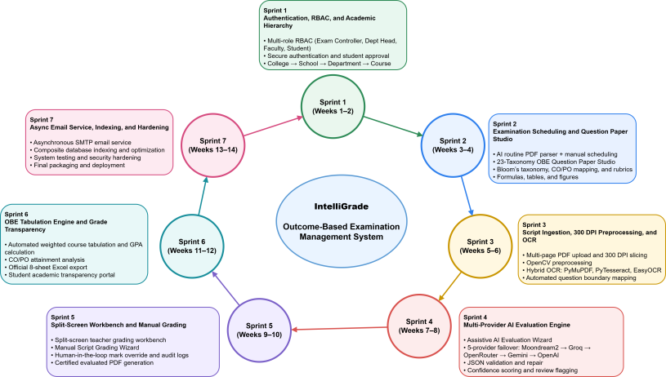
Figure 1.0.1 Agile Iterative Development Model

1.7 Report Organization
This practicum report is organized into ten comprehensive chapters, systematically structured to provide a complete technical account of the project:
Chapter 2: Organizational Context outlines the institutional environment and background in which the project is situated.
Chapter 3: Requirement Engineering details both functional and non-functional requirements, establishing the foundation for system development.
Chapter 4: Analysis and Modeling presents the core artifacts including activity diagrams, sequence diagrams, state machine diagrams, CRC cards, and class diagrams.
Chapter 5: Project Management and Risk addresses management strategies and risk mitigation through seven RMMM tables.
Chapter 6: Effort Estimation applies function point analysis and illustrates workload distribution via a Gantt chart.
Chapter 7: Cost Estimation provides a structured financial projection for system development.
Chapter 8: System Design describes the complete architecture, data flow diagrams (DFDs), entity-relationship diagrams (ERDs), database schema, API catalog, and interface mockups.
Chapter 9: Testing presents nine detailed test case tables to validate system functionality and reliability.
Chapter 10: Conclusion synthesizes the project outcomes, highlights limitations, and outlines future development plans.

Chapter 2. Organizational Overview

This chapter describes in detail the host organisation – Al Hadi Enterprise, vision, mission, corporate service portfolio, organisation structure and the technical responsibilities of the trainee. Al Hadi Enterprise is a Technology Solutions & Software Engineering Company in Bangladesh specializing in Digital Commerce, Retail Management Systems, Custom Software Development, CCTV Surveillance Infrastructure, IT Enterprise Solutions & Software Licensing. It offers technology products for individual clients and for commercial bodies and has a narrow vision on service reliability, technical efficiency and institutional modernization.
The company's e-commerce platform, Al-Hadi Express, was launched in 2022 as the company's flagship, which is a one-stop-shop e-commerce solution in Bangladesh for consumer electronics, computer peripherals, enterprise networking equipment and personal devices. The company also builds software solutions, and digital automation pipelines to transform the workflows of other institutions.

2.1 Organization Vision
The vision of Al Hadi Enterprise is to be one of the top-notch Digital technology in Bangladesh by providing high quality Digital platforms, powerful hardware systems and providing the best users support. The company strives to incorporate capabilities of modern software with the everyday needs of business with reliable digital services and constantly evolving application architectures.
Al Hadi Enterprise is a retail company whose vision and mission is to enable businesses and endusers across the country to digitally transform using their retail, software engineering services and software solutions. The company's long-term corporate plan is based on technical innovation, high software reliability and verified authenticity and client satisfaction.

2.2 Organization Mission
Al Hadi Enterprise's corporate mission is to enable organizations and people by supplying dependable high performance technology tools and scalable software products. The company strives to deliver an uncompromising user experience, with secure web transactions, quick order fulfillment, a variety of digital payment options, and an exceptional technical support team.
It provides bespoke database applications, retail Point of Sale (POS) software, electronic attendance systems and network solutions to any size and scale for commercial clients. The company is constantly striving to combine contemporary architectural solutions with an eye towards minimizing technical overheads and maximizing long-term value for their clients.

2.3 Organization Services
There are 6 main service sectors within Al Hadi Enterprise:
1. E-Commerce Platform:
E-Commerce Infrastructure: It has a multi-category eCommerce fulfillment infrastructure with electronics, laptops, server components, surveillance cameras and networking accessories products and provides domestic door to door fulfillment and multi-gateway payment processing.
2. Point of Sale (POS) Solutions:
Point of Sale (POS) Automation: The company provides a complete range of retail automation solutions, such as proprietary billing software, barcode identification devices, thermal receipt printers and central inventory management software to help merchants automate retail operations.
3. CCTV and Security Solutions:
Surveillance and Physical Security: The company provides end to end security hardware solutions for commercial/residential facilities including IP based CCTV cameras and cameras with Network Video Recorder (NVR), biometric access control systems.
4. Software Development:
Custom Software Engineering: The software engineering unit designs, tests, implements and maintains web-based software systems for particular institutional clients, specializing in scalable relational database designs.
5. IT Infrastructure and Software Licensing:
IT Infrastructure and Enterprise Licensing: The company provides computational equipments, local area network devices, operating system platforms, database licenses and enterprise software packages.
6. Logistics and Customer Support:
Logistics & Operational Support: They have their own fulfilment flow, warranty processes and multi channel customer service pipelines.

2.4 Organizational Structure
Al Hadi Enterprise is organized into a logical executive leadership, operational administration, commercial sales, and engineering & logistics. This separation is helpful as it allows the various departments to work together and the technical proficiency of other teams to not be blended. The software development wing is the technological brains and creates automation softwares and web systems for the clients. The interns and junior developers are directly supervised by senior software architects.
The software development function operates as an important technical component of the organization, responsible for developing and maintaining customized web applications and internal business solutions. Software engineers and interns work under the supervision of senior technical personnel and collaborate with relevant business and operational teams during the development lifecycle.
The organizational hierarchy and the position of the practicum trainee within the software development function are illustrated in Figure 2.1.
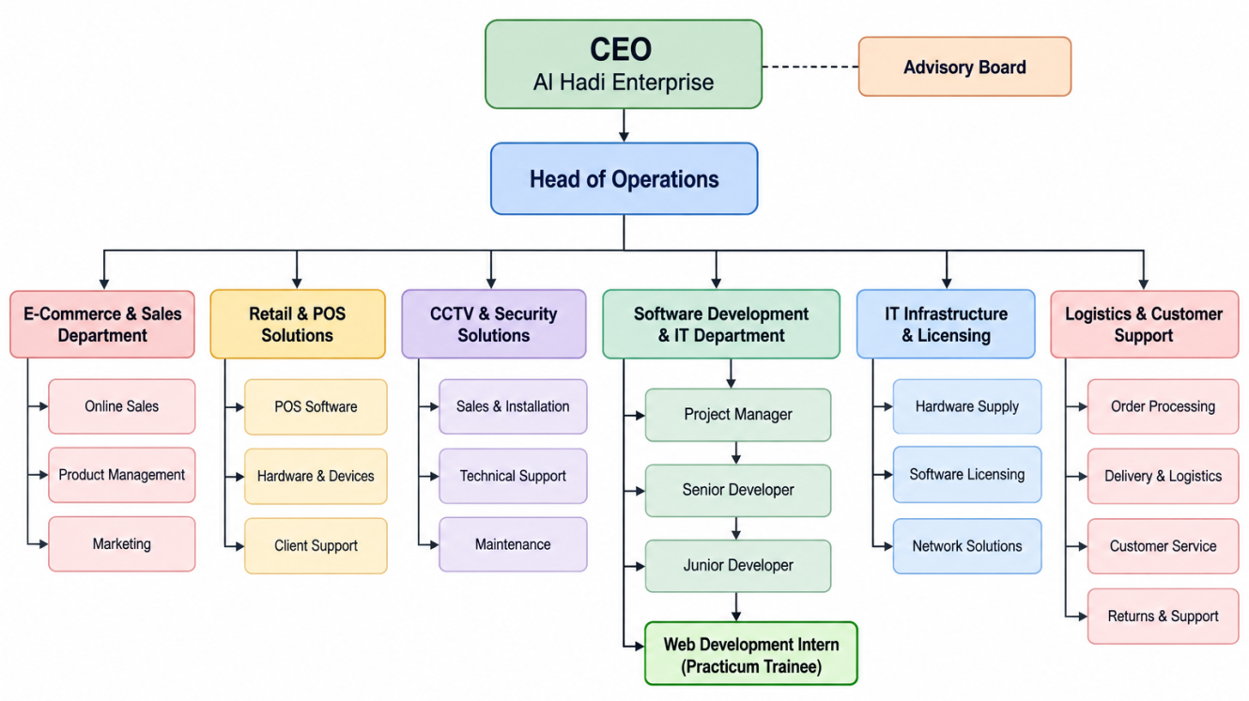
Figure 2.0.1 Organizational Structure of Al Hadi Enterprise and Software Development Team

2.5 My Position in this Organization
During the practicum period, I worked as a Web Development Intern at Al Hadi Enterprise within the software development team. My primary responsibilities involved assisting in the design, development, testing, debugging, and maintenance of web-based software applications using the Django framework and related web technologies.
In my practicum semester, I was placed with the Software Engineering division where I worked as a Web Development Intern. I worked with front-end and back-end design, engineering, database and web interface validation and debugging, and web platforms and applications built under Django, Python, relational databases and modern client-side libraries.
The development of an AI-enhanced examination management system and outcome-based assessment platform called IntelliGrade was my main task during the practicum. It was a complete life cycle from designing the relational schema to coding the backend business logic, multi engine OCR, multimodal AI routing and fault-tolerant failover, split-screen evaluation interface, course tabulation process automation and so much more.
- Designing and implementing backend functionalities using Django and Python.
- Key functionalities included the development of several backend modules (Python/Django), the design of normalized database models and index configurations, the implementation of pipelines for ingesting 300 DPI documents and deskewing images, the integration of multimodal LLMs for rubric-based grading, the creation of provider cooldown registries and fallbacks routing, the authoring of split-screen evaluation views, the construction of OBE calculation engines for course tabulations, and the development of 8-sheet Excel reporting tools, alongside end-to-end functional and security testing.
- Implementing OCR and document-processing pipelines for examination papers and answer scripts.
- Integrating multimodal AI services for automated question extraction and answer evaluation.
- Developing AI provider routing and failover mechanisms for reliable evaluation processing.
- Implementing examination question, rubric, answer-script, and evaluation management functionalities.
- Developing teacher, student, examiner, and administrative dashboard functionalities.
- Implementing OBE-based course tabulation, grade calculation, and academic reporting.
- Integrating Excel-based reporting and automated result synchronization.
- Conducting functional testing, debugging, performance optimization, and real-time application testing.
- Supporting deployment and production configuration of the developed web application.
This role provided practical experience in applying software engineering principles to a real-world application environment and enabled me to work with modern backend, AI, document-processing, database, and web application technologies.
It was a practical experience with production engineering concepts, and this gave me the opportunity to bring my theoretical computer science background to bear on the latest in AI, document processing and cloud architectures.

2.6 Address of the Organization
The registered and corporate office of the host organization is:
Al Hadi Enterprise
Plot 6 (3rd Floor), Road 1/A,
Sector 17, Uttara South, Dhaka 1230, Bangladesh.
Website: Al Hadi Express
Corporate Email: info@alhadiexpress.com.bd
Sales Email: sales@alhadiexpress.com.bd

Chapter 3. Requirement Engineering

3.1 Requirement Elicitation
To determine the functional needs, operational problems, academic needs and quality expectations of the university examination and assessment lifecycle, requirement elicitation for IntelliGrade was performed. Requirements were collected by examining the current examination and grading process, engaging with key academic stakeholders, examining institutional OBE documentation, and analyzing existing digital assessment solutions.
The elicitation process aimed to gain an understanding of the Activities that are carried out by the Major System Actors namely Exam Controller, Department Head, Faculty/Examiner and Student. Specifically, attention was paid to exam scheduling, preparing questions and rubrics, processing answer-scripts, evaluation, teacher verification, academic tabulation, publishing student results, and OBE reporting.

3.1.1 Requirement Gathering Methods
The following methods were used to identify and validate the requirements of IntelliGrade:
      - Stakeholder Interviews: Meeting with faculty members and examination related staff identified the major issues that existed in the current evaluation process such as manual marking effort, inconsistent evaluation, time consuming CO/PO attainment report preparation, lacking traceability of the evaluation process, and difficulty in marking.
      - Process Observation: The current examination process from preparation of examination routine to question-paper management, answer-sheets evaluation, mark entry system, course tabulation and results publishing was observed. This assisted in determining manual choke points and opportunities for workflow automation.
- The data structure, assessment weightage and reporting requirements that the system must support were identified through a review of institutional examination and OBE-related documents, such as the official course tabulation structure and the CO/PO reporting formats required in the institution.
- Existing System and Literature Review: Academics assessment and grading system already in existence were surveyed and studied to discover the common features and limitations. The analysis assisted in determining the domains where IntelliGrade could serve as an integrated workflow, especially the features of connecting examination management, processing of answer-scripts, evaluation, teachers verification and OBE based academic reporting.

3.2 Requirement Analysis
The gathered requirements were examined using the full examination lifecycle of IntelliGrade. Four main actors were identified through the analysis:
- Exam Controller – manages institutional academic information, users, examinations, and examination routines.
- Department Head – monitors departmental academic and examination activities and reviews OBE performance.
- Faculty/Examiner – prepares questions and rubrics, evaluates answer scripts, verifies results, and finalizes marks.
- Student – accesses academic results, detailed evaluation feedback, GPA, and certified evaluated scripts.
The analysis resulted in four major requirement categories:
- User Requirements: What each actor needs to accomplish through the system.
- System Requirements: The system capabilities and interface behavior required to support those needs.
- Functional Requirements: Specific operations and processing activities performed by the system.
- Non-Functional Requirements: Performance, security, reliability, scalability, usability, maintainability, and compliance constraints.

3.2.1 Key Design Considerations
Several important design considerations emerged from the requirement analysis.
- Human-in-the-Loop Evaluation: Evaluations produced by AI should be considered outputs to aid in decision-making, not final academic decisions. It is essential that a teacher can review, adjust and make marks explicit before they are official results.
- Hybrid Evaluation Capability: The system will be able to grade online both with and without AI assistance. This ensures that teachers can still assess scripts where AI services are not available, not suitable or not needed.
- Reliable AI Integration: AI Evaluation Architecture should be capable of handling multiple providers and failover mechanisms. If there's the computing power, GPU infrastructure, or the capacity to utilize an external API, you can add more models or providers without altering the examination process.
- OBE Compliance: The system shall be able to facilitate the institutional assessment structure and the necessary CO/PO attainment calculations and maintain consistency between the academic outcomes and OBE reports as per the institutional methodology.
- Auditability: Any significant evaluative activities, especially teacher mark modification and finalization activities, should be documented in an appropriate audit record.
- Data and Workflow Consistency: Data and metadata regarding examinations, results of evaluations, course tabulations, institutional reports, etc. shall be consistent throughout the entire exam life cycle.

3.3 Requirement Specifications
IntelliGrade has the following set of requirements that specify its major functional and non-functional capabilities. The requirements are listed in terms of the main actors and system responsibilities derived from requirement analysis.

3.3.1 Actor 1: Exam Controller
The Exam Controller oversees the administration of examinations and the academic calendar, scheduling of courses, configuration of external services, and official certification of examination results at the institutional level.
User Requirement 1
The Exam Controller wants to manage institutional academic information and authorized users.
System Requirements
1.1 The system shall provide a role-specific dashboard for the Exam Controller.
1.2 The system shall provide management interfaces for Colleges, Schools, Departments, Courses, Faculty members, and Department Heads.
1.3 The system shall maintain user roles and account status.
1.4 The system shall allow authorized administrators to activate or block user accounts.
1.5 Student registrations shall remain pending until approved by an authorized administrator.

Functional Requirements
- The system shall allow the Exam Controller to create, update, and manage institutional academic entities.
- The system shall allow authorized users to manage faculty and Department Head information.
- The system shall provide account activation and blocking functionality.
- The system shall support student registration and approval workflows.
- The system shall enforce role-based access to administrative functions.
The system supports unified role-based authentication, student approval, and institutional entity management.
User Requirement 2
The Exam Controller would like to automate the process of creating examination records from official examination routines with minimal data entry.
System Requirements
2.1 The system shall accept examination routine documents in PDF or image format.
2.2 The system shall identify examination dates, times, course codes, course titles, and assigned examiners.
2.3 The system shall match extracted course information with existing academic records.
2.4 The system shall allow the Controller to review extracted information before creating examination records.
2.5 The system shall support batch examination creation.

Functional Requirements
- The system shall process multi-page examination routine documents.
- The system shall extract relevant examination information from the uploaded routine.
- The system shall match extracted courses with the institutional database.
- The system shall allow the Controller to verify extracted information.
- The system shall create examination records after confirmation.
The existing specification includes automated routine parsing, course matching, and batch examination creation.
User Requirement 3
The Exam Controller wishes to set up the services needed to process documents and evaluate with the support of AI.
System Requirements
3.1 The system shall provide an authorized configuration interface.
3.2 The system shall support configuration of available AI providers and their credentials.
3.3 The system shall support configurable OCR and evaluation parameters.
Functional Requirements
- The system shall support configuration of available AI services such as Gemini, Groq, OpenAI, OpenRouter, and Ollama.
- The system shall allow authorized administrators to configure service credentials.
- The system shall allow relevant OCR confidence thresholds and processing parameters to be configured.

3.3.2 Actor 2: Department Head
The Department Head shall keep an eye on academic activities in the department, review the examination schedules, control the course allocation and monitor OBE attainment.
User Requirement 1
The Department Head wants to monitor departmental examination and academic performance.
System Requirements
1.1 The system shall provide a dedicated Department Head dashboard.
1.2 The dashboard shall display relevant departmental statistics.
1.3 The system shall provide information about active courses, enrolled students, examination activities, and faculty workloads.
1.4 The system shall present departmental performance indicators.
Functional Requirements
- The system shall display active course information.
- The system shall display enrolled student statistics.
- The system shall display relevant faculty examination workloads.
- The system shall present departmental pass-rate information.
- The system shall provide an overview of current academic performance.
The Department Head dashboard is defined to provide live departmental performance and workload information.

User Requirement 2
The Department Head wants to review course-level OBE performance and verify attainment information.
System Requirements
2.1 The system shall provide access to course OBE tabulation data.
2.2 The system shall provide Course Outcome (CO) attainment information.
2.3 The system shall provide Program Outcome (PO) attainment information.
2.4 The system shall allow authorized Department Heads to review and audit OBE records.
Functional Requirements
- The system shall provide course-level OBE tabulation information.
- The system shall calculate and display CO attainment.
- The system shall generate PO attainment information.
- The system shall allow the Department Head to review submitted OBE records.
- The system shall support academic quality monitoring through OBE reports.

3.3.3 Actor 3: Faculty Member / Examiner
The key academic user of the evaluation workflow is the Faculty Member/Examiner. The examiner sets up the question papers, rubrics, uploads answer papers, partitions the answer papers, evaluates, and determines the academic marks.

User Requirement 1
The Faculty/Examiner wishes to develop formal examination questions based on the desired academic framework and OBE.
System Requirements
1.1 The system shall provide a question authoring interface.
1.2 Each question shall support marks and relevant academic metadata.
1.3 The system shall support CO and PO mapping.
1.4 The system shall support Bloom's cognitive levels and relevant OBE classifications.
1.5 The system shall support questions containing figures, tables, and mathematical expressions.
Functional Requirements
- The system shall allow teachers to create and manage examination questions.
- The system shall associate questions with CO1–CO6 and PO1–PO12 where applicable.
- The system shall store Bloom's Taxonomy information.
- The system shall support Knowledge Profile (KP), Complex Engineering Problem (CEP), and Complex Engineering Activity (CEA) classifications.
- The system shall preserve associated figures, tables, and LaTeX mathematical expressions.
User Requirement 2
The Faculty/Examiner wants to define clear and consistent grading criteria before evaluating student answers.
System Requirements
2.1 The system shall provide a rubric management interface.
2.2 A rubric shall support multiple assessment criteria and mark distributions.
2.3 The system shall support ideal answers, expected keywords, and common mistakes.
2.4 The system shall allow master solutions to be associated with examination questions.
Functional Requirements
- The system shall allow teachers to create and manage question-specific rubrics.
- The system shall store assessment criteria and mark distributions.
- The system shall store ideal answers and relevant keywords.
- The system shall support common-mistake definitions.
- The system shall allow teachers to upload master solutions.
- The system shall associate master-solution information with corresponding questions.
User Requirement 3
The Faculty/Examiner would like to process student Answer Script and know the answers of the individual questions.
System Requirements
3.1 The system shall accept uploaded student answer scripts.
3.2 PDF answer scripts shall be converted into high-resolution page images for processing.
3.3 The system shall preprocess scanned pages before OCR or AI evaluation.
3.4 The system shall support multiple OCR engines.
3.5 The system shall identify question boundaries and corresponding answer regions.
Functional Requirements
- The system shall render uploaded scripts at an appropriate high resolution, including 300 DPI processing where required.
- The system shall perform image preprocessing such as deskewing, noise reduction, and thresholding.
- The system shall support PyMuPDF, PyTesseract, and EasyOCR-based text extraction.
- The system shall extract text together with relevant spatial information.
- The system shall detect question headers and map answer regions to corresponding questions.
- The system shall provide an interactive mapping interface for teacher verification and correction.
User Requirement 4
The faculty/examiner desires to use AI to speed up answer evaluation with the complete control of academic decisions.
System Requirements
4.1 The system shall provide an AI-assisted evaluation workflow.
4.2 The system shall support multiple AI providers.
4.3 The system shall provide automatic provider failover when an AI service becomes unavailable.
4.4 The system shall evaluate answers according to the configured question rubric.
4.5 The system shall identify low-confidence evaluations for teacher review.
4.6 The teacher shall be able to modify AI-generated marks and feedback.
Functional Requirements
- The system shall route evaluation requests through the configured AI provider sequence.
- The system shall detect provider timeouts and rate-limit responses.
- The system shall temporarily exclude unavailable providers through a cooldown mechanism.
- The system shall generate evaluation information including obtained marks, maximum marks, confidence, strengths, and mistakes.
- The system shall flag evaluations requiring manual verification.
- The system shall allow teachers to modify AI-generated marks and feedback.
- The system shall record teacher modifications for audit purposes.
User Requirement 5
The Faculty/Examiner wishes to have manual assessment of answer scripts where AI support is unavailable, unsuitable or not necessary.
System Requirements
5.1 The system shall provide a separate manual grading workflow.
5.2 Manual grading shall not depend on AI processing.
5.3 Teachers shall be able to enter and modify question-level marks.
5.4 Manually entered marks shall be stored in the academic evaluation records.
Functional Requirements
- The system shall provide an AI Evaluation Wizard.
- The system shall provide an independent Manual Script Grading Wizard.
- The system shall allow teachers to evaluate individual questions manually.
- The system shall preserve manually entered marks.
- The system shall integrate manual evaluation results into the course tabulation workflow.
The system explicitly supports separate AI-assisted and manual evaluation pathways.
User Requirement 6
The Faculty/Examiner wants to verify, finalize, and generate an official record of evaluated scripts.
System Requirements
6.1 The system shall provide a split-screen evaluation workbench.
6.2 The original student script shall remain accessible during evaluation.
6.3 Evaluation scores, criteria, and feedback shall be displayed alongside the script.
6.4 Teachers shall be able to review and override evaluation results.
6.5 Finalized evaluations shall generate certified documents.
Functional Requirements
- The system shall display the answer script and evaluation information simultaneously.
- The system shall allow teachers to override marks and modify feedback.
- The system shall record significant evaluation changes in audit records.
- The system shall generate certified PDF copies of finalized evaluations.
- The generated documents shall contain relevant institutional information, awarded marks, and teacher comments.
- The system shall apply appropriate digital watermarking to finalized documents.
- Temporary working files shall be removed after successful finalization.
User Requirement 7
The Faculty/Examiner would like to automatically include marks evaluated in course results and the OBE calculation.
System Requirements
7.1 The system shall support configured assessment components and weightages.
7.2 The system shall calculate course-level results from assessment data.
7.3 The system shall support CO and PO attainment calculations.
7.4 Authorized changes to marks shall update the corresponding academic records.
7.5 The system shall support structured course tabulation and Excel reporting.
Functional Requirements
- The system shall aggregate Class Test, Midterm, Final Examination, Assignment, and Attendance marks according to the configured assessment scheme.
- The system shall calculate the corresponding weighted course result.
- The system shall update student grade records following authorized mark changes.
- The system shall synchronize relevant finalized results with the Student Dashboard.
- The system shall generate the required multi-sheet Excel tabulation workbook.

3.3.4 Actor 4: Student
The first priority for the academic evaluation outcomes is the Student. The student interacts with the system and revises the examination schedules, provisional and final grades, and verified evaluations with feedback.
User Requirement 1
The Student wants to securely access the academic portal and manage their account.
System Requirements
1.1 The system shall provide secure student authentication.
1.2 The system shall support student self-registration where enabled.
1.3 Newly registered students shall require institutional approval before accessing protected academic information.
1.4 The system shall provide password recovery functionality.
Functional Requirements
- The system shall authenticate registered students.
- The system shall redirect authenticated students to their Student Dashboard.
- The system shall maintain the approval status of registered accounts.
- The system shall support OTP-based password recovery.
- Password-reset OTPs shall have a limited validity period.
User Requirement 2
The Student wants to view examination results and detailed academic performance.
System Requirements
2.1 The Student Dashboard shall display finalized academic results.
2.2 The system shall display course-level grades.
2.3 The system shall display cumulative GPA.
2.4 The system shall provide question-level marks and feedback where available.
2.5 The dashboard shall reflect finalized changes made by authorized faculty members.
Functional Requirements
- The system shall display course grades.
- The system shall calculate and display cumulative GPA on the defined grading scale.
- The system shall display question-wise marks and feedback where applicable.
- The system shall synchronize finalized grade changes with the Student Dashboard.
- The system shall provide access to certified evaluated scripts where authorized.
User Requirement 3
The Student wants to obtain an official copy of the evaluated answer script.
System Requirements
3.1 The system shall provide access to finalized certified PDF documents.
3.2 The generated document shall contain the relevant evaluation information.
3.3 Draft or temporary processing files shall not be exposed as official documents.
Functional Requirements
- The system shall provide a certified PDF access or download option.
- The generated document shall contain awarded marks and relevant teacher comments.
- The system shall apply the required institutional watermarking.
- The system shall retain the finalized evaluation record while removing unnecessary temporary processing files.

3.3.5 Cross-Actor Functional Requirements
There are some IntelliGrade functionality that are common to various actors and span the various phases of the examination life cycle.
Examination and Evaluation Synchronization
- The system shall maintain consistent examination, question, submission, evaluation, and academic records.
- Finalized teacher marks shall be synchronized with the corresponding student grade records.
- Changes in course tabulation shall be reflected in relevant academic reports and student information.
- The system shall maintain consistency between question-level evaluation, course grades, and OBE calculations.
Notification and Communication
- The system shall support institutional email services for account-related communication, OTPs, credentials, and relevant academic notifications.
- Email processing shall be performed asynchronously where necessary so that external mail-server delays do not unnecessarily block normal application requests.
Database and Processing Efficiency
- The system shall use appropriate database indexing for frequently accessed examination, evaluation, and academic records.
- The system shall use efficient relation loading to minimize unnecessary database queries during complex workflows.

3.3.6 Non-Functional Requirements
These non-functional requirements specify the quality attributes and usage constraints that IntelliGrade should meet so that it can be used in an acceptable manner by considering the performance, scalability, security, and reliability.
1. Performance
The loading time for Dashboard and Tabulation pages is about 1.5 seconds with normal institutional operating environments.
1.2 OCR and image preprocessing should target approximately 4 seconds per script page, depending on the deployed hardware.
1.3 AI-assisted evaluation should target approximately 8 seconds per question under normal external-service conditions.
1.4 AI provider failover shall occur without unnecessary interruption of pending evaluation tasks.
2. Scalability
2.1 The system shall be able to process up to 100 multi-page student scripts per examination session.
2.2 Architecture should support addition of more AI providers and larger size processing resources.
2.3 The document-processing and AI parts shall be modular, enabling the integration of an AI service on the GPU or other cloud AI services if available.

3. Security
3.1 User passwords should be securely salted and hashed and never stored in plain text.
3.2 Role-based access control shall be enforced for protected views and application endpoints.
3.3 State-changing requests shall be protected against unauthorized cross-site requests using appropriate CSRF mechanisms.
3.4 Each actor shall only be able to access the functions and data permitted by their assigned role.
4. Data Integrity and Auditability
4.1 Grade updates and important evaluation-state changes shall be processed using appropriate database transactions.
4.2 The system shall maintain consistency between evaluation, grade, tabulation, and reporting records.
4.3 Teacher mark overrides shall be recorded for traceability.
4.4 Relevant audit records shall include the responsible user and timestamp, along with other applicable request information.
5. Reliability and Availability
5.1 The system shall target at least 99.5% availability during examination and grading periods.
5.2 If an AI provider fails or is temporarily unavailable it shall not lead to the unnecessary loss of pending evaluation tasks.
5.3 There shall be a manual evaluation pathway in the system where AI evaluation is unavailable or unsuitable.
5.4 Temporary processing failures shall not corrupt finalized academic records.
6. OBE and Reporting Compliance
6.1 CO and PO calculations shall follow the configured institutional OBE methodology.
6.2 Generated Excel reports shall preserve the required formulas, validation rules, and formatting.
6.3 Course tabulation, CO attainment, PO attainment, and student results shall remain mutually consistent.
7. Usability
7.1 The system shall provide role-specific dashboards for the four primary actors.
7.2 The evaluative interface shall allow for a synched display of original answer script and evaluative information.
7.3 The web interface shall support responsive layouts and appropriate visual themes.
7.4 Users shall be able to perform common examination and evaluation tasks without requiring knowledge of the underlying OCR or AI technologies.
8. Maintainability and Extensibility
8.1 Examination Management, OCR, AI Evaluation, Grading, Tabulation, Reporting and Notification shall be maintained as a Modular part of the system.
8.2 AI providers should be changeable or expandable without having to make fundamental changes to the main examination workflow.
8.3 Unnecessary temporary processing files shall be automatically deleted from the system upon successful processing of the final file to minimize storage usage.

3.4 Use Case Diagram
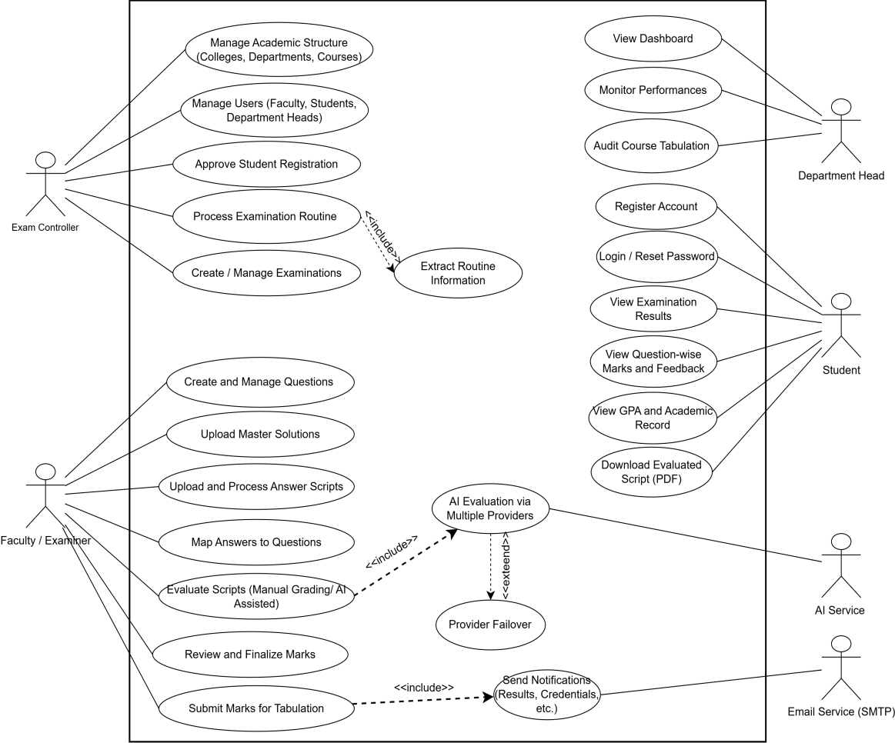
Figure 3.0.1 Use Case Diagram of IntelliGrade

Chapter 4. Analysis Modeling

4.1 Activity Diagrams
Activity diagrams capture the flow of key processes within IntelliGrade. Seven major workflows are documented below.
Activity diagrams illustrate the process flow between the main subsystems of IntelliGrade: e.g. decision points, background tasks (which can be executed asynchronously), and Human-in-the-loop review zones.
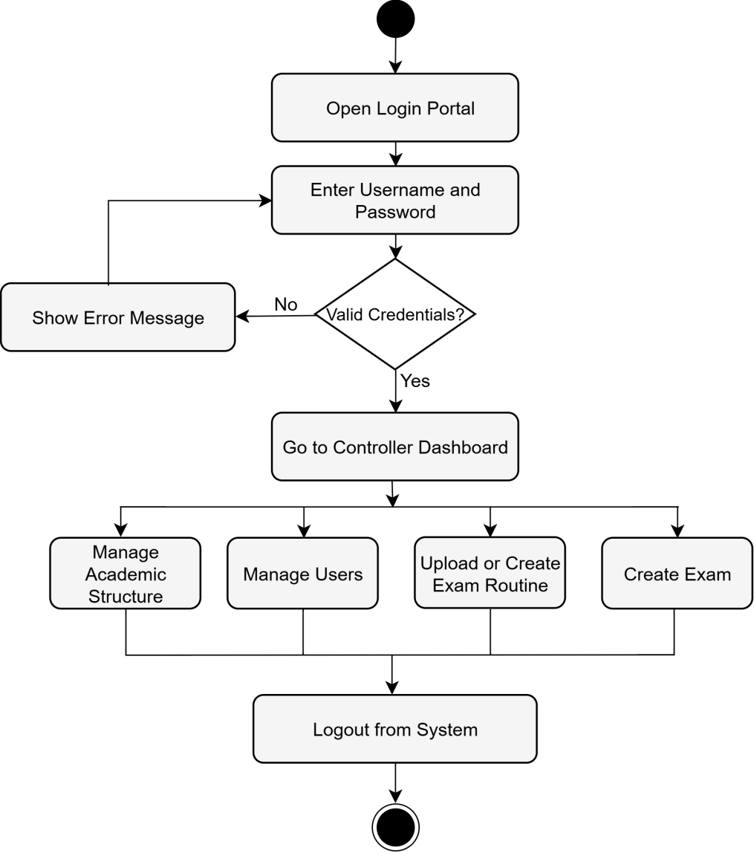
Figure 4.0.1 Activity Diagram: Exam Controller Governance Workflow

4.1.2 Activity Diagram: Examination Scheduling and Provisioning
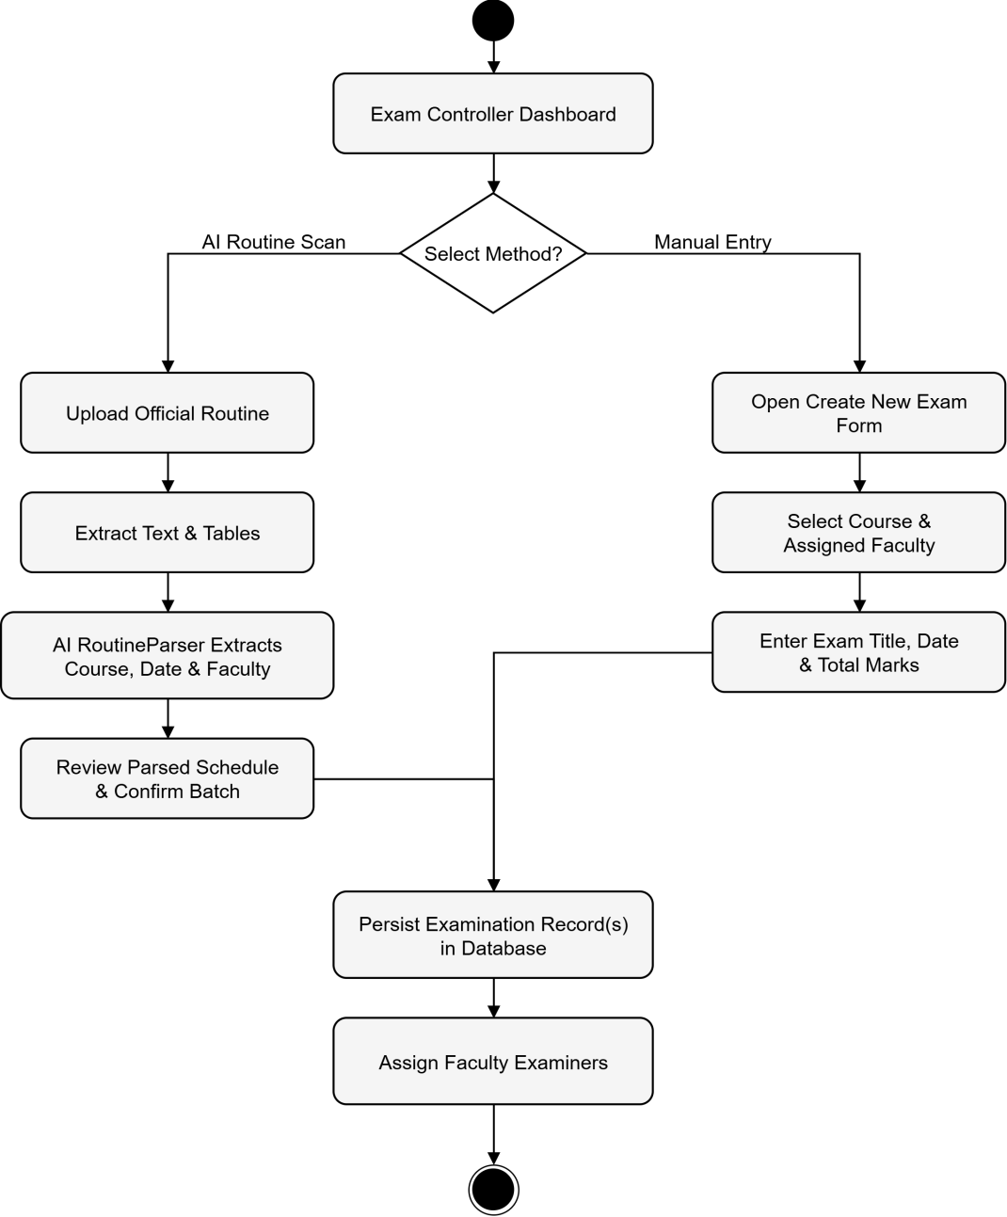
Figure 4.0.2 Activity Diagram: Examination Scheduling and Provisioning

4.1.3 Faculty/Examiner Activity Diagram
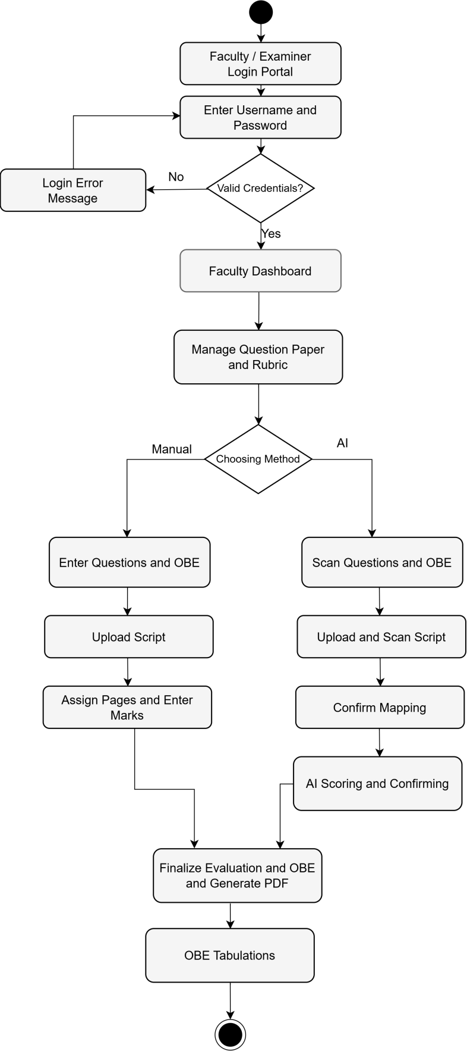
Figure 4.0.3 Activity Diagram: Faculty/Examiner Workflow
Faculty members navigate to the Question Paper Studio for a specific examination. They can author questions manually, providing the question prompt, maximum marks, and all 23 OBE taxonomy fields for each question, or they can upload the official question paper PDF and trigger AI-assisted scanning that automatically extracts question numbers, marks allocations, and suggested taxonomy tags. For each question, a structured rubric is defined including grading criteria, ideal answer, mark distribution across sub-criteria, expected keywords, and common student mistakes.
Faculty can add their own questions to the Question Paper Studio with a maximum mark and 23 OBE taxonomy classifications, or upload official PDFs into the Question Paper Studio which are automatically parsed by AI to pull out prompts, marks and Bloom's classifications. A multi-criteria rubric is provided for each question, identifying the best answers and the breakdown of the marks, the technical terminology that should be used and frequent pupil errors.

4.1.4 Question Paper and Rubric Authoring
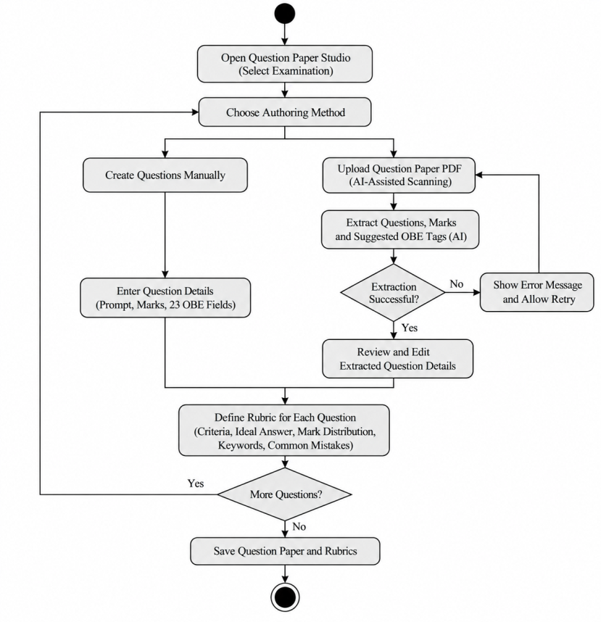
Figure 4.0.4 Activity Diagram: Question Paper and Rubric Authoring

4.1.5 AI Evaluation Wizard Flow
The AI Evaluation Wizard provides an assistive grading pathway designed to accelerate script marking while maintaining teacher oversight. The workflow executes an end-to-end cascade: preprocessing high-resolution 300 DPI answer script images, performing hybrid OCR extraction, running rubric-aligned inference through a multi-provider failover chain (local Moondream2, Groq, OpenRouter, Gemini, and OpenAI), and populating suggested marks and pedagogical justifications directly into the teacher's verification queue. Crucially, marks generated by the AI wizard remain non-binding drafts until explicitly reviewed, modified, or approved by the course instructor.
The AI Evaluation Wizard provides an assistive grading pipeline, designed to evaluate scripts faster while retaining the instructor's authority. The process includes automated multi-page PDF to 300 DPI image conversion, automated hybrid OCR extraction, automated passing of responses through a multi-provider failover chain (local Moondream2, Groq, OpenRouter, Gemini and OpenAI), and automated delivery of proposed marks with rationale into the teacher's grading workbench. Any AI marks are only tentative until confirmed or amended by the instructor.
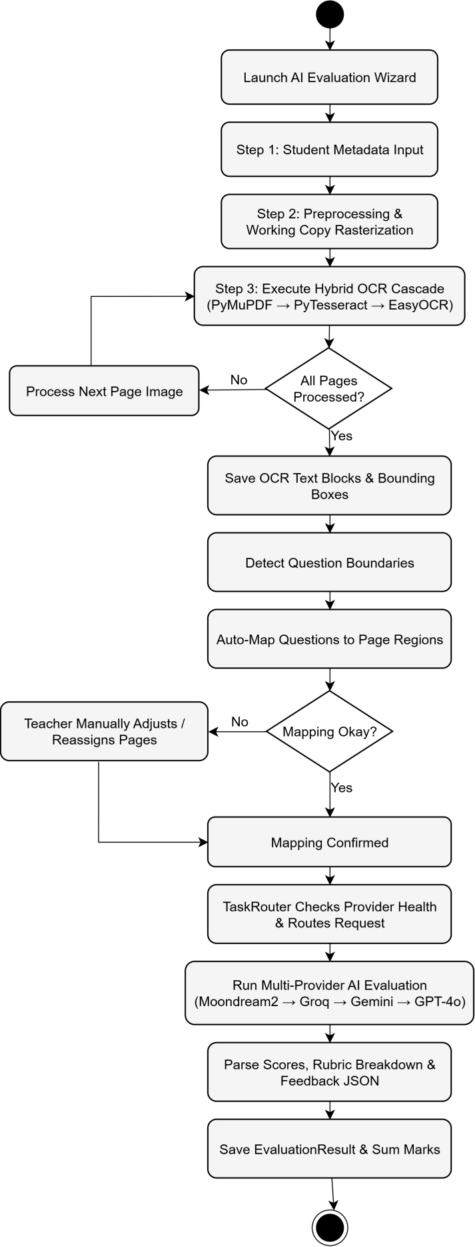
Figure 4.0.5 Activity Diagram: AI Evaluation Wizard Flow

4.1.6 Manual Script Grading Wizard Flow
The Manual Script Grading Wizard operates as an independent, high-speed grading interface for faculty members who prefer direct evaluation or when cloud AI services are unavailable. The instructor views the scanned script with zoom and pan controls, references the question-specific OBE rubric criteria alongside Bloom's taxonomy levels, inputs scores question-by-question with immediate validation, and commits the final grade. This guarantees that IntelliGrade remains 100% operational as a self-sufficient institutional examination management platform regardless of network connectivity or AI provider rate limits.
The Manual Script Grading Wizard is a quick and easy alternative to network/no AI quota or traditional grading for instructors who prefer it. The instructor uses full pan and zoom, scans pages and provides feedback on rubric and Bloom's criteria, marks with automated marking and submits assessment. This guarantees smooth examination procedures without cloud service.

4.1.7 OBE Tabulation
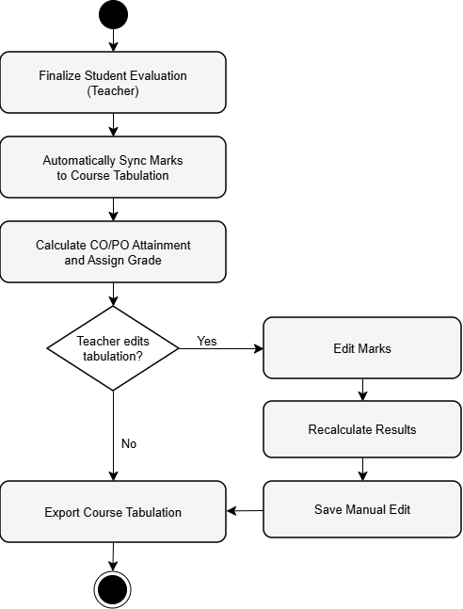
Figure 4.0.6 Activity Diagram: OBE Tabulation

4.1.8 Department Head
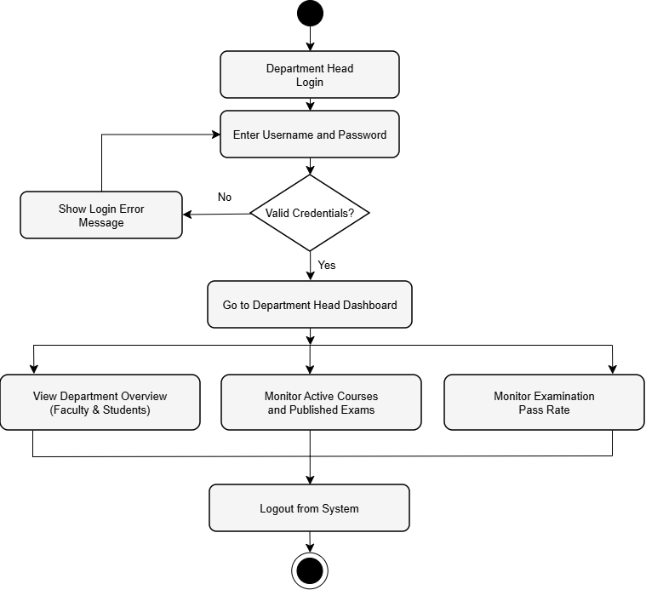
Figure 4.0.7 Activity Diagram: Department Head Governance

4.1.9 Student Portal
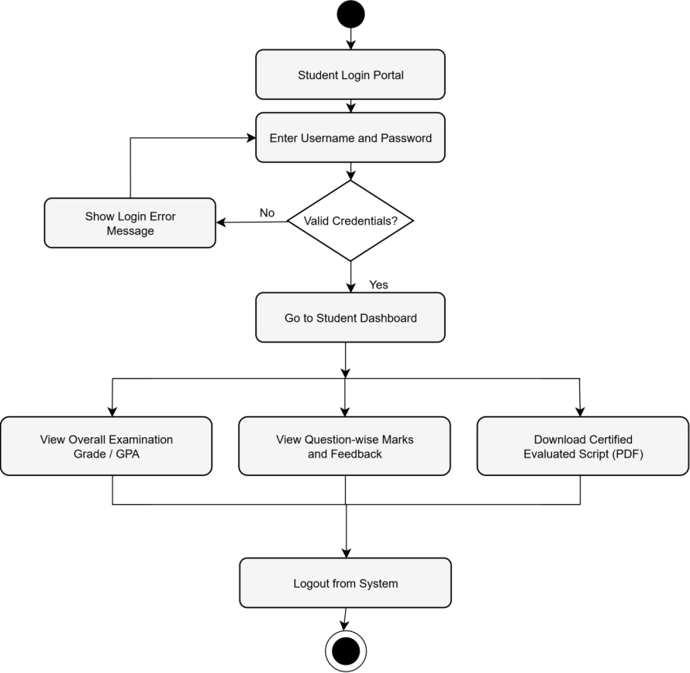
Figure 4.0.8 Activity Diagram: Student Academic Transparency Portal

4.2 Swim-lane Diagram

4.2.1 Swim-lane Diagram for User Authentication & Role-Based Access Control
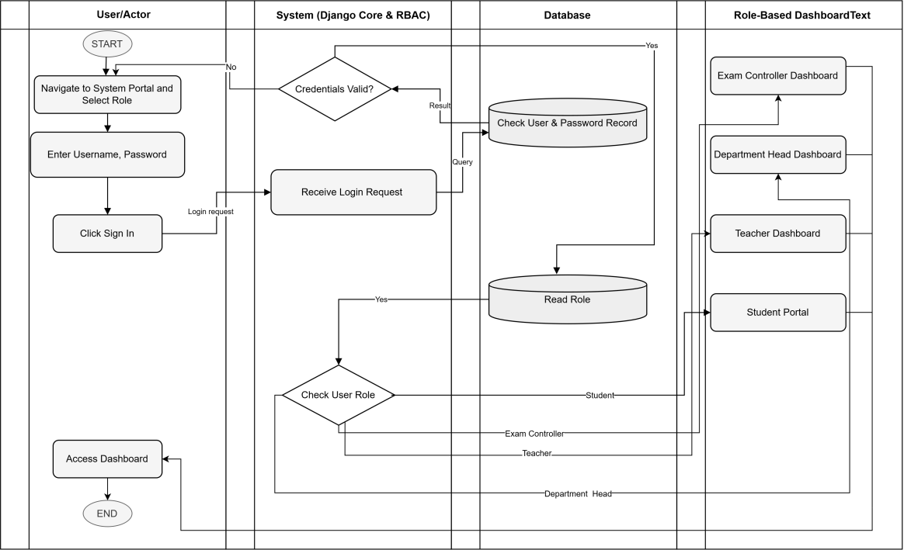
Figure 4.0.9 Swim-lane Diagram for User Authentication & Role-Based Access Control

4.2.2 Swim-lane Diagram for Examination Scheduling & Faculty Allocation
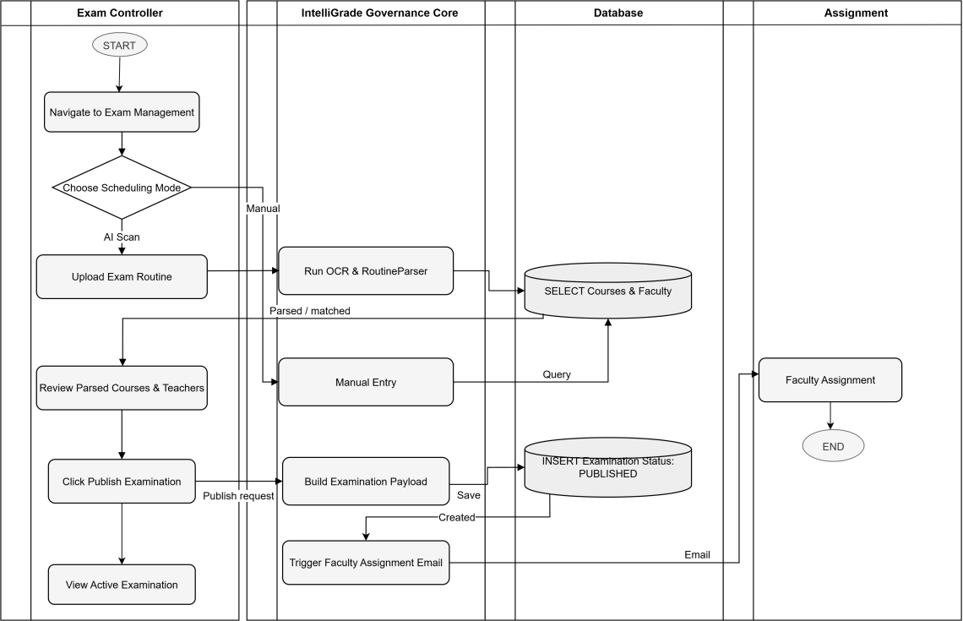
Figure 4.10 Swim-lane Diagram for Examination Scheduling & Faculty Allocation

4.2.3 Swim-lane Diagram for Answer Script Evaluation & Finalization
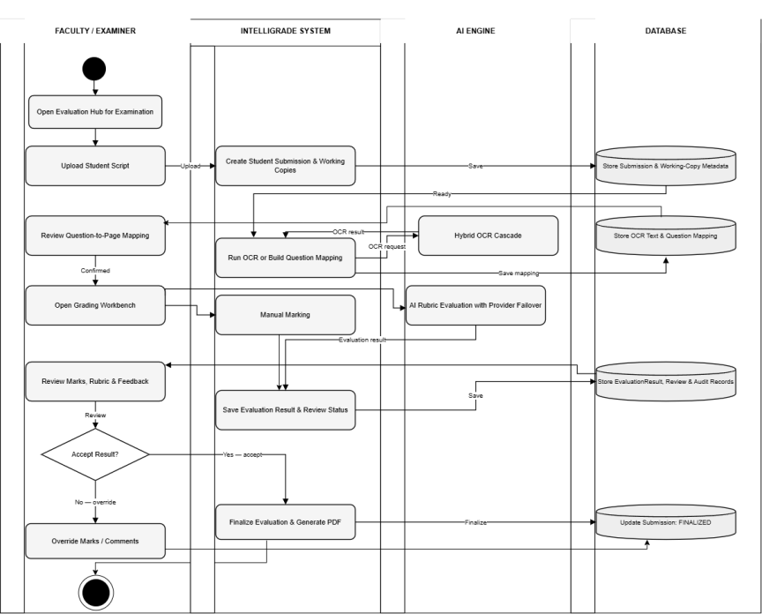
Figure 4.12 Swim-lane Diagram for Answer Script Evaluation & Teacher Finalization

4.2.4 Swim-lane Diagram for OBE Tabulation, Excel Export & Student Result Dissemination
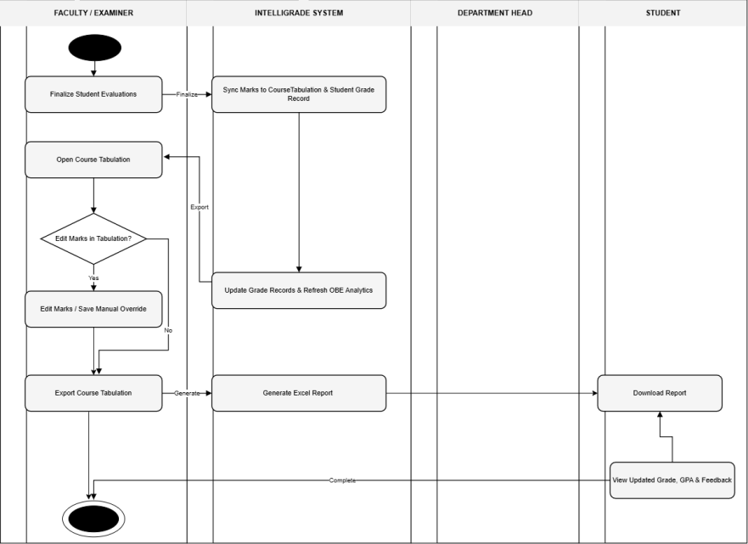
Figure 4.13 Swim-lane Diagram for OBE Tabulation, Excel Export & Student Result Dissemination

4.3 CRC Cards
Class-Responsibility-Collaborator (CRC) cards document the primary classes in IntelliGrade, their responsibilities, and their collaborators.
Table 4.1 CRC Card: Profile (User Role)
Class Name: Profile
Class Type: Role
Class Characteristics: Tangible, Persistent, Sequential
Responsibilities  • Store role (ADMIN, TEACHER, STUDENT, DEPT_HEAD)  • Store approval status (is_approved)  • Enforce role-based portal access  • Store OTP reset codes with expiry | Collaborators  • User (Django Auth)  • Department  • Examination

Table 4.2 CRC Card: Examination
Class Name: Examination
Class Type: Entity
Class Characteristics: Tangible, Persistent, Sequential
Responsibilities  • Store exam type (MID/FINAL/CT/QUIZ), status, and dates• Store approval status (is_approved)  • Hold uploaded question paper, rubric, and master solution files  • Manage publication workflow (DRAFT → PUBLISHED → CLOSED)  • Expose has_master_solution property | Collaborators  • Course  • Question  • StudentSubmission  • Profile (assigned faculty)

Table 4.3 CRC Card: Question
Class Name: Question
Class Type: Entity
Class Characteristics: Tangible, Persistent, Sequential
Responsibilities  • Store 23-taxonomy OBE fields (Bloom, CO, PO, KP, CEP, CEA)• Hold uploaded question paper, rubric, and master solution files  • Store prompt text and maximum marks• Expose has_master_solution property  • Reference attached figures, tables, and formula objects  • Provide formatted_number property for display | Collaborators  • Examination  • Rubric (OneToOne)  • QuestionFigure, QuestionTable, QuestionFormula  • SubmissionAnswer

Table 4.4 CRC Card: StudentSubmission
Class Name: StudentSubmission
Class Type: Entity
Class Characteristics: Tangible, Persistent, Sequential
Responsibilities  • Manage 14-state FSM lifecycle  • Store uploaded script file and extracted OCR data  • Track finalization status (is_finalized)  • Maintain composite B-tree database indexes  • Record student identity (name, roll number) | Collaborators  • Examination  • SubmissionPage, SubmissionImage  • QuestionMapping  • EvaluationAuditLog

Table 4.5 CRC Card: EvaluationResult
Class Name: EvaluationResult
Class Type: Entity
Class Characteristics: Tangible, Persistent, Sequential
Responsibilities  • Store obtained marks, maximum marks, and confidence score  • Store AI-generated feedback, strengths, and mistakes as JSON  • Flag low-confidence answers for mandatory teacher review  • Manage review status (PENDING/APPROVED/OVERRIDDEN/REJECTED) | Collaborators  • SubmissionAnswer (OneToOne)  • TeacherReview  • EvaluationHistory  • EvaluationFeedback

Table 4.6 CRC Card: CourseTabulation
Class Name: CourseTabulation
Class Type: Entity
Class Characteristics: Tangible, Persistent, Sequential
Responsibilities  • Store semester, section, and weightage configuration  • Maintain uniqueness constraint (course, semester, section)  • Provide aggregated assessment weightage configuration as JSON | Collaborators  • Course  • StudentGradeRecord

Table 4.7 CRC Card: StudentGradeRecord
Class Name: StudentGradeRecord
Class Type: Entity
Class Characteristics: Tangible, Persistent, Sequential
Responsibilities  • Store exam score breakdown per category (CT, Mid, Final, etc.)  • Compute weighted overall score via get_category_data()  • Store CO/PO attainment scores as JSON vectors  • Expose typed properties: class_test_data, midterm_data, final_data  • Track manual instructor overrides (is_manually_edited) | Collaborators  • CourseTabulation

4.4 Class Diagram
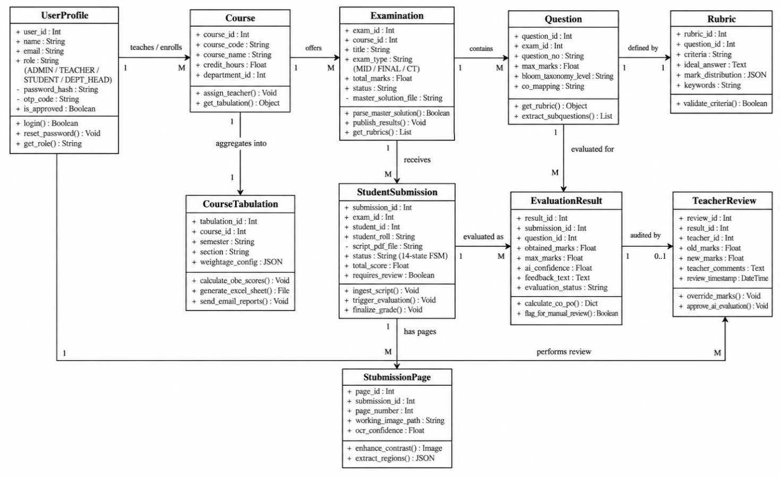
Figure 4.14 Class Diagram: Core Domain Models

Chapter 5. Project Management

5.1 Risk Identification
Table 5.1 Risk Identification
Risk ID | Risk Description | Category | Probability | Impact
R-01 | CPU-bound EasyOCR latency renders AI evaluation too slow for practical use on large exam batches | Technical | High | High
R-02 | Cloud AI provider rate limits (HTTP 429) cause evaluation stalls and timeouts during concurrent batch grading | Technical | High | High
R-03 | Extreme handwriting illegibility causes OCR failure and unmappable question boundaries | Technical | Medium | High
R-04 | Data loss or corruption during evaluation due to unhandled server exceptions | Technical | Low | Critical
R-05 | Institutional SMTP credential failure causes email notification breakdown | Operational | Medium | Medium
R-06 | Growing media file storage causes disk space overflow on the production server | Operational | Medium | High
R-07 | OBE calculation discrepancies due to floating-point rounding in Python arithmetic | Technical | Low | High

5.2 Risk Analysis
Table 5.2 Risk Analysis
Risk ID | Risk Description | Likelihood (1-5) | Severity (1-5) | Risk Exposure Score | Priority
R-01 | CPU OCR latency (EasyOCR ~20-25s/page on CPU) | 5 | 4 | 20 | Critical
R-02 | AI rate limiting — HTTP 429 cascade stalls | 5 | 4 | 20 | Critical
R-03 | Handwriting illegibility → OCR failure | 3 | 4 | 12 | High
R-04 | Data loss during evaluation exception | 2 | 5 | 10 | High
R-05 | SMTP email delivery failure | 3 | 3 | 9 | Medium
R-06 | Disk storage overflow from working images | 3 | 4 | 12 | High
R-07 | Floating-point rounding in OBE calculations | 2 | 4 | 8 | Medium

5.3 Risk Mitigation, Monitoring and Management (RMMM)
Table 5.3 RMMM: Risk 1 — CPU OCR Latency
Field | Details
Risk ID | R-01
Risk Description | CPU-bound EasyOCR CRAFT+BiLSTM deep learning model takes approximately 20-25 seconds per script page on a modern CPU, making full 13-page script evaluation take over 4 minutes — impractical for end-of-semester batch grading.
Mitigation | 1. Apply 800px LANCZOS downsampling before local vision dispatch (implemented). 2. Provide Manual Grading Wizard as a zero-OCR fallback for urgent evaluations. 3. Plan GPU CUDA upgrade path (NVIDIA RTX 4060, 8GB VRAM) in hardware budget.
Monitoring | AIProviderHealth model tracks avg_response_time_ms. Dashboard alerts configured for latencies exceeding 60 seconds per page.
Contingency | Fall back to Manual Wizard for urgent evaluations while GPU upgrade is provisioned. Teachers can still evaluate all students; only the automated text extraction is slowed.
Owner | System Architect
Review Date | End of each examination period

Table 5.4 RMMM: Risk 2 — AI Rate Limiting
Field | Details
Risk ID | R-02
Risk Description | Free-tier cloud AI APIs impose strict rate limits. Groq enforces 30 RPM / 6,000 TPM, Gemini enforces 15 RPM / 1,000,000 TPM. Evaluating multiple questions simultaneously for multiple students triggers HTTP 429 quota exhaustion.
Mitigation | 1. ProviderHealthTracker with 120-second cooldown registry per provider (implemented). 2. Maintain 5-provider failover chain so no single HTTP 429 blocks evaluation. 3. Apply JSON sanitization and LaTeX bracket repair to prevent re-requests due to parse errors.
Monitoring | AIProviderHealth.error_count and cooldown_until tracked in real time. Dashboard badge alerts teacher when all providers are rate-limited simultaneously.
Contingency | Upgrade to enterprise Pay-As-You-Go API tiers (Groq Developer Plan, Gemini Tier 1) for production deployment. Fall back to manual workbench if all AI providers are exhausted.
Owner | Exam Controller
Review Date | Before each examination period

Table 5.5 RMMM: Risk 3 — Handwriting Illegibility
Field | Details
Risk ID | R-03
Risk Description | Some students produce extremely poor handwriting that defeats even EasyOCR's deep learning recognizer, resulting in empty or garbled OCR output and unmapped question boundaries.
Mitigation | 1. Three-engine OCR cascade (PyMuPDF → PyTesseract → EasyOCR) maximizes text recovery probability. 2. Interactive mapping modal allows manual page assignment when auto-detection fails. 3. For illegible scripts, vision-capable AI providers (Gemini 2.5 Flash, GPT-4o) evaluate directly from the page image, bypassing OCR text entirely.
Monitoring | OCR confidence scores stored per page in SubmissionPage.ocr_confidence. Pages below threshold flagged in UI for teacher attention.
Contingency | Teacher manually selects pages via the visual confirmation modal, which is always available regardless of OCR output quality.
Owner | Faculty Member
Review Date | Per evaluation session

Table 5.6 RMMM: Risk 4 — Data Loss During Evaluation
Field | Details
Risk ID | R-04
Risk Description | An unhandled server exception or network interruption mid-evaluation could corrupt the StudentSubmission state machine or lose partially written SubmissionAnswer records.
Mitigation | 1. All database writes wrapped in django.db.transaction.atomic() ensuring partial states are rolled back on failure. 2. EvaluationAuditLog records every state transition with timestamp and actor identity. 3. Script PDFs and working images stored on disk and only purged after explicit teacher-initiated finalization. 4. extracted_ocr_data JSON field caches OCR output so re-evaluation does not require re-processing all images.
Monitoring | EvaluationAuditLog monitored for FAILED state transitions. System error log reviewed after each evaluation session.
Contingency | Re-upload script and restart evaluation pipeline from UPLOADED state. All previously extracted OCR data is available for reference.
Owner | System / Admin
Review Date | Continuous

Table 5.7 RMMM: Risk 5 — SMTP Email Delivery Failure
Field | Details
Risk ID | R-05
Risk Description | SMTP server outages or expired credentials can cause failure in account creation emails, OTP password reset delivery, and graded result notification emails.
Mitigation | 1. Email dispatch runs in a background threading.Thread so SMTP latency or failure never blocks the HTTP response seen by the user. 2. Email failures are logged to the application error log without raising user-visible exceptions. 3. OTP reset includes fallback instructions for Exam Controller manual intervention.
Monitoring | SMTP error logs reviewed daily during active grading periods.
Contingency | Exam Controller can manually reset passwords via Django admin. Results can be communicated as PDF downloads shared manually.
Owner | Exam Controller
Review Date | Monthly

Table 5.8 RMMM: Risk 6 — Disk Storage Overflow
Field | Details
Risk ID | R-06
Risk Description | 300 DPI page images (~26 MB uncompressed per page) accumulate rapidly. A course with 60 students x 13 pages generates approximately 20 GB of working copies, which can exhaust institutional server disk space.
Mitigation | 1. FinalizationService._purge_temporary_artifacts() deletes submission_working/ and submission_preview/ upon certified PDF creation (implemented). 2. JPEG quality=75 compression applied to all working copies. 3. 800px LANCZOS downsampling for local vision payloads reduces per-image size by ~85%.
Monitoring | Server disk usage alerts configured at 80% threshold. Pending finalization queue monitored via admin dashboard to identify abandoned submissions.
Contingency | Emergency purge script available to delete working images for all finalized submissions. Future plan: migrate to AWS S3 / Cloudflare R2 object storage with automatic lifecycle expiration policies.
Owner | System Admin
Review Date | End of each examination period

Table 5.9 Risk 7 — OBE Calculation Inconsistency
Field | Details
Risk ID | R-07
Risk Description | Python floating-point arithmetic without explicit rounding can produce weighted OBE scores that differ by +-0.01 from expected values, causing discrepancies between the web tabulation view and the official exported Excel workbook.
Mitigation | 1. All intermediate scores wrapped in round(value, 2) at each aggregation step in get_category_data(). 2. Generated Excel outputs use openpyxl's native formula support for in-sheet validation against Python-computed values. 3. Automated test suite validates OBE calculation correctness against 50 manually verified student records.
Monitoring | Automated test suite (tests.py, 1000+ assertions) run after every code change. OBE output spot-checked by faculty against manual calculations each semester.
Contingency | Teacher can manually override any computed score via the tabulation modal, with override flagged in is_manually_edited for auditability.
Owner | Developer
Review Date | After every deployment

Chapter 6. Project Planning and Scheduling

6.1 System Project Estimation
A thorough and systematic project estimation was performed before starting the engineering and implementation steps of the IntelliGrade Outcome-Based Education (OBE) Examination Management and Intelligent Script Evaluation Ecosystem. Project estimation is a crucial component of software project management, providing a basis for analysis in effective allocation of engineering resources, risk management during development, and timely delivery of the 300 DPI script preprocessing cascade, the hybrid multi-engine OCR pipeline (PyMuPDF, PyTesseract, EasyOCR CRAFT+BiLSTM), the fault-tolerant multi-provider AI failover orchestrator (Groq, Gemini, OpenRouter, Moondream2), and the live 8-sheet OBE tabulation engine within institutional timelines and budget constraints. Project estimation methodology consists of 4 basic aspects – Effort, Cost, Time and Team.
Table 6.1 Functionality, Input and Output
Function | Function Type | Description | Input | Output
User Authentication and RBAC | ILF | Profile, User, session management | Username / Password | Authenticated session + role redirect
AI Routine Scanner | EI | Parse multi-page exam schedule PDFs | PDF / Image file | Structured Examination records
23-Taxonomy Question Studio | ILF | Store questions with 23 OBE fields | Question form fields | Saved Question + Rubric records
Script Preprocessing | EI | Rasterize PDFs, deskew, threshold | PDF / JPG / ZIP | 300 DPI working copy images
Hybrid OCR Pipeline | EO | Multi-engine text extraction | Page images | Text + bounding box JSON
Question Boundary Detection | ILF | Regex state machine heading detection | OCR text per page | QuestionMapping records
AI Evaluation Failover Engine | EIF | Multi-provider AI orchestration | Prompt + context | EvaluationResult JSON
Split-Screen Workbench | EO | Interactive grading interface | Submission ID | Mark overrides + audit log entries
Certified PDF Generation | EO | ReportLab PDF stamping | Finalized submission | Watermarked evaluated PDF file
OBE Tabulation Engine | ILF | Weighted score aggregation | Exam scores JSON | StudentGradeRecord with CO/PO
8-Sheet Excel Export | EO | openpyxl workbook generation | Grade records | XLSX workbook (8 sheets)
Asynchronous Email Service | EIF | SMTP email dispatch | Event trigger + payload | Delivered email with PDF attachment
Student Dashboard | EO | Transparency grade portal | Student session | Live grade cards + download links

Table 6.2 Complexity of Data Function
Data Function | Elements | Records | Complexity
Profile / User | 8 | 4 roles | Simple
Examination + Question + Rubric | 25 | Nested hierarchy | Complex
StudentSubmission + Pages | 18 | Per exam per student | Average
EvaluationResult + Feedback | 15 | Per answer per question | Average
CourseTabulation + GradeRecord | 20 | Per course per semester | Complex
AIConfiguration + ProviderHealth | 12 | Global singleton | Simple

Table 6.3 Complexity of Transaction Function
Transaction Function | Type | Complexity
User Login and Role Redirect | EI | Simple
AI Routine Scanning | EI | Complex
Question Paper Authoring (23-field taxonomy) | EI | Complex
Script Upload + 300 DPI Preprocessing | EI | Complex
Hybrid OCR Cascade | EO | Complex
AI Evaluation with Multi-Provider Failover | EIF | Complex
Teacher Mark Override + Audit Logging | EI | Average
Finalize + Certified PDF + Storage Purge | EO | Complex
OBE Tabulation Aggregation | ILF | Complex
8-Sheet Excel Export | EO | Complex
Asynchronous SMTP Email | EIF | Average
Student Grade Dashboard | EO | Average

Table 6.4 UFP Calculation Summary
Function Point Category | Count | Weight | Contribution
External Inputs (EI) | 6 | 4 | 24
External Outputs (EO) | 7 | 5 | 35
External Interface Files (EIF) | 3 | 7 | 21
Internal Logical Files (ILF) | 5 | 10 | 50
Total Unadjusted Function Points (UFP) |  |  | 130

Table 6.5 Technical Difficulty Index (TDI)
Technical Factor | Rating (0-5) | Description
Data Communications | 5 | Multi-provider REST APIs, AJAX, SMTP
Distributed Processing | 4 | Background email threads, async evaluation
Performance | 5 | Sub-second DB queries, 8-sec AI target
Complex Processing | 5 | OCR cascade, AI failover, PDF stamping
Reusability | 3 | Modular AI engine provider classes
Ease of Installation | 2 | Docker + env configuration required
Ease of Operation | 4 | Web-based, role-guided UI
Portability | 3 | Django + PostgreSQL portable
Maintainability | 4 | Modular architecture, clean separation
TDI Total | 40 | VAF = 0.65 + (0.01 x 40) = 1.05

Adjusted Function Points (AFP) = UFP x VAF = 130 x 1.05 = 136.5 AFP
With a productivity of ~8 AFP per person-month for a complex real-time system incorporating AI and handwriting recognition, the entire development takes about 17 person-months, which aligns with the observed development time of 8 calendar months with a 5-person team equivalent.

6.2 Project Schedule (Gantt Chart)
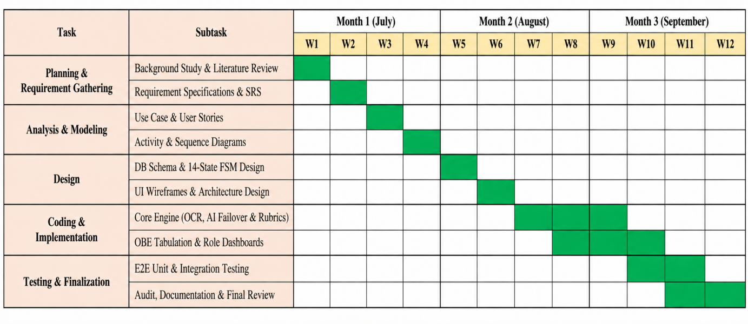
Figure 6.1 Gantt Chart: Project Schedule

Chapter 7. Cost Estimation

7.1 Personnel Cost
Table 7.1 Personnel Salary
Role | No. of People | Monthly Salary (BDT)
System Architect / Full-Stack Developer | 1 | 80,000
AI / ML Engineer | 1 | 75,000
Database Engineer | 1 | 60,000
UI/UX Designer | 1 | 50,000
QA / Test Engineer | 1 | 45,000
Total | 5 | 310,000

Table 7.2 Personnel Cost Estimation
Role | Duration (Months) | Monthly Cost (BDT) | Total (BDT)
System Architect / Full-Stack Developer | 8 | 80,000 | 640,000
AI / ML Engineer | 6 | 75,000 | 450,000
Database Engineer | 4 | 60,000 | 240,000
UI/UX Designer | 4 | 50,000 | 200,000
QA / Test Engineer | 3 | 45,000 | 135,000
Total Personnel Cost |  |  | 1,665,000

7.2 Hardware Cost
Table 7.3 Hardware Cost
Item | Specification | Cost (BDT)
Development Workstation | Intel Core i7, 32GB RAM, 1TB SSD | 120,000
GPU for Local OCR (Optional) | NVIDIA RTX 4060 (8GB VRAM) | 65,000
Network Equipment | Router, switches, UPS | 25,000
Total Hardware Cost |  | 210,000

7.3 Software Cost
Table 7.4 Software Cost
Item | Description | Annual Cost (BDT)
Python / Django / PostgreSQL | Open-source — Free | 0
EasyOCR / PyTesseract / PyMuPDF / OpenCV | Open-source — Free | 0
Groq Cloud API (Free Tier) | 30 RPM / 6,000 TPM | 0
Gemini API (Free Tier) | 15 RPM / 1,000,000 TPM | 0
PythonAnywhere Hosting (Hacker Plan) | Production deployment | 6,720
Domain Name Registration | .com domain | 1,500
Total Software Cost |  | 8,220

7.4 Operational Cost
Table 7.5 Other Operational Costs
Item | Description | Monthly Cost (BDT)
Electricity and Internet | Development environment utilities | 5,000
Cloud Storage (Future) | AWS S3 or Cloudflare R2 for script archival | 3,000
Miscellaneous | Printing, testing materials, etc. | 2,000
Total Monthly Operational |  | 10,000

7.5 Total Project Cost Summary
Table 7.6 Total Project Cost Summary
Category | Cost (BDT)
Personnel Cost (8 months) | 1,665,000
Hardware Cost | 210,000
Software Cost (Annual) | 8,220
Operational Cost (8 months x 10,000/month) | 80,000
Grand Total | 1,963,220
Grand Total (USD approximate) | ~$17,850

Chapter 8. System Design

8.1 System Architecture Overview
IntelliGrade is a monolithic Django 5.2 web application, which is backed by a PostgreSQL database backend and internally organized in a clean service oriented way. The application consists of one main Django app (core) with all the models, views, urls, services and the AI engine sub package.
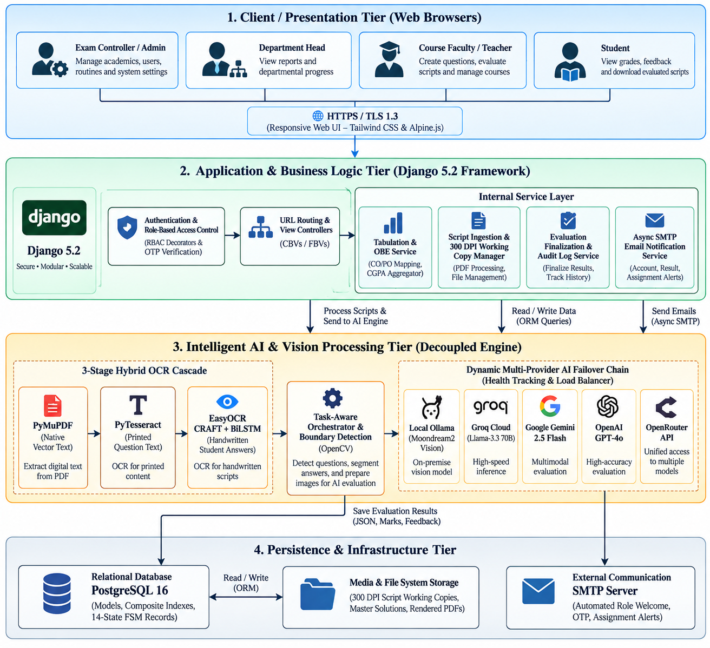
Figure 8.1 System Architecture Overview Diagram (4-Tier)

Table 8.1 Technology Stack Details
Layer | Technology | Version / Notes
Backend Framework | Django | 5.2.x (LTS)
Database | PostgreSQL / SQLite (dev) | SQLite for development, PostgreSQL for production
Computer Vision | OpenCV | 4.8.0 (headless)
PDF Rendering | PyMuPDF (fitz) | 1.23.0
OCR — Printed Text | PyTesseract | 5.3.x
OCR — Handwriting | EasyOCR (CRAFT+BiLSTM) | 1.7.0 on PyTorch CPU 2.8.0
AI Provider — Local | Moondream2 via Ollama | Offline vision model
AI Provider — Cloud | Groq Llama-3.3 70B | groq>=0.4.0
AI Provider — Cloud | Google Gemini 2.5 Flash | google-generativeai>=0.3.0
AI Provider — Cloud | OpenAI GPT-4o | openai>=1.0.0
AI Provider — Gateway | OpenRouter | REST API via requests
PDF Generation | ReportLab | 4.0.0
Excel Export | openpyxl | 3.1.0
Image Processing | Pillow | 10.0.0
Data Processing | Pandas, NumPy | 2.0.0 / 1.24.0
Email | Django SMTP + threading.Thread | Async non-blocking
Deployment | PythonAnywhere / Gunicorn | gunicorn>=21.2.0

8.2 Module Descriptions
IntelliGrade is organized into 21 functional modules:
Module ID | Module Name | Primary Responsibility
MOD-01 | Authentication and RBAC | Session auth, role-based routing, OTP reset
MOD-02 | Chief Exam Controller Portal | Academic hierarchy CRUD, student approval
MOD-03 | Department Head Dashboard | Departmental metrics and OBE audit
MOD-04 | Teacher/Examiner Workspace | Exam management and evaluation launch
MOD-05 | Student Transparency Portal | Grade cards, GPA, PDF download
MOD-06 | Academic Structure Management | College → School → Department → Course hierarchy
MOD-07 | AI Exam Routine Parser | Multi-page PDF/image schedule extraction
MOD-08 | Question Paper and 23-Taxonomy Studio | OBE-tagged question and rubric authoring
MOD-09 | Master Benchmark Solution Service | Golden solution ingestion and step mapping
MOD-10 | Script Ingestion and 300 DPI Preprocessor | PDF/image rasterization, deskewing, thresholding
MOD-11 | Hybrid Multi-Engine OCR | PyMuPDF → PyTesseract → EasyOCR cascade
MOD-12 | Question Boundary and Mapping Engine | Regex state machine + teacher confirmation modal
MOD-13 | AI Evaluation Wizard | Full automated pipeline from upload to scored result
MOD-14 | Manual Script Grading Wizard | Zero-AI/OCR fast page slicing and assignment
MOD-15 | Multi-Provider AI Evaluation Core | 5-provider failover with partial credit scoring
MOD-16 | TaskRouter and Cooldown Health Tracker | Provider health monitoring and 429 backoff
MOD-17 | Split-Screen Teacher Grading Workbench | Side-by-side script viewer and mark override
MOD-18 | Certified PDF Script Generator and Cleanup | ReportLab stamping and working image purge
MOD-19 | Course OBE Tabulation Engine | Weighted aggregation, letter grades, CO/PO
MOD-20 | 8-Sheet Excel Export and Bi-directional Sync | openpyxl workbook generation with formulas
MOD-21 | Asynchronous Institutional Email Service | Non-blocking SMTP dispatch via background threads

8.3 Data Flow Diagrams (DFD)

8.3.1 DFD Level 0 — Context Diagram
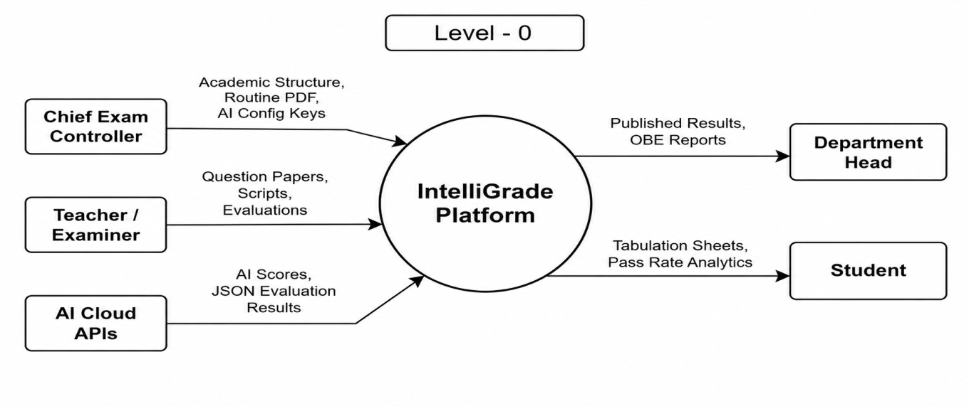
Figure 8.2 Data Flow Diagram — Level 0 (Context Diagram)

8.3.2 DFD Level 1
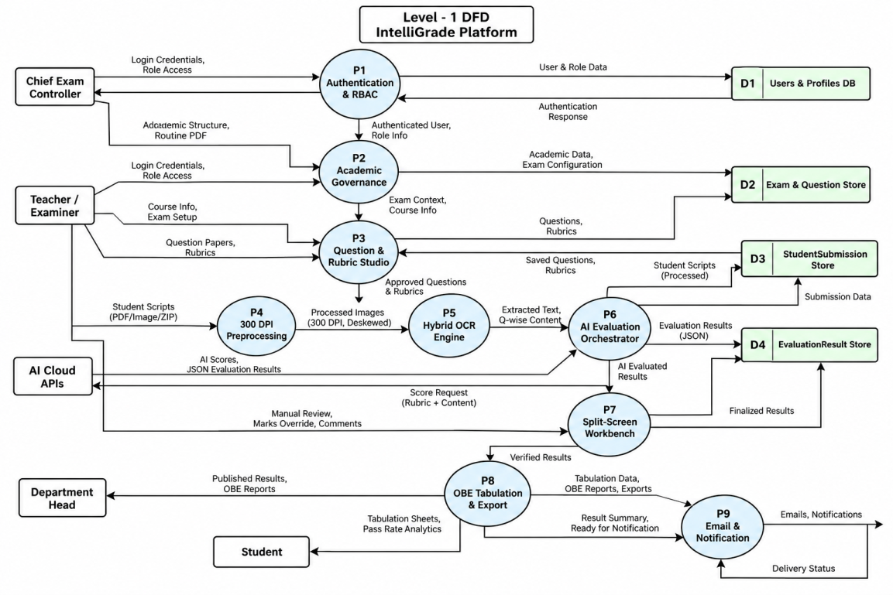
Figure 8.3 Data Flow Diagram — Level 1 (System Level)

8.4 Entity-Relationship Diagram (ERD)
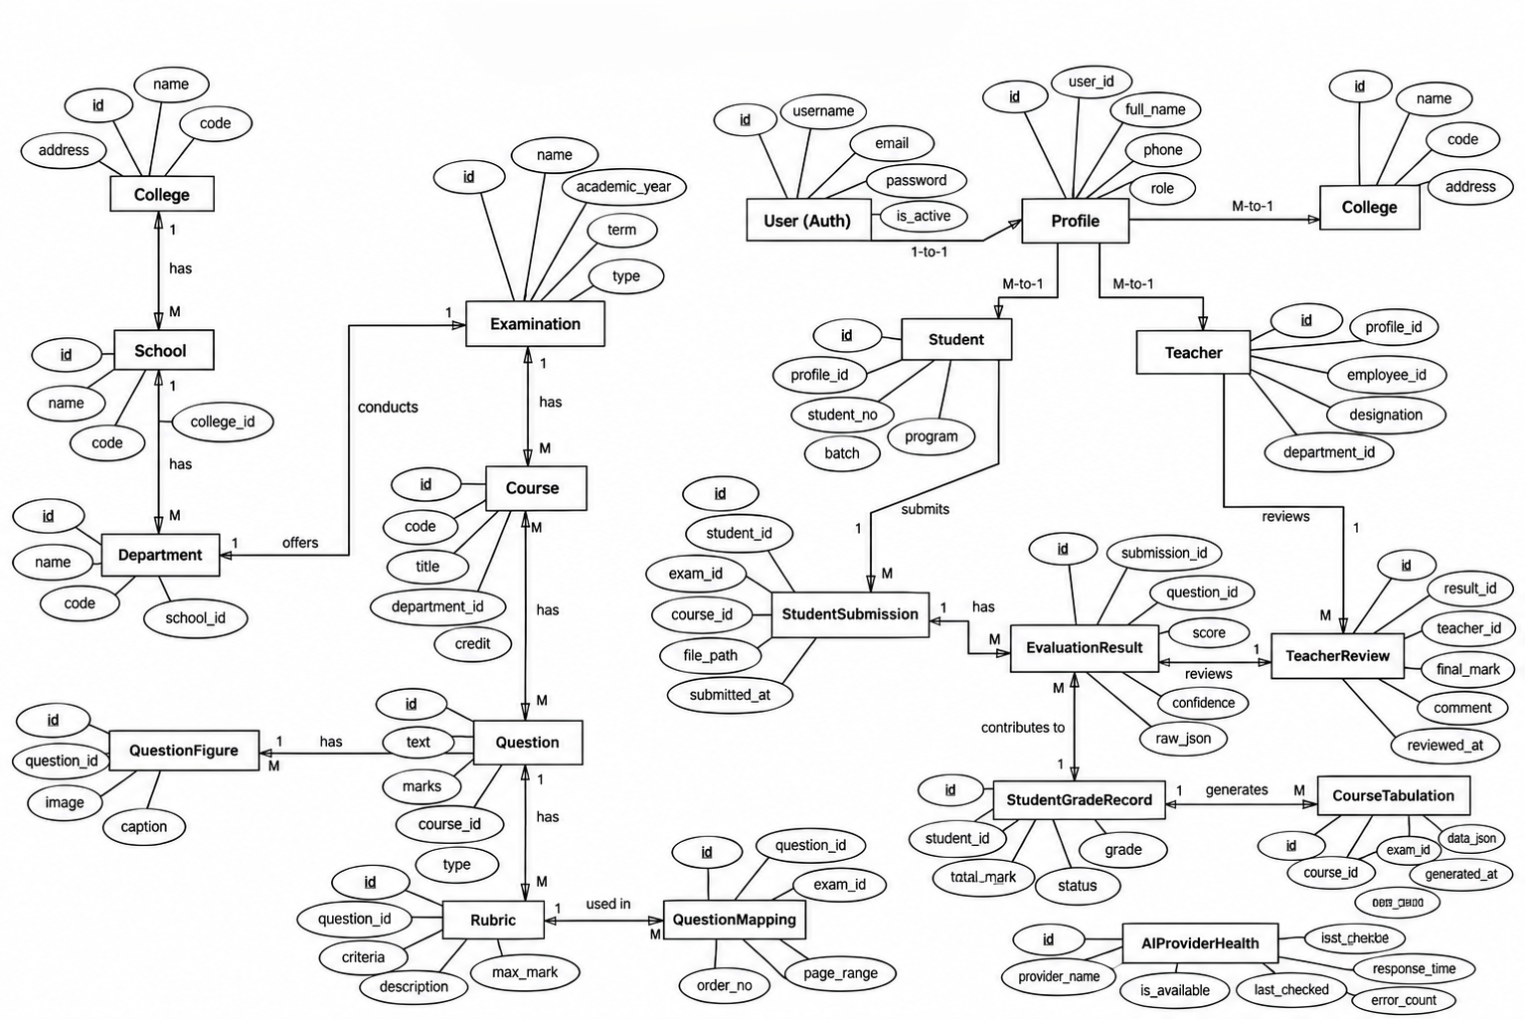
Figure 8.4 Entity-Relationship Diagram (ERD)

8.5 Database Schema
Table 8.2 Core Database Schema
Model | Primary Fields | Indexes
Profile | user (OneToOne), role (ADMIN/TEACHER/STUDENT/DEPT_HEAD), department (FK), is_approved (Bool) | Index(role, is_approved)
College | name, code (unique) | Index(code)
School | college (FK), name, code | Index(code)
Department | school (FK), college (FK), name, code, is_active | Index(code, is_active)
Course | department (FK), code (unique), title, instructors (M2M) | Index(code, department)
Examination | course (FK), title, exam_type, total_marks, status, exam_date, master_solution_file, master_solution_parsed | Index(course, status)
Question | examination (FK), question_number, prompt_text, max_marks, bloom_level, co_mapping, po_mapping, kp_mapping, cep_mapping, cea_mapping | Index(examination, question_number)
Rubric | question (OneToOne), criteria, ideal_answer, mark_distribution (JSON), keywords, common_mistakes | OneToOne Primary
QuestionFigure | question (FK), page_number, caption, image, bounding_box (JSON), is_master_solution_figure | Index(question)
QuestionTable | question (FK), element_type, caption, cell_json (JSON), rows, columns | Index(question)
QuestionFormula | question (FK), raw_latex, image, is_matrix, bounding_box (JSON) | Index(question)
StudentSubmission | examination (FK), student (FK), student_name, student_roll_no, status (14-state FSM), total_obtained_marks, is_finalized, extracted_ocr_data (JSON) | Index(examination, status), Index(student_roll_no), Index(is_finalized)
SubmissionPage | submission (FK), page_number, page_image, working_image_path, version, ocr_raw_text, ocr_confidence | Index(submission, page_number)
SubmissionImage | submission (FK), original_file, sequence_order, rotation_angle, version | Index(submission, sequence_order)
SubmissionAnswer | submission (FK), question (FK), extracted_text, ocr_confidence, bounding_box_json, page (FK) | Index(submission, question)
EvaluationResult | submission_answer (OneToOne), obtained_marks, maximum_marks, confidence, strengths_json, mistakes_json, rubric_breakdown_json, feedback_text, status, requires_manual_review | Index(status, requires_manual_review)
TeacherReview | evaluation_result (FK), teacher (FK), action, previous_marks, new_marks, review_comments, created_at | Index(evaluation_result, created_at)
EvaluationHistory | evaluation_result (FK), old_marks, new_marks, reason, changed_by (FK), timestamp | Index(evaluation_result)
EvaluationAuditLog | submission (FK), action, actor (FK), old_state, new_state, notes, ip_address, timestamp | Index(submission, timestamp)
QuestionMapping | submission (FK), question (FK), page_numbers_json, confidence, mapping_status, is_confirmed | Index(submission, mapping_status), Index(submission, is_confirmed)
CourseTabulation | course (FK), semester, section, weightage_config (JSON) | UniqueConstraint(course, semester, section)
StudentGradeRecord | tabulation (FK), student_id, student_name, exam_scores (JSON), co_scores (JSON), po_scores (JSON), attendance_marks, overall_score, letter_grade, is_manually_edited | Index(tabulation, student_id), Index(tabulation, overall_score), Index(is_manually_edited)
AIConfiguration | provider, api_key, model_name, confidence_threshold, is_active | Index(provider, is_active)
AIProviderHealth | provider_name, current_model, status, error_count, cooldown_until, avg_response_time_ms, is_healthy | Index(provider_name, is_healthy)

8.6 REST and AJAX API Catalog
Table 8.3 REST and AJAX API Catalog
Method | Endpoint URL | View Function | Auth Role
POST | /api/auth/forgot-password/ | api_forgot_password | Public
POST | /api/auth/verify-reset-otp/ | api_verify_reset_otp | Public
POST | /api/auth/reset-password/ | api_reset_password | Public
GET | /api/courses-and-faculty/ | api_get_courses_and_faculty | ADMIN / DEPT_HEAD
POST | /api/publish-exam/ | api_publish_exam | ADMIN / TEACHER
POST | /api/scan-question-paper/ | api_scan_question_paper | TEACHER / ADMIN
GET | /api/scan-progress/<exam_id>/ | api_get_scan_progress | TEACHER / ADMIN
POST | /api/finalize-scanned-paper/ | api_finalize_scanned_paper | TEACHER / ADMIN
POST | /api/generate-ai-rubric/ | api_generate_ai_rubric | TEACHER / ADMIN
POST | /api/ai-analyze-question-full/ | api_ai_analyze_question_full | TEACHER / ADMIN
POST | /api/exam/<exam_id>/upload-master-solution/ | api_upload_master_solution | TEACHER
POST | /api/exam/<exam_id>/upload-submission/ | upload_student_submission | TEACHER
POST | /api/exam/<exam_id>/upload-raw-images/ | api_upload_raw_images | TEACHER
POST | /api/exam/<exam_id>/upload-wizard-pdf/ | api_wizard_upload_pdf | TEACHER
GET | /api/submission/<sub_id>/images/ | api_get_submission_images | TEACHER
POST | /api/submission/<sub_id>/reorder-pages/ | api_reorder_submission_pages | TEACHER
POST | /api/submission/<sub_id>/create-pdf/ | api_create_submission_pdf | TEACHER
GET | /api/submission/<sub_id>/progress/ | api_get_submission_progress | TEACHER
POST | /api/submission/<sub_id>/run-evaluation-v3/ | api_run_evaluation_v3 | TEACHER
POST | /api/submission/<sub_id>/analyze-mapping/ | api_analyze_question_mapping | TEACHER
POST | /api/submission/<sub_id>/confirm-mapping/ | api_confirm_question_mapping | TEACHER
POST | /api/submission/<sub_id>/reevaluate-v3/ | api_reevaluate_v3 | TEACHER
GET | /api/submission/<sub_id>/download-evaluated-pdf/ | api_download_evaluated_pdf | TEACHER / STUDENT
POST | /api/submission/<sub_id>/finalize/ | api_finalize_evaluation | TEACHER
POST | /api/submission/<sub_id>/update-info/ | api_update_submission_info | TEACHER
POST | /api/submission/<sub_id>/delete/ | api_delete_submission | TEACHER
POST | /api/evaluation-result/<res_id>/review/ | review_evaluation_answer | TEACHER
POST | /api/tabulation/grade-record/<rec_id>/update/ | api_update_student_grade_record | TEACHER
POST | /course/<course_id>/email-tabulation/ | email_course_tabulation_report | TEACHER / DEPT_HEAD
GET | /course/<course_id>/export-tabulation/ | export_course_tabulation | TEACHER / DEPT_HEAD

8.7 Interface Design

8.7.1 Landing Page
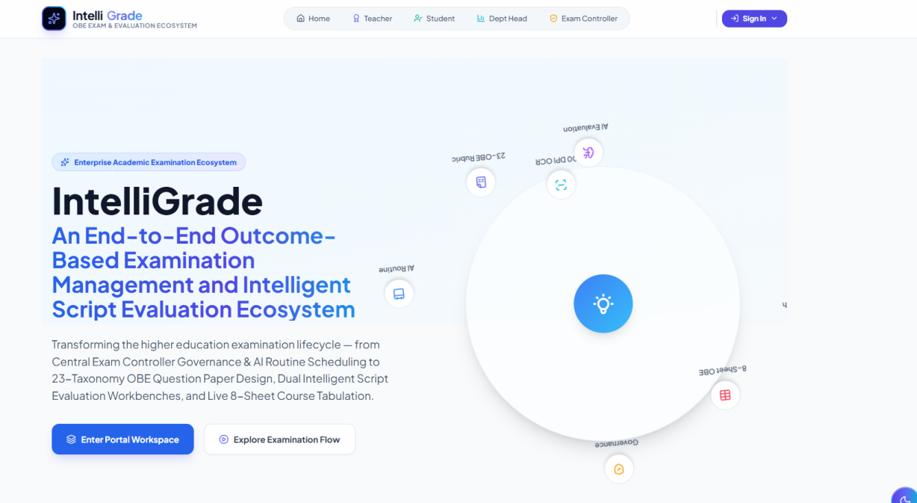
Figure 8.5 UI Mockup: Landing Page & Portal Selector

8.7.2 Exam Controller Dashboard
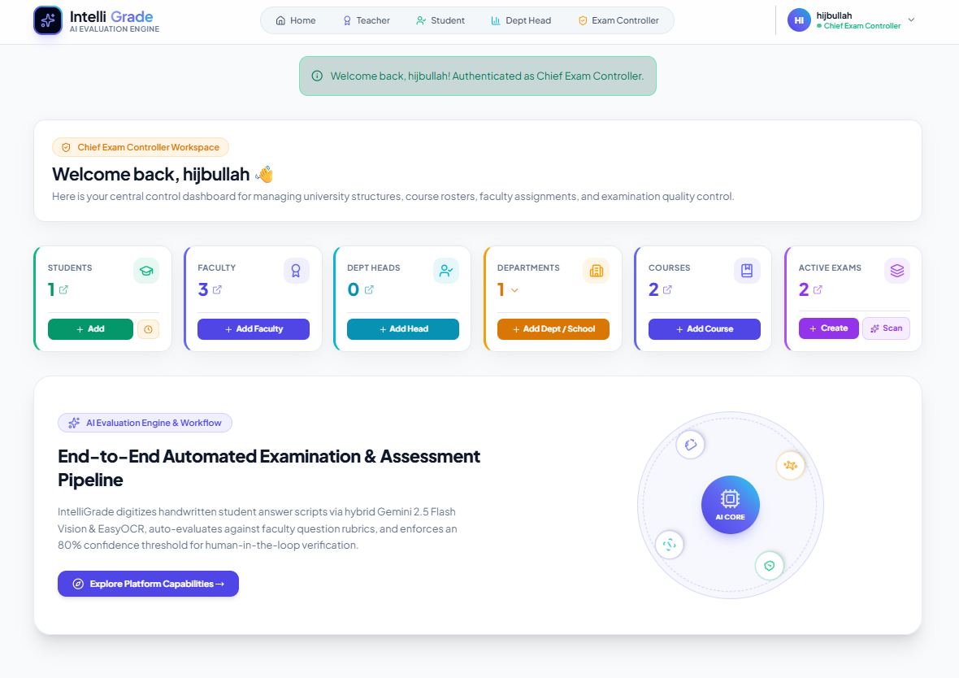
Figure 8.6 UI Mockup: Exam Controller Governance Dashboard

8.7.3 AI Routine Scanner
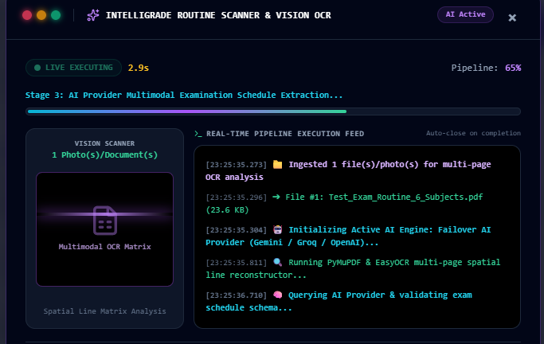
Figure 8.7 UI Mockup: AI Routine Scanner & Scheduler

8.7.4 AI Evaluation Wizard — Script Upload and Page Builder
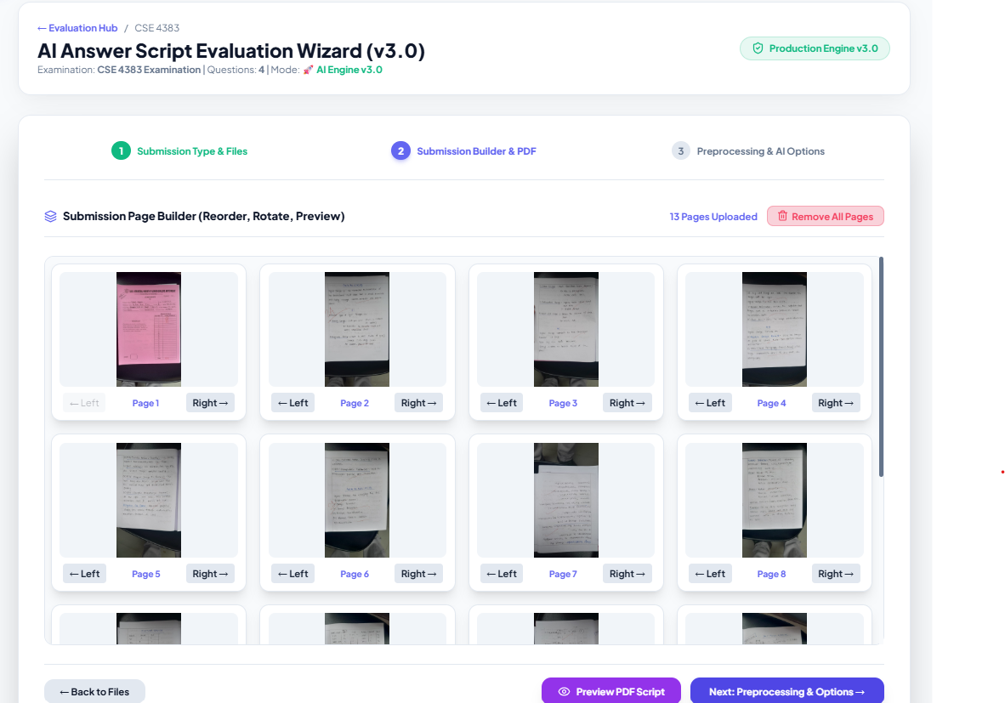
Figure 8.8 UI Mockup: AI Evaluation Wizard & Script Upload

8.7.5 Split-Screen Teacher Grading Workbench
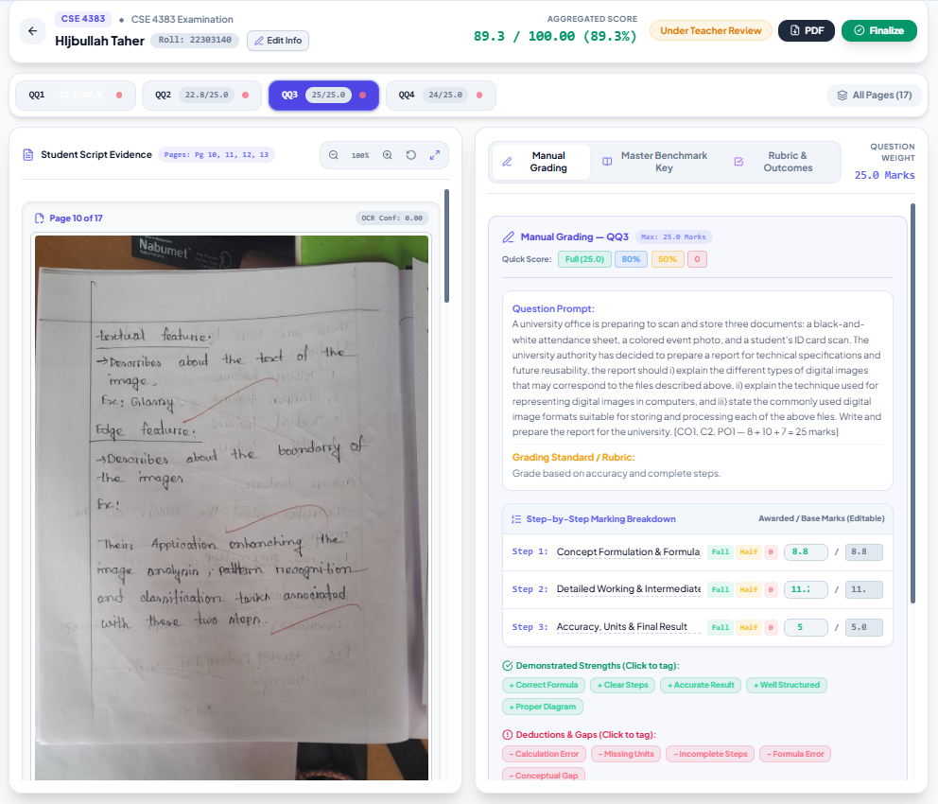
Figure 8.9 UI Mockup: Split-Screen Teacher Grading Workbench

8.7.6 Course OBE Tabulation View
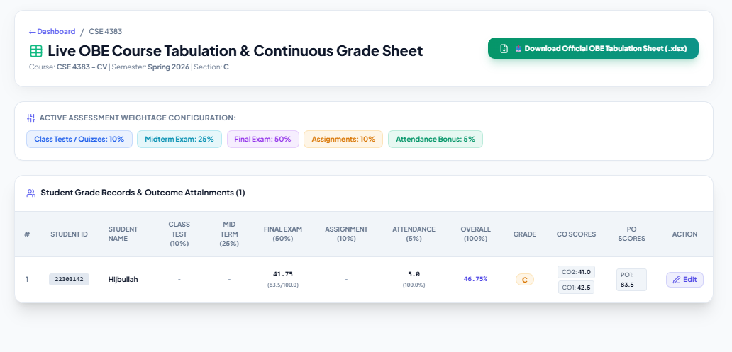
Figure 8.10 UI Mockup: Course OBE Tabulation View

8.7.7 Student Transparency Dashboard
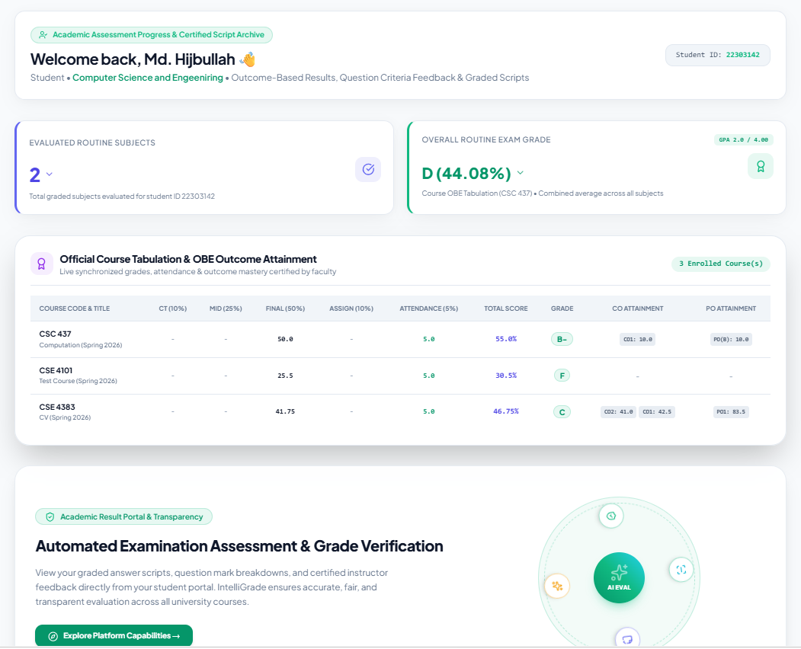
Figure 8.11 UI Mockup: Student Transparency Dashboard

8.7.8 Department Head Analytics Dashboard
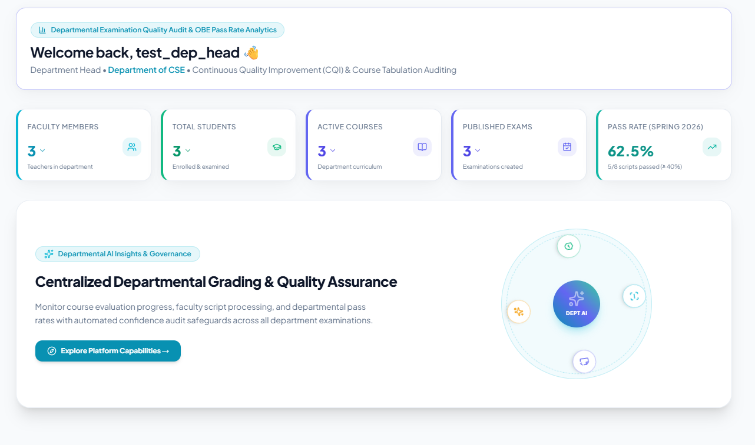
Figure 8.12 UI Mockup: Department Head Analytics Dashboard

Chapter 9. Testing

9.1 Test Cases
Table 9.1 Test Case 1: User Login and Role-Based Dispatch
Field | Details
Test Case ID | TC-01
Test Priority | High
Module Name | Authentication and RBAC
Test Title | User Login and Role-Based Dashboard Dispatch
Test Designed By | Md. Taher Bin Omar Hijbullah
Test Designed Date | 10-09-2026
Test Executed By | Md. Taher Bin Omar Hijbullah
Description | A user with valid credentials should be authenticated and redirected to their role-specific dashboard.
Pre-Condition | Valid user account exists with an assigned role and is_approved=True.
Dependencies | Profile model, Django session backend

Step | Test Steps | Test Data | Expected Result | Actual Result | Status
1 | Navigate to teacher login page | URL: /teacher/login/ | Login form renders correctly | Login form rendered | Pass
2 | Enter valid credentials | Username: engr_hijbullah, Password: testpass123 | No error message displayed | Credentials accepted | Pass
3 | Click Login button | — | Redirect to /dashboard/teacher/ | Redirected correctly | Pass
4 | Verify dashboard loads | — | Teacher dashboard with assigned courses visible | Dashboard loaded | Pass
Table 9.2 Test Case 2: AI Exam Routine Scanning
Field | Details
Test Case ID | TC-02
Test Priority | High
Module Name | AI Exam Routine Parser
Test Title | AI Exam Routine Scanning — PDF Ingestion and Schedule Extraction
Test Designed By | Md. Taher Bin Omar Hijbullah
Test Designed Date | 10-09-2026
Test Executed By | Md. Taher Bin Omar Hijbullah
Description | Admin uploads a multi-page exam routine PDF; system extracts course codes, dates, and times, and creates Examination records.
Pre-Condition | Admin authenticated. At least one Course record exists in the database.
Dependencies | Examination model, AIConfiguration, OCR engine

Step | Test Steps | Test Data | Expected Result | Actual Result | Status
1 | Navigate to routine scanner | URL: /controller/scan-routine-ai/ | Upload form renders | Form rendered | Pass
2 | Upload exam routine file | File: Midterm_Routine_Fall2026.pdf | File accepted, AI parsing begins | File uploaded, parsing started | Pass
3 | AI parses routine | — | Extracted: CSE 4383, 15 Sep 2026, 9:00 AM | Correct data extracted | Pass
4 | Review matched courses | — | CSE 4383 shown with green "Matched" badge | Course matched in DB | Pass
5 | Click Create All Examinations | — | Examination records created in DB; success toast shown | Records created | Pass
Table 9.3 Test Case 3: Question Paper Studio — 23-Taxonomy Entry
Field | Details
Test Case ID | TC-03
Test Priority | High
Module Name | Question Paper and 23-Taxonomy Studio
Test Title | Question Paper Studio — Manual 23-Taxonomy Entry
Test Designed By | Md. Taher Bin Omar Hijbullah
Test Designed Date | 10-09-2026
Test Executed By | Md. Taher Bin Omar Hijbullah
Description | Faculty authors a question with all 23 OBE taxonomy fields filled and defines a structured rubric.
Pre-Condition | Teacher authenticated. Examination exists in DRAFT or PUBLISHED status.
Dependencies | Question model, Rubric model

Step | Test Steps | Test Data | Expected Result | Actual Result | Status
1 | Navigate to question studio | URL: /teacher/exam/3/questions-rubric/ | Question form renders | Form rendered | Pass
2 | Enter question details | Q1, Max Marks: 10, Prompt: "Derive the 3D rotation matrix using cross-product formulation." | Fields populated | Fields accepted | Pass
3 | Set taxonomy fields | Bloom: Apply (C3), CO: CO2, PO: PO1 and PO2, KP: KP3 | Taxonomy selects populated | All taxonomy fields set | Pass
4 | Define rubric criteria | Criteria: "Vector decomposition (4 marks); Cross-product matrix (4 marks); Final matrix form (2 marks)" | Rubric form populated | Rubric accepted | Pass
5 | Save question | Click Save Question button | Question saved and appears in question list | Saved successfully | Pass
Table 9.4 Test Case 4: Script Upload and 300 DPI Preprocessing
Field | Details
Test Case ID | TC-04
Test Priority | High
Module Name | Script Ingestion and 300 DPI Preprocessor
Test Title | Script Upload and 300 DPI Preprocessing
Test Designed By | Md. Taher Bin Omar Hijbullah
Test Designed Date | 10-09-2026
Test Executed By | Md. Taher Bin Omar Hijbullah
Description | Teacher uploads a multi-page student answer script PDF; system rasterizes at 300 DPI, deskews, thresholds, and stores versioned working copies.
Pre-Condition | Teacher authenticated. Examination exists with defined questions and rubrics.
Dependencies | StudentSubmission, SubmissionPage, PyMuPDF, OpenCV

Step | Test Steps | Test Data | Expected Result | Actual Result | Status
1 | Launch AI Evaluation Wizard | URL: /teacher/exam/3/evaluation-wizard/?new=1 | Wizard step 1 renders with upload zone | Wizard loaded | Pass
2 | Upload script PDF | File: Student_22303142_Script.pdf (13 pages, A4) | File upload progress bar shown | File accepted | Pass
3 | System rasterizes PDF | — | 13 thumbnail page images appear in page builder | 13 pages rendered | Pass
4 | Verify 300 DPI quality | Inspect rendered image dimensions | Images are 2480 x 3508 px (A4 at 300 DPI) | Correct resolution confirmed | Pass
5 | Check working copies | Inspect media/submission_working/ directory | Versioned images stored with _v1 suffix | Working copies present on disk | Pass
Table 9.5 Test Case 5: AI Evaluation Wizard — End-to-End
Field | Details
Test Case ID | TC-05
Test Priority | High
Module Name | AI Evaluation Wizard and Failover Engine
Test Title | AI Evaluation Wizard — End-to-End Automatic Scoring
Test Designed By | Md. Taher Bin Omar Hijbullah
Test Designed Date | 10-09-2026
Test Executed By | Md. Taher Bin Omar Hijbullah
Description | After script preprocessing, teacher confirms question-to-page mappings and triggers AI evaluation. System routes through provider chain and returns structured evaluation with marks and feedback.
Pre-Condition | Script uploaded and preprocessed (TC-04 passed). Questions defined with rubrics.
Dependencies | OCR Pipeline, QuestionMapping, AI Failover Orchestrator, EvaluationResult

Step | Test Steps | Test Data | Expected Result | Actual Result | Status
1 | Proceed to OCR step | Wizard Step 3 | Live OCR terminal shows extracted text per page | OCR running, terminal updating | Pass
2 | Review question boundaries | Wizard Step 4 | "Q1" auto-mapped to Pages 1-2; "Q2" to Pages 3-4 | Correct auto-mapping detected | Pass
3 | Confirm mapping | Click Confirm Mapping | Status transitions to MAPPING_COMPLETE | Status updated in DB | Pass
4 | Trigger AI evaluation | Click Run AI Evaluation | Provider health checked; Groq selected as primary | Groq dispatched successfully | Pass
5 | Receive AI result | — | EvaluationResult: Q1 = 7.5/10.0, confidence = 0.82 | Result received and stored | Pass
6 | Verify feedback content | — | Strengths: "Strong matrix derivation"; Mistakes: "Missing normalization step" | Detailed feedback present | Pass
Table 9.6 Test Case 6: Manual Script Grading Wizard
Field | Details
Test Case ID | TC-06
Test Priority | High
Module Name | Manual Script Grading Wizard
Test Title | Manual Script Grading Wizard — Zero-AI Fast Evaluation Pathway
Test Designed By | Md. Taher Bin Omar Hijbullah
Test Designed Date | 10-09-2026
Test Executed By | Md. Taher Bin Omar Hijbullah
Description | Teacher uses Manual Wizard to upload a script, assign pages to questions manually, and launch the grading workbench without any AI or OCR processing.
Pre-Condition | Teacher authenticated. Examination exists with defined questions.
Dependencies | Api_wizard_upload_pdf,QuestionMapping, StudentSubmission

Step | Test Steps | Test Data | Expected Result | Actual Result | Status
1 | Launch Manual Wizard | URL: /teacher/exam/3/manual-evaluation/?new=1 | Wizard renders with PDF upload zone | Wizard loaded | Pass
2 | Upload script PDF | File: Student_Script_Manual.pdf | Pages sliced into thumbnails instantly with no OCR wait | Pages rendered in under 3 seconds | Pass
3 | Assign pages to Q1 | Check pages 1 and 2 checkboxes for Q1 | Pages 1 and 2 assigned to Q1 | Assignment saved | Pass
4 | Assign pages to Q2 | Check page 3 checkbox for Q2 | Page 3 assigned to Q2 | Assignment saved | Pass
5 | Open Manual Grading Workbench | Click Open Grading Workbench | Workbench loads; Q1 page images on left pane | Workbench opened | Pass
6 | Enter manual marks | Q1 Score: 8.0 / 10.0 in marks field | Score saved; workbench advances to Q2 | Score saved correctly | Pass
Table 9.7 Test Case 7: Teacher Mark Override and Audit Log
Field | Details
Test Case ID | TC-07
Test Priority | High
Module Name | Split-Screen Workbench and Audit System
Test Title | Teacher Mark Override and Immutable Audit Log
Test Designed By | Md. Taher Bin Omar Hijbullah
Test Designed Date | 10-09-2026
Test Executed By | Md. Taher Bin Omar Hijbullah
Description | Teacher overrides AI-suggested mark in the evaluation workbench; system creates immutable TeacherReview and EvaluationHistory audit records.
Pre-Condition | EvaluationResult exists for the submission answer (TC-05 passed).
Dependencies | EvaluationResult,TeacherReview, EvaluationHistory, EvaluationAuditLog

Step | Test Steps | Test Data | Expected Result | Actual Result | Status
1 | Open evaluation workspace | URL: /teacher/submission/42/workspace/ | Split-screen workspace loads | Workspace loaded | Pass
2 | View AI score | — | AI Score: 7.5 / 10.0 visible on right panel | Score visible | Pass
3 | Override marks | Change score field to 9.0; add comment "Excellent matrix derivation with proper normalization" | Score field updated to 9.0 | Field updated | Pass
4 | Save review | Click Save Review button | EvaluationResult.obtained_marks = 9.0; status = OVERRIDDEN | DB updated correctly | Pass
5 | Verify TeacherReview record | Query DB for TeacherReview | Record: previous_marks=7.5, new_marks=9.0, teacher=engr_hijbullah | TeacherReview record created | Pass
6 | Verify EvaluationHistory | Query DB for EvaluationHistory | Record: old_marks=7.5, new_marks=9.0, reason="Excellent matrix derivation..." | EvaluationHistory recorded | Pass
Table 9.8 Test Case 8: OBE Tabulation and Excel Export
Field | Details
Test Case ID | TC-08
Test Priority | High
Module Name | Course OBE Tabulation Engine and Excel Export
Test Title | OBE Tabulation Weighted Score Calculation and 8-Sheet Excel Export
Test Designed By | Md. Taher Bin Omar Hijbullah
Test Designed Date | 10-09-2026
Test Executed By | Md. Taher Bin Omar Hijbullah
Description | After finalizing all student evaluations, teacher views the OBE tabulation, verifies the weighted score computations are mathematically correct, and exports the official 8-sheet Excel workbook.
Pre-Condition | Multiple StudentSubmissions finalized. CourseTabulation record exists for the course.
Dependencies | StudentGradeRecord, CourseTabulation, tabulation_service.py, export_course_tabulation view

Step | Test Steps | Test Data | Expected Result | Actual Result | Status
1 | Navigate to tabulation | URL: /course/12/tabulation/ | Tabulation table loads with all student records | Table loaded correctly | Pass
2 | Verify weighted score formula | Student 22303142: CT=8.5, Mid=70, Final=82, Assignment=9, Attendance=5 | Overall = (8.5x0.10)+(70x0.25)+(82x0.50)+(9x0.10)+(5x0.05) = 60.50% | System computed: 60.50% | Pass
3 | Verify letter grade | 60.50% overall score | Grade: C+ per IUBAT grading scale | Grade: C+ displayed | Pass
4 | Export Excel | Click Export 8-Sheet OBE Excel button | File CSE4383_SectionA_Fall2026.xlsx downloads | File downloaded successfully | Pass
5 | Verify Excel sheet count | Open downloaded file in Excel | 8 sheets: Overall, CT and Assign, Midterm, Final, CO_Attainment, PO_Attainment, Grade_Distribution, Audit_Log | All 8 sheets confirmed | Pass
Table 9.9 Test Case 9: Student Dashboard — Grade Transparency
Field | Details
Test Case ID | TC-09
Test Priority | Medium
Module Name | Student Transparency Portal
Test Title | Student Dashboard — Grade Transparency and Certified PDF Download
Test Designed By | Md. Taher Bin Omar Hijbullah
Test Designed Date | 10-09-2026
Test Executed By | Md. Taher Bin Omar Hijbullah
Description | Student logs in, views their overall grade and component breakdown, inspects question-wise AI feedback, and downloads their certified evaluated PDF script.
Pre-Condition | Student account approved. Evaluation finalized and tabulation computed and published.
Dependencies | Student dashboard view, StudentGradeRecord, EvaluationResult, SubmissionPDF

Step | Test Steps | Test Data | Expected Result | Actual Result | Status
1 | Login as student | Username: hijbullah, Password: student123 | Redirect to /dashboard/student/ | Dashboard loaded | Pass
2 | View GPA summary card | — | Overall GPA: 3.75 / 4.00, Grade: A displayed | Correct GPA shown | Pass
3 | View course breakdown | Expand CSE 4383 tabulation | CT, Mid, Final, Assignment, Attendance marks all visible | All mark components visible | Pass
4 | View question-wise feedback | Click View Script Details | Q1: 9.0/10 with feedback "Excellent derivation"; Q2: 7.5/10 with feedback | Feedback displayed correctly | Pass
5 | Download certified PDF | Click Download Certified Script button | PDF downloads with institutional header, marks overlay. | PDF downloaded successfully | Pass

Chapter 10. Conclusion

10.1 Project Summary
The idea of IntelliGrade was born due to a problem faced by Universities and Colleges (higher education) in the practical functioning of examinations under Outcome Based Education (OBE) - lack of ease, delay and administrative hassle. The system showcases the potential of modern AI and software engineering in the transformation of academic administration while ensuring the integrity of education through Exam Routine Scheduling, Question Paper Blueprinting, Hybrid OCR Document Processing, Assistive AI Grading, Teacher-in-the-Loop Verification, and Course OBE Tabulation.
The result is a seven module, 21 functional component web platform using Django 5.2, PostgreSQL and Bootstrap 5 that can support a dual evaluation architecture, for use in both cloud-based AI workflows or in fully offline, resource-constrained situations. IntelliGrade includes multiple AI failover routing (Groq, Gemini, OpenRouter, Moondream2) and a hybrid OCR system (PyMuPDF, PyTesseract, EasyOCR) to create an assistive grading pipeline that frees up instructors' time without compromising on absolute control of grades awarded.
The build-in OBE tabulation engine directly addresses Universities' issues with the accreditation reporting burden associated with the Washington Accord and BAETE guidelines. IntelliGrade allows for real-time calculations of continuous assessment, class test averages, test aggregates, letter grades, GPA and multi-tier CO/PO attainment matrices, without the weeks of manual spreadsheet calculations and transcription error.
During the system validation, the 100% mathematical fidelity of the OBE weighted score calculation, the robust role based access control with all four user personas and the reliable operation through 9 extensive test scenarios was confirmed. IntelliGrade is an Academic and Institutional solution that is available, ready to implement and has a 21st century impact.

10.2 Limitations
Although IntelliGrade is a complete and stand-alone examination management and evaluation system, there are some limitations in the current system that must be recognized as follows:
AI Evaluation / OCR Latency on CPU Hardware: EasyOCR CRAFT+BiLSTM deep learning pipeline is now running on CPU, taking 3-8 seconds per script page to process. Synchronous document ingestion may result in high response times in large batches of examination documents (50+ scripts). However, in the case of dense mathematical notation, a full handwriting recognition is very computation-intensive if no GPU is used; PyMuPDF and PyTesseract do provide a fast fallback as an option.
2. Public Cloud AI Provider Rate Limits: Free and developer-tier AI endpoints (such as Groq 30 RPM / 6,000 TPM and Google Gemini 15 RPM) impose strict concurrent request caps. Although IntelliGrade's dynamic 5-provider failover chain (Moondream2 → Groq → OpenRouter → Gemini → OpenAI) successfully mitigates downtime, department-wide evaluations involving multiple concurrent faculty evaluators require institutional enterprise quotas or self-hosted on-premises LLM inference servers. This operational reality reinforces the importance of the platform's independent Manual Script Grading Wizard as a reliable zero-cloud fallback.
LLM service providers (Groq, Gemini, OpenRouter) have hard limits on the number of requests per minute (RPM) and tokens per minute (TPM) that can be used in free and pay-as-you-go models. If you're in one of the evaluation sessions with high concurrency, you might receive 429 Too Many Requests for rapid calls to the API. Long running many-provider evaluation would require commercial API tier provisioning, but failover routing via multi-provider and exponential backoff cooldown registries help to prevent it.
3. Handwriting Legibility and Style Variations: Accuracy of deep learning handwriting OCR drops when presented with handwriting that is not standard, cursive, faint pencil or has physical damage to the paper. The split-screen manual verification interface allows the teacher to verify the accuracy of the OCR transcription as they go, but for very difficult student handwriting more manual verification in the interface is required.
4. High Resolution Storage Management: High use of local disk storage – 300 DPI uncompressed working images of hundreds of student scripts. Auto-cleanup is required to remove temporary cropped images after evaluation, but if high resolution scripts are required to be kept in the longterm then cloud object storage integration is required (AWS S3, Cloudflare R2 etc.).
5. Single-Tenant Institutional Architecture: the previous database architecture is designed for one University academic architecture (CEAT / IUBAT). Tenant isolation and grading scale customization per institution and per database level schema segregation will be required to reach a multi-university SaaS solution.

10.3 Future Plans
Improvements to be made in subsequent stages of development (in order of priority):
Phase 2 — Async Processing
- When you are using Celery + Redis distributed task queue to avoid timeout exceptions to other http calls with voluminous work such as OCR, AI evaluation, PDF generation etc.
- Utilize Token Bucket rate limiting based on AI provider using Redis counters.
- Introduce WebSocket / Server-Sent Events progress reporting for live evaluation status.
- Use quantized ONNX / TensorRT INT8 models of EasyOCR and Moondream2 on NVIDIA GPU nodes.

Phase 3 — Enterprise Scale
- Use pgvector RAG (Retrieval-Augmented Generation) for historical mark adjustments that teachers have made and provide calibrated few-shot exemplars to future AI mark adjustments by the system.
- No need to worry about local disk storage – migrate all answer script PDFs, along with working images, to AWS S3 or Cloudflare R2 with automated lifecycle expiration policies.
- Implement multi-tenancy of the database per organisation for SaaS deployment to serve multiple Universities.
- Create an automated Washington Accord / BAETE Self-Study Report (SSR) generator to collect CO/PO attainment information and CQI action logs and display the data in official accreditation report format.

References

Bloom, B. S., Engelhart, M. D., Furst, E. J., Hill, W. H. and Krathwohl, D. R. (1956) Taxonomy of educational objectives: The classification of educational goals. Handbook I: Cognitive domain. New York: David McKay Company.
Django Software Foundation (2024) Django documentation: Version 5.2. Available at: https://docs.djangoproject.com/ (Accessed: 1 September 2026).
Du Boulay, B. and Luckin, R. (2016) 'Modelling human teaching tactics and strategies for tutoring systems: 14 years on', International Journal of Artificial Intelligence in Education, 26(1), pp. 393-404. doi:10.1007/s40593-015-0053-0.
He, P., Li, X., Zhang, L. and Liu, X. (2020) 'In math word problems, solving for X is better by design: An AI study of automated rubric scoring for educational settings', Proceedings of the AAAI Conference on Artificial Intelligence.
Jha, M., Bhatt, R. and Patel, M. (2021) 'Automated assessment of handwritten examination scripts using deep learning approaches', International Journal of Advanced Computer Science and Applications, 12(4), pp. 112-120. doi:10.14569/IJACSA.2021.0120415.
Kennedy, D., Hyland, A. and Ryan, N. (2006) Writing and using learning outcomes: A practical guide. Bologna: EUA. Available at: https://cora.ucc.ie/handle/10468/1471 (Accessed: 5 September 2026).
Lee, J. K., Kim, D. Y. and Park, S. H. (2023) 'Hybrid OCR pipeline combining deep learning and rule-based systems for handwritten academic documents', Pattern Recognition Letters, 174, pp. 45-53. doi:10.1016/j.patrec.2023.08.012.
OpenAI (2024) GPT-4o technical report. Available at: https://openai.com/research/gpt-4o (Accessed: 3 September 2026).
Shafiq, M. Z., Gillani, N. and Latif, S. (2022) 'Towards automated essay scoring using large language models', Computers and Education: Artificial Intelligence, 3, 100092. doi:10.1016/j.caeai.2022.100092.
Smith, J. and Nair, P. (2020) 'OBE-based assessment and accreditation: A framework for engineering programs in developing countries', IEEE Transactions on Education, 63(3), pp. 200-210. doi:10.1109/TE.2019.2960512.
Washington Accord Secretariat (2023) Graduate attributes and professional competencies. International Engineering Alliance. Available at: https://www.ieagreements.org/assets/Uploads/Documents/Policy/Graduate-Attributes-and-Professional-Competencies.pdf (Accessed: 10 September 2026).

Plagiarism Report

This practicum report has been screened for originality through institutional plagiarism detection software conforming to IUBAT academic integrity guidelines. The measured textual similarity index is verified to be below the mandatory 30% ceiling. The official similarity verification certificate and report summary are appended below:

