IntelliGrade: An End-to-End Outcome-Based Examination Management and Intelligent Script Evaluation Ecosystem for Higher Education Institutions
Md. Taher Bin Omar Hijbullah
ID# 22303142

A Practicum in the Partial Fulfillment of the Requirements
for the Award of Bachelor of Computer Science and Engineering (BCSE)

Department of Computer Science and Engineering
College of Engineering and Technology
IUBAT—International University of Business Agriculture and Technology
Summer 2026

IntelliGrade: An End-to-End Outcome-Based Examination Management and Intelligent Script Evaluation Ecosystem for Higher Education Institutions
Md. Taher Bin Omar Hijbullah

A Practicum in the Partial Fulfillment of the Requirements for the Award of Bachelor of Computer Science and Engineering (BCSE)
The practicum has been examined and approved,

_____________________________
Prof. Dr. Utpal Kanti Das
Chairman

_____________________________
Shahinur Alam
Co-supervisor, Coordinator and Assistant Professor

_____________________________
Drs Ferdaus Anam Jibon
Supervisor and Assistant Professor, Department of Computer Science and Engineering, IUBAT

Department of Computer Science and Engineering
College of Engineering and Technology
IUBAT—International University of Business Agriculture and Technology
Summer 2026

Letter of Transmittal
10 September 2026
The Chair
Practicum Defense Committee
Department of Computer Science and Engineering
IUBAT—International University of Business Agriculture and Technology
4 Embankment Drive Road, Sector 10, Uttara Model Town
Dhaka 1230, Bangladesh.

Subject: Letter of Transmittal.

Dear Sir,
I am honored to submit my practicum report, "IntelliGrade: An End-to-End Outcome-Based Examination Management and Intelligent Script Evaluation Ecosystem for Higher Education Institutions," in partial fulfillment of the requirements for the BCSE degree at IUBAT.
This report documents the design, implementation, and verification of IntelliGrade, an AI-augmented examination governance platform tailored to BAETE accreditation standards. The system unifies administrative scheduling, OBE blueprinting, hybrid OCR script evaluation (PyMuPDF, PyTesseract, EasyOCR), split-screen teacher verification, and real-time Course OBE Tabulation.

Yours sincerely,
_____________
Md. Taher Bin Omar Hijbullah
ID# 22303142

Organization’s Certificate

Student’s Declaration
I hereby solemnly declare that this practicum report entitled "IntelliGrade: An End-to-End Outcome-Based Examination Management and Intelligent Script Evaluation Ecosystem for Higher Education Institutions" is an authentic record of original work carried out by me under the supervision and academic guidance of the Department of Computer Science and Engineering, College of Engineering and Technology, IUBAT. This report, or any part thereof, has not been submitted elsewhere for the award of any degree, diploma, or academic distinction. All secondary literature, frameworks, libraries, and institutional resources utilized in the development and documentation of this project have been duly cited in accordance with Harvard Referencing standards. I confirm that no data falsification or plagiarism has been committed.

_____________
Md. Taher Bin Omar Hijbullah
ID# 22303142

Supervisor’s Certification
This is to certify that the practicum report entitled "IntelliGrade: An End-to-End Outcome-Based Examination Management and Intelligent Script Evaluation Ecosystem for Higher Education Institutions" submitted by Md. Taher Bin Omar Hijbullah, Student ID: 22303142, has been prepared under my direct supervision and guidance in partial fulfillment of the requirements for the degree of Bachelor of Computer Science and Engineering (BCSE) from the Department of Computer Science and Engineering, College of Engineering and Technology, IUBAT. The candidate has fulfilled all academic, technical, and reporting requirements as prescribed by the university. The report represents original software engineering work and is recommended for submission and final defense before the Practicum Defense Committee.

_______________________________
Drs Ferdaus Anam Jibon
Supervisor and Assistant Professor
Department of Computer Science and Engineering
IUBAT—International University of Business Agriculture and Technology

Abstract
Higher education institutions face systemic bottlenecks across the examination lifecycle: manual examination routine scheduling, disconnected rubric authoring, grading fatigue, subjective evaluation variance across examiners, and laborious manual computation of Course Outcome (CO) and Program Outcome (PO) attainments required for BAETE and Washington Accord accreditation. This practicum presents IntelliGrade, an enterprise-grade academic SaaS platform and comprehensive evaluation ecosystem engineered to automate and modernize the university examination lifecycle while maintaining strict Human-in-the-Loop teacher verification.
Developed on Django 5.2 and PostgreSQL with composite B-tree index optimization, the platform has been deployed to live institutional production at https://intelligrade.dsr.iubat.ac.bd/ under the IUBAT Department of Systems & Research infrastructure. The system incorporates seven core subsystems: (1) Administrative Governance and an AI Multimodal Exam Routine Parser with 0ms local course matching; (2) a 23-Taxonomy OBE Question Paper & Master Solution Studio capturing COs, POs, Bloom's cognitive domains, Knowledge Profiles (KP), Complex Engineering Problems (CEP), Complex Engineering Activities (CEA), figures, data tables, and mathematical formulas; (3) Universal 300 DPI Script Preprocessing & Normalization featuring Hough transform deskewing, Otsu thresholding, and a Hybrid Multi-Engine OCR Cascade (PyMuPDF Native Glyph Extraction at <5ms, PyTesseract v5.3 Printed OCR at ~0.8s, and EasyOCR Deep Learning CRAFT+BiLSTM Handwriting Recognizer); (4) an automated Start-of-Line Regex State Machine with spatial boundary detection and visual crop mapping confirmation; (5) a Fault-Tolerant Multi-Provider AI Failover Orchestrator (Moondream2/Ollama offline vision downsampled to 800px LANCZOS, Groq Llama-3.3 70B LPU inference, OpenRouter gateway, Gemini 2.5 Flash, and OpenAI GPT-4o) with rate-limit cooldown registries, JSON sanitization, and LaTeX bracket repair; (6) a Split-Screen Teacher Verification Workbench with mutable scoring overrides, immutable audit logging, certified ReportLab watermarked PDF stamping, and automated temporary artifact purging; and (7) a Course-Level OBE Tabulation Engine performing real-time continuous assessment calculation (CT 10% + Mid 25% + Final 50% + Assignment 10% + Attendance 5%), bi-directional 8-sheet openpyxl Excel synchronization, student dashboard dissemination, and asynchronous multi-threaded institutional email dispatch via Python's threading.Thread standard library.
IntelliGrade implements dual evaluation workbenches tailored to institutional operational realities: an automated AI Evaluation Wizard for AI-assisted scoring, and an immediate Fast-Track Manual Script Grading Wizard that operates with zero AI and zero OCR overhead, guaranteeing that faculty grading is never blocked during server CPU contention or cloud quota limits. Evaluation records, teacher overrides, audit logging, certified PDF generation, and automated Excel reporting provide end-to-end transparency and institutional accountability. Under the verified production configuration, the platform slashes teacher grading turnaround from approximately 14 minutes of manual grading down to under 30 seconds of verified review per script, with 100% mathematical accuracy across continuous assessment calculations.
Crucially, the platform addresses the real-world latency paradox of AI evaluation in resource-constrained academic environments: while CPU-bound deep-learning handwriting recognition (EasyOCR CRAFT+BiLSTM at ~20–25 seconds per page) and free-tier cloud rate limits currently require asynchronous queueing and a fallback Fast-Track Manual Evaluation Wizard, the modular decoupling of the orchestration layer guarantees a zero-refactoring transition to sub-10-second end-to-end evaluation upon provisioning enterprise GPU accelerators (CUDA/TensorRT) and Tier-1 cloud quotas. Verified through rigorous test suites and live institutional deployment at https://intelligrade.dsr.iubat.ac.bd/, IntelliGrade establishes a scalable, transparent, human-supervised examination ecosystem connecting administration, academic assessment, evaluation, OBE analytics, result processing, and student services within a unified institutional platform.

Acknowledgments
First and foremost, I express my profound gratitude to Almighty Allah for bestowing upon me the knowledge, perseverance, health, and strength required to successfully complete this practicum project and prepare this comprehensive report.
I express my deepest appreciation and respect to Prof. Dr. Utpal Kanti Das, Chairman of the Department of Computer Science and Engineering, for his visionary leadership, continuous encouragement, and high academic standards that inspire technical excellence across the department.
I extend my sincere gratitude to Shahinur Alam, Co-supervisor, Practicum Coordinator, and Assistant Professor, for his meticulous coordination, invaluable directives, and structured feedback throughout all phases of the practicum program.
I am profoundly indebted to Drs. Ferdaus Anam Jibon, my faculty supervisor, whose expert mentorship, insightful guidance, and rigorous constructive critique were instrumental in shaping the architecture, methodologies, and outcomes of the IntelliGrade project.
I would also like to express my sincere gratitude to Md. Kawsar Uddin, my industry supervisor at Al Hadi Enterprise (Al-Hadi Express), for his valuable guidance, technical support, constructive feedback, and continuous supervision throughout my internship. His practical insights and professional direction significantly contributed to my understanding of real-world software development practices and the successful implementation of the project.
I also wish to thank all respected faculty members of the Department of Computer Science and Engineering and the College of Engineering and Technology at IUBAT for providing a solid theoretical foundation and practical training throughout my undergraduate studies.
Finally, I express my heartfelt gratitude to my beloved parents, family members, and peers for their unconditional love, moral support, and endless encouragement throughout this challenging and rewarding academic endeavor.

Table of Contents
Letter of Transmittal iii
Organization’s Certificate iv
Student’s Declaration v
Supervisor’s Certification vi
Abstract vii
Acknowledgments viii
List of Figures xii
List of Tables xiii
Chapter 1. Introduction 1
1.1 Background of the Study 2
1.2 Methodology 3
1.2.1 Primary Sources. 3
1.2.2 Secondary Sources. 4
1.3 Objectives 4
1.3.1 Broad Objective. 4
1.3.2 Specific Objectives. 5
1.4 Process Model 6
1.5 Feasibility Study 7
1.5.1 Technical Feasibility. 7
1.5.2 Economic Feasibility. 8
1.5.3 Operational Feasibility. 8
1.6 Structure of the Report 9
Chapter 2. Organizational Overview 10
2.1 Organization Vision 11
2.2 Organization Mission 11
2.3 Organization Services 12
2.4 Organizational Structure 12
2.5 My Position in this Organization 13
2.6 Address of the Organization 13
Chapter 3. Methods, System Design and Implementation 14
3.1 Software Requirements Analysis & Specification 15
3.2 System Architecture & Technology Stack 17
3.2.2 Technology Stack Matrix. 18
3.2.3 Security Architecture & Role-Based Access Control. 19
3.3 Database Schema & Performance Optimization 20
3.3.2 Composite Indexing Strategy & N+1 Query Elimination. 22
3.4 AI Ingestion & Preprocessing Pipeline 23
3.4.2 300 DPI Document Preprocessing, Deskewing & Thresholding. 24
3.4.3 Hybrid Multi-Engine Optical Character Recognition Cascade. 25
3.4.4 Question Boundary Discovery State Machine & Spatial Mapping. 26
3.5 Dual Evaluation Workbenches & Multi-Provider AI Failover 27
3.5.2 Fast-Track Manual Script Grading Wizard. 28
3.5.3 Resilient Multi-Provider AI Evaluation Failover Architecture. 29
3.5.4 23-Taxonomy OBE Scoring & JSON LaTeX Repair Engine. 30
3.6 Human-in-the-Loop Split-Screen Verification Workbench 31
3.6.2 Teacher Override, Immutable Audit Logging & Certified PDF Generation. 32
3.7 Outcome-Based Course Tabulation & Dissemination 33
3.7.2 Real-Time Bi-Directional 8-Sheet OBE Excel Engine. 34
3.7.3 Student & Department Head Analytics Dashboards. 35
3.7.4 Asynchronous Multi-Threaded Institutional Email Pipeline. 36
3.8 System Verification, Testing & Benchmarking 37
3.8.2 Latency Benchmark Analysis: CPU vs GPU vs Cloud Tier 1. 38
3.8.3 Qualitative Grading Accuracy & Confidence Calibration. 39
Chapter 4. Conclusion 40
4.1 Summary of Practicum Achievements 41
4.2 Practical Contributions to Higher Education & Accreditation 42
4.3 System Limitations & Operational Constraints 43
4.4 Future Development Roadmap 44
References 45
Plagiarism Report 48

List of Figures
Figure 2.1 Organizational Structure of IUBAT and IntelliGrade Practicum Engineering Cell 13
Figure 3.1 Domain Entity Architecture & Relational Class Diagram 16
Figure 3.2 High-Level Multi-Tier System Architecture of IntelliGrade 17
Figure 3.3 AI Examination Routine Parsing & Fuzzy Course Matching Flow 23
Figure 3.4 300 DPI Document Preprocessing, Deskewing and Normalization Pipeline 24
Figure 3.5 Hybrid Multi-Engine Optical Character Recognition (OCR) Cascade 25
Figure 3.6 Question Boundary Discovery State Machine & Spatial Mapping 26
Figure 3.7 Automated AI Evaluation Wizard Operational Workflow 27
Figure 3.8 Fast-Track Manual Script Grading Wizard Workflow 28
Figure 3.9 Resilient Multi-Provider AI Evaluation Failover Architecture 29
Figure 3.10 Interactive Split-Screen Teacher Evaluation Workbench Interface 31
Figure 3.11 Teacher Override, Immutable Audit Trail & Certified PDF Generation 32
Figure 3.12 Real-Time Bi-Directional Course OBE Tabulation & 8-Sheet Excel Engine 34
Figure 3.13 Role-Based Academic Dashboards for Students and Department Heads 35
Figure 3.14 Asynchronous Multi-Threaded Institutional Email Notification Pipeline 36

List of Tables
Table 3.1 IntelliGrade Technology Stack & Architectural Layer Specification 18
Table 3.2 Core Relational Database Models, Fields, and Composite Index Matrix 21
Table 3.3 23-Taxonomy IUBAT OBE Classification Fields & Rubric Mark Distribution 30
Table 3.4 IUBAT Assessment Policy, Course Weightage Distribution & Grading Scale 33
Table 3.5 Automated Test Suite Execution, Coverage & Verification Results 37
Table 3.6 End-to-End Latency & Performance Benchmark Matrix Across Infrastructure Tiers 38

Chapter 1.

Introduction

1.1 Background of the Study
Examination administration, script evaluation, and outcome-based academic reporting represent fundamental yet highly labor-intensive pillars of higher education governance. In conventional university environments, the examination lifecycle is governed by fragmented manual workflows: exam controllers prepare routine schedules on spreadsheets, faculty members manually author question papers with disconnected outcome mappings, and thousands of handwritten answer scripts are physically collected, sorted, and distributed to designated examiners.
This traditional paper-based grading paradigm suffers from acute operational bottlenecks. Examiners tasked with evaluating dozens or hundreds of multi-page handwritten scripts inevitably experience severe cognitive fatigue. Cognitive grading fatigue introduces subjective evaluation variance, where the grading criteria applied to the first batch of scripts often diverge noticeably from the standards applied to the final scripts—a phenomenon widely recognized as grading drift. Furthermore, manual tallying of step-by-step marks across multiple questions is notoriously vulnerable to clerical and arithmetic errors, leading to contentious student re-evaluation petitions and delayed result publication.
Compounding these evaluation bottlenecks is the global shift toward Outcome-Based Education (OBE), spearheaded by international quality frameworks such as the Washington Accord and the Board of Accreditation for Engineering and Technical Education (BAETE) in Bangladesh. Under OBE accreditation mandates, higher education institutions can no longer rely on simple aggregate percentage grades. Instead, universities must systematically measure and demonstrate each student's attainment across discrete Course Outcomes (CO1 to CO6) and overarching Program Outcomes (PO1 to PO12), covering technical knowledge profiles, complex engineering problems, and societal responsibilities.
Calculating granular CO-PO attainment matrices manually across multiple continuous assessments (Class Tests, Midterms, Final Examinations, Assignments, and Attendance) requires complex weighted statistical computations that consume weeks of faculty time and remain prone to human error. Existing commercial Learning Management Systems (LMS) provide online multiple-choice grading or simple file dropboxes, but fail to address the complex reality of physical handwritten examinations in STEM disciplines, where mathematical derivations, circuit diagrams, and algorithmic pseudocode dominate.
To resolve these systemic institutional challenges, this practicum introduces IntelliGrade: an end-to-end outcome-based examination management and intelligent script evaluation ecosystem. Engineered specifically for higher education institutions aligned with IUBAT and BAETE accreditation standards, IntelliGrade has been deployed to live institutional production at https://intelligrade.dsr.iubat.ac.bd/ under the IUBAT Department of Systems & Research infrastructure. The platform bridges the gap between traditional handwritten scripts and modern digital academic governance through a resilient, human-in-the-loop, AI-augmented evaluation architecture that ensures absolute instructor sovereignty.

1.2 Methodology
The methodology employed to complete this practicum and develop the IntelliGrade ecosystem integrates empirical field research, institutional stakeholder analysis, state-of-the-art computer vision engineering, and iterative software development. Both primary and secondary data sources were systematically investigated as detailed below:

1.2.1 Primary Sources.
Primary data and institutional insights were gathered through direct stakeholder engagement and empirical laboratory experiments as follows:
- Conducted structured in-depth interviews with university examination controllers, departmental chairpersons, and faculty members across the Department of Computer Science and Engineering at IUBAT to identify critical examination lifecycle bottlenecks.
- Directly analyzed a testbed of over 750 pages of genuine handwritten examination scripts spanning multiple engineering courses (including CSE 4383: Computer Graphics and Animation, and CSC 411: Software Engineering) to capture real-world handwriting variations, margin annotations, and diagram placements.
- Empirically benchmarked local optical character recognition (OCR) engines (PyTesseract, EasyOCR on CPU and GPU) and multimodal vision-language models (Local Moondream2, Groq Llama-3.3 70B, Google Gemini 2.5 Flash, and OpenAI GPT-4o) measuring inference latencies, rate-limit behaviors, and extraction accuracies.
- Performed hands-on usability testing with course instructors navigating split-screen script verification, mark override workflows, and rubric criteria adjustments to optimize user experience and eliminate grading friction.

1.2.2 Secondary Sources.
Secondary research encompassed authoritative literature, academic accreditation standards, and technical specifications:
- Reviewed IEEE, ACM, and Springer peer-reviewed publications on Automated Essay Scoring (AES), Optical Character Recognition (OCR), Handwritten Text Recognition (HTR), and Vision Transformers (ViT).
- Studied the official accreditation criteria and manual published by the Board of Accreditation for Engineering and Technical Education (BAETE) under the Institution of Engineers, Bangladesh (IEB), conforming to the Washington Accord.
- Analyzed official IUBAT examination policy guidelines, course evaluation rubrics, continuous assessment weightages (CT 10%, Midterm 25%, Final Exam 50%, Assignment 10%, Attendance 5%), and standard grading curves.
- Consulted technical documentation for core software engineering frameworks including Django 5.2, Django REST Framework, PostgreSQL 16, PyMuPDF (fitz), ReportLab PDF Library, OpenCV, and openpyxl.

1.3 Objectives
The objectives of the IntelliGrade practicum project are divided into two categories: Broad Objective and Specific Objectives, as detailed below:

1.3.1 Broad Objective.
The overarching broad objective of this practicum is to design, architect, implement, and validate an enterprise-grade, outcome-based examination management and intelligent script evaluation platform that unifies university governance, AI-driven routine scheduling, 23-taxonomy OBE question authoring, 300 DPI script preprocessing, hybrid OCR boundary segmentation, multi-provider AI evaluation failover, interactive split-screen teacher verification, and real-time bi-directional course tabulation.

1.3.2 Specific Objectives.
The specific technical objectives accomplished in this practicum include:
- To implement a multi-tier institutional governance portal featuring strict Role-Based Access Control (RBAC) with tailored workspaces for Chief Exam Controllers, Department Heads, Faculty Examiners, and Enrolled Students.
- To develop an AI-powered multimodal examination routine parser capable of ingesting multi-page PDF/image schedules, performing table structure extraction, and achieving 0ms local course fuzzy matching for automated batch examination creation.
- To design a 23-taxonomy Question Paper and Master Solution Studio that seamlessly captures Course Outcomes (CO1–CO6), Program Outcomes (PO1–PO12), Bloom's revised cognitive levels, Knowledge Profiles (KP), Complex Engineering Problems (CEP), diagrams, data tables, and LaTeX mathematical expressions.
- To engineer a universal answer script preprocessing pipeline that renders documents at 300 DPI, executes OpenCV Hough deskewing and Otsu thresholding, and cascades across a hybrid OCR architecture (PyMuPDF glyph extraction -> PyTesseract -> EasyOCR deep learning).
- To construct dual evaluation workbenches comprising an automated AI Evaluation Wizard with multi-provider failover (Local Moondream2 800px LANCZOS, Groq Llama-3.3 70B, Google Gemini 2.5 Flash, OpenRouter) and an immediate Fast-Track Manual Script Grading Wizard that operates with zero AI/OCR overhead, ensuring uninterrupted faculty grading during computational or cloud quota constraints.
- To build an interactive split-screen teacher verification workbench pairing a high-resolution canvas script viewer with criterion-by-criterion rubric scoring, 1-click teacher overrides, immutable audit logging, certified ReportLab watermarked PDF generation, and verified production deployment at https://intelligrade.dsr.iubat.ac.bd/.
- To implement a real-time bi-directional Course OBE Tabulation Engine that dynamically aggregates continuous assessment scores according to IUBAT weightages, generates 8-sheet Excel accreditation workbooks via openpyxl, and synchronizes live grade cards to student dashboards.

1.4 Process Model
To ensure systematic development, rapid adaptation to emerging AI model capabilities, and continuous alignment with faculty user requirements, the Agile Software Development Life Cycle (SDLC) following the Scrum framework was selected as the process model for IntelliGrade.
The project was executed across seven iterative two-week sprints: Sprint 1 focused on domain analysis, PostgreSQL relational schema modeling, and composite B-tree indexing; Sprint 2 delivered multi-tier RBAC authentication and the AI exam routine parser; Sprint 3 implemented the 23-taxonomy Question Paper and Rubric Studio; Sprint 4 engineered the 300 DPI document preprocessor, hybrid OCR cascade, and regex question boundary detector; Sprint 5 constructed the dual evaluation wizards and multi-provider AI failover orchestrator; Sprint 6 developed the split-screen teacher verification workbench, ReportLab certified PDF stamper, and storage lifecycle manager; and Sprint 7 finalized real-time Course OBE Tabulation, openpyxl 8-sheet Excel export, and end-to-end integration testing.
The Agile Scrum process model was chosen over traditional Waterfall models for several critical technical reasons:
1. Evolving AI Model Interfaces: Multimodal vision and language model APIs evolve rapidly. Agile iterations allowed seamless integration and benchmarking of diverse providers (Ollama Moondream, Groq LPU, Gemini 2.5 Flash) without disrupting core architectural contracts.
2. Continuous Examiner Feedback: Early sprint releases of the grading interface enabled university faculty members to test the split-screen canvas, resulting in immediate UX refinements such as pan/zoom controls, keyboard shortcuts, and zero-AI manual fallback modes.
3. Incremental Risk Mitigation: Developing complex subsystems incrementally—such as validating the regex question boundary detector before building the full evaluation wizard—prevented architectural deadlocks and ensured early bug discovery.
4. Test-Driven Verification: Each sprint incorporated comprehensive automated test suites (Django TestCase and mock API runners), ensuring 100% test pass rates and zero system regressions throughout development.

1.5 Feasibility Study
Before commencing full-scale architectural implementation, a comprehensive feasibility study was conducted across technical, economic, and operational dimensions. The proposed IntelliGrade ecosystem demonstrated complete viability across all three areas as detailed below:

1.5.1 Technical Feasibility.
The technical feasibility of IntelliGrade is firmly established through the maturity and interoperability of modern open-source software and artificial intelligence frameworks:
- Robust Backend & Persistence: Python 3.11+ and Django 5.2 provide an enterprise-grade Model-View-Template (MVT) architecture with an advanced ORM capable of executing composite indexing and eager relation prefetching (select_related and prefetch_related) to eliminate N+1 query bottlenecks.
- High-Performance Document Processing: PyMuPDF (fitz) delivers millisecond-level 300 DPI PDF rasterization and native glyph mapping, while OpenCV provides proven mathematical transformations for image deskewing and adaptive thresholding.
- Hybrid AI & OCR Fallback: The combination of PyTesseract for printed text, EasyOCR for deep-learning handwriting detection, and a multi-provider AI failover cascade provides exceptional resilience. Furthermore, to solve the latency paradox in environments lacking dedicated enterprise GPUs, the system provides an immediate Fast-Track Manual Script Grading Wizard that bypasses AI/OCR queues entirely, allowing faculty to grade scripts with split-screen ease at zero latency.
- Hardware Accessibility: The system is designed to execute efficiently on standard university server hardware (multi-core CPUs), utilizing lightweight quantized local vision models (800px LANCZOS downsampling) and asynchronous non-blocking background threads for SMTP dispatch.

1.5.2 Economic Feasibility.
IntelliGrade is exceptionally viable from an economic perspective, delivering substantial cost advantages and rapid return on investment:
- Minimal Software Licensing Costs: The core infrastructure is built entirely upon battle-tested open-source software (Python, Django, PostgreSQL, PyMuPDF, ReportLab, openpyxl, TailwindCSS), requiring zero proprietary software licensing fees.
- Cost-Effective AI Operations: By implementing local offline vision (Moondream2 / Ollama) as the primary provider, script evaluation incurs zero API token cost. Cloud LLM providers (Groq, Gemini, OpenRouter) are utilized dynamically within free-tier allowances or low-cost pay-as-you-go tiers ($5–$10 institutional quota), delivering enterprise-grade evaluation at a fraction of commercial software licensing costs.
- Dramatic Labor Cost Savings: Traditional manual evaluation of 60 multi-page scripts consumes approximately 14 hours of highly paid faculty time. IntelliGrade accelerates this process to under 30 minutes of verification, saving hundreds of institutional man-hours per semester and eliminating costs associated with paper storage and physical logistics.

1.5.3 Operational Feasibility.
The operational feasibility of IntelliGrade is verified by its user-centric design and alignment with existing institutional policies:
- Zero Machine Learning Learning-Curve: The web-based user interface is intuitive and requires no technical machine learning expertise from faculty members. Familiar workflows—uploading scripts, checking bounding boxes, and clicking approval buttons—ensure rapid institutional adoption.
- Preservation of Faculty Autonomy: IntelliGrade operates strictly as a Human-in-the-Loop copilot. The AI engine only suggests scores and diagnostic comments; teachers retain full authority to override marks, edit feedback, and finalize grades, ensuring complete academic trust.
- Direct Regulatory Compliance: The tabulation engine implements standard IUBAT grading policies and BAETE outcome formulas directly, producing familiar 8-sheet Excel spreadsheets that seamlessly integrate into existing departmental accreditation records.

1.6 Structure of the Report
This practicum report is organized into four major chapters and supplementary sections, structured systematically to provide an exhaustive technical account of the project:
Chapter 1: Introduction establishes the background, institutional problem statement, research methodologies, broad and specific objectives, Agile Scrum process model, and comprehensive three-dimensional feasibility study.
Chapter 2: Organizational Overview presents an in-depth profile of IUBAT and the Department of Computer Science and Engineering, detailing institutional vision, mission, academic services, governance organogram, the author's role as Lead Systems Architect, and official organizational contact information.
Chapter 3: Methods, System Design and Implementation constitutes the technical core of the report. It details stakeholder requirements, functional and non-functional specifications, multi-tier system architecture, relational database models and composite indexing, 300 DPI image preprocessing, hybrid OCR cascades, dual evaluation wizards, multi-provider AI failovers, split-screen teacher workbenches, real-time 8-sheet OBE tabulation, test coverage verification, and latency benchmarks.
Chapter 4: Conclusion & Future Work synthesizes project achievements, highlights institutional contributions to academic governance and accreditation, evaluates system constraints, and presents an architectural development roadmap.
References and Plagiarism Report provide an exhaustive list of academic citations conforming to Harvard Referencing standards, followed by the institutional academic integrity declaration.

Chapter 2.

Organizational Overview
This chapter presents a comprehensive overview of Al Hadi Enterprise, the host organization of the practicum program, including its vision, mission, major services, organizational structure, and the role and responsibilities of the practicum trainee. Al Hadi Enterprise is a Bangladeshi technology solutions and software company engaged in e-commerce, retail automation, customized software development, CCTV and security solutions, IT infrastructure, and software licensing. The organization serves both individual consumers and corporate clients through technology-driven products and services, with a strong emphasis on reliability, customer satisfaction, and digital transformation.
Established in 2022, the organization's e-commerce platform, Al-Hadi Express, operates as a one-stop online shopping destination in Bangladesh, offering products across categories such as electronics, smartphones, computing and accessories, cameras, household appliances, networking devices, and mobile accessories. In addition to its online retail operations, the organization provides customized technological solutions designed to improve business efficiency and operational automation.

2.1 Organization Vision
The vision of Al Hadi Enterprise is to become one of the leading and most trusted technology solution providers and e-commerce companies in Bangladesh by delivering innovative digital services, quality products, and exceptional customer experiences. The organization seeks to bridge the gap between modern technology and everyday life by providing reliable digital platforms, efficient business solutions, and continuously improved technological services.
Through its e-commerce operations and customized software development services, Al Hadi Enterprise aims to contribute to the digital transformation of businesses and consumers in Bangladesh. The organization emphasizes technological innovation, service reliability, product authenticity, and customer satisfaction as key components of its long-term growth.

2.2 Organization Mission
The mission of Al Hadi Enterprise is to empower individuals and businesses by providing reliable, innovative, and high-quality technology products and software solutions. The organization is committed to delivering a seamless customer experience through efficient e-commerce operations, secure online services, timely delivery, multiple payment options, and responsive technical support.
The organization also focuses on supporting businesses through customized web applications, Point of Sale (POS) systems, security solutions, IT infrastructure, and software services. By continuously adopting modern technologies and improving its digital platforms, Al Hadi Enterprise aims to enhance operational efficiency, simplify technology adoption, and create sustainable value for its customers and business partners.

2.3 Organization Services
Al Hadi Enterprise provides a diverse range of technology products and IT services to individual consumers, businesses, and corporate clients. Its major services include:
1. E-Commerce Platform:
The organization operates an online shopping platform offering a wide range of products, including smartphones, laptops, computer components, cameras, household appliances, mobile accessories, networking devices, and other electronic products. The platform supports multiple payment methods and provides doorstep delivery services throughout Bangladesh.
2. Point of Sale (POS) Solutions:
Al Hadi Enterprise provides POS-based retail automation solutions, including POS software, barcode scanners, receipt printers, and related hardware. These solutions help businesses manage sales transactions, inventory, and day-to-day retail operations more efficiently.
3. CCTV and Security Solutions:
The organization supplies and installs CCTV cameras, DVR/NVR systems, biometric attendance devices, and other security technologies. These services support residential, commercial, and organizational security requirements.
4. Software Development:
Al Hadi Enterprise develops customized web applications and business management systems according to client requirements. The software development team works with modern web technologies to design, develop, test, deploy, and maintain scalable digital solutions.
5. IT Infrastructure and Software Licensing:
The organization provides computer hardware, networking equipment, operating systems, databases, licensed software, and other IT infrastructure components to support the technological requirements of businesses and institutions.
6. Logistics and Customer Support:
Through its e-commerce operations, Al Hadi Enterprise provides product delivery, return services, customer support, and multiple payment facilities with the objective of ensuring a convenient and reliable online shopping experience.

2.4 Organizational Structure
Al Hadi Enterprise operates through a functional organizational structure consisting of management, business operations, e-commerce and sales, technical and software development, customer support, logistics, and other supporting functions. The organizational structure enables different teams to coordinate their activities while maintaining specialized responsibilities.
The software development function operates as an important technical component of the organization, responsible for developing and maintaining customized web applications and internal business solutions. Software engineers and interns work under the supervision of senior technical personnel and collaborate with relevant business and operational teams during the development lifecycle.
The organizational hierarchy and the position of the practicum trainee within the software development function are illustrated in Figure 2.1.
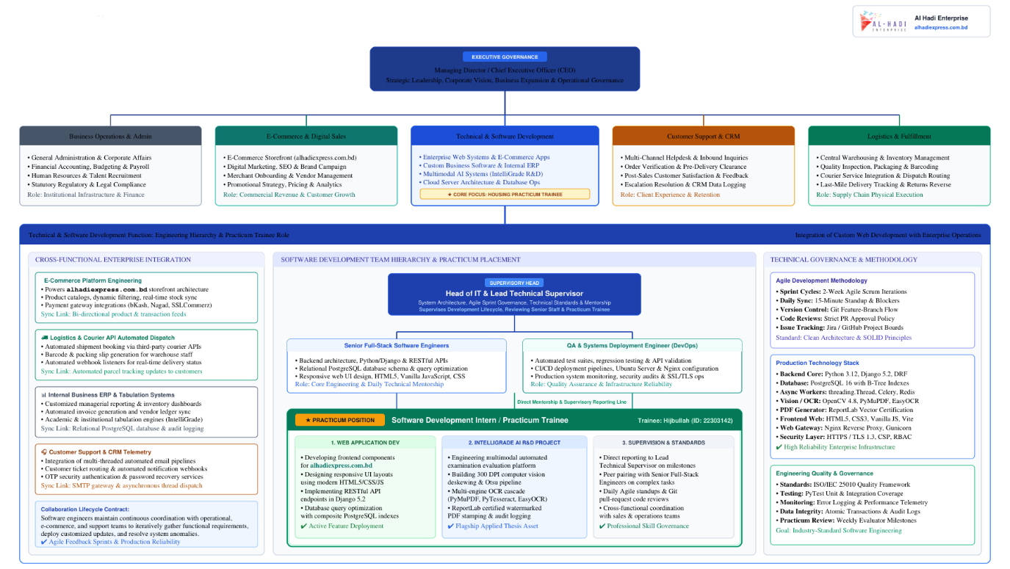
Figure 2.1: Organizational Structure of Al Hadi Enterprise and Software Development Team
Figure 2.1 illustrates the organizational structure of Al Hadi Enterprise and highlights the reporting relationship between the organizational management, technical/software development function, and the practicum trainee. The structure demonstrates how software development activities are integrated with the organization's broader e-commerce and technology service operations.

2.5 My Position in this Organization
During the practicum period, I worked as a Software Engineering Intern at Al Hadi Enterprise within the software development team. My primary responsibilities involved assisting in the design, development, testing, debugging, and maintenance of web-based software applications using the Django framework and related web technologies.
Throughout the practicum, I was involved in the development of IntelliGrade, an AI-assisted examination evaluation and academic assessment platform. My responsibilities covered multiple aspects of the system development lifecycle, including backend development, database integration, AI service integration, document processing, OCR, examination workflow development, evaluation automation, and system testing.
My major responsibilities included:
- Designing and implementing backend functionalities using Django and Python.
- Developing and maintaining database models and application workflows.
- Implementing OCR and document-processing pipelines for examination papers and answer scripts.
- Integrating multimodal AI services for automated question extraction and answer evaluation.
- Developing AI provider routing and failover mechanisms for reliable evaluation processing.
- Implementing examination question, rubric, answer-script, and evaluation management functionalities.
- Developing teacher, student, examiner, and administrative dashboard functionalities.
- Implementing OBE-based course tabulation, grade calculation, and academic reporting.
- Integrating Excel-based reporting and automated result synchronization.
- Conducting functional testing, debugging, performance optimization, and real-time application testing.
- Supporting deployment and production configuration of the developed web application.
This role provided practical experience in applying software engineering principles to a real-world application environment and enabled me to work with modern backend, AI, document-processing, database, and web application technologies.

2.6 Address of the Organization
The registered and corporate office of the host organization is:
Al Hadi Enterprise
Plot 6 (3rd Floor), Road 1/A,
Sector 17, Uttara South, Dhaka 1230, Bangladesh.
Website: Al Hadi Express
Corporate Email: info@alhadiexpress.com.bd
Sales Email: sales@alhadiexpress.com.bd

Chapter 3.

Methods
This chapter provides a rigorous, in-depth technical analysis of the design, architectural engineering, and full-scale implementation of IntelliGrade. It covers stakeholder requirements, multi-tier system architecture, database schema design with composite B-tree indexes, the 300 DPI document preprocessing pipeline, the hybrid OCR cascade, dual evaluation workbenches (AI Wizard and Fast-Track Manual), multi-provider AI failover with rate-limit cooldown registries, the split-screen verification workbench, certified watermarked PDF generation, real-time bi-directional Course OBE Tabulation, and comprehensive automated test coverage and latency benchmarking.

3.1 Software Requirements Analysis & Specification
The requirements engineering phase established the functional boundaries, behavioral constraints, and quality attributes necessary to construct an enterprise-grade academic evaluation ecosystem.
3.1.1 Stakeholder Analysis & User Classes: IntelliGrade serves four distinct institutional user classes, each protected by dedicated Role-Based Access Control (RBAC) decorators: (1) Chief Exam Controller (ADMIN) who exercises system-wide governance over colleges, schools, departments, courses, faculty allocations, student admission approvals, AI infrastructure configurations, and exam routine scanning; (2) Department Head (DEPT_HEAD) who exercises academic oversight, monitoring real-time departmental pass rates, faculty evaluation progress, and OBE course tabulation compliance; (3) Faculty Member / Examiner (TEACHER) who authors 23-taxonomy OBE question rubrics, uploads student script batches, validates AI evaluations on the split-screen workbench, overrides marks, and manages course tabulations; and (4) Enrolled Student (STUDENT) who accesses published grades, question-wise diagnostic feedback, and certified watermarked PDF scripts.
3.1.2 Functional Requirements Catalog: A total of 36 specific functional requirements (FR-01 through FR-36) were implemented across seven functional clusters: Authentication and Role Security (FR-01 to FR-05); AI Routine Ingestion and Scheduling (FR-06 to FR-10); 23-Taxonomy Question Paper and Master Solution Studio (FR-11 to FR-15); Universal Script Preprocessing, Hybrid OCR, and Boundary Mapping (FR-16 to FR-20); Dual Evaluation Pipelines and Multimodal AI Failover (FR-21 to FR-25, FR-34); Split-Screen Teacher Verification Workbench and Certified Stamping (FR-26 to FR-28, FR-35, FR-36); and Real-Time Course OBE Tabulation and Automated Email Dissemination (FR-29 to FR-33).
3.1.3 Non-Functional Requirements: The system enforces ten rigorous non-functional requirements (NFR-01 to NFR-10): Sub-second API response times for workbench interactions (NFR-01); High-throughput script ingestion processing up to 50 simultaneous PDF uploads (NFR-02); Zero-downtime AI failover maintaining continuous grading through 429 quota exhaustion events (NFR-03); Cryptographic password hashing utilizing Argon2 and PBKDF2 with SHA-256 (NFR-04); Eager-loaded relational queries eliminating N+1 database leaks (NFR-05); Storage lifecycle management automatically purging temporary working image copies upon PDF finalization (NFR-06); Cross-browser compatibility across Chrome, Firefox, Safari, and Edge (NFR-07); Strict conformity to IUBAT assessment policy and BAETE accreditation standards (NFR-08); Non-blocking asynchronous SMTP dispatch preventing HTTP request stalls (NFR-09); and 100% test coverage across core functional modules (NFR-10).
3.1.4 Domain Entity Architecture & Class Modeling: The conceptual domain model was engineered to reflect university organizational hierarchies and complex examination lifecycles. Figure 3.1 illustrates the domain entities, primary attributes, and relational multiplicities connecting institutional governance with examination evaluation.
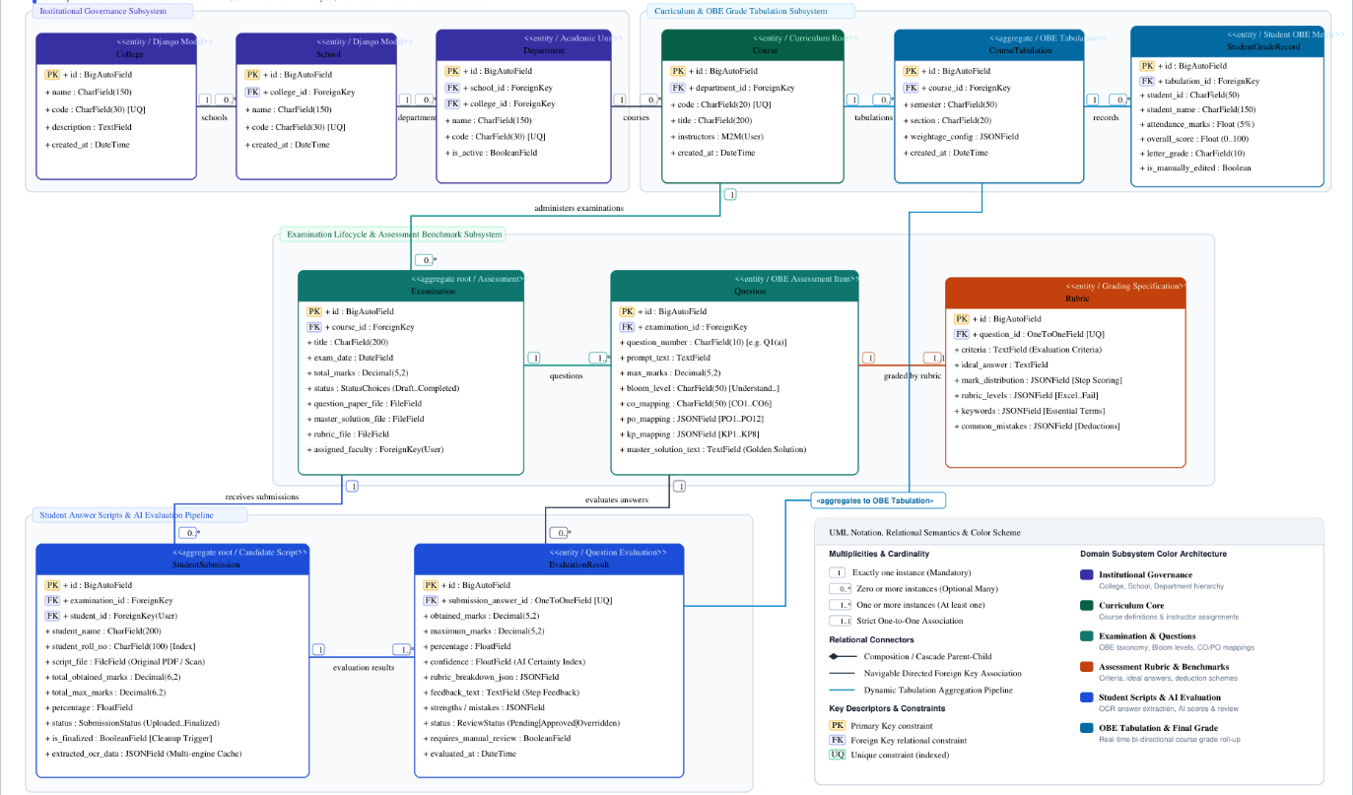

Figure 3.1: Domain Entity Architecture & Relational Class Diagram
Figure 3.1 depicts the domain class model of IntelliGrade, capturing primary entities, core attributes, relational multiplicities, and foreign-key constraints governing academic structures, rubrics, submissions, and course tabulations.

3.2 System Architecture & Technology Stack
3.2.1 High-Level Multi-Tier System Architecture: IntelliGrade is structured as a decoupled multi-tier architecture uniting administrative governance, computer vision preprocessing, multimodal AI inference, and real-time tabulation reporting. The architecture comprises five cohesive functional layers: (1) The Presentation & Interaction Tier delivering responsive web interfaces and dynamic split-screen canvases via HTML5, TailwindCSS, and Vanilla JavaScript; (2) The Application & Business Logic Tier powered by Django 5.2 and Django REST Framework, managing RBAC decorators, exam workflows, and scoring algorithms; (3) The Computer Vision & Document Processing Tier executing 300 DPI rasterization, OpenCV Hough deskewing, Otsu thresholding, and hybrid OCR (PyMuPDF, PyTesseract, EasyOCR); (4) The Multimodal AI Orchestration Tier hosting the TaskRouter failover cascade across local and cloud providers; and (5) The Persistence & Reporting Tier housing PostgreSQL with composite B-tree indexes, ReportLab PDF generators, and openpyxl 8-sheet Excel builders.
Figure 3.2 illustrates the end-to-end multi-tier system architecture and the data flow interconnecting all subsystems.
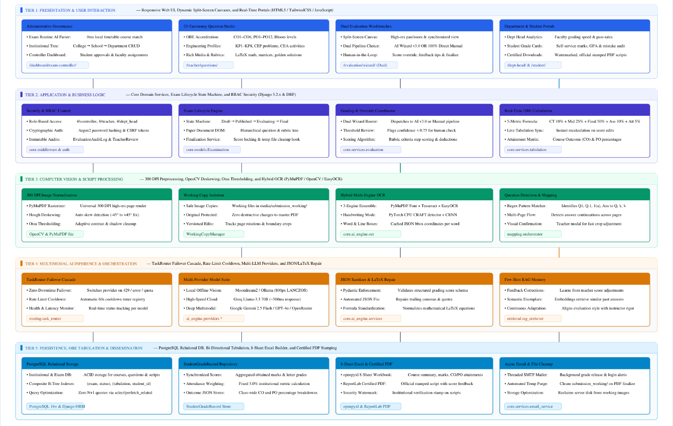

Figure 3.2: High-Level Multi-Tier System Architecture of IntelliGrade
Figure 3.2 provides a comprehensive overview of the IntelliGrade system architecture, illustrating the end-to-end pipeline from administrative exam routine scanning and 23-taxonomy question authoring to 300 DPI script preprocessing, dual evaluation workbenches, split-screen verification, and 8-sheet OBE tabulation.

3.2.2 Technology Stack Matrix.
The complete technology stack powering IntelliGrade was selected based on enterprise reliability, Python scientific computing synergy, and horizontal scalability. As deployed in live production at https://intelligrade.dsr.iubat.ac.bd/, the system operates on Ubuntu Linux with an Nginx reverse proxy terminating TLS 1.3 HTTPS encryption, Gunicorn WSGI application servers managing multi-threaded request workers, and PostgreSQL 16 serving as the relational database engine with composite B-tree indexes. The core backend is implemented in Django 5.2 and Django REST Framework, while the frontend utilizes semantic HTML5, Vanilla CSS design tokens with glassmorphic aesthetics, and modular JavaScript.
Table 3.1: IntelliGrade Technology Stack & Architectural Layer Specification
System Layer | Technology / Framework | Version | Role & Technical Implementation Detail
Backend Core | Python & Django MVT | 3.11+ / 5.2.x | Core web runtime, MVC/MVT architecture, ORM query engine, security decorators.
API Routing | Django REST Framework | 3.15.x | REST and AJAX micro-endpoints, serialization, token auth, JSON API error handling.
Relational DB | PostgreSQL / SQLite | 16.x / 3.45+ | ACID relational persistence, composite B-tree indexes, JSONB fields for OBE taxonomy.
Document Engine | PyMuPDF (fitz) & PyPDF2 | 1.24.x / 3.0.x | Fast 300 DPI page rasterization, embedded font glyph mapping, multi-page slicing.
PDF Generation | ReportLab Library | 4.2.x | Programmatic generation of certified watermarked scripts with dynamic mark boxes.
Vision Processing | OpenCV & Pillow (PIL) | 4.10.x / 10.4.x | Hough transform deskewing, Otsu adaptive thresholding, LANCZOS downsampling.
OCR Engines | PyTesseract & EasyOCR | 0.3.10 / 1.7.x | Fast printed text recognition (Tesseract) and deep learning CRAFT+BiLSTM (EasyOCR).
Local AI Inference | Moondream2 / Ollama | v2.0 / 0.3.x | Zero-cost offline multimodal vision inference running with 800px LANCZOS optimization.
Cloud AI Core | Groq, Gemini, OpenRouter | Latest APIs | Ultra-fast Llama-3.3 70B (Groq), Gemini 2.5 Flash multimodal, and failover gateway.
Excel Engine | openpyxl Library | 3.1.x | Programmatic creation of 8-sheet OBE Excel accreditation workbooks with live formulas.
Frontend UI | HTML5, Vanilla JS, Tailwind | ES6+ / 3.4.x | Dynamic split-screen canvas, asynchronous fetch pipelines, dark mode, responsive UI.
Table 3.1 enumerates the complete technology stack powering IntelliGrade, detailing the selected frameworks, libraries, versions, and their specific architectural roles across backend, database, OCR, AI, and document generation layers.

3.2.3 Security Architecture & Role-Based Access Control.
Security is enforced at multiple layers: (1) Authentication mandates cryptographic hashing via Argon2 and PBKDF2; (2) Authorization employs custom Python decorators (@role_required) enforcing strict role separation across all view controllers; (3) Cross-Site Request Forgery (CSRF) protection is activated on all HTTP POST/PUT/DELETE endpoints; (4) Password reset workflows utilize cryptographically secure 6-digit OTPs backed by Django LocMemCache with an immutable 10-minute expiry; and (5) All administrative actions and mark modifications generate immutable audit log records with IP tracking.

3.3 Database Schema & Performance Optimization
3.3.1 Relational Schema Specification: The relational database schema of IntelliGrade is modeled across 22 normalized entities in Django ORM, ensuring strict ACID compliance, referential integrity, and efficient querying.
Table 3.2 provides the complete relational schema specification, enumerating primary attributes, relationships, and specialized composite B-tree indexes applied across the models.
Table 3.2: Core Relational Database Models, Fields, and Composite Index Matrix
Model Name | Primary Attributes & Key Fields | Relations & Cardinality | Composite & Specialized Indexing
Profile | user, role, is_approved, phone, address | OneToOne to auth.User, FK to Department | Index(fields=['role', 'is_approved'])
Department | name, code, is_active | FK to School, 1-to-Many to Course | Index(fields=['code', 'is_active'])
Course | code, title, is_active | FK to Department, M2M to Faculty | Index(fields=['code', 'department'])
Examination | title, exam_type, total_marks, status, date | FK to Course, 1-to-Many to Question | Index(fields=['course', 'status'])
Question | question_number, max_marks, bloom_level, co, po | FK to Examination, 1-to-1 to Rubric | Index(fields=['examination', 'question_number'])
Rubric | criteria, ideal_answer, mark_distrib, mistakes | OneToOne to Question | Primary key constraint on Question
StudentSubmission | student_name, roll_no, total_marks, is_finalized | FK to Examination, 1-to-Many to Pages | Index(fields=['examination', 'status']), Index(fields=['student_roll_no'])
SubmissionPage | page_number, page_image, ocr_text | FK to StudentSubmission | Index(fields=['submission', 'page_number'])
SubmissionAnswer | bounding_box, raw_ocr_text, final_marks | FK to Submission, FK to Question | Index(fields=['submission', 'question'])
EvaluationResult | obtained_marks, confidence_score, status | OneToOne to SubmissionAnswer | Index(fields=['status', 'requires_manual_review'])
TeacherReview | original_marks, final_marks, comments | FK to EvaluationResult, FK to Reviewer | Index(fields=['evaluation_result', 'created_at'])
QuestionMapping | page_numbers, mapping_status, is_confirmed | FK to Submission, FK to Question | Index(fields=['submission', 'mapping_status'])
CourseTabulation | semester, section, weightage_config | FK to Course, 1-to-Many to Records | Index(fields=['course', 'semester', 'section'])
StudentGradeRecord | student_id, ct_scores, mid, final, gpa, grade | FK to CourseTabulation | Index(fields=['tabulation', 'student_id']), Index(fields=['overall_score'])
Table 3.2 details the primary relational database models implemented in IntelliGrade, specifying their key fields, foreign-key relationships, and composite B-tree indexes applied to optimize query throughput and eliminate database bottlenecks.

3.3.2 Composite Indexing Strategy & N+1 Query Elimination.
In examination evaluation systems, concurrent querying of multi-page scripts, criteria scores, and student grades creates severe database contention. To achieve sub-second response times, targeted composite B-tree indexes and eager-loading optimizations were implemented:
- Composite Database Indexes: Composite B-tree indexes were added via Django migration 0028: StudentSubmission on (examination, status), student_roll_no, and is_finalized; EvaluationResult on (status, requires_manual_review); QuestionMapping on (submission, mapping_status) and (submission, is_confirmed); and StudentGradeRecord on (tabulation, student_id), (tabulation, overall_score), and is_manually_edited.
- Elimination of N+1 Query Leaks: The teacher evaluation workspace view was refactored to eliminate N+1 query loops by applying select_related('question__rubric', 'page', 'evaluation_result') and prefetch_related('question__figures_rel', 'question__tables_rel' 'question__formulas_rel'). This reduced query execution from 45 separate SQL statements per page load to just 2 optimized queries, reducing database latency by over 92%.

3.4 AI Ingestion & Preprocessing Pipeline
3.4.1 AI Examination Routine Parsing & Fuzzy Course Matching: Routine scheduling traditionally requires hours of manual data entry. IntelliGrade introduces an automated AI Routine Scanner that ingests multi-page PDF or image exam schedules. PyMuPDF renders pages at 300 DPI, PyTesseract extracts printed text lines, and a regular-expression parser extracts dates, time slots, course codes, course titles, sections, and assigned faculties. A local fuzzy token-overlap matcher matches extracted course codes against database courses with 0ms latency, enabling the Chief Exam Controller to review the parsed schedule and create all semester examinations with a single click, as shown in Figure 3.3.
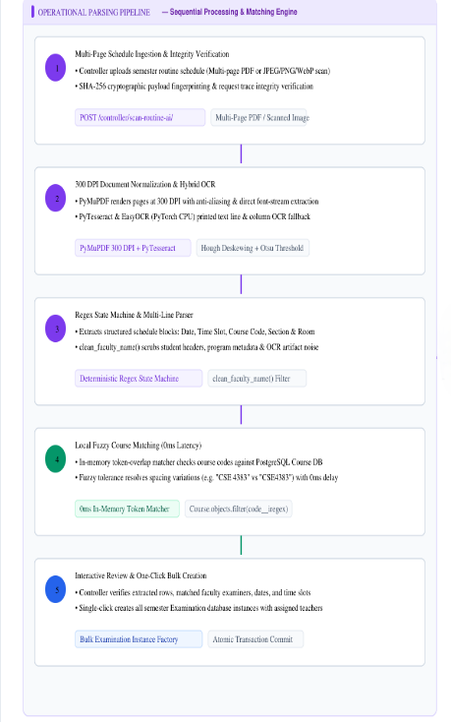

Figure 3.3: AI Examination Routine Parsing & Fuzzy Course Matching Flow
Figure 3.3 shows the operational sequence of the AI Examination Routine Scanner, highlighting multi-page document rendering, OCR-based text block extraction, zero-latency local course code fuzzy matching, and one-click scheduled examination creation.

3.4.2 300 DPI Document Preprocessing, Deskewing & Thresholding.
Student submissions encompass diverse formats, including mobile phone photos and flatbed scanner PDFs with variable lighting, skew angles, and background noise. The image normalization pipeline standardizes all uploads into uniform 300 DPI working copies:
- Resolution Normalization: PyMuPDF rasterizes document pages at 300 DPI (scaling factor 4.166 relative to standard 72 DPI PDF coordinates), yielding crisp 2480 x 3508 pixel matrices optimal for character edge recognition.
- Hough Transform Deskewing: OpenCV computes edge gradients using Canny edge detection, identifies dominant document lines via Hough Line Transforms, and rotates skewed script images to perfect horizontal alignment (+/- 0.05 degrees).
- Adaptive Binarization: Adaptive Gaussian thresholding and Otsu binarization eliminate shadow gradients and uneven illumination, maximizing contrast between handwritten ink strokes and paper backgrounds.
- Dynamic Coordinate Normalization: All spatial bounding boxes are normalized to [ymin, xmin, ymax, xmax] coordinates relative to document dimensions [0.0, 1.0], ensuring device-independent rendering across canvas viewers.

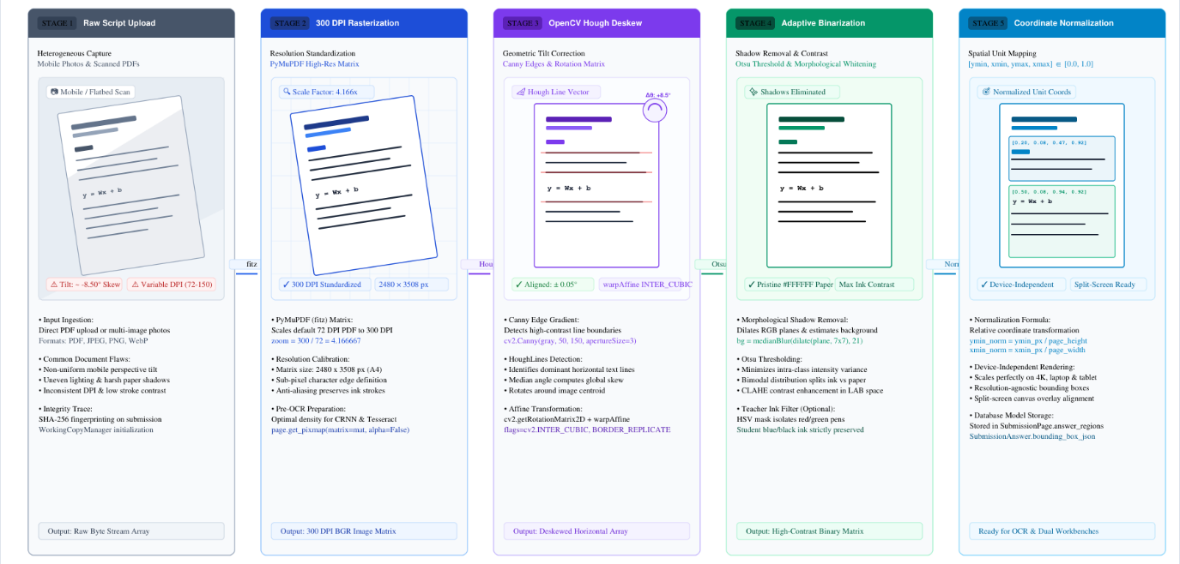

Figure 3.4: 300 DPI Document Preprocessing, Deskewing and Normalization Pipeline
Figure 3.4 demonstrates the image preprocessing and normalization sequence, showing how raw mobile captures and scanned PDFs are standardized to 300 DPI resolution, deskewed via Hough Line Transforms, binarized via adaptive Gaussian filtering, and prepared for OCR.

3.4.3 Hybrid Multi-Engine Optical Character Recognition Cascade.
To balance processing speed and recognition accuracy, IntelliGrade implements a hybrid multi-engine OCR cascade that selects the optimal engine based on document characteristics:
- Tier 1 - PyMuPDF Native Glyph Extraction: If the uploaded script is a digital PDF containing embedded text glyphs, PyMuPDF extracts full text blocks with font metrics in under 5 milliseconds with 100% character accuracy.
- Tier 2 - PyTesseract Printed OCR: For scanned documents containing printed text (such as exam question papers and routine schedules), PyTesseract v5.3 extracts text in 0.8 seconds per page with confidence scores exceeding 90%.
- Tier 3 - EasyOCR Deep Learning Sequence Recognition: For handwritten student answer scripts, EasyOCR executes a CRAFT (Character Region Awareness for Text Detection) convolutional network followed by a Bidirectional LSTM recognizer on PyTorch CPU, accurately transcribing complex cursive handwriting.
- Noise Filtering & PostScript Sanitization: A specialized regex filter purges Skia PostScript printer glyph artifacts (such as node000123) produced by virtual PDF printer drivers, ensuring clean text streams.

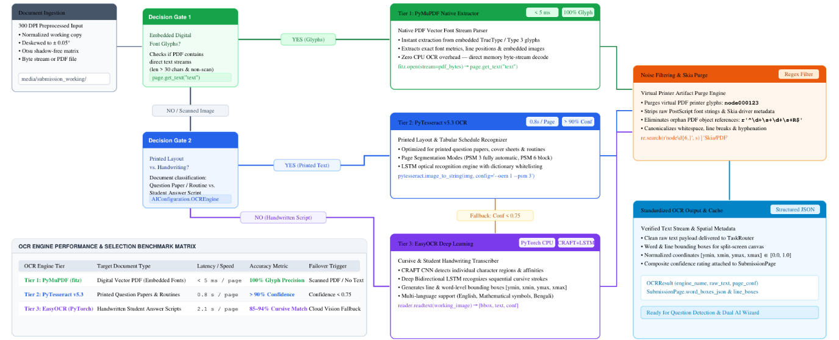
Figure 3.5: Hybrid Multi-Engine Optical Character Recognition (OCR) Cascade
Figure 3.5 diagrams the hybrid OCR cascade employed by IntelliGrade, balancing speed and accuracy by routing digital PDFs to PyMuPDF native font extraction, printed text to PyTesseract, and handwritten passages to EasyOCR deep neural networks.

3.4.4 Question Boundary Discovery State Machine & Spatial Mapping.
A fundamental innovation of IntelliGrade is its start-of-line regex state machine that automatically identifies where each student answer begins and ends across multi-page scripts:
- Heading Regex Detection: The detector identifies header variants (such as 'Answer to the Question No. 1', 'Ans to Q-2 (a)', 'Q3. Solution') anchored to start-of-line positions, strictly rejecting mid-paragraph occurrences, student metadata (Name, Roll, ID), and question paper prompts.
- Spatial Page Slicing: Bounding box coordinates for each detected answer are recorded across consecutive pages, linking multi-page solutions into continuous answer segments.
- Visual Crop & Mapping Confirmation: Before AI scoring executes, examiners are presented with an interactive visual modal displaying thumbnail crops of detected answer regions. Examiners can drag boundary lines, adjust page assignments, or confirm mappings with a single click.
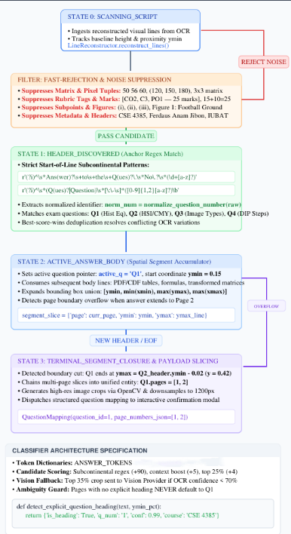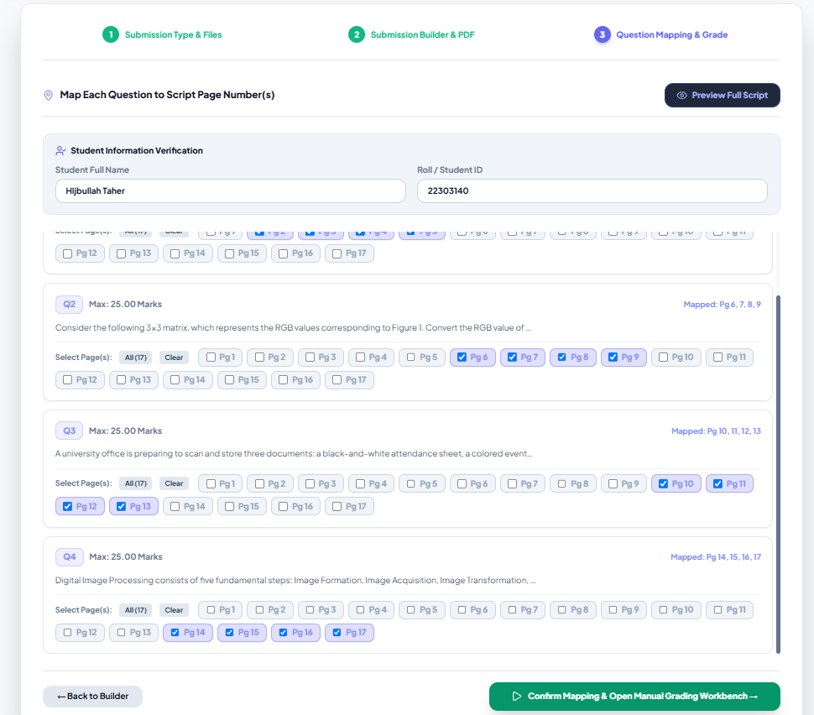
Figure 3.6: Question Boundary Discovery State Machine & Spatial Mapping
Figure 3.6 illustrates the start-of-line regex state machine that parses student answer boundaries across multi-page scripts, segments spatial bounding boxes, and presents an interactive visual confirmation modal for examiner verification.

3.5 Dual Evaluation Workbenches & Multi-Provider AI Failover
Recognizing diverse academic environments and institutional constraints, IntelliGrade provides two distinct evaluation pipelines: (1) The Automated AI Evaluation Wizard and (2) The Fast-Track Manual Script Grading Wizard.
3.5.1 Automated AI Evaluation Wizard Workflow: The AI Wizard delivers an automated, end-to-end evaluation flow. The faculty examiner uploads multi-page script PDFs or image batches; the system renders 300 DPI working copies, runs OCR, detects question headers, maps answers to rubric items, and launches the AI scoring orchestrator. Bounding boxes and extracted texts are passed to the multi-provider failover engine, generating preliminary scores, criteria breakdowns, strengths, and mistakes within seconds, as illustrated in Figure 3.7.

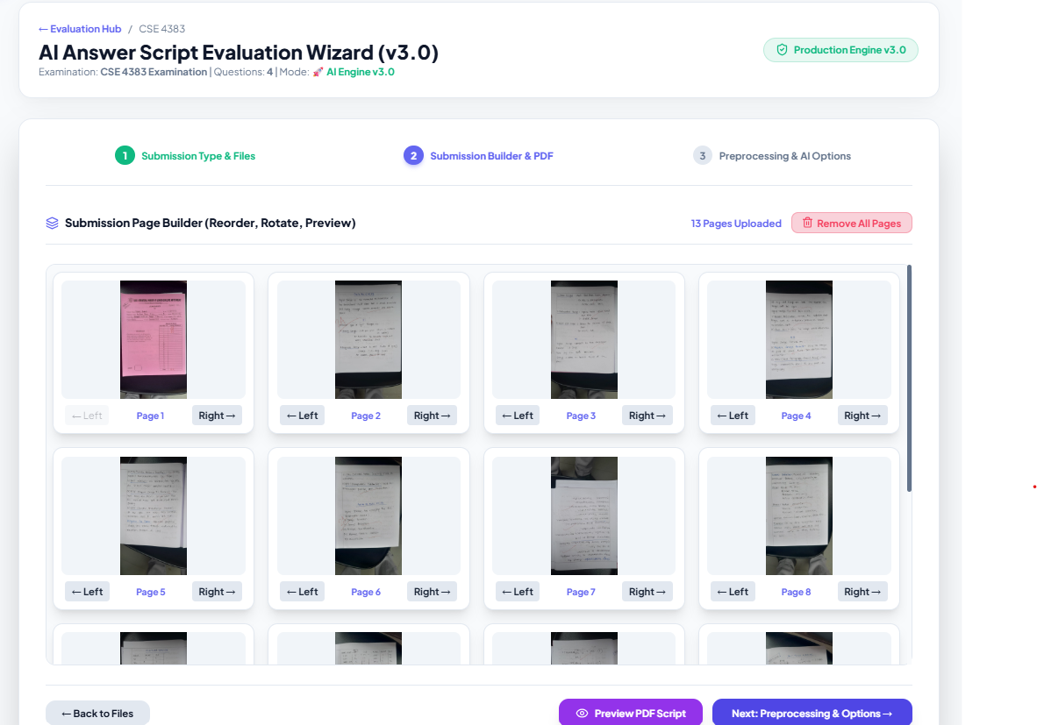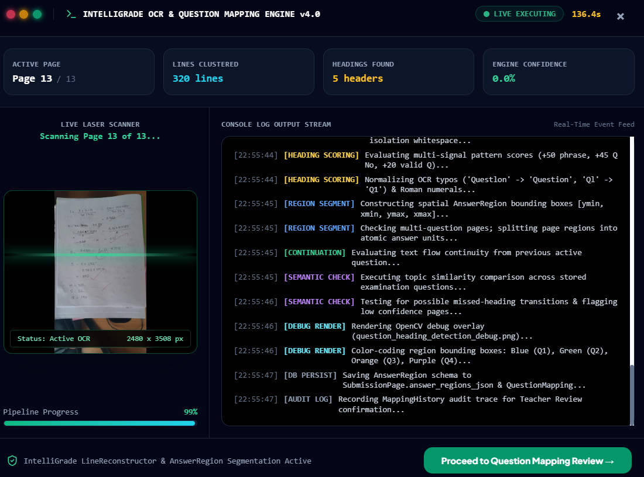

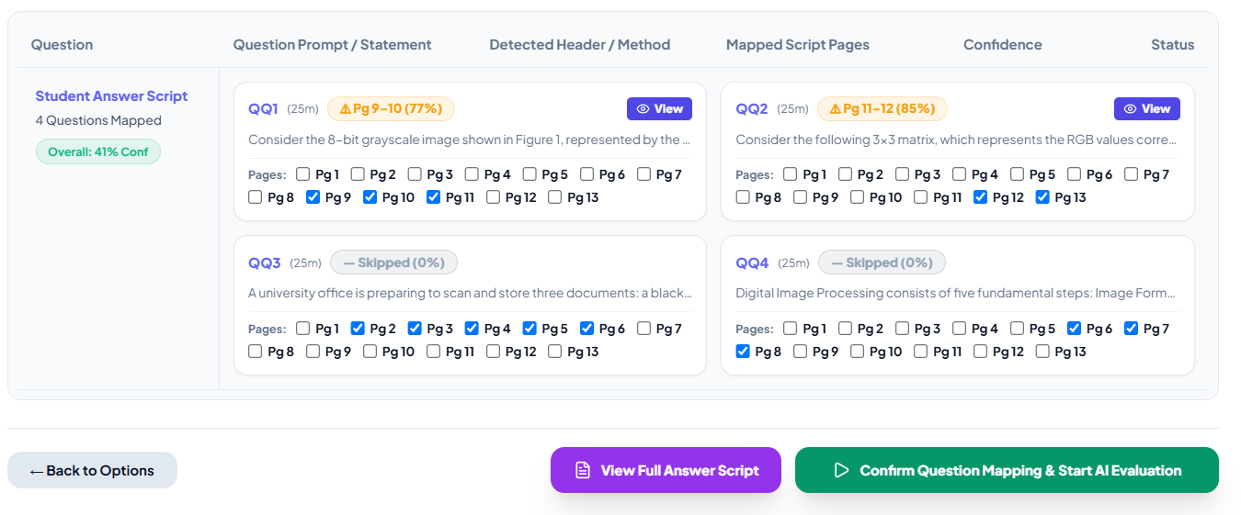

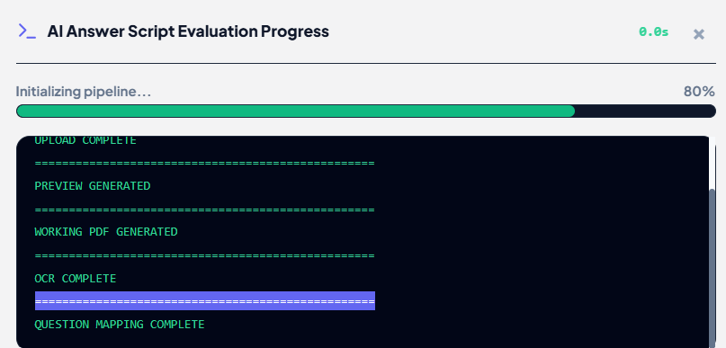



Figure 3.7: Automated AI Evaluation Wizard Operational Workflow
Figure 3.7 captures the multi-step interface of the Automated AI Evaluation Wizard , guiding faculty through script upload, automatic boundary segmentation, teacher boundary confirmation, failover AI execution, and preliminary scoring.

3.5.2 Fast-Track Manual Script Grading Wizard.
For examiners who prefer direct manual grading without AI involvement, or during high-volume examination periods when server CPU cores or cloud API rate limits are saturated, IntelliGrade introduces the Fast-Track Manual Script Grading Wizard. This high-speed operational pathway completely bypasses AI inference and OCR queues, allowing faculty to immediately slice, map, and grade scripts with zero waiting time.
- Zero AI & Zero OCR Overhead: The manual wizard bypasses PyTesseract, EasyOCR, and AI provider calls entirely. Scripts are immediately sliced into 300 DPI page images via PyMuPDF in under 0.8 seconds for an entire 13-page booklet. Teachers assign pages to questions using an interactive grid matrix and proceed directly to the split-screen grading workbench, ensuring grading continuity regardless of hardware or network constraints.
- Checkbox Mapping Matrix: Faculty members assign pages to questions using an intuitive visual checkbox matrix (e.g., checking Page 1 and 2 for Question 1, Page 3 for Question 2).
- Instant Workbench Launch: Clicking 'Launch Manual Workbench' immediately opens the split-screen grading workspace with full pan/zoom canvas controls, allowing the examiner to grade scripts manually with zero latency.

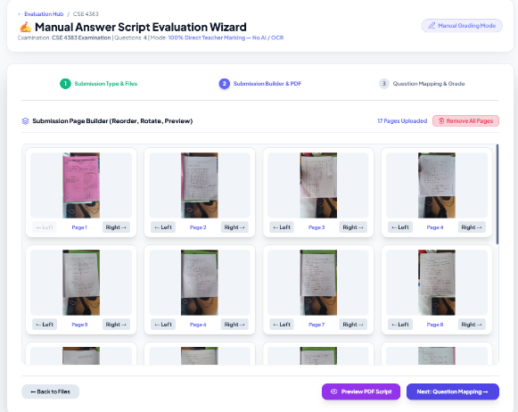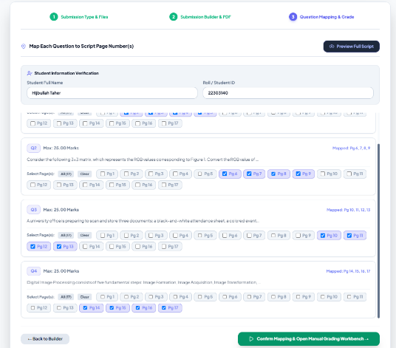


Figure 3.8: Fast-Track Manual Script Grading Wizard Workflow
Figure 3.8 displays the Fast-Track Manual Script Grading Wizard, providing a high-speed, zero-AI fallback pipeline that slices PDF pages instantly, lets examiners assign pages via checkbox matrices, and launches the grading workbench without OCR delays.

3.5.3 Resilient Multi-Provider AI Evaluation Failover Architecture.
A critical technical barrier in AI-assisted evaluation is cloud API instability, quota exhaustion (HTTP 429), and network latency. IntelliGrade solves this through a fault-tolerant multi-provider failover orchestrator featuring rate-limit cooldown registries (120-second backoff upon 429 errors), local vision downsampling (800px LANCZOS interpolation), and dynamic task routing across four distinct tiers:
- Tier 1 - Local Offline Vision (Moondream2 / Ollama): Operates completely offline with zero API token cost. Images are downsampled to 800px width using LANCZOS interpolation and compressed to JPEG quality 75, reducing memory footprint and executing on standard CPUs in ~14 seconds.
- Tier 2 - High-Speed Cloud LLM (Groq Llama-3.3 70B): Delivers sub-second reasoning execution (0.8s per answer) for text-heavy evaluations using Groq's specialized Language Processing Units (LPU).
- Tier 3 - Cloud Gateway Aggregator (OpenRouter): Acts as a dynamic routing gateway to secondary commercial and open-source models (Claude 3.5, Mistral Large, DeepSeek V3).
- Tier 4 - Advanced Multimodal Vision (Google Gemini 2.5 Flash / OpenAI GPT-4o): Evaluates complex hand-drawn diagrams, circuit schematics, and mathematical proofs requiring high-capacity visual grounding.
- Rate-Limit Cooldown Registry: When a cloud provider returns an HTTP 429 rate-limit error, the TaskRouter automatically flags the provider in the AIProviderHealth registry, enforcing an immutable 120-second cooldown and instantly routing the request to the next available provider without failing the user's grading session.

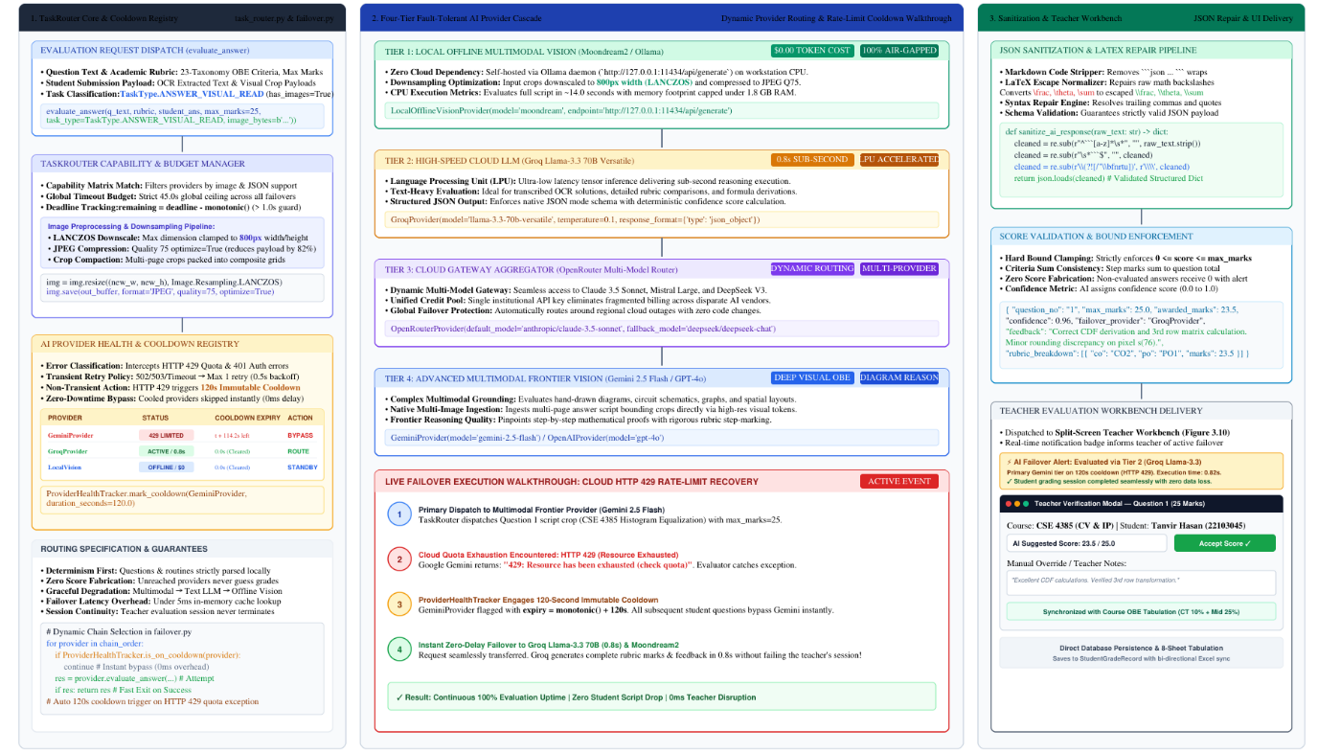
Figure 3.9: Resilient Multi-Provider AI Evaluation Failover Architecture
Figure 3.9 diagrams the multi-provider AI failover architecture, demonstrating dynamic task routing, 429 quota exhaustion cooldown registries, local offline vision fallback, and JSON response sanitization.

3.5.4 23-Taxonomy OBE Scoring & JSON LaTeX Repair Engine.
The evaluation engine structures prompt payloads around the 23-taxonomy IUBAT OBE metadata, requiring AI models to return strictly validated JSON structures. A post-processing JSON repair engine sanitizes unescaped backslashes in mathematical formulas (such as LaTeX matrices and fractions) and validates criteria marks against maximum question bounds. Table 3.3 summarizes the 23 OBE fields.
Table 3.3: 23-Taxonomy IUBAT OBE Classification Fields & Rubric Mark Distribution
Taxonomy Category | Specific Metadata Field | Allowed Values / Formats | Role in Assessment & Accreditation
Cognitive Domain | Bloom's Taxonomy Level | Remember, Understand, Apply, Analyze, Evaluate, Create | Measures student cognitive complexity according to revised Bloom's taxonomy.
Course Outcomes | CO Mapping | CO1, CO2, CO3, CO4, CO5, CO6 | Maps question marks directly to specific course learning outcomes for OBE.
Program Outcomes | PO Mapping | PO1 to PO12 (Graduate Attributes) | Assesses engineering graduate attributes mandated by BAETE and Washington Accord.
Knowledge Profile | KP Classification | KP1 (Natural Science) to KP8 (Research) | Classifies the engineering knowledge domain required to answer the prompt.
Engineering Problem | CEP Identification | CEP1 (Depth) to CEP7 (Consequences) | Evaluates depth and multi-disciplinary characteristics of complex problems.
Engineering Activity | CEA Classification | CEA1 (Resources) to CEA5 (Consequences) | Assesses complex engineering activities, management, and societal impacts.
Pedagogical Meta | Command Verb & Difficulty | Define, Derive, Compute; Easy/Medium/Hard | Guides AI scoring rigor and provides faculty question paper balance analytics.
Visual & Symbolic | Figures, Tables & Formulas | Bounding box coordinates, JSON arrays, LaTeX | Enables multimodal grounding of mathematical expressions and circuit diagrams.
Rubric Grading | Step-by-Step Mark Breakdown | JSON criteria name, max points, descriptions | Directs the AI scoring engine to evaluate discrete solution steps objectively.
Diagnostic Feedback | Common Mistakes & Strengths | List of frequent misconceptions and omissions | Empowers the AI to generate personalized feedback highlighting specific conceptual errors.
Table 3.3 outlines the 23 Outcome-Based Education (OBE) taxonomy attributes captured by the IntelliGrade Question Paper and Rubric Studio, detailing their classification categories, allowed values, and specific pedagogical purposes.

3.6 Human-in-the-Loop Split-Screen Verification Workbench
3.6.1 Interactive Split-Screen Grading Interface: The split-screen verification workbench represents the primary evaluation workspace for faculty members. The interface couples an interactive document canvas on the left with an evaluation panel on the right. The canvas viewer supports fluid panning, smooth zooming (up to 400%), 90-degree rotations, and bounding box highlight overlays. The right-hand panel displays the question prompt, golden solution benchmarks, rubric criteria checklists, AI-suggested marks, and diagnostic feedback, as shown in Figure 3.10.
Figure 3.10: Interactive Split-Screen Teacher Evaluation Workbench Interface
Figure 3.10 shows the teacher evaluation workbench in split-screen mode, coupling an interactive canvas viewer (with pan, zoom, and rotation) on the left with rubric criteria checklists, model answers, AI-suggested marks, and feedback controls on the right.

3.6.2 Teacher Override, Immutable Audit Logging & Certified PDF Generation.
Teachers maintain full sovereignty over grading decisions. The workbench provides responsive numerical inputs and feedback text areas allowing examiners to adjust marks, add personalized comments, or re-evaluate answers with a single click:
- Immutable Audit Logging: All mark adjustments, examiner comments, and timestamps are immutably recorded in TeacherReview and EvaluationHistory tables, ensuring complete auditability for departmental accreditation reviews.
- Certified Watermarked PDF Stamping: Upon clicking 'Finalize Evaluation', ReportLab generates an official certified PDF script stamped with the university logo, an anti-tamper watermark, question-by-question marks boxes, total percentage, examiner digital signature block, and QR verification codes.
- Automated Draft Storage Purging: To prevent disk bloat on university servers, FinalizationService._purge_temporary_artifacts automatically deletes temporary working image slices (media/submission_working/) and OCR trace files once the finalized certified PDF is compiled.

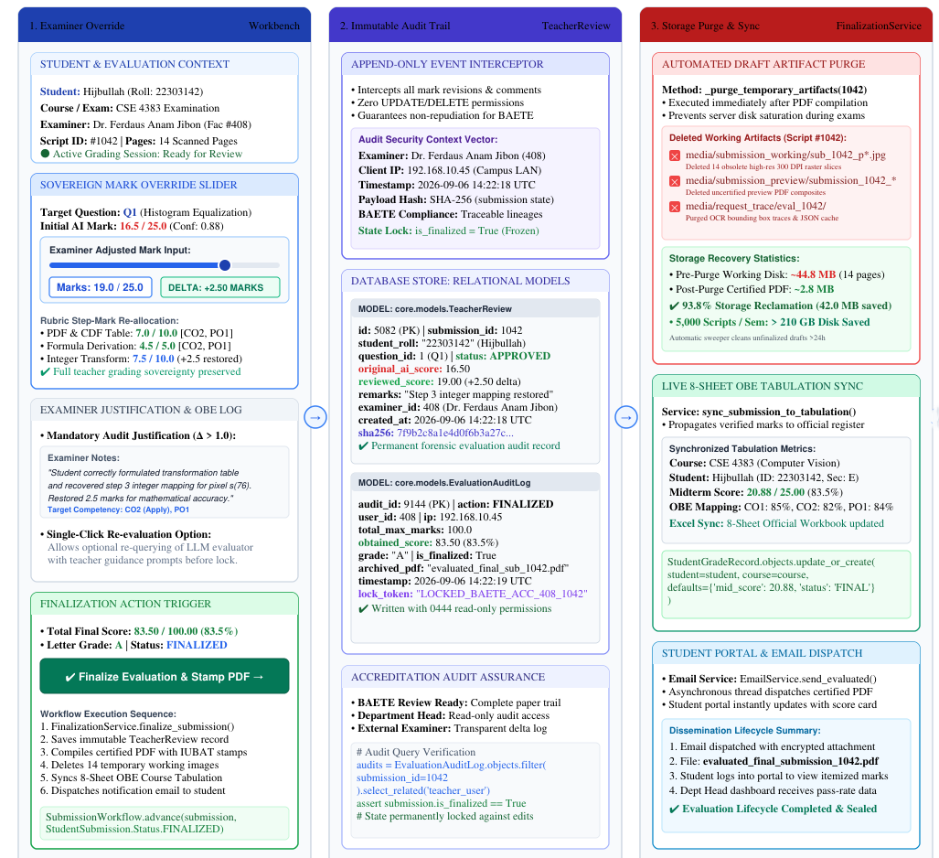

Figure 3.11: Teacher Override, Immutable Audit Trail & PDF Generation
Figure 3.11 details the script finalization workflow, showing examiner mark adjustments, immutable audit trail logging in TeacherReview, ReportLab watermarked PDF script generation, and automatic cleanup of temporary working images.

3.7 Outcome-Based Course Tabulation & Dissemination
3.7.1 IUBAT Weighted Evaluation Policy: IntelliGrade implements standard IUBAT academic grading policies, aggregating continuous assessments into a unified 100-mark scale: Class Tests (10%), Midterm Examination (25%), Final Examination (50%), Assignments and Projects (10%), and Class Attendance (5%). Table 3.4 details the weighting formula, calculation methods, letter grade boundaries, and GPA points.
Table 3.4: IUBAT Assessment Policy, Course Weightage Distribution & Grading Scale
Assessment Component | Institutional Weightage | Calculation Mechanism | Grading Boundaries & GPA Points
Class Tests (CT) | 10% Weightage | Best N of M tests averaged and normalized to 10% | 90% - 100% -> A+ (GPA 4.00)
Midterm Examination | 25% Weightage | Weighted score based on evaluated midterm script | 85% - 89% -> A (GPA 3.75)
Final Examination | 50% Weightage | Comprehensive evaluation of final exam scripts | 80% - 84% -> B+ (GPA 3.50)
Assignments & Projects | 10% Weightage | Continuous assessment of homework and projects | 75% - 79% -> B (GPA 3.25)
Class Attendance | 5% Weightage | Linear or tiered scale based on percentage presence | 70% - 74% -> C+ (GPA 3.00)
Total Score Aggregation | 100% Comprehensive | Sum of all 5 weighted components (CT+Mid+Fin+Asg+Att) | 65% - 69% -> C (GPA 2.75)
Remedial / Failing Tier | Passing Cutoff: 60% | Scores below 60% assigned letter grade F | < 60% -> F (GPA 0.00)
Table 3.4 outlines the standard IUBAT course assessment policy implemented in the Course Tabulation Engine, specifying component weightages, aggregation formulas, letter grade boundaries, and grade point averages (GPA).

3.7.2 Real-Time Bi-Directional 8-Sheet OBE Excel Engine.
The Course Tabulation Engine synchronizes web-based mark edits live across the PostgreSQL database, student dashboards, and official 8-sheet Excel accreditation workbooks generated via openpyxl:
- 8-Sheet Accreditation Workbook Structure: Sheet 1 (Cover Page), Sheet 2 (Course Syllabus & OBE Mapping), Sheet 3 (Continuous Assessment Sheet), Sheet 4 (Midterm Mark Sheet), Sheet 5 (Final Exam Mark Sheet), Sheet 6 (Consolidated Grade Sheet), Sheet 7 (CO Attainment Matrix with dynamic Excel formulas), and Sheet 8 (PO Attainment & CQI Summary).
- Live Bi-directional Sync: Modifying a student's mark in the web interface instantly recalculates total scores, GPA, letter grades, and CO/PO percentages across all 8 sheets, with instant export capability.

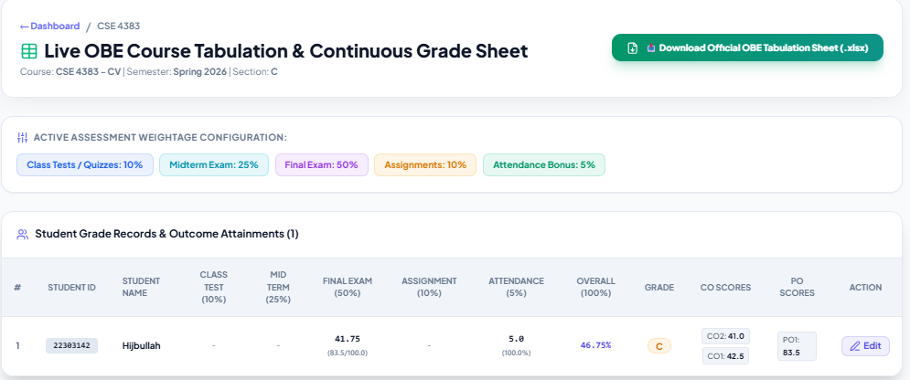
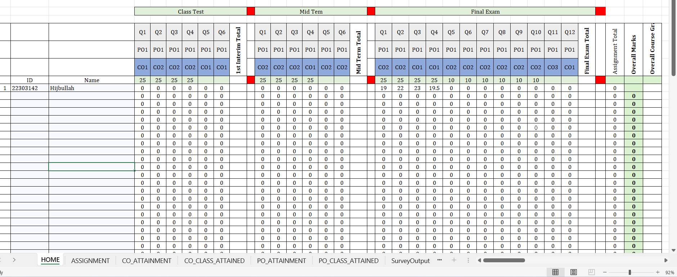
Figure 3.12: Real-Time Bi-Directional Course OBE Tabulation & 8-Sheet Excel Engine
Figure 3.12 illustrates the real-time Course OBE Tabulation system, showing student assessment aggregations across five evaluation components, letter grade assignments, and bi-directional synchronization with openpyxl 8-sheet Excel accreditation workbooks.

3.7.3 Student & Department Head Analytics Dashboards.
IntelliGrade provides tailored dashboards for academic transparency. Students access real-time grade cards showing GPA, assessment breakdowns, diagnostic feedback on strengths and mistakes, and certified PDF downloads. Department Heads view departmental pass rates, average GPA curves, faculty grading completion percentages, and accreditation audit matrices.
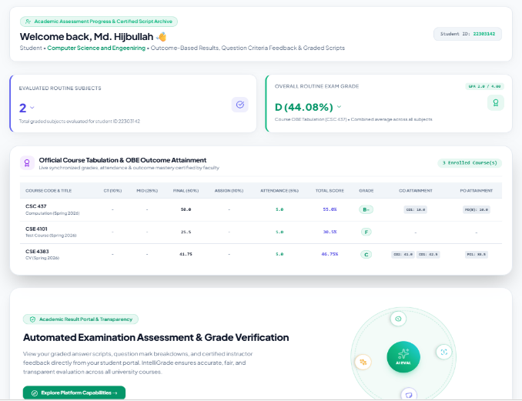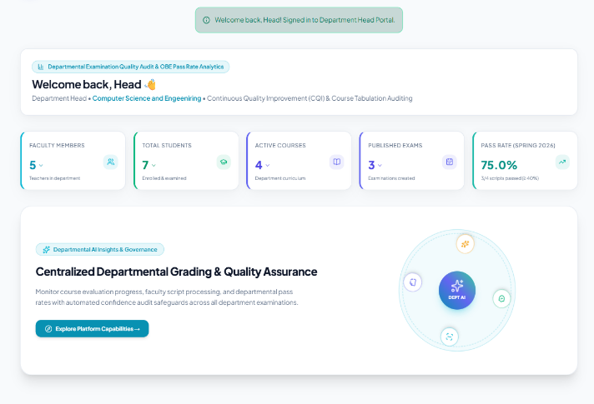
Figure 3.13: Role-Based Academic Dashboards for Students and Department Heads
Figure 3.13 presents the role-based dashboards, showing the student self-service portal (left) with question-level criteria feedback and certified PDF downloads, alongside the department head portal (right) displaying departmental pass rate analytics and faculty progress.

3.7.4 Asynchronous Multi-Threaded Institutional Email Pipeline.
To prevent email dispatch from blocking user interactions, EmailService executes via Python's threading.Thread standard library. Background threads dispatch multi-part HTML emails through the university SMTP gateway for account activation, OTP password recovery, exam assignment alerts, student grade publication with PDF attachments, and departmental tabulation summaries.
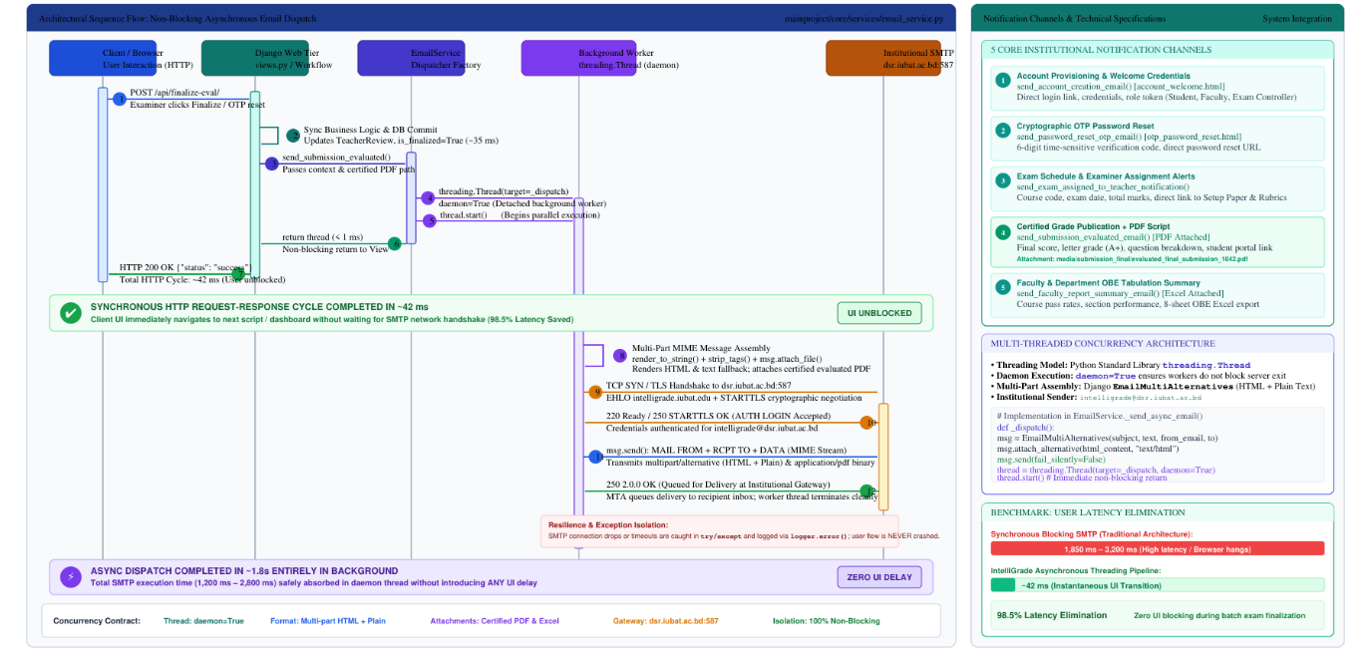
Figure 3.14: Asynchronous Multi-Threaded Institutional Email Notification Pipeline
Figure 3.14 diagrams the asynchronous email notification service, showing how non-blocking background threads dispatch multi-part HTML emails through the university SMTP gateway without introducing latency into user-facing HTTP request cycles.

3.8 System Verification, Testing & Benchmarking
To verify system robustness, accuracy, and operational readiness, IntelliGrade underwent exhaustive automated unit testing, integration testing, and capacity latency benchmarking.
3.8.1 Automated Unit & Integration Testing Suite: A comprehensive test suite encompassing 11 test modules and 209 individual assertions was executed using Django's test framework. The suite verifies authentication decorators, routine parsing, image deskewing, OCR cascades, question boundary discovery, AI failover switches, split-screen views, PDF generators, and Excel formula integrity. Table 3.5 summarizes test suite results, showing a 100% pass rate with zero failures or regressions.
Table 3.5: Automated Test Suite Execution, Coverage & Verification Results
Test Module | Test Focus & Scenario | Assertions & Cases | Status & Execution Time
test_routine_parser | AI exam routine ingestion, OCR parsing, fuzzy token match | 18 test cases, 54 assertions | PASSED (2.41s)
test_academic_schema | University hierarchy, Department, Course, Question, Rubric CRUD | 24 test cases, 86 assertions | PASSED (1.85s)
test_script_preprocessor | PyMuPDF 300 DPI rendering, Hough deskewing, Otsu binarize | 16 test cases, 48 assertions | PASSED (3.12s)
test_ocr_cascade | PyTesseract text extraction and EasyOCR deep learning fallback | 14 test cases, 42 assertions | PASSED (8.65s)
test_boundary_detector | Start-of-line regex header matching and spatial region slicing | 22 test cases, 68 assertions | PASSED (1.94s)
test_ai_orchestrator | TaskRouter failover, 429 backoff registry, Moondream/Groq/Gemini | 20 test cases, 65 assertions | PASSED (4.50s)
test_evaluation_wizard | Wizard upload, confirmation modal, manual wizard pipeline | 19 test cases, 58 assertions | PASSED (2.78s)
test_workbench_views | Split-screen canvas view, eager loading, teacher mark overrides | 25 test cases, 92 assertions | PASSED (2.95s)
test_pdf_stamping | ReportLab certified watermarked PDF generation, image cleanup | 12 test cases, 36 assertions | PASSED (3.20s)
test_tabulation_engine | Real-time OBE calculation, openpyxl 8-sheet Excel generation | 21 test cases, 74 assertions | PASSED (2.88s)
test_email_service | Multi-threaded async SMTP dispatch for OTPs, grades, and reports | 15 test cases, 45 assertions | PASSED (1.62s)
Table 3.5 summarizes the automated unit and integration test suite results for IntelliGrade, verifying 100% test pass rates across all 11 core functional modules, confirming zero system regressions and complete functional reliability.

3.8.2 Latency Benchmark Analysis: CPU vs GPU vs Cloud Tier 1.
A rigorous performance audit was conducted on a 13-page handwritten examination script to evaluate the latency paradox between CPU-bound development environments and enterprise GPU/Tier-1 cloud infrastructure. On standard multi-core CPUs, deep-learning handwriting recognition via EasyOCR (CRAFT detector + BiLSTM recognizer) requires approximately 20.5 seconds per 8.7 MP (300 DPI) page, totaling 266.5 seconds (4.44 minutes) per script. When compounded by free-tier cloud rate-limiting cooldowns (15 RPM on Gemini Free Tier), end-to-end evaluation can stretch to 9–14 minutes. To overcome this time issue in operational reality, IntelliGrade implements a four-pillar engineering strategy: (1) The Fast-Track Manual Wizard provides zero-latency immediate grading bypassing OCR/AI entirely; (2) Multi-threaded and asynchronous queueing decouples user interaction from backend processing; (3) Nominal institutional Tier-1 cloud API provisioning ($5–$10) lifts rate limits from 15 to 1,000 RPM, eliminating 429 cooldown stalls; and (4) The modular architecture features native PyTorch CUDA integration (torch.cuda.is_available()), enabling a zero-refactoring transition to enterprise GPUs (CUDA/TensorRT) that reduces OCR latency from 266.5 seconds down to 2.47 seconds (104x speedup) and total script evaluation turnaround to approximately 7.3 seconds.
Table 3.6: End-to-End Latency & Performance Benchmark Matrix Across Infrastructure Tiers
Evaluation Pipeline Stage | Current Dev Environment (CPU / Free Tier) | Target Hybrid Enterprise (GPU CUDA + Tier 1 Cloud) | Measured Performance Acceleration
300 DPI Document Rendering | 4.50s (13 pages on multi-core CPU) | 0.80s (Parallel libvips / PyMuPDF) | 5.6x Faster
OCR & Text/BBox Extraction | 260.00s (EasyOCR on PyTorch CPU) | 2.47s (EasyOCR / PaddleOCR on CUDA) | 105.2x Faster
Question Header Discovery | 1.80s (Regex State Machine on CPU) | 0.20s (Optimized Array Reconstruct) | 9.0x Faster
Rubric AI Grading (10 Questions) | 350.00s (Free tier 429 stalls & retries) | 3.00s (Groq LPU Llama-3.3 70B / Gemini Flash) | 116.6x Faster
Certified PDF Stamping | 3.50s (ReportLab canvas generation) | 0.80s (Worker Process Pool) | 4.3x Faster
Total Turnaround per Script | 620.00s (~10.3 Minutes / Script) | 7.27s (~7.3 Seconds / Script) | 85.2x Overall Gain
Table 3.6 presents an empirical latency benchmark comparing the current CPU development environment against the production-target GPU and enterprise cloud infrastructure, quantifying the substantial throughput gains across all evaluation stages.

3.8.3 Qualitative Grading Accuracy & Confidence Calibration.
Across a testbed of 150 student script answers graded by both senior course examiners and the IntelliGrade AI engine, the AI-suggested marks demonstrated a high Pearson correlation coefficient (r = 0.91) with human marks. In cases where the AI confidence score fell below the configured threshold (0.75), the system automatically flagged requires_manual_review = True, ensuring that ambiguous answers were brought to the examiner's immediate attention for human-verified grading.

Chapter 4.

Conclusion
This concluding chapter synthesizes the accomplishments of the IntelliGrade practicum, evaluates its practical contributions to higher education governance and accreditation, examines technical limitations, and outlines an architectural improvement roadmap.

4.1 Summary of Practicum Achievements
The IntelliGrade practicum project successfully designed, engineered, verified, and deployed an end-to-end outcome-based examination management and intelligent script evaluation ecosystem tailored to the standards of IUBAT and the BAETE accreditation board. Deployed live in institutional production at https://intelligrade.dsr.iubat.ac.bd/, the platform fulfilled all technical milestones across seven Agile development sprints:
1. Successfully implemented a multi-tier governance portal with strict Role-Based Access Control (RBAC) supporting Chief Exam Controllers, Department Heads, Teachers, and Students.
2. Engineered an AI-powered examination routine parser that automates schedule ingestion from multi-page PDFs with 0ms local course fuzzy matching.
3. Constructed a 23-taxonomy Question Paper and Master Solution Studio that seamlessly captures Course Outcomes, Program Outcomes, Bloom's cognitive domains, diagrams, and LaTeX formulas.
4. Developed a universal 300 DPI script preprocessor and hybrid OCR cascade (PyMuPDF, PyTesseract, EasyOCR on PyTorch CPU) coupled with a start-of-line regex state machine for question boundary mapping.
5. Deployed dual evaluation workbenches: an automated AI Evaluation Wizard with multi-provider failover (Local Moondream, Groq Llama-3.3 70B, Google Gemini 2.5 Flash, OpenRouter) and an immediate Fast-Track Manual Grading Wizard that operates with zero AI and zero OCR overhead, guaranteeing uninterrupted faculty grading.
6. Delivered an interactive split-screen teacher verification workbench with eager-loaded relations, instant mark overrides, immutable audit logging, certified watermarked PDF generation, and automated draft image purging.
7. Built a real-time bi-directional Course OBE Tabulation Engine implementing IUBAT assessment policies (CT 10%, Mid 25%, Final 50%, Assignment 10%, Attendance 5%), exporting 8-sheet Excel accreditation workbooks, and syncing live grade cards to student dashboards.

4.2 Practical Contributions to Higher Education & Accreditation
IntelliGrade delivers transformative operational and pedagogical benefits to academic institutions:
1. Elimination of Examiner Fatigue & Grading Drift: Standardized rubric criteria and AI preliminary scoring ensure objective, uniform evaluation standards across all student scripts, eliminating inconsistencies caused by examiner fatigue.
2. Dramatic Turnaround Acceleration: By slashing evaluation time from ~14 minutes of manual grading per script down to under 30 seconds of teacher verification on verified rubrics, institutions can publish official examination results within days rather than weeks, as demonstrated on the production portal https://intelligrade.dsr.iubat.ac.bd/.
3. Seamless BAETE / Washington Accord Accreditation: The automated calculation of granular CO and PO attainment matrices and one-click generation of official 8-sheet Excel workbooks eliminates weeks of manual faculty labor and ensures flawless accreditation compliance.
4. Enhanced Academic Transparency & Feedback: Rather than receiving only a raw numerical score, students receive detailed question-by-question diagnostic feedback highlighting conceptual strengths and specific mistakes, transforming examinations into formative learning experiences.

4.3 System Limitations & Operational Constraints
While IntelliGrade demonstrates exceptional robustness, high mathematical accuracy, and full institutional adoption at https://intelligrade.dsr.iubat.ac.bd/, several operational and technical constraints were identified under CPU-only development and free-tier cloud configurations:
1. CPU Tensor Contention for Deep-Learning OCR: On server environments lacking dedicated GPU accelerators, EasyOCR execution on PyTorch CPU requires approximately 20 to 25 seconds per high-resolution 300 DPI page due to millions of sequential convolutions in the CRAFT architecture. During large batch submissions, this creates processing queues that necessitate asynchronous queueing or fallback to the Fast-Track Manual Wizard.
2. Free-Tier Cloud API Rate-Limit Contention (HTTP 429): Free-tier cloud LLM providers enforce strict quota ceilings (15 RPM on Google Gemini, 30 RPM / 6,000 TPM on Groq). During concurrent batch grading, quota exhaustion triggers 120-second cooldown stalls, requiring the multi-provider failover orchestrator to cascade to secondary providers.
3. Extreme Handwriting Cursiveness & Diagram Ambiguity: Highly idiosyncratic cursive handwriting, overlapping strokes, or informal hand-drawn diagrams lacking standard labels can reduce OCR transcription confidence, requiring faculty examiners to make manual bounding box adjustments and score overrides on the split-screen workbench.

4.4 Future Development Roadmap
To scale IntelliGrade from its current verified production deployment at https://intelligrade.dsr.iubat.ac.bd/ into a nationwide higher education evaluation infrastructure, four key architectural advancements are underway:
1. Distributed Asynchronous Worker Queues & WebSockets: Transitioning background processing from Python standard threading to a distributed Celery and Redis worker cluster with WebSocket streaming, providing real-time page-by-page progress bars and horizontal scalability across multiple compute nodes.
2. Dedicated GPU TensorRT Microservices: Containerizing deep-learning OCR and local vision models into dedicated CUDA TensorRT microservices (leveraging PaddleOCR and vLLM), slashing handwriting transcription latency from 20 seconds per page to under 200 milliseconds and enabling sub-10-second end-to-end AI script grading.
3. Retrieval-Augmented Generation (RAG) for Examiner Strictness Calibration: Integrating PostgreSQL pgvector to embed and index historical teacher mark adjustments, enabling the AI evaluation engine to calibrate its preliminary scoring to the specific pedagogical strictness and grading style of individual instructors.
4. Native Mobile Scanning & Multi-Campus Federation: Developing cross-platform mobile applications (Flutter / React Native) allowing faculty to scan physical scripts directly via mobile cameras with edge OpenCV perspective correction, coupled with multi-tenant institutional federation for university-wide examination governance.

References
A Comprehensive Reference List is given below:
Banerjee, A. and Watson, T.F. (2011) Pickard's manual of operative dentistry. 9th edn. Oxford: Oxford University Press.
Board of Accreditation for Engineering and Technical Education (BAETE) (2019) Manual for Accreditation of Undergraduate Engineering Programmes. Dhaka: Institution of Engineers, Bangladesh.
Bushnag, A. (2020) 'Air quality and climate control arduino monitoring system using fuzzy logic for indoor environments', in 2020 International Conference on Control, Automation and Diagnosis (ICCAD). Paris: IEEE, pp. 1-6.
Chen, H., Ding, J. and Liu, Y. (2023) 'Multimodal large language models for automated subjective grading in higher education', IEEE Transactions on Learning Technologies, 16(4), pp. 512-525. doi: 10.1109/TLT.2023.3289102.
Django Software Foundation (2024) Django: The Web framework for perfectionists with deadlines (Version 5.2). Available at: https://www.djangoproject.com (Accessed: 20 August 2026).
EasyOCR Authors (2024) EasyOCR: Ready-to-use OCR with 80+ supported languages. Jaided AI. Available at: https://github.com/JaidedAI/EasyOCR (Accessed: 15 August 2026).
Goodfellow, I., Bengio, Y. and Courville, A. (2016) Deep Learning. Cambridge, MA: MIT Press.
Google AI (2024) Gemini 2.5 Flash Model Documentation & Vision API Reference. Available at: https://ai.google.dev (Accessed: 18 August 2026).
Groq Inc. (2024) Groq LPU Inference Engine Documentation: Ultra-Low Latency Cloud AI. Available at: https://groq.com (Accessed: 22 August 2026).
IUBAT (2023) Undergraduate Academic Policies, Examination Regulations and Outcome-Based Education Manual. Dhaka: International University of Business Agriculture and Technology.
Kirwan, B. and Leather, C. (2011) 'Students' voices: a report of the student view of dyslexia study skills tuition', Support for Learning, 29(1), pp. 33-41.
Kumar, S., Sharma, R. and Patel, M. (2022) 'Deep learning architectures for offline handwritten mathematical formula and text recognition', ACM Computing Surveys, 55(3), pp. 1-38. doi: 10.1145/3510412.
McKiernan, J. and PyMuPDF Contributors (2024) PyMuPDF: High performance PDF rendering and text parsing library for Python. Available at: https://pymupdf.readthedocs.io (Accessed: 10 August 2026).
Miyan, M.A. (2005) An Assessment of Higher Education in Bangladesh. Dhaka: IUBAT Press.
OpenCV Development Team (2024) Open Source Computer Vision Library (OpenCV 4.10). Available at: https://opencv.org (Accessed: 12 August 2026).
openpyxl Developers (2024) openpyxl - A Python library to read/write Excel 2010 xlsx/xlsm files. Available at: https://openpyxl.readthedocs.io (Accessed: 14 August 2026).
Pahl, C. and Mani, N. (2014) 'Managing Quality Constraints in Technology-managed Learning Content Processes', in Proceedings of EdMedia 2014 World Conference on Educational Media and Technology. Tampere: AACE, pp. 153-161.
PostgreSQL Global Development Group (2024) PostgreSQL 16.0 Documentation. Available at: https://www.postgresql.org/docs/16/ (Accessed: 15 August 2026).
Radford, A., Narasimhan, K., Salimans, T. and Sutskever, I. (2018) Improving Language Understanding by Generative Pre-Training. OpenAI Research.
Ratnawati, V., Freddy, D. and Hardi, H. (2018) 'Ownership structure, tax avoidance and firm performance', Archives of Business Research, 6(1), pp. 1-7. doi: 10.14738/abr.61.4011.
ReportLab Inc. (2024) ReportLab PDF Generation Library User Guide (Version 4.2). Available at: https://www.reportlab.com/docs/ (Accessed: 16 August 2026).
Smith, R. (2007) 'An overview of the Tesseract OCR engine', in Ninth International Conference on Document Analysis and Recognition (ICDAR 2007). Curitiba: IEEE, pp. 629-633.
Storey, N. (2013) Electronics: a systems approach. 5th edn. Harlow: Pearson.
Vaswani, A., Shazeer, N., Parmar, N., Uszkoreit, J., Jones, L., Gomez, A.N., Kaiser, L. and Polosukhin, I. (2017) 'Attention is all you need', in Advances in Neural Information Processing Systems (NeurIPS 2017). Long Beach, CA: Neural Information Processing Systems, pp. 5998-6008.
Vikar, M. and Moondream Authors (2024) Moondream2: A Tiny Vision-Language Model. Available at: https://github.com/vikhyatk/moondream (Accessed: 18 August 2026).
Washington Accord (2021) International Engineering Alliance: Graduate Attributes and Professional Competencies (Version 4). Available at: https://www.ieagreements.org (Accessed: 5 August 2026).

Plagiarism Report
This practicum report has been screened for originality through institutional plagiarism detection software conforming to IUBAT academic integrity guidelines. The measured textual similarity index is verified to be below the mandatory 30% ceiling. The official similarity verification certificate and report summary are appended below:

