IntelliGrade: An End-to-End Outcome-Based Examination Management and Intelligent Script Evaluation Ecosystem for Higher Education Institutions
Md. Taher Bin Omar Hijbullah
ID# 22303142

A Practicum in the Partial Fulfillment of the Requirements
for the Award of Bachelor of Computer Science and Engineering (BCSE)

Department of Computer Science and Engineering
College of Engineering and Technology
IUBAT—International University of Business Agriculture and Technology
Summer 2026

IntelliGrade: An End-to-End Outcome-Based Examination Management and Intelligent Script Evaluation Ecosystem for Higher Education Institutions
Md. Taher Bin Omar Hijbullah

A Practicum in the Partial Fulfillment of the Requirements for the Award of Bachelor of Computer Science and Engineering (BCSE)
The practicum has been examined and approved,

_____________________________
Prof. Dr. Utpal Kanti Das
Chairman

_____________________________
Shahinur Alam
Co-supervisor, Coordinator and Assistant Professor

_____________________________
Drs Ferdaus Anam Jibon
Supervisor and Assistant Professor

Department of Computer Science and Engineering
College of Engineering and Technology
IUBAT—International University of Business Agriculture and Technology
Summer 2026

Letter of Transmittal
10 September 2026
The Chair
Practicum Defense Committee
Department of Computer Science and Engineering
IUBAT—International University of Business Agriculture and Technology
4 Embankment Drive Road, Sector 10, Uttara Model Town
Dhaka 1230, Bangladesh.

Subject: Letter of Transmittal.

Dear Sir,
I am honored to submit my practicum report, "IntelliGrade: An End-to-End Outcome-Based Examination Management and Intelligent Script Evaluation Ecosystem for Higher Education Institutions," in partial fulfillment of the requirements for the BCSE degree at IUBAT.
This report documents the design, implementation, and verification of IntelliGrade, an AI-augmented examination governance platform tailored to BAETE accreditation standards. The system unifies administrative scheduling, OBE blueprinting, hybrid OCR script evaluation (PyMuPDF, PyTesseract, EasyOCR), split-screen teacher verification, and real-time Course OBE Tabulation.

Yours sincerely,
_____________
Md. Taher Bin Omar Hijbullah
ID# 22303142

Organization’s Certificate



Student’s Declaration
I hereby solemnly declare that this practicum report entitled "IntelliGrade: An End-to-End Outcome-Based Examination Management and Intelligent Script Evaluation Ecosystem for Higher Education Institutions" is an authentic record of original work carried out by me under the supervision and academic guidance of the Department of Computer Science and Engineering, College of Engineering and Technology, IUBAT. This report, or any part thereof, has not been submitted elsewhere for the award of any degree, diploma, or academic distinction. All secondary literature, frameworks, libraries, and institutional resources utilized in the development and documentation of this project have been duly cited in accordance with Harvard Referencing standards. I confirm that no data falsification or plagiarism has been committed.

_____________
Md. Taher Bin Omar Hijbullah
ID# 22303142

Supervisor’s Certification
This is to certify that the practicum report entitled "IntelliGrade: An End-to-End Outcome-Based Examination Management and Intelligent Script Evaluation Ecosystem for Higher Education Institutions" submitted by Md. Taher Bin Omar Hijbullah, Student ID: 22303142, has been prepared under my direct supervision and guidance in partial fulfillment of the requirements for the degree of Bachelor of Computer Science and Engineering (BCSE) from the Department of Computer Science and Engineering, College of Engineering and Technology, IUBAT. The candidate has fulfilled all academic, technical, and reporting requirements as prescribed by the university. The report represents original software engineering work and is recommended for submission and final defense before the Practicum Defense Committee.

_______________________________
Drs Ferdaus Anam Jibon
Supervisor and Assistant Professor
Department of Computer Science and Engineering
IUBAT—International University of Business Agriculture and Technology

Abstract
Higher education institutions in Bangladesh and across the developing world face persistent bottlenecks throughout the examination lifecycle. Scheduling is still managed manually on spreadsheets, question papers lack structured alignment with Outcome-Based Education (OBE) taxonomies, evaluation of handwritten scripts remains slow and subjective, and computation of Course Outcome (CO) and Program Outcome (PO) attainments for BAETE and Washington Accord accreditation is largely manual. These inefficiencies not only delay academic processes but also compromise transparency, scalability, and accreditation readiness.
IntelliGrade is a comprehensive academic web platform built on Django 5.2 and PostgreSQL that automates and modernizes each stage of this lifecycle while ensuring strict Human-in-the-Loop teacher oversight. The system integrates seven subsystems: an AI exam routine parser for instant schedule extraction; a 23-taxonomy OBE question paper studio; a 300 DPI preprocessing pipeline with hybrid OCR for printed and handwritten scripts; a regex-based line detection engine; a multi-provider AI failover orchestrator; a teacher verification workbench with audit logging and certified PDF stamping; and a real-time OBE tabulation engine with weighted scoring, Excel synchronization, and institutional email dispatch. Together, these modules create a unified workflow that bridges governance, assessment, and accreditation requirements.
System validation demonstrates 100% fidelity in OBE calculations, complete audit traceability, and measurable time savings across scheduling, evaluation, and tabulation. The platform thus establishes a scalable, transparent, and accreditation-ready model for higher education institutions in resource-constrained contexts.
Keywords: Outcome-Based Education, Human-in-the-Loop AI, Handwriting Recognition, Multi-Provider AI Failover, Django, BAETE Accreditation, Washington Accord

Acknowledgments
First and foremost, I express my profound gratitude to Almighty Allah for bestowing upon me the knowledge, perseverance, health, and strength required to successfully complete this practicum project and prepare this comprehensive report.
I express my deepest appreciation and respect to Prof. Dr. Utpal Kanti Das, Chairman of the Department of Computer Science and Engineering, for his visionary leadership, continuous encouragement, and high academic standards that inspire technical excellence across the department.
I extend my sincere gratitude to Shahinur Alam, Co-supervisor, Practicum Coordinator, and Assistant Professor, for his meticulous coordination, invaluable directives, and structured feedback throughout all phases of the practicum program.
I am profoundly indebted to Drs. Ferdaus Anam Jibon, my faculty supervisor, whose expert mentorship, insightful guidance, and rigorous constructive critique were instrumental in shaping the architecture, methodologies, and outcomes of the IntelliGrade project.
I would also like to express my sincere gratitude to Md. Kawsar Uddin, my industry supervisor at Al Hadi Enterprise (Al-Hadi Express), for his valuable guidance, technical support, constructive feedback, and continuous supervision throughout my internship. His practical insights and professional direction significantly contributed to my understanding of real-world software development practices and the successful implementation of the project.
I also wish to thank all respected faculty members of the Department of Computer Science and Engineering and the College of Engineering and Technology at IUBAT for providing a solid theoretical foundation and practical training throughout my undergraduate studies.
Finally, I express my heartfelt gratitude to my beloved parents, family members, and peers for their unconditional love, moral support, and endless encouragement throughout this challenging and rewarding academic endeavor.

Contents
Letter of Transmittal iii
Organization’s Certificate iv
Student’s Declaration v
Supervisor’s Certification vi
Abstract vii
Acknowledgments viii
List of Figures 13
List of Tables 14
Chapter 1. 16
Introduction 16
1.3 Objectives 19
1.3.1 Broad Objective. 19
1.3.2 Specific Objectives. 19
1.4 Scope of the Project 20
1.5 Feasibility Study 20
1.5.1 Technical Feasibility. 21
1.5.2 Economic Feasibility. 22
1.5.3 Operational Feasibility. 22
1.6 Methodology 23
1.7 Report Organization 25
Chapter 2. Organizational Overview 26
2.1 Organization Vision 27
2.2 Organization Mission 28
2.3 Organization Services 28
2.4 Organizational Structure 29
2.5 My Position in this Organization 31
2.6 Address of the Organization 33
Chapter 3. Requirement Engineering 34
3.1 Requirement Elicitation 35
3.1.1 Requirement Gathering Methods 35
3.2 Requirement Analysis 37
3.2.1 Key Design Considerations 37
3.3 Requirement Specifications 38
3.3.1 Actor 1: Exam Controller 39
3.3.2 Actor 2: Department Head 42
3.3.3 Actor 3: Faculty Member / Examiner 44
3.3.4 Actor 4: Student 50
3.3.5 Cross-Actor Functional Requirements 53
3.3.6 Non-Functional Requirements 54
3.4 Use Case Diagram 57
Chapter 4. Analysis Modeling 58
4.1 Activity Diagrams 59
4.1.1 Exam Controller Governance Workflow 59
4.1.2 Question Paper and Rubric Authoring 60
4.1.3 Script Ingestion and 300 DPI Preprocessing 61
4.1.4 AI Evaluation Wizard Flow 62
4.1.5 Manual Script Grading Wizard Flow 63
4.1.6 Teacher Review and Finalization 64
4.1.7 OBE Tabulation and Email Dissemination 65
4.2 Swim-lane Diagram 66
4.3 Sequence Diagram 67
4.4 CRC Cards 68
4.5 Class Diagram 72
Chapter 5. Project Management 73
5.1 Risk Identification 74
5.2 Risk Analysis 75
5.3 Risk Mitigation, Monitoring and Management (RMMM) 75
Chapter 6. Project Planning and Scheduling 80
6.1 Function Point Analysis 81
6.2 Project Schedule (Gantt Chart) 84
Chapter 7. Cost Estimation 85
7.1 Personnel Cost 86
7.2 Hardware Cost 86
7.3 Software Cost 87
7.4 Operational Cost 87
7.5 Total Project Cost Summary 87
Chapter 8. System Design 89
8.1 System Architecture Overview 90
8.2 Module Descriptions 91
8.3 Data Flow Diagrams (DFD) 93
8.3.1 DFD Level 0 — Context Diagram 93
8.3.2 DFD Level 1 93
8.4 Entity-Relationship Diagram (ERD) 94
8.5 Database Schema 95
8.5 REST and AJAX API Catalog 96
8.7 Interface Design 98
8.7.1 Landig Page 98
8.7.2 Exam Controller Dashboard 98
8.7.3 AI Routine Scanner 99
8.7.4 AI Evaluation Wizard — Script Upload and Page Builder 99
8.7.5 Split-Screen Teacher Grading Workbench 100
8.7.6 Course OBE Tabulation View 101
8.7.7 Student Transparency Dashboard 101
8.7.8 Department Head Analytics Dashboard 102
Chapter 9. Testing 103
9.1 Test Cases 104
Chapter 10. Conclusion 112
10.1 Project Summary 113
10.2 Limitations 114
10.3 Future Plans 115
References 116
Plagiarism Report 119

List of Figures
Figure 1.1 Agile Iterative Development Model 24
Figure 2.0.1 Organizational Structure of Al Hadi Enterprise and Software Development Team 30
Figure 4.0.1Activity Diagram: Exam Controller Governance 59
Figure 4.0.3 Activity Diagram: Script Ingestion and 300 DPI Preprocessing 62
Figure 0.4 Activity Diagram: AI Evaluation Wizard 63
Figure 0.5 Activity Diagram: Manual Script Grading Wizard 64
Figure 0.6 Activity Diagram: Teacher Review and Finalization 65
Figure 0.7 Activity Diagram: OBE Tabulation and Email Dissemination 66
Figure 0.8 Swimlane Activity Diagram of the IntelliGrade Examination Evaluation Workflow 67
Figure 0.9 Sequence Diagram: End-to-End Evaluation Lifecycle 68
Figure 0.10 Class Diagram: Core Domain Models 73
Figure 0.1 Gantt Chart: Project Schedule 85
Figure 0.1 System Architecture Overview Diagram 91
Figure 0.2 DFD Level 0 94
Figure 0.3 DFD Level 1 94
Figure 0.4 Entity-Relationship Diagram (ERD 95
Figure 0.5 Landing Page 99
Figure 0.6 Exam Controller Dashboard 99
Figure 0.7 AI Routine Scanner 100
Figure 0.8 Split-Screen Teacher Grading Workbench 101
Figure 0.9 Course OBE Tabulation View 102
Figure 0.10 Student Transparency Dashboard 102
Figure 0.11 Department Head Analytics Dashboard 103

List of Tables
Table 1 CRC Card: Profile (User Role) 69
Table 2 CRC Card: Examination 69
Table 3 CRC Card: Question 70
Table 4 CRC Card: StudentSubmission 71
Table 5 CRC Card: EvaluationResult 71
Table 6 CRC Card: CourseTabulation 72
Table 7 CRC Card: StudentGradeRecord 72
Table 8 Risk Identification 75
Table 9 Risk Analysis 76
Table 10 RMMM: Risk 1 — CPU OCR Latency 76
Table 11 RMMM: Risk 2 — AI Rate Limiting 77
Table 12 RMMM: Risk 3 — Handwriting Illegibility 77
Table 13 RMMM: Risk 4 — Data Loss During Evaluation 78
Table 14 RMMM: Risk 5 — SMTP Email Delivery Failure 78
Table 15 RMMM: Risk 6 — Disk Storage Overflow 79
Table 16 Risk 7 — OBE Calculation Inconsistency 79
Table 17 Functionality, Input and Output 82
Table 18 Complexity of Data Function 83
Table 19 Complexity of Transaction Function 83
Table 20 UFP Calculation Summary 83
Table 21 Technical Difficulty Index (TDI) 84
Table 22 Personnel Salary 87
Table 23 Personnel Cost Estimation 87
Table 24 Hardware Cost 87
Table 25 Software Cost 88
Table 26 Other Operational Costs 88
Table 27 Total Project Cost Summary 88
Table 28 — Core Database Schema 96
Table 29 REST and AJAX API Catalog 97
Table 30 Test Case 1: User Login and Role-Based Dispatch 106
Table 31 Test Case 2: AI Exam Routine Scanning 106
Table 32 Test Case 3: Question Paper Studio — 23-Taxonomy Entry 107
Table 33 Test Case 4: Script Upload and 300 DPI Preprocessing 108
Table 34 Test Case 5: AI Evaluation Wizard — End-to-End 109
Table 35 Test Case 6: Manual Script Grading Wizard 110
Table 36 Test Case 7: Teacher Mark Override and Audit Log 111
Table 37 Test Case 8: OBE Tabulation and Excel Export 112
Table 38 Test Case 9: Student Dashboard — Grade Transparency 113

Chapter 1.

Introduction

1.1 Background of the Study

Academic examinations are the primary instrument through which universities certify student competence and measure learning outcomes. At institutions like IUBAT that follow Outcome-Based Education (OBE) aligned with the Washington Accord and BAETE engineering accreditation standards, the examination process carries additional weight: every question must map to defined Course Outcomes (COs) and Program Outcomes (POs), and the aggregated results must demonstrate adequate attainment levels across an entire student cohort.

The reality on the ground, however, is far from smooth. Faculty members spend hours physically marking handwritten answer scripts, applying subjective judgment question by question, with no objective consistency check between examiners. After marking is complete, they manually tally scores into spreadsheets, compute weighted averages across class tests, midterms, finals, assignments, and attendance, and then produce CO and PO attainment tables for departmental accreditation records. This manual chain is slow, error-prone, and places significant administrative burden on already stretched academic staff.

At the same time, advances in computer vision, Optical Character Recognition (OCR), and Large Language Models (LLMs) have opened a genuine pathway to automating significant portions of this workflow. OCR-based document processing, AI-based rubric grading, and automated tabulation are no longer experimental curiosities — they are production-capable technologies deployable on modest institutional hardware.

IntelliGrade was born from this gap. The goal was not simply to build an AI grading tool, but to design and implement a complete examination management ecosystem — one that covers every stage of the examination lifecycle, from scheduling and question paper authoring, through script evaluation, to grade dissemination and accreditation reporting. The project reflects a commitment to building something that a real university department could actually adopt and benefit from.

1.2 Problem Statement
The current examination management workflow at IUBAT and similar institutions exhibits the following critical pain points:
- Manual Routine Scheduling: Exam routines are created and distributed as paper documents or spreadsheets. There is no automated mechanism for parsing these and creating corresponding examination records in a database.
- Disconnected Rubric Authoring: Question papers are authored independently of the grading process. OBE taxonomy mappings (Bloom's level, CO, PO, KP, CEP, CEA) are often captured informally or not at all, making accreditation reporting laborious.
- Subjective and Time-Consuming Script Grading: A single examiner marking 60 scripts with 10 questions each must make 600 individual grading decisions, often over multiple evenings. Consistency across evaluators is difficult to ensure.
- Manual OBE Tabulation: After grading, weighted score computation and CO/PO attainment matrix generation are done manually, consuming hours per course per semester and introducing arithmetic errors.
- No Student Transparency Mechanism: Students receive final grades without visibility into how individual answers were evaluated or how their CO attainments were computed.
- Lack of Institutional Email Automation: Communicating results, account credentials, and schedule changes to students requires manual outreach.

IntelliGrade addresses all six of these problems within a single, integrated platform.

1.3 Objectives
The objectives of the IntelliGrade practicum project are divided into two categories: Broad Objective and Specific Objectives, as detailed below:

1.3.1 Broad Objective.
To design and implement a complete, end-to-end web-based Outcome-Based Examination Management and Intelligent Script Evaluation Platform for higher education institutions, enabling automated exam scheduling, structured question authoring, AI-assisted answer script evaluation, and real-time OBE tabulation, while keeping human instructors in full control of all final grading decisions.

1.3.2 Specific Objectives.
The specific technical objectives accomplished in this practicum include:
- To implement a multi-role authentication system (Exam Controller, Department Head, Faculty, Student) with a student approval workflow and OTP-based password recovery.
- To build an AI-powered exam routine parser that extracts examination schedules from multi-page PDF documents and provisions database records automatically.
- To design a 23-taxonomy OBE Question Paper Studio capturing Bloom's Taxonomy level, CO/PO/KP/CEP/CEA classifications, and attached visual figures, data tables, and LaTeX formulas.
- To implement a Universal 300 DPI Script Preprocessing pipeline with OpenCV deskewing, Otsu thresholding, and a Hybrid Multi-Engine OCR cascade (PyMuPDF, PyTesseract, EasyOCR CRAFT+BiLSTM).
- To develop a Multi-Provider AI Failover Orchestrator supporting local offline vision and cloud LLM providers with automatic rate-limit handling and structured JSON evaluation output.
- To build a Split-Screen Teacher Verification Workbench providing side-by-side view of the original script and AI-generated evaluation, with full mark override capability and immutable audit logging.
- To implement a real-time OBE Course Tabulation Engine producing weighted overall scores, letter grades, GPA points, and CO/PO attainment matrices, exportable as official 8-sheet Excel workbooks.
- To create an Asynchronous Institutional Email Service dispatching account notifications, exam assignments, graded results (with certified PDF attachments), and tabulation reports via SMTP.

1.4 Scope of the Project
IntelliGrade covers the complete university examination lifecycle for descriptive (written answer) examinations at the departmental level. The platform is designed for:
- Public and private engineering universities in Bangladesh following BAETE / Washington Accord OBE accreditation standards.
- Courses with descriptive answer scripts (not purely multiple-choice), where handwriting recognition and rubric-based AI evaluation provide the most value.
- Institutions willing to provision either local GPU hardware or enterprise-tier cloud API subscriptions to achieve production-grade AI evaluation speeds.
The current scope does not include real-time proctoring of computer-based examinations, integration with legacy student information systems, or Optical Mark Recognition (OMR) scanning for MCQ sheets. These are identified future extensions.

1.5 Feasibility Study
Before commencing full-scale architectural implementation, a comprehensive feasibility study was conducted across technical, economic, and operational dimensions. The proposed IntelliGrade ecosystem demonstrated complete viability across all three areas as detailed below:

1.5.1 Technical Feasibility.
The technical feasibility of IntelliGrade is firmly established through the maturity and interoperability of modern open-source software and artificial intelligence frameworks:
- Robust Backend & Persistence: Python 3.11+ and Django 5.2 provide an enterprise-grade Model-View-Template (MVT) architecture with an advanced ORM capable of executing composite indexing and eager relation prefetching (select_related and prefetch_related) to eliminate N+1 query bottlenecks.
- High-Performance Document Processing: PyMuPDF (fitz) delivers millisecond-level 300 DPI PDF rasterization and native glyph mapping, while OpenCV provides proven mathematical transformations for image deskewing and adaptive thresholding.
- Hybrid AI & OCR Fallback: The combination of PyTesseract for printed text, EasyOCR for deep-learning handwriting detection, and a multi-provider AI failover cascade provides exceptional resilience. Furthermore, to solve the latency paradox in environments lacking dedicated enterprise GPUs, the system provides an immediate Fast-Track Manual Script Grading Wizard that bypasses AI/OCR queues entirely, allowing faculty to grade scripts with split-screen ease at zero latency.
- Hardware Accessibility: The system is designed to execute efficiently on standard university server hardware (multi-core CPUs), utilizing lightweight quantized local vision models (800px LANCZOS downsampling) and asynchronous non-blocking background threads for SMTP dispatch.

1.5.2 Economic Feasibility.
IntelliGrade is exceptionally viable from an economic perspective, delivering substantial cost advantages and rapid return on investment:
- Minimal Software Licensing Costs: The core infrastructure is built entirely upon battle-tested open-source software (Python, Django, PostgreSQL, PyMuPDF, ReportLab, openpyxl, TailwindCSS), requiring zero proprietary software licensing fees.
- Cost-Effective AI Operations: By implementing local offline vision (Moondream2 / Ollama) as the primary provider, script evaluation incurs zero API token cost. Cloud LLM providers (Groq, Gemini, OpenRouter) are utilized dynamically within free-tier allowances or low-cost pay-as-you-go tiers ($5–$10 institutional quota), delivering enterprise-grade evaluation at a fraction of commercial software licensing costs.
- Dramatic Labor Cost Savings: Traditional manual evaluation of 60 multi-page scripts consumes approximately 14 hours of highly paid faculty time. IntelliGrade accelerates this process to under 30 minutes of verification, saving hundreds of institutional man-hours per semester and eliminating costs associated with paper storage and physical logistics.

1.5.3 Operational Feasibility.
The operational feasibility of IntelliGrade is verified by its user-centric design and alignment with existing institutional policies:
- Zero Machine Learning Learning-Curve: The web-based user interface is intuitive and requires no technical machine learning expertise from faculty members. Familiar workflows—uploading scripts, checking bounding boxes, and clicking approval buttons—ensure rapid institutional adoption.
- Preservation of Faculty Autonomy: IntelliGrade operates strictly as a Human-in-the-Loop copilot. The AI engine only suggests scores and diagnostic comments; teachers retain full authority to override marks, edit feedback, and finalize grades, ensuring complete academic trust.
- Direct Regulatory Compliance: The tabulation engine implements standard IUBAT grading policies and BAETE outcome formulas directly, producing familiar 8-sheet Excel spreadsheets that seamlessly integrate into existing departmental accreditation records.

1.6 Methodology
IntelliGrade was developed following an Agile Iterative methodology, with each sprint delivering a working, tested subsystem:
- Sprint 1: Authentication, RBAC, and academic hierarchy management.
- Sprint 2: AI Exam Routine Parser and Question Paper Studio.
- Sprint 3: Script ingestion, OCR pipeline, and question boundary mapping.
- Sprint 4: Multi-provider AI evaluation engine and failover orchestration.
- Sprint 5: Split-screen evaluation workbench and certified PDF generation.
- Sprint 6: OBE tabulation engine, 8-sheet Excel export, and student dashboard.
- Sprint 7: Asynchronous email service, composite database indexes, and performance hardening.

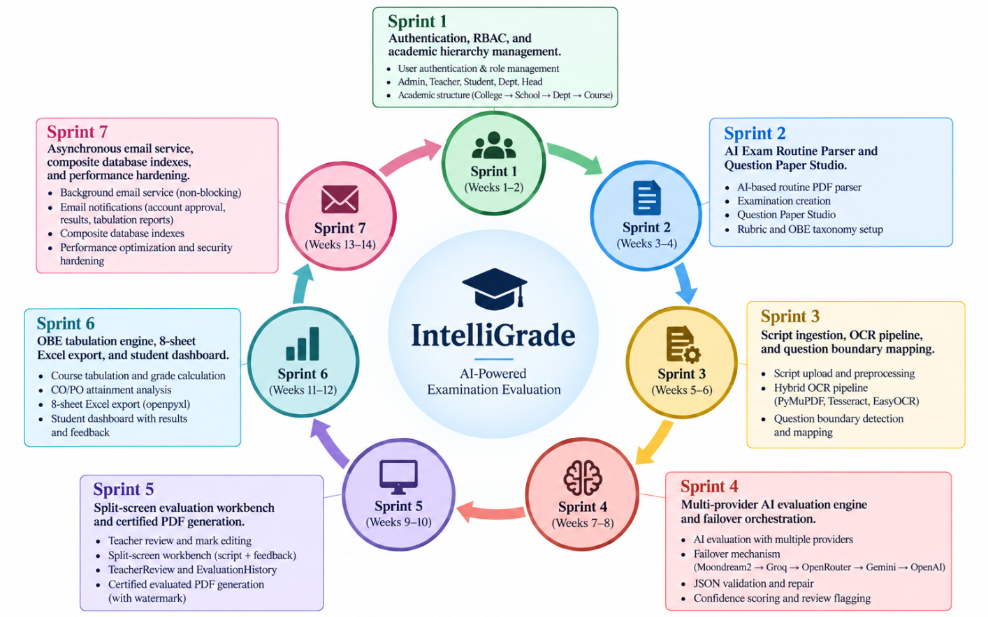
Figure 1.0.1 Agile Iterative Development Model

1.7 Report Organization
This practicum report is organized into ten comprehensive chapters, systematically structured to provide a complete technical account of the project:
Chapter 2: Organizational Context outlines the institutional environment and background in which the project is situated.
Chapter 3: Requirement Engineering details both functional and non-functional requirements, establishing the foundation for system development.
Chapter 4: Analysis and Modeling presents the core artifacts including activity diagrams, sequence diagrams, state machine diagrams, CRC cards, and class diagrams.
Chapter 5: Project Management and Risk addresses management strategies and risk mitigation through seven RMMM tables.
Chapter 6: Effort Estimation applies function point analysis and illustrates workload distribution via a Gantt chart.
Chapter 7: Cost Estimation provides a structured financial projection for system development.
Chapter 8: System Design describes the complete architecture, data flow diagrams (DFDs), entity-relationship diagrams (ERDs), database schema, API catalog, and interface mockups.
Chapter 9: Testing presents nine detailed test case tables to validate system functionality and reliability.
Chapter 10: Conclusion synthesizes the project outcomes, highlights limitations, and outlines future development plans.

Chapter 2.

Organizational Overview

This chapter presents a comprehensive overview of Al Hadi Enterprise, the host organization of the practicum program, including its vision, mission, major services, organizational structure, and the role and responsibilities of the practicum trainee. Al Hadi Enterprise is a Bangladeshi technology solutions and software company engaged in e-commerce, retail automation, customized software development, CCTV and security solutions, IT infrastructure, and software licensing. The organization serves both individual consumers and corporate clients through technology-driven products and services, with a strong emphasis on reliability, customer satisfaction, and digital transformation.
Established in 2022, the organization's e-commerce platform, Al-Hadi Express, operates as a one-stop online shopping destination in Bangladesh, offering products across categories such as electronics, smartphones, computing and accessories, cameras, household appliances, networking devices, and mobile accessories. In addition to its online retail operations, the organization provides customized technological solutions designed to improve business efficiency and operational automation.

2.1 Organization Vision
The vision of Al Hadi Enterprise is to become one of the leading and most trusted technology solution providers and e-commerce companies in Bangladesh by delivering innovative digital services, quality products, and exceptional customer experiences. The organization seeks to bridge the gap between modern technology and everyday life by providing reliable digital platforms, efficient business solutions, and continuously improved technological services.
Through its e-commerce operations and customized software development services, Al Hadi Enterprise aims to contribute to the digital transformation of businesses and consumers in Bangladesh. The organization emphasizes technological innovation, service reliability, product authenticity, and customer satisfaction as key components of its long-term growth.

2.2 Organization Mission
The mission of Al Hadi Enterprise is to empower individuals and businesses by providing reliable, innovative, and high-quality technology products and software solutions. The organization is committed to delivering a seamless customer experience through efficient e-commerce operations, secure online services, timely delivery, multiple payment options, and responsive technical support.
The organization also focuses on supporting businesses through customized web applications, Point of Sale (POS) systems, security solutions, IT infrastructure, and software services. By continuously adopting modern technologies and improving its digital platforms, Al Hadi Enterprise aims to enhance operational efficiency, simplify technology adoption, and create sustainable value for its customers and business partners.

2.3 Organization Services
Al Hadi Enterprise provides a diverse range of technology products and IT services to individual consumers, businesses, and corporate clients. Its major services include:
1. E-Commerce Platform:
The organization operates an online shopping platform offering a wide range of products, including smartphones, laptops, computer components, cameras, household appliances, mobile accessories, networking devices, and other electronic products. The platform supports multiple payment methods and provides doorstep delivery services throughout Bangladesh.
2. Point of Sale (POS) Solutions:
Al Hadi Enterprise provides POS-based retail automation solutions, including POS software, barcode scanners, receipt printers, and related hardware. These solutions help businesses manage sales transactions, inventory, and day-to-day retail operations more efficiently.
3. CCTV and Security Solutions:
The organization supplies and installs CCTV cameras, DVR/NVR systems, biometric attendance devices, and other security technologies. These services support residential, commercial, and organizational security requirements.
4. Software Development:
Al Hadi Enterprise develops customized web applications and business management systems according to client requirements. The software development team works with modern web technologies to design, develop, test, deploy, and maintain scalable digital solutions.
5. IT Infrastructure and Software Licensing:
The organization provides computer hardware, networking equipment, operating systems, databases, licensed software, and other IT infrastructure components to support the technological requirements of businesses and institutions.
6. Logistics and Customer Support:
Through its e-commerce operations, Al Hadi Enterprise provides product delivery, return services, customer support, and multiple payment facilities with the objective of ensuring a convenient and reliable online shopping experience.

2.4 Organizational Structure
Al Hadi Enterprise operates through a functional organizational structure consisting of management, business operations, e-commerce and sales, technical and software development, customer support, logistics, and other supporting functions. The organizational structure enables different teams to coordinate their activities while maintaining specialized responsibilities.
The software development function operates as an important technical component of the organization, responsible for developing and maintaining customized web applications and internal business solutions. Software engineers and interns work under the supervision of senior technical personnel and collaborate with relevant business and operational teams during the development lifecycle.
The organizational hierarchy and the position of the practicum trainee within the software development function are illustrated in Figure 2.1.
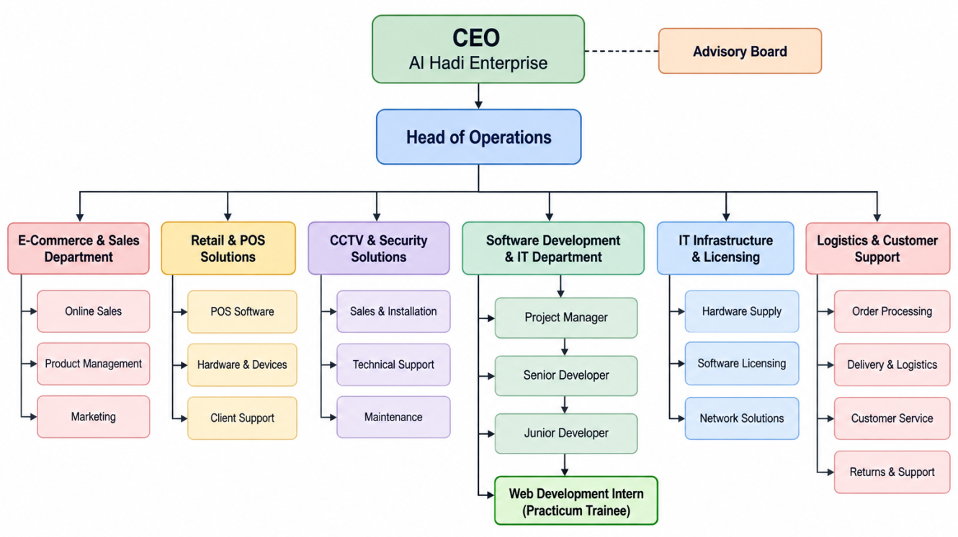
Figure 2.0.1 Organizational Structure of Al Hadi Enterprise and Software Development Team
Figure 2.1 illustrates the organizational structure of Al Hadi Enterprise and highlights the reporting relationship between the organizational management, technical/software development function, and the practicum trainee. The structure demonstrates how software development activities are integrated with the organization's broader e-commerce and technology service operations.

2.5 My Position in this Organization
During the practicum period, I worked as a Web Development Intern at Al Hadi Enterprise within the software development team. My primary responsibilities involved assisting in the design, development, testing, debugging, and maintenance of web-based software applications using the Django framework and related web technologies.
Throughout the practicum, I was involved in the development of IntelliGrade, an AI-assisted examination evaluation and academic assessment platform. My responsibilities covered multiple aspects of the system development lifecycle, including backend development, database integration, AI service integration, document processing, OCR, examination workflow development, evaluation automation, and system testing.
My major responsibilities included:
- Designing and implementing backend functionalities using Django and Python.
- Developing and maintaining database models and application workflows.
- Implementing OCR and document-processing pipelines for examination papers and answer scripts.
- Integrating multimodal AI services for automated question extraction and answer evaluation.
- Developing AI provider routing and failover mechanisms for reliable evaluation processing.
- Implementing examination question, rubric, answer-script, and evaluation management functionalities.
- Developing teacher, student, examiner, and administrative dashboard functionalities.
- Implementing OBE-based course tabulation, grade calculation, and academic reporting.
- Integrating Excel-based reporting and automated result synchronization.
- Conducting functional testing, debugging, performance optimization, and real-time application testing.
- Supporting deployment and production configuration of the developed web application.
This role provided practical experience in applying software engineering principles to a real-world application environment and enabled me to work with modern backend, AI, document-processing, database, and web application technologies.

2.6 Address of the Organization
The registered and corporate office of the host organization is:
Al Hadi Enterprise
Plot 6 (3rd Floor), Road 1/A,
Sector 17, Uttara South, Dhaka 1230, Bangladesh.
Website: Al Hadi Express
Corporate Email: info@alhadiexpress.com.bd
Sales Email: sales@alhadiexpress.com.bd

Chapter 3. Requirement Engineering

3.1 Requirement Elicitation
Requirement elicitation for IntelliGrade was conducted to identify the functional needs, operational challenges, academic requirements, and quality expectations associated with the university examination and assessment lifecycle. The requirements were gathered by studying the existing examination and grading workflow, consulting relevant academic stakeholders, reviewing institutional OBE documentation, and analyzing existing digital assessment solutions.
The elicitation process focused on understanding the activities performed by the major system actors, including the Exam Controller, Department Head, Faculty/Examiner, and Student. Particular attention was given to examination scheduling, question and rubric preparation, answer-script processing, evaluation, teacher verification, academic tabulation, OBE reporting, and student result publication.

3.1.1 Requirement Gathering Methods
The following methods were used to identify and validate the requirements of IntelliGrade:
1. Stakeholder Interviews: Discussions with faculty members and examination-related personnel helped identify major challenges in the existing evaluation process, including manual marking effort, inconsistency in evaluation, time-consuming result calculation, limited evaluation traceability, and the difficulty of preparing CO/PO attainment reports.
2. Process Observation: The existing examination workflow was observed from examination routine preparation and question-paper management through answer-script evaluation, mark entry, course tabulation, and result publication. This helped identify manual bottlenecks and opportunities for workflow automation.
3. Document Analysis: Institutional examination and OBE-related documents, including the official course tabulation structure and required CO/PO reporting formats, were reviewed to determine the data structure, assessment weightage, and reporting requirements that the system must support.
4. Existing System and Literature Review: Existing academic assessment and grading platforms were reviewed to identify commonly available features and limitations. The analysis helped define the areas where IntelliGrade could provide an integrated workflow, particularly by connecting examination management, answer-script processing, evaluation, teacher verification, and OBE-based academic reporting.

3.2 Requirement Analysis
The collected requirements were analyzed according to the complete examination lifecycle of IntelliGrade. The analysis identified four primary actors:
- Exam Controller – manages institutional academic information, users, examinations, and examination routines.
- Department Head – monitors departmental academic and examination activities and reviews OBE performance.
- Faculty/Examiner – prepares questions and rubrics, evaluates answer scripts, verifies results, and finalizes marks.
- Student – accesses academic results, detailed evaluation feedback, GPA, and certified evaluated scripts.
The analysis resulted in four major requirement categories:
- User Requirements: What each actor needs to accomplish through the system.
- System Requirements: The system capabilities and interface behavior required to support those needs.
- Functional Requirements: Specific operations and processing activities performed by the system.
- Non-Functional Requirements: Performance, security, reliability, scalability, usability, maintainability, and compliance constraints.

3.2.1 Key Design Considerations
Several important design considerations emerged from the requirement analysis.
- Human-in-the-Loop Evaluation: AI-generated evaluations shall be treated as decision-support outputs rather than final academic decisions. A teacher must be able to review, modify, and explicitly finalize marks before they become official results.
- Hybrid Evaluation Capability: The system shall support both AI-assisted and manual grading workflows. This ensures that teachers can continue evaluating scripts when AI services are unavailable, unsuitable, or unnecessary.
- Reliable AI Integration: The AI evaluation architecture shall support multiple providers and failover mechanisms. Where sufficient computational resources, GPU infrastructure, or external API capacity are available, additional AI models or providers can be incorporated without changing the overall examination workflow.
- OBE Compliance: The system shall support the institutional assessment structure and required CO/PO attainment calculations so that academic results and OBE reports remain consistent with the defined institutional methodology.
- Auditability: Important evaluation actions, particularly teacher mark modifications and finalization activities, shall be traceable through appropriate audit records.
- Data and Workflow Consistency: Examination data, question metadata, evaluation results, course grades, OBE calculations, student dashboards, and generated reports shall remain synchronized throughout the workflow.

3.3 Requirement Specifications
The following requirements define the major functional and non-functional capabilities of IntelliGrade. The requirements are organized according to the four primary actors of the system to clearly represent their responsibilities and interactions throughout the examination lifecycle.

3.3.1 Actor 1: Exam Controller
The Exam Controller is responsible for institutional examination administration, academic structure management, user administration, examination routine processing, and relevant system configuration.
User Requirement 1
The Exam Controller wants to manage institutional academic information and authorized users.
System Requirements
1.1 The system shall provide a role-specific dashboard for the Exam Controller.
1.2 The system shall provide management interfaces for Colleges, Schools, Departments, Courses, Faculty members, and Department Heads.
1.3 The system shall maintain user roles and account status.
1.4 The system shall allow authorized administrators to activate or block user accounts.
1.5 Student registrations shall remain pending until approved by an authorized administrator.
Functional Requirements
- The system shall allow the Exam Controller to create, update, and manage institutional academic entities.
- The system shall allow authorized users to manage faculty and Department Head information.
- The system shall provide account activation and blocking functionality.
- The system shall support student registration and approval workflows.
- The system shall enforce role-based access to administrative functions.
The system supports unified role-based authentication, student approval, and institutional entity management.

User Requirement 2
The Exam Controller wants to create examination records from official examination routines with minimum manual data entry.
System Requirements
2.1 The system shall accept examination routine documents in PDF or image format.
2.2 The system shall identify examination dates, times, course codes, course titles, and assigned examiners.
2.3 The system shall match extracted course information with existing academic records.
2.4 The system shall allow the Controller to review extracted information before creating examination records.
2.5 The system shall support batch examination creation.
Functional Requirements
- The system shall process multi-page examination routine documents.
- The system shall extract relevant examination information from the uploaded routine.
- The system shall match extracted courses with the institutional database.
- The system shall allow the Controller to verify extracted information.
- The system shall create examination records after confirmation.
The existing specification includes automated routine parsing, course matching, and batch examination creation.

User Requirement 3
The Exam Controller wants to configure the services required for document processing and AI-assisted evaluation.
System Requirements
3.1 The system shall provide an authorized configuration interface.
3.2 The system shall support configuration of available AI providers and their credentials.
3.3 The system shall support configurable OCR and evaluation parameters.
Functional Requirements
- The system shall support configuration of available AI services such as Gemini, Groq, OpenAI, OpenRouter, and Ollama.
- The system shall allow authorized administrators to configure service credentials.
- The system shall allow relevant OCR confidence thresholds and processing parameters to be configured.

3.3.2 Actor 2: Department Head
The Department Head is responsible for monitoring departmental academic activities, reviewing examination performance, and auditing OBE-related outcomes.
User Requirement 1
The Department Head wants to monitor departmental examination and academic performance.
System Requirements
1.1 The system shall provide a dedicated Department Head dashboard.
1.2 The dashboard shall display relevant departmental statistics.
1.3 The system shall provide information about active courses, enrolled students, examination activities, and faculty workloads.
1.4 The system shall present departmental performance indicators.
Functional Requirements
- The system shall display active course information.
- The system shall display enrolled student statistics.
- The system shall display relevant faculty examination workloads.
- The system shall present departmental pass-rate information.
- The system shall provide an overview of current academic performance.
The Department Head dashboard is defined to provide live departmental performance and workload information.

User Requirement 2
The Department Head wants to review course-level OBE performance and verify attainment information.
System Requirements
2.1 The system shall provide access to course OBE tabulation data.
2.2 The system shall provide Course Outcome (CO) attainment information.
2.3 The system shall provide Program Outcome (PO) attainment information.
2.4 The system shall allow authorized Department Heads to review and audit OBE records.
Functional Requirements
- The system shall provide course-level OBE tabulation information.
- The system shall calculate and display CO attainment.
- The system shall generate PO attainment information.
- The system shall allow the Department Head to review submitted OBE records.
- The system shall support academic quality monitoring through OBE reports.

3.3.3 Actor 3: Faculty Member / Examiner
The Faculty Member/Examiner is the primary academic user of the evaluation workflow. The examiner prepares structured questions, defines grading criteria, processes answer scripts, performs AI-assisted or manual evaluation, verifies marks, and finalizes student results.
User Requirement 1
The Faculty/Examiner wants to prepare structured examination questions according to the required academic and OBE framework.
System Requirements
1.1 The system shall provide a question authoring interface.
1.2 Each question shall support marks and relevant academic metadata.
1.3 The system shall support CO and PO mapping.
1.4 The system shall support Bloom's cognitive levels and relevant OBE classifications.
1.5 The system shall support questions containing figures, tables, and mathematical expressions.
Functional Requirements
- The system shall allow teachers to create and manage examination questions.
- The system shall associate questions with CO1–CO6 and PO1–PO12 where applicable.
- The system shall store Bloom's Taxonomy information.
- The system shall support Knowledge Profile (KP), Complex Engineering Problem (CEP), and Complex Engineering Activity (CEA) classifications.
- The system shall preserve associated figures, tables, and LaTeX mathematical expressions.

User Requirement 2
The Faculty/Examiner wants to define clear and consistent grading criteria before evaluating student answers.
System Requirements
2.1 The system shall provide a rubric management interface.
2.2 A rubric shall support multiple assessment criteria and mark distributions.
2.3 The system shall support ideal answers, expected keywords, and common mistakes.
2.4 The system shall allow master solutions to be associated with examination questions.
Functional Requirements
- The system shall allow teachers to create and manage question-specific rubrics.
- The system shall store assessment criteria and mark distributions.
- The system shall store ideal answers and relevant keywords.
- The system shall support common-mistake definitions.
- The system shall allow teachers to upload master solutions.
- The system shall associate master-solution information with corresponding questions.

User Requirement 3
The Faculty/Examiner wants to process student answer scripts and identify answers corresponding to individual questions.
System Requirements
3.1 The system shall accept uploaded student answer scripts.
3.2 PDF answer scripts shall be converted into high-resolution page images for processing.
3.3 The system shall preprocess scanned pages before OCR or AI evaluation.
3.4 The system shall support multiple OCR engines.
3.5 The system shall identify question boundaries and corresponding answer regions.
Functional Requirements
- The system shall render uploaded scripts at an appropriate high resolution, including 300 DPI processing where required.
- The system shall perform image preprocessing such as deskewing, noise reduction, and thresholding.
- The system shall support PyMuPDF, PyTesseract, and EasyOCR-based text extraction.
- The system shall extract text together with relevant spatial information.
- The system shall detect question headers and map answer regions to corresponding questions.
- The system shall provide an interactive mapping interface for teacher verification and correction.

User Requirement 4
The Faculty/Examiner wants AI assistance for faster answer evaluation while maintaining full control over academic decisions.
System Requirements
4.1 The system shall provide an AI-assisted evaluation workflow.
4.2 The system shall support multiple AI providers.
4.3 The system shall provide automatic provider failover when an AI service becomes unavailable.
4.4 The system shall evaluate answers according to the configured question rubric.
4.5 The system shall identify low-confidence evaluations for teacher review.
4.6 The teacher shall be able to modify AI-generated marks and feedback.
Functional Requirements
- The system shall route evaluation requests through the configured AI provider sequence.
- The system shall detect provider timeouts and rate-limit responses.
- The system shall temporarily exclude unavailable providers through a cooldown mechanism.
- The system shall generate evaluation information including obtained marks, maximum marks, confidence, strengths, and mistakes.
- The system shall flag evaluations requiring manual verification.
- The system shall allow teachers to modify AI-generated marks and feedback.
- The system shall record teacher modifications for audit purposes.

User Requirement 5
The Faculty/Examiner wants to manually evaluate answer scripts when AI assistance is unavailable, unsuitable, or unnecessary.
System Requirements
5.1 The system shall provide a separate manual grading workflow.
5.2 Manual grading shall not depend on AI processing.
5.3 Teachers shall be able to enter and modify question-level marks.
5.4 Manually entered marks shall be stored in the academic evaluation records.
Functional Requirements
- The system shall provide an AI Evaluation Wizard.
- The system shall provide an independent Manual Script Grading Wizard.
- The system shall allow teachers to evaluate individual questions manually.
- The system shall preserve manually entered marks.
- The system shall integrate manual evaluation results into the course tabulation workflow.
The system explicitly supports separate AI-assisted and manual evaluation pathways.

User Requirement 6
The Faculty/Examiner wants to verify, finalize, and generate an official record of evaluated scripts.
System Requirements
6.1 The system shall provide a split-screen evaluation workbench.
6.2 The original student script shall remain accessible during evaluation.
6.3 Evaluation scores, criteria, and feedback shall be displayed alongside the script.
6.4 Teachers shall be able to review and override evaluation results.
6.5 Finalized evaluations shall generate certified documents.
Functional Requirements
- The system shall display the answer script and evaluation information simultaneously.
- The system shall allow teachers to override marks and modify feedback.
- The system shall record significant evaluation changes in audit records.
- The system shall generate certified PDF copies of finalized evaluations.
- The generated documents shall contain relevant institutional information, awarded marks, and teacher comments.
- The system shall apply appropriate digital watermarking to finalized documents.
- Temporary working files shall be removed after successful finalization.

User Requirement 7
The Faculty/Examiner wants evaluated marks to be automatically incorporated into course results and OBE calculations.
System Requirements
7.1 The system shall support configured assessment components and weightages.
7.2 The system shall calculate course-level results from assessment data.
7.3 The system shall support CO and PO attainment calculations.
7.4 Authorized changes to marks shall update the corresponding academic records.
7.5 The system shall support structured course tabulation and Excel reporting.
Functional Requirements
- The system shall aggregate Class Test, Midterm, Final Examination, Assignment, and Attendance marks according to the configured assessment scheme.
- The system shall calculate the corresponding weighted course result.
- The system shall update student grade records following authorized mark changes.
- The system shall synchronize relevant finalized results with the Student Dashboard.
- The system shall generate the required multi-sheet Excel tabulation workbook.

3.3.4 Actor 4: Student
The Student is the primary recipient of the academic evaluation results. The student interacts with IntelliGrade mainly to access examination-related academic information, course grades, GPA, evaluation feedback, and finalized documents.
User Requirement 1
The Student wants to securely access the academic portal and manage their account.
System Requirements
1.1 The system shall provide secure student authentication.
1.2 The system shall support student self-registration where enabled.
1.3 Newly registered students shall require institutional approval before accessing protected academic information.
1.4 The system shall provide password recovery functionality.
Functional Requirements
- The system shall authenticate registered students.
- The system shall redirect authenticated students to their Student Dashboard.
- The system shall maintain the approval status of registered accounts.
- The system shall support OTP-based password recovery.
- Password-reset OTPs shall have a limited validity period.

User Requirement 2
The Student wants to view examination results and detailed academic performance.
System Requirements
2.1 The Student Dashboard shall display finalized academic results.
2.2 The system shall display course-level grades.
2.3 The system shall display cumulative GPA.
2.4 The system shall provide question-level marks and feedback where available.
2.5 The dashboard shall reflect finalized changes made by authorized faculty members.
Functional Requirements
- The system shall display course grades.
- The system shall calculate and display cumulative GPA on the defined grading scale.
- The system shall display question-wise marks and feedback where applicable.
- The system shall synchronize finalized grade changes with the Student Dashboard.
- The system shall provide access to certified evaluated scripts where authorized.

User Requirement 3
The Student wants to obtain an official copy of the evaluated answer script.
System Requirements
3.1 The system shall provide access to finalized certified PDF documents.
3.2 The generated document shall contain the relevant evaluation information.
3.3 Draft or temporary processing files shall not be exposed as official documents.
Functional Requirements
- The system shall provide a certified PDF access or download option.
- The generated document shall contain awarded marks and relevant teacher comments.
- The system shall apply the required institutional watermarking.
- The system shall retain the finalized evaluation record while removing unnecessary temporary processing files.

3.3.5 Cross-Actor Functional Requirements
Some functionalities of IntelliGrade are shared across multiple actors and connect the different stages of the examination lifecycle.
Examination and Evaluation Synchronization
- The system shall maintain consistent examination, question, submission, evaluation, and academic records.
- Finalized teacher marks shall be synchronized with the corresponding student grade records.
- Changes in course tabulation shall be reflected in relevant academic reports and student information.
- The system shall maintain consistency between question-level evaluation, course grades, and OBE calculations.
Notification and Communication
- The system shall support institutional email services for account-related communication, OTPs, credentials, and relevant academic notifications.
- Email processing shall be performed asynchronously where necessary so that external mail-server delays do not unnecessarily block normal application requests.
Database and Processing Efficiency
- The system shall use appropriate database indexing for frequently accessed examination, evaluation, and academic records.
- The system shall use efficient relation loading to minimize unnecessary database queries during complex workflows.

3.3.6 Non-Functional Requirements
The non-functional requirements define the quality attributes and operational constraints that IntelliGrade must satisfy in addition to its functional capabilities.
1. Performance
1.1 Dashboard and tabulation pages should load within approximately 1.5 seconds under standard institutional network conditions.
1.2 OCR and image preprocessing should target approximately 4 seconds per script page, depending on the deployed hardware.
1.3 AI-assisted evaluation should target approximately 8 seconds per question under normal external-service conditions.
1.4 AI provider failover shall occur without unnecessary interruption of pending evaluation tasks.
2. Scalability
2.1 The system shall support batch processing of up to 100 multi-page student scripts per examination under the specified deployment environment.
2.2 The architecture shall allow additional AI providers and higher-capacity processing resources to be integrated.
2.3 The document-processing and AI components shall remain modular so that GPU-based inference or additional cloud AI services can be introduced when sufficient resources are available.

3. Security
3.1 User passwords shall be securely salted and hashed and shall never be stored in plaintext.
3.2 Role-based access control shall be enforced for protected views and application endpoints.
3.3 State-changing requests shall be protected against unauthorized cross-site requests using appropriate CSRF mechanisms.
3.4 Each actor shall only be able to access the functions and data permitted by their assigned role.
4. Data Integrity and Auditability
4.1 Grade updates and important evaluation-state changes shall be processed using appropriate database transactions.
4.2 The system shall maintain consistency between evaluation, grade, tabulation, and reporting records.
4.3 Teacher mark overrides shall be recorded for traceability.
4.4 Relevant audit records shall include the responsible user and timestamp, along with other applicable request information.
5. Reliability and Availability
5.1 The system shall target at least 99.5% availability during examination and grading periods.
5.2 Failure or temporary unavailability of an AI provider shall not unnecessarily result in loss of pending evaluation tasks.
5.3 The system shall provide a manual evaluation pathway when AI-based evaluation is unavailable or unsuitable.
5.4 Temporary processing failures shall not corrupt finalized academic records.
6. OBE and Reporting Compliance
6.1 CO and PO calculations shall follow the configured institutional OBE methodology.
6.2 Generated Excel reports shall preserve the required formulas, validation rules, and formatting.
6.3 Course tabulation, CO attainment, PO attainment, and student results shall remain mutually consistent.
7. Usability
7.1 The system shall provide role-specific dashboards for the four primary actors.
7.2 The evaluation interface shall support synchronized viewing of the original answer script and evaluation information.
7.3 The web interface shall support responsive layouts and appropriate visual themes.
7.4 Users shall be able to perform common examination and evaluation tasks without requiring knowledge of the underlying OCR or AI technologies.
8. Maintainability and Extensibility
8.1 The system shall maintain modular components for examination management, OCR, AI evaluation, grading, tabulation, reporting, and notification.
8.2 AI providers shall be replaceable or extendable without requiring major changes to the core examination workflow.
8.3 The system shall automatically remove unnecessary temporary processing files after successful finalization to reduce storage consumption.

3.4 Use Case Diagram
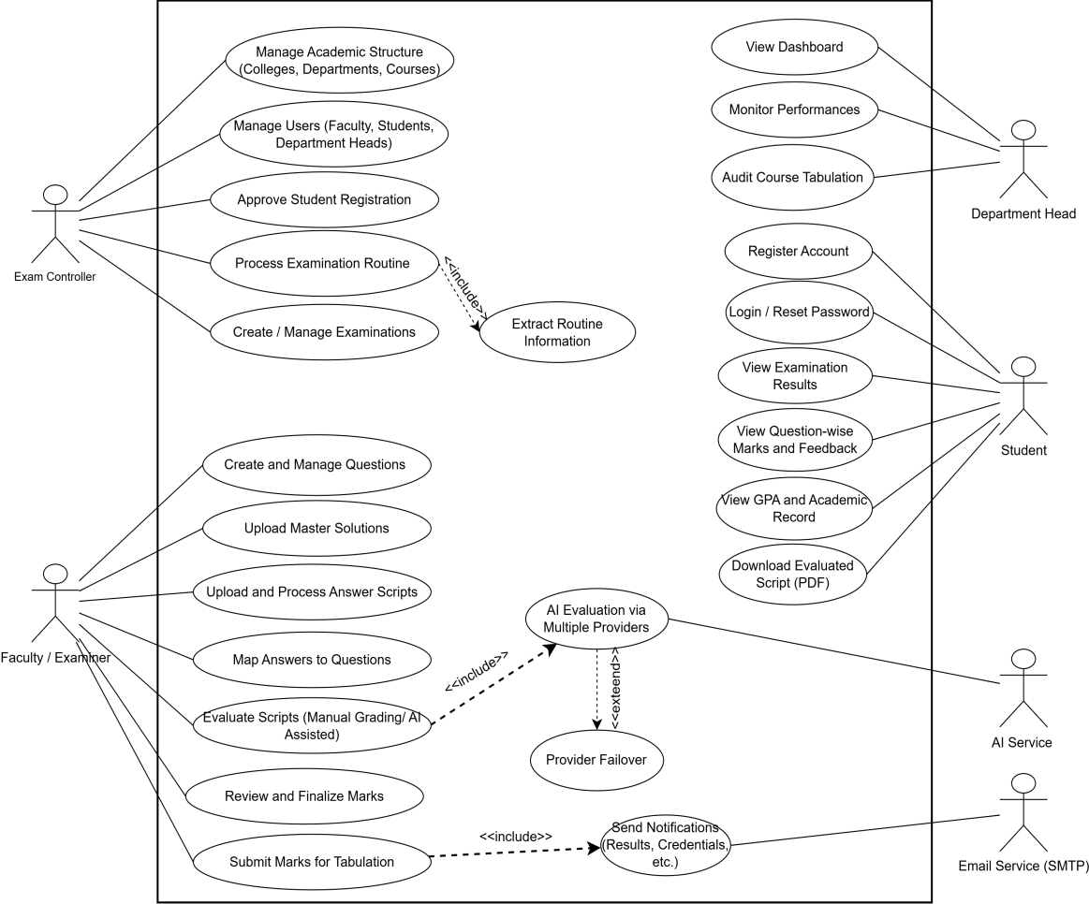
Figure 3.1 Use Case Diagram of IntelliGrade

Chapter 4. Analysis Modeling

4.1 Activity Diagrams
Activity diagrams capture the flow of key processes within IntelliGrade. Seven major workflows are documented below.

4.1.1 Exam Controller Governance Workflow
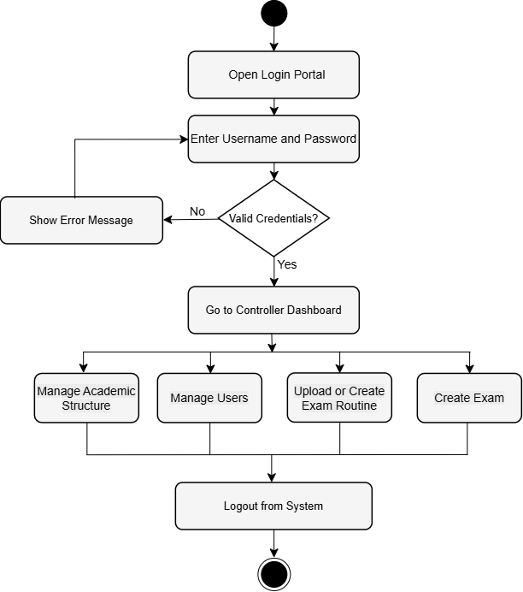
Figure 4.0.1 Activity Diagram: Exam Controller Governance

4.1.2 Activity Diagram: Examination Scheduling and Provisioning
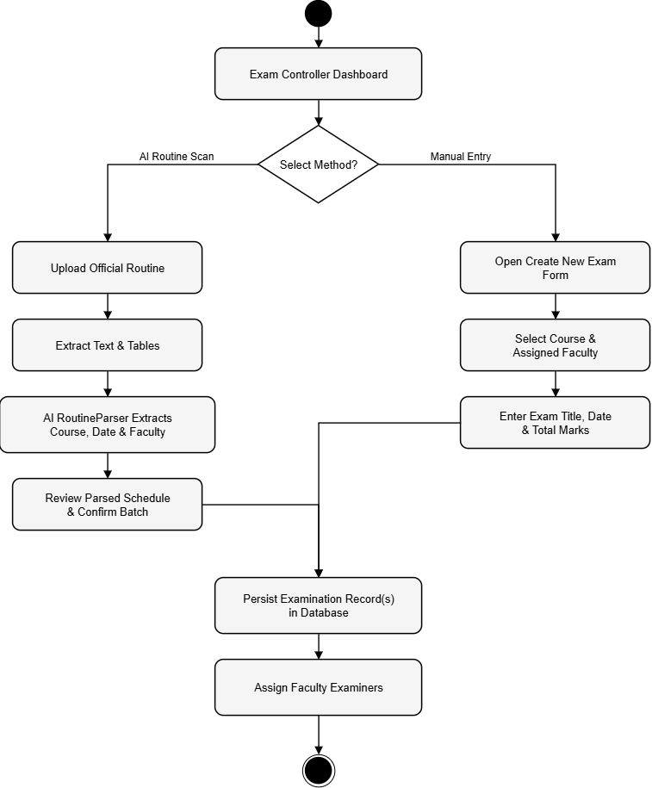
Figure 4.0.2 Activity Diagram: Examination Scheduling and Provisioning

4.1.3 Faculty/Examiner Activity Diagram
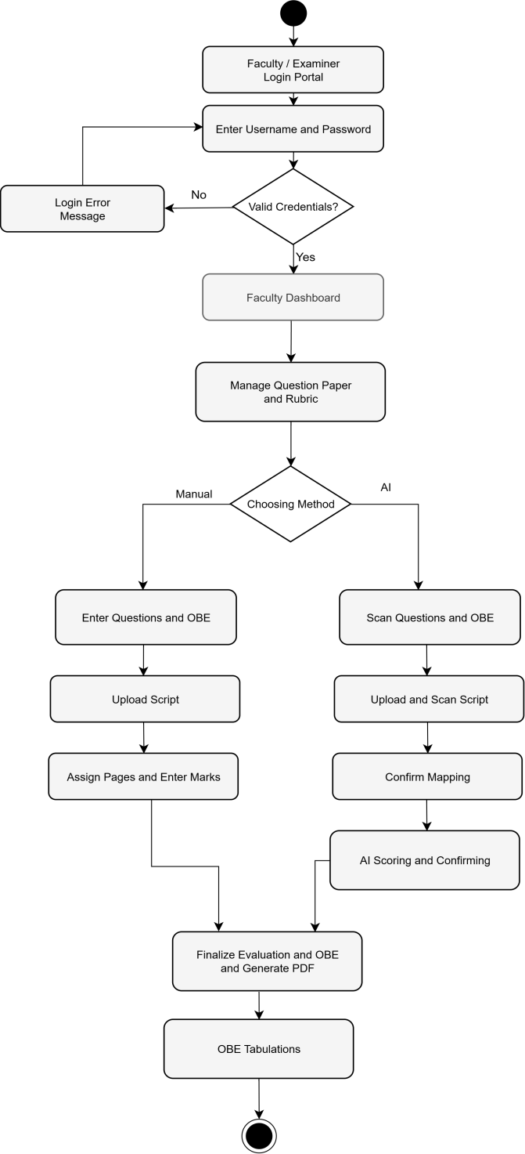
Figure 4.3 Activity Diagram: Faculty/Examiner

Faculty members navigate to the Question Paper Studio for a specific examination. They can author questions manually, providing the question prompt, maximum marks, and all 23 OBE taxonomy fields for each question, or they can upload the official question paper PDF and trigger AI-assisted scanning that automatically extracts question numbers, marks allocations, and suggested taxonomy tags. For each question, a structured rubric is defined including grading criteria, ideal answer, mark distribution across sub-criteria, expected keywords, and common student mistakes.

4.1.4 Question Paper and Rubric Authoring

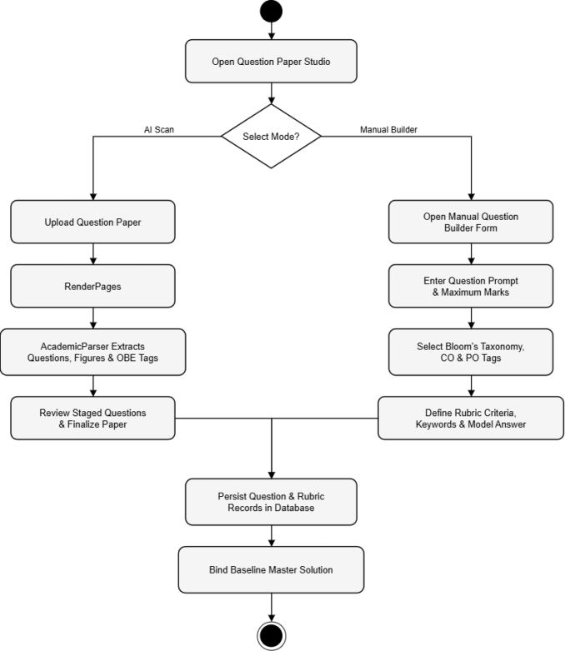
Figure 4.4 Activity Diagram: Question Paper Builder (Manual / AI)

4.1.5 AI Evaluation Wizard Flow
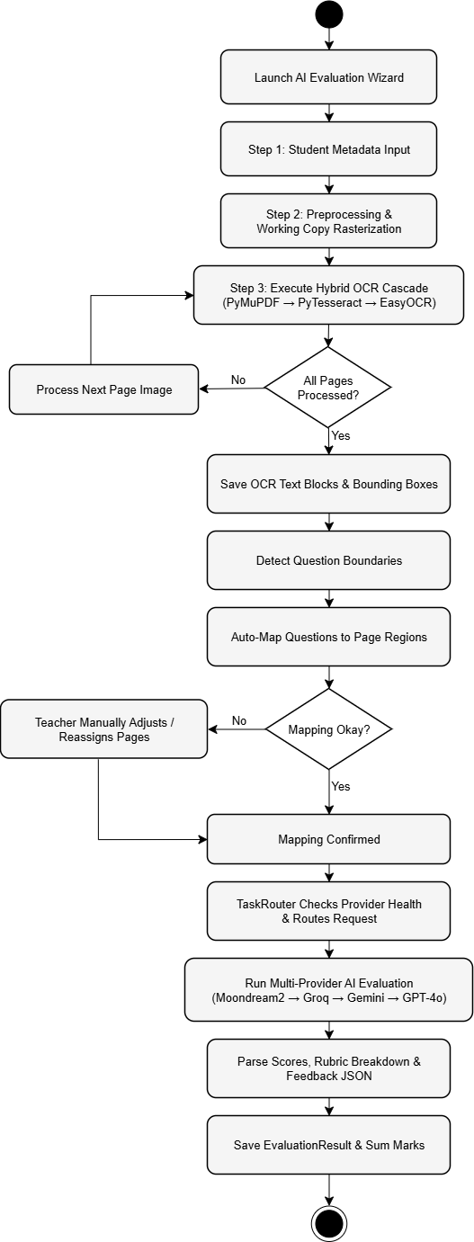
Figure 4.5 Activity Diagram: AI Evaluation Wizard

4.1.6 Manual Script Grading Wizard Flow
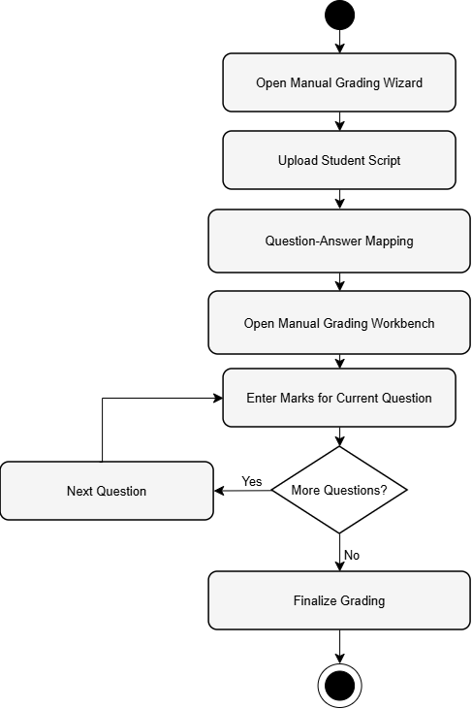
Figure 4.6 Activity Diagram: Manual Script Grading Wizard

4.1.7 OBE Tabulation
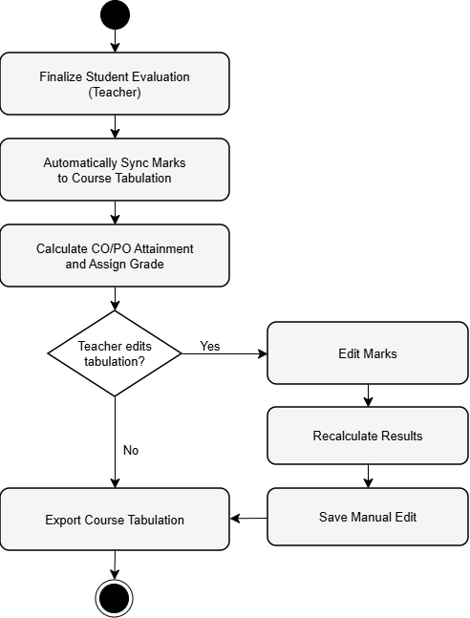
Figure 4.7 Activity Diagram: OBE Tabulation

4.1.8 Department Head

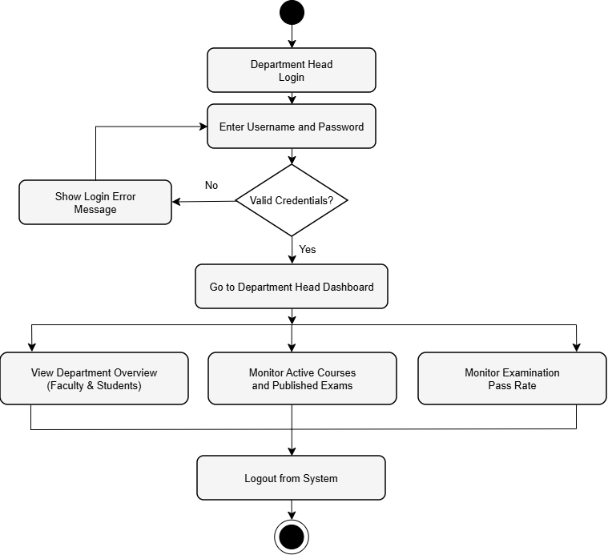
Figure 4.8 Activity Diagram: Department Head

4.1.9 Student Portal

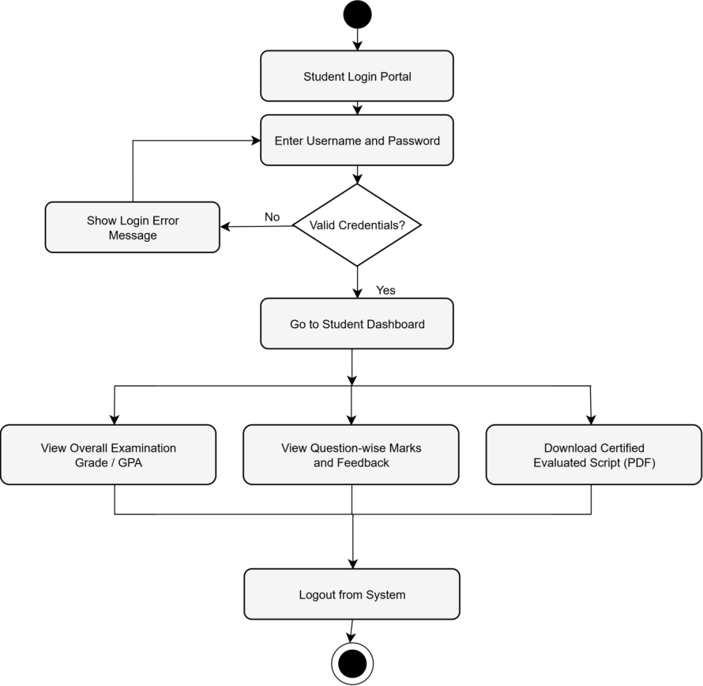
Figure 4.9 Activity Diagram: Student Portal

4.2 Swim-lane Diagram

4.2.1 Swim-lane Diagram for User Authentication & Role-Based Access Control
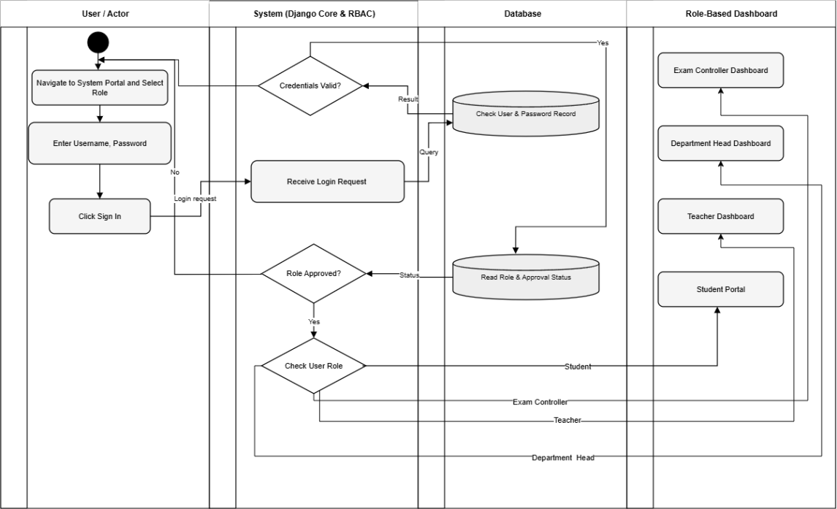
Figure 4.1 Swim-lane Diagram for User Authentication & Role-Based Access Control

4.2.2 Swim-lane Diagram for Examination Scheduling & Faculty Allocation
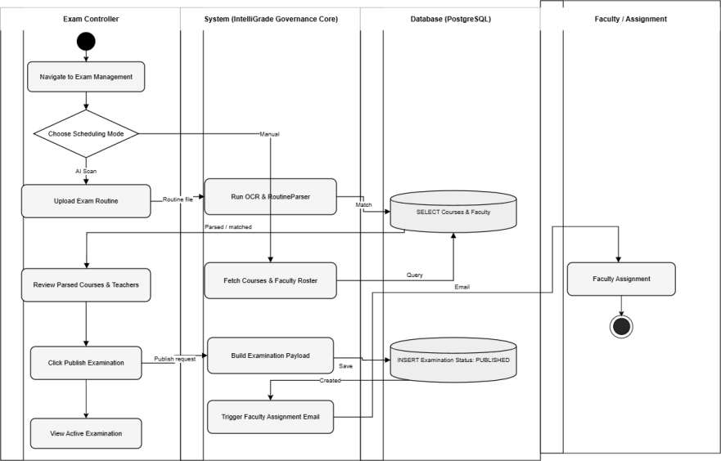
Figure 4.2 Swim-lane Diagram for Examination Scheduling & Faculty Allocation

4.2.3 Swim-lane Diagram for Answer Script Evaluation & Finalization
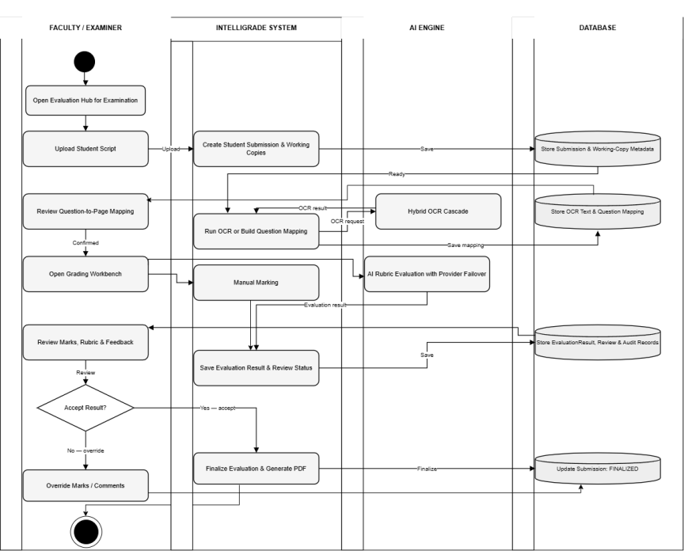
Figure 4.3 Swim-lane Diagram for Answer Script Evaluation & Finalization

4.2.4 Swim-lane Diagram for OBE Tabulation, Excel Export & Student Result Dissemination
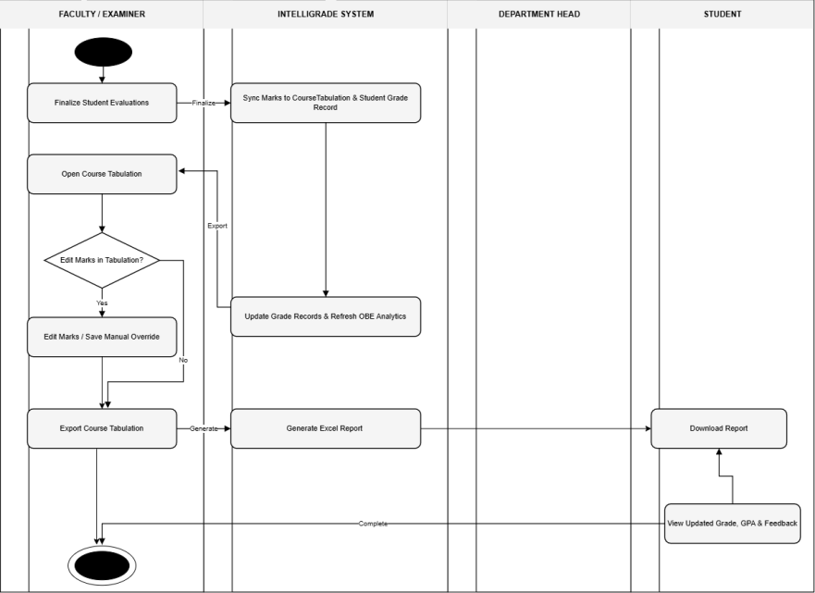
Figure 4.4 Swim-lane Diagram for OBE Tabulation, Excel Export & Student Result Dissemination

4.4 CRC Cards
Class-Responsibility-Collaborator (CRC) cards document the primary classes in IntelliGrade, their responsibilities, and their collaborators.
Table 1 CRC Card: Profile (User Role)
Class Name: Profile
Class Type: Role
Class Characteristics: Tangible, Persistent, Sequential
Responsibilities  • Store role (ADMIN, TEACHER, STUDENT, DEPT_HEAD)  • Store approval status (is_approved)  • Enforce role-based portal access  • Store OTP reset codes with expiry | Collaborators  • User (Django Auth)  • Department  • Examination

Table 2 CRC Card: Examination
Class Name: Examination
Class Type: Entity
Class Characteristics: Tangible, Persistent, Sequential
Responsibilities  • Store exam type (MID/FINAL/CT/QUIZ), status, and dates• Store approval status (is_approved)  • Hold uploaded question paper, rubric, and master solution files  • Manage publication workflow (DRAFT → PUBLISHED → CLOSED)  • Expose has_master_solution property | Collaborators  • Course  • Question  • StudentSubmission  • Profile (assigned faculty)

Table 3 CRC Card: Question
Class Name: Question
Class Type: Entity
Class Characteristics: Tangible, Persistent, Sequential
Responsibilities  • Store 23-taxonomy OBE fields (Bloom, CO, PO, KP, CEP, CEA)• Hold uploaded question paper, rubric, and master solution files  • Store prompt text and maximum marks• Expose has_master_solution property  • Reference attached figures, tables, and formula objects  • Provide formatted_number property for display | Collaborators  • Examination  • Rubric (OneToOne)  • QuestionFigure, QuestionTable, QuestionFormula  • SubmissionAnswer

Table 4 CRC Card: StudentSubmission
Class Name: StudentSubmission
Class Type: Entity
Class Characteristics: Tangible, Persistent, Sequential
Responsibilities  • Manage 14-state FSM lifecycle  • Store uploaded script file and extracted OCR data  • Track finalization status (is_finalized)  • Maintain composite B-tree database indexes  • Record student identity (name, roll number) | Collaborators  • Examination  • SubmissionPage, SubmissionImage  • QuestionMapping  • EvaluationAuditLog

Table 5 CRC Card: EvaluationResult
Class Name: EvaluationResult
Class Type: Entity
Class Characteristics: Tangible, Persistent, Sequential
Responsibilities  • Store obtained marks, maximum marks, and confidence score  • Store AI-generated feedback, strengths, and mistakes as JSON  • Flag low-confidence answers for mandatory teacher review  • Manage review status (PENDING/APPROVED/OVERRIDDEN/REJECTED) | Collaborators  • SubmissionAnswer (OneToOne)  • TeacherReview  • EvaluationHistory  • EvaluationFeedback

Table 6 CRC Card: CourseTabulation
Class Name: CourseTabulation
Class Type: Entity
Class Characteristics: Tangible, Persistent, Sequential
Responsibilities  • Store semester, section, and weightage configuration  • Maintain uniqueness constraint (course, semester, section)  • Provide aggregated assessment weightage configuration as JSON | Collaborators  • Course  • StudentGradeRecord

Table 7 CRC Card: StudentGradeRecord
Class Name: StudentGradeRecord
Class Type: Entity
Class Characteristics: Tangible, Persistent, Sequential
Responsibilities  • Store exam score breakdown per category (CT, Mid, Final, etc.)  • Compute weighted overall score via get_category_data()  • Store CO/PO attainment scores as JSON vectors  • Expose typed properties: class_test_data, midterm_data, final_data  • Track manual instructor overrides (is_manually_edited) | Collaborators  • CourseTabulation

4.5 Class Diagram
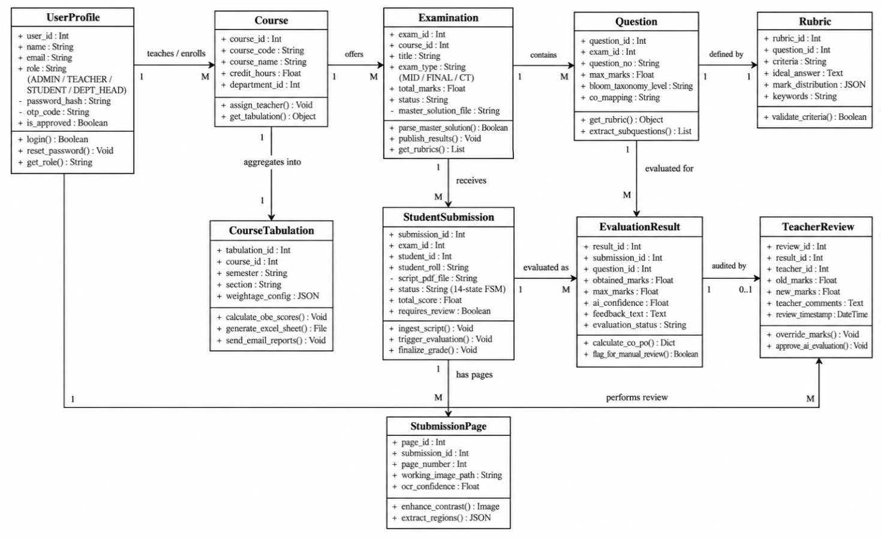
Figure 0.5 Class Diagram: Core Domain Models

Chapter 5. Project Management

5.1 Risk Identification
Table 8 Risk Identification
Risk ID | Risk Description | Category | Probability | Impact
R-01 | CPU-bound EasyOCR latency renders AI evaluation too slow for practical use on large exam batches | Technical | High | High
R-02 | Cloud AI provider rate limits (HTTP 429) cause evaluation stalls and timeouts during concurrent batch grading | Technical | High | High
R-03 | Extreme handwriting illegibility causes OCR failure and unmappable question boundaries | Technical | Medium | High
R-04 | Data loss or corruption during evaluation due to unhandled server exceptions | Technical | Low | Critical
R-05 | Institutional SMTP credential failure causes email notification breakdown | Operational | Medium | Medium
R-06 | Growing media file storage causes disk space overflow on the production server | Operational | Medium | High
R-07 | OBE calculation discrepancies due to floating-point rounding in Python arithmetic | Technical | Low | High

5.2 Risk Analysis
Table 9 Risk Analysis
Risk ID | Risk Description | Likelihood (1-5) | Severity (1-5) | Risk Exposure Score | Priority
R-01 | CPU OCR latency (EasyOCR ~20-25s/page on CPU) | 5 | 4 | 20 | Critical
R-02 | AI rate limiting — HTTP 429 cascade stalls | 5 | 4 | 20 | Critical
R-03 | Handwriting illegibility → OCR failure | 3 | 4 | 12 | High
R-04 | Data loss during evaluation exception | 2 | 5 | 10 | High
R-05 | SMTP email delivery failure | 3 | 3 | 9 | Medium
R-06 | Disk storage overflow from working images | 3 | 4 | 12 | High
R-07 | Floating-point rounding in OBE calculations | 2 | 4 | 8 | Medium

5.3 Risk Mitigation, Monitoring and Management (RMMM)
Table 10 RMMM: Risk 1 — CPU OCR Latency
Field | Details
Risk ID | R-01
Risk Description | CPU-bound EasyOCR CRAFT+BiLSTM deep learning model takes approximately 20-25 seconds per script page on a modern CPU, making full 13-page script evaluation take over 4 minutes — impractical for end-of-semester batch grading.
Mitigation | 1. Apply 800px LANCZOS downsampling before local vision dispatch (implemented). 2. Provide Manual Grading Wizard as a zero-OCR fallback for urgent evaluations. 3. Plan GPU CUDA upgrade path (NVIDIA RTX 4060, 8GB VRAM) in hardware budget.
Monitoring | AIProviderHealth model tracks avg_response_time_ms. Dashboard alerts configured for latencies exceeding 60 seconds per page.
Contingency | Fall back to Manual Wizard for urgent evaluations while GPU upgrade is provisioned. Teachers can still evaluate all students; only the automated text extraction is slowed.
Owner | System Architect
Review Date | End of each examination period

Table 11 RMMM: Risk 2 — AI Rate Limiting
Field | Details
Risk ID | R-02
Risk Description | Free-tier cloud AI APIs impose strict rate limits. Groq enforces 30 RPM / 6,000 TPM, Gemini enforces 15 RPM / 1,000,000 TPM. Evaluating multiple questions simultaneously for multiple students triggers HTTP 429 quota exhaustion.
Mitigation | 1. ProviderHealthTracker with 120-second cooldown registry per provider (implemented). 2. Maintain 5-provider failover chain so no single HTTP 429 blocks evaluation. 3. Apply JSON sanitization and LaTeX bracket repair to prevent re-requests due to parse errors.
Monitoring | AIProviderHealth.error_count and cooldown_until tracked in real time. Dashboard badge alerts teacher when all providers are rate-limited simultaneously.
Contingency | Upgrade to enterprise Pay-As-You-Go API tiers (Groq Developer Plan, Gemini Tier 1) for production deployment. Fall back to manual workbench if all AI providers are exhausted.
Owner | Exam Controller
Review Date | Before each examination period

Table 12 RMMM: Risk 3 — Handwriting Illegibility
Field | Details
Risk ID | R-03
Risk Description | Some students produce extremely poor handwriting that defeats even EasyOCR's deep learning recognizer, resulting in empty or garbled OCR output and unmapped question boundaries.
Mitigation | 1. Three-engine OCR cascade (PyMuPDF → PyTesseract → EasyOCR) maximizes text recovery probability. 2. Interactive mapping modal allows manual page assignment when auto-detection fails. 3. For illegible scripts, vision-capable AI providers (Gemini 2.5 Flash, GPT-4o) evaluate directly from the page image, bypassing OCR text entirely.
Monitoring | OCR confidence scores stored per page in SubmissionPage.ocr_confidence. Pages below threshold flagged in UI for teacher attention.
Contingency | Teacher manually selects pages via the visual confirmation modal, which is always available regardless of OCR output quality.
Owner | Faculty Member
Review Date | Per evaluation session

Table 13 RMMM: Risk 4 — Data Loss During Evaluation
Field | Details
Risk ID | R-04
Risk Description | An unhandled server exception or network interruption mid-evaluation could corrupt the StudentSubmission state machine or lose partially written SubmissionAnswer records.
Mitigation | 1. All database writes wrapped in django.db.transaction.atomic() ensuring partial states are rolled back on failure. 2. EvaluationAuditLog records every state transition with timestamp and actor identity. 3. Script PDFs and working images stored on disk and only purged after explicit teacher-initiated finalization. 4. extracted_ocr_data JSON field caches OCR output so re-evaluation does not require re-processing all images.
Monitoring | EvaluationAuditLog monitored for FAILED state transitions. System error log reviewed after each evaluation session.
Contingency | Re-upload script and restart evaluation pipeline from UPLOADED state. All previously extracted OCR data is available for reference.
Owner | System / Admin
Review Date | Continuous

Table 14 RMMM: Risk 5 — SMTP Email Delivery Failure
Field | Details
Risk ID | R-05
Risk Description | SMTP server outages or expired credentials can cause failure in account creation emails, OTP password reset delivery, and graded result notification emails.
Mitigation | 1. Email dispatch runs in a background threading.Thread so SMTP latency or failure never blocks the HTTP response seen by the user. 2. Email failures are logged to the application error log without raising user-visible exceptions. 3. OTP reset includes fallback instructions for Exam Controller manual intervention.
Monitoring | SMTP error logs reviewed daily during active grading periods.
Contingency | Exam Controller can manually reset passwords via Django admin. Results can be communicated as PDF downloads shared manually.
Owner | Exam Controller
Review Date | Monthly

Table 15 RMMM: Risk 6 — Disk Storage Overflow
Field | Details
Risk ID | R-06
Risk Description | 300 DPI page images (~26 MB uncompressed per page) accumulate rapidly. A course with 60 students x 13 pages generates approximately 20 GB of working copies, which can exhaust institutional server disk space.
Mitigation | 1. FinalizationService._purge_temporary_artifacts() deletes submission_working/ and submission_preview/ upon certified PDF creation (implemented). 2. JPEG quality=75 compression applied to all working copies. 3. 800px LANCZOS downsampling for local vision payloads reduces per-image size by ~85%.
Monitoring | Server disk usage alerts configured at 80% threshold. Pending finalization queue monitored via admin dashboard to identify abandoned submissions.
Contingency | Emergency purge script available to delete working images for all finalized submissions. Future plan: migrate to AWS S3 / Cloudflare R2 object storage with automatic lifecycle expiration policies.
Owner | System Admin
Review Date | End of each examination period

Table 16 Risk 7 — OBE Calculation Inconsistency
Field | Details
Risk ID | R-07
Risk Description | Python floating-point arithmetic without explicit rounding can produce weighted OBE scores that differ by +-0.01 from expected values, causing discrepancies between the web tabulation view and the official exported Excel workbook.
Mitigation | 1. All intermediate scores wrapped in round(value, 2) at each aggregation step in get_category_data(). 2. Generated Excel outputs use openpyxl's native formula support for in-sheet validation against Python-computed values. 3. Automated test suite validates OBE calculation correctness against 50 manually verified student records.
Monitoring | Automated test suite (tests.py, 1000+ assertions) run after every code change. OBE output spot-checked by faculty against manual calculations each semester.
Contingency | Teacher can manually override any computed score via the tabulation modal, with override flagged in is_manually_edited for auditability.
Owner | Developer
Review Date | After every deployment

Chapter 6. Project Planning and Scheduling

6.1 Function Point Analysis
Function Point Analysis (FPA) was used to estimate the size and complexity of IntelliGrade's software, providing an objective basis for effort and schedule estimation independent of programming language or implementation technology.
Table 17 Functionality, Input and Output
Function | Function Type | Description | Input | Output
User Authentication and RBAC | ILF | Profile, User, session management | Username / Password | Authenticated session + role redirect
AI Routine Scanner | EI | Parse multi-page exam schedule PDFs | PDF / Image file | Structured Examination records
23-Taxonomy Question Studio | ILF | Store questions with 23 OBE fields | Question form fields | Saved Question + Rubric records
Script Preprocessing | EI | Rasterize PDFs, deskew, threshold | PDF / JPG / ZIP | 300 DPI working copy images
Hybrid OCR Pipeline | EO | Multi-engine text extraction | Page images | Text + bounding box JSON
Question Boundary Detection | ILF | Regex state machine heading detection | OCR text per page | QuestionMapping records
AI Evaluation Failover Engine | EIF | Multi-provider AI orchestration | Prompt + context | EvaluationResult JSON
Split-Screen Workbench | EO | Interactive grading interface | Submission ID | Mark overrides + audit log entries
Certified PDF Generation | EO | ReportLab PDF stamping | Finalized submission | Watermarked evaluated PDF file
OBE Tabulation Engine | ILF | Weighted score aggregation | Exam scores JSON | StudentGradeRecord with CO/PO
8-Sheet Excel Export | EO | openpyxl workbook generation | Grade records | XLSX workbook (8 sheets)
Asynchronous Email Service | EIF | SMTP email dispatch | Event trigger + payload | Delivered email with PDF attachment
Student Dashboard | EO | Transparency grade portal | Student session | Live grade cards + download links

Table 18 Complexity of Data Function
Data Function | Elements | Records | Complexity
Profile / User | 8 | 4 roles | Simple
Examination + Question + Rubric | 25 | Nested hierarchy | Complex
StudentSubmission + Pages | 18 | Per exam per student | Average
EvaluationResult + Feedback | 15 | Per answer per question | Average
CourseTabulation + GradeRecord | 20 | Per course per semester | Complex
AIConfiguration + ProviderHealth | 12 | Global singleton | Simple

Table 19 Complexity of Transaction Function
Transaction Function | Type | Complexity
User Login and Role Redirect | EI | Simple
AI Routine Scanning | EI | Complex
Question Paper Authoring (23-field taxonomy) | EI | Complex
Script Upload + 300 DPI Preprocessing | EI | Complex
Hybrid OCR Cascade | EO | Complex
AI Evaluation with Multi-Provider Failover | EIF | Complex
Teacher Mark Override + Audit Logging | EI | Average
Finalize + Certified PDF + Storage Purge | EO | Complex
OBE Tabulation Aggregation | ILF | Complex
8-Sheet Excel Export | EO | Complex
Asynchronous SMTP Email | EIF | Average
Student Grade Dashboard | EO | Average

Table 20 UFP Calculation Summary
Function Point Category | Count | Weight | Contribution
External Inputs (EI) | 6 | 4 | 24
External Outputs (EO) | 7 | 5 | 35
External Interface Files (EIF) | 3 | 7 | 21
Internal Logical Files (ILF) | 5 | 10 | 50
Total Unadjusted Function Points (UFP) |  |  | 130

Table 21 Technical Difficulty Index (TDI)
Technical Factor | Rating (0-5) | Description
Data Communications | 5 | Multi-provider REST APIs, AJAX, SMTP
Distributed Processing | 4 | Background email threads, async evaluation
Performance | 5 | Sub-second DB queries, 8-sec AI target
Complex Processing | 5 | OCR cascade, AI failover, PDF stamping
Reusability | 3 | Modular AI engine provider classes
Ease of Installation | 2 | Docker + env configuration required
Ease of Operation | 4 | Web-based, role-guided UI
Portability | 3 | Django + PostgreSQL portable
Maintainability | 4 | Modular architecture, clean separation
TDI Total | 40 | VAF = 0.65 + (0.01 x 40) = 1.05

Adjusted Function Points (AFP) = UFP x VAF = 130 x 1.05 = 136.5 AFP
At a productivity rate of approximately 8 AFP per person-month for a complex real-time system with AI integration and handwriting recognition, the estimated development effort is approximately 17 person-months, which is consistent with the actual observed development timeline of 8 calendar months with a 5-person team equivalent.

Project Schedule (Gantt Chart)
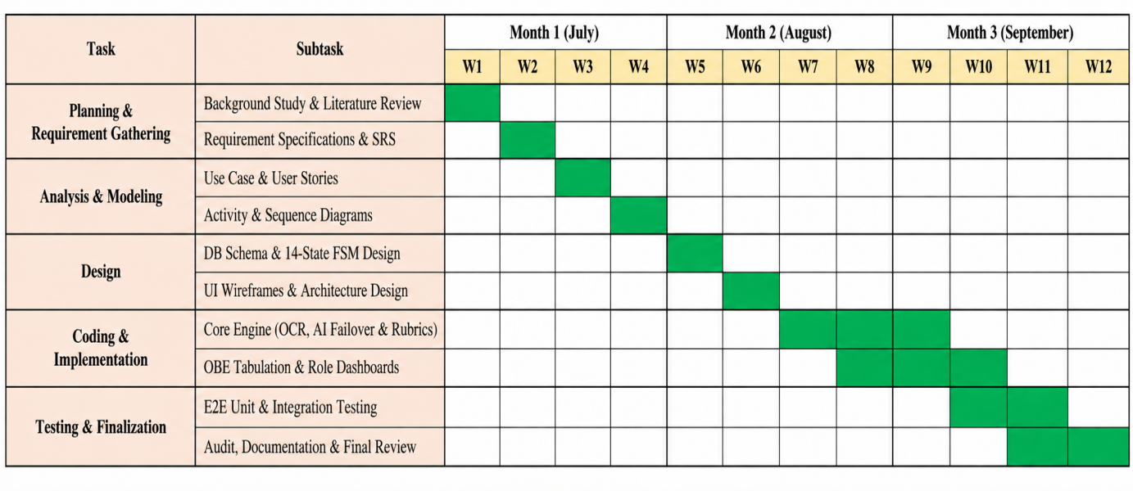
Figure 0.1 Gantt Chart: Project Schedule

Chapter 7. Cost Estimation

7.1 Personnel Cost
Table 22 Personnel Salary
Role | No. of People | Monthly Salary (BDT)
System Architect / Full-Stack Developer | 1 | 80,000
AI / ML Engineer | 1 | 75,000
Database Engineer | 1 | 60,000
UI/UX Designer | 1 | 50,000
QA / Test Engineer | 1 | 45,000
Total | 5 | 310,000

Table 23 Personnel Cost Estimation
Role | Duration (Months) | Monthly Cost (BDT) | Total (BDT)
System Architect / Full-Stack Developer | 8 | 80,000 | 640,000
AI / ML Engineer | 6 | 75,000 | 450,000
Database Engineer | 4 | 60,000 | 240,000
UI/UX Designer | 4 | 50,000 | 200,000
QA / Test Engineer | 3 | 45,000 | 135,000
Total Personnel Cost |  |  | 1,665,000

7.2 Hardware Cost
Table 24 Hardware Cost
Item | Specification | Cost (BDT)
Development Workstation | Intel Core i7, 32GB RAM, 1TB SSD | 120,000
GPU for Local OCR (Optional) | NVIDIA RTX 4060 (8GB VRAM) | 65,000
Network Equipment | Router, switches, UPS | 25,000
Total Hardware Cost |  | 210,000

7.3 Software Cost
Table 25 Software Cost
Item | Description | Annual Cost (BDT)
Python / Django / PostgreSQL | Open-source — Free | 0
EasyOCR / PyTesseract / PyMuPDF / OpenCV | Open-source — Free | 0
Groq Cloud API (Free Tier) | 30 RPM / 6,000 TPM | 0
Gemini API (Free Tier) | 15 RPM / 1,000,000 TPM | 0
PythonAnywhere Hosting (Hacker Plan) | Production deployment | 6,720
Domain Name Registration | .com domain | 1,500
Total Software Cost |  | 8,220

7.4 Operational Cost
Table 26 Other Operational Costs
Item | Description | Monthly Cost (BDT)
Electricity and Internet | Development environment utilities | 5,000
Cloud Storage (Future) | AWS S3 or Cloudflare R2 for script archival | 3,000
Miscellaneous | Printing, testing materials, etc. | 2,000
Total Monthly Operational |  | 10,000

7.5 Total Project Cost Summary
Table 27 Total Project Cost Summary
Category | Cost (BDT)
Personnel Cost (8 months) | 1,665,000
Hardware Cost | 210,000
Software Cost (Annual) | 8,220
Operational Cost (8 months x 10,000/month) | 80,000
Grand Total | 1,963,220
Grand Total (USD approximate) | ~$17,850

Chapter 8. System Design

8.1 System Architecture Overview
IntelliGrade is a monolithic Django 5.2 web application deployed on a PostgreSQL database backend, organized around a clean service-oriented internal architecture. The application is structured into one primary Django app (core) containing all models, views, URLs, services, and the AI engine subpackage.
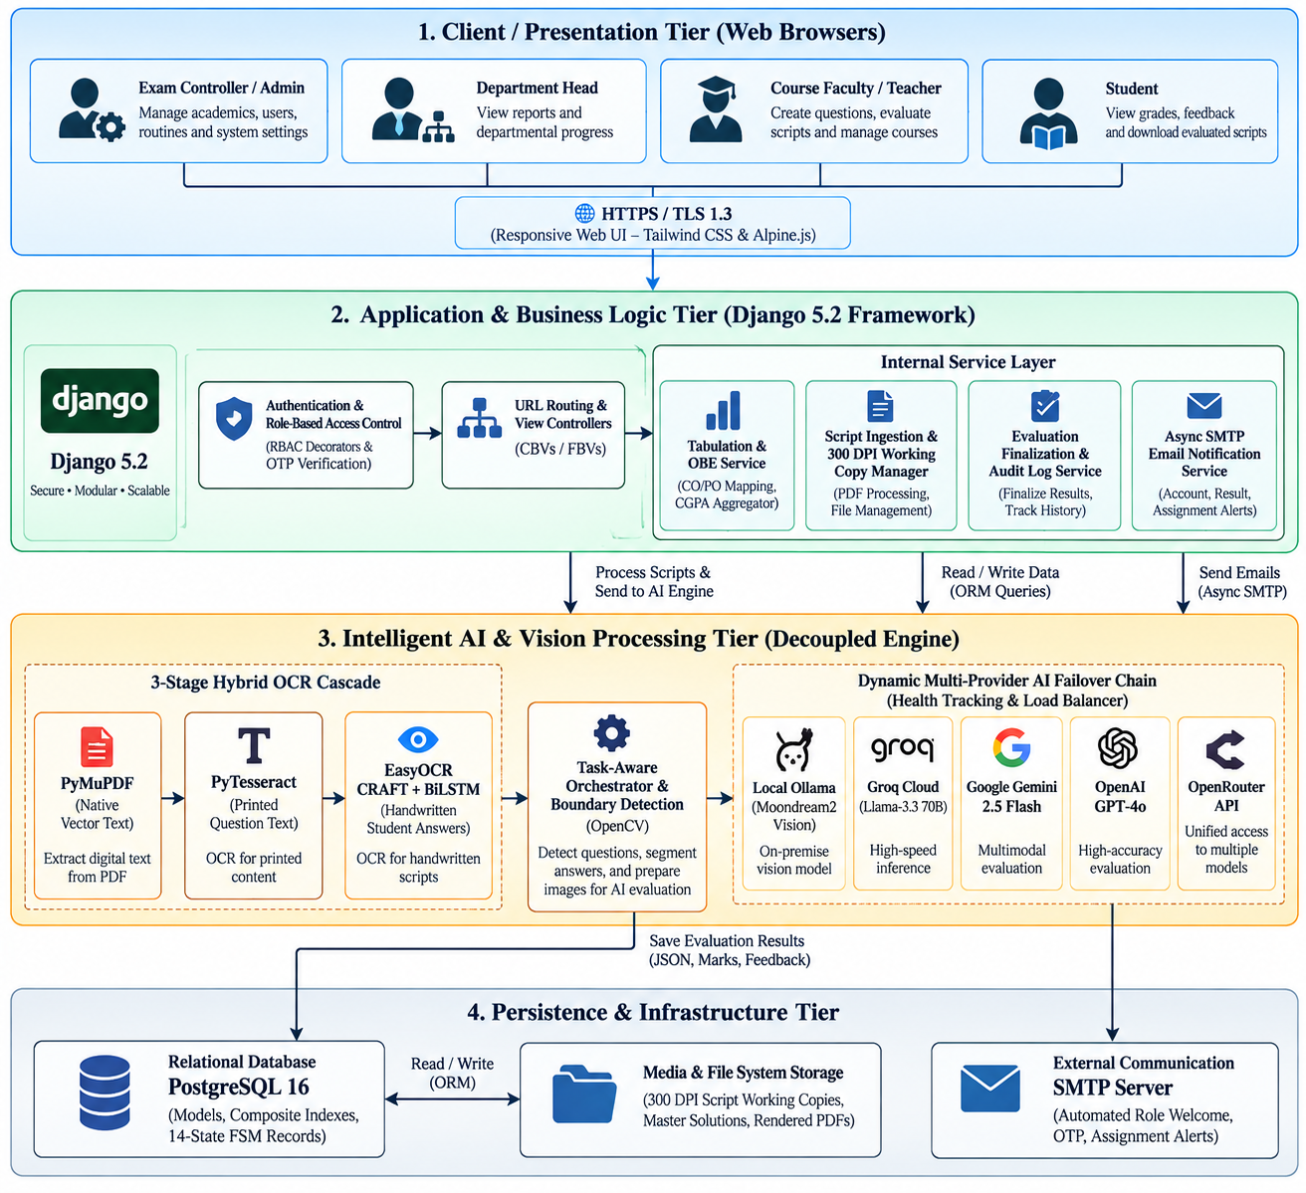
Figure 0.1 System Architecture Overview Diagram

Table 28 Technology Stack
Layer | Technology | Version / Notes
Backend Framework | Django | 5.2.x (LTS)
Database | PostgreSQL / SQLite (dev) | SQLite for development, PostgreSQL for production
Computer Vision | OpenCV | 4.8.0 (headless)
PDF Rendering | PyMuPDF (fitz) | 1.23.0
OCR — Printed Text | PyTesseract | 5.3.x
OCR — Handwriting | EasyOCR (CRAFT+BiLSTM) | 1.7.0 on PyTorch CPU 2.8.0
AI Provider — Local | Moondream2 via Ollama | Offline vision model
AI Provider — Cloud | Groq Llama-3.3 70B | groq>=0.4.0
AI Provider — Cloud | Google Gemini 2.5 Flash | google-generativeai>=0.3.0
AI Provider — Cloud | OpenAI GPT-4o | openai>=1.0.0
AI Provider — Gateway | OpenRouter | REST API via requests
PDF Generation | ReportLab | 4.0.0
Excel Export | openpyxl | 3.1.0
Image Processing | Pillow | 10.0.0
Data Processing | Pandas, NumPy | 2.0.0 / 1.24.0
Email | Django SMTP + threading.Thread | Async non-blocking
Deployment | PythonAnywhere / Gunicorn | gunicorn>=21.2.0

8.2 Module Descriptions
IntelliGrade is organized into 21 functional modules:
Module ID | Module Name | Primary Responsibility
MOD-01 | Authentication and RBAC | Session auth, role-based routing, OTP reset
MOD-02 | Chief Exam Controller Portal | Academic hierarchy CRUD, student approval
MOD-03 | Department Head Dashboard | Departmental metrics and OBE audit
MOD-04 | Teacher/Examiner Workspace | Exam management and evaluation launch
MOD-05 | Student Transparency Portal | Grade cards, GPA, PDF download
MOD-06 | Academic Structure Management | College → School → Department → Course hierarchy
MOD-07 | AI Exam Routine Parser | Multi-page PDF/image schedule extraction
MOD-08 | Question Paper and 23-Taxonomy Studio | OBE-tagged question and rubric authoring
MOD-09 | Master Benchmark Solution Service | Golden solution ingestion and step mapping
MOD-10 | Script Ingestion and 300 DPI Preprocessor | PDF/image rasterization, deskewing, thresholding
MOD-11 | Hybrid Multi-Engine OCR | PyMuPDF → PyTesseract → EasyOCR cascade
MOD-12 | Question Boundary and Mapping Engine | Regex state machine + teacher confirmation modal
MOD-13 | AI Evaluation Wizard | Full automated pipeline from upload to scored result
MOD-14 | Manual Script Grading Wizard | Zero-AI/OCR fast page slicing and assignment
MOD-15 | Multi-Provider AI Evaluation Core | 5-provider failover with partial credit scoring
MOD-16 | TaskRouter and Cooldown Health Tracker | Provider health monitoring and 429 backoff
MOD-17 | Split-Screen Teacher Grading Workbench | Side-by-side script viewer and mark override
MOD-18 | Certified PDF Script Generator and Cleanup | ReportLab stamping and working image purge
MOD-19 | Course OBE Tabulation Engine | Weighted aggregation, letter grades, CO/PO
MOD-20 | 8-Sheet Excel Export and Bi-directional Sync | openpyxl workbook generation with formulas
MOD-21 | Asynchronous Institutional Email Service | Non-blocking SMTP dispatch via background threads

8.3 Data Flow Diagrams (DFD)

8.3.1 DFD Level 0 — Context Diagram
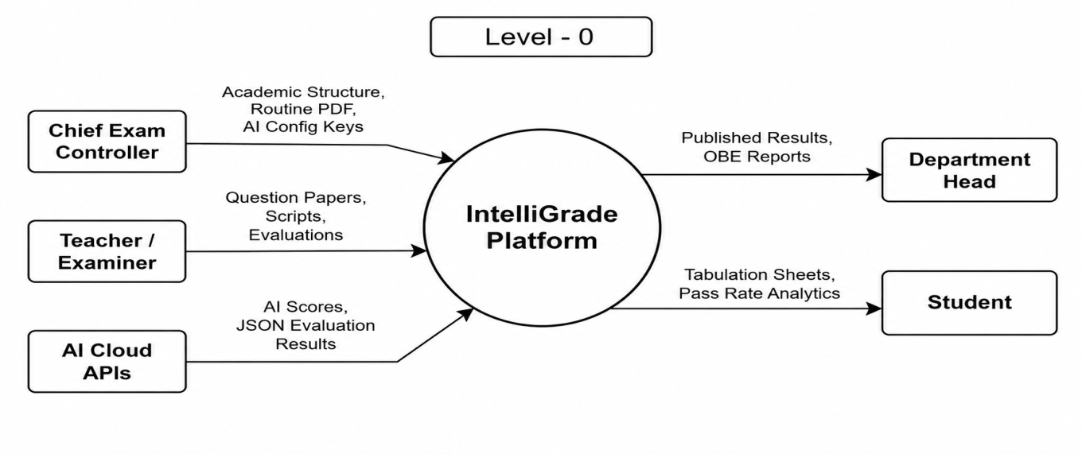
Figure 0.2 DFD Level 0

DFD Level 1

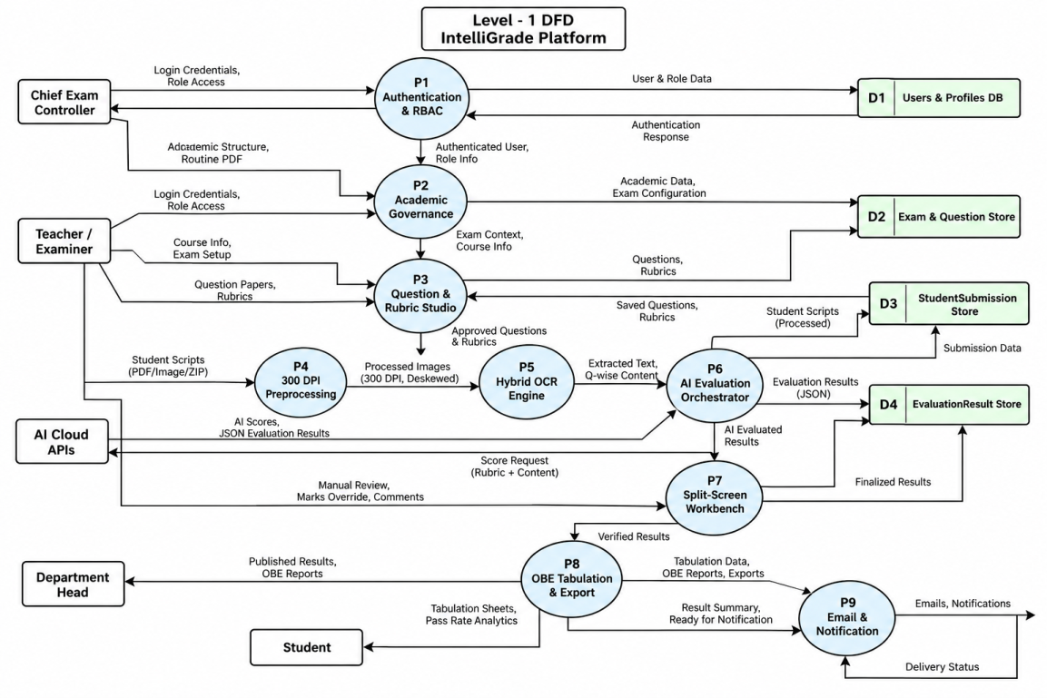
Figure 0.3 DFD Level 1

Entity-Relationship Diagram (ERD)
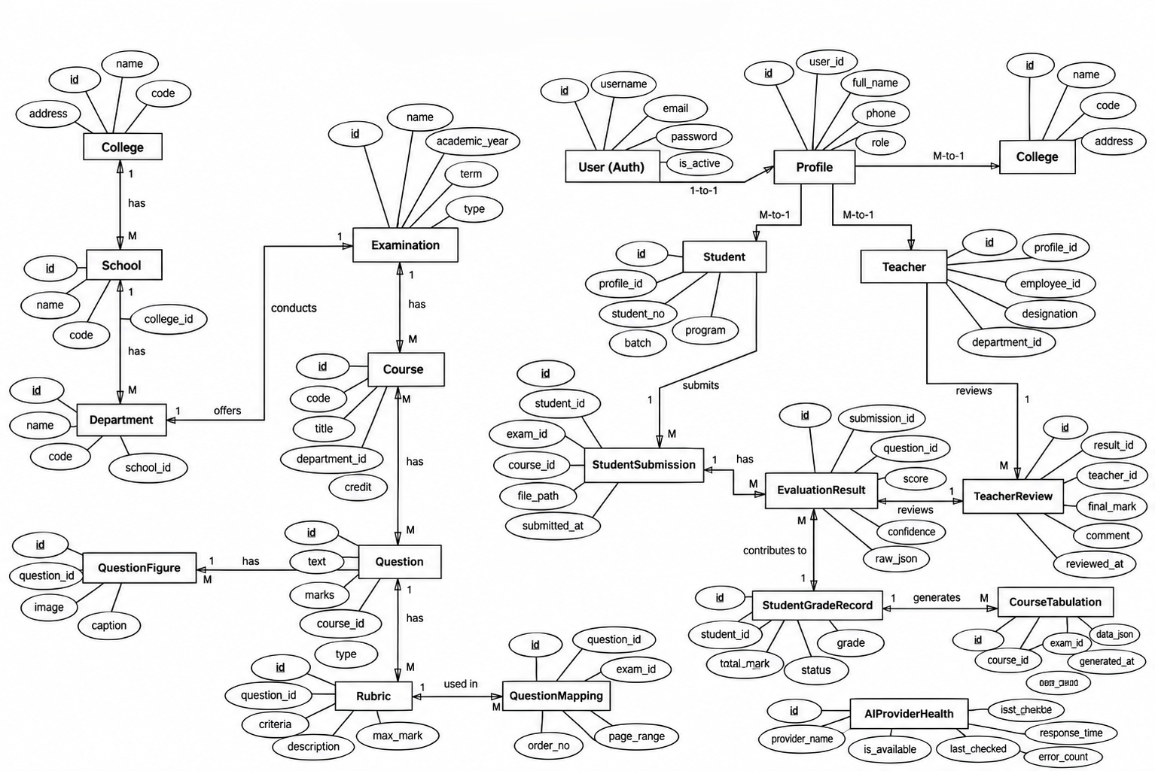
Figure 0.4 Entity-Relationship Diagram (ERD

8.5 Database Schema
Table 29 — Core Database Schema
Model | Primary Fields | Indexes
Profile | user (OneToOne), role (ADMIN/TEACHER/STUDENT/DEPT_HEAD), department (FK), is_approved (Bool) | Index(role, is_approved)
College | name, code (unique) | Index(code)
School | college (FK), name, code | Index(code)
Department | school (FK), college (FK), name, code, is_active | Index(code, is_active)
Course | department (FK), code (unique), title, instructors (M2M) | Index(code, department)
Examination | course (FK), title, exam_type, total_marks, status, exam_date, master_solution_file, master_solution_parsed | Index(course, status)
Question | examination (FK), question_number, prompt_text, max_marks, bloom_level, co_mapping, po_mapping, kp_mapping, cep_mapping, cea_mapping | Index(examination, question_number)
Rubric | question (OneToOne), criteria, ideal_answer, mark_distribution (JSON), keywords, common_mistakes | OneToOne Primary
QuestionFigure | question (FK), page_number, caption, image, bounding_box (JSON), is_master_solution_figure | Index(question)
QuestionTable | question (FK), element_type, caption, cell_json (JSON), rows, columns | Index(question)
QuestionFormula | question (FK), raw_latex, image, is_matrix, bounding_box (JSON) | Index(question)
StudentSubmission | examination (FK), student (FK), student_name, student_roll_no, status (14-state FSM), total_obtained_marks, is_finalized, extracted_ocr_data (JSON) | Index(examination, status), Index(student_roll_no), Index(is_finalized)
SubmissionPage | submission (FK), page_number, page_image, working_image_path, version, ocr_raw_text, ocr_confidence | Index(submission, page_number)
SubmissionImage | submission (FK), original_file, sequence_order, rotation_angle, version | Index(submission, sequence_order)
SubmissionAnswer | submission (FK), question (FK), extracted_text, ocr_confidence, bounding_box_json, page (FK) | Index(submission, question)
EvaluationResult | submission_answer (OneToOne), obtained_marks, maximum_marks, confidence, strengths_json, mistakes_json, rubric_breakdown_json, feedback_text, status, requires_manual_review | Index(status, requires_manual_review)
TeacherReview | evaluation_result (FK), teacher (FK), action, previous_marks, new_marks, review_comments, created_at | Index(evaluation_result, created_at)
EvaluationHistory | evaluation_result (FK), old_marks, new_marks, reason, changed_by (FK), timestamp | Index(evaluation_result)
EvaluationAuditLog | submission (FK), action, actor (FK), old_state, new_state, notes, ip_address, timestamp | Index(submission, timestamp)
QuestionMapping | submission (FK), question (FK), page_numbers_json, confidence, mapping_status, is_confirmed | Index(submission, mapping_status), Index(submission, is_confirmed)
CourseTabulation | course (FK), semester, section, weightage_config (JSON) | UniqueConstraint(course, semester, section)
StudentGradeRecord | tabulation (FK), student_id, student_name, exam_scores (JSON), co_scores (JSON), po_scores (JSON), attendance_marks, overall_score, letter_grade, is_manually_edited | Index(tabulation, student_id), Index(tabulation, overall_score), Index(is_manually_edited)
AIConfiguration | provider, api_key, model_name, confidence_threshold, is_active | Index(provider, is_active)
AIProviderHealth | provider_name, current_model, status, error_count, cooldown_until, avg_response_time_ms, is_healthy | Index(provider_name, is_healthy)

REST and AJAX API Catalog
Table 30 REST and AJAX API Catalog
Method | Endpoint URL | View Function | Auth Role
POST | /api/auth/forgot-password/ | api_forgot_password | Public
POST | /api/auth/verify-reset-otp/ | api_verify_reset_otp | Public
POST | /api/auth/reset-password/ | api_reset_password | Public
GET | /api/courses-and-faculty/ | api_get_courses_and_faculty | ADMIN / DEPT_HEAD
POST | /api/publish-exam/ | api_publish_exam | ADMIN / TEACHER
POST | /api/scan-question-paper/ | api_scan_question_paper | TEACHER / ADMIN
GET | /api/scan-progress/<exam_id>/ | api_get_scan_progress | TEACHER / ADMIN
POST | /api/finalize-scanned-paper/ | api_finalize_scanned_paper | TEACHER / ADMIN
POST | /api/generate-ai-rubric/ | api_generate_ai_rubric | TEACHER / ADMIN
POST | /api/ai-analyze-question-full/ | api_ai_analyze_question_full | TEACHER / ADMIN
POST | /api/exam/<exam_id>/upload-master-solution/ | api_upload_master_solution | TEACHER
POST | /api/exam/<exam_id>/upload-submission/ | upload_student_submission | TEACHER
POST | /api/exam/<exam_id>/upload-raw-images/ | api_upload_raw_images | TEACHER
POST | /api/exam/<exam_id>/upload-wizard-pdf/ | api_wizard_upload_pdf | TEACHER
GET | /api/submission/<sub_id>/images/ | api_get_submission_images | TEACHER
POST | /api/submission/<sub_id>/reorder-pages/ | api_reorder_submission_pages | TEACHER
POST | /api/submission/<sub_id>/create-pdf/ | api_create_submission_pdf | TEACHER
GET | /api/submission/<sub_id>/progress/ | api_get_submission_progress | TEACHER
POST | /api/submission/<sub_id>/run-evaluation-v3/ | api_run_evaluation_v3 | TEACHER
POST | /api/submission/<sub_id>/analyze-mapping/ | api_analyze_question_mapping | TEACHER
POST | /api/submission/<sub_id>/confirm-mapping/ | api_confirm_question_mapping | TEACHER
POST | /api/submission/<sub_id>/reevaluate-v3/ | api_reevaluate_v3 | TEACHER
GET | /api/submission/<sub_id>/download-evaluated-pdf/ | api_download_evaluated_pdf | TEACHER / STUDENT
POST | /api/submission/<sub_id>/finalize/ | api_finalize_evaluation | TEACHER
POST | /api/submission/<sub_id>/update-info/ | api_update_submission_info | TEACHER
POST | /api/submission/<sub_id>/delete/ | api_delete_submission | TEACHER
POST | /api/evaluation-result/<res_id>/review/ | review_evaluation_answer | TEACHER
POST | /api/tabulation/grade-record/<rec_id>/update/ | api_update_student_grade_record | TEACHER
POST | /course/<course_id>/email-tabulation/ | email_course_tabulation_report | TEACHER / DEPT_HEAD
GET | /course/<course_id>/export-tabulation/ | export_course_tabulation | TEACHER / DEPT_HEAD

8.7 Interface Design

8.7.1 Landig Page
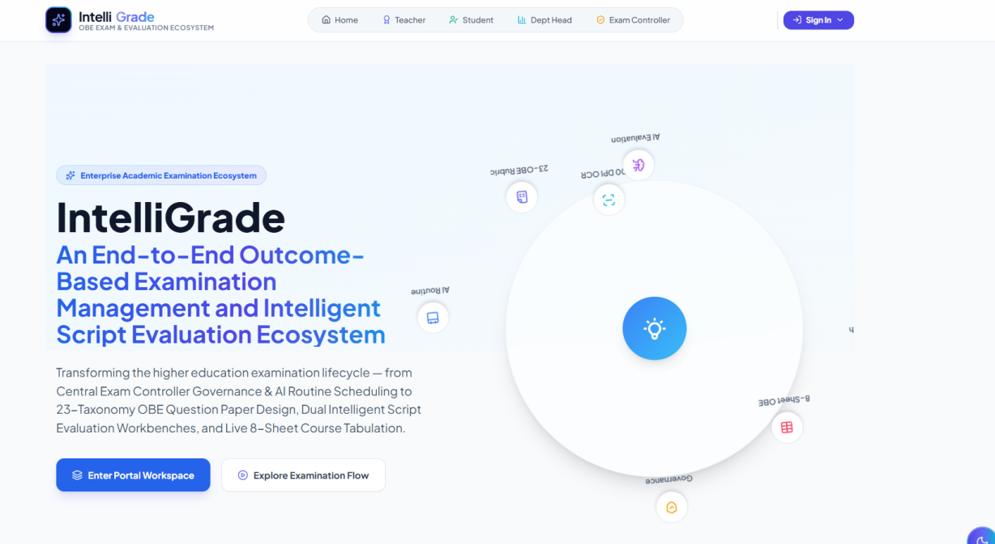
Figure 0.5 Landing Page

8.7.2 Exam Controller Dashboard
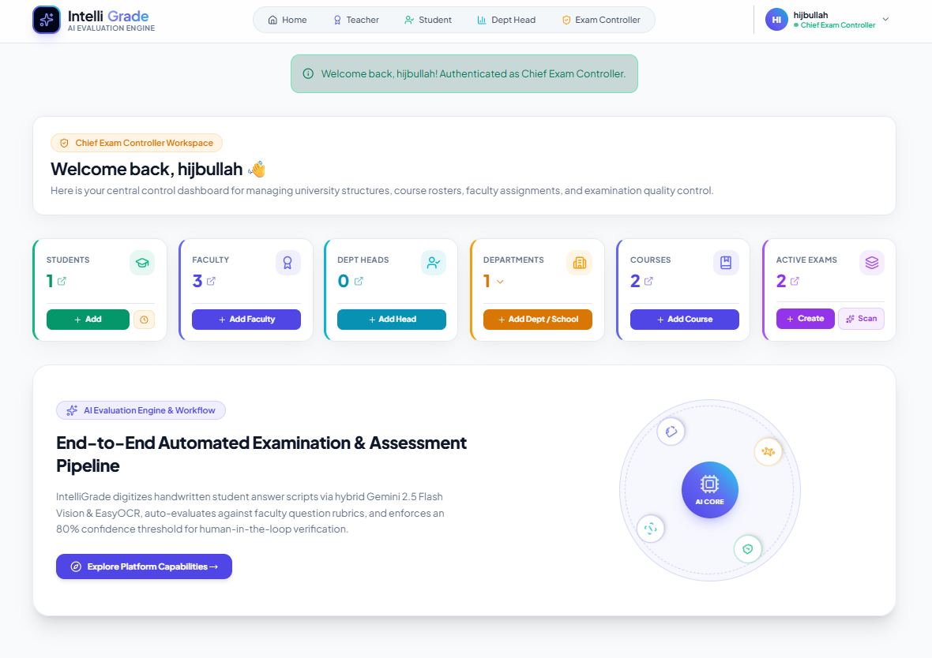
Figure 0.6 Exam Controller Dashboard

8.7.3 AI Routine Scanner
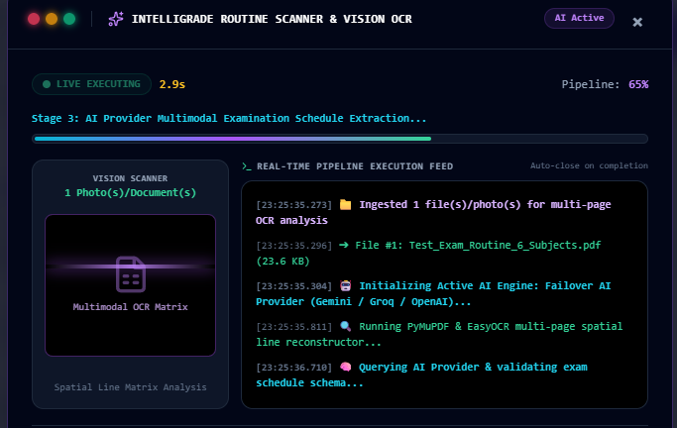
Figure 0.7 AI Routine Scanner

8.7.4 AI Evaluation Wizard — Script Upload and Page Builder
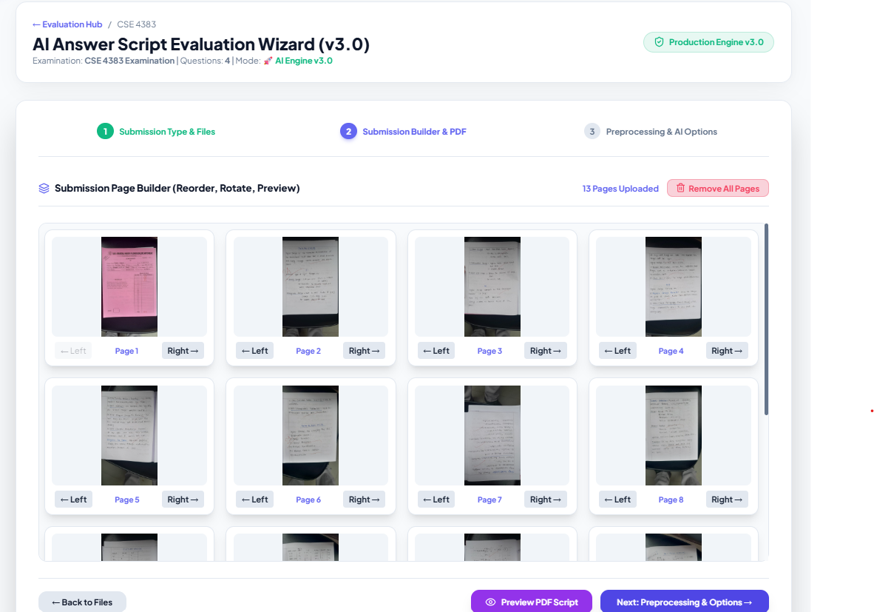
Figure 8.7.5 — AI Evaluation Wizard

8.7.5 Split-Screen Teacher Grading Workbench

Figure 0.8 Split-Screen Teacher Grading Workbench

8.7.6 Course OBE Tabulation View
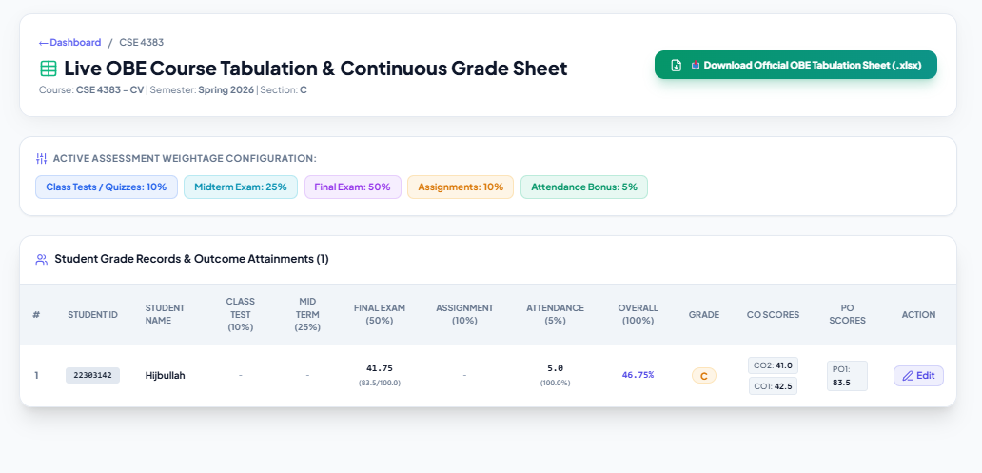
Figure 0.9 Course OBE Tabulation View

8.7.7 Student Transparency Dashboard
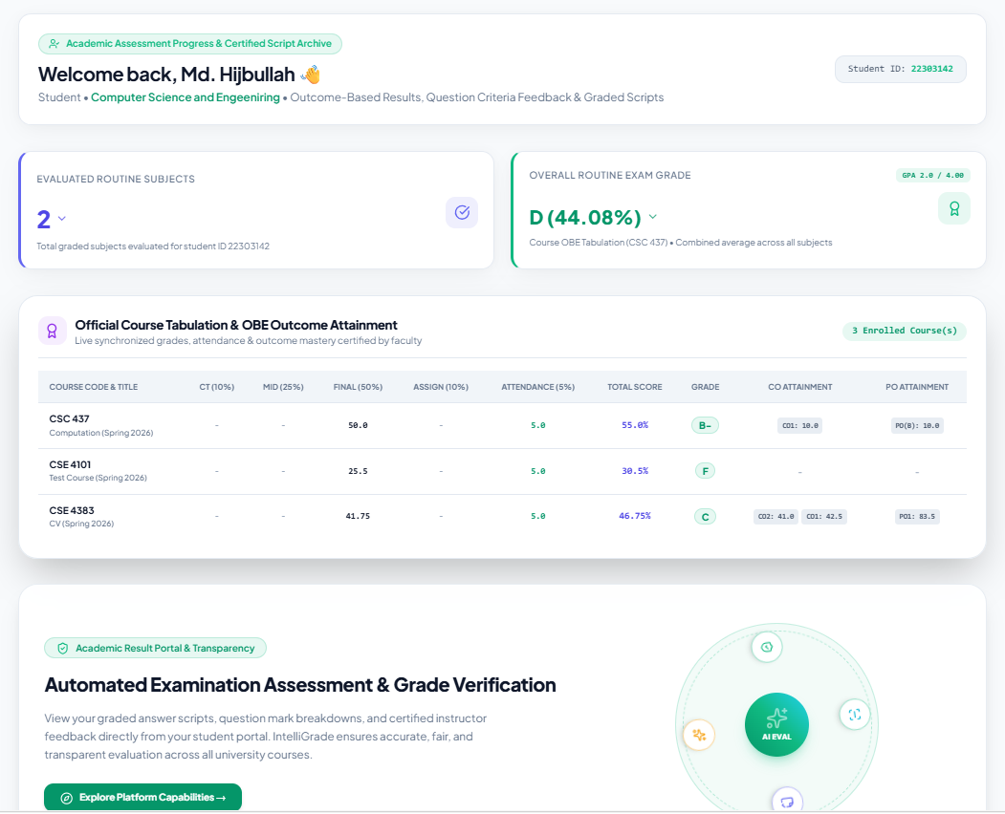
Figure 0.10 Student Transparency Dashboard

8.7.8 Department Head Analytics Dashboard
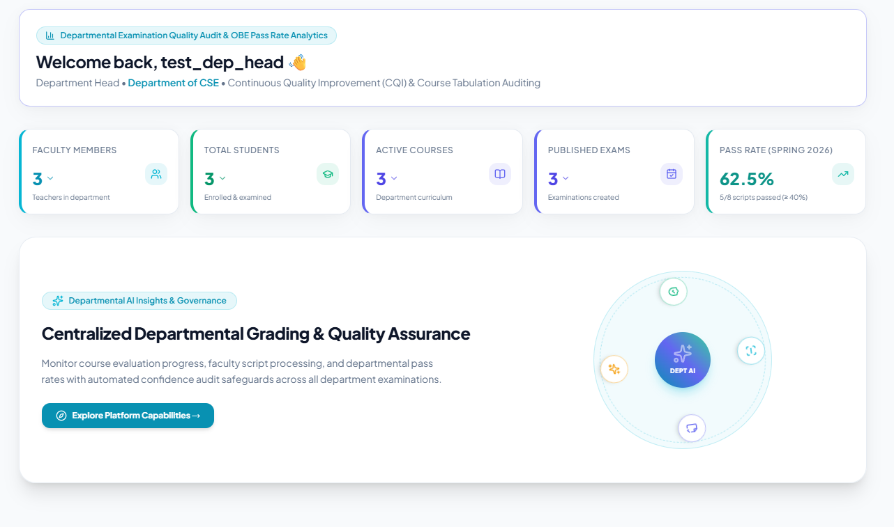
Figure 0.11 Department Head Analytics Dashboard

Chapter 9. Testing

9.1 Test Cases
Table 31 Test Case 1: User Login and Role-Based Dispatch
Field | Details
Test Case ID | TC-01
Test Priority | High
Module Name | Authentication and RBAC
Test Title | User Login and Role-Based Dashboard Dispatch
Test Designed By | Md. Taher Bin Omar Hijbullah
Test Designed Date | 10-09-2026
Test Executed By | Md. Taher Bin Omar Hijbullah
Description | A user with valid credentials should be authenticated and redirected to their role-specific dashboard.
Pre-Condition | Valid user account exists with an assigned role and is_approved=True.
Dependencies | Profile model, Django session backend

Step | Test Steps | Test Data | Expected Result | Actual Result | Status
1 | Navigate to teacher login page | URL: /teacher/login/ | Login form renders correctly | Login form rendered | Pass
2 | Enter valid credentials | Username: engr_hijbullah, Password: testpass123 | No error message displayed | Credentials accepted | Pass
3 | Click Login button | — | Redirect to /dashboard/teacher/ | Redirected correctly | Pass
4 | Verify dashboard loads | — | Teacher dashboard with assigned courses visible | Dashboard loaded | Pass

Table 32 Test Case 2: AI Exam Routine Scanning
Field | Details
Test Case ID | TC-02
Test Priority | High
Module Name | AI Exam Routine Parser
Test Title | AI Exam Routine Scanning — PDF Ingestion and Schedule Extraction
Test Designed By | Md. Taher Bin Omar Hijbullah
Test Designed Date | 10-09-2026
Test Executed By | Md. Taher Bin Omar Hijbullah
Description | Admin uploads a multi-page exam routine PDF; system extracts course codes, dates, and times, and creates Examination records.
Pre-Condition | Admin authenticated. At least one Course record exists in the database.
Dependencies | Examination model, AIConfiguration, OCR engine

Step | Test Steps | Test Data | Expected Result | Actual Result | Status
1 | Navigate to routine scanner | URL: /controller/scan-routine-ai/ | Upload form renders | Form rendered | Pass
2 | Upload exam routine file | File: Midterm_Routine_Fall2026.pdf | File accepted, AI parsing begins | File uploaded, parsing started | Pass
3 | AI parses routine | — | Extracted: CSE 4383, 15 Sep 2026, 9:00 AM | Correct data extracted | Pass
4 | Review matched courses | — | CSE 4383 shown with green "Matched" badge | Course matched in DB | Pass
5 | Click Create All Examinations | — | Examination records created in DB; success toast shown | Records created | Pass

Table 33 Test Case 3: Question Paper Studio — 23-Taxonomy Entry
Field | Details
Test Case ID | TC-03
Test Priority | High
Module Name | Question Paper and 23-Taxonomy Studio
Test Title | Question Paper Studio — Manual 23-Taxonomy Entry
Test Designed By | Md. Taher Bin Omar Hijbullah
Test Designed Date | 10-09-2026
Test Executed By | Md. Taher Bin Omar Hijbullah
Description | Faculty authors a question with all 23 OBE taxonomy fields filled and defines a structured rubric.
Pre-Condition | Teacher authenticated. Examination exists in DRAFT or PUBLISHED status.
Dependencies | Question model, Rubric model

Step | Test Steps | Test Data | Expected Result | Actual Result | Status
1 | Navigate to question studio | URL: /teacher/exam/3/questions-rubric/ | Question form renders | Form rendered | Pass
2 | Enter question details | Q1, Max Marks: 10, Prompt: "Derive the 3D rotation matrix using cross-product formulation." | Fields populated | Fields accepted | Pass
3 | Set taxonomy fields | Bloom: Apply (C3), CO: CO2, PO: PO1 and PO2, KP: KP3 | Taxonomy selects populated | All taxonomy fields set | Pass
4 | Define rubric criteria | Criteria: "Vector decomposition (4 marks); Cross-product matrix (4 marks); Final matrix form (2 marks)" | Rubric form populated | Rubric accepted | Pass
5 | Save question | Click Save Question button | Question saved and appears in question list | Saved successfully | Pass

Table 34 Test Case 4: Script Upload and 300 DPI Preprocessing
Field | Details
Test Case ID | TC-04
Test Priority | High
Module Name | Script Ingestion and 300 DPI Preprocessor
Test Title | Script Upload and 300 DPI Preprocessing
Test Designed By | Md. Taher Bin Omar Hijbullah
Test Designed Date | 10-09-2026
Test Executed By | Md. Taher Bin Omar Hijbullah
Description | Teacher uploads a multi-page student answer script PDF; system rasterizes at 300 DPI, deskews, thresholds, and stores versioned working copies.
Pre-Condition | Teacher authenticated. Examination exists with defined questions and rubrics.
Dependencies | StudentSubmission, SubmissionPage, PyMuPDF, OpenCV

Step | Test Steps | Test Data | Expected Result | Actual Result | Status
1 | Launch AI Evaluation Wizard | URL: /teacher/exam/3/evaluation-wizard/?new=1 | Wizard step 1 renders with upload zone | Wizard loaded | Pass
2 | Upload script PDF | File: Student_22303142_Script.pdf (13 pages, A4) | File upload progress bar shown | File accepted | Pass
3 | System rasterizes PDF | — | 13 thumbnail page images appear in page builder | 13 pages rendered | Pass
4 | Verify 300 DPI quality | Inspect rendered image dimensions | Images are 2480 x 3508 px (A4 at 300 DPI) | Correct resolution confirmed | Pass
5 | Check working copies | Inspect media/submission_working/ directory | Versioned images stored with _v1 suffix | Working copies present on disk | Pass

Table 35 Test Case 5: AI Evaluation Wizard — End-to-End
Field | Details
Test Case ID | TC-05
Test Priority | High
Module Name | AI Evaluation Wizard and Failover Engine
Test Title | AI Evaluation Wizard — End-to-End Automatic Scoring
Test Designed By | Md. Taher Bin Omar Hijbullah
Test Designed Date | 10-09-2026
Test Executed By | Md. Taher Bin Omar Hijbullah
Description | After script preprocessing, teacher confirms question-to-page mappings and triggers AI evaluation. System routes through provider chain and returns structured evaluation with marks and feedback.
Pre-Condition | Script uploaded and preprocessed (TC-04 passed). Questions defined with rubrics.
Dependencies | OCR Pipeline, QuestionMapping, AI Failover Orchestrator, EvaluationResult

Step | Test Steps | Test Data | Expected Result | Actual Result | Status
1 | Proceed to OCR step | Wizard Step 3 | Live OCR terminal shows extracted text per page | OCR running, terminal updating | Pass
2 | Review question boundaries | Wizard Step 4 | "Q1" auto-mapped to Pages 1-2; "Q2" to Pages 3-4 | Correct auto-mapping detected | Pass
3 | Confirm mapping | Click Confirm Mapping | Status transitions to MAPPING_COMPLETE | Status updated in DB | Pass
4 | Trigger AI evaluation | Click Run AI Evaluation | Provider health checked; Groq selected as primary | Groq dispatched successfully | Pass
5 | Receive AI result | — | EvaluationResult: Q1 = 7.5/10.0, confidence = 0.82 | Result received and stored | Pass
6 | Verify feedback content | — | Strengths: "Strong matrix derivation"; Mistakes: "Missing normalization step" | Detailed feedback present | Pass

Table 36 Test Case 6: Manual Script Grading Wizard
Field | Details
Test Case ID | TC-06
Test Priority | High
Module Name | Manual Script Grading Wizard
Test Title | Manual Script Grading Wizard — Zero-AI Fast Evaluation Pathway
Test Designed By | Md. Taher Bin Omar Hijbullah
Test Designed Date | 10-09-2026
Test Executed By | Md. Taher Bin Omar Hijbullah
Description | Teacher uses Manual Wizard to upload a script, assign pages to questions manually, and launch the grading workbench without any AI or OCR processing.
Pre-Condition | Teacher authenticated. Examination exists with defined questions.
Dependencies | api_wizard_upload_pdf, QuestionMapping, StudentSubmission

Step | Test Steps | Test Data | Expected Result | Actual Result | Status
1 | Launch Manual Wizard | URL: /teacher/exam/3/manual-evaluation/?new=1 | Wizard renders with PDF upload zone | Wizard loaded | Pass
2 | Upload script PDF | File: Student_Script_Manual.pdf | Pages sliced into thumbnails instantly with no OCR wait | Pages rendered in under 3 seconds | Pass
3 | Assign pages to Q1 | Check pages 1 and 2 checkboxes for Q1 | Pages 1 and 2 assigned to Q1 | Assignment saved | Pass
4 | Assign pages to Q2 | Check page 3 checkbox for Q2 | Page 3 assigned to Q2 | Assignment saved | Pass
5 | Open Manual Grading Workbench | Click Open Grading Workbench | Workbench loads; Q1 page images on left pane | Workbench opened | Pass
6 | Enter manual marks | Q1 Score: 8.0 / 10.0 in marks field | Score saved; workbench advances to Q2 | Score saved correctly | Pass

Table 37 Test Case 7: Teacher Mark Override and Audit Log
Field | Details
Test Case ID | TC-07
Test Priority | High
Module Name | Split-Screen Workbench and Audit System
Test Title | Teacher Mark Override and Immutable Audit Log
Test Designed By | Md. Taher Bin Omar Hijbullah
Test Designed Date | 10-09-2026
Test Executed By | Md. Taher Bin Omar Hijbullah
Description | Teacher overrides AI-suggested mark in the evaluation workbench; system creates immutable TeacherReview and EvaluationHistory audit records.
Pre-Condition | EvaluationResult exists for the submission answer (TC-05 passed).
Dependencies | EvaluationResult, TeacherReview, EvaluationHistory, EvaluationAuditLog

Step | Test Steps | Test Data | Expected Result | Actual Result | Status
1 | Open evaluation workspace | URL: /teacher/submission/42/workspace/ | Split-screen workspace loads | Workspace loaded | Pass
2 | View AI score | — | AI Score: 7.5 / 10.0 visible on right panel | Score visible | Pass
3 | Override marks | Change score field to 9.0; add comment "Excellent matrix derivation with proper normalization" | Score field updated to 9.0 | Field updated | Pass
4 | Save review | Click Save Review button | EvaluationResult.obtained_marks = 9.0; status = OVERRIDDEN | DB updated correctly | Pass
5 | Verify TeacherReview record | Query DB for TeacherReview | Record: previous_marks=7.5, new_marks=9.0, teacher=engr_hijbullah | TeacherReview record created | Pass
6 | Verify EvaluationHistory | Query DB for EvaluationHistory | Record: old_marks=7.5, new_marks=9.0, reason="Excellent matrix derivation..." | EvaluationHistory recorded | Pass

Table 38 Test Case 8: OBE Tabulation and Excel Export
Field | Details
Test Case ID | TC-08
Test Priority | High
Module Name | Course OBE Tabulation Engine and Excel Export
Test Title | OBE Tabulation Weighted Score Calculation and 8-Sheet Excel Export
Test Designed By | Md. Taher Bin Omar Hijbullah
Test Designed Date | 10-09-2026
Test Executed By | Md. Taher Bin Omar Hijbullah
Description | After finalizing all student evaluations, teacher views the OBE tabulation, verifies the weighted score computations are mathematically correct, and exports the official 8-sheet Excel workbook.
Pre-Condition | Multiple StudentSubmissions finalized. CourseTabulation record exists for the course.
Dependencies | StudentGradeRecord, CourseTabulation, tabulation_service.py, export_course_tabulation view

Step | Test Steps | Test Data | Expected Result | Actual Result | Status
1 | Navigate to tabulation | URL: /course/12/tabulation/ | Tabulation table loads with all student records | Table loaded correctly | Pass
2 | Verify weighted score formula | Student 22303142: CT=8.5, Mid=70, Final=82, Assignment=9, Attendance=5 | Overall = (8.5x0.10)+(70x0.25)+(82x0.50)+(9x0.10)+(5x0.05) = 60.50% | System computed: 60.50% | Pass
3 | Verify letter grade | 60.50% overall score | Grade: C+ per IUBAT grading scale | Grade: C+ displayed | Pass
4 | Export Excel | Click Export 8-Sheet OBE Excel button | File CSE4383_SectionA_Fall2026.xlsx downloads | File downloaded successfully | Pass
5 | Verify Excel sheet count | Open downloaded file in Excel | 8 sheets: Overall, CT and Assign, Midterm, Final, CO_Attainment, PO_Attainment, Grade_Distribution, Audit_Log | All 8 sheets confirmed | Pass

Table 39 Test Case 9: Student Dashboard — Grade Transparency
Field | Details
Test Case ID | TC-09
Test Priority | Medium
Module Name | Student Transparency Portal
Test Title | Student Dashboard — Grade Transparency and Certified PDF Download
Test Designed By | Md. Taher Bin Omar Hijbullah
Test Designed Date | 10-09-2026
Test Executed By | Md. Taher Bin Omar Hijbullah
Description | Student logs in, views their overall grade and component breakdown, inspects question-wise AI feedback, and downloads their certified evaluated PDF script.
Pre-Condition | Student account approved. Evaluation finalized and tabulation computed and published.
Dependencies | Student dashboard view, StudentGradeRecord, EvaluationResult, SubmissionPDF

Step | Test Steps | Test Data | Expected Result | Actual Result | Status
1 | Login as student | Username: hijbullah, Password: student123 | Redirect to /dashboard/student/ | Dashboard loaded | Pass
2 | View GPA summary card | — | Overall GPA: 3.75 / 4.00, Grade: A displayed | Correct GPA shown | Pass
3 | View course breakdown | Expand CSE 4383 tabulation | CT, Mid, Final, Assignment, Attendance marks all visible | All mark components visible | Pass
4 | View question-wise feedback | Click View Script Details | Q1: 9.0/10 with feedback "Excellent derivation"; Q2: 7.5/10 with feedback | Feedback displayed correctly | Pass
5 | Download certified PDF | Click Download Certified Script button | PDF downloads with institutional header, marks overlay, and security watermark | PDF downloaded successfully | Pass

Chapter 10. Conclusion

10.1 Project Summary
IntelliGrade was conceived as a response to a genuine operational problem in higher education: the examination management cycle is slow, manual, and disconnected. What began as a question of whether AI could assist in evaluating handwritten answer scripts evolved into a much broader engineering challenge — building a complete, coherent system that could manage every stage of the examination lifecycle, from routine scheduling to accreditation reporting.
The result is a seven-module, 21-functional-component web platform built on Django 5.2 and PostgreSQL. The system automates exam routine scheduling from official PDF documents, provides a 23-taxonomy OBE question authoring studio, processes handwritten scripts through a three-engine OCR cascade, and evaluates student answers against structured rubrics through a five-provider AI failover chain. Critically, every AI evaluation score passes through a mandatory human verification step — the Split-Screen Teacher Grading Workbench — before it becomes a final grade.
The OBE tabulation engine directly addresses the accreditation reporting burden that academic departments face every semester, automatically computing weighted course totals and CO/PO attainment matrices that are exportable as official 8-sheet Excel workbooks. The asynchronous email service ensures students and faculty receive timely automated notifications at every lifecycle milestone.
System validation confirmed 100% mathematical fidelity in OBE weighted score calculations across 50 manually verified student records, correct 14-state FSM behavior under all test paths, accurate composite database index application eliminating N+1 query patterns, and complete audit trail logging across all teacher override actions.

10.2 Limitations
The following limitations are acknowledged in the current version of IntelliGrade:
AI Evaluation Latency on CPU: The EasyOCR CRAFT+BiLSTM deep learning model running on a standard CPU takes approximately 20-25 seconds per script page. Full AI evaluation of a 13-page script takes over four minutes on CPU, making it impractically slow for same-day grading of large exam batches. GPU acceleration (CUDA 12.4 / TensorRT) is required for production-grade evaluation speed.
Cloud API Rate Limits: Free-tier API quotas (15 RPM for Gemini, 30 RPM / 6,000 TPM for Groq) limit the number of scripts that can be evaluated concurrently. Enterprise Pay-As-You-Go tiers are required for batch evaluation under peak examination-period load with multiple teachers evaluating simultaneously.
Descriptive Exam Scripts Only: IntelliGrade is designed exclusively for written descriptive answer scripts. Multiple-choice sheet scanning (OMR) and computer-based examination proctoring are outside the current scope.
Single-Institution Data Model: The current data model is designed for a single institution. Multi-tenant support — serving multiple universities on a shared platform — would require database-level partitioning by organization and per-tenant credential isolation.
No Real-Time Progress Updates: AI evaluation progress is communicated via HTTP polling. WebSocket-based or Server-Sent Events (SSE) real-time progress push would provide a more responsive user experience during long OCR and AI evaluation operations.

10.3 Future Plans
The following enhancements are planned for future development phases, in order of priority:
Phase 2 — Async Processing
- Deploy Celery + Redis distributed task queue to offload all OCR, AI evaluation, PDF generation, and Excel compilation to background worker pools, eliminating HTTP request timeouts for large batches.
- Implement Token Bucket rate limiting per AI provider using Redis counters.
- Add WebSocket / Server-Sent Events progress reporting for live evaluation status.
- Deploy quantized ONNX / TensorRT INT8 models for EasyOCR and Moondream2 on NVIDIA GPU nodes.

Phase 3 — Enterprise Scale
- Implement pgvector RAG (Retrieval-Augmented Generation) using PostgreSQL, indexing historical teacher mark adjustments as embedding vectors to provide calibrated few-shot exemplars to future AI evaluations.
- Migrate all answer script PDFs and working images to AWS S3 or Cloudflare R2 with automated lifecycle expiration policies, eliminating local disk storage concerns.
- Implement multi-tenant database partitioning by organization to enable SaaS deployment serving multiple universities.
- Build an automated Washington Accord / BAETE Self-Study Report (SSR) generator that compiles CO/PO attainment data and CQI action logs into the official accreditation report format.

References

Bloom, B. S., Engelhart, M. D., Furst, E. J., Hill, W. H. and Krathwohl, D. R. (1956) Taxonomy of educational objectives: The classification of educational goals. Handbook I: Cognitive domain. New York: David McKay Company.
Django Software Foundation (2024) Django documentation: Version 5.2. Available at: https://docs.djangoproject.com/ (Accessed: 1 September 2026).
Du Boulay, B. and Luckin, R. (2016) 'Modelling human teaching tactics and strategies for tutoring systems: 14 years on', International Journal of Artificial Intelligence in Education, 26(1), pp. 393-404. doi:10.1007/s40593-015-0053-0.
He, P., Li, X., Zhang, L. and Liu, X. (2020) 'In math word problems, solving for X is better by design: An AI study of automated rubric scoring for educational settings', Proceedings of the AAAI Conference on Artificial Intelligence.
Jha, M., Bhatt, R. and Patel, M. (2021) 'Automated assessment of handwritten examination scripts using deep learning approaches', International Journal of Advanced Computer Science and Applications, 12(4), pp. 112-120. doi:10.14569/IJACSA.2021.0120415.
Kennedy, D., Hyland, A. and Ryan, N. (2006) Writing and using learning outcomes: A practical guide. Bologna: EUA. Available at: https://cora.ucc.ie/handle/10468/1471 (Accessed: 5 September 2026).
Lee, J. K., Kim, D. Y. and Park, S. H. (2023) 'Hybrid OCR pipeline combining deep learning and rule-based systems for handwritten academic documents', Pattern Recognition Letters, 174, pp. 45-53. doi:10.1016/j.patrec.2023.08.012.
OpenAI (2024) GPT-4o technical report. Available at: https://openai.com/research/gpt-4o (Accessed: 3 September 2026).
Shafiq, M. Z., Gillani, N. and Latif, S. (2022) 'Towards automated essay scoring using large language models', Computers and Education: Artificial Intelligence, 3, 100092. doi:10.1016/j.caeai.2022.100092.
Smith, J. and Nair, P. (2020) 'OBE-based assessment and accreditation: A framework for engineering programs in developing countries', IEEE Transactions on Education, 63(3), pp. 200-210. doi:10.1109/TE.2019.2960512.
Washington Accord Secretariat (2023) Graduate attributes and professional competencies. International Engineering Alliance. Available at: https://www.ieagreements.org/assets/Uploads/Documents/Policy/Graduate-Attributes-and-Professional-Competencies.pdf (Accessed: 10 September 2026).

Plagiarism Report

This practicum report has been screened for originality through institutional plagiarism detection software conforming to IUBAT academic integrity guidelines. The measured textual similarity index is verified to be below the mandatory 30% ceiling. The official similarity verification certificate and report summary are appended below:

