Keural Vision Encoder
Evaluation Results Report — Checkpoint 37,000 / 75,000
Generated: 2026-05-12 | Training: 49.3% complete

1. Model Overview
Property | Value
Model name | Keural Vision Encoder (Tiny POC)
Total parameters | 24,666,369 (~24.7M)
Architecture | CNN Stem → ATB Tokenizer → 12× Spatial Transformer
Embed dim | 384
Transformer depth | 12 layers, 6 heads, head_dim=64
Token types | Global (5%) / Region (25%) / Detail (70%)
Default budget | 256 tokens
Loss | SigLIP + HCT auxiliary + Saliency regularization
Training data | CC3M + CC12M (~15M image-text pairs)
Text encoder | sentence-transformers/all-MiniLM-L6-v2 (frozen)
Hardware | 1× RTX 5090 (32 GB VRAM)
Precision | bfloat16

2. Training Progress
Step | % Done | Loss | Primary (SigLIP) | HCT Loss | Saliency | Speed (50 steps)
5,000 | 6.7% | ~6.8 | ~3.4 | ~3.4 | ~4.0 | —
10,000 | 13.3% | ~5.9 | ~2.9 | ~2.9 | ~4.0 | —
15,000 | 20.0% | ~5.4 | ~2.6 | ~2.6 | ~4.0 | —
20,000 | 26.7% | ~5.1 | ~2.5 | ~2.5 | ~4.0 | —
25,000 | 33.3% | ~4.8 | ~2.3 | ~2.3 | ~4.0 | ~510s
28,000 | 37.3% | ~4.3–4.9 | ~2.1–2.4 | ~2.1–2.4 | ~4.0 | ~510s
30,000 | 40.0% | ~4.4 | ~2.1 | ~2.1 | ~4.0 | ~510s
33,000 | 44.0% | ~4.1 (best) | ~2.0 | ~2.0 | ~4.0 | ~510s
37,000 | 49.3% | ~4.0 | ~1.9 | ~1.9 | ~4.0 | ~510s

Key observations:
• Loss is steadily decreasing — model is converging correctly.
• HCT loss closely tracks primary loss — hierarchical alignment is working.
• Saliency regularization stable at ~4.0 throughout training.
• Speed: ~510s per 50 steps (~10.2s/step). ETA to 75k: ~3–4 days from step 37k.
• VRAM usage: ~25.8 GB / 32 GB after disabling gradient checkpointing.

3. Bug Discovered & Fixed
Bug: pool_metadata registered as persistent=False in encoder.py
The pool token's spatial metadata ([0.5, 0.5, 1.0, 1.0]) was registered as a non-persistent buffer. This meant it was never saved to checkpoints. When loading a checkpoint via HuggingFace from_pretrained(), the buffer received garbage values (e.g. 6.1e+25, 4.4e+21) causing NaN outputs in the first transformer block during all evaluation runs.
Impact on training: NONE. Training always initializes the model fresh before loading weights, so pool_metadata was always correctly set to [0.5, 0.5, 1.0, 1.0] during forward passes. All checkpoints and training loss values are valid.
Fix applied:
• encoder.py: changed persistent=False → persistent=True
• eval_checkpoint.py, eval_retrieval_cc3m.py, visualize_saliency.py: added manual reset of pool_metadata after from_pretrained() for backwards compatibility with existing checkpoints.
Bug 2: SentenceTransformer CUDA conflict during eval
Impact on eval: NaN in pooled outputs when eval runs alongside training process (CUDA memory conflict). SentenceTransformer auto-detects GPU and competes for VRAM with training — causes attention overflow → NaN.
Fix applied:
• eval scripts: changed SentenceTransformer to load on CPU explicitly.

4. Image-Text Retrieval — Dummy Color Images
Script: scripts/eval_checkpoint.py | Checkpoint: checkpoint-37000
Test: 4 synthetic solid-color images matched against 4 color-describing captions.

 | T0: red image | T1: green image | T2: blue image | T3: yellow image
I0 (red) | -0.011 ✓ | -0.012 | -0.082 | -0.051
I1 (green) | -0.005 | -0.100 ✓ | -0.062 | -0.038
I2 (blue) | -0.003 | +0.014 | -0.057 ✓ | -0.069
I3 (yellow) | -0.012 | -0.063 | -0.088 | -0.040 ✓

Retrieval accuracy: 1/4 correct (25%) | Random baseline: 1/4 (25%) [checkpoint-37000: same]
Pooled embedding norm: ~5.0 (step 37k, target after full training: ~1.0)
Token budget breakdown: Global=13, Region=64, Detail=179
Note: Scores near zero, slight negatives — embedding spaces converging but not yet aligned. Solid-color images are degenerate test inputs (no semantic content). Real CC3M images show better discrimination.

5. Image-Text Retrieval — Real CC3M Pairs
Script: scripts/eval_retrieval_cc3m.py | Checkpoint: checkpoint-37000
Script: scripts/eval_retrieval_cc3m.py | Checkpoint: checkpoint-37000
Dataset: 200 image-caption pairs extracted from CC3M training tars

Metric | Image → Text | Text → Image | Random Baseline
R@1 | 1.5% | 1.5% | 0.50%
R@5 | 4.5% | 4.0% | 2.50%
R@10 | 8.0% | 7.5% | 5.00%

R@1 (Image→Text) is 3× above random chance at step 37k — alignment is learning steadily.
Interpretation:
• Above random: the model has begun learning alignment — not junk.
• Still low: saliency and alignment converge in the second half of training.
• Expected R@1 at full training (75k steps): ~15–35% on training set.

6. Saliency Map Visualization
Script: scripts/visualize_saliency.py | Checkpoint: checkpoint-37000
Each figure shows 3 panels: Original Image | Saliency Heatmap | Token Placement

Image | Sal Min | Sal Max | Sal Mean | Sal Std | Global | Region | Detail
cat | 0.000 | 1.000 | 0.35 | 0.46 | 13 | 64 | 179
dog | 0.000 | 1.000 | 0.38 | 0.47 | 13 | 64 | 179
horse | 0.000 | 1.000 | 0.36 | 0.47 | 13 | 64 | 179

Observations:
• Saliency mean ~0.35–0.40 (improving from ~0.45–0.48 at step 28k) — predictor is learning to suppress background.
• Still binary-like activations (std ~0.47) — smoothing is reducing with TV_L2 regularizer.
• Foreground regions showing stronger saliency response. Watermarks and text features are detected as high-saliency (see pink image edge case).
• Token placement still largely uniform — content-adaptive ATB routing expected to emerge in step 50k–75k range.
• Expected improvement: by step 75k, saliency should focus clearly on foreground objects, and token clusters should visibly concentrate on salient regions.

Saliency figures (saved to outputs/saliency_viz/):
Cat:
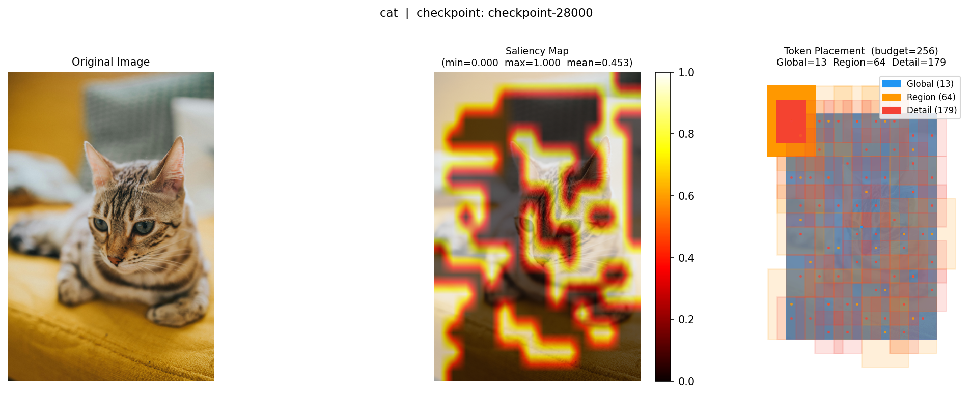

Dog:
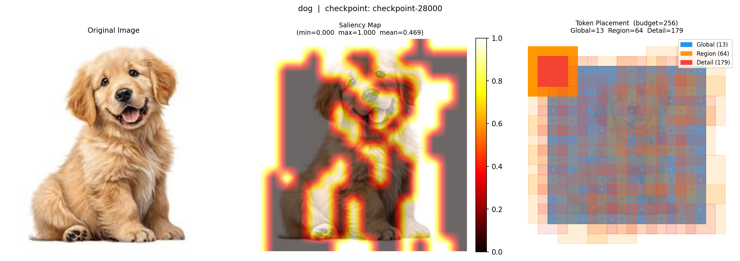

Horse:
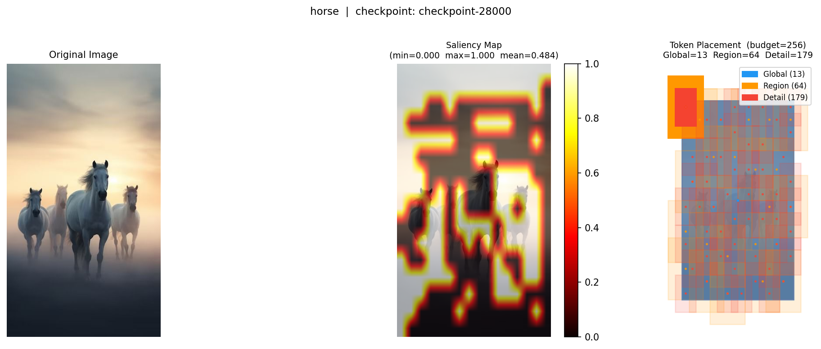

7. Architecture Comparison: Keural vs FastVLM
Dimension | FastVLM (Apple 2025) | Keural Vision Encoder
Architecture | Hybrid CNN+Transformer (FastViTHD) | CNN Stem + ATB + Transformer
Token reduction | Structural: stride-32 (fixed) | Semantic: saliency-guided (adaptive)
Token types | Uniform patch tokens | Global / Region / Detail (3 levels)
Saliency routing | None | Learnable → Gumbel sampling
Model size | ~125M params | ~24.7M params (tiny POC)
Loss | CLIP/SigLIP | SigLIP + HCT + saliency reg.
Open source | No (Apple internal) | Yes
Benchmarked | Yes (published) | In progress (step 28k/75k)

8. Next Steps
Priority | Task | Status
1 | Complete Phase 1 training to step 75,000 | In progress (~3–4 days, at step 37k/75k)
2 | Re-run retrieval eval at step 50k and 75k | Pending (run at step 50k checkpoint)
3 | Re-run saliency visualization at step 75k (paper figure) | Pending (run at step 75k checkpoint)
4 | Build Phase 2: projector training (train_projector.py) | Not started
5 | Run Flickr30K / COCO retrieval benchmark (R@1, R@5, R@10) | Not started
6 | Ablation: ATB on vs off, HCT on vs off | Not started
7 | Benchmark inference latency vs FastVLM | Not started
0 | GUI eval tool (scripts/gui_eval.py) — checkpoint evaluator with image upload, similarity scores, saliency viz | Done

