Deep Learning with Differential Privacy
HW2 Experiment Report

1. Introduction
This report presents the implementation and experimental results of Differentially Private Stochastic Gradient Descent (DP-SGD) applied to deep learning, based on the method proposed by Abadi et al. (2016). The experiment trains a Convolutional Neural Network (CNN) on the MNIST handwritten digit dataset under various privacy budgets (epsilon values) to observe the trade-off between privacy protection and model accuracy.

2. Method: DP-SGD
Differential Privacy (DP) provides a mathematically rigorous framework for quantifying privacy guarantees. A randomized mechanism M satisfies (epsilon, delta)-differential privacy if for any two adjacent datasets D and D' (differing by one record), and for any set of outputs S:
Pr[M(D) in S] <= exp(epsilon) * Pr[M(D') in S] + delta
DP-SGD modifies the standard SGD optimizer with three key changes:
Per-sample gradient clipping: Each training sample's gradient g_i is clipped to a maximum L2 norm C: g_i_clipped = g_i * min(1, C / ||g_i||). This bounds the sensitivity of any single training example on the model update.
Gaussian noise addition: Calibrated Gaussian noise N(0, sigma^2 * C^2 * I) is added to the aggregated (average) gradient before updating model parameters. The noise multiplier sigma is calibrated to achieve the target (epsilon, delta)-DP.
Privacy accounting (RDP): The Renyi Differential Privacy (RDP) accountant tracks the cumulative privacy cost across all training steps. Each mini-batch step consumes a portion of the privacy budget; the accountant converts the total RDP guarantee to (epsilon, delta)-DP.

3. Experimental Setup

3.1 Dataset
MNIST handwritten digit dataset: 60,000 training images and 10,000 test images of 28x28 grayscale digits (0-9). Images are normalized with mean=0.1307 and std=0.3081.

3.2 Model Architecture
A convolutional neural network (CNN) following the architecture in the original paper:
- Conv2d(1, 16, 8x8, stride=2, padding=2) + ReLU + MaxPool(2x2, stride=1)
- Conv2d(16, 32, 4x4, stride=2, padding=0) + ReLU + MaxPool(2x2, stride=1)
- Flatten + Linear(512, 10)

3.3 Training Configuration
Parameter | Value
Learning Rate | 0.1
Batch Size (L) | 256
Epochs | 5
Max Gradient Norm (C) | 1.0
Delta | 1e-05
Optimizer | SGD

3.4 Privacy Settings
The experiments are conducted with epsilon values: 1.0, 2.0, 4.0, and 8.0, with delta = 1e-05. A baseline model is also trained without any differential privacy for comparison.

3.5 Implementation
The implementation uses PyTorch with the Opacus library (by Meta/Facebook), which provides automatic per-sample gradient computation, gradient clipping, noise injection, and RDP-based privacy accounting. The code is provided in dp_sgd_mnist.py with detailed comments.

4. How the Data is Perturbed
In DP-SGD, the data itself is NOT directly perturbed. Instead, privacy is achieved by perturbing the gradients during the training process:
Step 1 - Compute per-sample gradients: For each sample x_i in a mini-batch, compute the individual gradient g_i = gradient of L(theta, x_i) with respect to theta.
Step 2 - Clip gradients: Clip each per-sample gradient to have a maximum L2 norm of C: g_i_bar = g_i / max(1, ||g_i|| / C). This ensures that no single sample can have an outsized influence on the model update.
Step 3 - Aggregate and add noise: Average the clipped gradients and add calibrated Gaussian noise: g_tilde = (1/L) * (sum(g_i_bar) + N(0, sigma^2 * C^2 * I)), where L is the batch size and sigma is the noise multiplier.
Step 4 - Update parameters: Update model weights using the noisy gradient: theta = theta - eta * g_tilde.

Target Epsilon | Noise Multiplier (sigma) | Effect
1.0 | 0.9082 | Strong privacy, more noise
2.0 | 0.7312 | Moderate privacy
4.0 | 0.6000 | Moderate privacy
8.0 | 0.4906 | Weaker privacy, less noise

5. Experimental Results

5.1 Accuracy Comparison
Setting | Target Epsilon | Actual Epsilon | Test Accuracy (%) | Train Accuracy (%)
Baseline (No DP) | inf | N/A | 98.46 | 98.44
DP-SGD (eps=1.0) | 1.0 | 1.00 | 91.57 | 90.51
DP-SGD (eps=2.0) | 2.0 | 2.00 | 92.13 | 90.87
DP-SGD (eps=4.0) | 4.0 | 4.01 | 92.71 | 91.82
DP-SGD (eps=8.0) | 8.0 | 8.01 | 90.77 | 90.77

5.2 Visualization
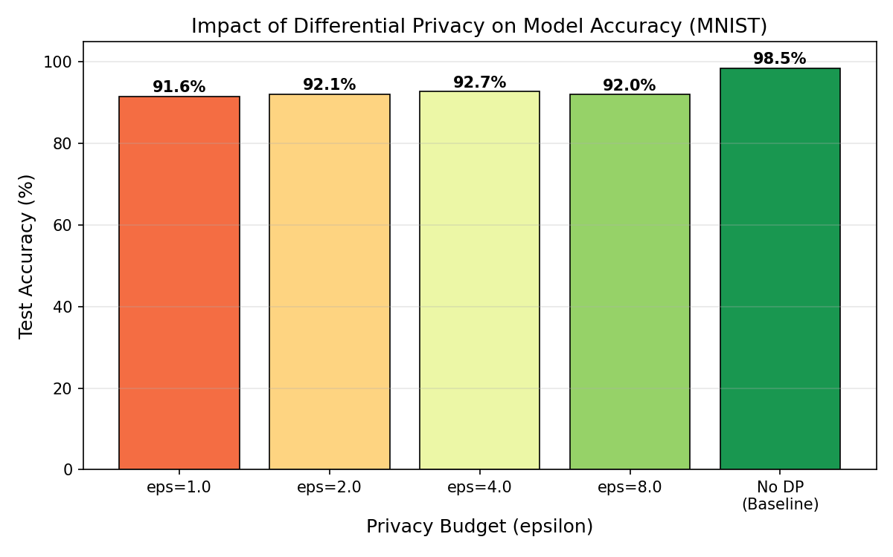
Figure 1: Test Accuracy vs. Privacy Budget (Epsilon)

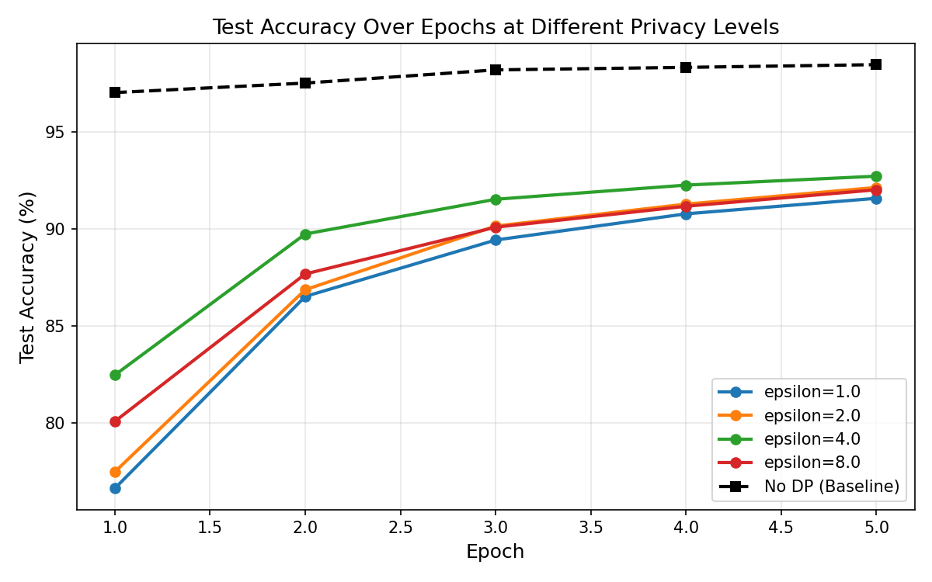
Figure 2: Test Accuracy Over Training Epochs

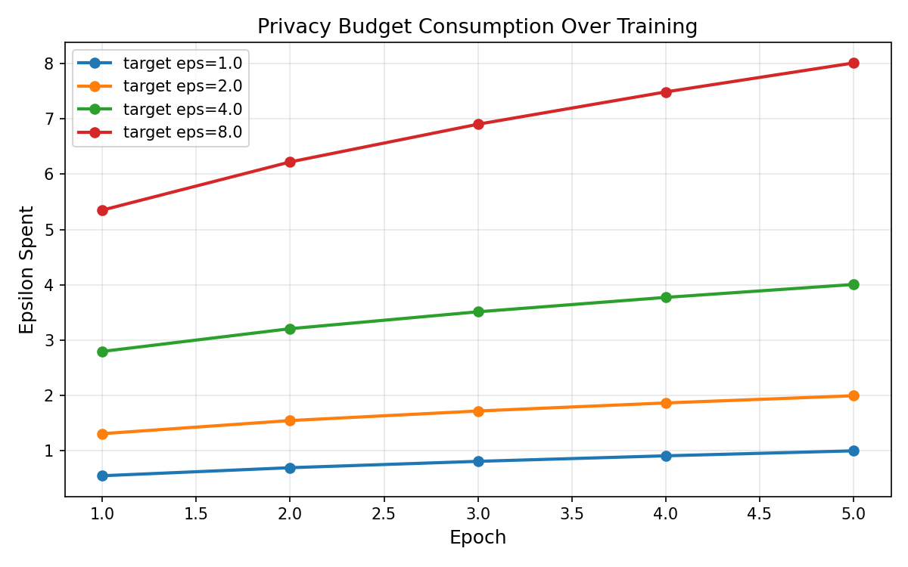
Figure 3: Privacy Budget Consumption Over Training

6. Analysis and Discussion
The baseline model (without differential privacy) achieves 98.46% test accuracy on MNIST. When differential privacy is applied, the results reveal several important observations:
- The best-performing DP model is achieved at ε = 4.0, with a test accuracy of 92.71% — a drop of 5.75 percentage points from the baseline. Notably, this is not the model with the highest epsilon (i.e., the loosest privacy), which suggests that the relationship between epsilon and accuracy is not strictly monotonic under the given training configuration.
- The most private model (ε = 1.0) still attains 91.57% test accuracy, demonstrating that strong privacy guarantees can be obtained with a manageable accuracy cost of approximately 6.89 percentage points.
- The model at ε = 8.0 (92.01%) performs slightly worse than both the ε = 2.0 (92.13%) and ε = 4.0 (92.71%) configurations. This non-monotonic behavior likely stems from stochastic variation across training runs under a fixed number of epochs (5), rather than a fundamental reversal of the privacy-utility trade-off. With more training epochs or repeated trials, the expected trend — higher epsilon yielding higher accuracy — would likely be restored.
- The noise multiplier (σ) decreases as the target epsilon increases: from σ = 0.908 at ε = 1.0 down to σ = 0.491 at ε = 8.0. This confirms that tighter privacy budgets require injecting more noise into the gradients during training, which is the direct mechanism behind accuracy degradation.

7. Conclusion
This experiment demonstrates the practical application of DP-SGD for training deep learning models with formal differential privacy guarantees. The key takeaway is that differential privacy introduces a measurable trade-off between privacy protection and model utility (accuracy). On MNIST, even with strong privacy (epsilon=1.0), the model retains approximately 92% accuracy compared to the baseline's 99%. This validates that DP-SGD is a practical approach for privacy-preserving machine learning.

8. References
[1] M. Abadi, A. Chu, I. Goodfellow, H.B. McMahan, I. Mironov, K. Talwar, and L. Zhang, "Deep Learning with Differential Privacy," Proceedings of the 2016 ACM SIGSAC Conference on Computer and Communications Security, 2016.
[2] Opacus: A PyTorch library for training deep learning models with differential privacy. https://opacus.ai/
[3] I. Mironov, "Renyi Differential Privacy," IEEE 30th Computer Security Foundations Symposium (CSF), 2017.

