**PROJECT ARRANGEMENTS.**

**Project proposal.**

**Project purpose and relevance.**

Cosmetics stores have been gaining more and more popularity lately. Every woman (and some men) wants to have a clear face and soft body skin.

There are thousands of skincare shops that offer an enormous amount of beauty products. This industry is high income flowing business area. Today it is impossible for business to have only offline products distribution area and each company want to go online.

Data Insight with the support of Arvato Rus has released an extended study "Online cosmetics market" [[source](https://datainsight.ru/sites/default/files/DI_Cosmetics_2020_Public.pdf)]. The study provides data on cosmetics stores that are among the TOP 1,000 online retailers by the number of orders for 2020, as well as the largest universal marketplaces (with annual online sales of at least 100 billion rubles per year) - for the latter, only sales in the beauty category are considered.

The study included 58 stores specializing in the sale of decorative and care cosmetics, perfumes, products for manicure, pedicure, and make-up artists.

Key points:

· 83 million orders worth 95 billion rubles were issued in 2020

· The average check was 1,150 rubles.

· In 2020, 158% more orders were placed in online cosmetics stores than in 2019.

· The share of online stores in the eCommerce market was 10% by the number of orders.

· The conversion rate of the sector is 5.1%.

· The share of advertising transitions in the sector was 10% versus 3% on average in the Russian eCommerce market.

As it takes much time to make an order using social media (WhatsApp or Instagram), which makes shopping challenging both for a customer and a salesman, an e-commerce website can deal with this problem. Users can view all items, set specific filters, add products to favourites for viewing later. What’s more, it is always possible to make an order at any time.

**Similar projects and competitors analysis.**

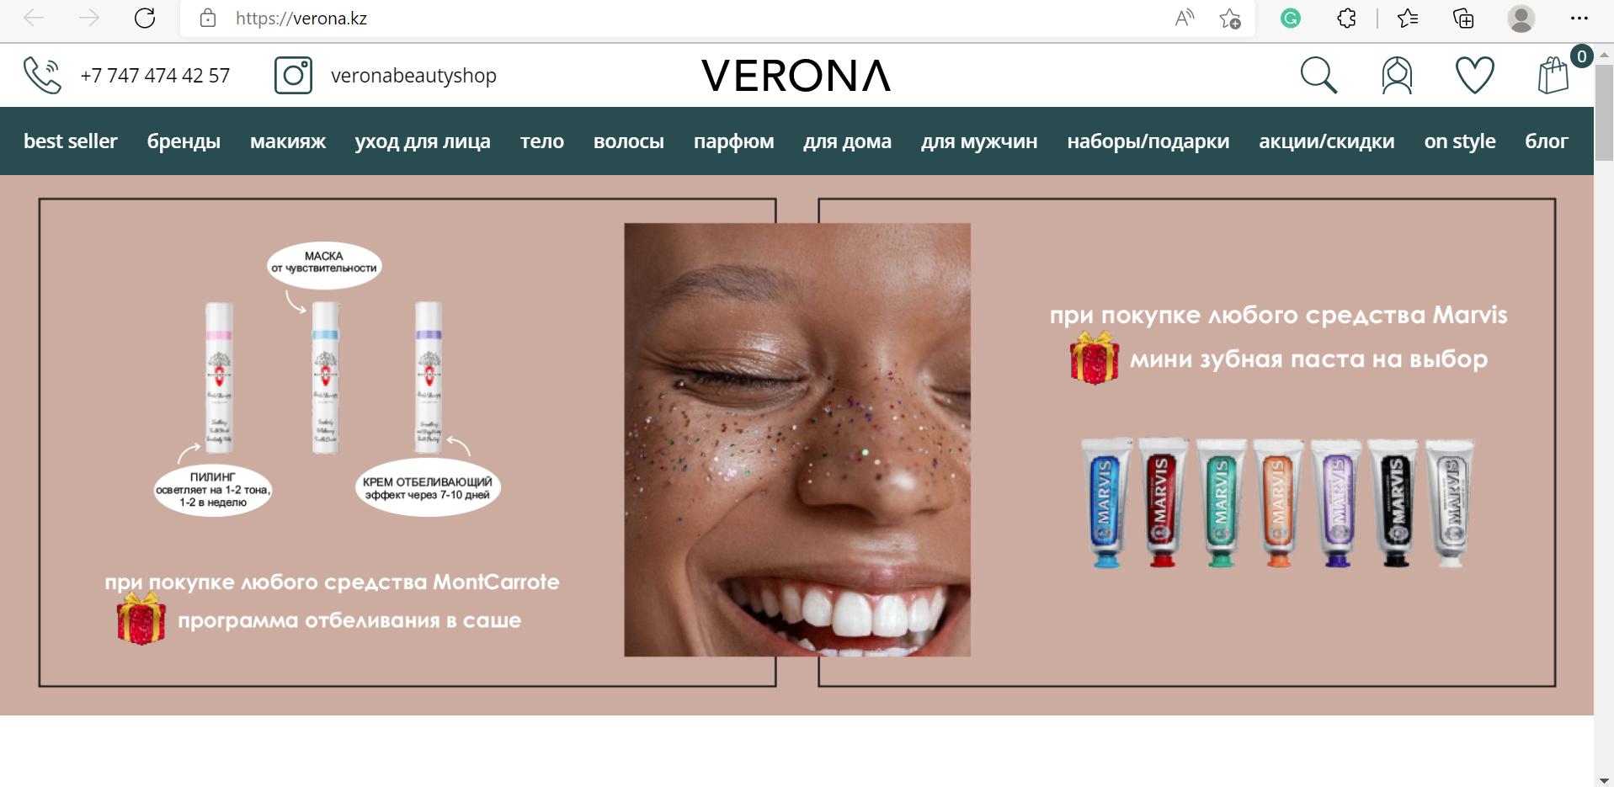

*Picture 1. The screenshot of Verona cosmetics store*

There are many beauty and cosmetics stores in Kazakhstan. One of the most popular is Verona online beauty store. As can be seen from the screenshot, the website has a typical e-commerce structure: navigation bar (includes different products categories, best sellers, discounts), the main page with special offers/gifts. There is a searching system, login/registration, favourites and cart icons.

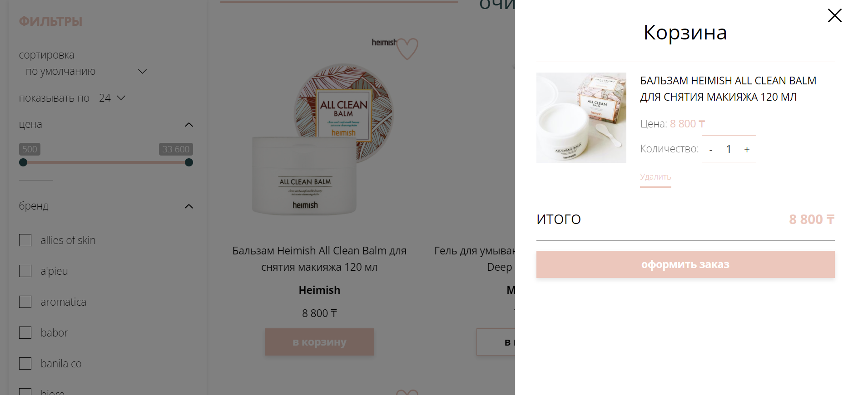

*Picture 2. Verona cosmetics cart*

If you add any product to your cart, the cart with this product is displayed automatically.

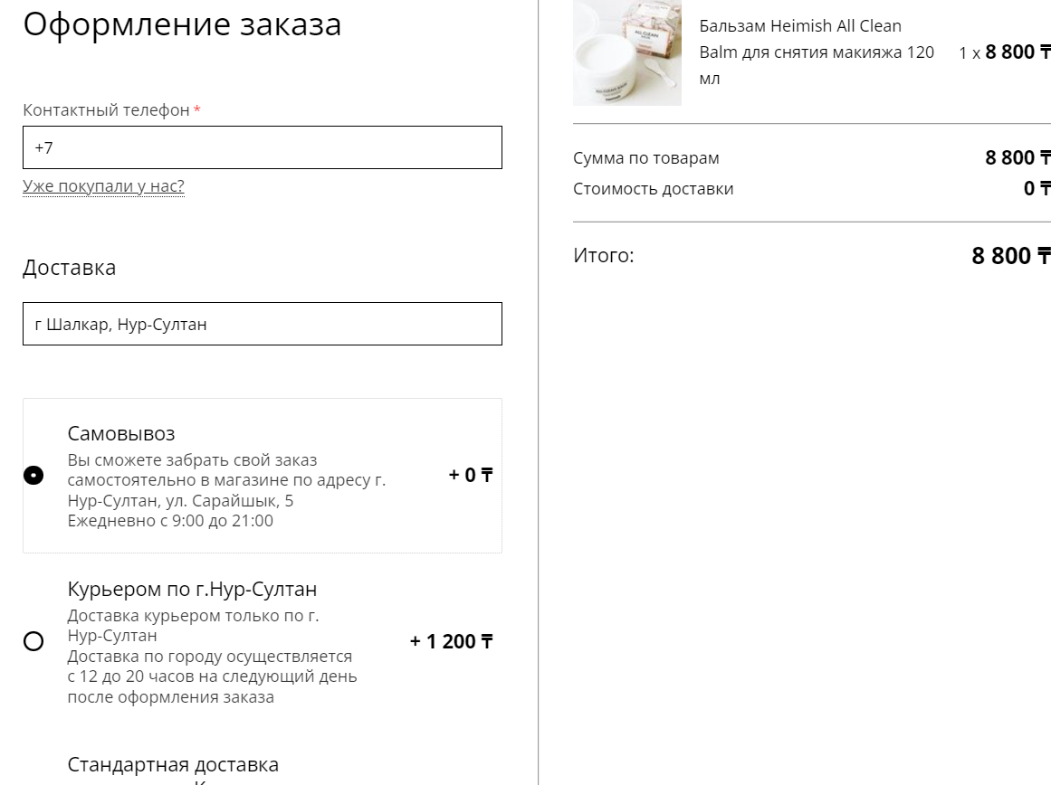

*Picture 3. Order processing*

When you make an order, it is not necessary to be logged in, however, if you are logged in, it is saved in your orders history.

**Project auditory.**

***Age of 14-18.***

Teenagers experience puberty, and, as a result, hormonal changes may affect their skin health. Issues such as acne may be a big problem for their self-esteem. That is why skincare cosmetics are relevant for them.

***Age of 19-45.***

Consumers of this age range use much more skincare products but they can afford more expensive and even luxe cosmetics than teenagers

***Age of 45+.***

From this age, women do skincare routine to keep their skin look young and fresh. For instance, they use anti-aging creams.

**Project features.**

An e-commerce website does not require special unique functionality. It must have a catalogue with products divided into categories where users can set specific filters. It also must have a search bar to find an appropriate product. Login and registration are required to make an order. Cart and payment are also mandatory.