电子科技大学2016-2017 学年第 二 学期期 末 考试 A 卷
考试科目： 数字逻辑设计及应用 考试形式： 闭卷 考试日期： 2017 年 月 日
成绩构成比例：平时 30/20 %， 期中 30/20 %， 小班研讨 20 %， 期末 40 %
本试卷由 V 部分构成，共 5 页。考试时长： 120 分钟 注：
题号 | I | II | III | IV | V | 合计
得分

得 分

I. Please fill out the correct answers in the brackets “( )” . ( 4’ X 10 = 40’ )
1. The 74x148 is an 8-input priority encoder with active low inputs and outputs. If its I0,I2 and I4 inputs are activated then the output code is ( 011).
2. If a 74x283 4-bit binary adder has A=1011 and B=1100 and C0=0 on its inputs, the 74x283’s outputs C4S3S2S1S0 is ( 10111 ).

3. If a D flip-flop is constructed by a T flip-flop with an enable input EN, then the input EN=( D⊕Q ).

4. To design a "110111" serial sequence generator, ( 3 ) flip-flops are need at least.

5. To build a modulus -191 counter, it requires at least ( 3 ) 74x162s, if its initial count is 808, its terminal count is ( 998 ).
6. A sequential circuit whose output depends only on its state is called a ( Moore ) state machine.
7. If an odd number of shift-register outputs are connected to the odd-parity circuit in an n-bit LFSR counter, its modulus is( 2^{n}-2 ).
8. The capacity of a memory that has 20 bits address bus and can store 8 bits at each address is ( 1 )MB.
9. When the input is 00001000 of an 8 bit DAC, the corresponding output voltage is -2V. The output voltage range for the DAC is ( -63.75 ~ 0 )V.

得 分

I I. Choose the only one correct answer and fill the item number in the brackets.

(3’ X 5=15’ )

1. If use a 74x85 magnitude comparator to compare only two 4-bits binary numbers, the 74x85’s cascading inputs should be ( B ).
A) ALTBIN=0, AEQBIN=0, AGTBIN=1 B) ALTBIN=0, AEQBIN=1, AGTBIN=0
C) ALTBIN=1, AEQBIN=0, AGTBIN=0 D) ALTBIN=1, AEQBIN=0, AGTBIN=1

2. For an edge-triggered D flip-flop, ( D ) is correct.
A) a change in the state of the flip-flop can only at a clock pulse edge
B) the state that the flip-flop goes to depends on the D input
C) the output follows the input at each clock pulse
D) all of these answers

3. An asynchronous counter differs from a synchronous counter in ( B ).
A)the value of the modulus B) the method of clocking
C) the type of flip-flops used D) the number of states in its sequence

4. With a 100KHz clock frequency for the decade counter 74x162 free-running mode, ( A ) is correct..
A) f_{QA}= 50KHz B) f_{QB}= 25KHz C) f_{QC}= 12.5KHz D) f_{QD}=6.25KHz

5.When an 8-bit serial in/serial out shift register is used for a 16μs time delay, the clock frequency must be ( A ).
A)500KHz B) 5KHz C) 50KHz D) 500Hz

得 分

III. A sequential circuit is shown in Fig. 1, where the frequency of CLK is 1MHz. Assume the initial state for Q2Q1Q0 is 000. (15')
(1) Write out the excitation equation and the transition equation for the circuit. (3')
(2) Draw the timing diagram for Q2, Q1 and Q0. （6'）
(3) Indicate the modulus of the circuit, and check whether it is self-correction. (4')
(4) What is the frequency for Q2 ? （2'）
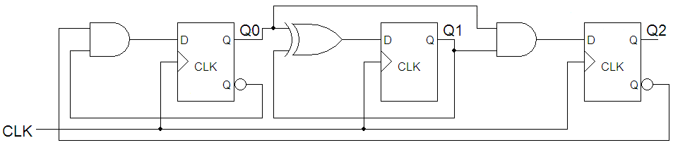
Fig. 1

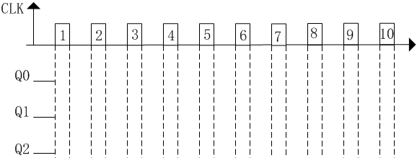

参考答案：
（1） Excitation equation: （共1.5分，每个激励方程正确得0.5分，错扣0.5分)
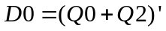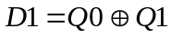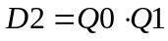
Transition equation: (共1.5分，每个转移方程正确得0.5分，错扣0.5分)
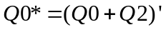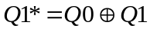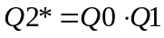
（2）本小题6分，每个波形2分。每个波形错一处扣0.5分，扣完该波形的2分为止。
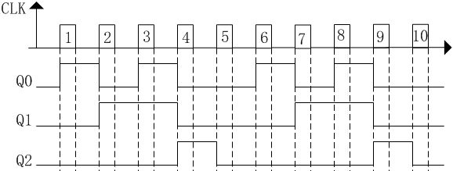
（3）该电路的模是5。（2分）
状态转换关系是：000--001--010--011--100--000 101--010 110--010 111--100
没有无效循环，因此该电路能自启动。（2分）
（4）由于Q2的频率是CLK的1/5，因此Q2的频率是200kHz。（2分）
IV. The output timing diagram of a synchronous sequential circuit is shown in Fig. 2. Design the circuit only using one 74163, one 74138 and necessary NAND gates. Assume the initial state QDQCQBQA for 74163 is 0000, and the output F1F2F3 is 101.
(1) Indicate the modulus of the counter, and write out LD_L（QC，QB，QA）. (3')
(2) Write out the canonical sum for F1(QC, QB, QA)，F2(QC, QB, QA)和F3(QC, QB, QA). (9')
(3) Draw the schematic diagram. (3')
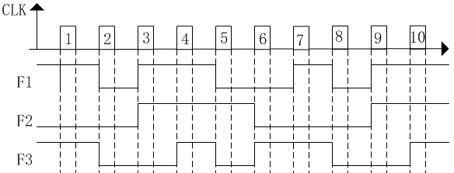
Fig. 2

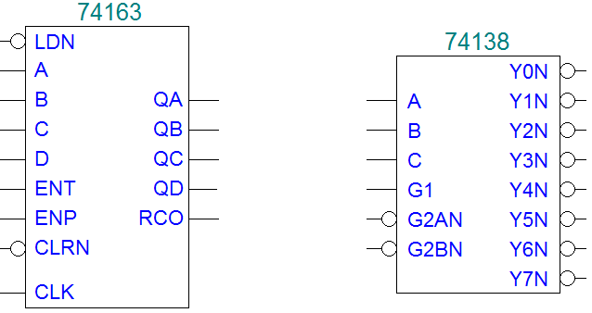

Function table for 74163
Inputs |  |  |  | Current State | Next state | Output
CLR_L | LD_L | ENT | ENP | Q_{D} Q_{C} Q_{B} Q_{A} | Q_{D}* Q_{C}* Q_{B}* Q_{A}* | RCO
0 | X | X | X | X X X X | 0 0 0 0 | 0
1 | 0 | X | X | X X X X | D C B A | 0
1 | 1 | 0 | X | X X X X | QD QC QB QA | 0
1 | 1 | X | 0 | X X X X | QD QC QB QA | 0
1 | 1 | 1 | 1 | 0 0 0 0 | 0 0 0 1 | 0
1 | 1 | 1 | 1 | 0 0 0 1 | 0 0 1 0 | 0
1 | 1 | 1 | 1 | 0 0 1 0 | 0 0 1 1 | 0
1 | 1 | 1 | 1 | 0 0 1 1 | 0 1 0 0 | 0
1 | 1 | 1 | 1 | …………. | ………….. | 0
1 | 1 | 1 | 1 | 1 1 1 1 | 0 0 0 0 | 1

参考答案
（1）根据波形图得到F1F2F3的转换关系是：101--000--110--111--010--001--101，该电路是一个模6计数器。【1分】
用74163设计一个模6计数器，其状态（QCQBQA）转移关系是：000--001--010--011--100-101--000。【表达式正确，得2分；错一处扣1分，扣完2分为止】
（2）列出QCQBQA与F1F2F3的关系表
QCQBQA | F1F2F3
000 | 101
001 | 000
010 | 110
011 | 111
100 | 010
101 | 001
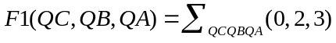 【表达式正确，得3分；错一处扣1分，扣完3分为止】
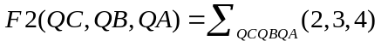 【表达式正确，得3分；错一处扣1分，扣完3分为止】
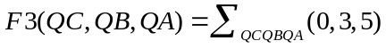 【表达式正确，得3分；错一处扣1分，扣完3分为止】
（3）连接电路图
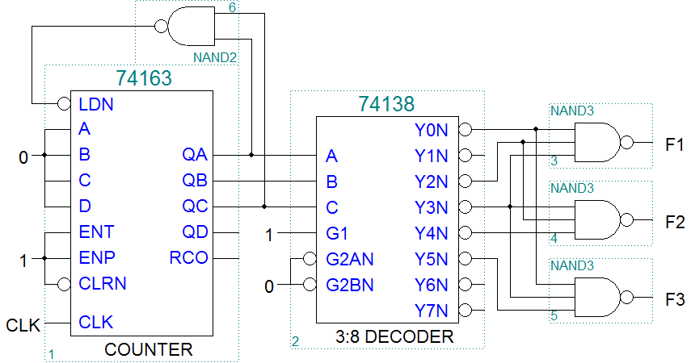
【电路连线正确得3分，错一处扣0.5分，扣完3分为止】

V. Analyze the circuit shown in Fig. 3. (15')
(1) Draw the whole state diagram for 74194. (5')
(2) Write out the logic function F1(QA ,QB,QC) and F2(QA,QB,QC). (4')
(3) Draw the timing diagram F1 and F2. (6')

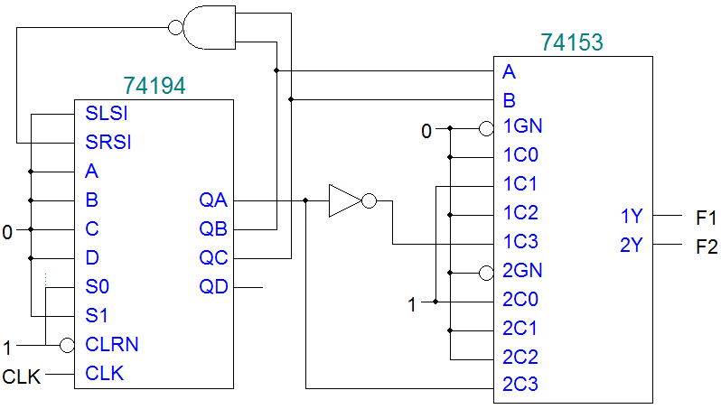
Fig. 3
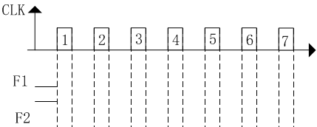
The function table for 74194
Iutputs |  | Next state |  |  |  | Function
S1 | S0 | QA* | QB* | QC* | QD* | Function
0 | 0 | QA | QB | QC | QD | Hold
0 | 1 | RIN | QA | QB | QC | Shift right
1 | 0 | QB | QC | QD | LIN | Shift left
1 | 1 | A | B | C | D | Load
参考答案：
（1）本小题5分，错一个状态转换扣1分，扣完5分为止。
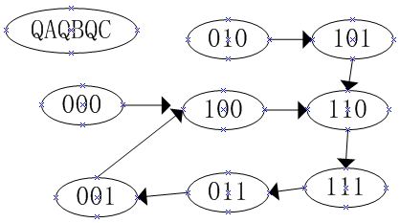
（2）本小题4分
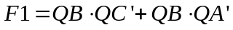 【错一项，扣1分，扣完2分为止】
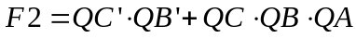 【错一项，扣1分，扣完2分为止】
（3）本小题6分
【F1波形3分，错一处，扣1分，扣完该波形的3分为止】
【F2波形3分，错一处，扣1分，扣完该波形的3分为止】
