电子科技大学2017-2018 学年第 一 学期期 末 考试 A 卷
考试科目： 数字逻辑设计及应用 考试形式： 闭卷 考试日期： 2018 年 01 月 日
成绩构成比例：平时 30/20 %， 期中 30/20 %， 小班研讨 20 %， 期末 40 %
本试卷由 V 部分构成，共 5 页。考试时长： 120 分钟 注： 不准带计算器
题号 | I | II | III | IV | V | 合计
得分

得 分

I. Please fill out the correct answers in the brackets “( )” . ( 4’ X 10 = 40’ )
1. An 7-bit ring counter has ( 2⁷-7或121 ) invalid states.
2. The state/output table of a synchronous FSM is shown in table 1, where x is the input and y is the output. The sequential circuit is a ( moore )(mealy/moore) machine. The modulus of the FSM is ( 4 ).
Table 1
S | x |  | y
S | 0 | 1 | y
A | A | B | 0
B | B | C | 0
C | C | D | 0
D | D | A | 1
 | S*

3. A circuit is shown in Fig. 1. If the input ABCD is 1001, then the output F is ( 0 ).

Fig. 1
4. To build a 16Kx32 RAM, ( 8 ) 8Kx8 RAMs are required.
5. The minimum output voltage of a 8-bit DAC is V_{LSB}=0.02V. The output voltage is ( 0.76 )V when the input is 00100110.
6. If the Q and Q* of a JK flip-flop are Q=0 and Q*=1, then J=( 1 ) and K=( d ).
7. Given the characteristic equation of a PG flip-flop: Q*=P'G'Q+PG', where P and G is the inputs of the flip-flop. If a JK flip-flop is used to build the PG flip-flop, then the input equation of the JK flip-flop are J=( PG' ), and K=( G ).

得 分

I I. Choose the correct answer and fill the item number in the brackets.

(3’ X 5=15’ )

1. A circuit is shown in Fig. 2. If ABCD is 0111, then EFGH is ( B )
A) 1100 B) 1101 C) 1110 D) 1111

Fig. 2
2. Which of the following is not a sequential circuit? ( C )
A) Register B) Flip-flop C) Decoder D) Counter

3. To generate a serial sequence 0100101 by shift register, ( D ) flip-flops in the register are required at least.
A) 3 B) 4 C) 5 D) 6

4. If an SR latch is built by NOR gates, then the metastable of the SR latch happens when the input SR are from ( B ).
A) 00 to 11 B) 11 to 00 C) 01 to 10 D) 10 to 01

5. A 4-bit ring counter is built by 74x194 where S1S0 is 10 and the feedback equation is LIN=QA. If the initial state of the counter is 0001, then the invalid state is ( C ).
A) 0001 B) 0010 C) 0101 D) 1000

III. Design a 3-bit Johnson counter with self-correction at minimal cost using D Flip-Flops and some gates. (14’)
得 分
(1) Draw the full state diagram with self-correction . [6’]
(2) Fill out the Karnaugh map of D0 . [4’]
(3) Write out the excitation expression of D0. [2’]
(4) Draw the logic circuit diagram. [2’]

【参考解答】
(1) 画出状态图，主循环状态转移正确得4分，自校正状态转移正确得2分，共6分。
000
100
110
001

011
111
101

010
Q0 Q1 Q2
D0=1
D0=1
D0=0
D0=0
D0=1
D0=0
D0=1
D0=1

11110001
Q0Q1
Q2
00
01
11
10
0
1
D0

(2) 填写D0卡诺图，每个格正确得0.5分，共4分。

(3) 写出D0表达式正确得2分。 D0 = Q2’ + Q0Q1’

(4) 画出逻辑电路图，正确得2分
D0
CLK
Q0
Q0
D1
CLK
Q1
Q1
Clock
D2
CLK
Q2
Q2

IV. Analyze the clocked synchronous state machine as shown below. (15’)
得 分
(1) Write out the excitation equations, transition equations and output equation. [3’]
(2) List out the transition/output table. [6’]
(3) Draw the state diagram. [4’]
(4) Describe the function for the logic circuit. [2’]

【参考解答】
(1) 共3分。
激励方程(正确得1分)：D0 = Q1' D1 = Q0·M+Q1'·Q0
转移方程(正确得1分)：Q0* = Q1' Q1* = Q0·M+Q1'·Q0
输出方程(正确得1分)：Z = Q1·Q0·M' + Q1·Q0'·M

(2) 填写转移输出表(每行正确得1.5分，共6分)
Transition/output table
Q1Q0 | M
Q1Q0 | 0 | 1
00 | 01/0 | 01/0
01 | 11/0 | 11/0
11 | 00/1 | 10/0
10 | 00/0 | 00/1
 | Q1*Q0*/Z

Transition/output table
Q0Q1 | M
Q0Q1 | 0 | 1
00 | 10/0 | 10/0
10 | 11/0 | 11/0
11 | 00/1 | 10/0
01 | 00/0 | 00/1
 | Q0*Q1*/Z

或

(3)画出状态图(每个状态转移正确得1分，共4分)
M=1
Z=1
Z=0
00
01
10

11
Q1Q0
Z=0
Z=0
M=1
M=0
Z=0
M=0
Z=1
M=1
Z=1
Z=0
00
10
01

11
Q0Q1
Z=0
Z=0
M=1
M=0
Z=0
M=0
Z=1

或

(4) 电路功能描述(正确得2分)：
模可变计数器，当M=1时为模4计数器，当M=0时为可自校正的模3计数器。计到最大值时输出1。

V. Design the following two types of “1101” sequence detector with 74x194 and some gates. RIN is the sequence input. Z is the ouput. Z=1 when the “1101” input sequence is detected and Z=0 otherwise. Draw the logic diagrams respectively. (6’)
得 分

【参考解答】
(1) Overlapable Mealy machine. (3分)
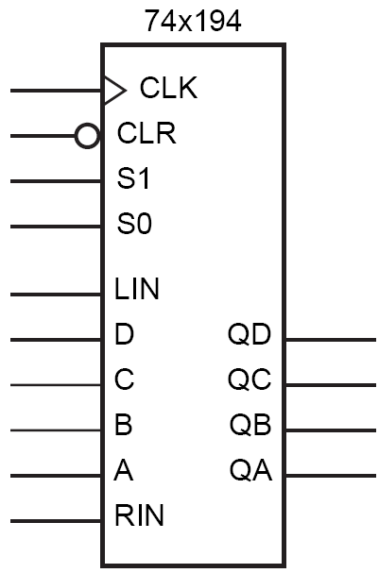
Clock
Vcc
Sequence input
Z

(2) Non-overlapable Moore machine. (3分)

Sequence input
Clock
Vcc
Z

VI. Analyze the state machine shown as below, which contains two 74x163 4-bit binary counters. The CLR and LD are synchronous inputs of 74x163. The output of U1 is Q3Q2Q1Q0 and the output of U2 is Q7Q6Q5Q4. (10’)
得 分
(1) Write out the logic expression LD_L for U₁ and CLR_L for U₂. [2’]
(2) Assume the initial state value of U1 is 3 and the initial state value of U2 is 0. List out the state value sequence of a state cycle for U1 and U2 respectively. [6’]
(3) What is the modulus of the logic circuit? [2’]

The function table for 74x163
Inputs |  |  |  | Current state | Next state | Outputs
CLR_L | LD_L | ENT | ENP | QD QC QB QA | QD* QC* QB* QA* | RCO
0 | X | X | X | X X X X | 0 0 0 0 | 0
1 | 0 | X | X | X X X X | D C B A | 0
1 | 1 | 0 | X | X X X X | QD QC QB QA | 0
1 | 1 | X | 0 | X X X X | QD QC QB QA | 0
1 | 1 | 1 | 1 | 0 0 0 0 | 0 0 0 1 | 0
1 | 1 | 1 | 1 | 0 0 0 1 | 0 0 1 0 | 0
1 | 1 | 1 | 1 | 0 0 1 0 | 0 0 1 1 | 0
1 | 1 | 1 | 1 | 0 0 1 1 | 0 1 0 0 | 0
1 | 1 | 1 | 1 | ∙ ∙ ∙ ∙ ∙ ∙ | ∙ ∙ ∙ ∙ ∙ ∙ | 0
1 | 1 | 1 | 1 | 1 1 1 1 | 0 0 0 0 | 1

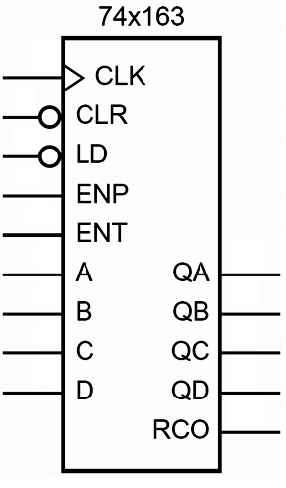
Vcc
Clock
Q0
Q1
Q2
Q3
Q4
Q5
Q6
Q7
U2
U1

【参考解答】
(1) 每个表达式正确得1分，共2分。
LD_L = Q₃’ CLR_L = (Q₅∙Q₄)’
(2) U1循环序列4分，U2循环序列2分, 共6分
U1: 3, 4, 5, 6, 7, 8 U2: 0, 1, 2, 3
(3) 正确得2分。
m = 12

