电子科技大学2018-2019 学年第 二 学期期 末 考试 A 卷
考试科目： 数字逻辑设计及应用 考试形式： 闭卷 考试日期： 2019 年 7 月 2 日
本试卷由 V 部分构成，共 6 页。考试时长： 120 分钟
成绩构成比例：平时成绩 60 %，期末成绩 40 % 注： 不准带计算器
题号 | I | II | III | IV | V | 合计
得分

得 分
I. Please fill out the correct answers in the brackets “( )”.
(Please refer to the appendix for the function description of 74 chips) ( 3’×10 = 30’ )

1. The waveforms of a sequential circuit are shown in Fig. 1, where A is input, and Y is output. It can be derived from Fig.1 that the circuit is ( synchronous ) (asynchronous / synchronous) FSM.
2. A sequential circuit is shown in Fig. 2. If the initial state is Q₂Q₁=00, then the output serial sequence from Q₁ is ( 0011或0110或1100或1001 ). If the frequency of the CLK is 100Hz, then the frequency of Q₁ is ( 25 ) Hz. The FSM has ( 0 ) invalid state(s).
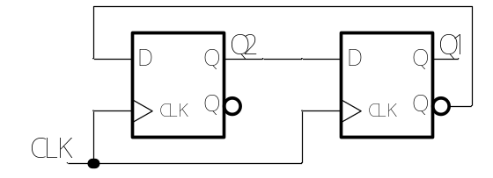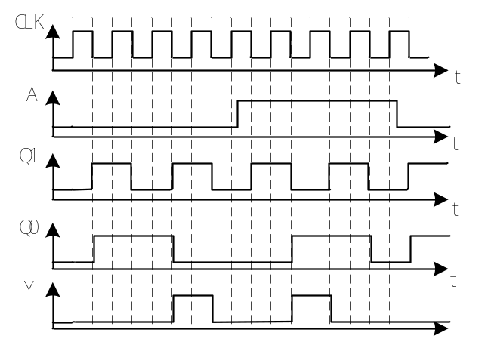 Fig. 1 Fig. 2

3. A ROM with 1024 bits capacity has 256 words. It can be used to implement a combinational circuit with ( 8 ) inputs and ( 4 ) outputs.
4. For an even-parity transceiver system, if the information bits sent are 0101010，then the parity bit should be ( 1 ).
5. If the minimum incremental output voltage of an 8-bit DAC is 0.05V, then the output voltage is ( 6.8 ) V for the DAC when the input is 10001000.
6. A modulo-185 counter requires ( 8 ) flip flops at least.
7. If a 19-bit LFSR counter is constructed by shift register, ( 5 ) 74x194 shift register(s) should be used at least.

得 分

II. Choose the correct answer and fill in the brackets. ( 3’×5 = 15’ )
1. The circuit shown in Fig. 3 is ( A ).
A. asynchronous counter B. asynchronous shift register
C. synchronous counter D. synchronous shift register

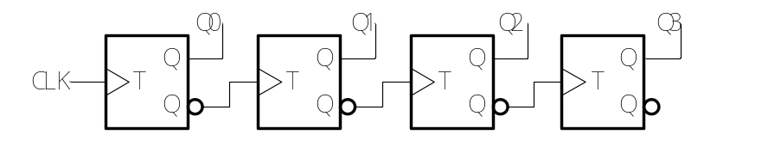
Fig. 3
2. The state diagram shown in Fig. 4 has ( B ) ambiguous states.
A. 1 B. 2 C. 3 D. 4
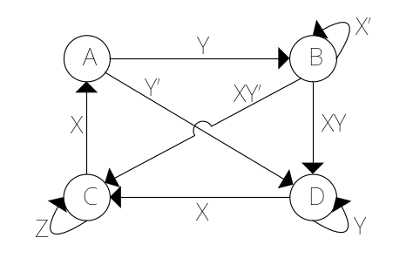
Fig. 4
3. The waveforms of inputs (A and B) and outputs (Q and QN) of a flip flop are shown in Fig. 5. It can be derived that it is a ( D ) flip flop.
A. T B. D C. S-R D. J-K
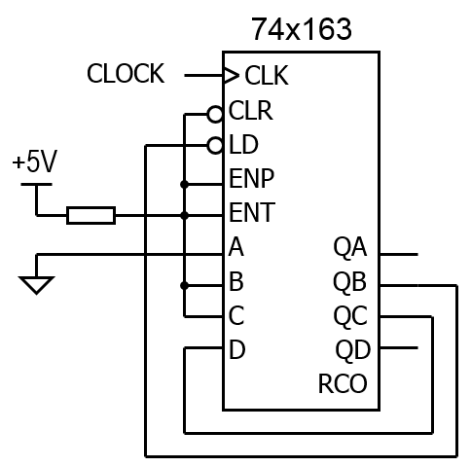
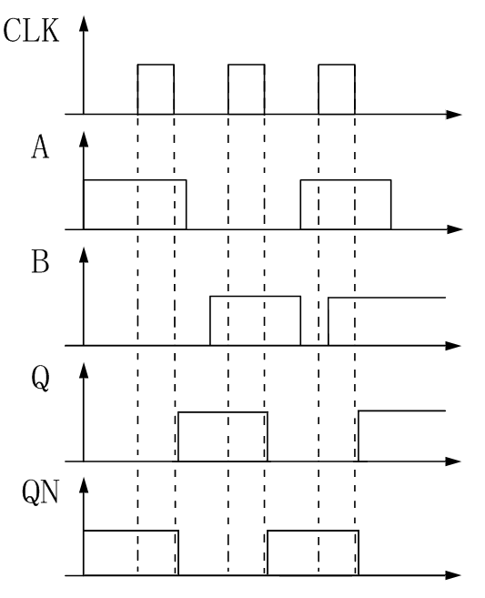
Fig. 5 Fig. 6

4. To generate a sequence signal 11010111 using shift register, ( D ) bits are required at least.
A. 2 B. 3 C. 4 D. 5
5. The modulo of the circuit shown in Fig. 6 is ( A ).
A. 3 B. 4 C. 6 D. 16

得 分

III. A verilog HDL module realizes a special binary counter. The count value is from 100 to 199. The output f will be asserted when the count value is an integer multiple of 4. The correct simulation result is shown below.
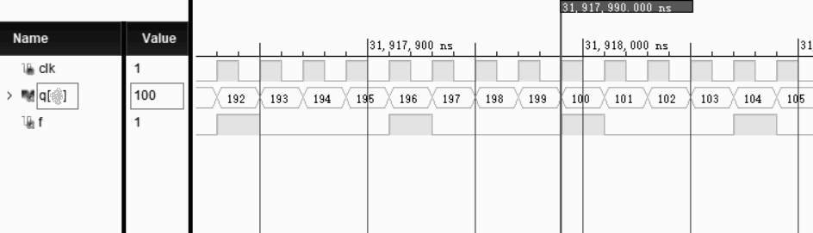
We writed this module code as shown below. But there are several errors. Please find the errors and correct them. ( 10’ )
module p1(clk, q, f); //1
input clk; //2
output [3:0] q; //3
output f; //4
reg [7:0] q = 0; //5
assign f = q[1] & q[0]; //6
always @ (posedge clk) //7
begin //8
if (q = 199) //9
q <= 0; //10
else //11
q <= q + 1; //12
end endmodule //13

Please write the number of error line and correct it. You can append lines below, if you think not enough.
Line ( 3 ) is error. Modified to: ( output [7:0] q; )
Line ( 5 ) is error. Modified to: ( reg [7:0] q = 100; )
Line ( 6 ) is error. Modified to: ( assign f = ~q[1] & ~q[0]; 或 assign f = ~(q[1] | q[0]);)
Line ( 9 ) is error. Modified to: ( if (q == 199) )
Line (10) is error. Modified to: ( q <= 100 )
Line ( ) is error. Modified to: ( )
Line ( ) is error. Modified to: ( )

得 分

IV. Analyze the sequential circuit as shown below. ( 21’ )
1. Write out the excitation equations and output equation. [4’]
2. List out the transition/output table. [6’]
3. Assume the initial state Q2Q1=00, draw the timing diagram for Q2 ,Q1 and Z. [11’]

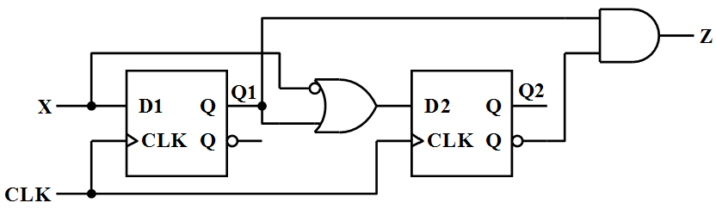

参考评分标准：
1. 激励方程: D1 = X（1分），D2= X’ + Q1（2分），输出方程: Z = Q2’ · Q1（1分）
2. 转移/输出表。 (6分)
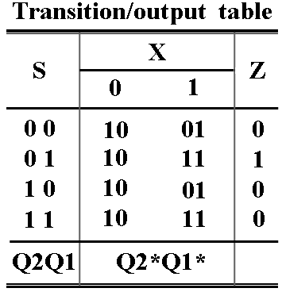
3. 定时图。（Q2、Q1的波形各3.5分，Z的波形4分，共11分。）
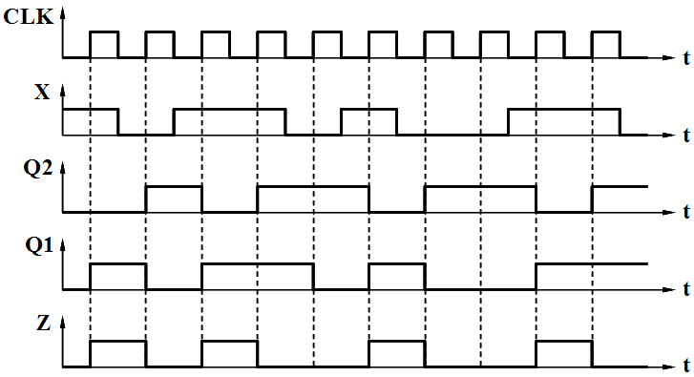

得 分

V. Design a Mealy machine for a sequence detector with a serial input sequence
of X = 1001 or 1101. The sequence may be overlap. The output Z = 1, when the
sequence of 1001 or 1101 is detected, and Z=0 otherwise. ( 24’ )
1. If we use D flip-flops to design it,
1) please list out the minimal state/output table [6’]
2) please list out the transition/output table with the minimal cost. [5’]
2. If we use only a 74x194 and a 74x151 to design it and use shift left mode for the 74x194,
1) please Write out the minterm list of the output Z (X, QB, QC, QD). [4’]
2) please draw a schematic diagram for the circuit. [9’]

参考评分标准：
1. 1) 填写状态/输出表（每格正确得0.5分，共6分）
The minimal state/output table

State meaning
StateX01Initial stateSTASTA, 0X1, 0Got 1X1X10, 0X11, 0Got 10X10X100, 0X1, 0Got 11X11X110, 0X11, 0Got 100X100STA, 0X1, 1Got 110X110STA, 0X1, 1S*, Z

The minimal transitiom/output table
StateState codeXQ2 Q1 Q001STA000000, 0001, 0X1001010, 0011, 0X10010100, 0001, 0X11011101, 0011, 0X100100000, 0001, 1X110101000, 0001, 1-----110ddd, dddd, d-----111ddd, dddd, dQ2* Q1* Q0*, Z

2) 填写转移/输出表（前6行，每行正确得0.5分，后两行，每行正确得1分，共5分）

2. 1) Z = ∑ _{X, QB, QC, QD} (12, 14) （正确得4分）
2) 电路原理图（74x194的CLK, CLR, S1, S0, LIN, Z每个连接正确得0.5分，共3分；74x151的C, B, A连接正确得2分，74x151的D0~D7每个连接正确得0.5分，共4分。该小题共9分）
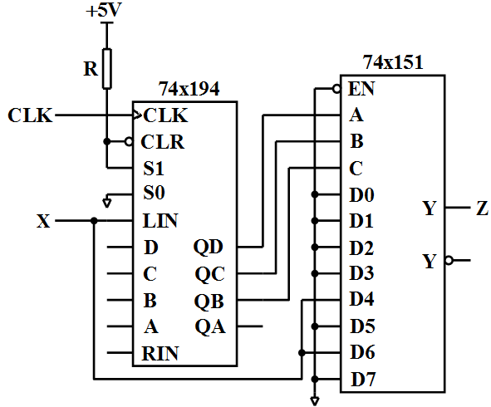
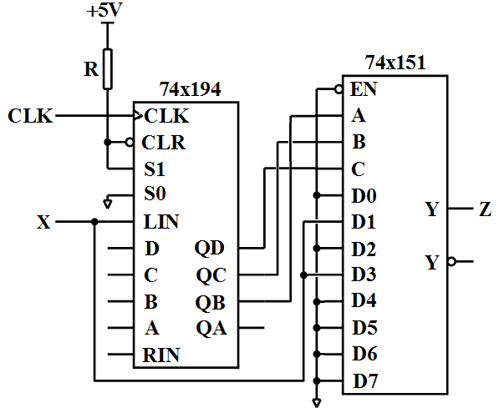
或

参考评分标准：
=======================================================
Appendix

