电子科技大学2020-2021学年第2学期期末考试 A 卷
考试科目： 数字逻辑设计及应用 考试形式： 闭卷 考试日期： 2021 年 7 月 6 日
本试卷由 六 部分构成，共 8 页。考试时长： 120 分钟
成绩构成比例：平时成绩 60 %，期末成绩 40 % 注：禁止使用计算器和英文词典
题号 | 一 | 二 | 三 | 四 | 五 | 六 | 七 | 八 | 合计
得分

(Please refer to the appendix for the function description of 74 chips)
得 分

I. Please fill out the correct answers in the brackets. (2’×15 = 30’)

1. (1111 0011 1011)_{2421BCD} = ( 1100 0110 1000 )_{excess-3}
2. (1011 1010)_{gray} = ( 1101 0011 )₂
3. Given two 8-bit numbers [A]_{one’s-complement} = 1111 1010, [B]_{signed-magnitude} = 0110 1010
[A-B] _{two’s-complement} = ( 1001 0001 ), Is it overflow? (Yes/No) ( No )
4. An odd-parity circuit is employed to generate parity bit for the information 110010101, then the parity bit is ( 0 )
5. The output states of an open-drain gate without the pull-up resistor are Hi-z and ( Low or 0 ).
6. The unused inputs of a CMOS NAND gate should be connected to ( High or 1 ).
7. 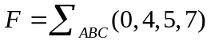=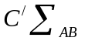( 0, 2 ) + ( 2, 3 )
8. A sequential logic circuit whose output depends only on its states is called a ( Moore ) state machine.
9. If a ROM has 8192 word lines and 8 bit lines, then it has ( 13 ) address input pins and its capacity is ( 8 ) KB.
10. If a D flip flop is constructed by a T flip flop with Enable, then the input EN of T flip flop is EN = ( or )
11. The minimum nonzero output voltage of an 8-bit DAC with single polarity is 10mV. The output voltage is ( 1.36 ) V when the input is 1000 1000.
12. For N variables, the sum of all the minterms is ( 1 ).

得 分

II. Choose the correct answer and fill in the brackets. ( 2’×10=20’ )

1. Which of the following number values is minimum ? ( C )
A. (198)₁₀ B. (001010000010)_{8421BCD}
C. (10100000)₂ D. (AF)₁₆

2. The dynamic power dissipation of a CMOS circuit has the form ( A ).
A. CV²f B. C²Vf C. CVf ² D. CVf

3. Which of the followings can form a complete set of logic gates? ( D )
A. 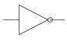 B. 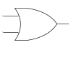 C. 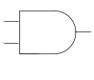 D. 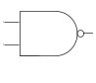
4. is NOT equivalent to ( D ).
A. B.
C. D.

5. Which of the followings is the dual of XNOR ? ( A )
A. XOR B. OR C. AND D. NOR

6. How many distinguished 1-cells are in ？( B )
A. 3 B. 4 C. 5 D. 6

7. To design a periodic sequence 001010 by shift register, ( B ) flip-flops are required at least.
A. 3 B. 4 C. 5 D. 6

8. How many valid states are in a 4-bit Johnson counter with self-correction? ( B )
A. 4 B. 8 C. 12 D. 16

9. How many states are NOT ambiguous in Fig.1 ( C ).
A. 1 B. 2 C. 3 D. 4
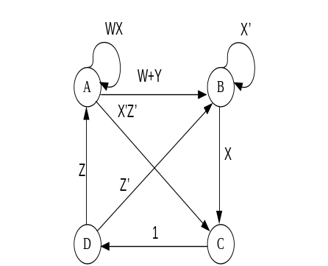
Fig. 1
10. If a 74x138 binary decoder has 110 on its inputs CBA and its enable inputs are active, the active LOW outputs Y6 Y5 should be ( C )
A. 11 B. 10 C. 01 D. 00

III. The following Verilog HDL program is to realize a serial sequence "10011" overlapable detector which is a Moore machine.
得 分
module SeqDetect (
input clk, //clock signal input
input in, //serial sequence input
output z //z=1 means the sequence was detected
);
reg [2:0] state = 3’d0;
reg [2:0] st = 3’d0;
parameter s0=3'd0, s1=3'd1, s2=3'd2, s3=3'd3, s4=3'd4, s5=3'd5;

always @ ( * ) begin
case (state)
s0: st = in ? s1 : s0;
s1: st = in ? s1 : s2;
s2: st = in ? s1 : s3 ;
s3: st = in ? s4 : s0 ;
s4: st = in ? s5 : s2 ;
s5: st = in ? s1 : s2 ;
default: st = s0;
endcase
end

always @ (posedge clk)
state <= st;

assign z = (state == s5) ;
endmodule
Please fill in the blank spaces to complete the program. (5’)

【参考答案及评分标准】 每空正确得1分。

得 分
IV. Analyze the sequential-circuit as shown below. (15’）

1. Write out the excitation equations and output equation. [3’]
2. List out transition/output table and draw a full state diagram. [4’]
3. Assume the initial state Q2Q1=00, draw the timing diagram for Q2 ,Q1 and Z. [6’]
4. Indicate the logic function of the circuit. [2’]
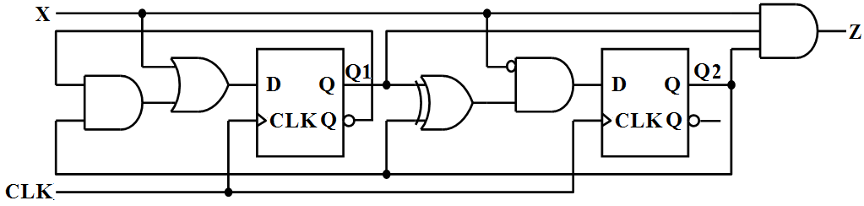
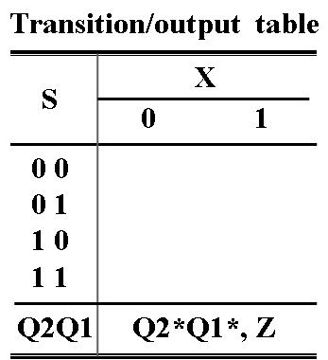
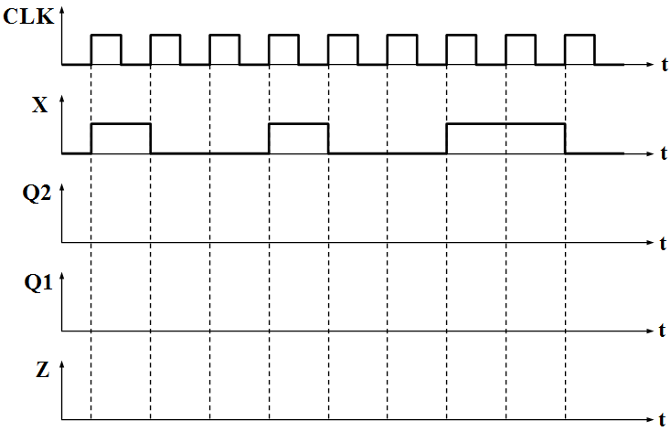

【参考答案及评分标准】
1. 激励方程: D1= X+Q2Q1’（1分），D2= X’(Q2⊕Q1)（1分），输出方程Z= XQ2Q1（1分）
2. 转移/输出表(正确得2分) 和 状态图(正确得2分)。

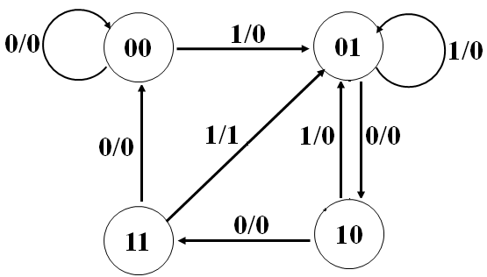
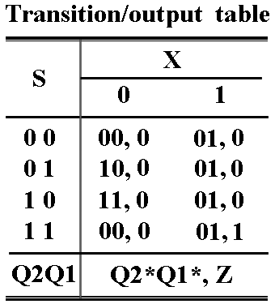

3. 定时图 (Q2、Q1的波形各2分，Z的波形2分，共6分）

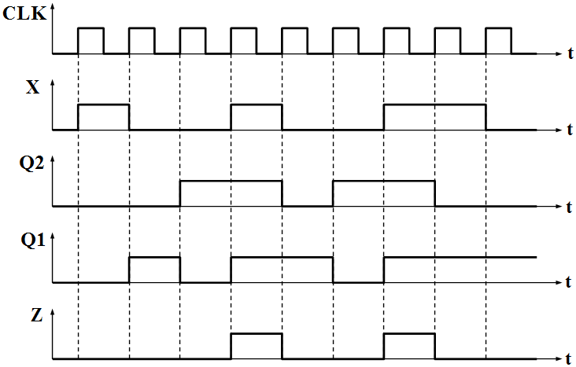

4. 功能描述（共2分）：Mealy（1分），可重叠的1001序列检测（1分）。

V. Design a code converter for 2421 to Excess-3 using only one comparator 74x85, one adder 74x283 and one inverter. The 2421 code input x should be connected to input A of 74x85 and 74x283. (15’)
得 分
1. Complete the truth table for the code converter. [5’]
2. Write out the logic expression of AGTBOUT(x₃,x_{2,}x₁,x₀). [4’]
3. Draw a schematic diagram for the circuit. [6’]

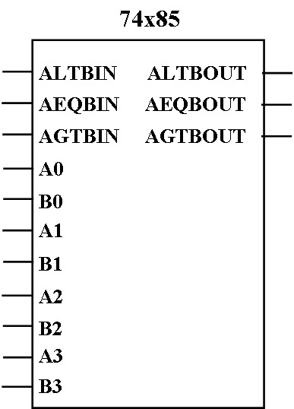
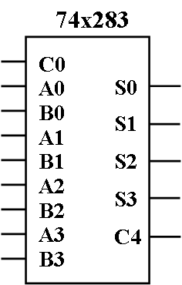
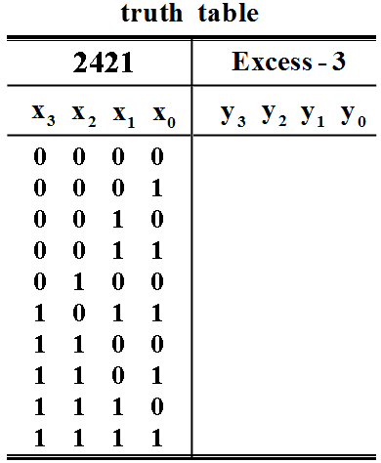

【参考答案及评分标准】
1. 真值表 (5分)
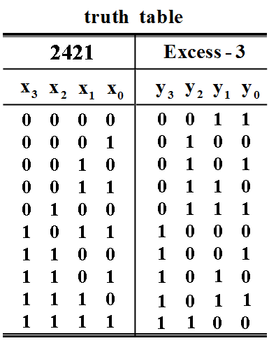
2. AGTBOUT(x₃,x_{2,}x₁,x₀) = x₃ + x₂(x₁ + x₀) (4分)
3. 电路图 (74x85连接3分，74x283连接3分，共6分)
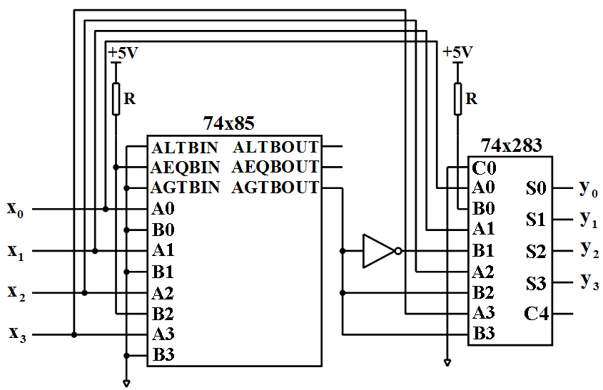

得 分
VI. Design a sequence signal generator with the shortest path self correcting to generate a serial output sequence Z = 1110 using only one 74x194 and one 74x151. Please select shift right mode for the 74x194. (15’)
1. List out the transition table and draw a full state diagram. [8’]
2. Write out the minterm list of the feedback function RIN(QA,QB,QC). [2’]
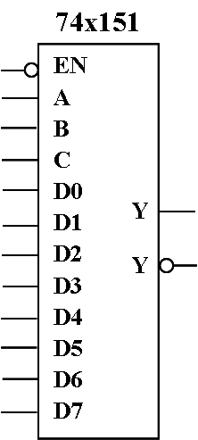
3. Draw a schematic diagram for the circuit. [5’]
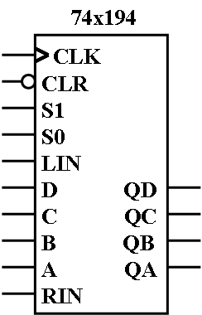

【参考答案及评分标准】
1. 转移表(正确得4分) 和 全状态图(正确得4分)
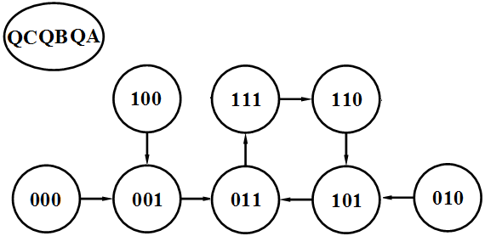
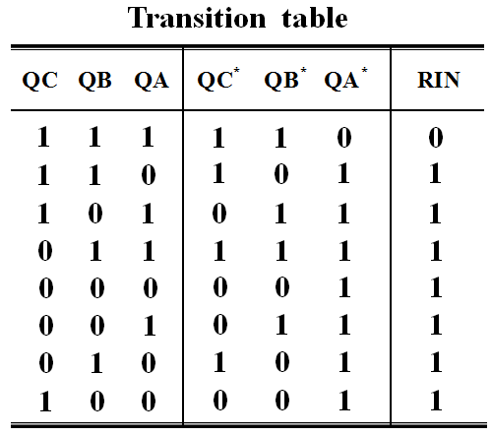
2. 反馈函数RIN(QC,QB,QA)= ∑_{QC,QB,QA}(0,1,2,3,4,5,6)（2分）
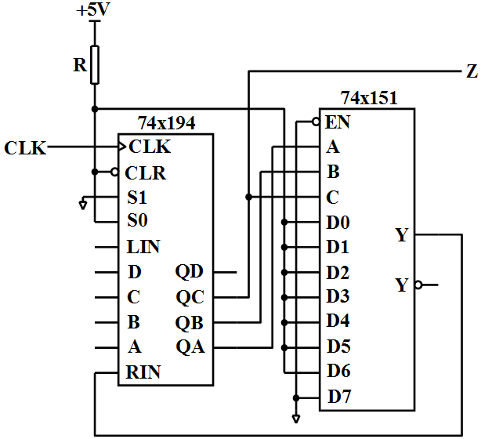
3. 电路图(正确得5分)

