电子科技大学2021-2022学年第1学期期末考试A卷
考试科目：数字逻辑设计及应用 考试形式： 闭卷 考试日期： 2023年 月 日
本试卷由 VI 部分构成，共 8 页。考试时长： 120 分钟
成绩构成比例：平时成绩 60 %，期末成绩 40 % 注：禁止使用计算器及英文辞典
题号 | 一 | 二 | 三 | 四 | 五 | 六 | 七 | 八 | 合计
得分

(Please refer to the appendix for the function description of 74 chips)
得 分

I. Please fill out the correct answers in the brackets “( )”. (2’×15 = 30’)

1. (49.125)₁₀ = ( 11 0001.001 )₂
2. (163)₁₀ = ( 00010110 0011 )_{8421BCD}
3. (1101 0110)₂ = ( 1011 1101 )_{gray}
4.(1110 1010) _{two’ complement} = ( -22 ) ₁₀
5.Given A_{two’complement}=1001 1001，B_{two’complement}=0101 0110，then (A-B) _{two’complement} = （ 0100 0011 ）. Is it overflow (Yes/No) ( Yes ).
6. Given 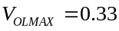V，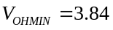V，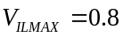V，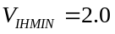V，then the High-state DC noise margin is（ 1.84 ）V。
7. .If F=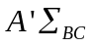(2,3)+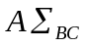(0,2,3)，then F^{D}=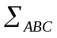 ( 2,6,7 )
8. If the output Y6_L of binary decoder 74x138 is 0 and other outputs are 1, then the inputs CBA are ( 110 ).
9. Given that the inputs C, B and A of 74x151 are a, b and c, the data inputs D₇D₆D₅D₄D₃D₂D₁D₀ are 10100101, then the output Y to the F is 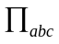 ( 1,3,4,6 ).
10. If the output of sequential circuit is only related to the state, then the circuit is called ( Moore ) (Moore/Mealy) machine.
11. An FSM with 5 flip flops has ( 32 ) states at most.
12.If the detector of ‘010’ serial sequence is designed in the way of MOORE machine, then the state machine needs ( 4 ) states at least.
13.Given that a ring counter has 6 valid states, then the number of flip flops in the counter is ( 6 ).
14. The output of a unipolar 8-bit DAC is 25.5V when the input is (1111 1111)₂. Then the output voltage is ( 0.1 )V if the input is (0000 0001)₂.

得 分

II. Choose the correct answer and fill in the brackets. ( 2’×10 = 20’ )

1.Which of the following is NOT true?（ B ）
A. 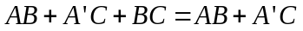
B.
C. If 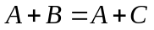 and ，then 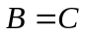
D. If 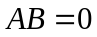 and 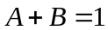，then 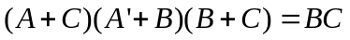
2. Which representation of a logical function is not unique?( C )
A. true table B. canonical sum C. minimal sum D.complete sum
3. Which of the following descriptions forthe unused inputs of CMOS NAND gate is NOT true?( C )
A. Connected to other used inputs B. Connected to logic 1
C. Connected to logic 0 D. Connect to VCCby pull-up resistor
4. If the clock frequency of 74x163 is 100KHz, then the frequency of its output QB is ( B )
A. 12.5KHz B. 25KHz C. 50KHz D. 100KHz
5.Which of the following expressions corresponds to a circuit with static hazard?( D )
A. 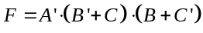 B.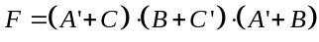
C.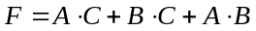 D. 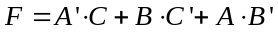
6. Given that the inputs of 74x283 are A3A2A1A0=1010, B3B2B1B0=0110, C0=1 respectively, the outputsC4S3S2S1S0 are ( A )
A.10001 B.10000 C.00001 D. 11000
7. Given that the inputs of 74x85 areALTBIN=1，AEQBIN=0，AGTBIN=0，A3A2A1A0=1010，B3B2B1B0=0110，respectively, then the outputs are ( A ).
A. ALTBOUT=0,AEQBOUT=0,AGTBOUT=1
B. ALTBOUT=0,AEQBOUT=1,AGTBOUT=0
C. ALTBOUT=1,AEQBOUT=0,AGTBOUT=0
D. ALTBOUT=0,AEQBOUT=0,AGTBOUT=0
8. How many valid states are in a 8-bit Johnson counter with self-correction? ( B )
A. 8 B. 16 C. 32 D. 64
9.74x148 is the priority encoder with valid low-level input. If the inputs I0, I4 and I7 are valid, then the outputs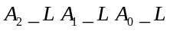 are ( D ).
A. 111 B. 011 C. 100 D. 000
10. The ROM memory chip with 20 address lines and 64 data lines has a storage capacity of ( D ) MB.
A. 1024 B. 256 C. 20 D. 8

得 分
III. Verilog HDL.[5’]
The input clock of sequential circuit is clk1, and the data input is a1，output is f1. At each rising edge of clk1, count the high level of a1. If the count value is an integer multiple of 3, then f1 is 1,otherwise f1 is 0. Design Verilog HDL module seq1. Please fill in the missing code on the underlines.

参考答案及评分标准(每个空1分)：
module seq1(input clk1,a1,output f1);
reg[0:1] cnt=0;
assign f1=cnt[1]&cnt[0];
always@(posedge clk1)
begin
if (a1)
if (cnt==3)
cnt=1;
else
cnt=cnt+1;
else
cnt=cnt;
end
Endmodule

IV. Combinational circuit analysis and design.[15’]
得 分
Logic Function F=AB+AC
（1）Write out the NAND-NAND expression of F. (3’)
(2) Write out the truth table and the minterm list of F_{(A,B,C)}. (6’)
(3) Realize the logic function F with 74x138 and an NAND gate. Complete the logic diagram . [6’]
参考答案及评分标准：
- F= ((AB)’(AC)’)’ (3分)
(2) 真值表 (4分，错1处扣0.5分)
F_{(A,B,C)}= (2分，错1处扣0.5分)

(3)使能1分，编码输入2分，输出3分
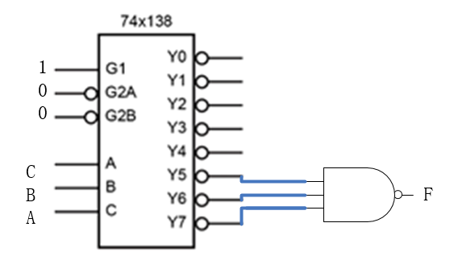
A B C | F
0 0 0 | 0
0 0 1 | 0
0 1 0 | 0
0 1 1 | 0
1 0 0 | 0
1 0 1 | 1
1 1 0 | 1
1 1 1 | 1

V. Sequential circuit design. [17’]
得 分
The state/output table is shown below. Data input is X and output is Z.Assign STA=00,X1=01,X10=10,X100=11.
- Please fill in the transition output table [4’]
- Design with D ff .Write out the minimal sum-of-products of transition equations、excitation equations and output equation for the circuit.[11’]
- Describe the function of the circuit.[2’]
参考答案及评分标准：
- 错1个小格扣0.5分
State | X
State | 0 | 1
STA | STA, 0 | X1, 0
X1 | X10, 0 | X1, 0
X10 | X100, 0 | X1, 0
X100 | STA, 0 | X1, 1
S*, Z
State | Q1Q0 | X
State | Q1Q0 | 0 | 1
STA | 00 | 00, 0 | 01, 0
X1 | 01 | 10, 0 | 01, 0
X10 | 10 | 11, 0 | 01, 0
X100 | 11 | 00, 0 | 01, 1
 |  | Q1* Q0*, Z

(2)Q1*= X’Q1’ Q0+X’Q1Q0’ (3)
Q0*= X+Q1Q0’（3）
D1= Q1*= X’Q1’ Q0+X’Q1Q0’ （2）
D0= Q0*= X+Q1Q0’（2）
Z=X Q1Q0 （1）
(3)The function of the circuit is 1001 sequence detector. (2)

得分
VI. Use only 74X163 and NAND gate to implement a modulo-5 counter circuit with counting sequence 8,9,10,11,12,8,9,10,.......The clock input is clk.[13’]
(1) Analyze and write out LD_L expressions as well as expressions for D, C, B,A (7’)
(2) Complete the schematic diagram. (6’)

参考答案及评分标准：
- If QDQCQBQA=1100,load 1000 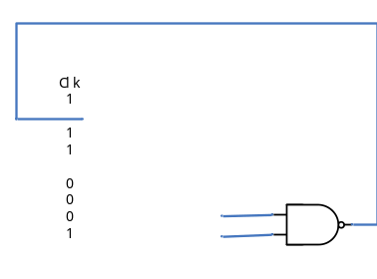
So LD_L=(QDQC)’ (3分)
DCBA=1000（4分）
- 输出QDQC连与非门正确2分, 除ABCD,CLK外的其他输入端正确1分

=====================================================

Appendix

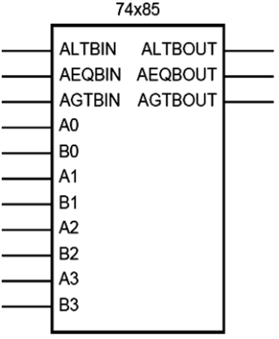

Function description: Comparator
A(A3 A2 A1 A0), B(B3 B2 B1 B0) are two 4-bit binary numbers input.
AGTBOUT=1 only when (A>B) or (A=B and AGTBIN=1).
ALTBOUT=1 only when (A<B) or (A=B and ALTBIN=1).
AEQBOUT=1 only when A=B and AEQBIN=1.
Signal name abbrev:
LT means Less Than. GT means Greater Than.
EQ means Equal. IN means Input. OUT means Output.

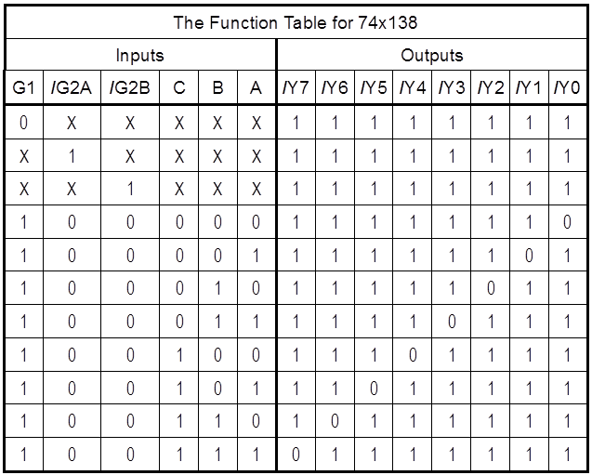

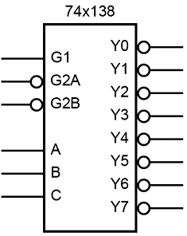

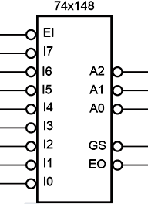
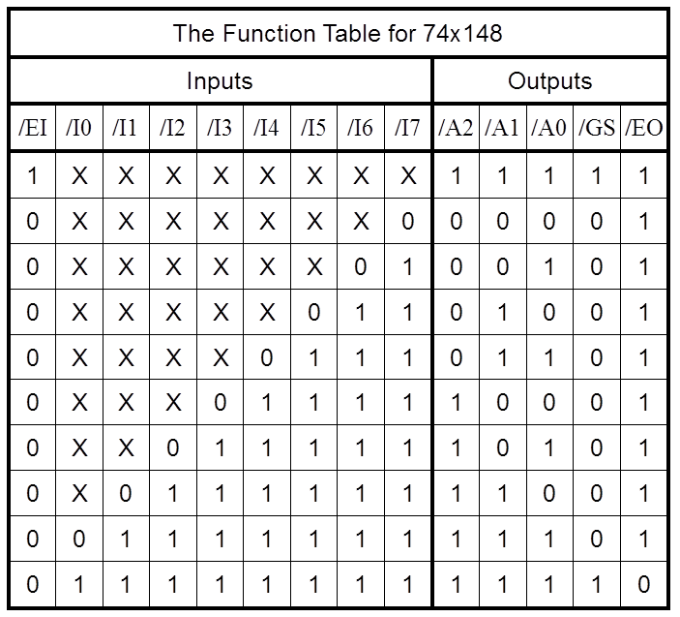

=====================================================

Appendix

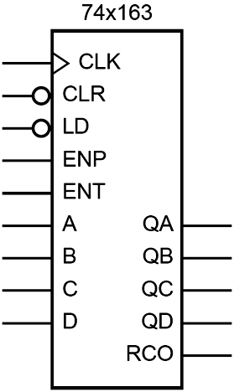
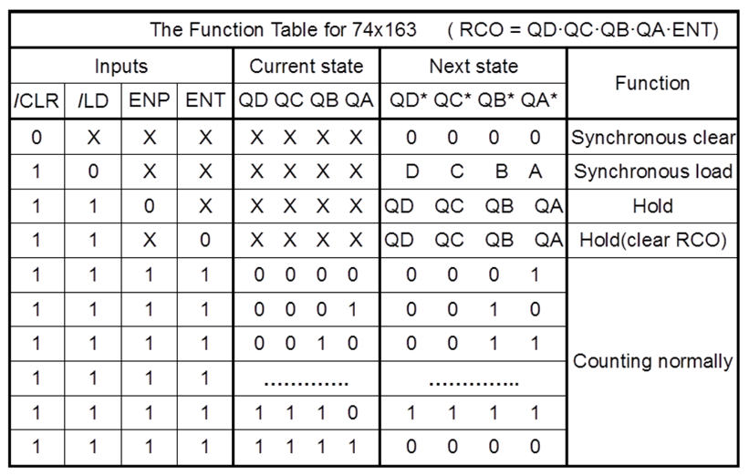

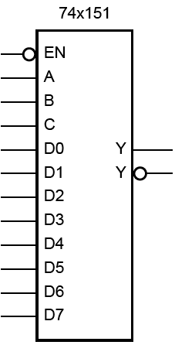
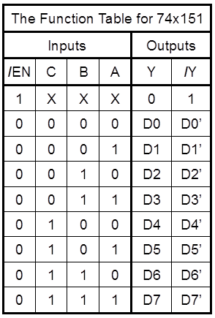

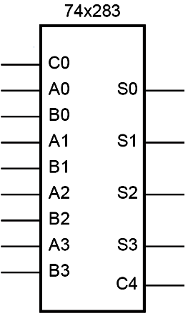

Function description: Adder
A(A3 A2 A1 A0), B(B3 B2 B1 B0) are two 4-bit binary number inputs.
C0 is the carry input.
S(S3 S2 S1 S0) is the sum output of C0 + A + B.
C4 is the carry output.

