电子科技大学2021-2022学年第1学期期末考试A卷
考试科目：数字逻辑设计及应用 考试形式： 闭卷 考试日期： 2022年 6 月 23 日
本试卷由 VI 部分构成，共 8 页。考试时长： 120 分钟
成绩构成比例：平时成绩 60 %，期末成绩 40 % 注：禁止使用计算器及英文辞典
题号 | 一 | 二 | 三 | 四 | 五 | 六 | 七 | 八 | 合计
得分

(Please refer to the appendix for the function description of 74 chips)
得 分

I. Please fill out the correct answers in the brackets “( )”. (2’×15 = 30’)

1. (0001 0110 0011) _{8421BCD} = ( 0001 1100 0011 ) _{2421BCD}
2. A_{two’s complement} = ( 1100 1101 ), (-A) _{two’s complement} = ( 0011 0011 )
3. (34.125)₁₀ = ( 10 0010.001 )₂
4. Given V_{OHmin} = 3.7V, V_{OLmax} = 0.2V, V_{ILmax} = 0.9V, V_{IHmin} = 2.1V, then High-state DC noise margin is ( 1.6 )V.
5. Given 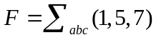, then 1, 3, 4, 5, 7）=1, 3)+ 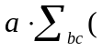0, 1, 3)
6. The output of the circuit shown in Fig.1 is F = Π_{ABC} ( 0, 1, 4, 6 ).
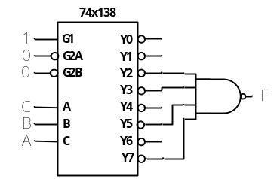
Fig.1
7. 74x283 is a 4-bit binary adder. Given S/A = 1, A3A2A1A0 = 1100, B3B2B1B0 = 1001, for the circuit shown in Fig.2, then S3S2S1S0 = ( 0011 )
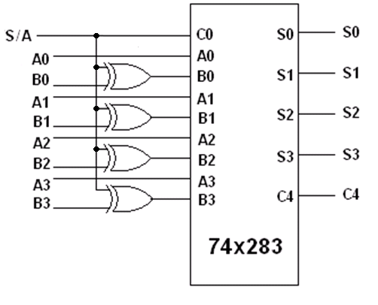
Fig.2
8. A modulo-28 counter requires ( 5 ) flip flops at least.
9. An FSM is called ( mealy ) machine when the output depends not only on its states but also on the input.
10. The number of valid states is ( 8 ) for an 8-bit ring counter.
11. The output voltage of a unipolar 8-bit DAC is 0.04V if the input is (0000 0001)₂. The output voltage is ( 5.12 )V when the input is (1000 0000)₂.
12. 74x85 is a 4-bit magnitude comparator. If the input ABCD shown in Fig.3 is 0100, the output F is ( 0 )
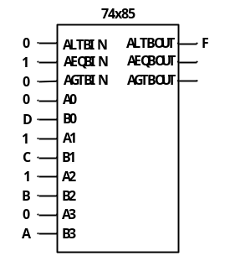
Fig.3
13. The three-state output is logic 1, logic 0 and ( Hi-z or Open or floating ).

得 分

II. Choose the correct answer and fill in the brackets. ( 2’×10 = 20’ )

1. X⊕Y is not equivalent to ( D )
A. X'⊕Y' B. X☉Y' C. (X☉Y)' D. X'☉Y'
2. The condition of static-1 hazard for 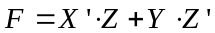 is ( B ).
A. X=0, Y=0 B. X=0, Y=1 C. X=1, Y=0 D. X=1, Y=1
3. The arithmetic operation 105= 42+23 is correct in one number system. The possible radix of the numbers in the equation is ( B ).
A. 5 B. 6 C. 7 D. 8
4. A modulo-264 counter requires ( C ) 74x163 binary counters at least.
A. 1 B. 2 C. 3 D. 4
5. Given a ROM with address input A0~A7 and data output D0~D3, how many word lines it has? ( D )
A. 4 B. 8 C. 16 D. 256
6. Which state(s) in Fig.4 is/are ambiguous ( C ).
A. State A and C B. State A C. StateA, B and D D. State A and B
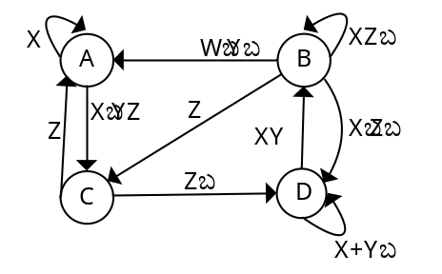
Fig. 4
7. To generate a sequence signal 11010111 using shift register, ( C ) bits are required at least.
A. 3 B. 4 C. 5 D. 6
8. Given logical function F(A,B,C,D)=(AB')'+(C'D+B'C)', the simplest expression is ( A ).
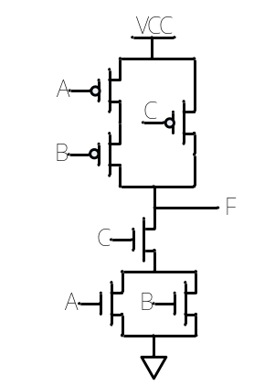
Fig. 5
A. A'+B+C 'D' B. A'+B+C ' C. A'+B+B'C 'D' D. A'+B
9. (64)₁₆ is equivalent to ( C ).
A. (94)₁₀ B. ( 0100 0000 0100 )₈₄₂₁
C. ( 1010110 )_{gray} D. (1100101)₂
10. The output of the circuit shown in Fig.5 is ( A )
A. ((A+B)C)’ B. (AB+C)’
C. (A+BC)’ D. (A(B+C))’

得 分
III. A Verilog module for the SHRG4U 4-bit shift register and it’s function table are shown as below. There are several errors in the Verilog module. Please find the errors and correct them. (6’)
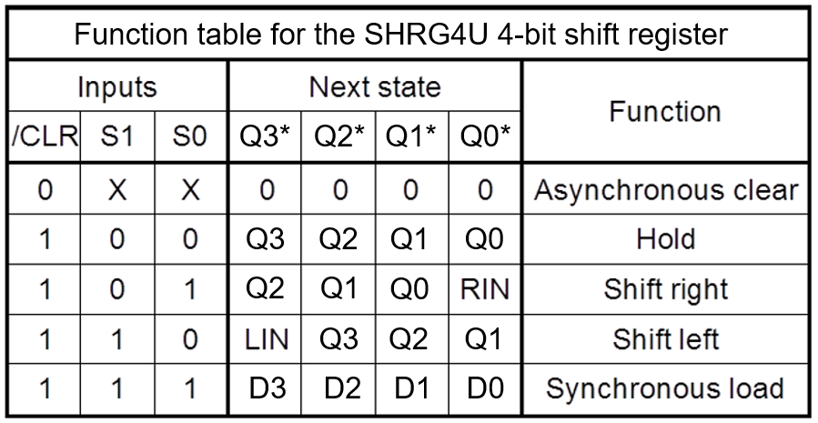

module SHRG4U( CLK, CLR_L, RIN, LIN, S, D, Q ); //1
input CLK, CLR_L, RIN, LIN; //2
input S; //3
input [3:0]D; //4
output reg [3:0]Q; //5
//6
always @ ( posedge CLK ) begin //7
if( CLR_L ) Q <= 0; //8
else case(S) //9
0: Q <= Q; //10
1: Q <= {RIN,Q[3:1]}; //11
2: Q <= {Q[2:0],LIN}; //12
3: Q <= D; //13
endcase //14
end //15
endmodule //16

【参考答案及评分标准】（每空1分，共6分）以下10处正确1个得1分，共6分
Line ( 3 ) is error. Modified to: ( input [1:0]S; )
Line ( 7 ) is error. Modified to: ( always @( posedge CLK or negedge CLR_L) begin )
Line ( 8 ) is error. Modified to: ( if(CLR_L==0) Q<=0; 或! CLR_L 或~ CLR_L )
Line ( 11 ) is error. Modified to: ( 1: Q <= { Q[2:0], RIN }; )
Line ( 12 ) is error. Modified to: ( 2: Q <= { LIN, Q[3:1] }; )

得 分

IV. A combination logic circuit is shown in Figure IV. (16’）

1. Analyse the combination logic circuit and write its logical expression. [3’]
2. Write out the canonical sum of F(A, B, C, D). [4’]
3. Please fill out the Karnaugh Map (Table IV) of F(A, B, C, D) . [4’]
4. If inputs (A B C D) are 8421-BCD codes, minimize the logic function F(A, B, C, D) into minimal AND-OR expression using Karnaugh Map (Table IV) you filled with minimal cost. [3’]
5. Minimize the logic function F(A, B, C, D) into minimal hazard free AND-OR expression . [2’]
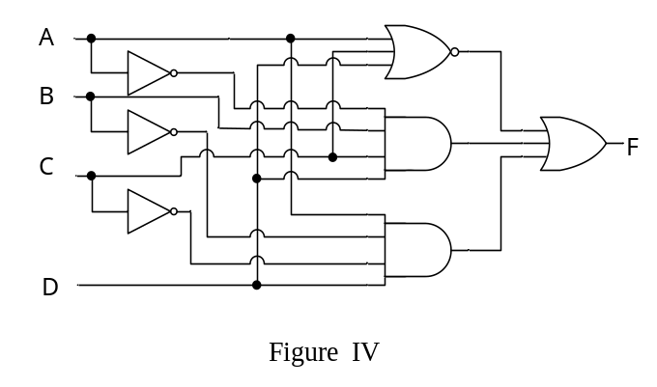
Table IV
AB  CD | 00 | 01 | 11 | 10
00 | 1 | 1 | d
01 |  |  | d | 1
11 |  | 1 | d | d
10 |  |  | d | d

【参考答案及评分标准】
1．F = (A+C+D)’ + A’BCD + AB’C’D （正确得3分）
2．F = A’BC’D’ + A’B’C’D’ + A’BCD + AB’C’D （正确得4分）
3．见Table IV，每格1分，共4分。
4．F = A’C’D’ + BCD+AD （无关项填写正确得1分，化简正确得2分；只有表达式，对一项得1分）
5．F = A’BC’D’ + A’B’C’D’ + A’BCD + AB’C’D ；F = (A+C+D)’ + A’BCD + AB’C’D；F = A’C’D’ + BCD+AD（3种答案都算对。2分）

得 分
V. Analyze the sequential-circuit as shown below, which contains two 74x163 4-bit binary counter. (8’)

1. Write out the logic expression of LD_L(RCO1，RCO2) for U₁ and U₂. [4’]
2. Assume the initial state is 196₁₀, write out the state sequence in a cycle for the circuit. [2’]
3. Indicate the modulus for the circuit. [2’]
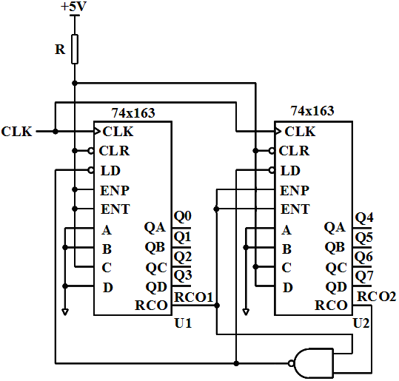

【参考答案及评分标准】
1. LD_L (RCO1，RCO2) = (RCO1·RCO2)’（4分）
2. 状态序列： 196, 197, 198…253, 254, 255, 196（2分）
3. modulus=60（2分）

得 分

VI. Analyze the clocked synchronous state machine in Figure VI. (20’）

1. Write out excitation equations and the output equation. [4’]
2. List out the transition/output table (Table VI). [8’]
3. Assume the initial state Q₃Q₂Q₁=000, draw the timing diagram for Q₃, Q₂, Q₁ and Z. [8’]

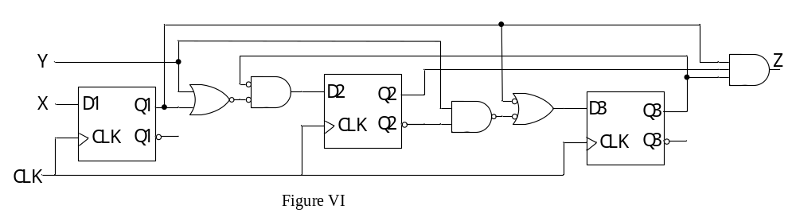
【参考答案及评分标准】
1．激励方程：D₁ = X D₂ = (Y+Q₁)Q₃’ D₃ = Y Q₂’+ Q₁’
输出方程：Z = Q₁ Q₂ Q₃ （每个方程1分，共4分）
2．填Table VI，每行1分，共8分。
Table VI Transition/output Table
S | XY |  |  |  | Z
S | 00 | 01 | 10 | 11
000 | 100 | 100 | 111 | 111 | 0
001 | 010 | 110 | 011 | 111 | 0
010 | 100 | 100 | 111 | 111 | 0
011 | 010 | 010 | 011 | 011 | 0
100 | 100 | 100 | 101 | 101 | 0
101 | 000 | 100 | 001 | 101 | 0
110 | 100 | 100 | 101 | 101 | 0
111 | 000 | 000 | 001 | 001 | 1
Q₃Q₂Q₁ | Q₃* Q₂* Q₁*

3．每个信号波形2分，共8分。
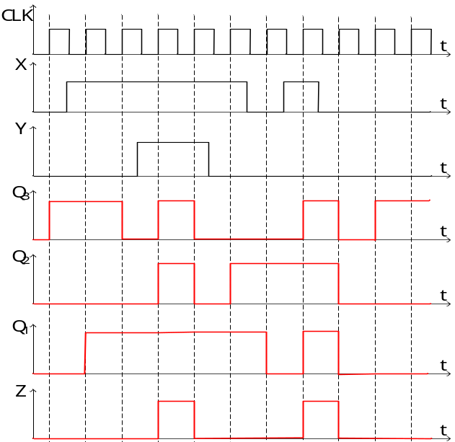

=====================================================
Appendix

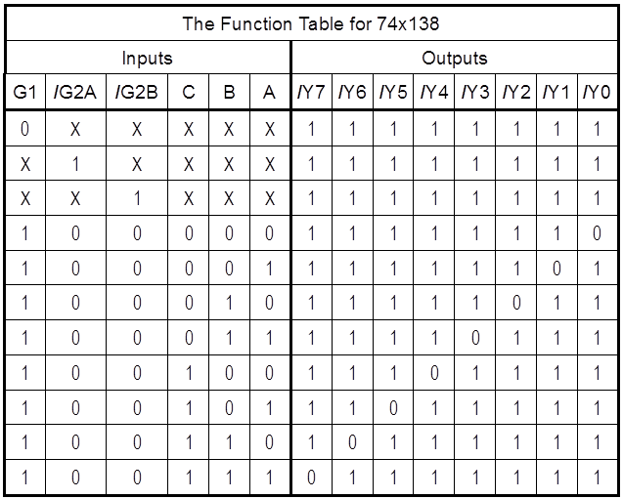

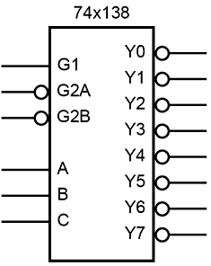

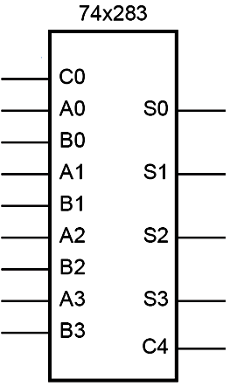

Function description: Adder
A(A3 A2 A1 A0), B(B3 B2 B1 B0) are two 4-bit binary number inputs.
C0 is the carry input.
S(S3 S2 S1 S0) is the sum output of C0 + A + B.
C4 is the carry output.

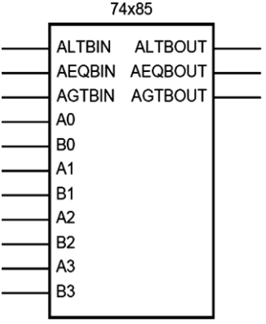
Function description: Comparator
A(A3 A2 A1 A0), B(B3 B2 B1 B0) are two 4-bit binary numbers input.
AGTBOUT=1 only when (A>B) or (A=B and AGTBIN=1).
ALTBOUT=1 only when (A<B) or (A=B and ALTBIN=1).
AEQBOUT=1 only when A=B and AEQBIN=1.
Signal name abbrev:
LT means Less Than. GT means Greater Than.
EQ means Equal. IN means Input. OUT means Output.

