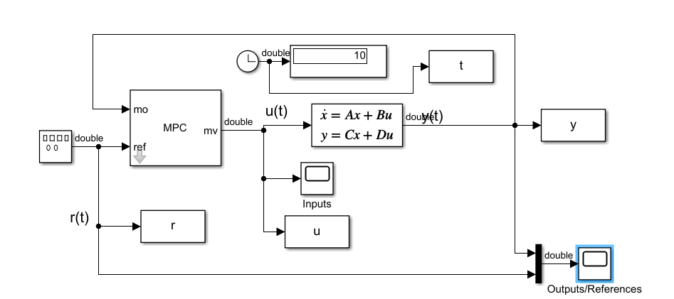

cwd = pwd;

tmpdir = tempname;

mkdir(tmpdir);

cd(tmpdir);

plant = ss(tf([3 1],[1 0.6 1]));

Ts = 0.1; %Sample time

p = 10; %Prediction horizon

m = 2; %Control horizon

Weights = struct('MV',0,'MVRate',0.01,'OV',1); % Weights

MV = struct('Min',-Inf,'Max',Inf,'RateMin',-100,'RateMax',100); % Input constraints

OV = struct('Min',-2,'Max',2); % Output constraints

mpcobj = mpc(plant,Ts,p,m,Weights,MV,OV);

mdl1 = 'mpc_rtwdemo';

open_system(mdl1)

sim(mdl1)

disp('Generating C code... Please wait until it finishes.')

set_param(mdl1,'RTWVerbose','off')

slbuild(mdl1);

if ispc

disp('Running executable...')

status = system(mdl1);

else

disp('The example only runs the executable on Windows system.')

end

**Load and plot two discrete-time transfer functions Pd and Cd of order 9 and 2, respectively:**

% Load Pd,Cd models

load numdemo Pd Cd

% Plot their frequency response

bode(Pd,'b',Cd,'r'), grid

legend('Pd','Cd')

Ltf = Pd * Cd; % TF

Lzp = zpk(Pd) * Cd; % ZPK

Lss = ss(Pd) * Cd; % SS

w = logspace(-1,3,100);

Lfrd = frd(Pd,w) * Cd; % FRD

sigma(Ltf,'b--',Lzp,'g',Lss,'r:',Lfrd,'m--',{1e-1,1e3});

legend('TF','ZPK','SS','FRD')

pzplot(Pd,'b',Cd,'r');

title('Pole/zero maps of Pd (blue) and Cd (red)');

axis([0.4 1.05 -1 1])