

**Bachelor of Information Technology**

**Project Report**

**Intake: *Feb, 2021***

**Database Design Document for Madan General Supplies**

**Submitted by: Submitted to:**

***Hikmat Raj Ghodasaini Mr. Mohan Singh Ayer***

***LC0003000841* Subject: *RDMS with SQL***

***hikmatraj.ghodasaini@pcmgmt.edu.np***

**Abstract**

As part of a course requirement, we students must create a database design for a real-life business environment, which will include documentation for the users. The project has five phases planning, analysis, design, and implementation. In the planning phase, we submitted a proposal to Madan General Supplies, which was approved by the owner and then conducted interviews to gather information about their supply processes. During the analysis phase, we examined the existing systems and data storage methods in detail to identify opportunities for improvement. We decided to design a database that could meet their requirements and be used even after the store has expanded. We created a conceptual model in the design phase and then developed a physical design. This report details the steps taken to complete the database design and is divided into five chapters, each with its own deliverables.

**Acknowledgment**

We received feedback from numerous individuals throughout the project and would like to express our gratitude to all those who directly or indirectly assisted us in completing this project. We are particularly grateful to Mr. Madan Bhandari for allowing us to work on this project and for his immense support in providing us with all the necessary documents and answering all of our queries despite his busy schedule managing the store. We also extend our appreciation to the supply staff for their encouragement and friendliness towards us as students. Furthermore, we thank Dr. Mohan Singh Ayer for his continuous support and mentorship throughout the project.

# Table of Contents

Table of Contents 3

1. Introduction 4

2. Problem Statement 4

3. The Objective of Study: 4

4. Literature Review: 4

5. Project Plan: 5

6. Project Budget 5

7. Methodology 6

8. Result: 9

9. Discussion and Limitations: 9

10. Conclusion 9

11. SCREENSHOTS: 10

6

# 1. Introduction

Our client is Mr. Prchanda Dahal who is the owner of prachanda General Supplies. prachanda General Supplies is a local retail business that specializes in supplying various goods to other shops and businesses as well as selling general goods to the community. The company requires a robust database system to help manage its inventory, sales, and customer data efficiently. This document presents a database design plan that addresses these needs.

# 2. Problem Statement

Prachanda General Supplies has been struggling to manage its inventory and customer data effectively. The current paper-based system is cumbersome, inefficient, and prone to errors, leading to lost sales and revenue. The company requires a reliable database system that can accurately track inventory levels, process sales orders, and manage customer data to improve business operations and increase customer satisfaction.

# 3. The objective of Study:

The primary objective of this study is to design a database system that can help prachanda General Supplies efficiently manage its inventory, sales, and customer data. The database system should be user-friendly, reliable, and flexible enough to adapt to the changing business environment.

# 4. Literature Review:

Efficient inventory management, sales tracking, and customer relationship management are critical to the success of any retail business. The literature suggests that a well-designed database system can help businesses achieve these goals by providing accurate and timely information to decision-makers. A database system should be designed based on the business’s specific needs, including the size of the inventory, the number of customers, and the complexity of the sales process.

# 5. Project Plan:

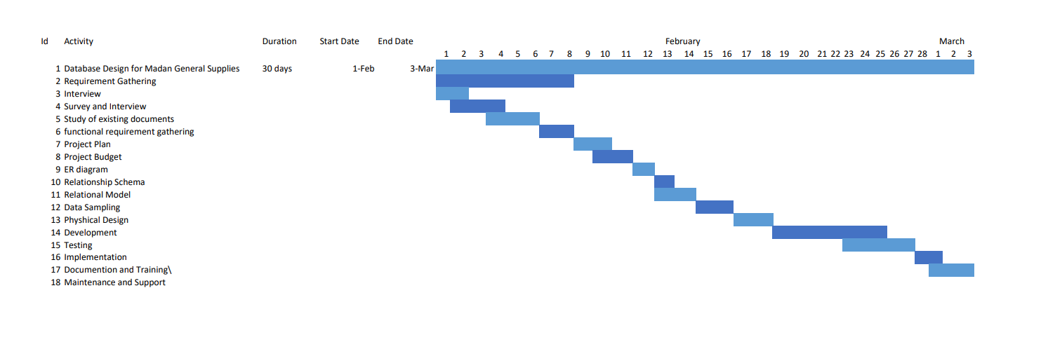

# 6. Project Budget

The project Budget is a detailed estimate of all costs required to complete the project.

|  |  |
| --- | --- |
| **Description** | **Cost** |
| Time (this includes total number of hours spent on this project) | Rs 12,000 |
| Transportation | Rs 3000 |
| Communication | Rs 500 |
| Hardware | Rs 45,000 |
| Software (this includes all the software used and the premium services used) | Rs 700 |
| **Total** | **Rs 60,700** |

***Table 1***

# 7. Methodology

The database design will follow a structured methodology that includes the following steps:

**Requirement Analysis:** We gathered various requirements just by observing the day-to-day function that occurs. We also investigated previously used file system to see what the necessities for the database are. Finally, we took an interview with Mr. Prachanda Dahal for the detailed requirements that the digital database must have.

1.1. **Functional Requirements:**

a. Show all the information about the customers and shops who get goods every month.

2. Show all the inventory information that is present and is on the way from the supplying company

3. Provide information about a selected item.

4. Show the orders made by the customers and stores separately and whether they were made offline or online.

5. Count the number of items in each inventory.

6. Be able to count the total sales made in a month and the total revenue.

1.2 **Non-Functional Requirements:**

a. The database system should be always available.

b. The database must be secured and safe from attacks and manipulation.

c. In the event of a crash, the database must always store a backup.

d. Only the owner has access to manipulate and change any data in the database.

1. **Database Design:**

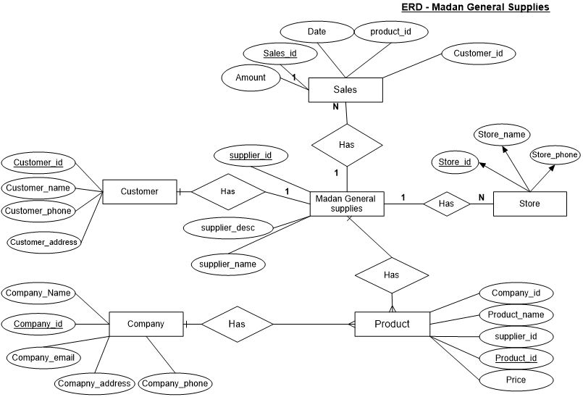Enhanced Entity-Relationship Diagram

**Fig:**1.1 *ER diagram*

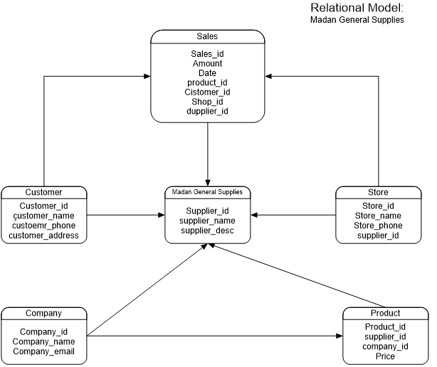

**Fig:1.2** *Relation diagram*

1. **Database Implementation:**

The database is created and is implemented with the required hardware in a server.

# 8. Result:

The resulting database design includes the following entities:

1. **Product:** This entity includes product information, such as product ID, product name, price, and quantity in stock.
2. **Supplier:** This entity includes supplier information, such as supplier ID, supplier name, and supplier description.
3. **Customer:** This entity includes customer information, such as customer ID, name, address, and contact information.
4. **Store:** This entity includes order information, such as store ID, store name, store contact information supplier id.
5. **Sales:** This entity includes sales information, such as sales ID, sales date, customer ID, product ID, quantity, and total revenue.

# 9. Discussion and Limitations:

This design process shed light on various things that need to be taken to make the most optimum database that is tailored to meet the needs of a customer.

The database design presented in this document is tailored to meet the specific needs of Prachanda General Supplies. The design may not be suitable for other businesses with different requirements. Additionally, the design is subject to the limitations of the database management system used to implement it, including the maximum number of records, fields per table, and database size. It is important to ensure that the database system is regularly maintained and updated to ensure its accuracy and efficiency in supporting business operations.

# 10. Conclusion

As part of our database management course, we acted as database designers for a real business called Prachanda General Supplies and completed the analysis, design, and implementation of their database over one semester using an SQL server. The success of the project depended on budget and time, and while it was completed within budget, time management was difficult due to a heavy workload. This project taught us to work under pressure, communicate effectively with clients, and think critically to create computerized solutions. Additionally, it improved our teamwork and coordination skills. Writing the functional and non-functional requirements posed a challenge, requiring extensive research and brainstorming. Moving forward, we hope to add more features that align with the store's policies.

# 11. SCREENSHOTS:

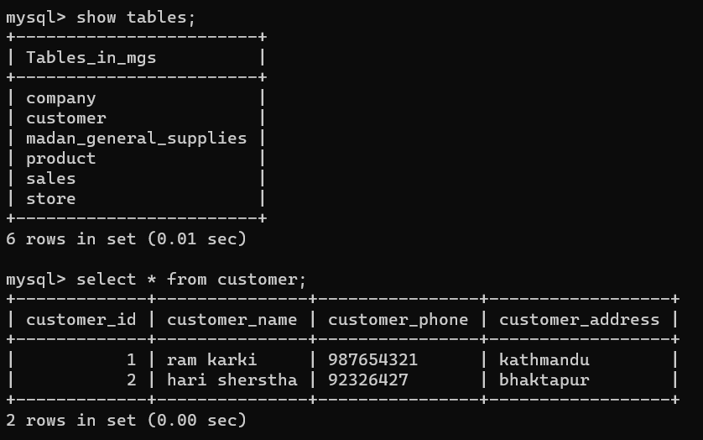

**Fig:2.1** *Customer*

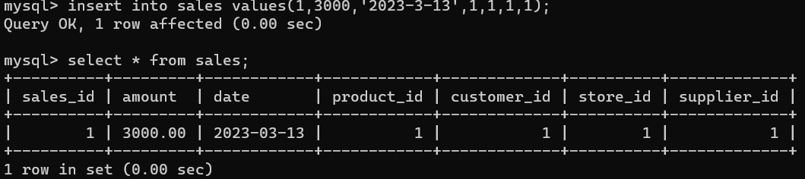**Fig:2.2** *Sales*

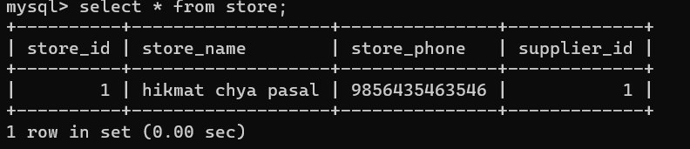

**Fig:2.3** *Store*

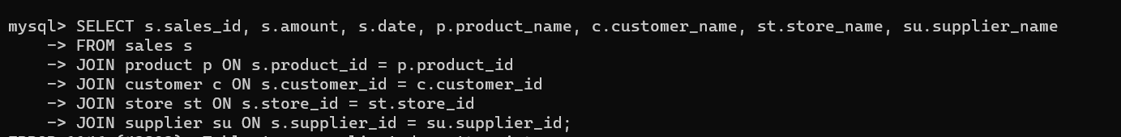

**Fig:3.1** Data