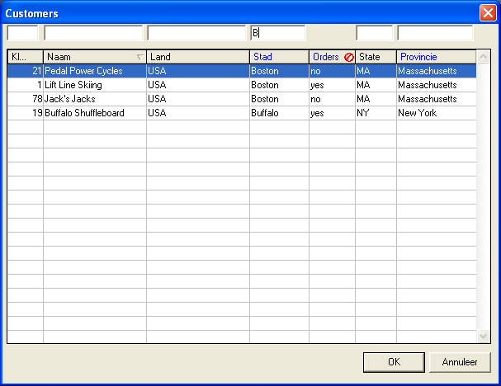

What is this?

This is a dynamic browserwindow, browse_exp.p in this zipfile, fed from a minimal repository to get the specific UI and query. It should compile starting from 9.1D as its most modern language-element is the CALL object. I have resized the name (and number) column a bit wit the mouse, you can see the number-label ends in a couple of periods. The last part of the columnheader always stays reserved for images. After that I clicked two times on the name-header, resulting first in an ascending and later in a descending sort. Notice the arrow-image. If you change the windows 3-D objects color in the settings for the operatingsystem the colors of the images change accordingly. If you resize a column with an image, the images move to the right place on end-resize. Orders is a calculated field (it indicates if the customer has orders), I forbid sorts on calculated fields. This is indicated by the image. Filter-fields are generated too, for non-calc fields. You can see the result of the filterfield on city. Non-indexed sorts are indicated by a blue column-label.
The dynamic browserwindow can be started in selection-browser modus (dialog-box), the picture above is an example of one. The other modus is a persistent window. You could extend browse-exp.p with a for example maintainance-buttons, make it work without db-connection etc. In that case, please inform me/send me your add-on's/bugfixes if you think it would be interesting for others. You can just steal whatever you like from it (the triangles I suppose?) too, and forget the rest. You can easily maintain the repository with the "browserbuilder" utility that I have put in this package also.
If you are on V10 and winXP and have not removed prowin32.exe.manifest from your bin-directory you will notice the xp-style browse with a slightly darker columnlabelcolor fo selected columlabels. If you want the arrowbitmaps exactly the same color you will have to edit the bitmaps in the package.
Note that this package has not been used in production yet and is not tested thoroughly. Please inform me when you find bugs on the mailaddress below.

How do I create a working development-environment?

- Get the freeware messageblaster-ocx on http://extra.newsguy.com/~bridge/mbocx32b.zip (it is spoken about on Jurjen's site) and register with regsvr32

- Create browse_exp.wrx by saving a new window named browse-exp.p with only an instance of the ocx on it.
- load extra.df

- add the "special" and the "experim" directory to the propath so that the files in special/adeuib and special/adecomm are found before those in your progress-installation.

compile the contents of the specialdir with the -zn parameter as some variables & temptables start with an underscore. The adeuib and adecomm includes are from OE10.1A, available at http://psdn.progress.com/cgi-bin/codeshare.cgi/search_results.w?category=10 . For lower versions you could have to downgrade a bit, there are possereleases available on http://possenet.progress.com/download/index.ssp .

- add to your custom progress.cst:
*NEW-CONTAINER &Browsecreator
NEW-TEMPLATE <your dir>/special/template/browsecreator.w

How do I create a browserinstance?
- Create one or more func-records as I did not develop a maintainance module for this table yet
(f.e. func="b-customer" wintitle="Customers")

- Select new - browsecreator in the appbuilder

- Select the function you want to maintain

- Maintain your query and columns with query and columnbuilder. Follow these rules for now:
> browse-exp.p does not handle by-phrases, so these should not be used
> browse-exp.p does not handle column-labels with more then one line, so these should not be
used
> browse-exp.p does handle calculated fields. If you edit the calcfield, you only supply a function-
name (without the ()), further you need to supply label and format.
You do not need to resize the browser or do anything else in the window as these changes are
not saved into the repository. The width of the browsercols are calculated from format &
columnlabel, the width of the browse is derived from those, row-height-pixels are hard-coded as
are the number of rows and font. The width and heigth of frame and window are derived from
those of the browse-widget.

When you are ready press on "save" in the appbuilder. adeuib/_advsrun.p recognizes the
needed special handling from the development-windowtitle and only writes the relevant info from the development-window to the database, informs you this is done with a message and
eventually presents functionframes for the calc-fields which are generated and presented in notepad. These should help you edit a superprocedure which name is presented in notepad. The super should be added to the ./calcsupers dir.

Please note that the extra images are not always repainted when running from
developmentwindows (with the appbuilder). If you start a mainwindow from a shortcut
and the browserwindows from there you will see that the repaint works under all circumstances.

Run the browsewindow from a button, menu-item or whatever, using
1. For the persistent window version code in the choose-trigger:
DEFINE VARIABLE hProc AS HANDLE NO-UNDO.
RUN browse_exp.p PERSISTENT SET hProc.
RUN setEntry IN hProc.

Assign as private-data for button or menu-item:
func.func value (browse-exp.p reads self:private-data).
2. For the selectiondialogbox version code in the choose-trigger:
RUN browse_exp.p.

Assign as private-data for button or menu-item, pipe-separated:
func.func value
“dialog”
<widgetname1=fieldname1,widgetname2=fieldname2,etc>

For example:
b-customer|dialog|FI-cust-num=cust-num,FI-name= name
(last entry means that the cust-num value is assigned to fillin FI-cust-num and name to
FI-name after choosing OK in the dialog-box.
Comments?

- Are welcome. Please send them to agent_008_nl@yahoo.com

