Python Final Project

Project Name:

Haoran lib spy

Project Description and planning:

As a library lover, there is saying “If I’m not in library, I’m just on the way to library”. The library of nctu is rich in inspiring books, however, sadly, after I became a college student of nctu, I found its library designed a website with mess layout. Especially it is hard to browse what new books have been add into the library. So I want to develop a mashup program to solve this annoying situation with my python programming skill, and incidentally get high pass in my class. So, the idea of the python program project will have following powerful functions (at least for me:). First, it should crawl the data of the new books from library website. Second, processing this data and ranking them with my reading taste, a common way is sorting the popular books in descending. Third, output these data with readable form, may be email, chat robot, and so on.

This project can be break into several parts. The first part is writing a program that can collect data from library website. Second, making good use of Google Books API to receive more detailed information and picture and review of a book. Browsing new books shouldn’t be full of title, it should companied with book cover and introduction to its contents. Google book api allow programmers to access detailed data of books what they have prepared. Finally, integrate this stuff into useful data, making browsing new books as clear as browsing online bookstores, and let user can use my achievement by chat bots or email senders.

Timeline :

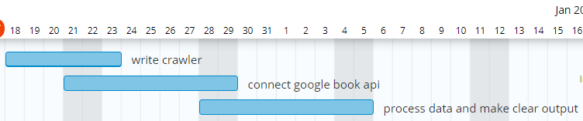

Update 1:

What have been done:

1. Crawl New book isbn from haoron library
2. Use isbn to send search request to google book api for book id
3. Use book id to retrieve book information in json from google book api
4. Formatizing these data into xlsx file to be browse easily

Changes on the final project plan:

1. Output data in excel rather than email or chatbot, because I found useful python library can visualize my list of books quickly. It(xlsxwriter) saved me a lot of time.
2. Add function that can deal with picture got from book api, adjust them into same size.

Timeline for the rest.

1/4(Sat) Add another web service, and deal with some detail.

1/5(Sun) Make sure all function work correctly and refactor my code, finish!