How does it work?

Crawl haoron lib website

Use two API: google search and google book

Use xlsxwriter to create xlsx file and Pillow to adjust all pictures to same size

step.1 run the following two commands:

""""""""""""""""""""""""""""""""""""""

pip install XlsxWriter

pip install Pillow

""""""""""""""""""""""""""""""""""""""

step.2 Execute AllinOne.py, the program needs an URL input and number of books.

Because the library website is equipped with Oauth2 system, which has certificate that makes my code can’t crawl it by static URL. So,

To get URL, open the website, pass the authorization (login if necessary)

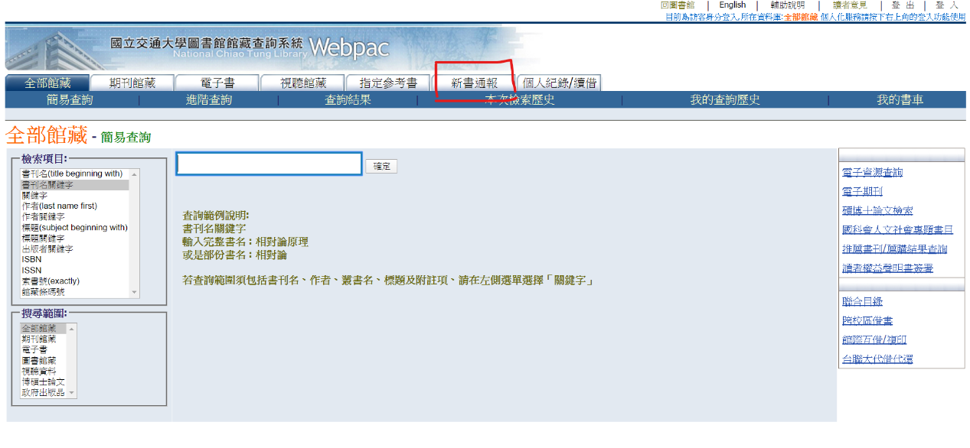<https://webpac.lib.nctu.edu.tw>

[](https://webpac.lib.nctu.edu.tw)

click “**新書通報**”

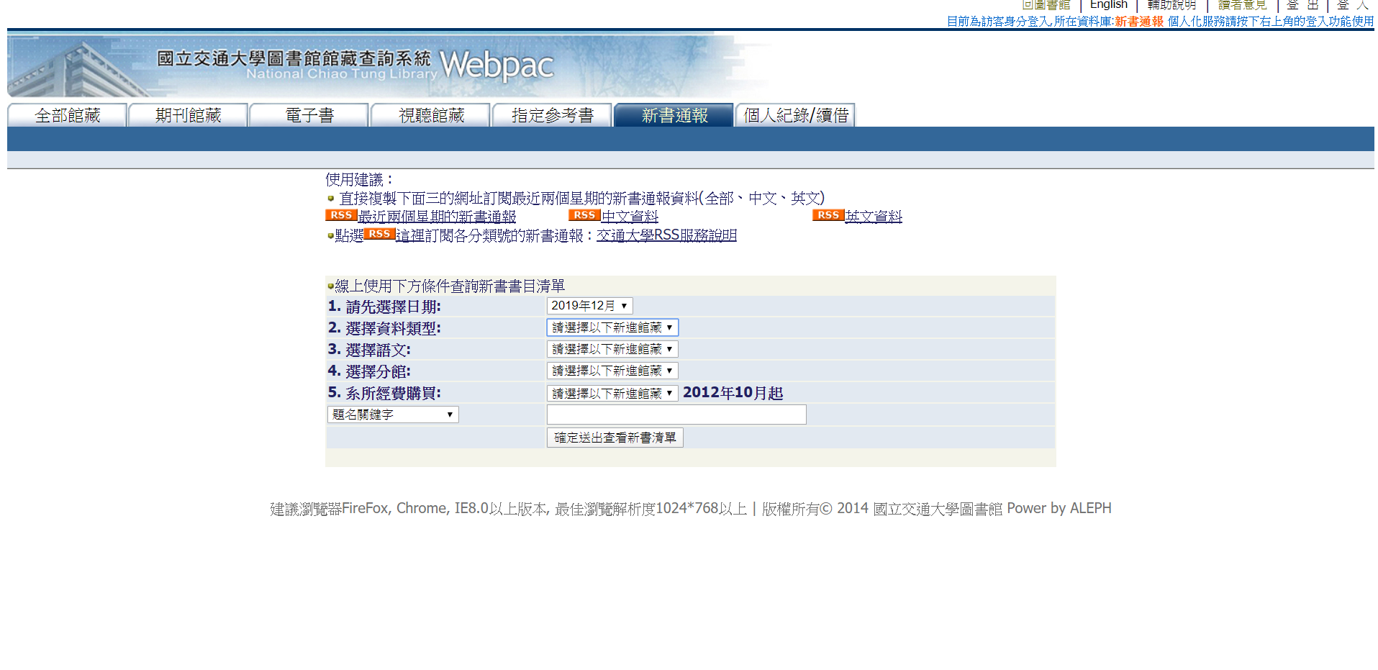

Select date and hit “**確定並送出新書清單**”

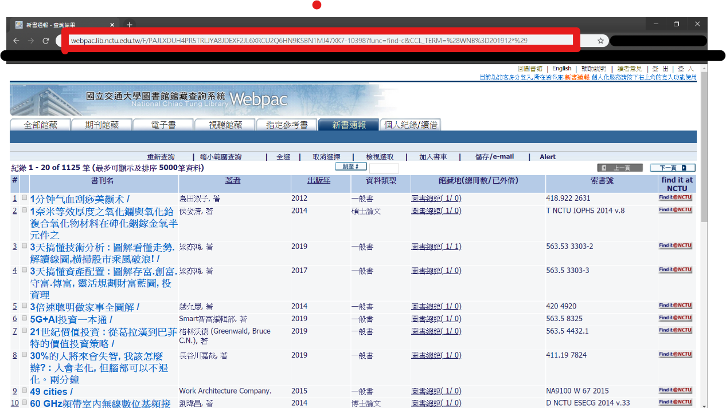

Copy the URL and enter it into SpyLibForIsbn.py

Wait until finish

