**Compiler Construction**

**Lab 2**

# **Task 1)**

**Single line comments**

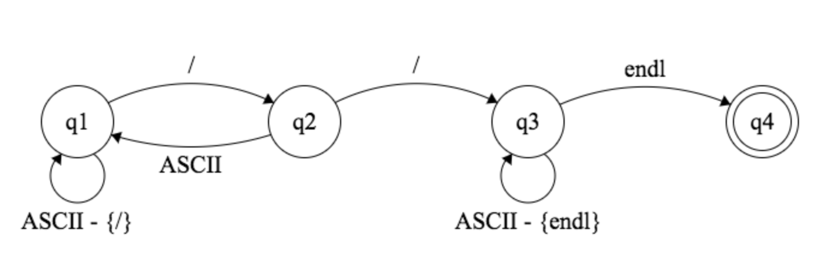

**Multi-line comments**

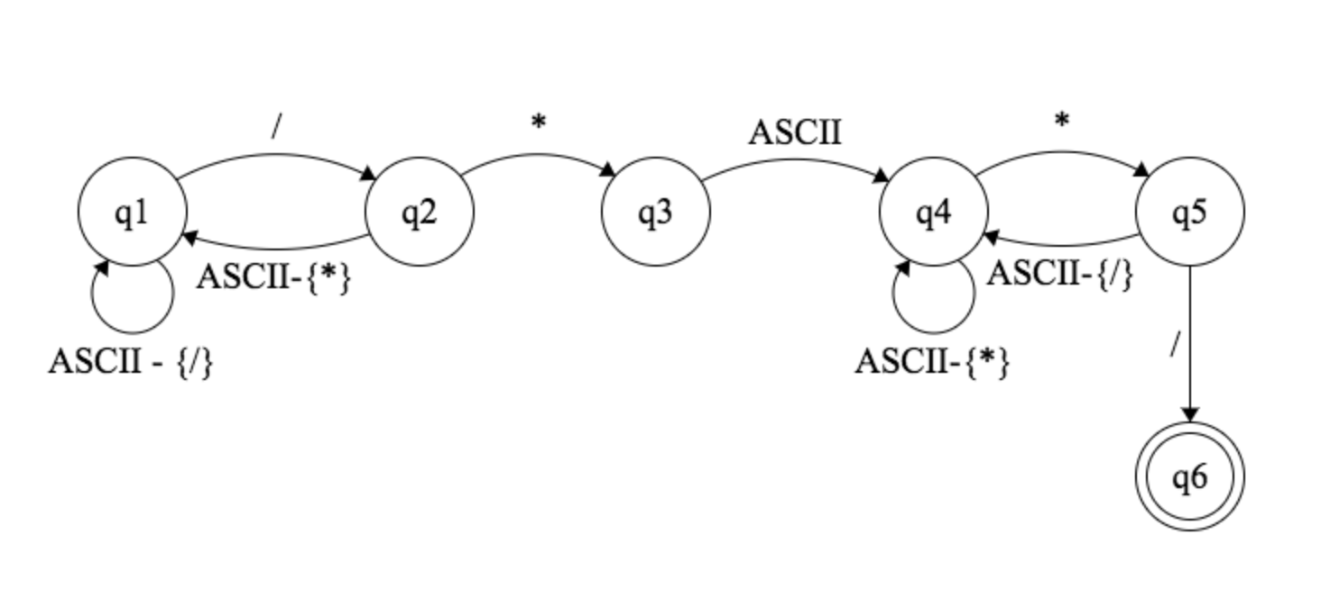 **Numbers**

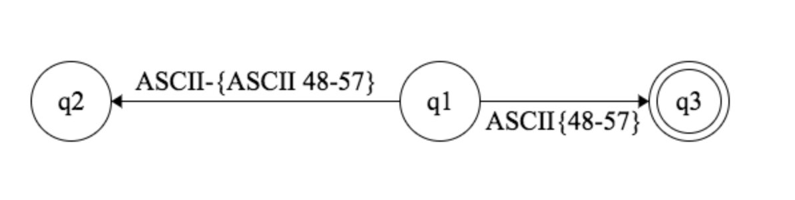

**Arithmetic OP**

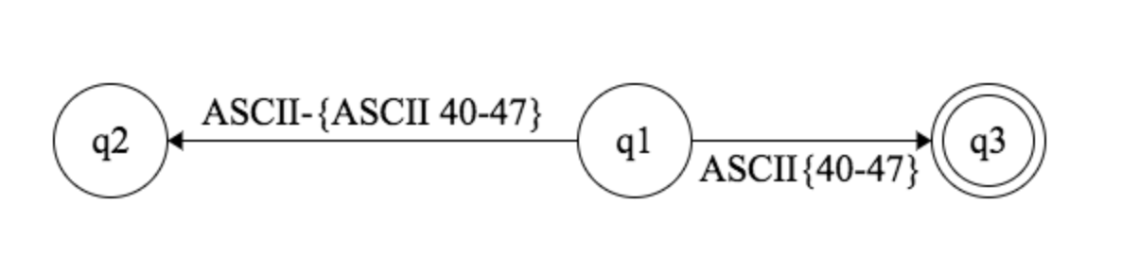

**Keywords**

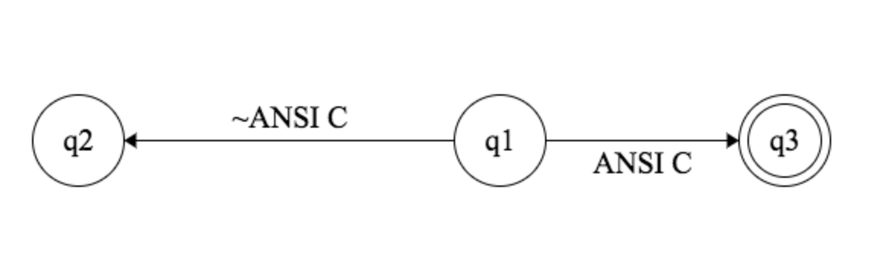

# **Task 3) Code**

#include <iostream>

#include <fstream>

#include <string>

using namespace std;

int main()

{

cout << "Hashim Ikram’s Lexer\n";

ifstream file;

string line;

bool single_comment_flag = false, multi_comment_flag = false;

int x;

file.open("/Users/Hashim/Documents/School/Semester7/CompilerConstruction/labs/lab2/lab-02/lab-02/input_scanner.txt");

if (file.is_open()) {

for (; getline(file, line); ) { //read a line and store it in string 'line'

for (int x = 0; x < line.size(); x++) { //scan each line char by char

switch (line.at(x)) {

case '/':

if ((x < line.size() - 1) && line.at(x + 1) == '/') //single line comment

single_comment_flag = true;

break;

case '*':

if (((x < line.size() - 1) && (x > 0)) && line.at(x - 1) == '/') //multi-line comment

multi_comment_flag = true;

else if (multi_comment_flag && ((x < line.size() - 1) && (x > 0)) && line.at(x + 1) == '/')

multi_comment_flag = false;

break;

default:

if (single_comment_flag || multi_comment_flag)

continue;

else

cout << line.at(x);

}

}

cout << "\n";

single_comment_flag = false;

}

}

cin >> x;

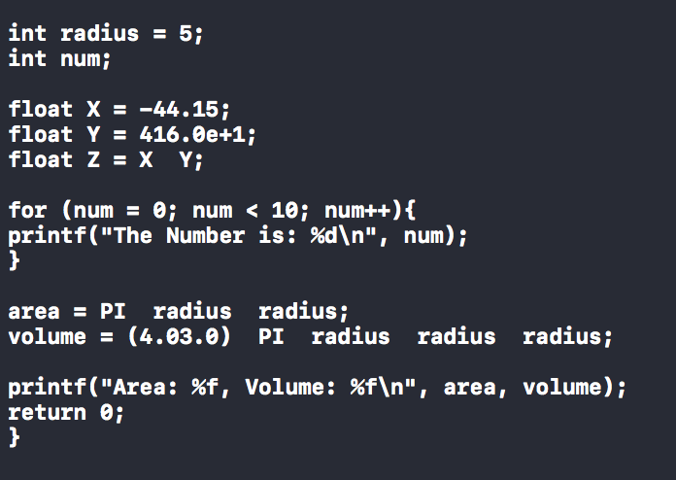 return 0;

}