**DATA COMMUNICATION & NETWORKS**

Metropolitan Area Network

Halil İbrahim Kaan Yıldız

Mehmet Mollaoğlu

Yenal Yılmaz

Data Communication and Computer Network

Midterm Project

Supervisors : Prof. Dr. Yalçın Çebi

Izmir, Turkey

Dokuz Eylül University Department of Computer Engineering

## Table of Contents

Table of Contents 2

1. Introduction 3
   1. Project Definition and Problem Formulation… 3
   2. The Purpose and Motivation of The Project 3
   3. Term Definitions 4
2. Method and Simulation 5
   1. Simulation and Modeling Concepts 5
   2. Simulation Environment/Tool 6
   3. Network Design Requirements 6
   4. Requirement Analysis 6
   5. Definition of the System Model 7
   6. Simulation Elements 9
3. Traffic Analysis and Simulation Results 10
   1. Network Design. 10
   2. Network Simulations 11
4. Conclusion 21
5. References 21

# CHAPTER 1

## Introduction

## Project Definition and Problem Formulation

Two Office of a company need a network over routers and switches connecting via ISP. In this context, offices will be connected to each other with the metropolitan area network application. Offices will be connected via ISP (Internet Service Provider).

## The purpose and motivation of the project

The motivation in this network project is to establish a reliable, efficient and quality infrastructure network in order to meet the demands of company’s offices in the best way.

The network will support E-MAIL, VoIP Conference, WEB, Wireless Connection , FTP, DNS, DHCP Protocols . Various features such as internet connection and inter-device communication will be provided among the devices in the network according to the design of network architecture.

## Term Definitions

End devices such as computers, laptop, tablet, cell-phone on the network act as Leaf Nodes. Routers, switches will control the network they are Central Nodes. Servers will provide data support to the network. Computer systems that we create using all of these devices are called topology. Topologies are architectural network design that designed by an authorized network administrator.

The project network uses “STAR” topology to connect each device and each facility with a central “switch” module.

A “PACKET” contains a source; destination, data, size, and other useful information that helps packet make it to the appropriate location and get reassembled properly. Protocol is rules that provides a communication and other transfer systems work in specified standards, harmoniously.

“CHANEL” is interval of frequency that data pass. System is all hardware in physical network and software that controls and operates interconnection of network devices.

“System” is a collection of elements or components that are organized for a common purpose.

“Switch”, in the context of networking is a high-speed device that receives incoming data packets and redirects them to their destination on a local area network (LAN).

“Router” is a Layer 3 network gateway device, meaning that it connects two or more networks and that the router operates at the network layer of the OSI model.

# CHAPTER 2

## Method and Simulation

## Simulation and Modeling Concepts

Dictionary means of the Simulation is ; After modeling a theoretical or physical real system in a computer environment, for this purpose, operating experiments in order to understand the behavior of the system or to evaluate different strategies is a technique that evaluates the features and behaviors of these systems through a computer. [1]

The simulations in this project are called network simulations. It is checked whether the infrastructure installed in these simulations works according to the requests. No matter how much network simulations are done, unexpected errors can always occur on the real network (i.e Deadlock). In network simulations, scenarios determined among the participants (Leaf Nodes, Internal Nodes, other devices) in the network are applied. Sending ping is a basic test to understand that communication has been provided between devices.

Writing, reading, updating, renaming Data; Accessing the Database; Sending and Receiving Mail; Web searching accessibility are special cases and simulated only on specified devices. Interpreting the gained / observed results of simulations is the purpose of simulation.

Modeling is to imitate real structures in computer structured systems. Routers, Switches and other elements are modeled in computer environments, then simulations are executed out on these models.

## Simulation Environment/Tool

Packet Tracer by Cisco Systems is a cross platform visual simulation tool. It supported on Linux, Android, iOS, Windows and MacOS.

Packet Tracer by Cisco Systems is a cross platform visual simulation tool. It supported on Linux, Android, iOS, Windows and MacOS. It has simple interface and command palette to perform operations. It allows users to create topologies. It has simulating facilities that has end and network devices to simulate networks before they are installed. It has extensive resources created by Cisco Systems and Users.

Devices can be programmed from the Command Line, also they can be programed from simple Device Interfaces.

## Network Design Requirements

In this section characteristics, architecture, structure, configuration, used protocols and design details of the system will be given. Protocols used in the network are TCP, VoIP, POP3, SMTP, FTP, DHCP, DNS, HTTP.

System network includes 2 subnetwork represents offices of a company. Both offices have 3 facilities and each facility has own local area networks.

## Requirement Analysis

There are many device requirement at the MAN. They are classified as 2 different classes. First one is the Network Devices, they are Routers, Switches, Access Points. They has many types. The second class is End Devices ( leaf device ), they are Servers, Workstations (Pc), Laptops, Phones and Tablets. Table at the below shows all devices at the network.

|  |  |  |  |  |  |  |  |
| --- | --- | --- | --- | --- | --- | --- | --- |
| Devices | | | | | | | |
| Router | Switch | Access  Point | Server | Pc | Laptop | Phone | Tablet |
| O1S1 | Switch  [0-6] | Access Point  [0-3] | DHCP | Workstation PC  [0-23] | Laptop  [0-2] | Phone  [0-11] | TablePC  [0-4] |
| O1S2 | FTP switch |  | Web Service  [0-9] |  |  |  |  |
| O2S1 | web services switch |  | DNS |  |  |  |  |
| O2S2 |  |  | Mail Server |  |  |  |  |
| midRouter1 |  |  | FTP Servers  [0-3] |  |  |  |  |
| ISP router |  |  |  |  |  |  |  |
| ISPCloudRouter |  |  |  |  |  |  |  |
|  |  |  |  |  |  |  |  |
|  |  |  |  |  |  |  |  |

Network Devices Table

The network requirements and specifications are given below:

1. Metropolitan area network design includes two distinct branch office in at the same city, which are connected by a router (over) via an ISP (Internet Service Provider).
2. First branch’s network is comprised of 3 distinct faculties (offices) and each facility has different requirements.

All specification for the first office is as following:

1. (first facility of first branch) First faculty has 3 workstation (Pc) users, 3 wireless users (laptop) and 3 smartphone (phone) users. These users browse web, send emails and transfer files by using their devices.
2. (second facility of first branch) Second faculty has 6 workstation (Pc) users who use Web and FTP. 2 of workstations are used for VoIP conference events.
3. (third facility of First branch) There are 10 web servers, 4 FTP servers, 1 DHCP server, 1 mail server, 1 DNS (Domain Name Server).
4. Second branch includes 3 distinct facility and each faculty includes different units and requirements.
5. (first facility of second branch) First facility has 5 workstation users, 5 wireless users and 5 tablet users who connect the Internet using wireless connection, browse Web and use email applications.
6. (second facility of second branch) Second facility has 5 workstation users and 2 smartphone users. They use web browsing, editing applications and transfer files.
7. (third facility of second branch) Third facility has 5 workstation users and 2 smartphone users. They use web browsing and email applications.

## Definitions of the System/Model

* + - Network uses star topology method to connect devices and subnetworks.
    - DHCP, DNS, WEB, E-MAIL, FTP servers’ services are deployed.
    - Facilities have a unique IP configuration and devices in same facilities use this IP configuration.
    - PCs, tablets, smart phones, servers are the nodes of network generates data to

transfer.

# CHAPTER 3

## Traffic Analysis and Simulation Results

## Network Design

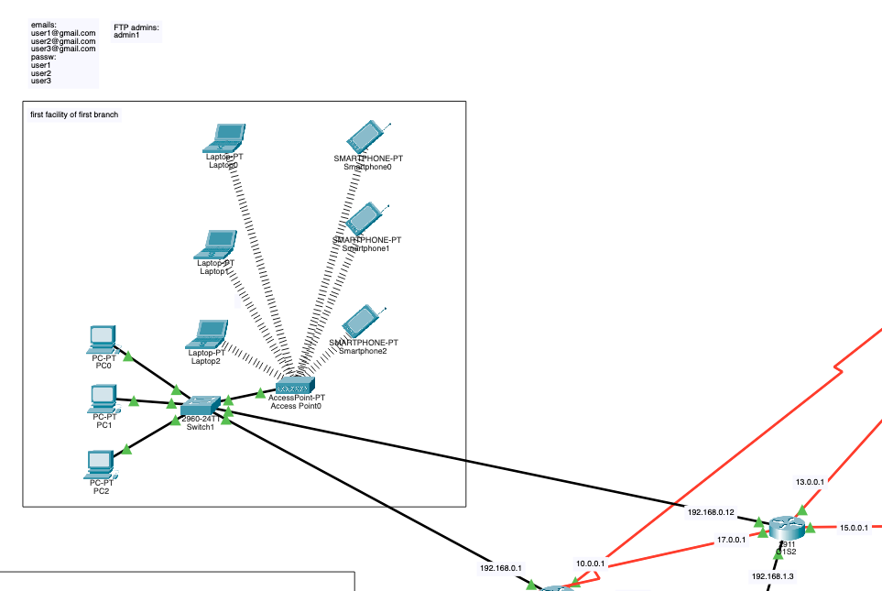

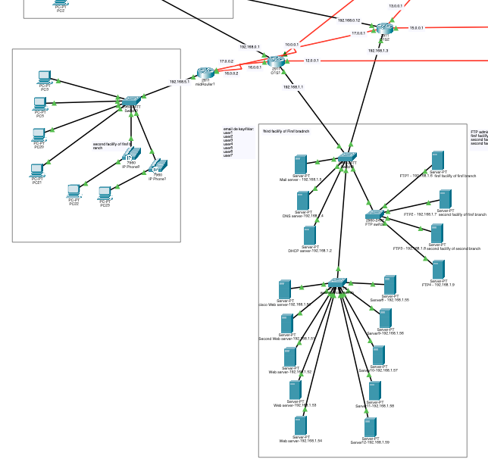

Network 1

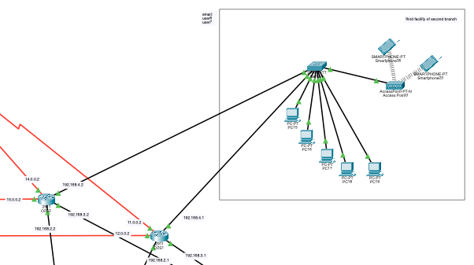

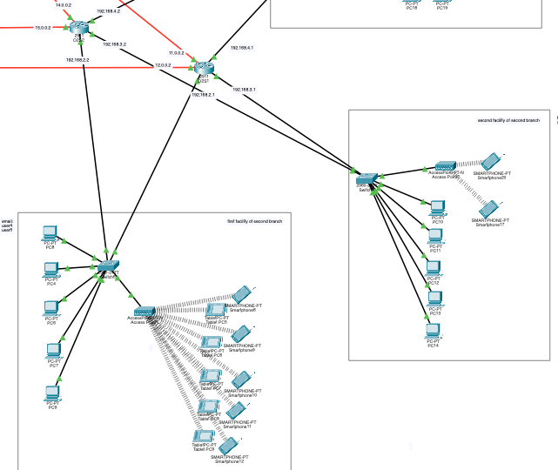

Network 2

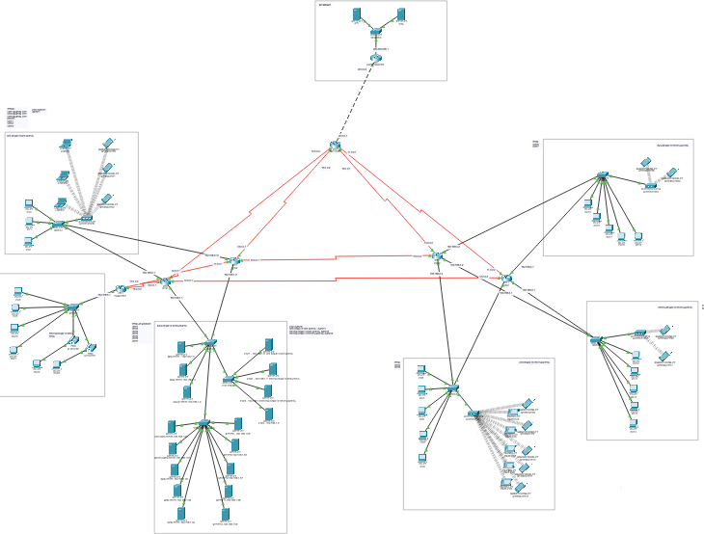

Metropolitan Area Network

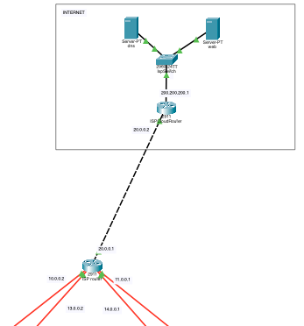

ISP

## Network Simulations

Network simulations made by network developer / designer / technician.

Simulations test the system with various scenarios. They are always a tolerance. Situations not considered in practice may occur when system start to run.

## Simulation Scenario 1:

A wireless user from first facility of second branch wants to read emails and browse Web.

Web browsing:

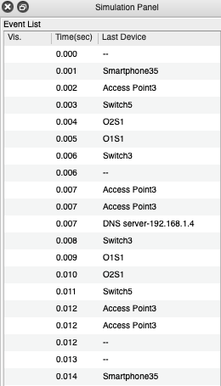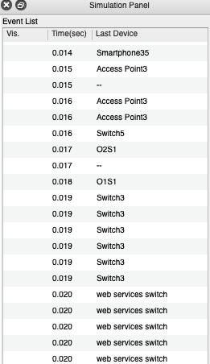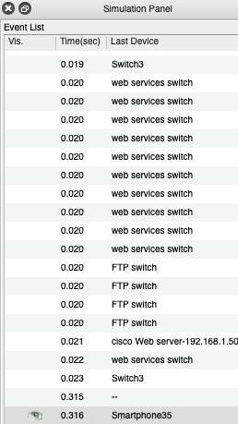

Reading e mail:

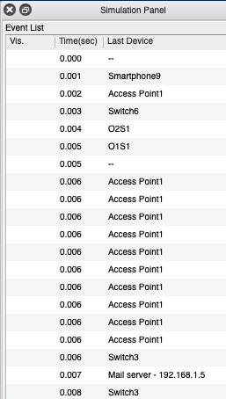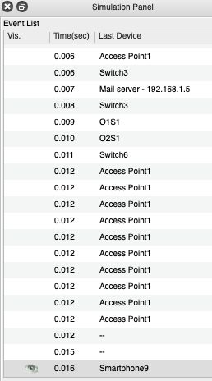

## Simulation Scenario 2:

A computer engineer from second facility of second branch developed a web application

and wants to send his/her code files to FTP server in the third facility of first branch.

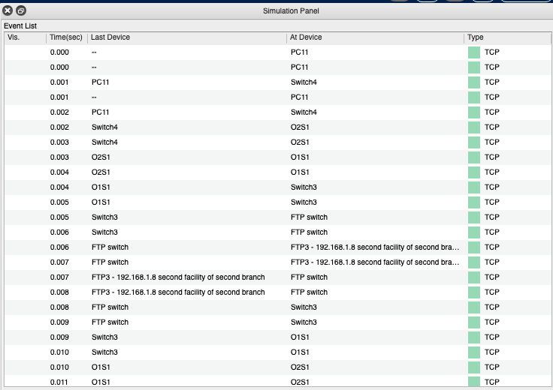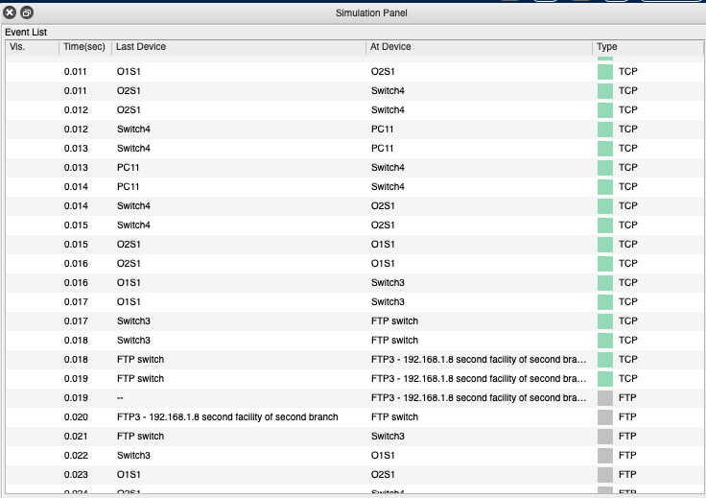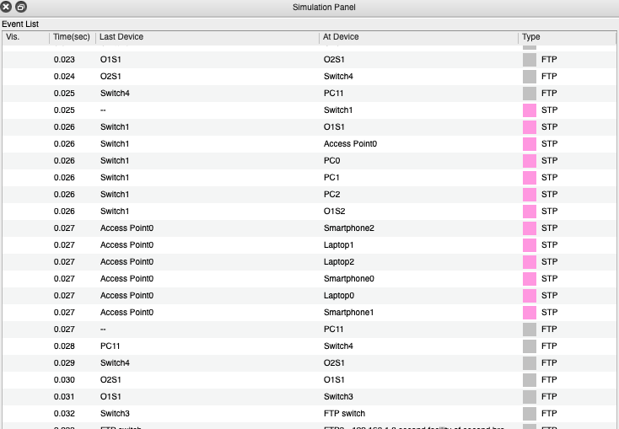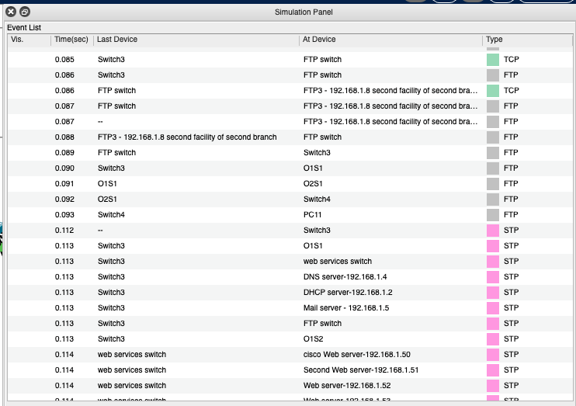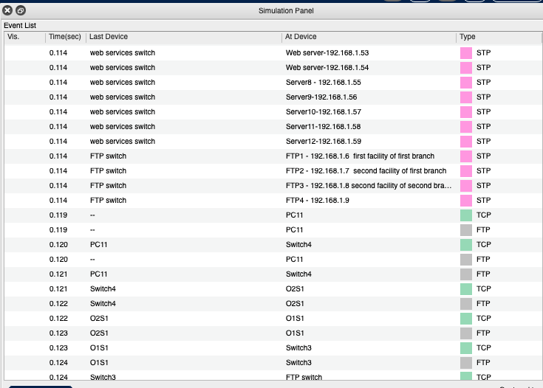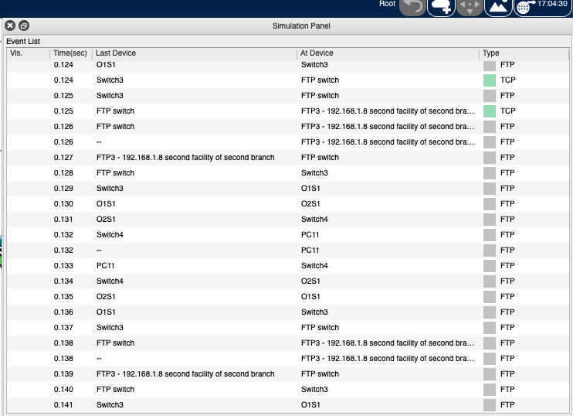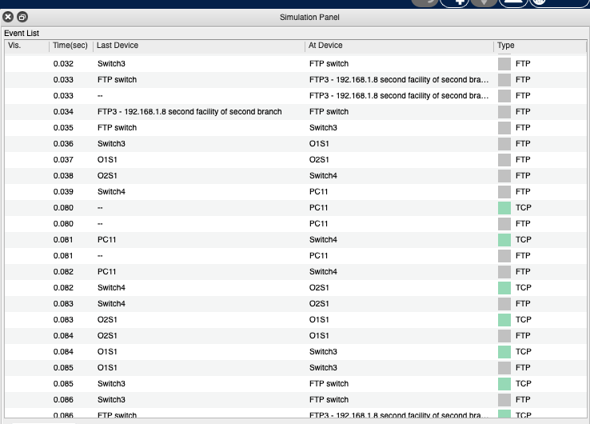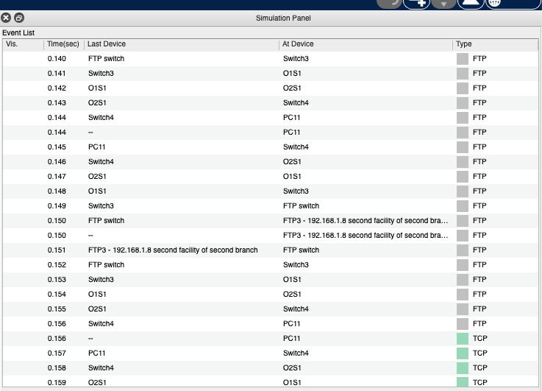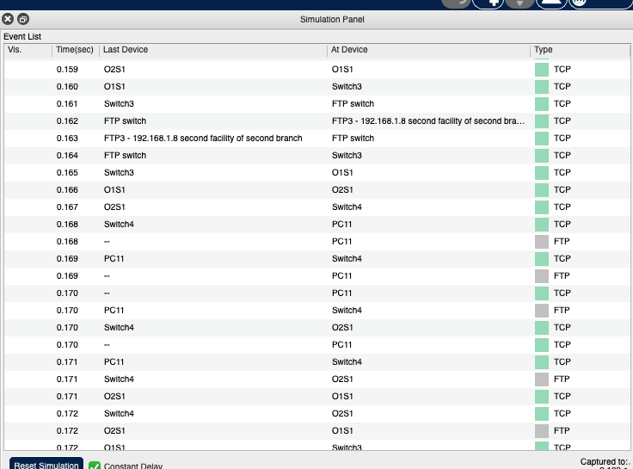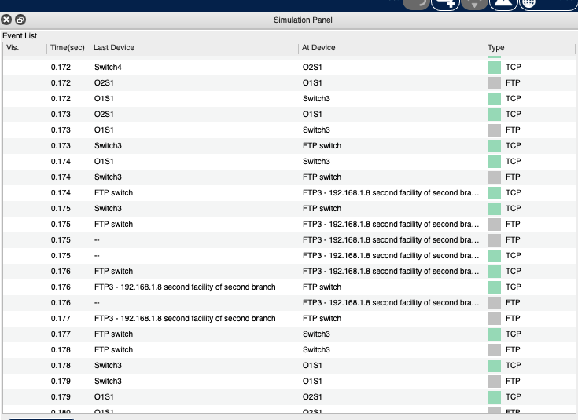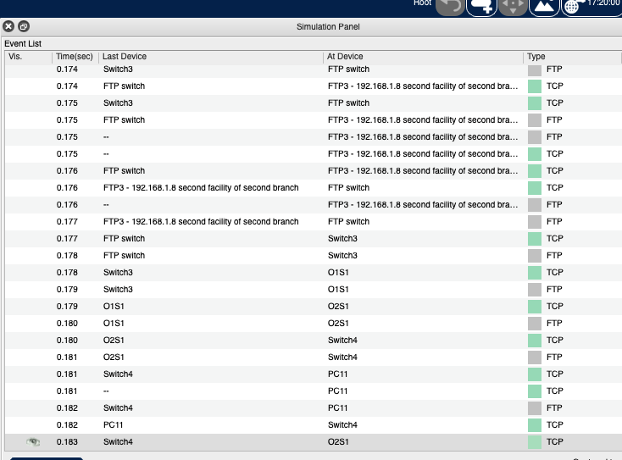

Operation time(sec) variable is shown in the pictures. myDevelopedProgram.txt file can be sent to the corresponding FTP server in third facility of first branch.

## Simulation Scenario 3:

Two users from second facility of first branch want to talk via VoIP.

## 

## 

## 

## 

## 

## 

## Simulation Scenario 4:

A user in the second facility of first branch wants to send an email message to his friend in

the second facility of second branch.

Sending mail:

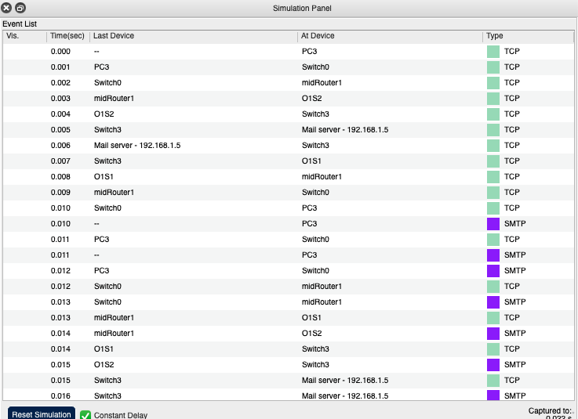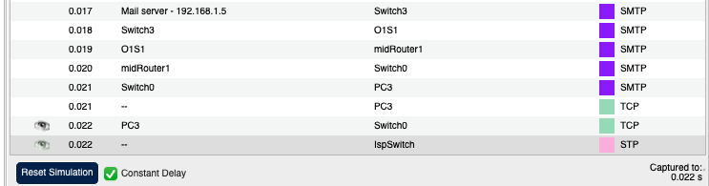

Receiving mail:

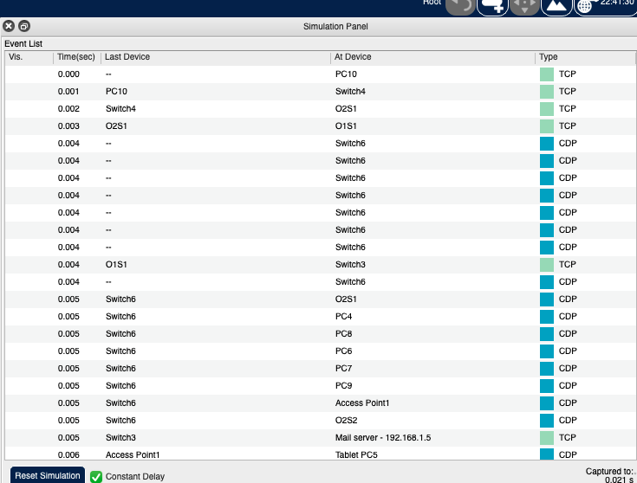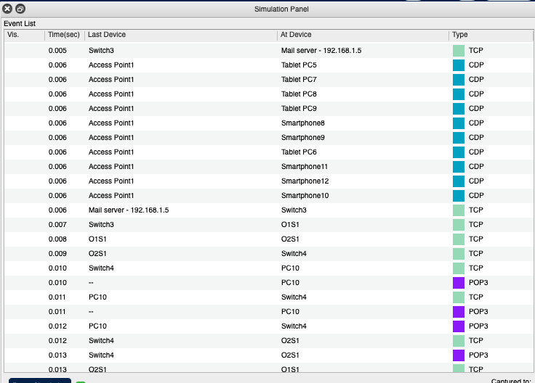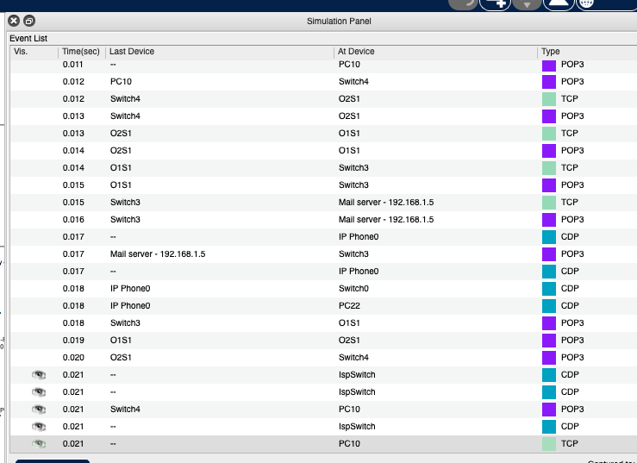

## Simulation Scenario 5:

A user from first facility of second branch pings Web server of second facility of first

branch.

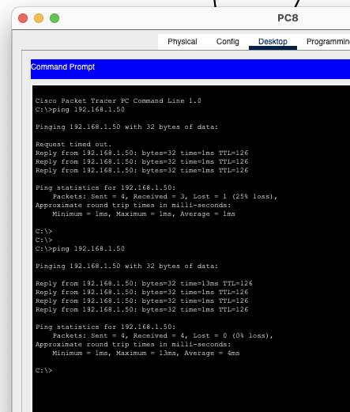

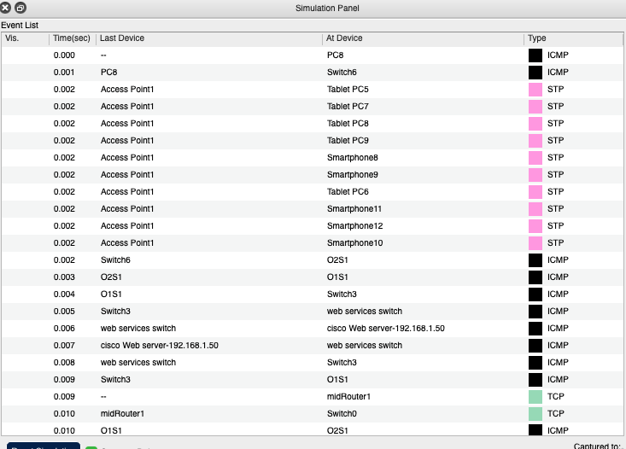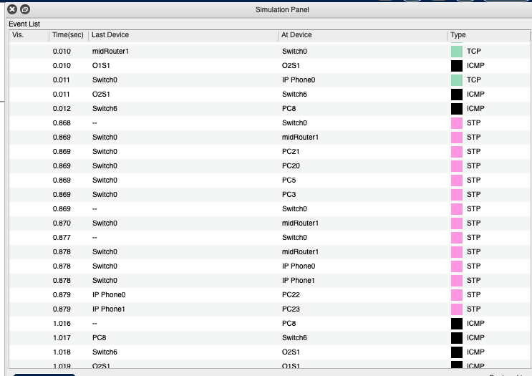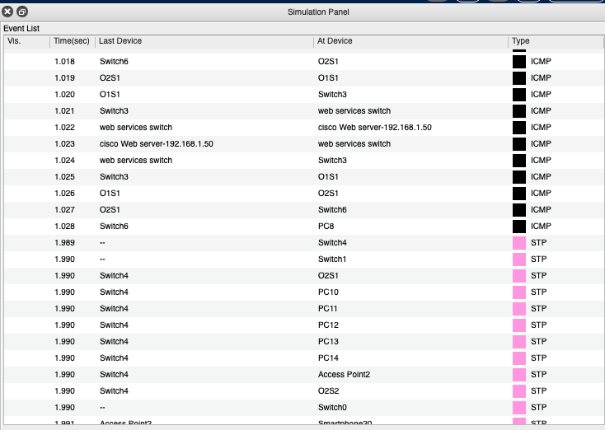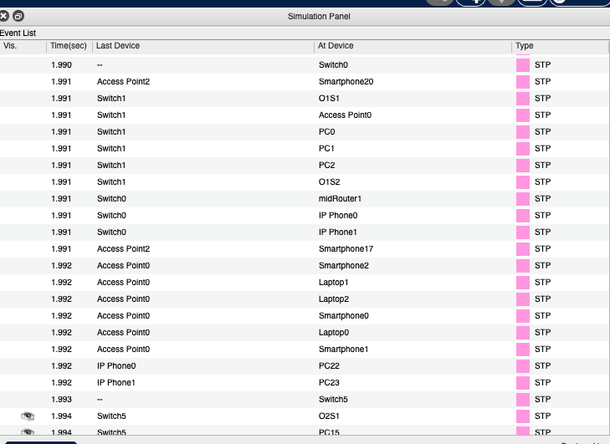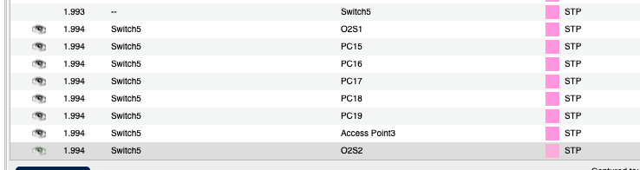

## Simulation Scenario 6:

A laptop user from first facility of first branch office wants to send email to her friend in

the first facility of second branch office.

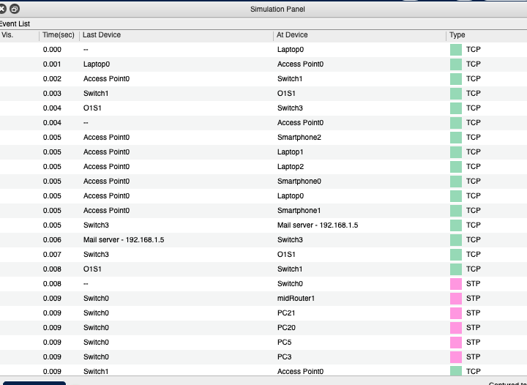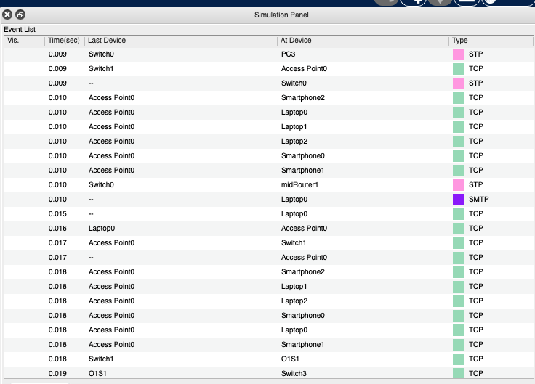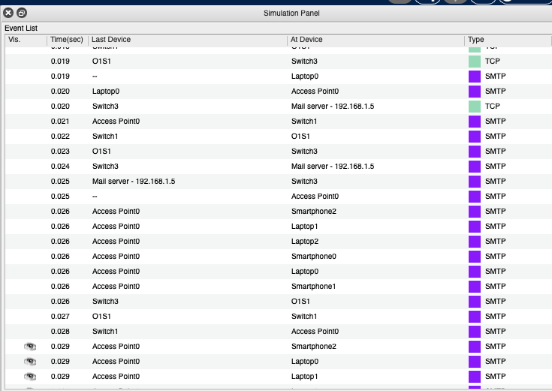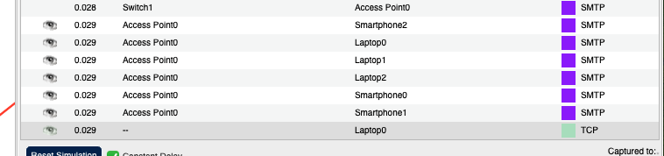

## Simulation Scenario 7:

A smartphone user from third facility of second branch office wants to use ssh to connect

to a Web server in the third facility of first branch office.

This scenario takes so much time(sec). because of that simulation statistic is so long. I took pictures of them a little.

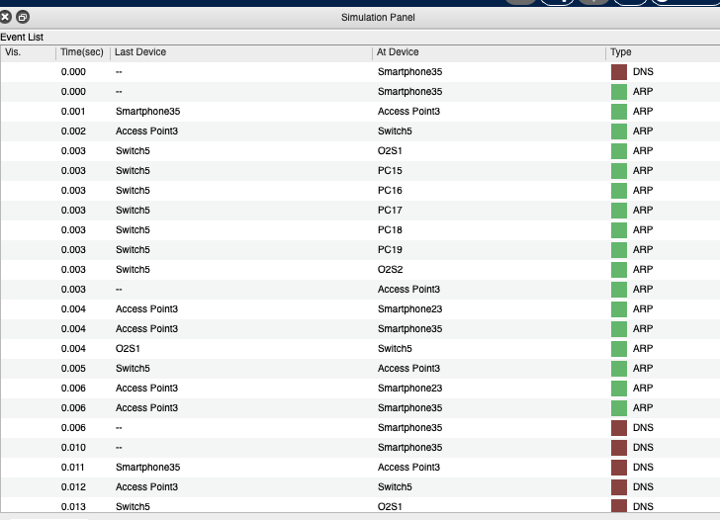 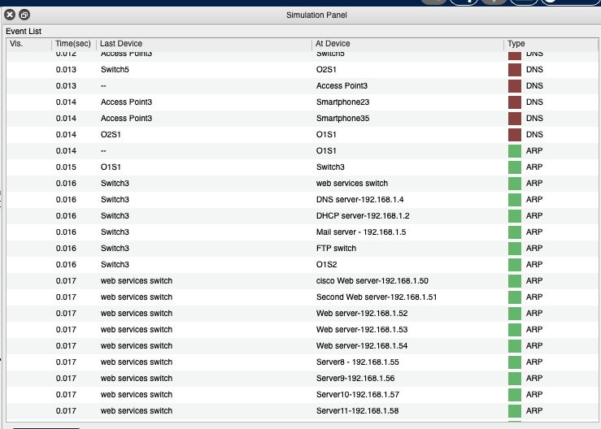

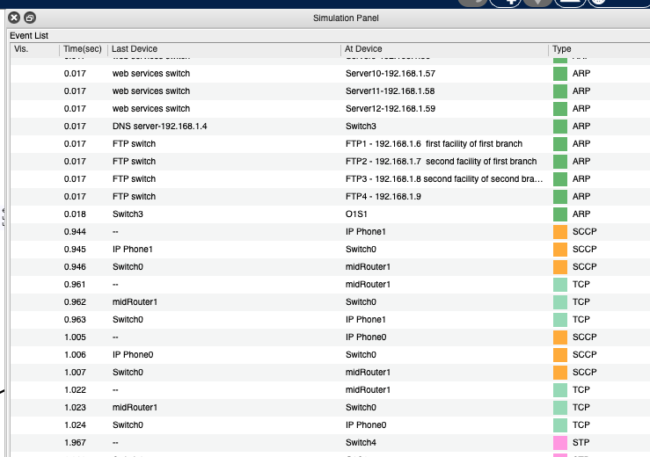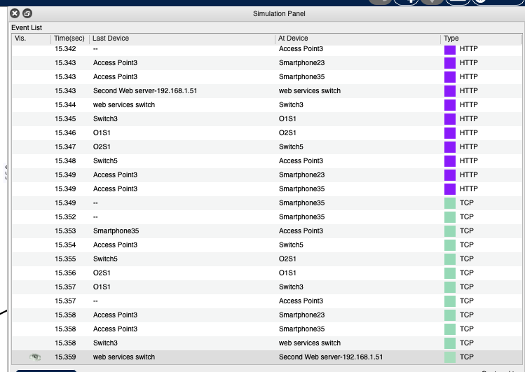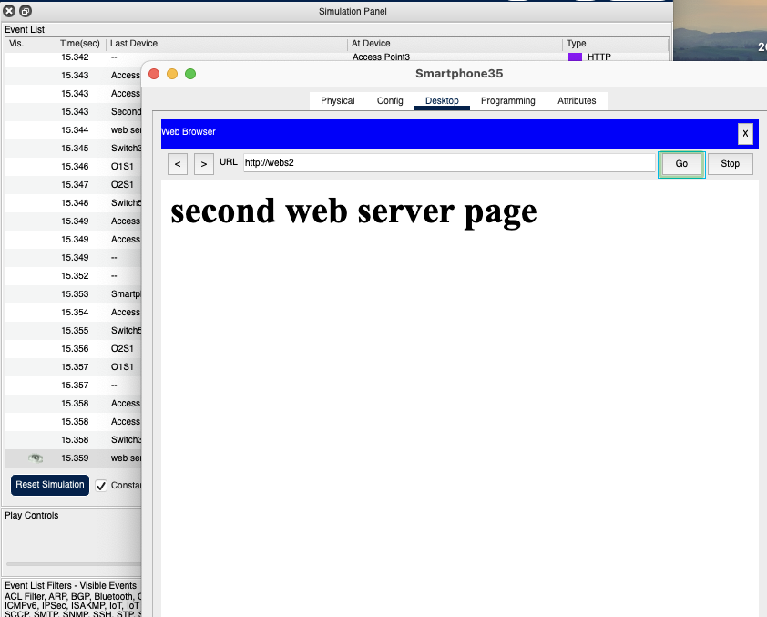

## Additional Simulation Scenario 1:

PC0 in the first facility of first branch send a file to corresponding FTP server.

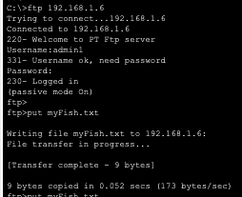

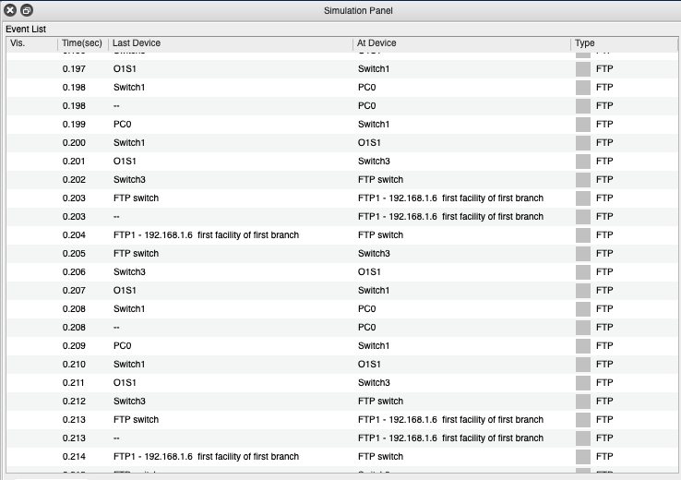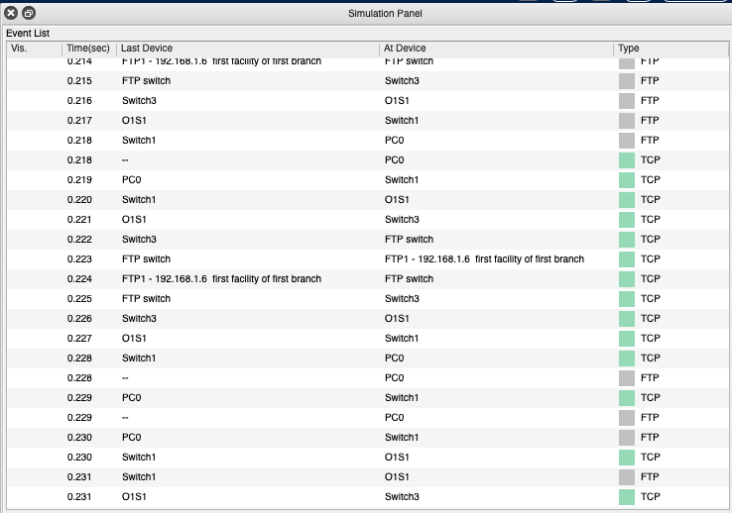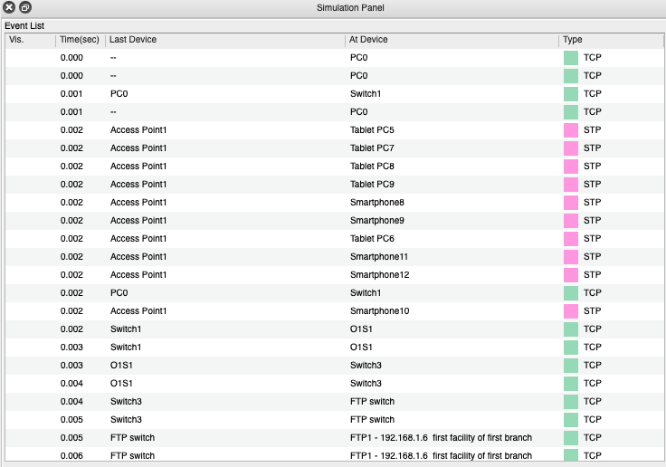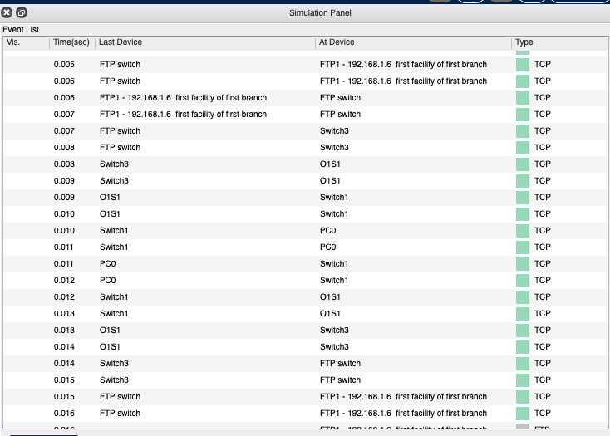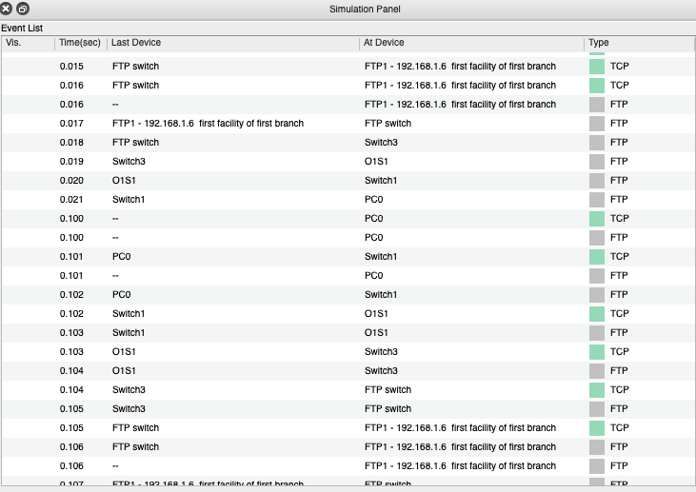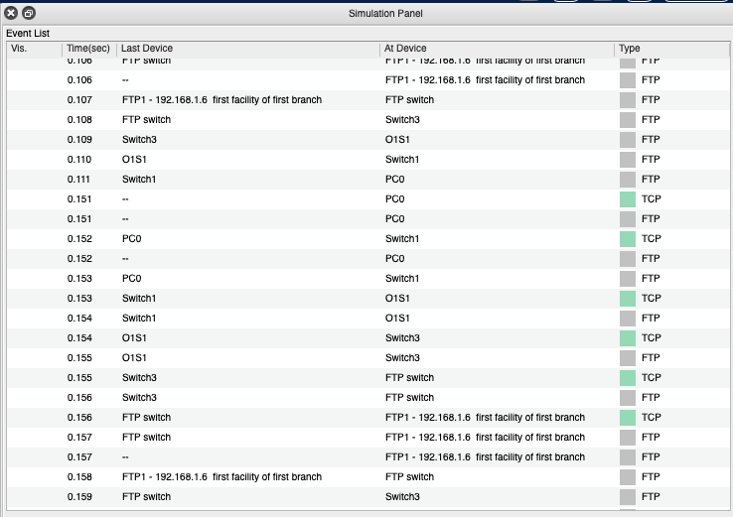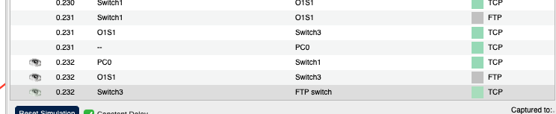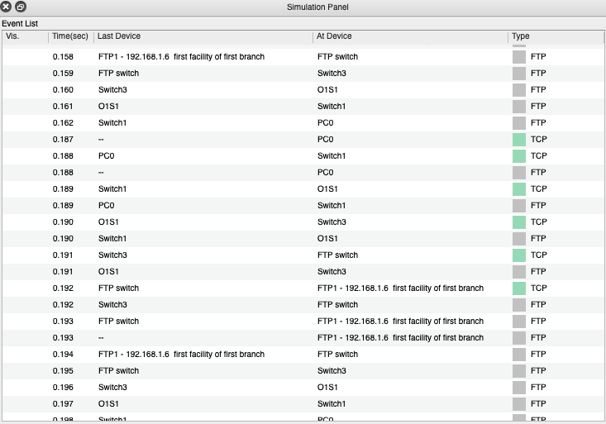

## Additional Simulation Scenario 2:

A User in MAN network system tries to search [www.isp.com](http://www.isp.com) on the web browser.

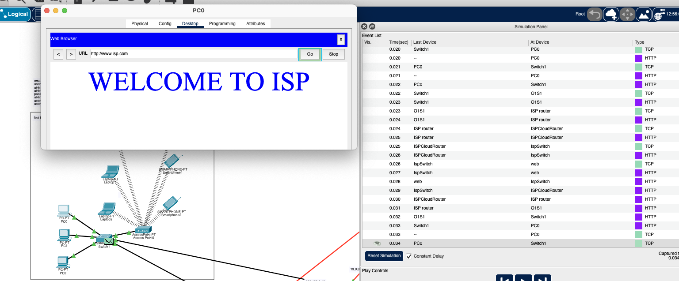

# CHAPTER 4

## Conclusion

Users can browse web, send and receive e-mails, transfer files and ping. DHCP server assigns IP and DNS address to all devices. All requirements are satisfied. Our offices has been created the MAN network in line with the demands of company administrations.

# CHAPTER 5

## References

1. https://[www.birendustrimuhendisi.com/simulasyon-nedir/](http://www.birendustrimuhendisi.com/simulasyon-nedir/)
2. https://community.cisco.com/t5/small-business-switches/configure-dhcp-on-vlan/td- p/1375589
3. [https://www.cisco.com/c/en/us/td/docs/switches/datacenter/nexus5000/sw/](http://www.cisco.com/c/en/us/td/docs/switches/datacenter/nexus5000/sw/) configuration/guide/cli/CLIConfigurationGuide/AccessTrunk.html
   * https://[www.youtube.com/watch?v=RB4LiS2lIXo](http://www.youtube.com/watch?v=RB4LiS2lIXo)
   * https://[www.netacad.com/courses/packet-tracer](http://www.netacad.com/courses/packet-tracer)
   * https://[www.youtube.com/watch?v=MXNM7_Kykaw](http://www.youtube.com/watch?v=MXNM7_Kykaw)