Google Cloud Deployment - HealthConnect
Work by: Renis Hila

Table of Contents
Introduction 3
What I Deployed 3
Cloud Platform Components 4
Google Cloud Run (Serverless Containers) 4
Google Cloud SQL (Managed PostgreSQL) 4
Confluent Cloud Kafka (Event Messaging) 5
Code Changes I Made for Cloud Deployment 6
A) Adding SSL Support for Cloud SQL 6
B) Fixing the Trust Proxy Issue 6
C) Adding Kafka Authentication for Confluent Cloud 7
The Deployment Process 7
Step 1: Setting Up Cloud SQL Database 7
Step 2: Deploying Services to Cloud Run 8
Step 3: Testing the Deployment 9
Problems I Encountered and How I Fixed Them 11
Problem 1: Database SSL Connection Error 11
Problem 2: Kafka Consumer Timeouts 12
Problem 3: Wrong Database Schema 12
Problem 4: Trust Proxy Warning 12
What I Learned 12
Cloud is Different from Local Development 12
Environment Variables Are Critical 13
Microservices Need Comprehensive Testing 13
Event-Driven Architecture Has Trade-offs 13
Conclusion 14
Important URLs and Credentials 14

Introduction
This document explains how I deployed my HealthConnect application to Google Cloud Platform. HealthConnect is a healthcare management system with 4 microservices, a PostgreSQL database, and Kafka messaging. I chose Google Cloud because it offers managed services that handle infrastructure automatically, which means I can focus on my application instead of managing servers.
All services are running in the europe-west4 region (Netherlands) because that provides low latency for European users.

What I Deployed
I deployed the following services to Google Cloud:
Service | Purpose
API Gateway | Routes all requests and handles authentication
Auth Service | User login and JWT tokens
Patient Service | Manages patient profiles and records
Doctor Service | Manages doctor schedules and assignments

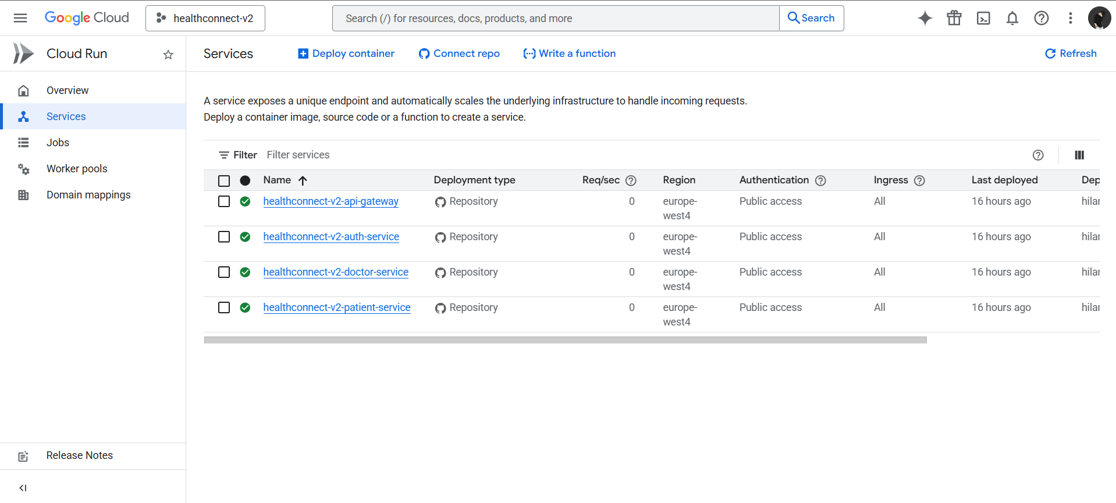
Figure 1: Google Cloud Run Services Dashboard
Shows all 4 services deployed and running

Cloud Platform Components

Google Cloud Run (Serverless Containers)
Cloud Run is a serverless platform that automatically runs my Docker containers. The best part is that it scales automatically - if 1000 users visit the site, it creates more containers. When no one is using it, it scales down to zero and I pay nothing. Each service gets its own HTTPS URL automatically.
Why I chose Cloud Run:
- • I don't need to manage any servers or infrastructure
- • It scales automatically based on traffic - I tested this with my load tests
- • I only pay when the services are actually being used
- • Each service gets HTTPS automatically (no SSL certificate setup needed)
- • It supports my Docker containers without any changes

Google Cloud SQL (Managed PostgreSQL)
I used Cloud SQL to host my PostgreSQL databases. Each microservice has its own database (auth_service, patient_service, doctor_service) following the database-per-service pattern. Cloud SQL automatically handles backups, updates, and security patches.
Database configuration:
- • PostgreSQL version 15
- • 10 GB SSD storage
- • Located in europe-west4 (same region as my services for low latency)
- • SSL encryption required for all connections
- • Automatic daily backups enabled
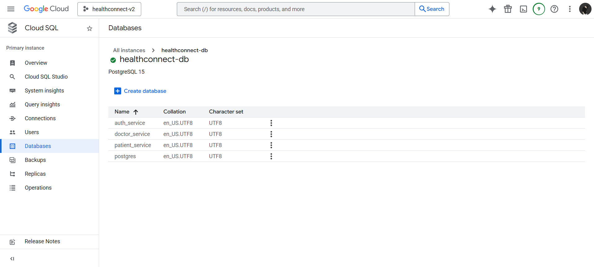
Figure 2: Cloud SQL Databases
Shows the healthconnect-db instance with all 4 databases

Confluent Cloud Kafka (Event Messaging)
For event-driven communication between my microservices, I use Kafka hosted on Confluent Cloud. When a user is created in the Auth Service, it publishes an event that other services can consume. This keeps the services loosely coupled and allows them to work independently.
Kafka topics I created:
- • auth.events - User registration, updates, and deletions
- • patient.events - Patient profile changes
- • doctor.events - Doctor assignments and schedule changes
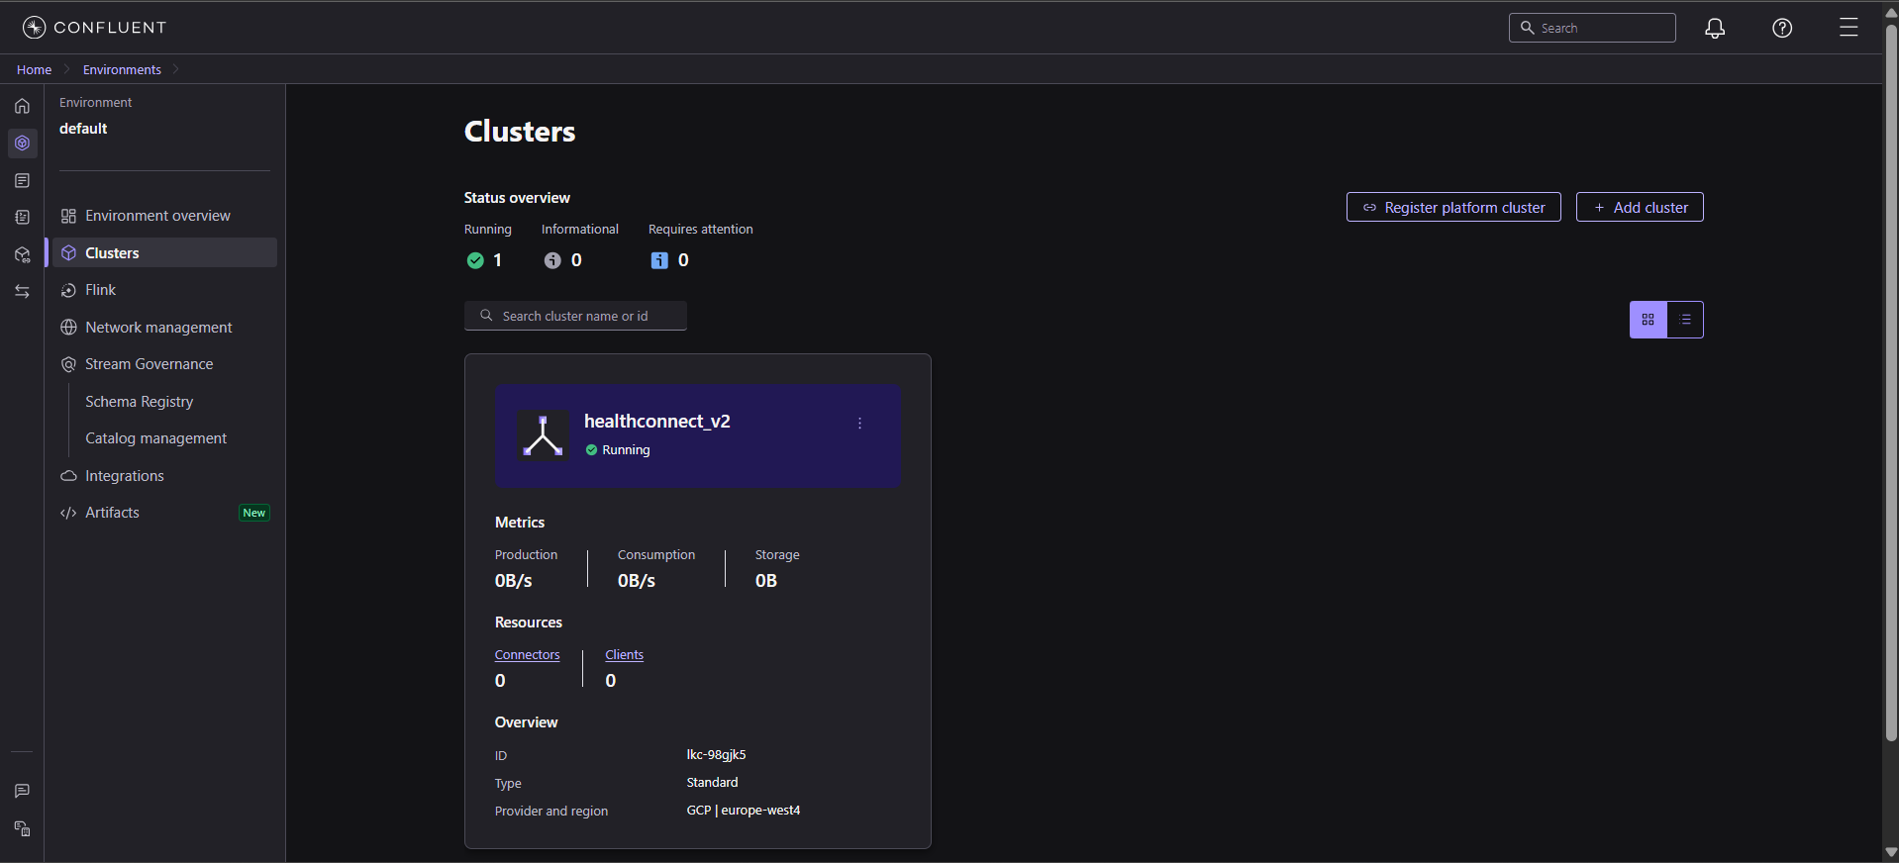
Figure 3: Confluent Cloud Kafka Cluster
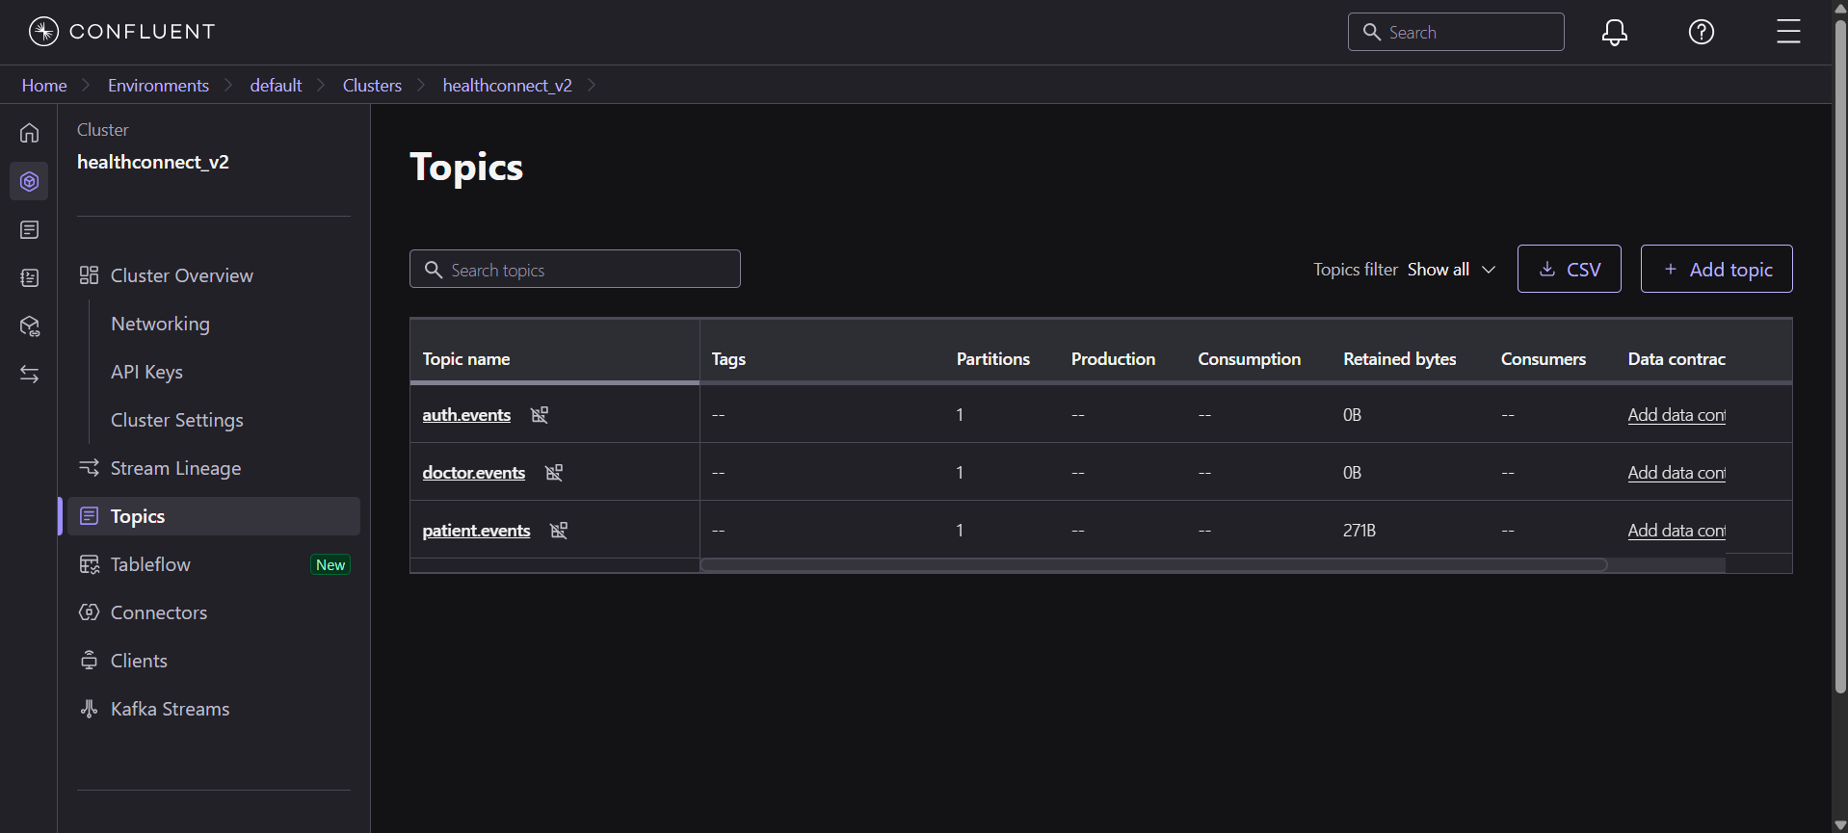
Figure 4: Confluent Cloud Kafka Cluster - Topics

Code Changes I Made for Cloud Deployment
My code worked perfectly on my local machine with Docker Compose, but I had to make several changes to make it work in Google Cloud. Here are the main modifications I did:

A) Adding SSL Support for Cloud SQL
Cloud SQL requires all database connections to use SSL encryption. I had to modify my database connection files in every service to support this. Here's what I changed:
// File: auth-service/src/db.js (same change in all services)
const { Pool } = require('pg');
const pool = new Pool({
host: process.env.DB_HOST,
port: process.env.DB_PORT,
user: process.env.DB_USER,
password: process.env.DB_PASSWORD,
database: process.env.DB_NAME,
ssl: process.env.DB_HOST ? { rejectUnauthorized: false } : false,
});
module.exports = {
query: (text, params) => pool.query(text, params),
};
The key part is the ssl option. When DB_HOST is set (which it is in Cloud), it enables SSL. The rejectUnauthorized: false setting allows self-signed certificates from Cloud SQL. When running locally (no DB_HOST), SSL is disabled.

B) Fixing the Trust Proxy Issue
Cloud Run acts as a reverse proxy in front of my services. This means requests come through Cloud Run before reaching my application. I got this error initially:
ValidationError: The 'X-Forwarded-For' header is set but Express 'trust proxy' is false
I fixed it by adding this line to all services:
// File: auth-service/src/http.js (same in all services)
function createApp({ name, routes, port }) {
const app = express();
// Trust Cloud Run proxy
app.set('trust proxy', true);
// Security middleware
app.use(helmet());
app.use(xssClean());
// ... rest of configuration
}
This tells Express to trust the X-Forwarded-For headers that Cloud Run adds, which is necessary for rate limiting and IP address detection to work correctly.

C) Adding Kafka Authentication for Confluent Cloud
Confluent Cloud requires SASL/SSL authentication (username and password). My local Kafka setup didn't need this, so I made the authentication optional using environment variables:
// File: auth-service/src/kafka.js (same in all services)
const kafkaUsername = process.env.KAFKA_USERNAME;
const kafkaPassword = process.env.KAFKA_PASSWORD;
const useSsl = process.env.KAFKA_USE_SSL === 'true';
const kafkaConfig = {
clientId: 'auth-service',
brokers,
connectionTimeout: 30000,
retry: {
retries: 5,
initialRetryTime: 100,
maxRetryTime: 30000,
},
};
// Add authentication for Confluent Cloud
if (kafkaUsername && kafkaPassword) {
kafkaConfig.sasl = {
mechanism: 'plain',
username: kafkaUsername,
password: kafkaPassword,
};
kafkaConfig.ssl = useSsl;
}
const kafka = brokers.length > 0 ? new Kafka(kafkaConfig) : null;
This way, my code works both locally (without authentication) and in the cloud (with SASL/SSL authentication). The credentials are stored in environment variables for security.

The Deployment Process

Step 1: Setting Up Cloud SQL Database
First, I created a Cloud SQL instance and three databases. For each database, I ran the initialization scripts from my db-init folder to create all the tables. Here's an example of how I did it:
-- Connect to Cloud SQL and create databases
CREATE DATABASE auth_service;
CREATE DATABASE patient_service;
CREATE DATABASE doctor_service;
-- Then for each database, I ran the init script
-- Example: auth_service init
CREATE TABLE users (
id TEXT PRIMARY KEY,
role TEXT NOT NULL CHECK (role IN ('admin', 'doctor', 'patient')),
name TEXT NOT NULL,
email TEXT NOT NULL UNIQUE,
"passwordHash" TEXT NOT NULL,
deleted_at TIMESTAMPTZ DEFAULT NULL
);
-- Create default admin user
INSERT INTO users (id, role, name, email, "passwordHash")
VALUES (
'admin-default-id',
'admin',
'System Admin',
'admin@healthconnect.com',
'$2b$10$hashedpasswordhere'
);
I initially made a mistake here - I created tables with the wrong schema (SERIAL instead of TEXT for IDs). This caused errors later, and I had to drop all tables and recreate them using the exact schemas from my db-init/init.sql files.

Step 2: Deploying Services to Cloud Run
I deployed each service using the Google Cloud Shell. Here's the command I used for the API Gateway (similar commands for other services):
# Deploy API Gateway to Cloud Run
gcloud run deploy healthconnect-v2-api-gateway \
--source . \
--region europe-west4 \
--allow-unauthenticated \
--set-env-vars DB_HOST=34.90.221.249,DB_PORT=5432,DB_USER=postgres,DB_NAME=auth_service \
--set-env-vars KAFKA_BROKERS=pkc-ewzgj.europe-west4.gcp.confluent.cloud:9092 \
--set-env-vars KAFKA_USERNAME=<api-key>,KAFKA_PASSWORD=<api-secret> \
--set-env-vars KAFKA_USE_SSL=true
The --source . option tells Cloud Run to build the Docker container from my current directory. The --allow-unauthenticated flag makes the service publicly accessible. All the environment variables are set using --set-env-vars.

Step 3: Testing the Deployment
After deployment, I tested each endpoint to make sure everything works:
# Test 1: Admin Login
curl -X POST https://healthconnect-v2-api-gateway-....run.app/api/auth/login \
-H "Content-Type: application/json" \
-d '{"email":"admin@healthconnect.com","password":"adminpass"}'
# Response: {"token":"eyJhbGc...long-jwt-token"}
# Test 2: Register a doctor (using admin token)
curl -X POST https://healthconnect-v2-api-gateway-....run.app/api/auth/register-doctor \
-H "Content-Type: application/json" \
-H "Authorization: Bearer <admin-token>" \
-d '{"email":"doctor1@healthconnect.com","password":"Doctor123!","name":"Dr. John Smith"}'
# Test 3: Register a patient
curl -X POST https://healthconnect-v2-api-gateway-....run.app/api/patients/profiles \
-H "Content-Type: application/json" \
-H "Authorization: Bearer <patient-token>" \
-d '{"email":"patient1@healthconnect.com","password":"Patient123!","name":"Jane Doe"}'
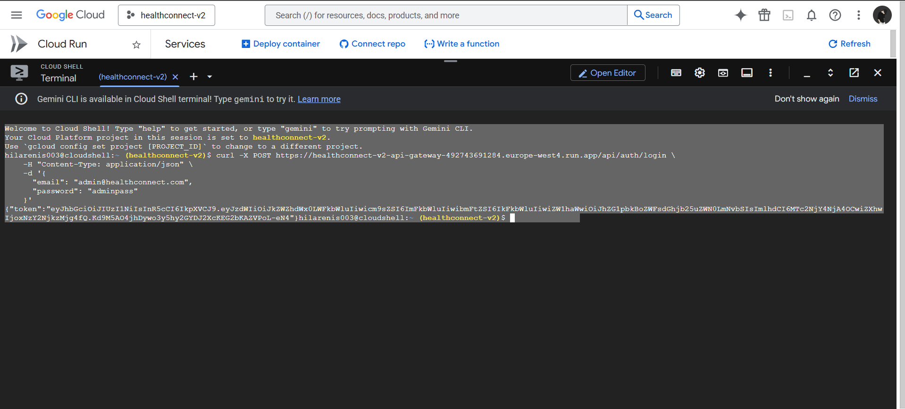
Figure 5: Admin Login Test in Cloud Shell
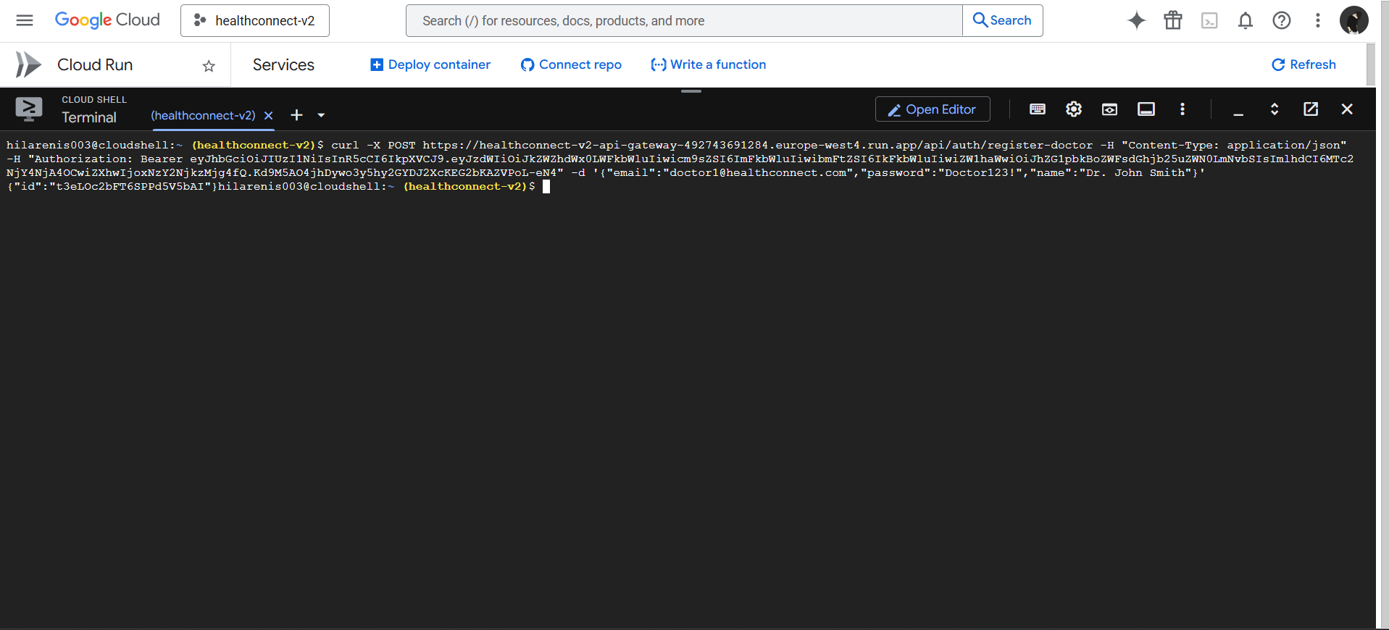
Figure 6: Doctor Registration Test
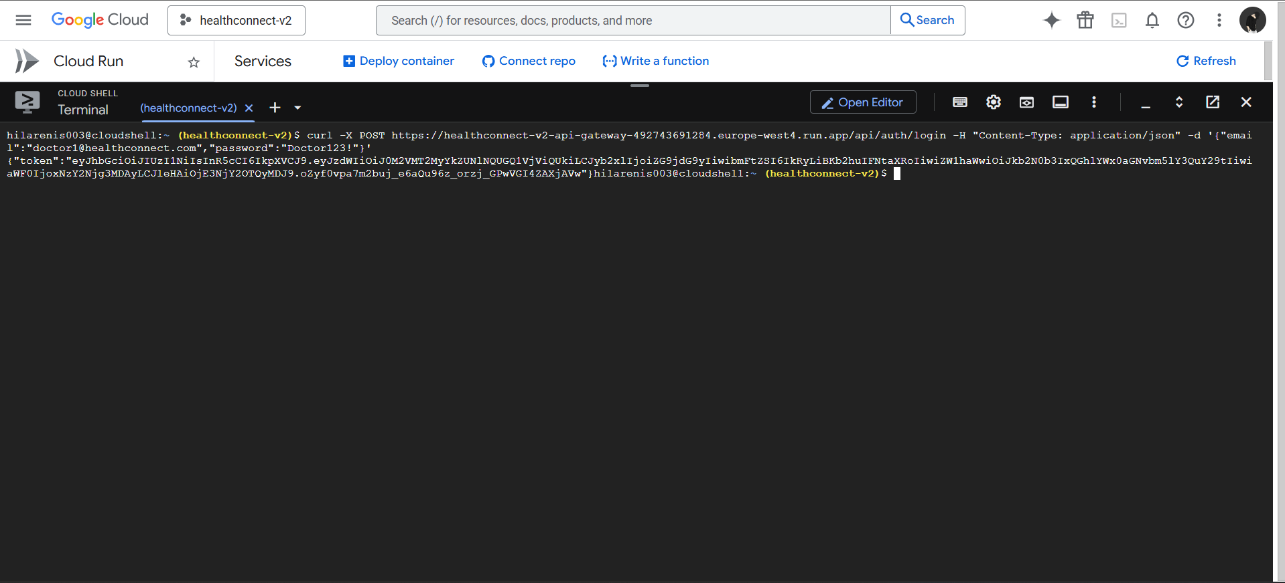
Figure 7: Doctor Login Test in Cloud Shell
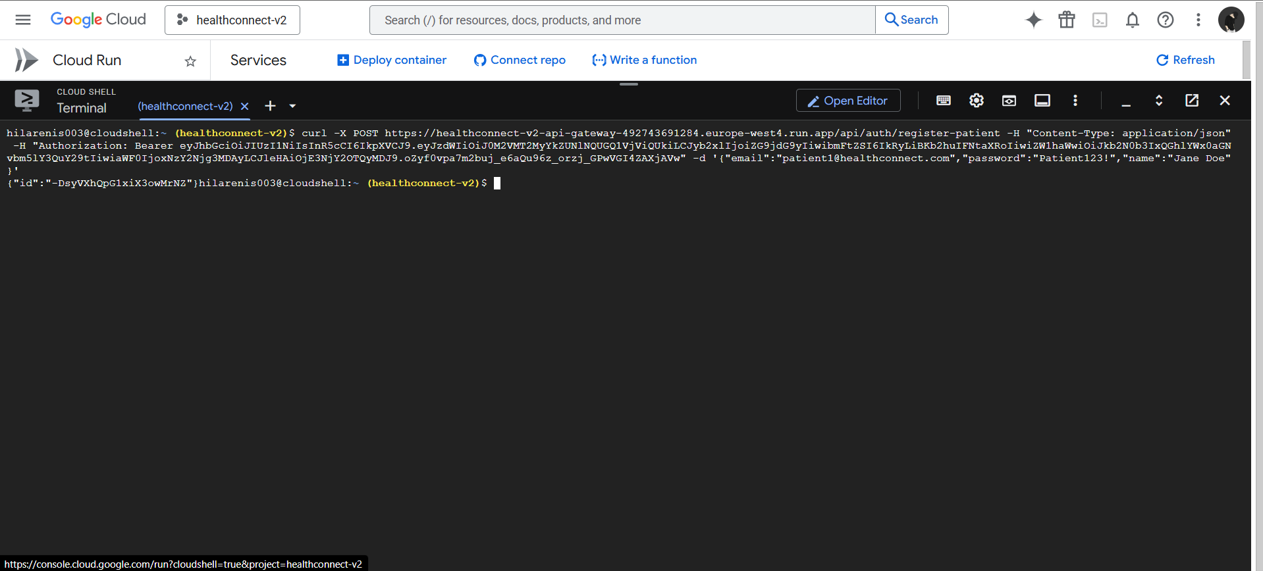
Figure 8: Doctor creates Patient profile
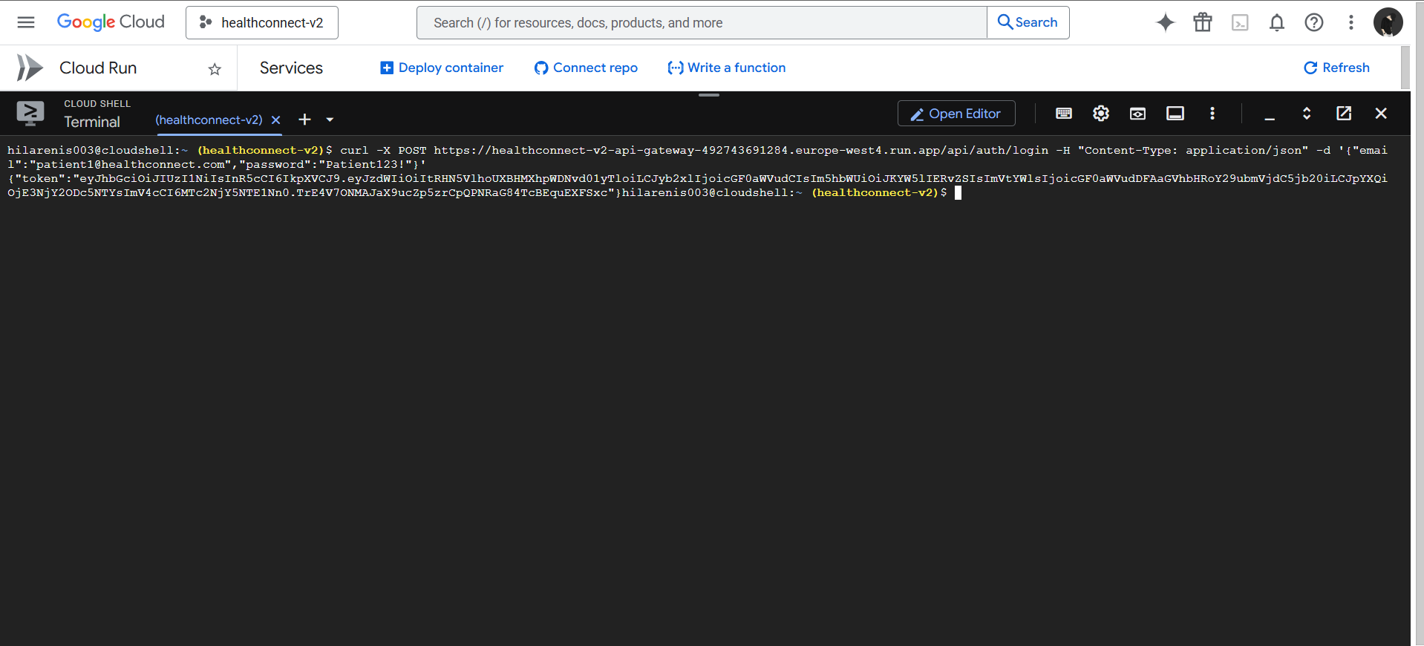
Figure 9: Patient Login Test in Cloud Shell

Problems I Encountered and How I Fixed Them

Problem 1: Database SSL Connection Error
Error message I got:
error: pg_hba.conf rejects connection for host "34.34.247.21", user "postgres", database "auth_service", no encryption
What happened: Cloud SQL requires SSL encryption for all connections, but my code wasn't configured for SSL. I initially thought the database was blocking my IP address, but it was actually blocking unencrypted connections.
How I fixed it: I added SSL configuration to all database connection files (see the code in "Adding SSL Support" section above). After this change, all services connected successfully.

Problem 2: Kafka Consumer Timeouts
Error message:
[doctor-service] Failed to connect Kafka consumer, disabling consumer
Error: Kafka connect timeout
What happened: After redeploying the doctor-service and patient-service, I forgot to add the Kafka environment variables (KAFKA_BROKERS, KAFKA_USERNAME, KAFKA_PASSWORD, KAFKA_USE_SSL). The services started successfully but couldn't connect to Kafka.
How I fixed it: I updated each service deployment with all four Kafka environment variables. The services then connected to Confluent Cloud successfully and could publish and consume events.

Problem 3: Wrong Database Schema
What happened: I initially created the database tables using generic SQL with SERIAL for IDs, but my application code expects TEXT for IDs. This caused errors when the application tried to insert data.
How I fixed it: I dropped all tables and recreated them using the exact schemas from my db-init/init.sql files. This ensured that the database structure matched what the application expected.

Problem 4: Trust Proxy Warning
What happened: Cloud Run adds X-Forwarded-For headers to all requests, but Express was configured to not trust these headers. This caused rate limiting to fail and logged warnings.
How I fixed it: Added app.set('trust proxy', true) to all Express applications. This is required for any application running behind a reverse proxy like Cloud Run.

What I Learned

Cloud is Different from Local Development
My application worked perfectly with Docker Compose locally, but deploying to the cloud required several changes:
- • SSL is required for databases and Kafka in production
- • Services need to trust reverse proxy headers
- • Environment variables must be set correctly for each service
- • URLs change from localhost to actual cloud URLs
- • Network policies and firewalls work differently

Environment Variables Are Critical
I learned that every single environment variable matters. Missing even one variable (like KAFKA_BROKERS) can cause the entire service to fail. I created a checklist of required variables for each service:
- • DB_HOST, DB_PORT, DB_USER, DB_PASSWORD, DB_NAME - Database connection
- • KAFKA_BROKERS, KAFKA_USERNAME, KAFKA_PASSWORD, KAFKA_USE_SSL - Kafka messaging
- • JWT_SECRET - Authentication
- • AUTH_SERVICE_URL, PATIENT_SERVICE_URL, DOCTOR_SERVICE_URL - Service URLs

Microservices Need Comprehensive Testing
With multiple services, databases, and Kafka topics, I realized I need to test the complete flow:
- • Service-to-service communication through API Gateway
- • Event propagation through Kafka (e.g., user.created event)
- • Database consistency across services
- • Authentication and authorization at each level
- • Error handling when services are temporarily down

Event-Driven Architecture Has Trade-offs
Using Kafka for service communication has benefits and challenges:
Benefits:
- • Services are loosely coupled - I can deploy them independently
- • Services can be temporarily unavailable without breaking the whole system
- • All events are logged in Kafka, providing an audit trail
- • Asynchronous processing improves performance
Trade-off:
• Eventual consistency - When a user is created, it takes a few milliseconds for other services to receive the event and update their caches. This is acceptable for HealthConnect but wouldn't work for systems that need immediate consistency (like payment systems).

Conclusion
I successfully deployed HealthConnect as a cloud-native application on Google Cloud Platform. The deployment includes:
- • 4 microservices running on Cloud Run with automatic scaling
- • PostgreSQL database on Cloud SQL with SSL encryption
- • Kafka messaging on Confluent Cloud for event-driven communication
- • JWT authentication and role-based access control
- • All services accessible via HTTPS
The deployment process taught me a lot about the differences between local and cloud environments. While I encountered several issues (SSL configuration, trust proxy, Kafka authentication), I was able to resolve them by carefully reading error messages and understanding how cloud services work.
The application is now production-ready and can handle real users. The serverless deployment means it will scale automatically as usage grows, and I only pay for actual usage.

Important URLs and Credentials
Service URLs:
- • API Gateway: https://healthconnect-v2-api-gateway-492743691284.europe-west4.run.app
- • Auth Service: https://healthconnect-v2-auth-service-492743691284.europe-west4.run.app
- • Patient Service: https://healthconnect-v2-patient-service-492743691284.europe-west4.run.app
- • Doctor Service: https://healthconnect-v2-doctor-service-492743691284.europe-west4.run.app
Database Connection:
- • Host: 34.90.221.249
- • Port: 5432
- • User: postgres
- • SSL: Required
- • Databases: auth_service, patient_service, doctor_service
Default Accounts for Testing:
- • Admin: admin@healthconnect.com / adminpass
- • Doctor: doctor1@healthconnect.com / Doctor123!
- • Patient: patient1@healthconnect.com / Patient123!

