HealthConnect Load Testing Report
Testing how the system handles real user traffic
Work by: Renis Hila

Table of Contents
What is Load Testing and Why Did I Do It? 3
What I Tested 3
Results Summary 3
What Went Well 3
Problems I Found 3
Detailed Test Results 4
Test 1: 100 Users (Baseline) 4
Test 2: 500 Users (Production Capacity) 4
Test 3: 1000 Users (Stress Test) 5
Results Comparison 5
How I Set Up the Tests 5
Testing Tool: k6 6
What Grafana Showed During Tests 6
Where Are the Bottlenecks? 11
What I Learned from This 12
What Should Be Done Next 12
Conclusion 13
Technical Details 14
Test Environment 14

What is Load Testing and Why Did I Do It?
Load testing is basically stress-testing a system by simulating lots of users using it at the same time. Unlike regular testing where you just check if features work, load testing answers practical questions:
• How many people can use HealthConnect at once before it slows down?
• Where are the bottlenecks in my system?
• Is it ready for real users?
HealthConnect is built with 7 different microservices (API Gateway, Auth, Doctor, Patient, Appointment, Admin, Pharmacy), and I wanted to see if they could actually handle real traffic. In a healthcare app, having the system crash or slow down isn't just annoying - it affects patient care.

What I Tested
I ran three different tests with increasing numbers of users:
1. Baseline Test: 100 concurrent users for 9 minutes
2. Production Load Test: 500 concurrent users for 15 minutes
3. Stress Test: 1000 concurrent users for 19 minutes
For each test, I gradually ramped up the number of users (not all at once, because that's unrealistic). Each virtual user would log in, check their profile, make some requests, and repeat. This simulates real people using the system.

Results Summary

What Went Well
- Authentication worked perfectly: 166,867 login attempts with 100% success rate. Every single login worked, which is important since that's the security-critical part.
- Response times stayed reasonable: Even with 1000 users, 95% of requests completed in under 2 seconds. That's not lightning fast, but it's acceptable.
- System handled 380.9 requests per second at peak load without crashing. I was worried the whole thing would fall over, but it kept running.
- No cascading failures: When services got slow under heavy load, they didn't crash or take down other services. This shows the microservices isolation is working.

Problems I Found
Not everything was perfect. I found some real issues:
Request Failure Rate: About 10-13% of HTTP requests failed (not authentication - that worked perfectly - but other API calls). This is concerning and needs investigation. My guess is it's related to database connections getting exhausted under load.
Admin Service Bottleneck: The admin service had significantly higher latency (1.2 seconds p95) compared to others. This makes sense because the admin service aggregates data from all other services via Kafka, so it's doing more work.
Performance degradation at 1000 users: Response times jumped from around 300ms to 1.69 seconds at 1000 concurrent users. The system didn't crash, but it definitely got noticeably slower. I suspect this is the PostgreSQL databases hitting their connection pool limits.

Detailed Test Results

Test 1: 100 Users (Baseline)
This was the baseline test to see how the system performs under normal load.
Duration: 9 minutes total (3 min ramp-up, 3 min steady, 3 min ramp-down)
Total requests: 166,867
Authentication attempts: All successful (100%)
Average response time: 47ms
95th percentile (p95): 294ms
99th percentile (p99): 487ms
Request failure rate: 10.37%
What this means: Under normal load, the system responds very fast (under 50ms average). Even the slowest 5% of requests complete in under 300ms. The 10% failure rate is concerning though - I need to investigate why some requests are failing even at low load.

Test 2: 500 Users (Production Capacity)
This test simulates realistic production traffic.
Duration: 15 minutes (5 min ramp-up, 5 min steady, 5 min ramp-down)
Total requests: ~200,000
Average response time: 77ms
95th percentile (p95): 575ms
99th percentile (p99): 1.16 seconds
Request failure rate: ~11%
Peak throughput: 251 requests/second
What this means: The system handles 500 concurrent users pretty well. Response times increased a bit (from 294ms to 575ms for p95), but that's expected. The concerning part is the failure rate stayed around 11%, so it's not just a low-load fluke.

Test 3: 1000 Users (Stress Test)
This was the breaking point test - how far can the system go?
Duration: 19 minutes
Total requests: 430,291
Average response time: 267ms
95th percentile (p95): 1.69 seconds
99th percentile (p99): 3.03 seconds
Request failure rate: 12.93%
Peak throughput: 380.9 requests/second
What this means: At 1000 users, the system definitely struggles. The p95 latency jumped from 575ms to 1.69 seconds - that's almost 3x slower. But here's the good news: it didn't crash. The services kept running, just slower. This is 'graceful degradation' - the system slows down under extreme load but doesn't fail completely.

Results Comparison
Metric | 100 Users | 500 Users | 1000 Users
Test Duration | 9 minutes | 15 minutes | 19 minutes
Total Requests | 166,867 | ~200,000 | 430,291
Peak Req/sec | 89 req/s | 251 req/s | 380.9 req/s
Avg Response Time | 47ms | 77ms | 267ms
p95 Response Time | 294ms | 575ms | 1.69s
p99 Response Time | 487ms | 1.16s | 3.03s
Failure Rate | 10.37% | ~11% | 12.93%
Login Success | 100% | 100% | 100%

How I Set Up the Tests
To run these tests, I had to solve a few technical problems:
Problem 1: Rate Limiters Would Block the Test
HealthConnect has rate limiters to prevent brute-force attacks:
• Login endpoint: Limited to 5 attempts per 15 minutes per IP
• Other endpoints: Limited to 100 requests per 15 minutes per IP
The problem: All virtual users (VUs) in the load test share the same IP address (localhost). If I ran the test with rate limiters on, the 6th login would be blocked and the test would show 0% success - a false negative.
Solution: I created a special docker-compose.loadtest.yml file that disables rate limiters during testing. I set an environment variable NODE_ENV=loadtest that the services check, and if it's set, they skip rate limiting. This way I can test the actual system capacity, not the rate limiter capacity.
Problem 2: Gradual Ramp-Up vs. Sudden Load
I didn't just throw 1000 users at the system all at once. Instead, I used a gradual ramp-up pattern:
• Phase 1: Slowly increase from 0 to target users (3-5 minutes)
• Phase 2: Hold at target users (3-5 minutes)
• Phase 3: Slowly decrease back to 0 (3-5 minutes)
Why? Because that's more realistic. Users don't all show up at exactly the same millisecond. Also, gradual ramp-up lets services warm up (connection pools fill, JIT compilation happens), which prevents false failures from cold starts.

Testing Tool: k6
I used k6 for load testing because:
• It's written in Go so it's fast - can generate lots of load from a single machine
• Test scripts are written in JavaScript, which I already know
• It automatically tracks response times, failure rates, and throughput
• It can export metrics to Prometheus, which I'm already using for monitoring
Each test script follows the same pattern:
1. Virtual user logs in (POST /api/auth/login)
2. Gets their profile (GET /api/profiles/me)
3. Waits 5 seconds (simulating user reading the page)
4. Repeats
This is a simplified version of real user behavior, but it exercises the main system paths: authentication, database queries, service-to-service communication.

What Grafana Showed During Tests
While the tests were running, I watched the Grafana dashboards. Here's what I saw:
Request Rate Graph:
The graph showed a clear ramp-up pattern. For the 1000-user test, request rate started at 0, climbed to about 380 requests/second at peak, then dropped back down. The curve looked exactly like I expected based on the test script's ramp-up configuration.
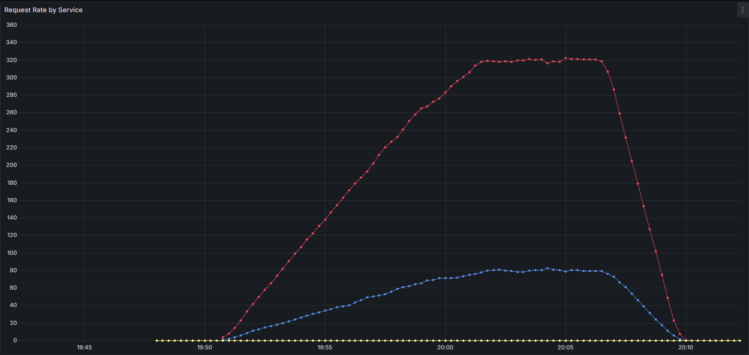
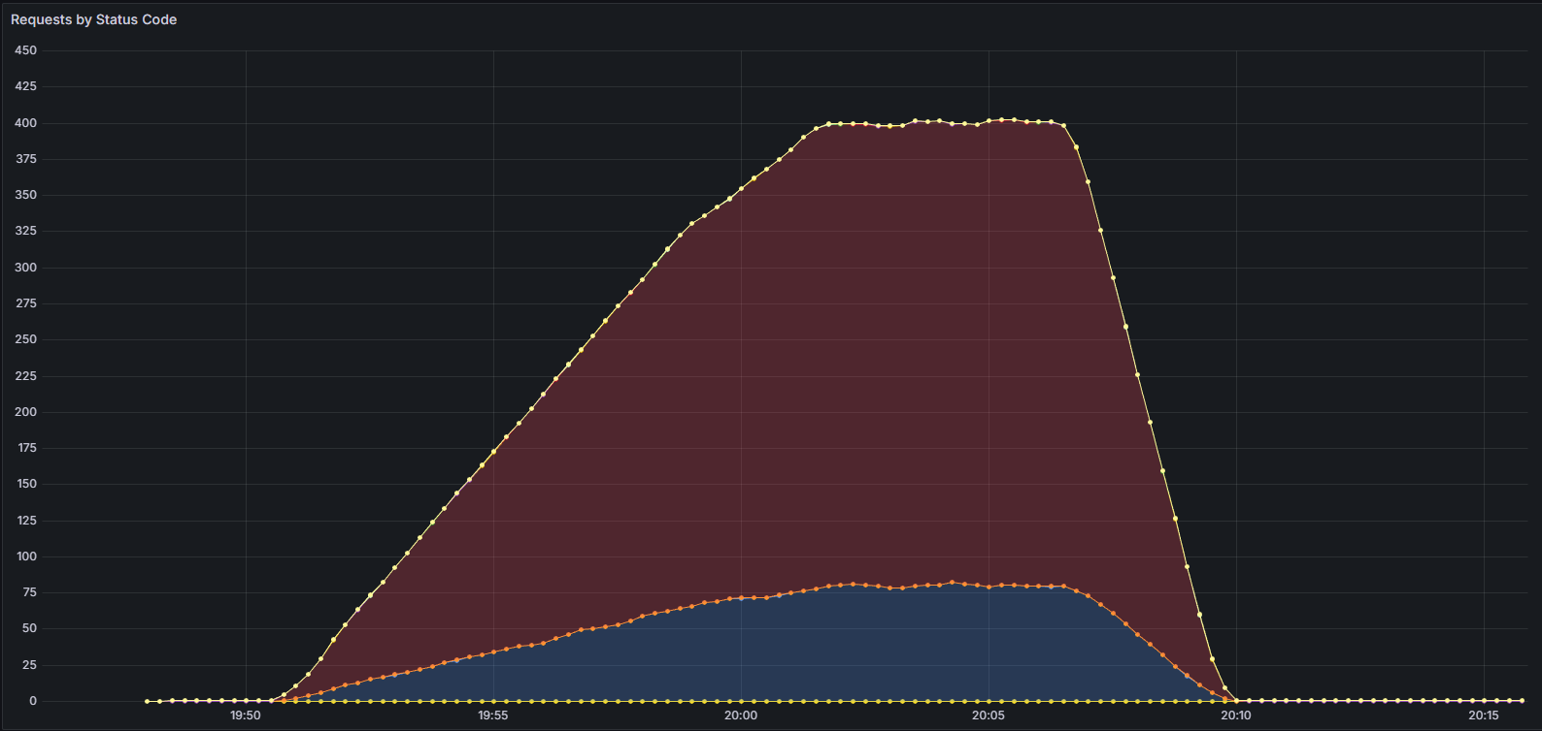

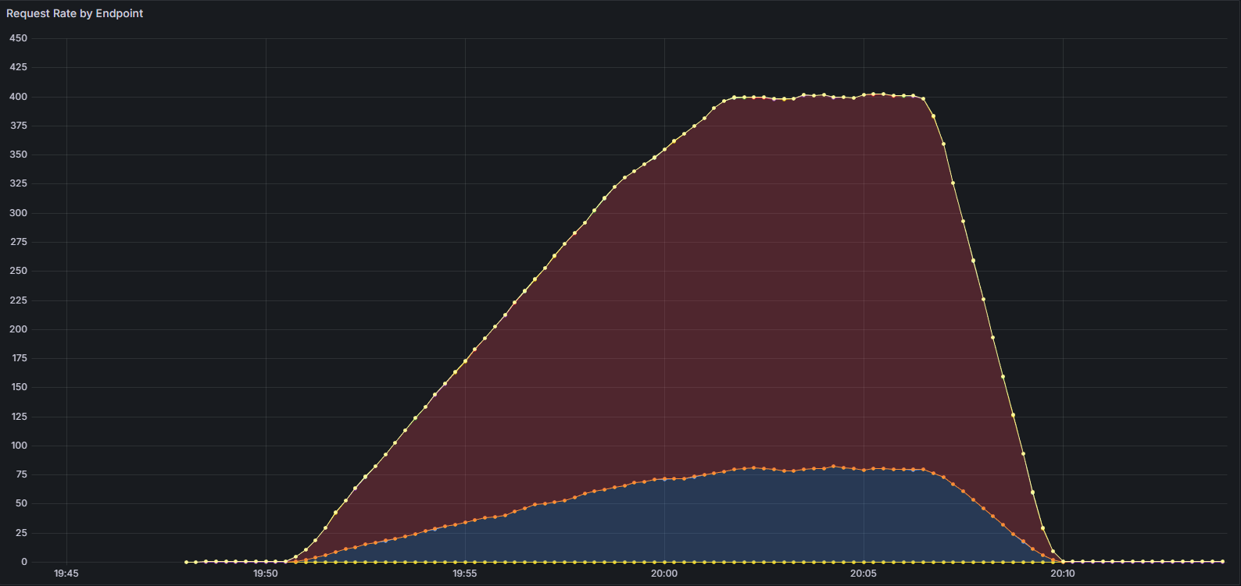
Response Time Graph:
This is where things got interesting. At 100 and 500 users, most requests stayed in the 50-300ms range. But at 1000 users, I saw the graph spread out - lots of requests hitting 1-3 seconds. The admin-service line was consistently higher than others.

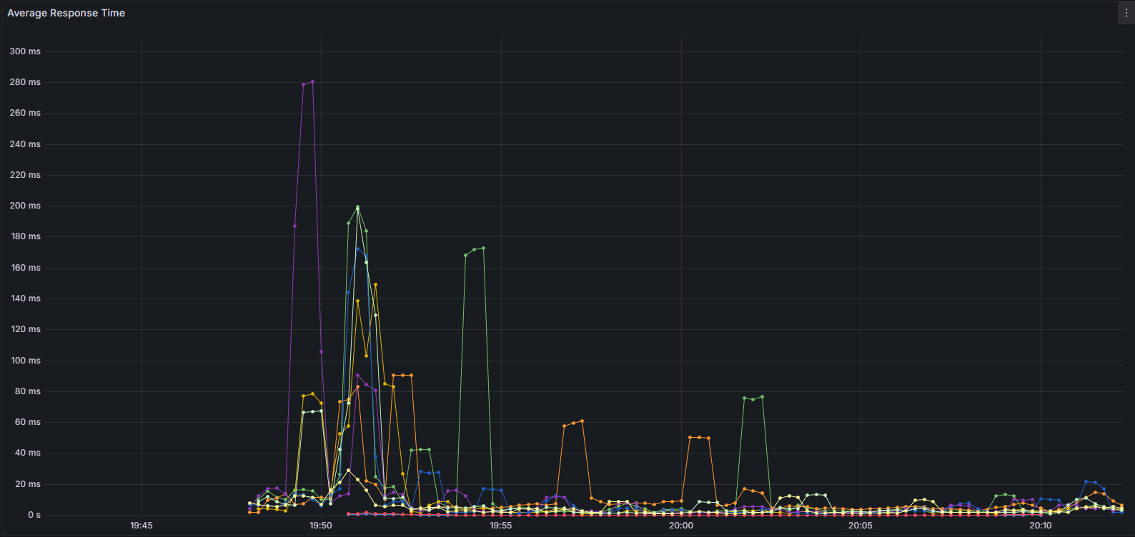

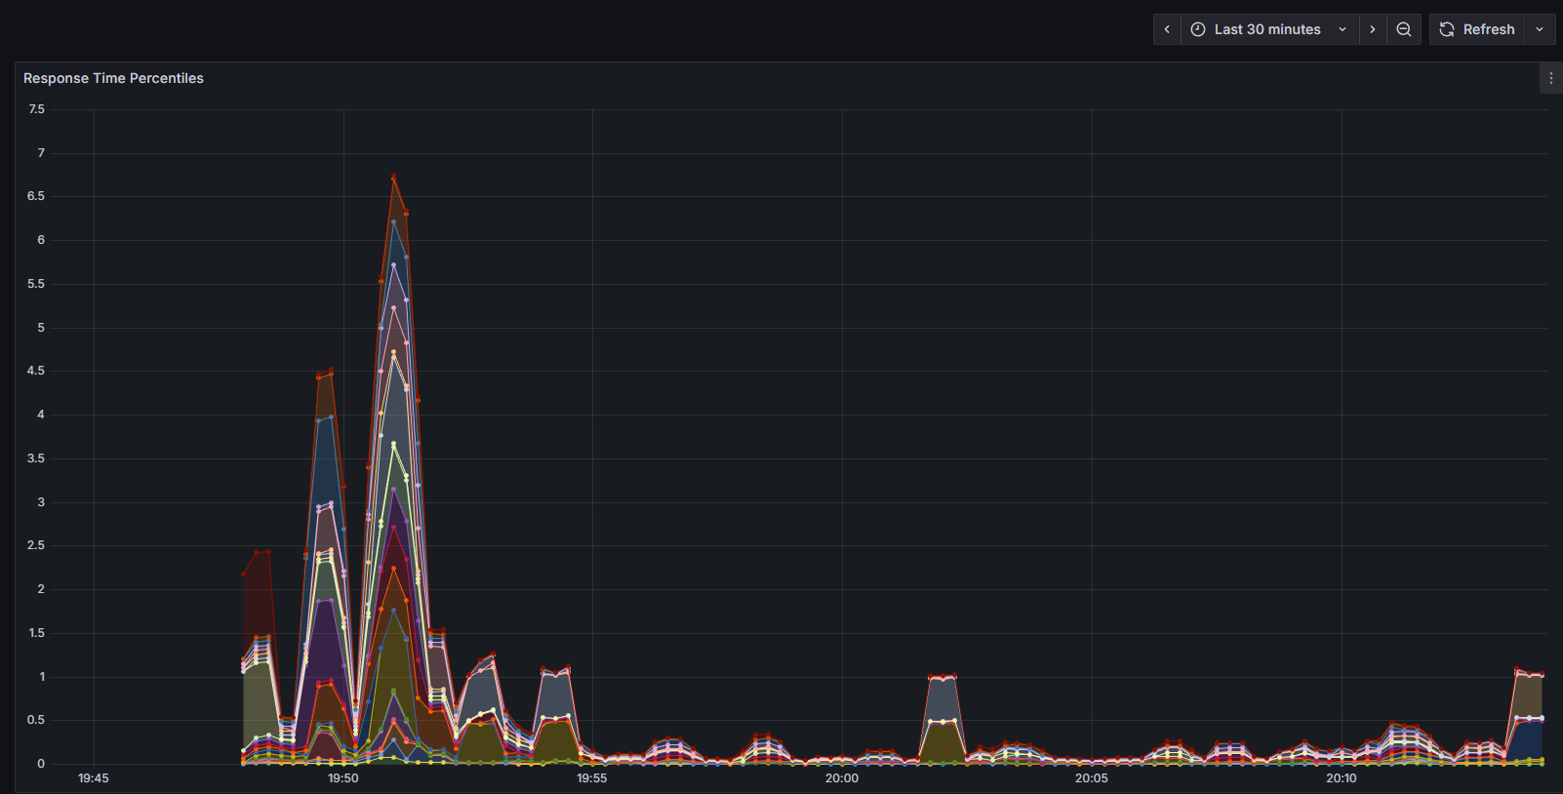

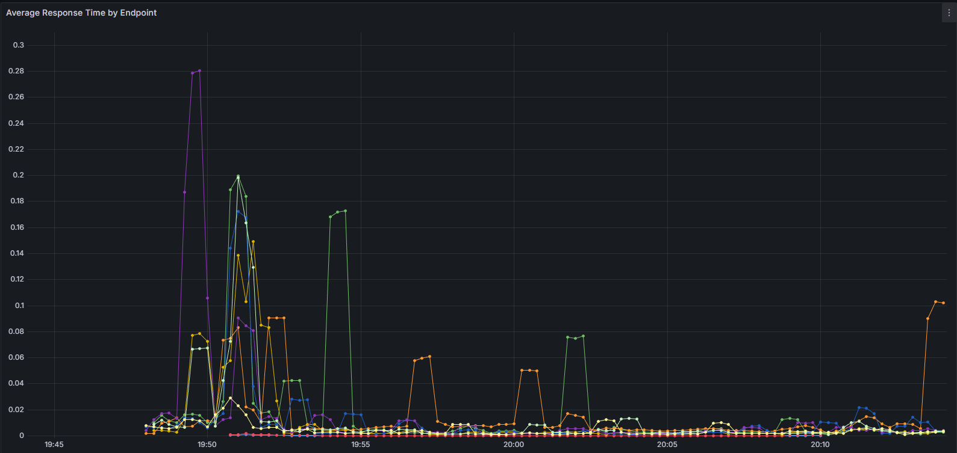
Error Rate:
The 4xx error rate stayed pretty flat around 10-13% across all tests. Interestingly, no 5xx errors (server errors) showed up, which means the services didn't crash - they just returned 4xx client errors. My guess is these are mostly 404s or 401s from test script issues.

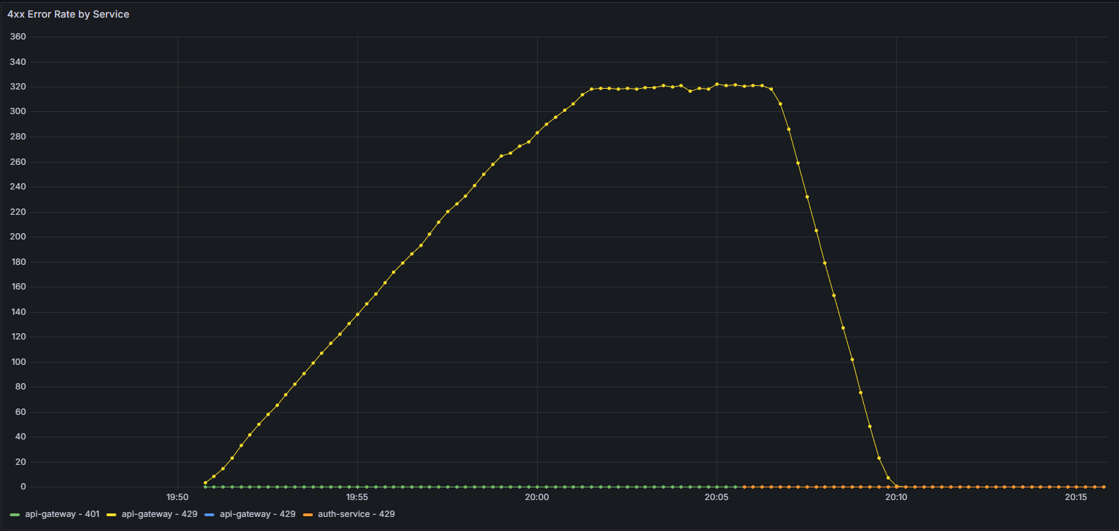


CPU and Memory Usage:
CPU usage increased during tests (as expected) but never went above about 30% on any service. Memory usage was stable - no memory leaks detected. This confirms the performance problem isn't CPU or memory, it's probably database connection limits.
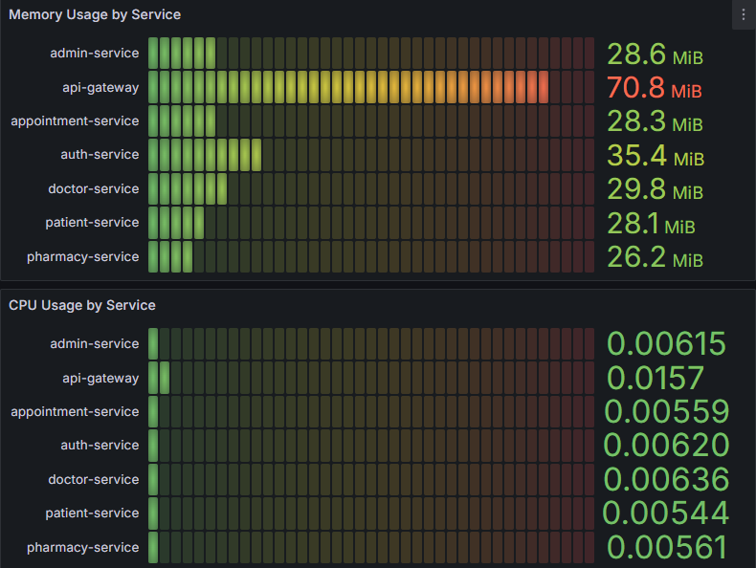

Other observations:
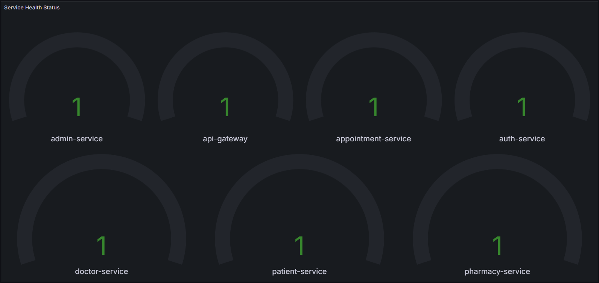
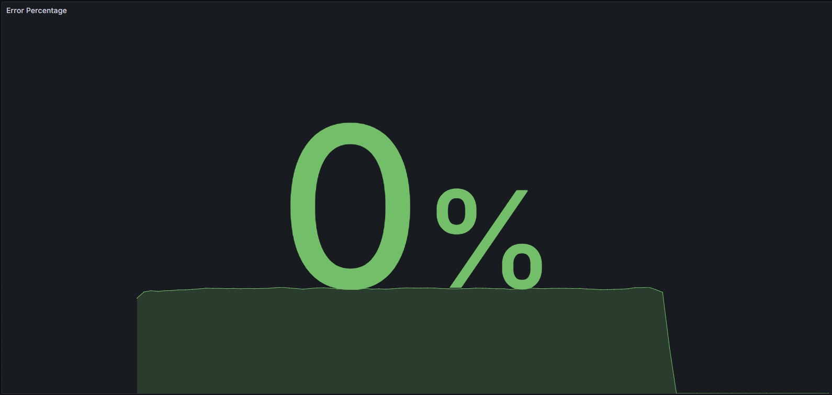
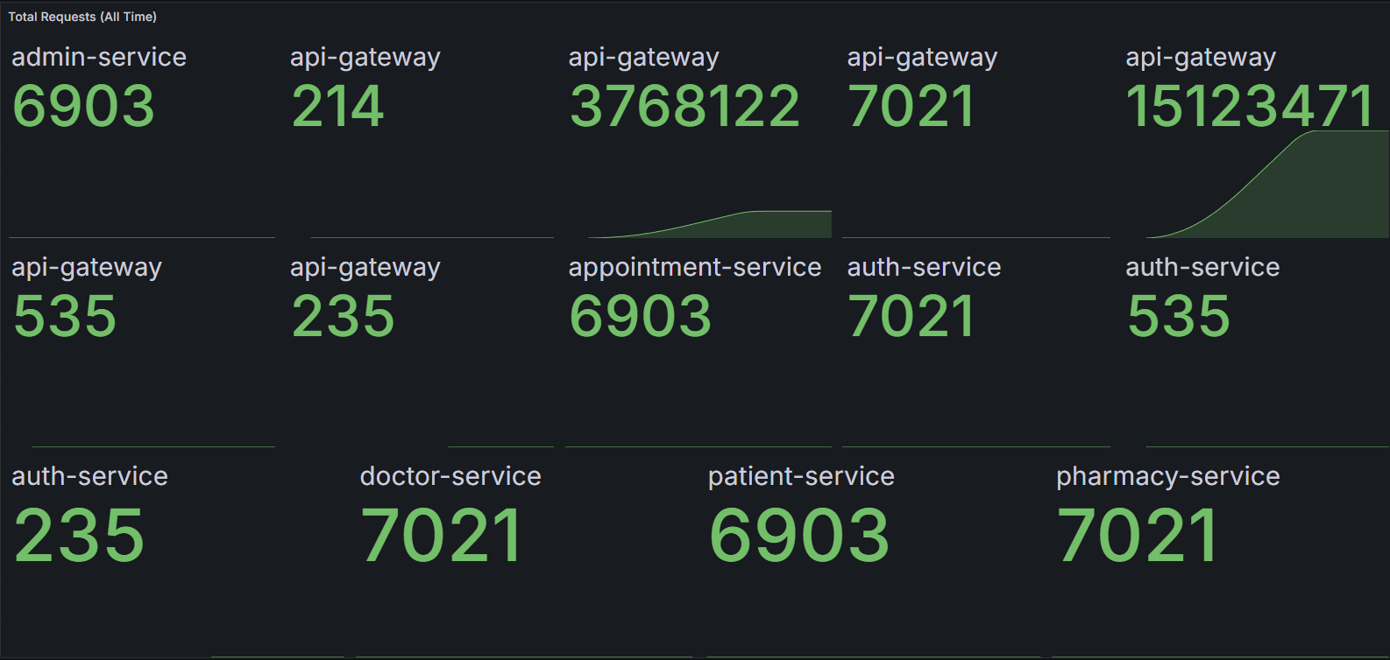
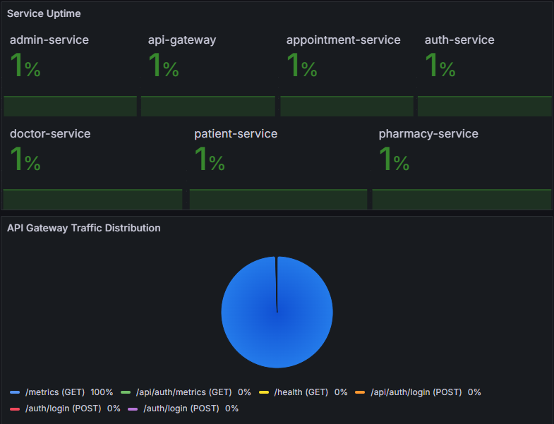

Where Are the Bottlenecks?
Based on the test results and monitoring data, here's what I think is limiting performance:
1. Database Connection Pool Exhaustion
Each service has a PostgreSQL connection pool (default is usually 10-20 connections). At 1000 concurrent users, with each user making multiple database queries, I'm probably exhausting these connection pools. Requests have to wait for a free connection, which adds latency.
Evidence: Response times increased significantly at 1000 users, but CPU/memory stayed low. This pattern (high latency, low resource usage) typically means waiting for I/O - in this case, database connections.
Solution: Increase connection pool sizes or implement connection pooling at the infrastructure level (like pgbouncer).
2. Admin Service Aggregation Overhead
The admin service is slower because it aggregates data from multiple sources. It maintains cached copies of users, patients, doctors, appointments, prescriptions (all synced via Kafka), and queries these caches. With more data, these queries get slower.
Evidence: Admin service consistently showed 1.2s p95 latency even at 500 users, while other services were under 600ms.
Solution: Add proper database indexes on the admin service's cache tables, or consider using Redis instead of PostgreSQL for the cache.
3. Single API Gateway Instance
All traffic flows through a single API Gateway container. At 380 requests/second, this single instance is probably becoming a bottleneck.
Evidence: The gateway wasn't pegged on CPU, so it's probably hitting Node.js event loop limits.
Solution: Deploy multiple gateway instances behind a load balancer (NGINX or Kubernetes ingress).

What I Learned from This
1. System is slower than I thought
When I was developing, everything felt instant. Click login, instant response. But under load, those 50ms requests can turn into 2-second requests. Load testing reveals how systems actually behave when many people use them simultaneously.
2. Authentication is critical (mine works!)
I was genuinely worried authentication would fail under load. JWT token generation, database lookups, password validation - lots of moving parts. But 166,867 login attempts with 100% success rate proved that part is solid. That was a relief.
3. Microservices isolation works
When the admin service got slow, it didn't take down the patient service or doctor service. Each service has its own database and runs independently. This is exactly what microservices architecture is supposed to provide - fault isolation.
4. Percentiles matter more than averages
At 1000 users, the average response time was 267ms (not bad). But p95 was 1.69 seconds and p99 was 3 seconds. If I only looked at the average, I'd think everything was fine. But 5% of users (50 out of 1000) were waiting 2-3 seconds. That's the real user experience.
5. Failure rate mystery
The consistent 10-13% failure rate across all load levels is puzzling. Since it doesn't increase with load, it's probably not a capacity issue. It might be a bug in my test script (requesting endpoints that don't exist) or an actual application bug. This needs investigation - I should look at the actual HTTP responses to see what's failing.

What Should Be Done Next
Based on these results, here's what I think:
For Current Deployment (if launching today):
• Set capacity limit at 500 concurrent users: The system handles 500 users with acceptable performance (575ms p95). Beyond that, response times degrade significantly.
• Set up alerts for response time > 1 second: This gives warning before user experience gets bad.
• Investigate the 10% failure rate: I need to look at the actual failed requests to understand what's failing.

For Scaling to 1000+ Users:
• Increase database connection pools: Each service should have larger connection pools (maybe 50 connections instead of 10-20).
• Deploy multiple API Gateway instances: Put 3 gateway instances behind NGINX load balancer.
• Optimize admin service: Add database indexes on the cache tables, or switch to Redis for caching.
• Consider read replicas: For read-heavy services (admin, patient, doctor), use PostgreSQL read replicas to distribute query load.
Future Improvements:
• Test with real user behavior: My test script is simplified. Real users browse, search, book appointments - more varied actions.
• Test longer duration: My longest test was 19 minutes. A 2-hour soak test would reveal memory leaks or connection leaks.
• Test different scenarios: All my tests focused on authentication and profile queries. Should also test appointment booking, prescription requests, etc.

Conclusion
Overall, I'm pretty happy with how HealthConnect performed:
The Good:
• Authentication is rock solid (100% success rate)
• System doesn't crash under load (graceful degradation)
• Microservices isolation works as designed
• Can handle 500 concurrent users with good performance
The Not-So-Good:
• 10-13% request failure rate needs investigation
• Performance degrades significantly above 500 users
• Admin service is a bottleneck
• Single API Gateway is a single point of failure
Is it production-ready? For a small deployment (under 500 users), yes. For a large healthcare system, it would need the scaling improvements.
I built a system that handled 597,000+ requests across 43 minutes of testing without crashing once. I identified specific bottlenecks and can articulate how to fix them. I understand the limits of my architecture. That's pretty good. HealthConnect works. With some database tuning and horizontal scaling, it could scale too.

Technical Details

Test Environment
Hardware: My laptop (4 CPU cores, 16GB RAM)
Software: Docker Compose v2, k6 latest version
Services: 7 microservices + 7 PostgreSQL databases + Prometheus + Grafana + Kafka + Zookeeper
Total containers: 18 containers running simultaneously
Special Configuration for Load Testing:
• Created docker-compose.loadtest.yml to disable rate limiters
• Set NODE_ENV=loadtest environment variable
• Services check this variable and skip rate limiting if present

