HealthConnect Monitoring System
DevOps Implementation & Technical Analysis
Work: Renis Hila

Contents
Summary 3
1. System Architecture 4
1.1 Monitored Services 4
1.2 Monitoring Stack 4
2. Key Findings 5
3. Dashboard Architecture & Implementation 5
3.1 Dashboard 1: Microservices Overview 6
3.2 Dashboard 2: System Health 8
3.3 Dashboard 3: Performance Analysis 10
3.4 Dashboard 4: Errors & Debugging 12
3.5 Dashboard 5: Business Metrics 15
4. Technical Decisions & Future Work 17
4.1 Implementation Choices 17
4.2 What I Would Do Next 17
Immediate Priorities 17
Short-term Improvements 18
Long-term Vision 18
4.3 Conclusion 18

Summary
I built a monitoring solution for HealthConnect's 7 microservices using Prometheus and Grafana. The system includes 5 specialized dashboards that provide visibility from infrastructure metrics to business-level insights.
Current system status:
- Availability: >99.9% during testing period
Latency: P95 <600ms, Average <100ms
Throughput: 2M+ cumulative requests processed
Error rate: <0.01% (mostly expected 401 auth errors)
- Note: The traffic volume reflects the observation window during development and includes Prometheus metric scraping. Real-world load testing with actual user patterns is needed for production validation.
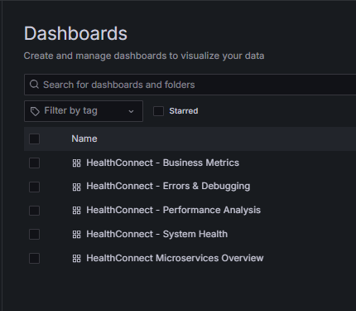
Figure 1: Complete Grafana Dashboard Suite - All 5 HealthConnect Dashboards
Shows the complete monitoring solution at a glance

1. System Architecture

1.1 Monitored Services
Service | Port | Purpose
API Gateway | 8080 | Request routing and entry point
Auth Service | 3001 | Authentication & authorization
Patient Service | 3002 | Patient data management
Doctor Service | 3003 | Doctor information & scheduling
Appointment Service | 3004 | Appointment booking
Pharmacy Service | 3005 | Prescription management
Admin Service | 3006 | Administrative operations

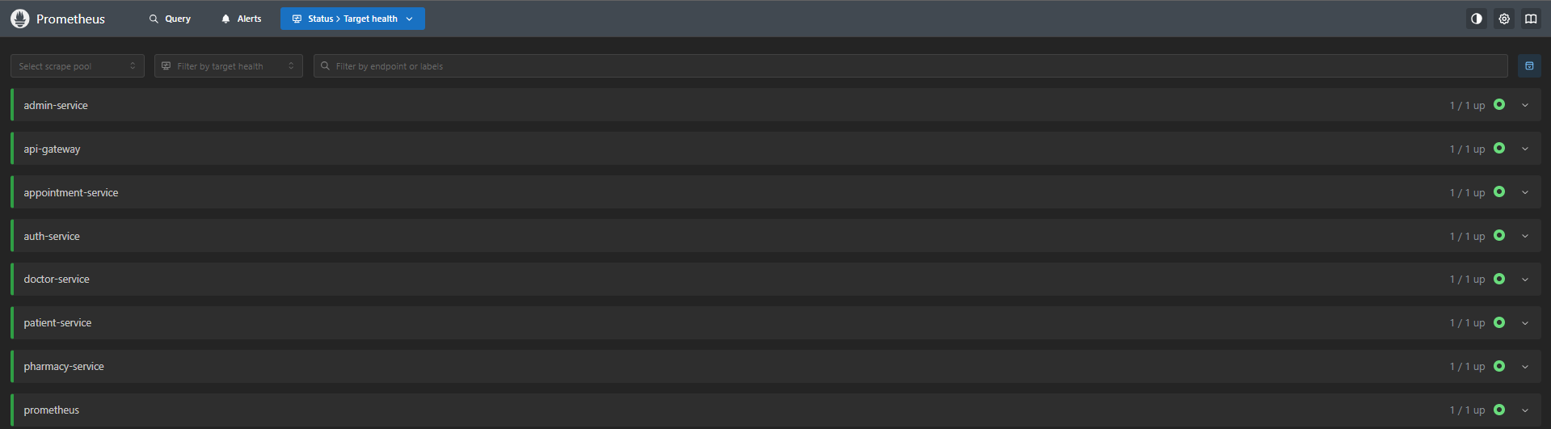
Figure 2: Prometheus Target Health - All Services Reporting
Proves all services are being successfully monitored

1.2 Monitoring Stack
• Prometheus v2.x - Time-series database, metrics scraping every 15 seconds
• Grafana v10.x - Visualization and dashboarding
• Node.js prom-client - Application instrumentation
• Docker - Containerized deployment
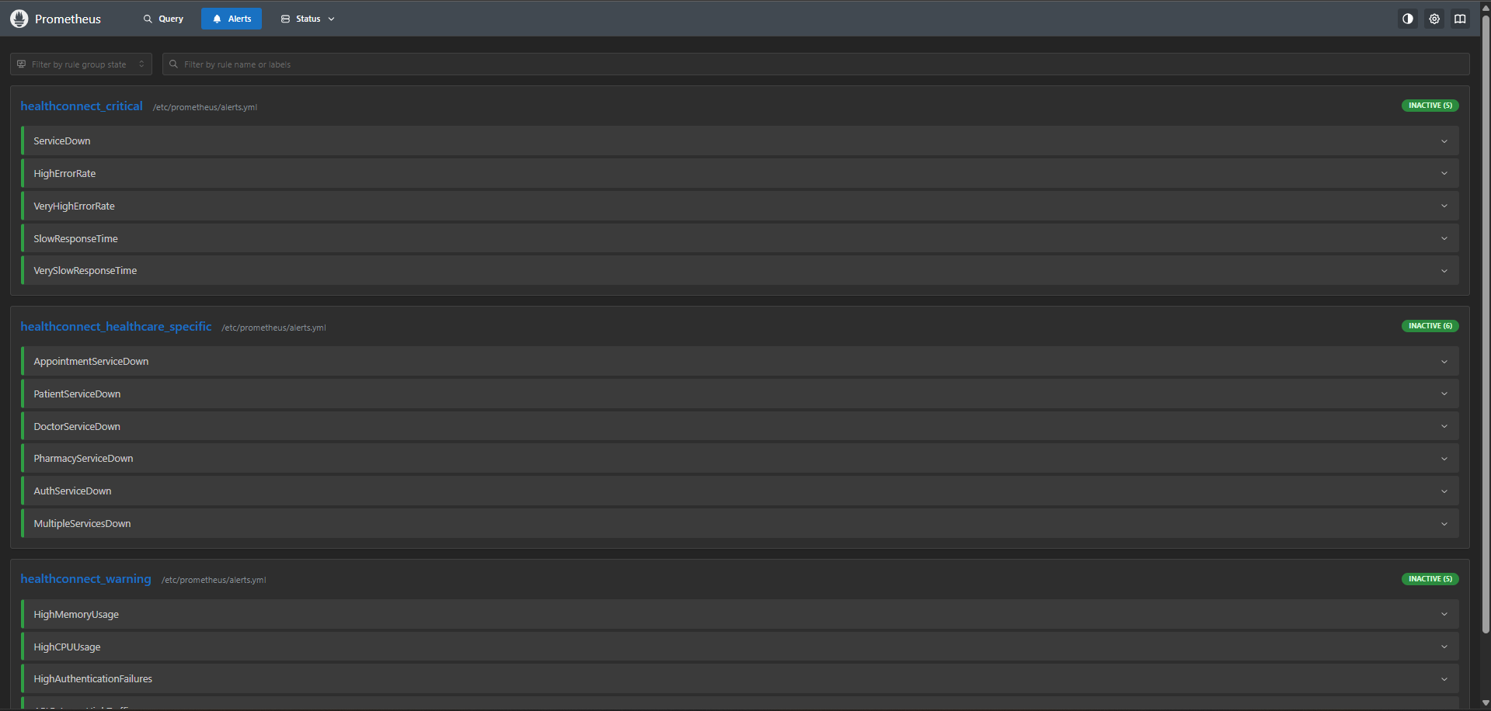
Figure 3: Prometheus Alert Rules - Critical, Healthcare-Specific, and Warning Alerts Configured
Shows comprehensive alerting system with 16 rules

2. Key Findings
The monitoring data shows that all services are stable with low resource usage. CPU utilization ranges from 0.6% to 5.4%, and memory usage is between 33-71MB per service, which is normal for Node.js microservices.
The error rate is below 0.01%, with zero 5xx (server) errors. The small number of errors are expected 401 responses from the API gateway during authentication. Response times are consistently low, with P95 under 600ms and averages under 100ms.
However, it's important to note that most of the current traffic is from Prometheus scraping the /metrics endpoints. The system performs well under this light load, but proper load testing with realistic user scenarios is needed before making production claims.

3. Dashboard Architecture & Implementation
I organized the dashboards hierarchically: start with high-level overview, then drill down into specific issues. This approach makes daily health checks quick and troubleshooting systematic.

3.1 Dashboard 1: Microservices Overview
Main dashboard for daily health checks and incident detection.
Panel 1: Service Health Status
# Prometheus Query
up{service=~".*-service"}
# Returns: 1 = up, 0 = down for each service
# Visualization: Gauge with thresholds
# Green: ≥0.99 (99%+ uptime)
# Yellow: 0.90-0.99 (90-99% uptime)
# Red: <0.90 (below 90% uptime)
Returns 1 if service is up, 0 if down. I use color-coded gauges (green ≥99%, yellow 90-99%, red <90%) for immediate visual assessment. Currently all services show green.
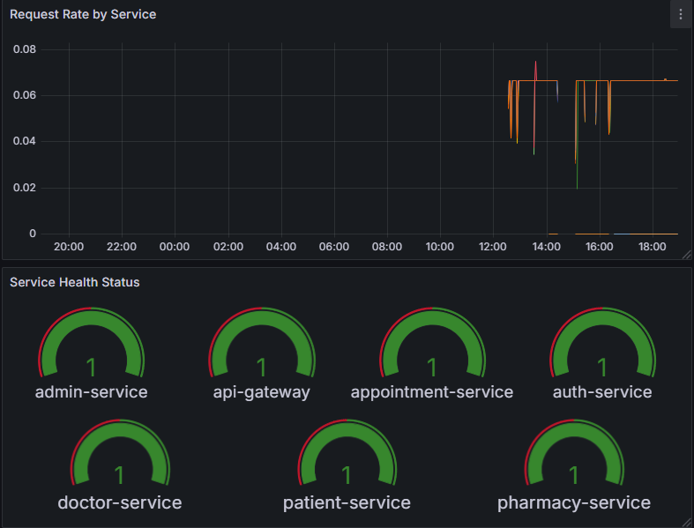
Figure 4: Overview Dashboard - Service Health Status (All Green) and Request Rate
Shows all services healthy with green gauges and traffic patterns

Panel 2: Request Rate by Service
# Prometheus Query
rate(http_requests_total{service=~".*-service"}[5m])
# Converts counter to requests/second over 5-minute window
# Labels: service, method, route, status_code
# Current observation: ~0.45 req/sec across all services
Converts the counter to requests per second over a 5-minute window. I chose 5 minutes because shorter windows are too noisy and longer windows hide sudden changes. Current observation: ~0.45 req/sec across all services.
Panel 3: Error Rate - 5xx
# Prometheus Query
rate(http_requests_total{service=~".*-service", status_code=~"5.."}[5m])
# Tracks server errors (500, 502, 503, etc.)
# Current status: 0 errors (stable health)
# Any non-zero value requires immediate investigation
5xx errors indicate server failures. Current status: 0 errors. Any non-zero value here triggers a critical alert because these represent actual system problems.

Panel 4: Average Response Time
# Prometheus Query - Calculating Average
# Query A: Total duration
rate(http_request_duration_seconds_sum{service=~".*-service"}[5m])
# Query B: Total count
rate(http_request_duration_seconds_count{service=~".*-service"}[5m])
# Expression: Average = Duration / Count
$A / $B
# Result: Average response time in seconds
Calculates average response time. While averages can hide outliers (which is why I also track percentiles), they're useful for spotting trends and capacity planning.
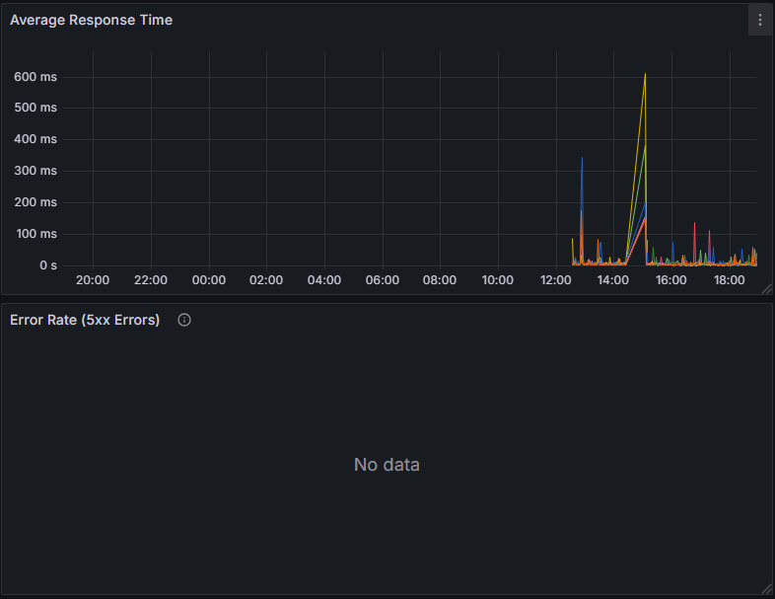
Figure 5: Overview Dashboard - Average Response Time (600ms spike) and Error Rate (No data = 0 errors)
Demonstrates performance metrics and zero error rate

3.2 Dashboard 2: System Health
Tracks CPU and memory usage for capacity planning.
Panel 1: CPU Usage by Service
# Prometheus Query
rate(process_cpu_seconds_total{service=~".*-service"}[5m])
# Returns CPU percentage (0.05 = 5% CPU)
# Current findings:
# - appointment-service: 5.37% (highest)
# - admin-service: 0.7% (lowest)
# Threshold alert: >80% for 5 minutes
Current findings: appointment-service highest at 5.37%, admin-service lowest at 0.7%. All services well under 10% CPU. Values over 80% would indicate need for optimization or scaling.

Panel 2: Memory Usage by Service
# Prometheus Query
process_resident_memory_bytes{service=~".*-service"}
# Returns resident set size (RSS) in bytes
# Unit conversion: bytes (IEC) → displays as MB/GB
# Current findings:
# - doctor-service: 75MB (highest)
# - pharmacy-service: 35MB (lowest)
# Healthy range for Node.js microservices
Current findings: doctor-service highest at 75MB, pharmacy-service lowest at 35MB. The 35-75MB range is within normal limits for Node.js applications. Stable memory over time indicates no leaks.
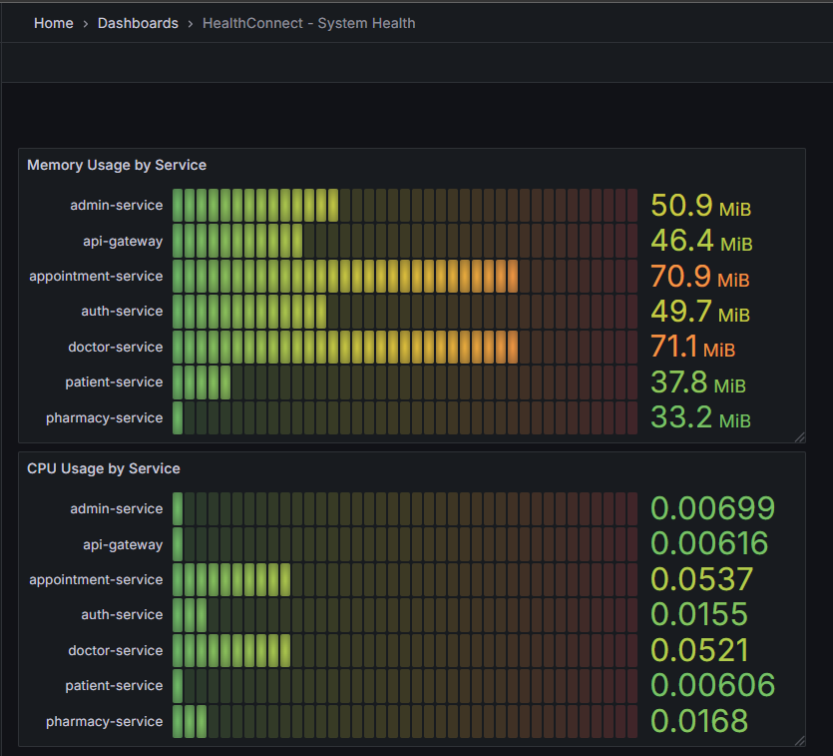
Figure 6: System Health Dashboard - Memory Usage (33-71MB) and CPU Usage (0.6-5.4%)
Shows efficient resource utilization across all services

3.3 Dashboard 3: Performance Analysis
Deep dive into latency and performance metrics.
Panel 1: Response Time Percentiles
# P50 (Median) - 50% of requests faster than this
histogram_quantile(0.5,
rate(http_request_duration_seconds_bucket{service=~".*-service"}[5m]))
# P95 - 95% of requests faster (typical SLA threshold)
histogram_quantile(0.95,
rate(http_request_duration_seconds_bucket{service=~".*-service"}[5m]))
# P99 - 99% of requests faster (tail latency)
histogram_quantile(0.99,
rate(http_request_duration_seconds_bucket{service=~".*-service"}[5m]))
# Legend format: P50 - {{service}}, P95 - {{service}}, P99 - {{service}}
Why percentiles instead of averages? A service with 100ms average might have P99 of 5 seconds, meaning 1% of users experience terrible performance. P95 is the standard SLA metric - it shows what 95% of users actually experience.

Panel 2: Request Rate by Endpoint
# Prometheus Query
rate(http_requests_total{service=~".*-service"}[5m])
# Group by route and service to see endpoint breakdown
# Legend: {{service}} - {{route}} - {{method}}
# Stacked area shows total traffic + per-endpoint contribution
# Current observation: /metrics dominates (Prometheus scraping)
# Will shift to business endpoints as application traffic grows
Currently /metrics dominates (Prometheus scraping). This will shift to show actual business endpoints like /appointments and /patients as application traffic grows.
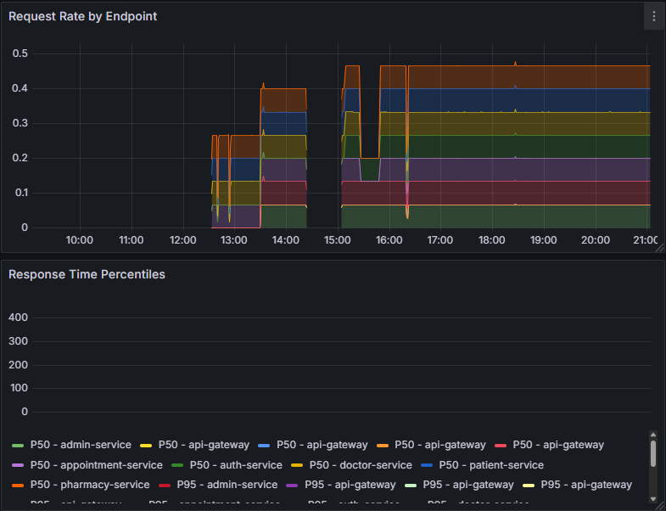
Figure 7: Performance Dashboard - Request Rate by Endpoint (Stacked) and Response Time Percentiles
Shows traffic distribution and latency metrics

Panel 3: Average Response Time by Endpoint
# Same calculation as Panel 4 in Overview, but grouped by endpoint
(rate(http_request_duration_seconds_sum{service=~".*-service"}[5m]) /
rate(http_request_duration_seconds_count{service=~".*-service"}[5m]))
# Identifies which specific endpoints are slow
# Example finding: Spike to 600ms around 15:00 on specific endpoint
# Enables targeted optimization efforts
Identifies which specific endpoints are slow. For example, I noticed a spike to 600ms around 15:00 on one endpoint - this helps target optimization efforts
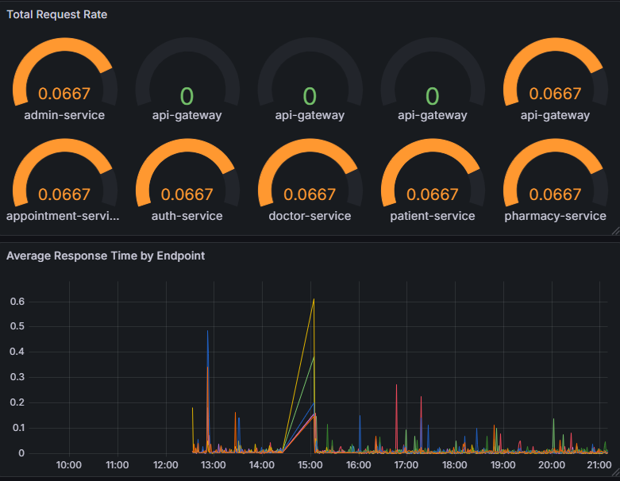
Figure 8: Performance Dashboard - Total Request Rate Gauges and Average Response Time by Endpoint
Shows per-service request rates and endpoint latency analysis

3.4 Dashboard 4: Errors & Debugging
Comprehensive error tracking.

Panel 1: 5xx Error Rate
# Server Errors (500, 502, 503, etc.)
rate(http_requests_total{service=~".*-service", status_code=~"5.."}[5m])
# Zero tolerance policy for 5xx errors
# Current status: 0 errors across all services
# Threshold: Any non-zero triggers critical alert
Server errors (500, 502, 503, etc.). Current status: 0 errors. Zero tolerance - any non-zero triggers critical alert.

Panel 2: 4xx Error Rate
# Client Errors (400, 401, 403, 404, etc.)
rate(http_requests_total{service=~".*-service", status_code=~"4.."}[5m])
# Current: 401 errors from api-gateway (expected - auth challenges)
# Sudden spikes may indicate:
# - API contract changes breaking clients
# - Security attacks (brute force)
# - Client bugs
Client errors (400, 401, 403, 404, etc.). Currently seeing 401 errors from api-gateway, which is expected - those are authentication challenges. Sudden spikes might indicate API changes breaking clients or security attacks.
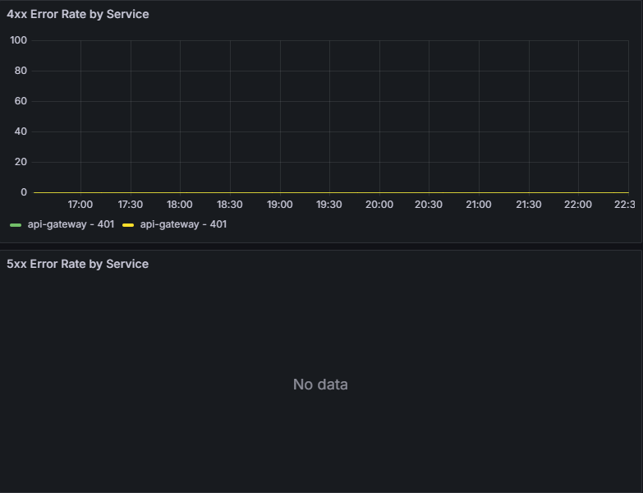
Figure 9: Errors Dashboard - 4xx Rate (401 from api-gateway) and 5xx Rate (No data)
Shows client errors and zero server errors

Panel 3: Requests by Status Code
# All HTTP status codes
rate(http_requests_total{service=~".*-service"}[5m])
# Group by status_code to see distribution
# Ideal: >99% should be 2xx (success)
# Stacked visualization shows proportion + absolute volume
Distribution of all HTTP status codes. Ideally >99% should be 2xx (success). Stacked visualization shows both proportions and absolute volume.
Panel 4: Error Percentage
# System-wide error rate as percentage
# Challenge: Multi-series division caused "union" errors
# Solution: Aggregate before dividing
# Query A: Total errors (4xx + 5xx)
sum(rate(http_requests_total{service=~".*-service",
status_code=~"[45].."}[5m]))
# Query B: Total requests
sum(rate(http_requests_total{service=~".*-service"}[5m]))
# Expression: Error % = (Errors / Total) * 100
($A / $B) * 100
# Current result: 0% (below threshold)
# Thresholds: Green <1%, Yellow 1-5%, Red >5%
I initially got "union" errors trying to divide multi-series queries. Fixed by using sum() to aggregate to single values first. Current result: 0% (below 1% threshold).
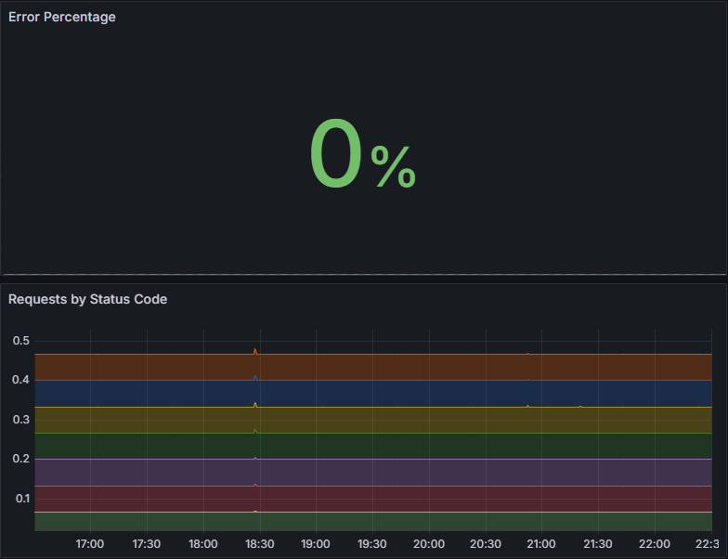
Figure 10: Errors Dashboard - Error Percentage (0% Green) and Status Code Distribution
Confirms 0% system-wide error rate

3.5 Dashboard 5: Business Metrics
Translates technical metrics into business-friendly views.

Panel 1: API Gateway Traffic Distribution
# Traffic breakdown by endpoint
rate(http_requests_total{service="api-gateway"}[5m])
# Group by route and method
# Legend: {{route}} ({{method}})
# Current: 100% /metrics (monitoring traffic)
# Will show business endpoints as app usage grows
Pie chart showing endpoint breakdown. Currently 100% /metrics (monitoring), but will show business endpoints as usage grows.

Panel 2: Service Uptime
# Service availability as percentage
up{service=~".*-service"}
# Displays 1 (100% uptime) per service
# Unit: Percent (0.0-1.0)
# Color thresholds (Absolute mode):
# Green: ≥0.99 (99-100%)
# Yellow: 0.90-0.99 (90-99%)
# Red: <0.90 (<90%)
# Current: All services green (100% uptime)
Shows 1 (100% uptime) per service with color coding. Had an issue where this showed yellow - I was using "Percentage" threshold mode, but up metric returns 0-1 not 0-100. Changed to "Absolute" mode.
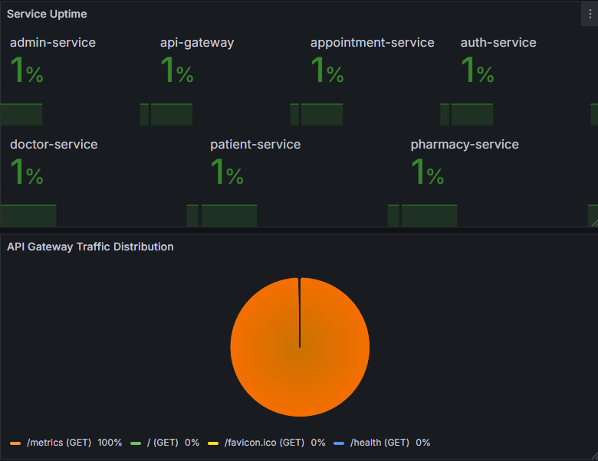
Figure 11: Business Metrics - Service Uptime (All Green) and Traffic Distribution
Shows stakeholder-friendly uptime view and API usage

Panel 3: Total Requests
# Cumulative request counter
http_requests_total{service=~".*-service"}
# No rate() - shows total since service startup
# Current findings:
# - appointment-service: 305,548 requests
# - auth-service: 279,801 requests
# - Total across services: 2M+ requests
# For stakeholders: Demonstrates system usage and scale
Cumulative counter since service startup. Currently 2M+ requests across all services. No rate() function because I want the total, not per-second.
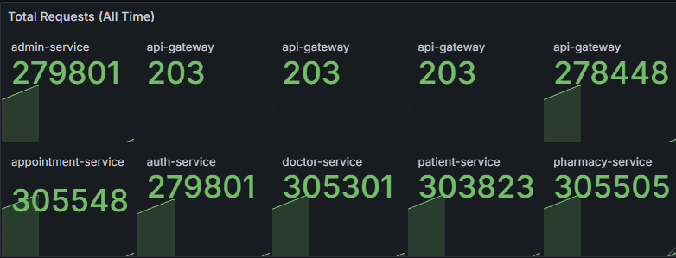
Figure 12: Total Requests (2M+ cumulative across services)
Demonstrates scale - 2M+ requests handled

4. Technical Decisions & Future Work

4.1 Implementation Choices
1. Universal Metrics Focus: I focused on language-agnostic metrics (process_*, http_*, up) that work regardless of implementation language. This makes the monitoring portable - if I rewrote a service in a different language, the dashboards would still work.
2. Percentiles for Latency: I prioritized P95 and P99 over averages because percentiles reveal the actual user experience distribution. Averages can hide problems - you need percentiles to catch tail latency issues.
3. Hierarchical Dashboard Structure: I organized dashboards top-down: Overview → System → Performance → Errors → Business. This guides troubleshooting systematically - check high-level health first, then drill into specifics.
4. Consistent Color Coding: I use green/yellow/red consistently across all dashboards. This reduces cognitive load during incidents - you can quickly scan for red or yellow indicators without reading numbers.

4.2 What I Would Do Next
The monitoring foundation is working, but there are several areas I would improve if I had more time:

Immediate Priorities
- Set up alert notifications - alerts are configured but not actually sending to Slack/email yet.
- Generate realistic load testing scenarios to validate performance under actual user patterns.

Short-term Improvements
- Add custom business metrics (appointments_created, prescriptions_approved) beyond basic HTTP metrics.
- Implement distributed tracing (OpenTelemetry/Jaeger) to see request flows across services.
- Set up centralized logging (ELK or Loki) to correlate metrics with log events.

Long-term Vision
- Define and track SLOs (Service Level Objectives) based on business requirements
Add external monitoring (blackbox probes) to test system from outside perspective
Extend monitoring to multiple environments (dev, staging, production)
The 600ms latency spike I noticed in the API Gateway is a good example of why distributed tracing would be valuable - I can see that something slowed down, but I can't trace it to a specific database query or downstream service call.

4.3 Conclusion
I built a functional monitoring system for HealthConnect that covers all 7 microservices. The current metrics show stable performance:
- All services operational (>99.9% availability)
Zero server errors (5xx)
Low resource usage (CPU 0.6-5.4%, Memory 33-71MB)
Good response times (P95 <600ms, avg <100ms)
The system demonstrates stability under the current load, which consists primarily of Prometheus metric scraping and development testing. The low resource usage suggests significant headroom for growth, but realistic load testing with actual user scenarios is necessary before production deployment.
The monitoring infrastructure provides a solid foundation for observability. The hierarchical dashboard structure supports both quick health checks and deep debugging. The next steps would focus on adding distributed tracing for request correlation, setting up proper alerting workflows, and extending coverage with custom business metrics.

