PakStream
Secure Media Streaming & Document Management Platform

Prototype Document

Document Title | Prototype Document
Project | PakStream — Secure Media Streaming & Document Management Platform
Version | 1.0
Date | June 02, 2026
Prepared By | PakStream Project Team
Status | For Submission (CSO Requirement)

Table of Contents
(In Microsoft Word: References → Table of Contents → Automatic Table to generate from the headings below.)

1. Introduction
This document presents the working prototype of PakStream. The prototype is a fully functional web application built with React (TypeScript) on the frontend and Node.js/Express on the backend. This document walks through the existing user interface screen by screen. Representative screenshots are available in the project's demo/ folder.

2. Available Screenshots
The following screenshots are included in the repository's demo/ folder:
- demo/dashboard.png: Main dashboard / content browse view.
- demo/documents.png: Document library and viewer.
- demo/logo.png: Application branding / logo.
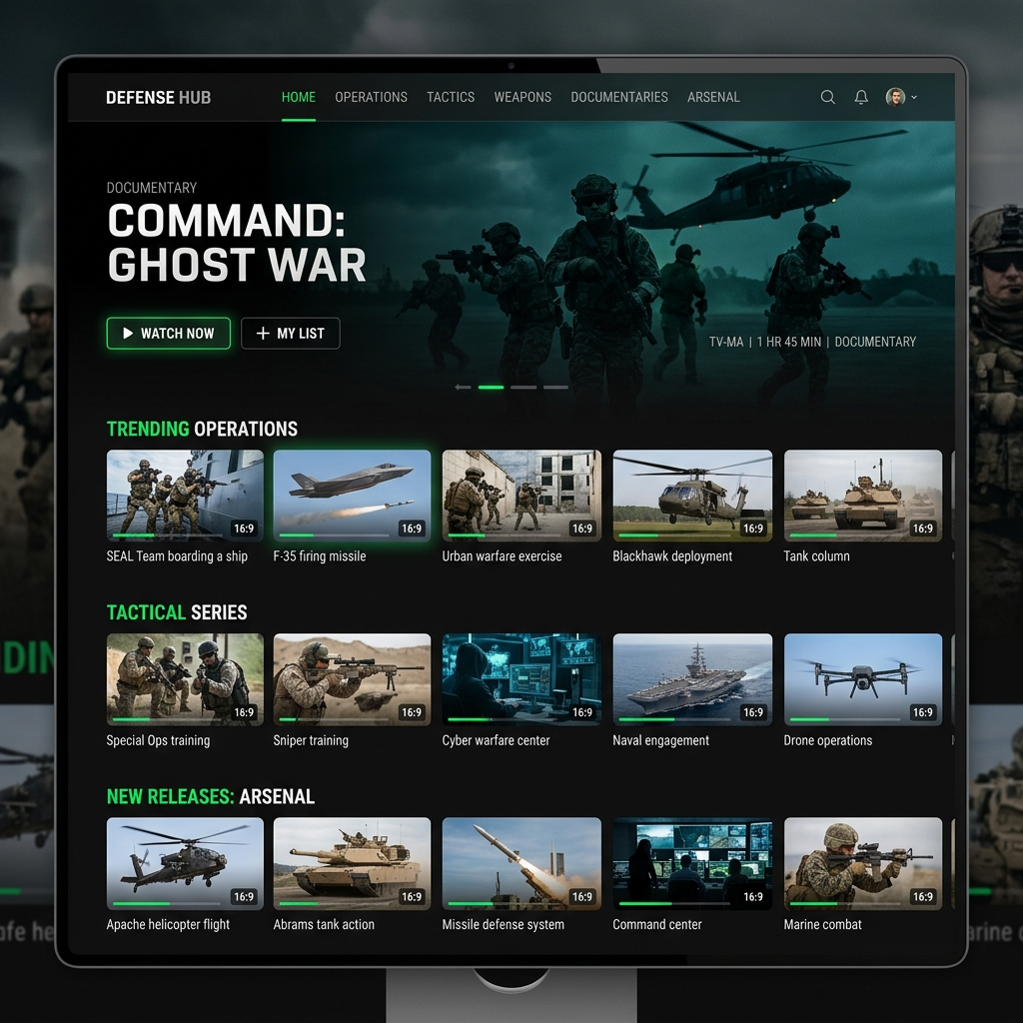
Figure 1 – Dashboard
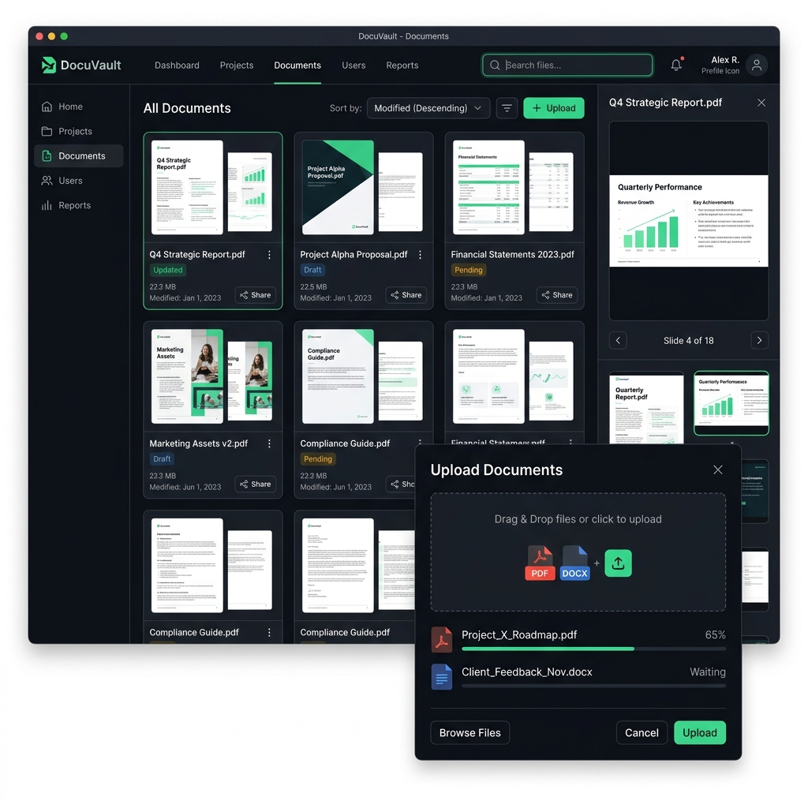
Figure 2 – Documents

3. Screen Walkthrough

3.1 Login & Registration
Entry screens for authentication. Users register with email and password; admins register using an admin key. On success a JWT is issued and the user is routed to their dashboard. Form validation and error messaging are provided.

3.2 User Dashboard
The landing experience after login. Presents featured and categorized content (videos, documents, presentations) in a Netflix-style browse layout with thumbnails, search, and category filters.

3.3 Video Player
Adaptive HLS player (HLS.js) with quality switching across 360p/480p/720p/1080p, play/pause/seek controls, view counting, and like/dislike actions.

3.4 Document Viewer
In-browser PDF viewer showing page-by-page navigation, page count, and a download option with SHA-256 integrity verification.

3.5 Presentation Viewer
Slide-by-slide viewer rendering converted PNG slides with next/previous navigation and thumbnails.

3.6 Premieres
List of scheduled live premiere events with countdowns; on start, playback is synchronized across viewers in real time via Socket.IO.

3.7 Admin Dashboard
Admin-only control center for uploading and managing videos, documents, and presentations, with real-time processing status indicators.

3.8 Analytics
Charts and metrics (via Recharts) summarizing views, downloads, and content usage for administrators.

3.9 User Management
Admin interface to list, search, and manage user accounts and roles.

3.10 Profile
User profile screen for editing avatar, bio, and account details.

4. Design & Interaction Notes
- Consistent dark, media-centric theme styled with Tailwind CSS.
- Responsive layouts adapting from desktop to mobile browsers.
- Real-time feedback for long-running uploads and transcoding jobs.
- Role-aware navigation: admin tools are hidden from standard users.

