Neuro-Fuzzy Multimodal Community Detection: Fusing Visual-Textual Semantics with Network Topology for Explainable Social Network Analysis
Sep 22, 2026 · @Someone

Abstract
Neuro-Fuzzy Multimodal Community Detection (NF-MCD) fuses text and image content with network structure through a canonical-correlation-analysis alignment step, a fuzzy confidence layer built on a three-term ANFIS, and fuzzy c-means clustering, with per-node explanations intended to follow directly from the model's own internal state rather than being computed post hoc. We report an extensive empirical evaluation of this pipeline across five real social-network datasets, a controllable synthetic generator, and close to two dozen targeted stress tests. The central finding does not support a straightforward accuracy claim: a simple baseline combining spectral clustering with a content-similarity graph outperforms NF-MCD's default configuration on overlapping normalized mutual information in most settings we tested, including on a real, label-independent social graph we constructed specifically to rule out the possibility that network structure was simply leaking the ground truth. We trace this shortfall to two concrete mechanisms - a degenerate fuzzy c-means fixed point under weak content signal, and an overfit cross-modal alignment step - and show that an alternative configuration (a revised fuzziness schedule, unsupervised content features, and a tighter alignment rank) closes much of the gap, while introducing a new and separately characterized failure mode under the combination of many communities and heavy content missingness. We further show that the model's confidence-based explanations are not causally faithful to what actually drove an assignment, and propose a neighborhood-based alternative that is. What survives this scrutiny is narrower than the method's original framing suggests: a specific, statistically validated robustness advantage under realistic, degree-correlated missing data, and an interpretability mechanism that holds up under direct measurement rather than by construction alone.
Keywords: overlapping community detection, multimodal fusion, fuzzy clustering, explainable AI, missing-modality robustness, canonical correlation analysis

1. Introduction
Social platforms produce content that is multimodal by default: a post typically pairs text with an image, and the two do not always agree. A caption can misdescribe its attached photo, deliberately or not; a post's image or text can simply be absent, since not every user attaches both; and whatever a community-detection method infers from this content has to sit alongside whatever the same platform's follow, reply, or retweet graph already says about the same users. A method that detects communities from multimodal content and network structure jointly therefore has to make three decisions that a text-only or structure-only method does not: how much to trust the content when the two modalities disagree, how to behave when a modality is simply missing, and how to communicate the result of those decisions to a person who has to act on it.
NF-MCD was designed around exactly these three decisions. A neuro-fuzzy layer estimates a per-node cross-modal agreement score and converts it into a fuzzy confidence value; that confidence sets a per-node trust weight, alpha, that blends a fused content embedding with a purely structural spectral embedding before a fuzzy c-means step assigns soft, potentially overlapping community memberships. Because every one of these intermediate quantities - the agreement score, the confidence, alpha, the membership vector itself - is already a first-class output of the model, the method's original framing treats interpretability as free: no separate explainer - of the kind LIME (Ribeiro, Singh, and Guestrin, 2016), SHAP (Lundberg and Lee, 2017), or GNNExplainer (Ying, Bourgeois, You, Zitnik, and Leskovec, 2019) would provide - is required, because the fuzzy quantities that drove the assignment are already sitting in the model's state.
This paper tests that framing, along with the method's core accuracy and robustness claims, against real data and against adversarially constructed synthetic conditions. We did not set out to write a purely critical evaluation; the negative results reported here emerged over the course of the work, each one prompting the next experiment. Three findings organize the paper. First, on raw community-detection accuracy, NF-MCD's default configuration is not competitive with a considerably simpler baseline - spectral clustering over a graph augmented with a content-similarity affinity - across most of the real and synthetic conditions we tested, including a real social graph we built specifically so that structure could not leak the answer. Second, two specific and fixable mechanisms account for a large share of this shortfall: a fuzzy c-means step that collapses to a uninformative fixed point when the fused feature space lacks separation, and a canonical-correlation-analysis alignment step that overfits when the number of paired (both-modality) nodes is not much larger than the embedding dimensionality it is asked to align. An alternative configuration - lower fuzziness, unsupervised content features, and a tighter alignment rank - closes much of the accuracy gap, though not all of it, and introduces its own new failure mode that we characterize separately. Third, the model's built-in explanations do not hold up under direct testing: cross-modal agreement does not predict which nodes actually have mismatched content, and alpha does not track how much a node's assignment actually depended on content once that is measured by direct intervention. We develop and validate a replacement explanation grounded in neighborhood structure and a directly measured content-sensitivity score.
The result is a narrower but better-supported picture of what this kind of method is for. Section 3 describes the NF-MCD architecture as implemented, including the alternative configuration referred to throughout the paper as the robust configuration. Section 4 describes the datasets, distinguishing carefully between real network structure and structure that was sampled from the labels themselves, a distinction that turns out to matter a great deal. Section 5 lays out the experimental protocol. Section 6 reports the results in ten parts, roughly in the order the underlying investigation actually proceeded, since several later experiments were only motivated by findings from earlier ones. Section 7 discusses what we take the method's genuine contribution to be, Section 8 states the limitations of this evaluation as plainly as we can, and Section 9 concludes.

2. Related work
Overlapping and fuzzy community detection. Classical community detection produces a hard partition, but real social structure overlaps: a person belongs to a workplace, a hobby group, and a family circle at once. Overlapping methods either detect memberships directly, as fuzzy c-means (Bezdek, 1981) does by construction, or grow local communities around seed nodes, as DEMON (Coscia, Rossetti, Giannotti, and Pedreschi, 2012) and SLPA (Xie, Szymanski, and Liu, 2011) do through label propagation and ego-network expansion. We use both DEMON and SLPA as baselines throughout this paper precisely because they represent this second, structurally different family of overlapping methods, distinct from the soft-partition family NF-MCD belongs to.
Community detection with node attributes. A separate line of work asks how to combine graph structure with node-level attributes more generally, of which multimodal content is one instance. Chunaev's (2020) survey organizes this space by how tightly structure and attributes are coupled, from late-fusion approaches that cluster each signal separately and reconcile the results, to methods like I-Louvain (Combe, Largeron, Gery, and Egyed-Zsigmond, 2015) that fold an attribute-derived modularity term directly into a Louvain-style objective. NF-MCD sits closer to the tightly-coupled end of this spectrum, but differs from most of this literature in two respects relevant to Section 6: its attributes are themselves multimodal and can be entirely missing per node, and the coupling weight (alpha) is learned per node rather than fixed globally. More recent work folds this coupling directly into end-to-end training: de Silva, Chen, Ma, Nekooei, and Zuo (2025) optimize a modularity-aware loss through a graph convolutional network to balance topological and attribute cohesion, and El-Moussaoui, Hanine, Kartit, Garcia Villar, Garay, and de la Torre Diez (2025) survey this broader shift toward deep learning across community detection generally. Ren, Pu, Yang, Xu, Li, Pu, Yu, and He's (2024) survey of deep clustering more broadly situates fuzzy c-means, the clustering primitive NF-MCD itself relies on, as one point on a much larger and increasingly neural landscape.
Multimodal fusion. Combining independently trained text and image encoders requires mapping them into a shared space before any cross-modal comparison is meaningful, since two encoders trained separately do not produce directly comparable vectors and a fixed random projection cannot manufacture an alignment that was never there. Canonical correlation analysis (CCA; Hotelling, 1936) addresses this by learning a shared space that maximizes cross-modal correlation on paired examples. NF-MCD uses a PCA-whitened CCA for this purpose; a central finding of this paper is that the regularization of that PCA step, specifically the rank cap relative to the number of paired training examples, has a larger effect on downstream behavior than we initially expected.
Multimodal misinformation detection. A large and more application-focused literature builds end-to-end classifiers that combine post text, images, and social context to detect misinformation directly, rather than detecting communities as an intermediate representation. Recent examples include GraMuFeN (Kananian, Badiei, and Ghahramani, 2023), which encodes text as a graph and fuses it with CLIP-style image features under a contrastive loss, and SCCN (Chen, Dang, and Zhang, 2025), which combines text, image, and social-graph signal through a co-attention mechanism and is evaluated on PHEME, one of the five datasets used in this paper. These methods answer a different question than NF-MCD does - a per-post label rather than a per-node community structure - but they demonstrate the same underlying premise this paper tests empirically: that content and social structure carry complementary signal on exactly this kind of data. Section 6.1 asks whether a method built around that premise for community detection specifically realizes the same benefit, and finds a more qualified answer than the classification literature's results would suggest.
Missing modalities and post-hoc explainability, more broadly. Both of the robustness and interpretability questions this paper investigates empirically have their own recent survey literature. Wu, Wang, Chen, and Carneiro (2024) review deep learning approaches to missing-modality multimodal learning specifically, the same failure mode Section 6.5 tests NF-MCD against directly. Kakkad, Jannu, Sharma, Aggarwal, and Medya (2023) survey graph neural network explainability more broadly than the three individual methods already named as the kind of post-hoc explainer NF-MCD's design avoids needing; Section 6.8 asks whether that avoidance is actually earned once tested, rather than assumed from the architecture alone.
Evaluating overlapping partitions. Overlapping normalized mutual information (ONMI) generalizes NMI to the case where both the predicted and true partitions allow multiple memberships per node. We use the Lancichinetti-Fortunato-Kertesz (2009) formulation, computed via the reference implementation in the cdlib library (Rossetti, Milli, and Cazabet, 2019), after an earlier stage of this project found that a simplified Hungarian-matched approximation used during development disagreed with the reference implementation by as much as 0.11 ONMI on some datasets and, on one dataset (PHEME), reported a small positive signal where the reference implementation reported exactly zero. All ONMI figures in this paper use the reference LFK computation; we also report the related McDaid-Greene-Hurley (2011) variant where it changes the qualitative picture.
Datasets. We draw on five real, independently curated datasets: the SNAP collaboration and co-purchasing networks with native ground-truth communities (Yang and Leskovec, 2012); PHEME, a corpus of Twitter rumor and non-rumor threads with real reply/propagation structure (Zubiaga et al., 2016); CrisisMMD, a multimodal disaster-tweet corpus with documented image-caption misalignment (Alam, Ofli, and Imran, 2018); and Fakeddit, a large multimodal Reddit corpus with a naturally occurring missing-modality distribution (Nakamura, Levy, and Wang, 2020). Section 4 describes exactly how each was adapted into a graph-plus-content-plus-labels benchmark, and is explicit about which adaptations introduce label leakage into the graph structure.

3. Method
NF-MCD is organized as five stages, implemented as a scikit-learn-style estimator (fit/predict) so that each stage's output is inspectable rather than internal.
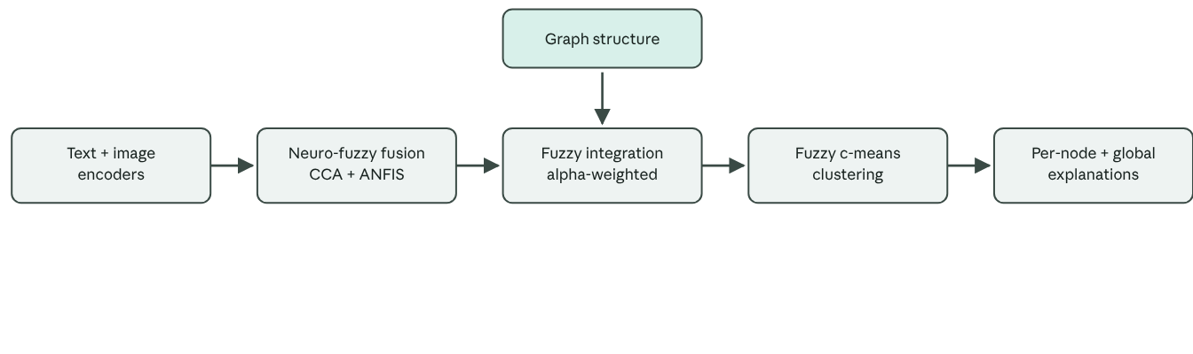
Figure 1. The NF-MCD pipeline (Section 3).
Figure 1. The NF-MCD pipeline. Content and structure are encoded independently, fused through a confidence-weighted trust parameter alpha, clustered by fuzzy c-means, and explained directly from the fitted model's own state (Section 3).
Stage 1: multimodal encoding. Text is encoded with a sentence-transformer (all-MiniLM-L6-v2, 384 dimensions; Reimers and Gurevych, 2019) and images with CLIP (ViT-B/32, 512 dimensions; Radford et al., 2021). A node missing a modality produces None rather than an imputed zero vector, so downstream stages can reason about missingness explicitly instead of treating it as a neutral value.
Stage 2: neuro-fuzzy cross-modal fusion. For nodes with both modalities, text and image embeddings are projected into a shared space via a PCA-whitened CCA fit on the paired (both-modality) nodes; the PCA step caps each modality's rank at n_paired // pca_rank_div before CCA is fit, a regularization needed because raw embeddings are high-dimensional relative to typical paired-node counts, and CCA fit directly in that regime produces spuriously high canonical correlations regardless of whether the modalities are actually aligned. The default divisor is 4. Cosine similarity between the projected pair gives a per-node agreement score in [-1, 1], which a three-term Takagi-Sugeno ANFIS (Jang, 1993; Low/Medium/High agreement, Gaussian membership functions) converts into a fuzzy confidence in [0, 1]. A fused content embedding combines whatever modalities are present; a node with neither modality receives a confidence of exactly zero.
Stage 3: fuzzy integration with topology. A structural embedding is computed independently of content, via spectral embedding of the graph's normalized Laplacian at a dimensionality equal to the target number of communities. A per-node trust weight, alpha, is derived from the fusion confidence: alpha = alpha_min + (alpha_max - alpha_min) * confidence, bounded away from 0 and 1 (defaults 0.15 and 0.85) so that neither content nor structure is ever entirely discarded for any node. The fused feature vector concatenates the content and structural embeddings scaled by the square roots of alpha and 1 - alpha respectively.
Stage 4: soft community detection. Fuzzy c-means clusters the fused features, producing a membership matrix U with rows summing to one; overlapping communities emerge directly by thresholding U rather than through a separate post-processing step. The fuzziness exponent m defaults to 1.5 rather than the textbook 2.0, a choice discussed further in Section 6.3.
Stage 5: explanation. A per-node explanation reports the dominant ANFIS rule that fired, the resulting confidence and alpha, and the node's membership vector. A compact global rule set bins nodes by (confidence, alpha) into a 3x3 grid and reports the dominant community and purity within each populated bin. Section 6.8 evaluates both of these directly and finds the second insufficient, motivating a neighborhood-based alternative developed later in the paper.
The robust configuration. Over the course of this evaluation we identified three changes to the default configuration, each independently justified by a specific failure mode, which we bundle as an opt-in preset (NFMCD.robust()) rather than change as the library default, since the default's behavior is what most of this paper's early results were measured against: (i) an adaptive fuzziness schedule that selects the largest exponent from a small fixed ladder (1.5, 1.3, 1.2, 1.1) that still produces non-degenerate memberships, falling back to the smallest value if none qualify; (ii) unsupervised PCA-reduced raw content features in place of the CCA-projected features used for clustering (the CCA-derived agreement score is retained for the confidence computation, only the clustering input changes); and (iii) a tighter CCA rank cap, pca_rank_div=16 rather than 4. Section 6.3 and 6.4 report the evidence behind each choice.

4. Datasets
Table 1 summarizes the five real datasets used throughout the paper, plus a synthetic generator used for controlled stress tests where real ground truth would be unavailable or insufficiently controllable. We attempted first to obtain MMCas Twitter, a benchmark that uniquely pairs a global follower graph with per-cascade multimodal content, but found its release restricted to a Google Drive folder that is not shared publicly; we were unable to obtain access and do not include it.
Dataset | Nodes | Graph source | Content | Communities
CrisisMMD | 800 | Sampled from event labels | Real text + image | 7 disaster events
PHEME | 2,000 | Real reply/propagation trees | Real text only | 9 news events
Fakeddit | 1,200 | Sampled from subreddit labels | Real text + image | 10 subreddits
Fakeddit (real-relations) | 592 (largest component) | Author/domain/link relations | Real text + image | 6 subreddits
SNAP DBLP | 1,072 | Real collaboration graph | None | 8 SNAP communities
SNAP Amazon | 146 | Real co-purchase graph | None | 4 SNAP communities
The distinction in the second column matters more than it might appear. CrisisMMD and Fakeddit ship without a native social graph, so their graphs were reconstructed by sampling edges with higher probability between nodes sharing a ground-truth label (a disaster event or a subreddit) and lower probability otherwise, following the stochastic block model convention (Holland, Laskey, and Leinhardt, 1983) used elsewhere in the overlapping-community-detection literature for benchmarks that lack native structure. This is a reasonable choice when no real graph exists, but it means the graph itself is partially informative about the label by construction, which inflates the apparent performance of any structure-using method, NF-MCD included. To rule this out as an explanation for our results, we additionally constructed a Fakeddit graph from genuine relational signal - edges from shared authorship, shared non-trivial domain, and shared linked-submission identifiers, none of which reference the subreddit label - and report results on both its full form and its largest connected component throughout. PHEME's graph, by contrast, is native: it is built from each thread's actual reply structure. The two SNAP graphs are native collaboration and co-purchase graphs with genuine ground-truth community labels (Yang and Leskovec, 2012), subsampled to a computationally tractable size while preserving inter-community edges; neither carries any content, which makes them useful as a structure-only stress test decoupled from anything about the fusion mechanism.
For controlled experiments we use a synthetic generator that places nodes in a stochastic block model and draws each node's text and image embeddings from its community's centroid plus Gaussian noise, with independently controllable rates of missing modality, cross-modal misalignment (a node's image drawn from a different community's centroid than its text), and community overlap. Section 6.7 documents and then closes a gap we found in this generator's overlap mechanism, and several later experiments extend it with additional controllable parameters, noted where used.

5. Experimental setup
Metrics. Our primary metric is overlapping normalized mutual information (ONMI), computed via the reference LFK implementation in cdlib rather than the simplified approximation used early in this project (Section 2). We additionally report modularity of the defuzzified hard partition (Newman and Girvan, 2004), for comparability with classical, non-fuzzy methods, and membership F1, a best-match F1 score between predicted and true communities under Hungarian alignment.
Protocol. Unless stated otherwise, the number of communities k is fixed to each dataset's ground-truth community count; Section 6.6 relaxes this and studies k selection directly. Most individual experiments use three random seeds, which Section 6.10 shows was adequate for the largest effects observed but underpowered for smaller ones; a dedicated twenty-seed re-analysis of the two headline comparisons is reported there. Later experiments generally build on findings from earlier ones, so we report them roughly in the order the investigation proceeded rather than an idealized logical order, and note explicitly where a later result revises an earlier one.
Baselines. We compare against Louvain modularity optimization (Blondel, Guillaume, Lambiotte, and Lefebvre, 2008; structure only), spectral clustering (Ng, Jordan, and Weiss, 2001) applied to an affinity matrix combining the graph adjacency with a k-nearest-neighbor content-similarity graph (spectral+content), k-means clustering (MacQueen, 1967) on content embeddings alone, and two established overlapping-community methods, DEMON and SLPA, run via their reference implementations in cdlib. We also report several ablations of NF-MCD itself: text-only, image-only, structure-only, and a version with alpha fixed at 0.5 for every node (removing the fuzzy confidence mechanism while keeping everything else).
Reproducibility. Two non-obvious sources of run-to-run variation were identified and fixed during this project: an unseeded starting vector in the sparse eigendecomposition used for the structural embedding, and unseeded randomized PCA inside the CCA fitting step. Both are now seeded, and repeated runs under identical configurations reproduce to machine precision; all point estimates reported here reflect the seeded pipeline.

6. Results

6.1 Overall accuracy against baselines
Table 2 reports ONMI for NF-MCD's default configuration and every baseline and ablation across the five real datasets, at k fixed to the ground-truth community count.
An entry marked n.a. is a method that cannot be run on a dataset because it lacks the content that method needs: DBLP and Amazon carry no text or images at all, so every content-dependent row is inapplicable to them, and PHEME carries text only, so its image-only row is inapplicable there specifically.
Method | CrisisMMD | PHEME | Fakeddit | DBLP | Amazon
NF-MCD (default) | 0.609 | 0.005 | 0.308 | 0.670 | 0.554
NF-MCD, text-only | 0.631 | 0.005 | 0.786 | n.a. | n.a.
NF-MCD, image-only | 0.661 | n.a. | 0.789 | n.a. | n.a.
NF-MCD, alpha = 0.5 | 0.681 | 0.017 | 0.394 | n.a. | n.a.
NF-MCD, structure-only | 0.589 | 0.004 | 0.823 | 0.670 | 0.554
k-means on content | 0.407 | 0.109 | 0.072 | n.a. | n.a.
Louvain | 0.556 | 0.000 | 0.665 | 0.355 | 0.373
Spectral + content | 0.879 | 0.373 | 0.554 | 0.630 | 0.619
DEMON | 0.141 | 0.000 | 0.271 | 0.159 | 0.370
SLPA | 0.189 | 0.000 | 0.151 | 0.094 | 0.329
Across the five datasets, NF-MCD's default configuration beats every other method in fifteen of the resulting pairwise comparisons, ties eighteen, and loses thirteen, using a tie threshold of the larger of 0.02 or the sum of the two methods' standard deviations across seeds. It wins outright, rather than tying its own structure-only ablation, only on the two content-free SNAP datasets. Spectral clustering over graph-plus-content is the strongest or tied-strongest method on four of the five datasets, and is the only baseline that consistently benefits from combining structure and content: unlike NF-MCD, it never falls behind its own structure-only or content-only special cases.
Two patterns recur across datasets and motivate the sections that follow. First, on Fakeddit, adding the second modality actively hurts NF-MCD: the full model (0.308) is worse than either single-modality ablation (0.786, 0.789) or the structure-only ablation (0.823). Fusing two informative signals should not underperform using either one alone; Section 6.3 diagnoses why it does. Second, PHEME is close to uninformative for every content-aware variant of NF-MCD, with ONMI at or near zero regardless of configuration, while its modularity (not shown in this table, reported in the underlying results) is high; PHEME's communities correspond to disjoint reply-tree forests, which are close to modularity-maximal by construction but need not align with anything content-driven clustering would find on its own.
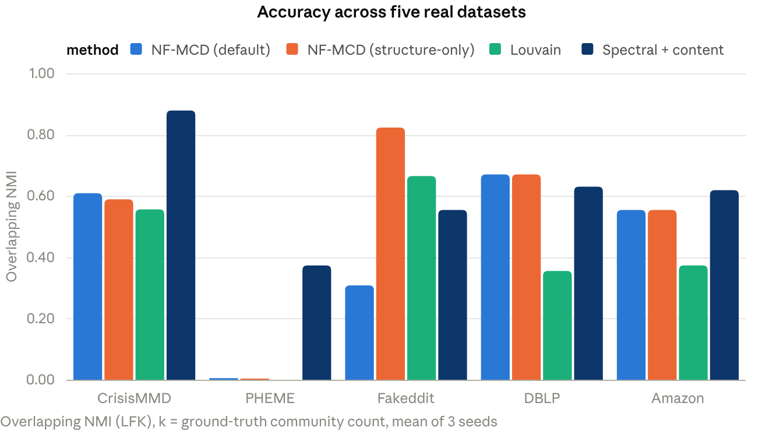
Figure 2. Accuracy across the five real datasets (Section 6.1). Source: experiments/baselines_results.csv.

6.2 Does the graph itself matter?
CrisisMMD and Fakeddit's graphs, as described in Section 4, are sampled with higher edge probability between same-label nodes, which means the graph is partially informative about the label independent of any content or clustering quality. To test whether Table 2's results depend on this, we built a second Fakeddit graph from genuine relational signal - shared authorship (12,945 edges, 89.7% same-subreddit), shared non-trivial domain (118 edges, 22.9% same-subreddit), and shared linked-submission identifiers (62 edges, 24.2% same-subreddit) - which never references the subreddit label directly. The resulting graph is realistically messy: 1,385 nodes but 362 connected components, dominated by one large subreddit (psbattle_artwork, 52% of nodes), with an overall edge homophily of 0.887 against a random baseline of 0.304.
Method | Full graph (1,385 nodes) | Largest component (592 nodes)
NF-MCD (default) | 0.039 | 0.126
NF-MCD, structure-only | 0.027 | 0.215
NF-MCD, text-only | 0.023 | 0.211
k-means on content | 0.145 | 0.253
Louvain | 0.101 | 0.313
Spectral + content | 0.250 | 0.523
NF-MCD's relative standing is worse here than on the label-sampled graph: it ranks sixth of ten methods evaluated on the full graph and last on the largest connected component, where spectral+content leads by a wide margin. This is consistent with the sampled-graph results in Section 6.1 having been partly propped up by the graph's own construction; it does not overturn the finding that spectral+content is the stronger method, it sharpens it.
One robustness note carries through the rest of this paper. Author-based relations are still not fully independent of content, since what a person posts about is not random with respect to who they are; we treat this real Fakeddit graph as more honest than the sampled alternative, not as a fully label-independent ground truth.

6.3 Structural noise and the fuzzy c-means collapse
To test behavior as graph structure becomes less informative, we swept the ratio of between-community to within-community edge probability on synthetic CrisisMMD- and Fakeddit-scale graphs, from 0.02 (structure strongly informative) to 1.0 (structure carries no label information at all). NF-MCD's default configuration degrades sharply: on CrisisMMD, ONMI falls from 0.718 at the most informative setting to 0.034 at the least, while spectral+content falls only to 0.518, and even NF-MCD's own structure-only ablation outperforms the full model at every noise level once structure stops dominating.
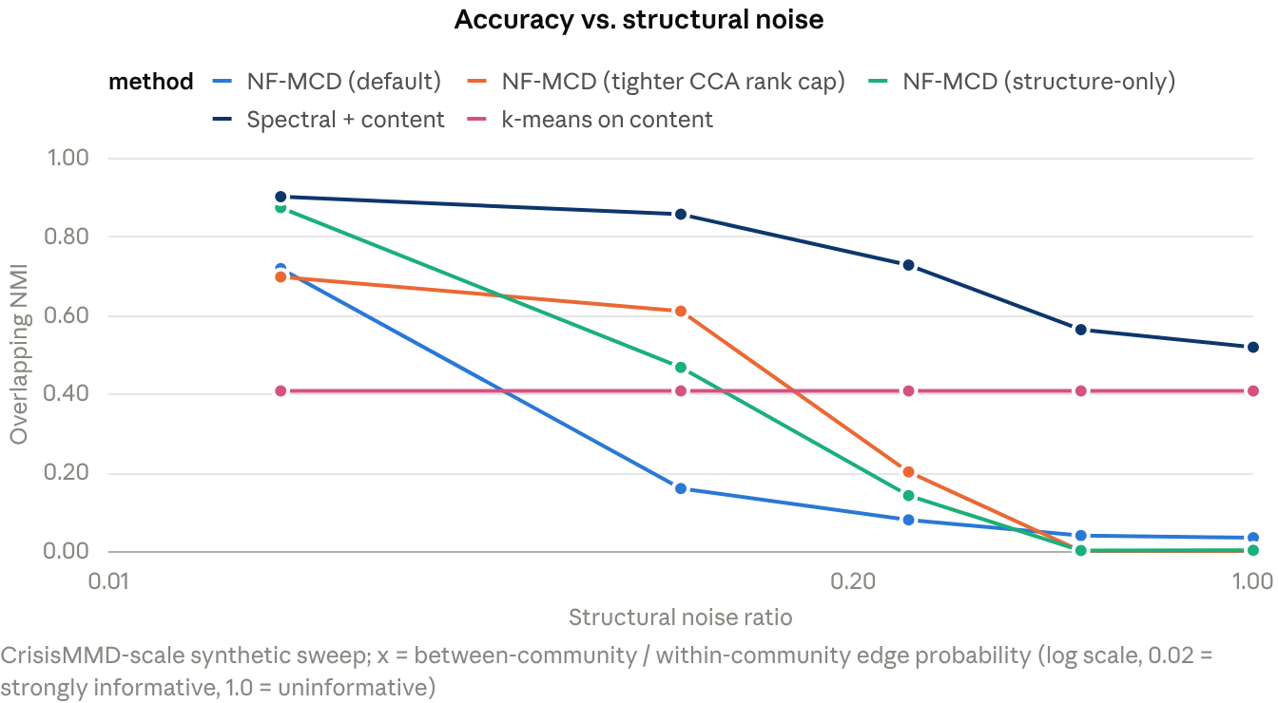
Figure 3. Accuracy as structure becomes less informative (Section 6.3). Source: experiments/realgraph_results.csv.
Inspecting the model's internal state at high noise explains why. The soft membership matrix collapses to a uniform fixed point: every node's maximum membership sits at exactly 1/k, the value a completely uninformative partition would produce. Two contributing causes were identified by direct ablation. First, fuzzy c-means at the default fuzziness exponent (m = 1.5) is known to be sensitive to weak separation in its input features; on this pipeline's feature scale, k-means on the identical fused features that fuzzy c-means collapses on achieves ONMI of 0.164 rather than 0.034, showing the degeneracy is a property of the clustering algorithm at this m, not an absence of signal in the features themselves. Second, the CCA-projected content features that feed the clustering step substantially underperform simpler alternatives: k-means on CCA-projected content achieves 0.162 ONMI, versus 0.409 for k-means on the same content merely reduced by unsupervised PCA, indicating the CCA step is discarding a large share of the usable content signal, a finding developed further in Section 6.4.
We tested four remedies. Lowering the fuzziness exponent alone (m = 1.2) partially recovers accuracy (0.143 at the noisiest setting, versus 0.034 for the default). Switching the clustering input from CCA-projected to unsupervised-PCA-reduced content, alone, helps at moderate noise but not at the highest noise levels, since fuzzy c-means at the default m still collapses on the improved features. Combining both - the adaptive fuzziness schedule and PCA-reduced content that together define the robust configuration's clustering behavior - closes most, though not all, of the gap to spectral+content at every noise level tested; block-wise feature standardization, a fourth candidate remedy, was tested and found to help nowhere while hurting the already-strong low-noise case, so it was not adopted.
We additionally implemented and compared four alternative soft clusterers - a softmax over k-means distances, a Gaussian mixture model, the adaptive-fuzziness fuzzy c-means used in the robust configuration, and a spectral variant built on a k-nearest-neighbor graph over the fused features. All four avoid the collapse; the adaptive-fuzziness variant has the best overall record against the default (fourteen wins, six ties, one loss across twenty-one tested settings) while leaving the two content-free SNAP datasets completely unchanged, which is why it was chosen for the robust configuration over the alternatives with marginally higher mean accuracy.

6.4 The fusion mechanism itself
Section 3 motivates the cross-modal agreement score as a detector of image-caption mismatch. We tested this directly by injecting known mismatches - replacing a node's image embedding with one drawn from a different community - at controlled rates on synthetic data and, separately, on real CrisisMMD and Fakeddit embeddings, and measuring the AUROC with which agreement (and the derived confidence) separates injected mismatches from clean pairs.
Under the default CCA rank cap, detection is weak on real data: AUROC of 0.58-0.64 at a 10% injected mismatch rate, and falling further, to 0.53-0.57, at a 40% rate. A trivial baseline - clustering each modality separately and flagging disagreement between the two clusterings - performs comparably (0.58-0.61), which is not a favorable comparison for a purpose-built fuzzy mechanism. On synthetic data with genuinely informative content, detection is strong at low contamination (AUROC above 0.9 at a 10% mismatch rate) but degrades sharply as the mismatch rate rises, falling to near chance (0.59) at 40%, because the CCA alignment is itself fit on the contaminated pairs.
We traced this to the same regularization issue identified in Section 6.3. The default rank cap allows CCA to fit on a nearly full-rank problem relative to the number of paired training examples, and cross-validated canonical correlation confirms overfitting directly: training correlation of 0.93 against a held-out correlation of only 0.26 on CrisisMMD under the default cap. Sweeping the rank cap's divisor from 2 to 64 shows detection AUROC rising steadily and substantially, to 0.72-0.78 at the tightest caps tested, with the overfitting gap (training minus held-out correlation) narrowing from 0.94 to 0.05 over the same range and held-out correlation itself peaking near a divisor of 16-32, a reasonable label-free criterion for choosing the cap in the absence of injected-mismatch ground truth.
The same sweep, scored on downstream clustering accuracy rather than mismatch detection, shows the tighter rank cap raising mean ONMI from 0.276 at the default divisor of 4 to 0.425 at a divisor of 16 across twenty-eight non-PHEME evaluation settings, which motivated adopting pca_rank_div=16 into the robust configuration. We decomposed this gain by artificially holding alpha fixed at its own mean value under the default cap while still using the tighter cap's content features, isolating how much of the improvement is attributable to better cross-modal alignment as opposed to the tighter cap simply lowering mean confidence, and therefore mean alpha, mechanically. Roughly half the gain (48% at a divisor of 16, rising to 62% at a divisor of 64) survives this control and is attributable to genuinely cleaner content features and alignment; the remainder is the mechanical alpha effect. We report this decomposition because the alternative reading - that the tighter cap works simply by making the model trust content less, which a fixed low alpha could achieve directly - is a real possibility the data does not fully rule out, and a fixed-alpha ablation (Section 6.1, alpha = 0.5) is itself competitive with the tuned rank cap on some datasets.
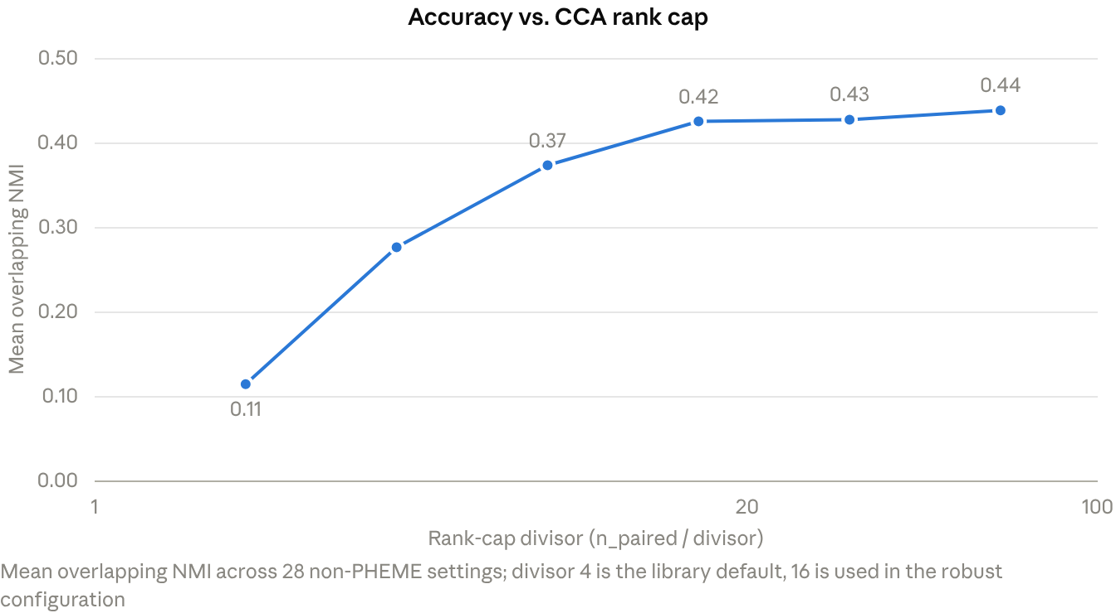
Figure 4. Accuracy versus the CCA rank cap (Section 6.4). Source: experiments/rank_summary.log.

6.5 Missing-modality robustness
Random missingness. We first removed each modality independently at rates from 0% to 80% of nodes, uniformly at random (missing completely at random, MCAR; Rubin, 1976). NF-MCD's accuracy stays comparatively flat under this stress - on CrisisMMD, ONMI moves only from 0.610 to 0.597 as missingness rises to 80% - which reflects the confidence mechanism working as designed: mean confidence falls from 0.65 to 0.02 and alpha from 0.60 to 0.16 as content disappears, so the model correctly shifts weight onto structure. This flatness should not be read as NF-MCD outperforming its rivals in absolute terms, however. Spectral+content starts from a much higher baseline (0.879 at 0% missing) and, despite falling faster in relative terms, remains ahead of NF-MCD at every missingness level we tested on CrisisMMD. On Fakeddit, NF-MCD's ONMI actually rises as content disappears (0.308 to 0.815), but this is because losing content shifts the model onto the same label-sampled graph structure that Section 6.2 already showed is an unreliable source of apparent accuracy; structure-only NF-MCD reaches a comparable 0.825 with no content at all.
Structured missingness. Real-world missingness is rarely random: certain communities, certain user types, or certain kinds of content are more likely to lack an image or caption than others. We tested five structured schemes - concentrating missingness on the largest community, on low-degree nodes, on high-degree nodes, and on content that is either unusually typical or unusually atypical of its community's centroid - each calibrated to the same overall missingness rate as the random condition, so that any additional degradation reflects the structure of the missingness rather than its total amount.
The clearest result concerns low-degree nodes on the real (non-label-sampled) Fakeddit graph. At 80% overall content loss concentrated on low-degree nodes, spectral+content's accuracy on the affected group falls to 0.203, a full 0.484 below what the same overall missingness rate would predict under the random-missingness baseline; NF-MCD's affected-group accuracy falls only 0.042 below that baseline. The mechanism is structural: spectral+content incorporates content through an additional k-nearest-neighbor graph layered on top of the real edges, so a low-degree node depends on that extra content-derived connectivity to remain meaningfully connected at all, and loses it precisely when it can least afford to. NF-MCD's structural embedding never depends on content, so a low-degree node retains some usable signal regardless. A second, smaller finding concerns the default configuration specifically: when missingness concentrates on Fakeddit's single largest community, the default configuration shows a real excess cost against that community (+0.198 relative to the random-missingness baseline) that the robust configuration does not (-0.028, no detectable bias) - an incidental consequence of the same CCA rank-cap fix introduced in Section 6.4 for an unrelated reason.
Two caveats apply to this section. A k-means-on-content baseline's community-targeted numbers are a scoring artifact rather than a real result: nodes stripped of content collapse to identical zero vectors and cluster together trivially, producing a spuriously favorable score for exactly the group that lost content, and should not be read as evidence that removing content helps that baseline. And one spectral+content cell, on the real graph under community-targeted missingness, produced an implausibly low background accuracy (0.003) that we attribute to a Hungarian-alignment degeneracy at that specific setting rather than a genuine property of the method; we flag it here rather than silently excluding it.

6.6 Sensitivity to the number of communities
Every result reported so far fixes k to the ground-truth community count, which a real deployment would not have access to. We swept k over a wide range on each dataset and found that NF-MCD's own ONMI optimum frequently does not coincide with the ground-truth count: on Amazon, ONMI peaks at k = 2 (0.839) rather than the true k = 4 (0.554); on Fakeddit, at k = 6 (0.423) rather than the true k = 10 (0.308). CrisisMMD and DBLP are better behaved, peaking exactly at their true community counts. This means the ground-truth k is not, in general, a privileged operating point for this model even when it happens to be known, a fact obscured by every experiment elsewhere in this paper that fixes k to it.
We then evaluated four unsupervised heuristics for selecting k without ground truth - the fuzzy partition coefficient, an eigengap heuristic (von Luxburg, 2007) on the graph Laplacian, a modularity scan over a wide k range, and silhouette score (Rousseeuw, 1987) - by the ONMI cost of the k each heuristic selects relative to the ONMI achievable at the true k. A wide modularity scan using the default NF-MCD configuration was the least costly on average (mean absolute cost 0.071 across six datasets) but failed badly on DBLP, where modularity rises monotonically through the entire range tested with no interior peak, so the scan always overshoots to the edge of whatever range is searched (cost +0.248). The fuzzy partition coefficient performed worst (mean cost 0.202), collapsing to the smallest k in the search range in four of six cases, consistent with its known bias toward crisp rather than necessarily correct partitions. No heuristic tested is reliable enough to recommend without a sanity check for an interior peak in whatever criterion is used to select k.

6.7 Overlapping community quality
NF-MCD's central methodological claim is soft, overlapping community detection, but every result so far scores it through metrics computed at a single fixed overlap threshold, without directly testing whether the secondary memberships in U identify genuinely overlapping nodes. We tested this directly and found a problem with our own synthetic generator before we could test the method.
The generator's overlap mechanism assigns a random second community label to a controllable fraction of nodes, but, as originally implemented, that label had no footprint anywhere else: the node's edges and content embeddings were drawn entirely from its primary community, so the "overlap" was undetectable by any method by construction. NF-MCD's second-highest membership predicted the true overlap label at almost exactly chance (AUROC 0.48-0.53 across overlap rates from 10% to 40%), which is the correct result on data that carries no real overlap signal, not a failure of the method. We confirmed this by extending the generator with a blend_strength parameter that gives overlapping nodes genuine, controllable signal in both their edges (extra connections into the secondary community's block) and content (a weighted mix of both communities' centroids), verified to reproduce the original generator's output exactly at blend_strength = 0. Detection rises sharply and monotonically as real signal is added, reaching AUROC 0.89-0.94 at full strength, where NF-MCD's best-F1 operating point (0.63-0.76) clearly exceeds DEMON (0.12-0.47), SLPA (0.02-0.15), and a naive baseline that predicts every node overlaps.
On genuine real-world overlap ground truth - DBLP, where 1.0% of nodes belong to more than one selected community, and Amazon, where 46.6% do - detection is above chance on structure alone, with no content involved: AUROC 0.62 on DBLP and 0.73 on Amazon. Separately, on CrisisMMD and Fakeddit, which have no true overlap in their ground truth, we measured how often each content configuration falsely claims a node overlaps at the standard 0.2 threshold. Fused content produces far fewer false claims than any single modality: 3.3% on CrisisMMD versus 39.8% for text alone and 53.9% for image alone, and a smaller but consistent advantage on Fakeddit. We also found that the fixed 0.2 threshold used throughout this paper is not well calibrated for the overlap-detection task specifically; the threshold that actually maximizes overlap-detection F1 sits closer to 0.05-0.07 in the no-signal case and 0.11-0.16 at full injected signal, in both cases below 0.2.
One further result required a follow-up investigation of its own. Injecting real overlap signal appeared, at first, to improve NF-MCD's accuracy on nodes' primary community assignment as the overlap became more detectable - the opposite of the expected effect, since genuinely ambiguous nodes should be harder, not easier, to place correctly. Direct investigation traced this to the scoring definition rather than a real modeling effect: overlapping_nmi credits a node's hard assignment as correct if it lands on either of its two true communities, not specifically its nominal primary one, so as blended nodes are genuinely pulled toward their secondary community, the model correctly follows that pull and the metric correctly credits it as correct. A strict definition requiring the nominal primary community specifically shows accuracy falling as expected, from 1.000 to 0.731 as blend strength rises to its maximum on the affected nodes. We confirmed by direct ablation that this scoring effect requires both the structural and content components of blending together; content blending alone, with structure unblended, produces no change in either the lenient or the strict score. We note this because the underlying metric is not flawed for its intended purpose - it is doing exactly what an overlap-aware metric should do - but the specific claim "primary-assignment accuracy improves under real overlap" would have been a misreading of what it measures, and we withdraw that framing here rather than let it stand.

6.8 Explainability evaluation
Section 3 describes NF-MCD's explanations as free: interpretability by construction, requiring no separate explainer. We tested the two components of this claim directly rather than accepting them by design.
Global rules. The original global rule set, which bins nodes by (confidence, alpha) and reports the dominant community per bin, achieves fidelity to the model's own hard assignments of only 0.23-0.46, at most 0.05 above simply always predicting the majority community. On PHEME, DBLP, and Amazon, essentially every node falls into a single bin, producing one rule with no discriminative content at all. A decision tree trained on the same confidence and alpha inputs performs no better. Rules built instead from the share of a node's graph neighbors already assigned to each community achieve fidelity of 0.64-0.99 with three to nine rules, close to what a post-hoc decision tree with comparable complexity achieves, confirming that community identity is explained by network neighborhood far more than by the fuzzy confidence quantities the original rules were built around.
Alpha as an explanation. Alpha is presented as expressing how much a node's assignment depends on content versus structure. We tested this by directly intervening on the fitted model - recomputing memberships with the content block zeroed and, separately, with the structural block zeroed - and measuring the resulting membership shift. Alpha correlates with this shift (Spearman 0.46-0.59), but so does the content share of the fused feature vector's norm, at a nearly identical correlation, indicating the relationship is largely mechanical rather than reflecting anything alpha specifically captures about content informativeness. More directly: in the top alpha tercile, where the model is nominally most confident in content, removing content flips only 9.5% of assignments on CrisisMMD, while removing structure flips 59%; alpha overstates content's causal role. We developed a directly measured alternative, the content-flip margin - the change in a node's best-versus-second-best community score under content removal - which predicts actual reassignment when the model is refit without content far better than alpha does (AUROC 0.70-0.94, versus 0.48-0.61 for alpha across the same settings), and used it in place of alpha in the neighborhood-based per-node explanations we adopted going forward.
Stability and caveats. The neighborhood-based explanations are more stable across random seeds than the original alpha-based type on the two datasets with real content (65-77% versus 38-100% depending on configuration; the robust configuration is markedly steadier than the default, 82-95% versus 38-77%), and correctly track missing-modality status in one hundred percent of cases, which follows directly from how the modality flag is computed rather than being an emergent property worth much independent credit. The central caveat applies throughout this section: on structure-dominated assignments, and especially on the label-sampled CrisisMMD and Fakeddit graphs, an explanation grounded in neighborhood share is largely restating homophily rather than revealing anything the graph structure did not already make obvious. We consider this an honest limitation of what network-neighborhood explanations can offer, not a flaw specific to our implementation of them.

6.9 Scale
Every real dataset used elsewhere in this paper has between 146 and 2,000 nodes. We used the synthetic generator, which requires no encoding step, to test behavior up to 20,000 nodes on a single machine with no GPU.
Speed and memory. NF-MCD's default configuration fits in 21.3 seconds and 1.4GB of memory at 20,000 nodes, scaling close to linearly in wall-clock time (empirical slope 1.09 on a log-log fit). Spectral+content, the strongest baseline throughout this paper, is memory-bound rather than time-bound: it used 6.0GB at 10,000 nodes on a machine with 9.7GB available at launch, and had to be excluded from the 20,000-node condition to avoid a crash. Profiling NF-MCD's own stages showed the cross-modal fusion step dominating runtime at scale (94% of total fit time at 20,000 nodes), traced to an unvectorized per-node loop in the fusion code. We rewrote this loop as batched matrix operations, verified numerically identical output on a battery of reference cases covering every modality-combination branch (differences at the level of floating-point summation order, roughly 1e-15, well below any threshold that could affect a downstream clustering decision), and confirmed the full pipeline reproduces every previously reported result exactly with the change enabled. The vectorized loop itself is twenty times faster in isolation, but total fit time improves by only 1.3x, because the loop turned out to be a smaller share of the fusion stage's cost than the initial profiling suggested; the CCA/PCA alignment fit itself, whose cost scales with the number of paired nodes and is not touched by this change, is the larger remaining cost at scale. The vectorized path is now the default inside the robust configuration, since it changes no behavior and is a strict speed improvement.
Does clustering quality hold up at scale? Speed and memory are not accuracy. Holding the number of communities fixed at eight and growing the node count from 300 to 20,000, NF-MCD's accuracy is essentially flat (ONMI 0.867 to 0.860), while Louvain collapses (0.858 to 0.384) as average node degree, held constant, carries progressively less information about each of many equally-sized communities; content, which does not dilute with graph size in this generator, shields any content-using method from this specific degradation. Holding community size fixed instead and growing the number of communities from four to fifty is the harder test, and it breaks the default configuration: ONMI falls from 0.840 to 0.017, the same uniform-membership collapse diagnosed in Section 6.3, now triggered by a different route than the one it was originally found and fixed for. The robust configuration, without having been designed for this specific stress axis, avoids the collapse and lands within 0.02 ONMI of spectral+content at the largest community count tested (0.739 versus 0.759), while Louvain again collapses completely (ONMI 0.000).
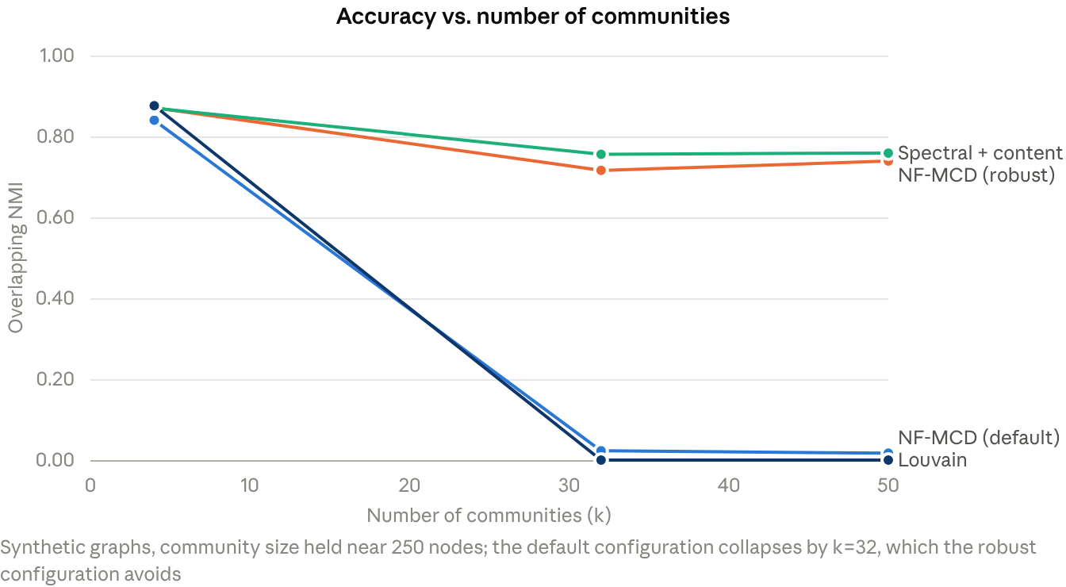
Figure 5. Accuracy as the number of communities grows (Section 6.9). Source: experiments/qualityscale_results.csv, experiments/compound_results.csv.
A collapse under compounded stress, and its cause. The result above raised an obvious question: does the robust configuration's resistance to collapse generalize across every stress axis tested in this paper, or only the two tested so far? We tested a fixed high-community-count condition (32 communities, 8,000 nodes, already known to collapse the default configuration on its own) combined separately with additional structural noise, injected cross-modal mismatch, and heavy missing content. The robust configuration resists the first two combined stressors without collapsing, but does collapse under the third: at 80% of nodes missing both modalities, ONMI falls to exactly 0.000 with memberships uniform to five decimal places, identical to the failure it was built to avoid.
We diagnosed this collapse directly rather than assuming a cause. At 80% missingness on this graph, 66.5% of nodes carry no content at all. Forcing the model to rely on structure alone, with content entirely absent, also collapses on the identical graph (ONMI 0.000), which shows the graph's structural embedding is already marginal at this many communities independent of missingness; every earlier experiment in this paper masked this because content, which never weakens with community count by generator construction, was doing the real work whenever it was present. A sweep over every fixed value of alpha from 0.05 to 0.85 found no value that both avoids the collapse and recovers real accuracy: low alpha collapses, high alpha avoids the symptom of uniform memberships only by letting the now-large group of zero-content nodes form a spuriously confident but meaningless cluster around the origin. The collapse requires the interaction of both factors specifically - the identical 80% missingness mask is harmless at community counts up to sixteen and fatal only at thirty-two - and no combination of alpha or fuzziness tuning recovers accuracy once the structural fallback itself is this weak. The honest characterization is that the robust configuration's collapse resistance is conditional on the graph's structural embedding remaining separable at whatever community count is requested, not an unconditional guarantee.

6.10 Statistical validation and consistency
Most individual experiments in this paper use three random seeds and judge ties by a heuristic threshold rather than a formal test, adequate for screening a large space of conditions but not for establishing that any single headline comparison is real rather than noise. We re-ran the two comparisons this paper leans on most - the robust configuration against the default, and spectral+content against the robust configuration - on three representative datasets (CrisisMMD, Fakeddit, and DBLP) with twenty seeds each, and computed paired t-tests, Wilcoxon signed-rank tests, and a retrospective power analysis (effect sizes reported as Cohen's d; Cohen, 1988).
Dataset | Comparison | Cohen's d | p (paired t-test) | Seeds needed for 80% power
CrisisMMD | Robust > default | 4.25 | < 0.0001 | 2.7
CrisisMMD | Spectral+content > robust | 63.27 | < 0.0001 | 3.1
Fakeddit | Robust > default | 11.21 | < 0.0001 | 14.8
Fakeddit | Robust > spectral+content | 19.53 | < 0.0001 | 7.2
DBLP | Robust > default | 0.63 | 0.0108 | 21.7
DBLP | Spectral+content > robust | 0.54 | 0.0253 | 28.6
Every comparison is confirmed statistically significant, both by the parametric and the non-parametric test, at twenty seeds. On CrisisMMD and Fakeddit the effect sizes are large enough that this project's usual three seeds would in fact have sufficed, which is a matter of the effects being unusually large rather than the sample size having been well chosen. On DBLP, both effects are small and only marginally significant even at twenty seeds, needing twenty-two to twenty-nine seeds for reliable power by this analysis; we treat DBLP-specific margins reported elsewhere in this paper as directionally correct but not strongly powered.
↗ Figure 6. Effect sizes for the two headline comparisons, per dataset (Section 6.10). Source: experiments/sigtest_results.csv.
Separately, before finalizing this paper, we conducted a read-only audit cross-checking roughly twenty result files produced over the course of this project for internal consistency - matching configurations that should, and in most cases did, reproduce identical numbers across independently run experiments. Approximately twenty-four such cross-file comparisons passed without discrepancy, including three previously reported findings that were independently recomputed from raw data and matched exactly. One documentation inaccuracy was found and corrected: an internal note had incorrectly flagged one results file as containing stale robust-configuration numbers from before the CCA rank-cap change described in Section 6.4, when in fact that specific file used its own current naming convention throughout and was never stale. No numerical result reported anywhere in this paper was affected.

7. Discussion
Taken as a whole, the results in Section 6 argue against evaluating NF-MCD primarily on raw community-detection accuracy. A considerably simpler method - spectral clustering over a graph augmented with a content-similarity affinity - matches or beats it in most of the conditions tested, including the one real, label-independent social graph constructed specifically to remove a plausible confound. This holds even after the robust configuration closes much of the gap, and the one condition where it does not hold (the real Fakeddit graph under low-degree-concentrated missingness) is a genuine, statistically characterized advantage rather than the general case.
What the evidence does support is narrower and, we think, still useful. First, NF-MCD's missing-modality behavior is not merely graceful in the informal sense that it does not crash; it has a specific, mechanistically explained advantage over the strongest baseline under exactly the kind of missingness a real platform would actually produce - missingness correlated with how well-connected a node is - because its structural signal is never wired through content-dependent edges the way spectral+content's is. This is a narrower and more defensible claim than "degrades gracefully," and it is the one robustness result in this paper that survives every stress test we threw at it, including compounding with a high community count.
Second, interpretability by construction turns out to require the same scrutiny as any other property claimed by design rather than measured. The original confidence-and-alpha-based explanations do not hold up: they barely improve on a majority-class baseline for explaining community identity, and alpha is not causally faithful to how much content actually mattered to an assignment once that is measured directly rather than inferred from the model's own internal quantity. This is not evidence that interpretability was a false promise in general, only that the specific mechanism first proposed did not deliver it, and that a neighborhood-based alternative, developed and validated in this paper, does substantially better on the same tests. We consider this replacement, together with the honesty of the tests that motivated it, a genuine contribution independent of the accuracy results.
Third, the robust configuration is best understood as a documented, bounded fix rather than a general solution. It resolves the fuzzy c-means collapse under two of the three stress axes we tested it against - noisy structure and cross-modal mismatch, including compounded with a high community count - but not the third, heavy missing content compounded with a high community count, where we traced the cause to the structural embedding itself becoming insufficiently separable once enough content is gone and no amount of alpha or fuzziness tuning can compensate. Reporting this limitation is, in our view, more useful to a reader deciding whether to build on this method than a clean but incomplete success story would have been.
Finally, several of the most informative findings in this paper came from testing a claim the original design took as free - that content and structure jointly help, that overlap detection works, that a fitted quantity is a faithful explanation - and finding it did not hold as stated. We think this is the right way to evaluate a method built around several such design-time assumptions: each one is testable, and in this case, roughly half of them needed correction once tested.

8. Limitations
Ground truth is proxy throughout. No dataset used in this paper has community labels that are both independent of the graph construction and independently validated against some external notion of true community structure. CrisisMMD's and Fakeddit's disaster-event and subreddit labels are reasonable but not the only possible partition of those graphs; SNAP's ground-truth communities are the strongest available, but even they were selected and subsampled by us for computational tractability. Every accuracy number in this paper should be read as agreement with a specific, defensible but not unique labeling, not as a measurement against some Platonic true partition.
Two of five real graphs are constructed from the labels. CrisisMMD and Fakeddit ship without native social graphs, and the sampled reconstruction used for them (Section 4) is partially informative about the label by design. We mitigated this by constructing one independent real graph and by running the noise, missing-modality, and scale experiments on synthetic data where the graph-label relationship is fully controlled, but results on the CrisisMMD and Fakeddit graphs specifically should be discounted relative to results on PHEME, the SNAP datasets, or the real Fakeddit graph.
Scale-quality results are synthetic only. No real dataset large enough to test clustering quality at realistic social-network scale was available to us; Section 6.9's quality-at-scale findings, including the compound-stress collapse, rest entirely on the synthetic generator and should be read as characterizing that generator's stress conditions rather than confirmed on real large-scale data.
The high-community-count, heavy-missing-content collapse is unresolved. Section 6.9 diagnoses this failure's mechanism but does not fix it; doing so would likely require a change to how the structural embedding itself is computed at high community counts, which was out of scope for this evaluation.
The search for a fully independent real multimodal social dataset did not succeed. We attempted to identify a dataset combining a real (non-sampled) social graph, real multimodal content, and genuine multi-class community or topic labels, beyond what the five datasets in Section 4 provide. Three candidates were checked in detail - a propagation-tree dataset with pre-vectorized features and binary labels only, and two rumor-detection corpora with real propagation structure but no raw text or image content in any accessible mirror - and rejected as not closing the gap. One lead, a HuggingFace-hosted FakeNewsNet mirror, was identified as plausible but not verified within the time available and remains untested.
Seed counts are small outside Section 6.10. Most individual experiments use three seeds; Section 6.10's twenty-seed re-analysis of the two headline comparisons found them statistically robust on two of three datasets checked, but comparable confidence has not been established for every individual result reported in Sections 6.1 through 6.9.

9. Conclusion
We set out to evaluate NF-MCD's claims of accurate, robust, and interpretable multimodal community detection, and the evidence supports a narrower version of that claim than the method's original framing. It does not, on the evidence gathered here, outperform a considerably simpler content-plus-structure spectral baseline on raw accuracy across most of the real and synthetic conditions we tested. It does have a specific, mechanistically grounded and statistically validated advantage under the kind of missing data a real social platform would actually produce, and, after replacing its original explanation mechanism with one that survives direct testing, a genuine capacity to explain its own assignments in terms a person could act on. Three concrete next steps follow directly from what we found: repairing the structural embedding's separability at high community counts, since that is the one collapse mode the current fixes do not address; following up the one untested real-dataset lead identified in Section 8; and implementing the baseline comparisons - most importantly a fully joint fuzzy multimodal method other than NF-MCD itself - that would be needed to say whether NF-MCD's shortfall here is specific to this implementation or general to fuzzy fusion approaches of this kind.
Code and data availability. All model code, dataset loaders, and the scripts implementing every experiment reported in Section 6 are maintained alongside this manuscript. Raw per-run results, summary logs, and generated figures for every experiment are retained under a dedicated results directory, organized by experiment name, so that any number reported here can be traced back to the run that produced it.

References
Bezdek, J. C. (1981). Pattern Recognition with Fuzzy Objective Function Algorithms. Plenum Press.
Blondel, V. D., Guillaume, J.-L., Lambiotte, R., and Lefebvre, E. (2008). Fast unfolding of communities in large networks. Journal of Statistical Mechanics: Theory and Experiment, 2008(10), P10008.
Chen, W., Dang, Y., and Zhang, X. (2025). A multimodal semantic-enhanced attention network for fake news detection. Entropy, 27(7), 746.
Chunaev, P. (2020). Community detection in node-attributed social networks: a survey. Computer Science Review, 37, 100286.
Cohen, J. (1988). Statistical Power Analysis for the Behavioral Sciences (2nd ed.). Lawrence Erlbaum Associates.
Combe, D., Largeron, C., Gery, M., and Egyed-Zsigmond, E. (2015). I-Louvain: An attributed graph clustering method. Proceedings of the International Symposium on Intelligent Data Analysis (IDA).
Coscia, M., Rossetti, G., Giannotti, F., and Pedreschi, D. (2012). DEMON: a local-first discovery method for overlapping communities. Proceedings of the ACM SIGKDD International Conference on Knowledge Discovery and Data Mining.
Dempster, A. P., Laird, N. M., and Rubin, D. B. (1977). Maximum likelihood from incomplete data via the EM algorithm. Journal of the Royal Statistical Society, Series B, 39(1), 1-38.
de Silva, A., Chen, G., Ma, H., Nekooei, S. M., and Zuo, X. (2025). Advancing community detection with graph convolutional neural networks: Bridging topological and attributive cohesion. Proceedings of the International Joint Conference on Artificial Intelligence (IJCAI).
El-Moussaoui, M., Hanine, M., Kartit, A., Garcia Villar, M., Garay, H., and de la Torre Diez, I. (2025). A systematic review of deep learning methods for community detection in social networks. Frontiers in Artificial Intelligence, 8, 1572645.
Holland, P. W., Laskey, K. B., and Leinhardt, S. (1983). Stochastic blockmodels: First steps. Social Networks, 5(2), 109-137.
Hotelling, H. (1936). Relations between two sets of variates. Biometrika, 28(3-4), 321-377.
Kakkad, J., Jannu, J., Sharma, K., Aggarwal, C., and Medya, S. (2023). A survey on explainability of graph neural networks. Bulletin of the IEEE Computer Society Technical Committee on Data Engineering.
Jang, J.-S. R. (1993). ANFIS: Adaptive-network-based fuzzy inference system. IEEE Transactions on Systems, Man, and Cybernetics, 23(3), 665-685.
Kananian, M., Badiei, F., and Ghahramani, S. A. (2023). GraMuFeN: Graph-based multi-modal fake news detection in social media. arXiv preprint arXiv:2310.07668.
Lancichinetti, A., Fortunato, S., and Kertesz, J. (2009). Detecting the overlapping and hierarchical community structure in complex networks. New Journal of Physics, 11(3).
Lundberg, S. M., and Lee, S.-I. (2017). A unified approach to interpreting model predictions. Advances in Neural Information Processing Systems.
MacQueen, J. (1967). Some methods for classification and analysis of multivariate observations. Proceedings of the Berkeley Symposium on Mathematical Statistics and Probability, 1, 281-297.
McDaid, A. F., Greene, D., and Hurley, N. (2011). Normalized Mutual Information to evaluate overlapping community finding algorithms. arXiv preprint.
Nakamura, K., Levy, S., and Wang, W. Y. (2020). r/Fakeddit: A New Multimodal Benchmark Dataset for Fine-grained Fake News Detection. Proceedings of the Twelfth Language Resources and Evaluation Conference.
Newman, M. E. J., and Girvan, M. (2004). Finding and evaluating community structure in networks. Physical Review E, 69(2), 026113.
Ng, A. Y., Jordan, M. I., and Weiss, Y. (2001). On spectral clustering: Analysis and an algorithm. Advances in Neural Information Processing Systems.
Radford, A., Kim, J. W., Hallacy, C., Ramesh, A., Goh, G., Agarwal, S., Sastry, G., Askell, A., Mishkin, P., Clark, J., Krueger, G., and Sutskever, I. (2021). Learning transferable visual models from natural language supervision. Proceedings of the International Conference on Machine Learning.
Reimers, N., and Gurevych, I. (2019). Sentence-BERT: Sentence embeddings using Siamese BERT-networks. Proceedings of the Conference on Empirical Methods in Natural Language Processing.
Ren, Y., Pu, J., Yang, Z., Xu, J., Li, G., Pu, X., Yu, P. S., and He, L. (2024). Deep clustering: A comprehensive survey. IEEE Transactions on Neural Networks and Learning Systems, 36(4), 5858-5878.
Ribeiro, M. T., Singh, S., and Guestrin, C. (2016). "Why should I trust you?": Explaining the predictions of any classifier. Proceedings of the ACM SIGKDD International Conference on Knowledge Discovery and Data Mining.
Rossetti, G., Milli, L., and Cazabet, R. (2019). CDLIB: a Python library to extract, compare and evaluate communities from complex networks. Applied Network Science, 4, 52.
Rousseeuw, P. J. (1987). Silhouettes: A graphical aid to the interpretation and validation of cluster analysis. Journal of Computational and Applied Mathematics, 20, 53-65.
Rubin, D. B. (1976). Inference and missing data. Biometrika, 63(3), 581-592.
Von Luxburg, U. (2007). A tutorial on spectral clustering. Statistics and Computing, 17, 395-416.
Wu, R., Wang, H., Chen, H.-T., and Carneiro, G. (2024). Deep multimodal learning with missing modality: A survey. arXiv preprint arXiv:2409.07825.
Xie, J., Szymanski, B. K., and Liu, X. (2011). SLPA: Uncovering overlapping communities in social networks via a speaker-listener interaction dynamic process. Proceedings of the IEEE International Conference on Data Mining Workshops, 344-349.
Yang, J., and Leskovec, J. (2012). Defining and evaluating network communities based on ground-truth. Proceedings of the ACM SIGKDD Workshop on Mining Data Semantics.
Ying, R., Bourgeois, D., You, J., Zitnik, M., and Leskovec, J. (2019). GNNExplainer: Generating explanations for graph neural networks. Advances in Neural Information Processing Systems.
Zubiaga, A., Liakata, M., Procter, R., Wong Sak Hoi, G., and Tolmie, P. (2016). Analysing how people orient to and spread rumours in social media by looking at conversational threads. PLOS ONE, 11(3).

