

TED UNIVERSITY

Faculty of Engineering

Department of Computer Engineering

SENG453/SENG311

Software Quality Assurance

Assignment 1 Report

JUnit Test Programming

Hilal Yurtoğlu

17386054060

1. **UML class diagram**

Below is the UML diagram representing the project structure:

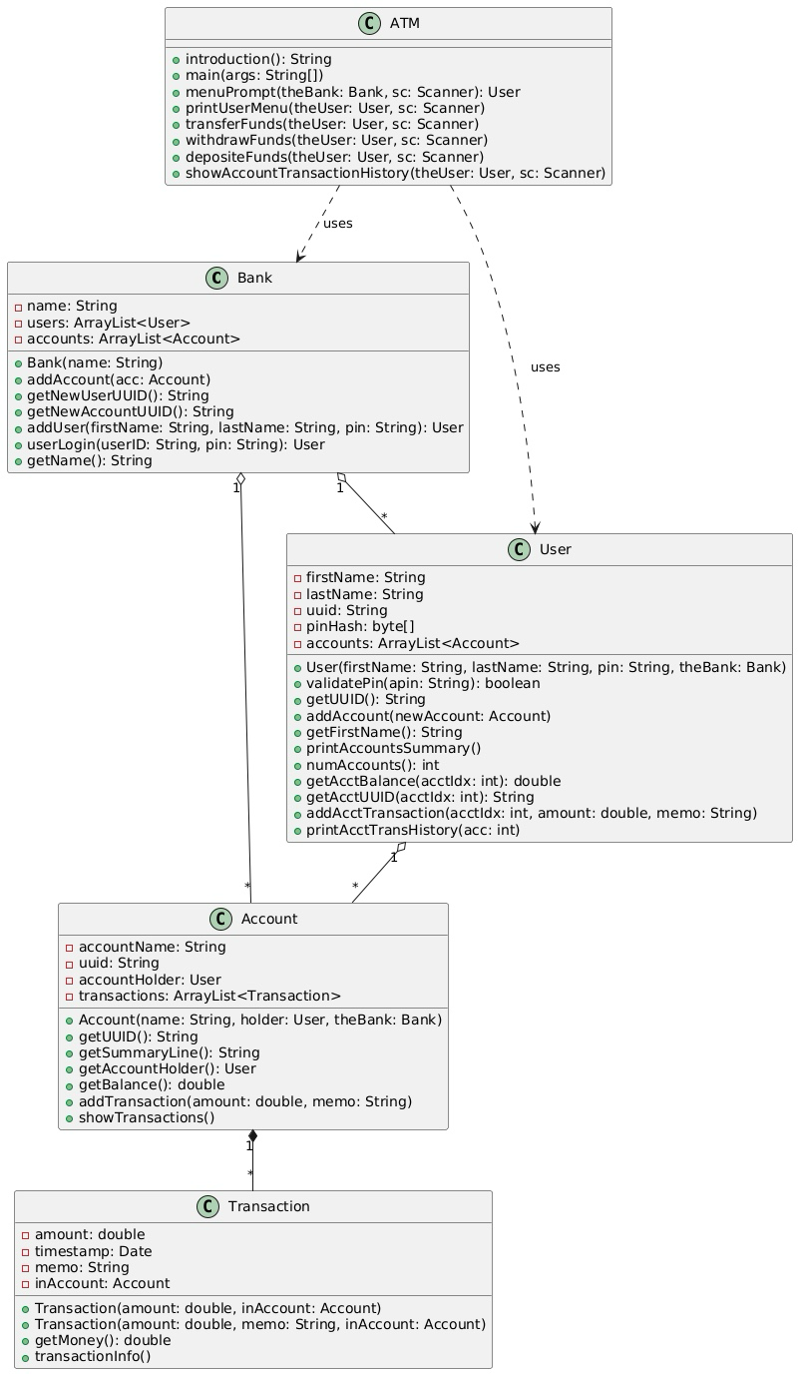

1. **Assertion statements and outputs**

JUnit Assertions is used to compare the results obtained at the end of the test scenario we have written with the expected results. If the expected result from a test scenario is the same as the result obtained, the test is considered successful.

Below are some assertion test cases used in the project:

* assertEquals/assertNotEquals:

Checks if values are equal or not

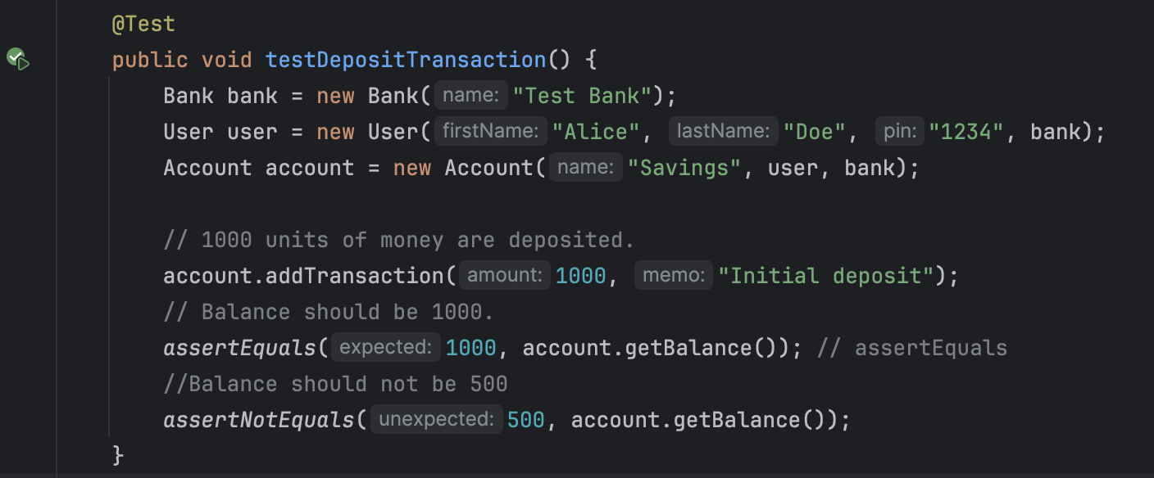

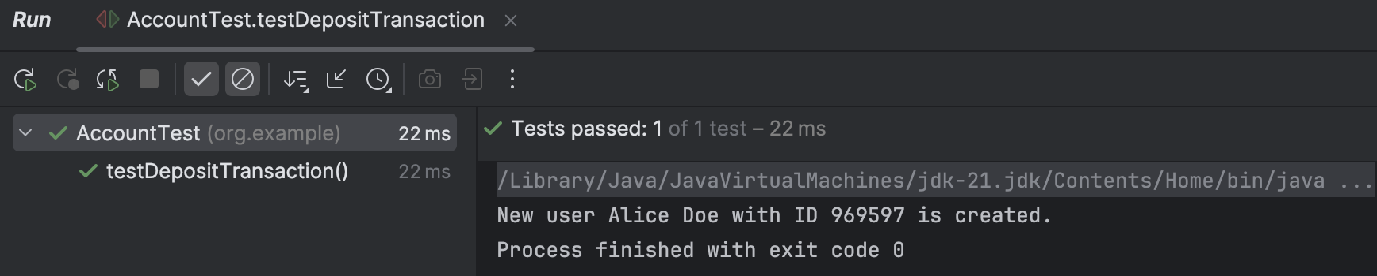

* assertNull:

Confirms if a value is null.

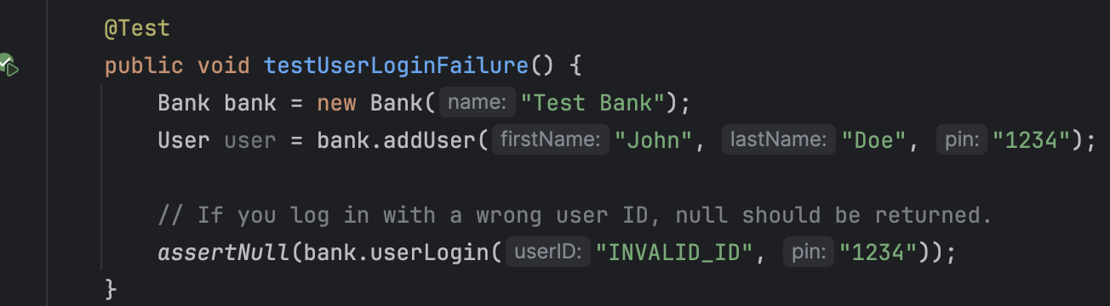

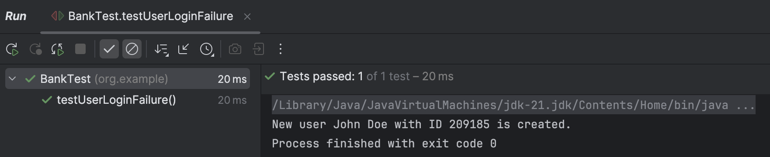

* assertTrue/assertFalse:

Ensures boolean expressions return expected results.

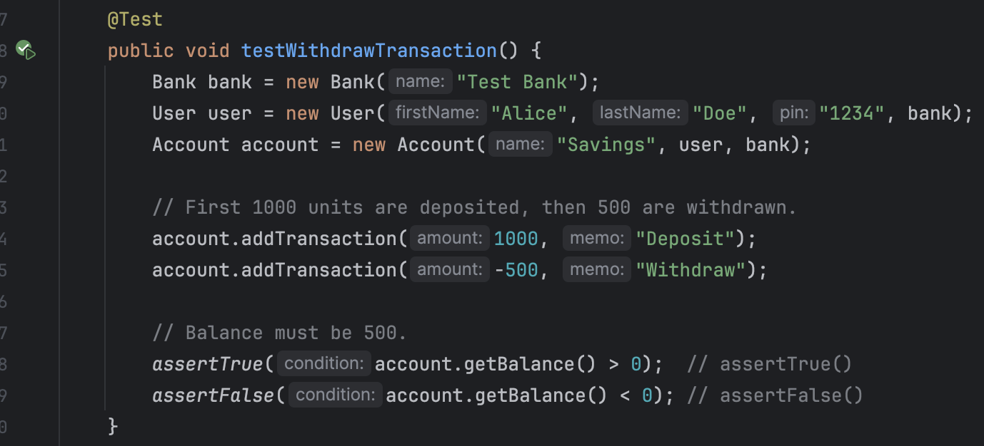

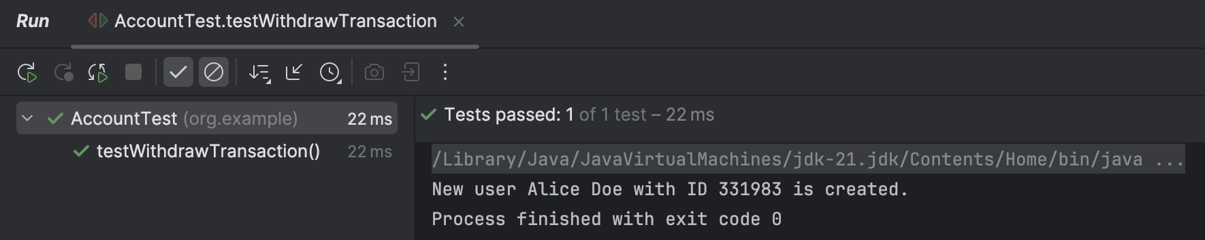

* assertSame/assertNotSame:

Verifies if two references point to the same object.

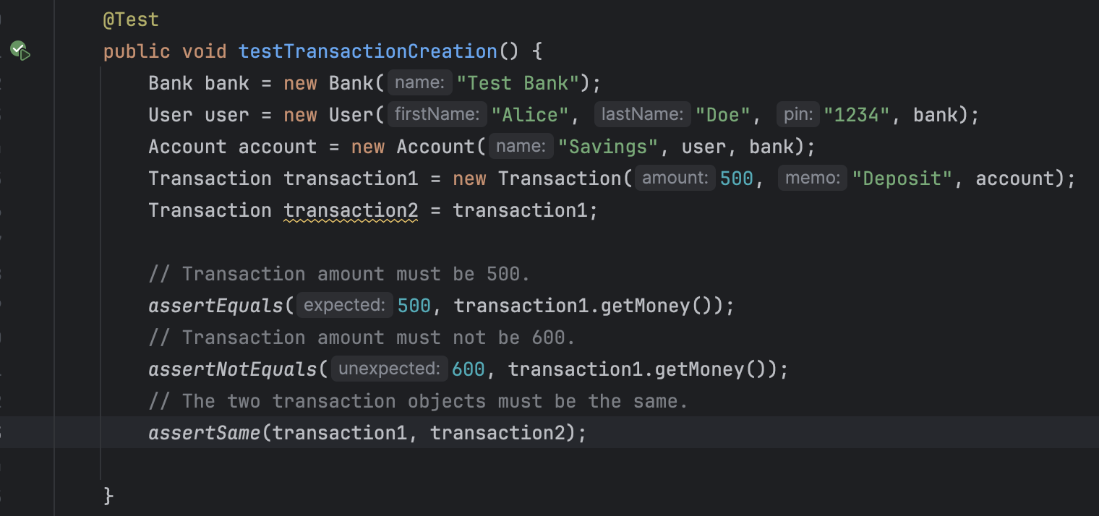

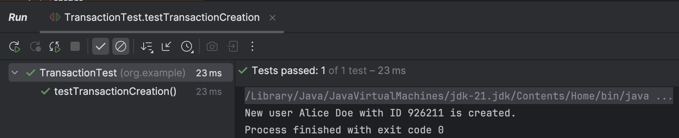

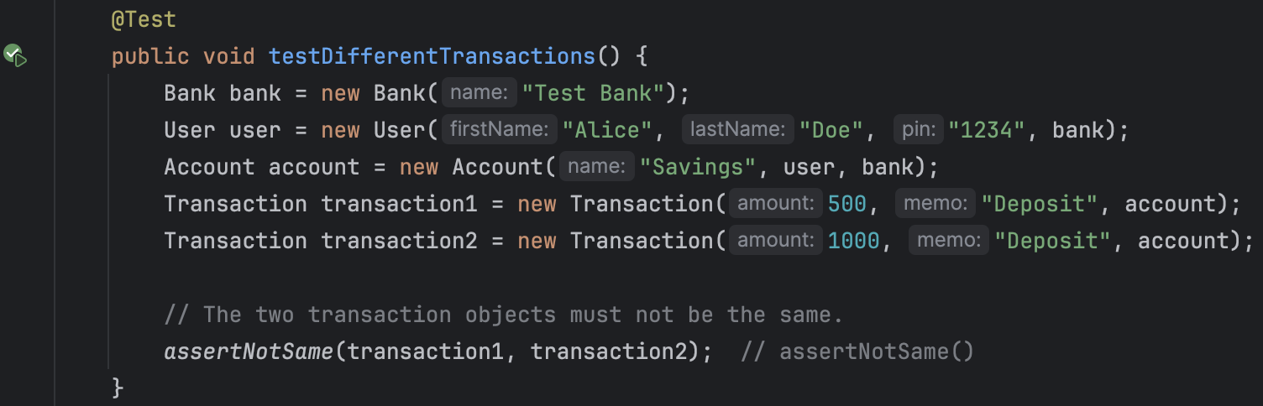

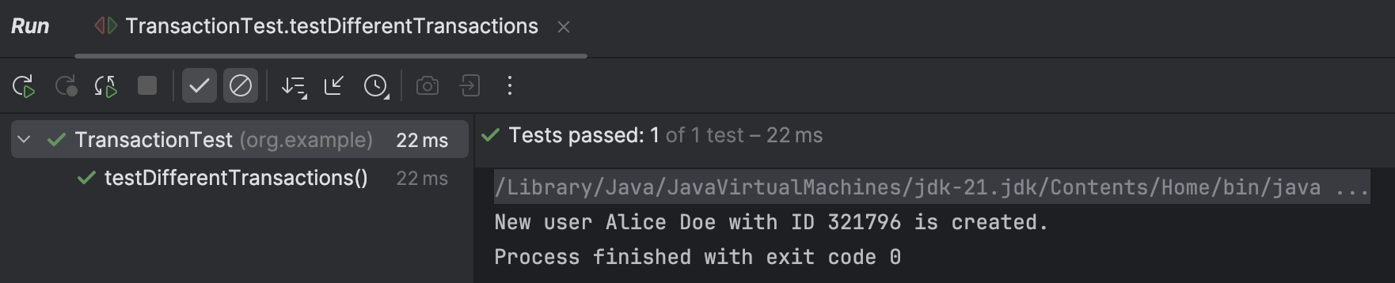

* assertThrows:

Confirms if a method throws an expected exception.

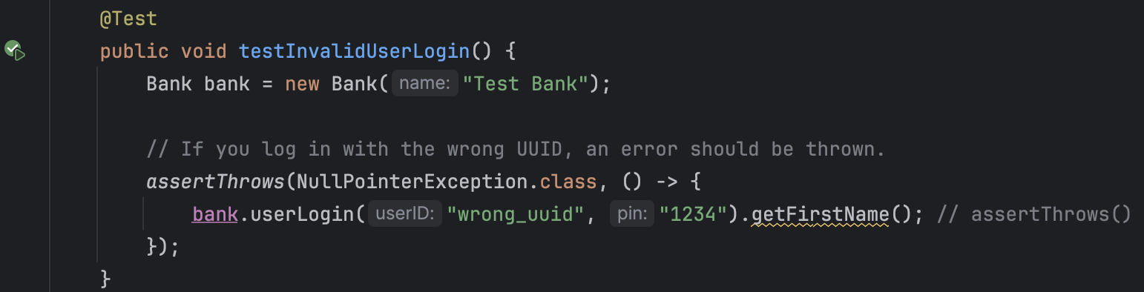

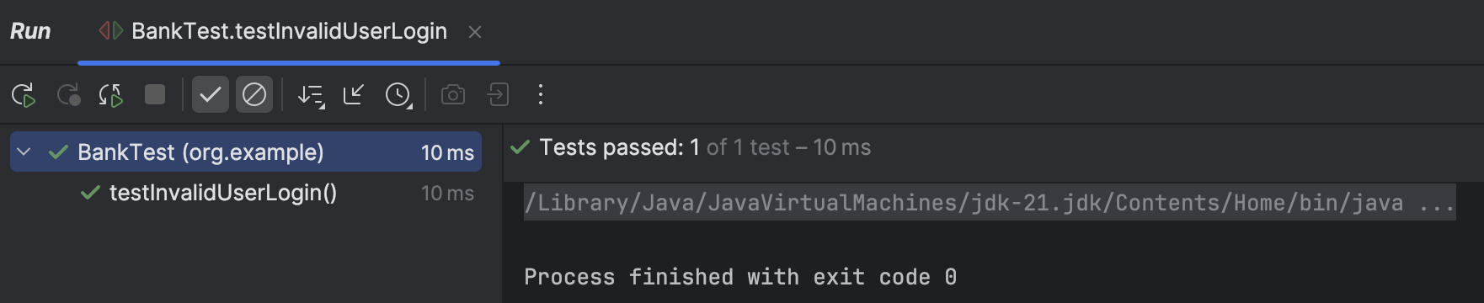

1. **Test suits and outputs**Group multiple related test cases into suites for organized testing.

The project includes two test suites:

* MyTestSuite_1:

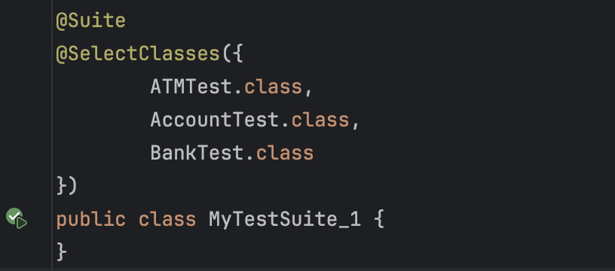

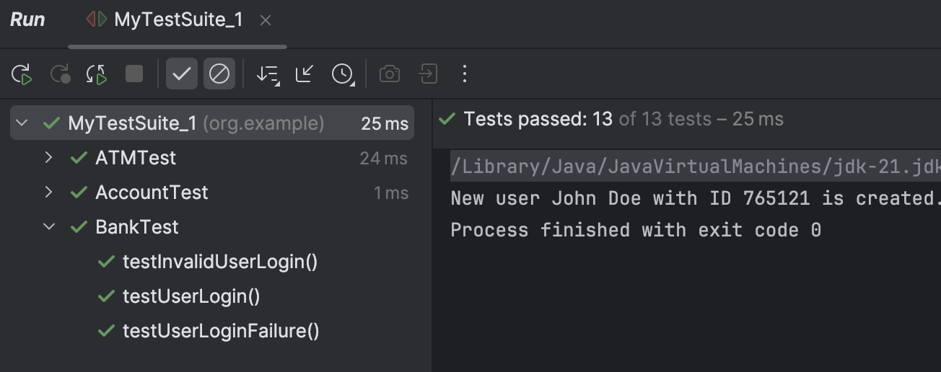

* MyTestSuite_2:

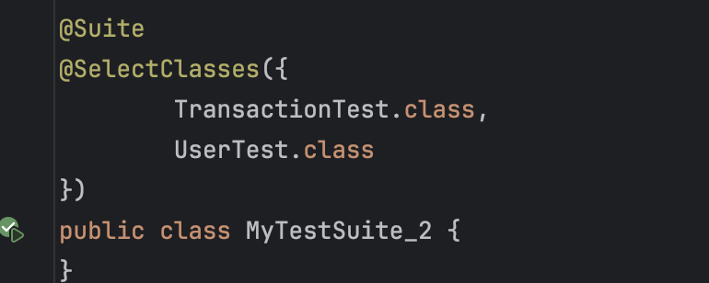

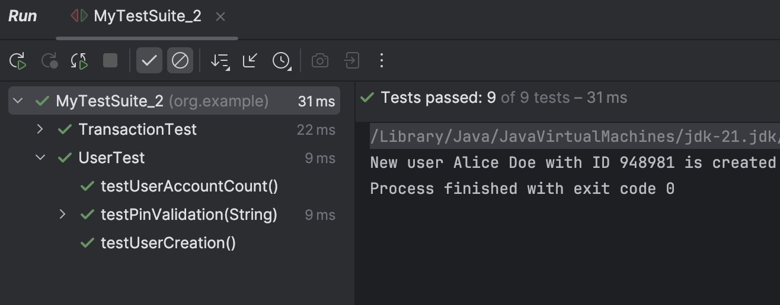

1. **Parameterized test and outputs**

• A test that runs multiple times with different input values.

• Ensures methods work for various cases without writing separate tests.

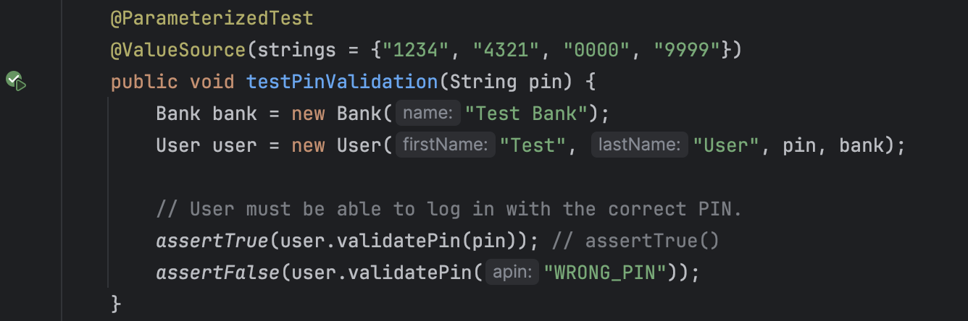

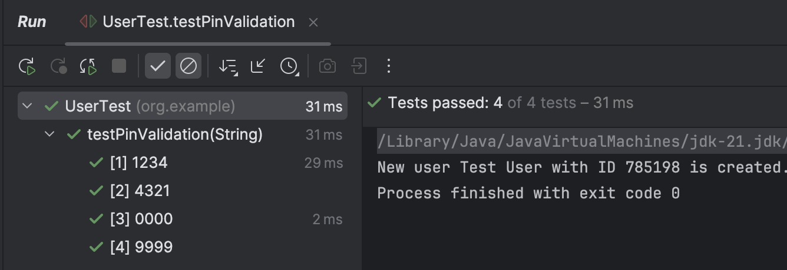

1. **Repeatable test and outputs**

• A test that always gives the same output when executed under the same conditions.

• Ensures consistency and reliability in testing.

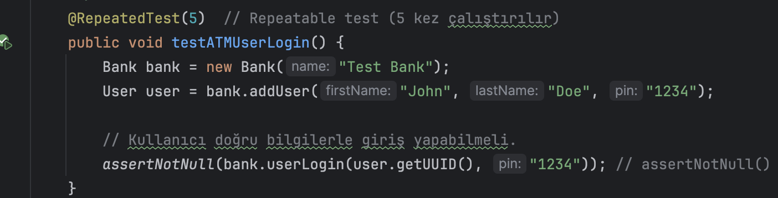

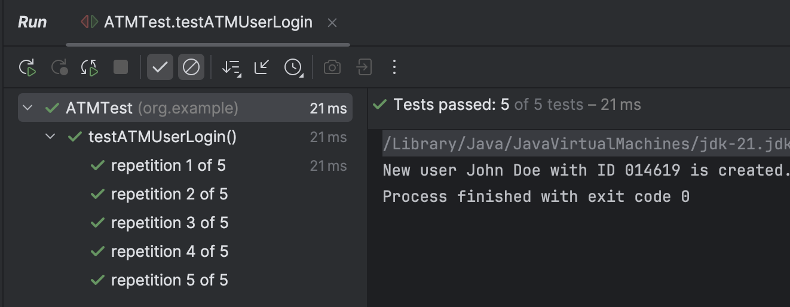

**Conclusion**

This report presents the **UML class diagram**, **test cases** and **test results** of the project. It includes **assertion statements, parameterized tests, repeatable tests, and test suite executions**. The testing process confirms that all components of the ATM system function correctly according to the specified requirements.