Effects of language mixing on bilingual children’s word learning

|  |
| --- |
| Krista Byers-Heinlein1, Amel Jardak1, Eva Fourakis2, & Casey Lew-Williams2 |
| 1 Concordia University |
| 2 Princeton University |
|  |

# Author note

This work was supported by a grant to KBH from the Natural Sciences and Engineering Research Council of Canada (402470-2011), grants to CLW and KBH from the National Institute of Child Health and Human Development (R01HD095912, R03HD079779), a grant to CLW from the Speech-Language-Hearing Foundation, support for KBH from the Concordia University Research Chairs program, and a fellowship to AJ from the Fonds de Recherche du Québec – Société et Culture. Portions of this work were presented at the 2018 Boston University Conference on Language Development. We thank Maritza Gomez, Christine E. Potter, the Children’s Home Society of New Jersey, the many members of the Concordia Infant Research Lab and the Princeton Baby Lab who assisted with testing participants, and the children and parents who participated.

Correspondence concerning this article should be addressed to Krista Byers-Heinlein, 7141 Sherbrooke St. West, Montréal, Québec, Canada, H4B 1R6. E-mail: [k.byers@concordia.ca](mailto:k.byers@concordia.ca)

Abstract

Language mixing is pervasive in bilingual children’s learning environments, and many caregivers alternate between two languages within the same sentence or conversation. Recent research shows that bilingual children are slower to process familiar words that occur at the moment following a language switch. Here we investigated the potential effects of language switching on children’s learning of new words. We tested two groups of 3-year-old children: French–English bilinguals (Experiment 1) and Spanish–English bilinguals (Experiment 2). Children were taught two words, one in single-language sentences (e.g., “Look! Do you see the dog on the teelo?”) and one in mixed-language sentences with a mid-sentence language switch (e.g., “Look! Do you see the *chien/perro* on the walem?). During the learning phase, children correctly identified the novel target when hearing both single-language and mixed-language sentences. However, when tested on their learning of the novel words, French–English bilinguals successfully recognized the word encountered in single-language sentences but failed to recognize the word encountered in mixed-language sentences. Spanish–English bilinguals failed to recognize either word. These findings suggest that language mixing can sometimes hinder children’s encoding of novel words that occur downstream, but leave open several possible underlying mechanisms.

*Keywords:* word learning, bilingualism, children, language mixing, code switching

Word count: X

Effects of language mixing on bilingual children’s word learning

By definition, children growing up in bilingual environments hear people switch between two languages. Language mixing varies substantially across bilingual environments: switches are much more common in some families than others, and they can occur at both very long and very short intervals. Many switches even occur within individual sentences. In a natural play study with Spanish–English bilingual families, all caregivers mixed their languages within sentences at least once, and some parents mixed in as many as one-third of their utterances (Bail, Morini, & Newman, 2015). Indeed, parents sometimes produce mixed-language sentences even when they overtly try to avoid them (Bail et al., 2015; Goodz, 1989). Given that language mixing is a normal part of bilingual environments, it is important to understand its relationship to children’s language learning. Here, we investigated whether and how language mixing affects 3-year-old children’s learning of new words.

Language mixing has been shown to affect toddlers’ comprehension of subsequent familiar words. In an eye-tracking paradigm, 20-month-old French–English bilinguals saw two familiar objects on a screen (e.g., dog, book), and one object was labeled in either a single-language sentence (“Find the dog!”) or a mixed-language sentence (“Find the *chien*!”; Byers-Heinlein, Morin-Lessard, & Lew-Williams, 2017). Toddlers were less accurate in looking to the target object when they heard it labeled in the mixed-language sentence than in the single-language sentence, particularly when switching occurred from their dominant to non-dominant language. An even stronger effect of dominance was found in a similar study of Spanish–English bilingual toddlers (Potter, Fourakis, Morin-Lessard, Byers-Heinlein, & Lew-Williams, 2019). However, not all types of language mixing affected word comprehension: when the language switch occurred at a sentence boundary, toddlers’ looking to the target object was not disrupted (Byers-Heinlein et al., 2017).

If language mixing can affect the processing of subsequent familiar words, then it could also affect the processing of subsequent unfamiliar words. Support for this idea comes from studies of incremental, real-time language processing with monolinguals. For example, in one study, toddlers heard sentences that ended with a word that was unfamiliar to them, such as “Mommy feeds the ferret”. Their looking patterns indicated that they were able to use the verb “feeds” to infer that “ferret” was an animal rather than an inanimate object (Goodman, McDonough, & Brown, 1998). Children’s efficiency in using familiar words to facilitate processing of subsequent words has been linked to vocabulary size and/or later vocabulary growth in both monolinguals (Fernald & Marchman, 2012; Fernald, Perfors, & Marchman, 2006; Lany, 2018; Lew-Williams & Fernald, 2007) and bilinguals (DeAnda, Hendrickson, Zesiger, Poulin-dubois, & Friend, 2018; Hurtado, Grüter, Marchman, & Fernald, 2014; Legacy, Zesiger, Friend, & Poulin-Dubois, 2016; Marchman, Fernald, & Hurtado, 2010). Based on this work, we hypothesized that the momentary processing delays associated with language mixing would impact the learning of a novel word that appeared later in the sentence.

To date, few studies have investigated links between language mixing and vocabulary growth in young children, and their results are equivocal. One large study (*N* = 181) with children aged 18 and 24 months learning English and a variety of other languages found that parents who reported more language mixing often had children with smaller vocabulary sizes (Byers-Heinlein, 2013). A smaller study did not find clear links between parental language mixing in the laboratory and vocabulary size in 18- to 24-month-olds (Bail et al., 2015). Two studies that measured mixing more indirectly (i.e., as the proportion of 30-minute blocks of time where both English and Spanish were spoken) also reported no links between mixing and 2.5-year-old children’s language development (Place & Hoff, 2011; 2016). The correlational nature of these studies makes it difficult to separate effects of mixing from other potentially confounding factors, such as parents’ language proficiency, or children’s absolute quantity of language exposure.

The goal of the current research was to examine whether and how mid-sentence language mixing might affect children’s learning of a novel word that appears moments later. We tested two populations of bilingual 3-year-olds: French–English bilingual children growing up in [omitted] (Experiment 1), and Spanish–English bilingual children growing up in [omitted] (Experiment 2). These groups differ on a number of dimensions, including the language pair they hear at home, the average socioeconomic status of families, the cultural milieu in which language learning takes place, and the degree of social and governmental support for bilingualism. Importantly, previous work has demonstrated that language mixing affects real-time word comprehension among children from both of these populations (Byers-Heinlein et al., 2017; Potter, Fourakis, Morin-Lessard, Byers-Heinlein, & Lew-Williams, 2018; 2019). Such comparisons are essential for evaluating the generalizability of findings across populations of bilingual learners.

Our experiments used an eye-tracking task with a learning phase and a test phase. During the learning phase, children were taught two novel words. One novel word always appeared at the end of a single-language sentence (e.g., “Look! Do you see the dog on the teelo?”), and the second novel word always appeared at the end of a mixed-language sentence, i.e., a sentence containing one word borrowed from the other language (e.g., “Look! Do you see the *chien/perro* on the walem?”). The novel word always appeared in the same language in which the sentence began, and this language was randomly assigned to be children’s dominant or non-dominant language. While listening to these sentences, children viewed pairs of familiar animals on top of novel objects (e.g., a bunny atop a novel purple object, and a dog atop a novel green object; see Figure 1). The visual scene required children to accurately identify the familiar referent in order to then locate the target novel referent. That is, children needed to first look to the dog to determine which of the two novel objects was being labeled. During the subsequent test phase, the two novel objects appeared side-by-side, with no familiar objects present, and children were assessed on their learning of label-object mappings.

Our main prediction was that children would show better learning of the novel word encountered in single-language sentences than in mixed-language sentences. Based on previous findings (Byers-Heinlein et al., 2017; Potter et al., 2019), we hypothesized that this would be due to a temporary disruption in language processing upon hearing the borrowed word. Specifically, upon hearing a language switch, children would be less able to identify and encode the mapping between the novel label and novel object. This would be evident in children’s behavior during the learning phase, where we predicted that children would spend less time gazing at the target novel object during mixed-language sentences than during single-language sentences.

We also considered several other potential results. First, it is possible that even when language mixing disrupts real-time processing, the uptake of new words is unaffected. Second, it is possible that we would not replicate previously reported effects of language mixing on language comprehension. In this case, we would either find that language mixing does not affect word learning, or that it does affect word learning but via another mechanism. Finally, considering the population differences noted above, French–English and Spanish–English bilingual children might show different patterns of looking, listening, and learning.

# Experiment 1: French–English bilinguals in [omitted]

## Method

The methods of Experiment 1 were approved by the [omitted] University Human Research Ethics board. Data were collected between November 2016 and April 2017, and parents provided informed consent prior to their child’s participation. As is common in laboratories that test hard-to-recruit populations such as bilingual children, children participated in a second, separate study, either immediately prior to or following participation in this experiment (the order of the two studies was counterbalanced). The results of that study are not reported here. Stimuli, data, and analysis scripts are available via the Open Science Framework at <https://osf.io/q2nzr/?view_only=51145827989c44eaae3d1d6a659f6ebf> [anonymized link for peer review].

### Participants

Children were recruited from a database of families interested in participating in research, principally identified via government birth lists. A total of 19 healthy French–English bilingual children were included in the final sample. A sensitivity analysis indicated that this sample size has 80% power to detect an effect size of dz = .68 or greater in a two-tailed *t*-test, which is the average effect size observed in word recognition paradigms in children older than 16 months according to MetaLab (<https://metalab.stanford.edu>; Bergmann et al., 2018). All children were growing up in [omitted]. Both French and English are widely spoken in the community, and the community generally holds positive attitudes toward both languages (Kircher, 2014). Childcare and elementary education are widely available in both languages.

Children had an average age of 3.50 years (range: 3.10 – 4.10). There were 12 males and 7 females. A modified version of the Language Experience and Proficiency Questionnaire (Marian, Blumenfeld, & Kaushanskaya, 2007) was used to assess the children’s language background and proficiency. As part of the questionnaire, parents were asked to rate their child’s proficiency in French and in English. A pre-determined inclusion criterion was that children were rated at least 7/10 in comprehension in both languages. Language dominance was established for each child as the language that was rated the highest for comprehension. When ratings were equal in both languages, the child’s dominant language was considered to be the mother’s dominant language. There were 10 English-dominant children and 9 French-dominant children. Age of acquisition of the languages varied across the sample: there were 8 children who were regularly exposed to both English and French from birth (i.e., were simultaneous bilinguals), and 11 who began regular exposure to their second language later in life (in all cases prior to age 18 months), usually upon starting daycare. Another 10 children were tested but not included in the final sample due to fussiness (*n* = 3), reported health or developmental issues (*n* = 3), not meeting pre-established language criteria (*n* =3), or because of technical difficulties (*n* = 1).

Children’s exposure to language mixing was measured via the Language Mixing Scale, a parent-report questionnaire that assesses the frequency of language mixing by the primary bilingual caregiver (Byers-Heinlein, 2013). The scale ranges from 0 (no language mixing) to 30 (frequent language mixing). The average score in this sample was 13.50 (range: 4 – 28).

Socioeconomic status was assessed via mothers’ highest educational attainment. All mothers had completed high school; specifically, 4 mothers had completed a graduate degree, 9 had completed a bachelor’s degree, 5 had completed other post-secondary training (e.g., college diploma, some university, trade school), and 1 had completed high school but had not received further formal education.

Children’s productive vocabulary size in English was assessed using the Developmental Vocabulary Assessment for Parents (DVAP; Libertus, Odic, Feigenson, & Halberda, 2015), which consisted of a checklist of words known by children aged 2–18 years based on words used in the Peabody Picture Vocabulary Test (PPVT; Dunn & Dunn, 2007). To assess children’s productive vocabulary size in French, we adapted a checklist similar to the DVAP, based on words used in the French adaptation of the PPVT (Échelle de vocabulaire en images Peabody; Dunn, Dunn, & Thériault-Whalen, 1993). The words are ordered from easy (e.g., boy, chair) to hard (e.g., honing, angler), and parents were asked to indicate which words their child could say. A parent who was familiar with the child’s vocabulary in a particular language filled out the form in that language. A parent who was familiar with the child’s vocabulary in a particular language filled out the form in that language. In some cases, each parent filled out a form in the language they usually used to interact with their child, while in other cases the same parent filled out both forms. One parent, who was not familiar with the language her child used at daycare, had the form filled out by a daycare worker. Data were missing for one language for one participant. Of the words on the DVAP, toddlers produced an average of 77 words in their dominant language (range: 37 – 177) and 48 words in their non-dominant language (range: 2 – 131), [$t(17)=6.08$, $p<.001$, *d* = 1.43]. The average number of words produced across both languages was 125 (range: 39 – 308).

### Visual Stimuli

Visual stimuli consisted of three animals (bunny, dog, fish) and two novel objects created for this study. Familiar animals were selected among words known by at least 50% of 18-month-olds in English, and at least 50% of 16-month-olds in English (see Fenson et al., 2007) and Québec French (Boudreault, Cabirol, Trudeau, Poulin-Dubois, & Sutton, 2007; Frank, Braginsky, Yurovsky, & Marchman, 2017). None of the animals or their French translations had phonological overlap at onset, nor were they cognates. Images of the animals were chosen from free online libraries. Images of platform-like novel objects were found online and digitally modified, such that they did not closely resemble any known object.

On learning trials, the objects were combined in a scene with each familiar object standing or sitting on top of a different novel object, with one novel–familiar object pair located on each side of the screen (Figure 1). The placement of familiar and novel objects was counterbalanced within and across children such that children saw two different familiar objects on each trial, but these varied across trials. On test trials, only the two novel objects were presented, without animals, and their left–right location was counterbalanced both within and across children.

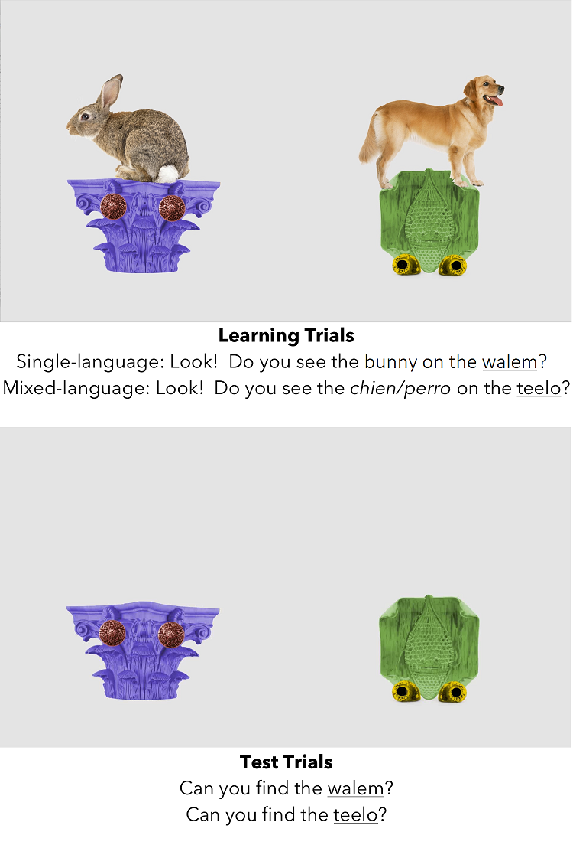

Figure 1: Auditory and visual stimuli for learning trials (A) and test trials (B) in Experiment 1 (French–English bilinguals) and Experiment 2 (Spanish–English bilinguals).

### Auditory stimuli

Auditory stimuli were recorded in a child-directed manner by a female native bilingual French–English speaker with no perceptible accent in either language. Two nonsense words, “walem” (*“walème”* in French) and “teelo” (*“tileau”* in French), were chosen to label the novel objects. They were produced with French phonology when embedded in a French carrier phrase, and English phonology when embedded in an English carrier phrase, as judged by native speakers of each language. The two words were carefully chosen to each have two syllables, different phonological onsets, different rhymes, and to sound masculine in French. Further, their onsets were different from the familiar objects’ onsets.

During the learning phase, each auditory stimulus consisted of a carrier phrase (“Look! Do you see the…” or *“Regarde! Vois-tu le…”*) that was followed by a familiar target word (bunny, dog, or fish) and a novel target word. Each sentence then labeled one of the animals and its corresponding novel object, such that children had to process the familiar word in order to determine the referent of the novel word. Stimuli were produced naturalistically, in either a single-language context where the carrier phrase, familiar target word, and novel target word were in the same language (e.g., “Look! Do you see the dog on the teelo?” or *“Regarde! Vois-tu le chien sur le tileau?”*), or in a mixed-language context where the familiar word was in a different language from the carrier phrase and the target novel word (e.g., “Look! Do you see the *chien* on the teelo?” or “*Regarde! Vois-tu le* dog *sur le tileau?*”). The familiar word was always pronounced with the phonology of the language it appeared in; “dog” was pronounced with an English accent, and *“chien”* was pronounced with a French accent. The target novel word was always pronounced with the phonology of the carrier phrase language.

During the test phrase, auditory stimuli consisted of simple sentences that directed children’s attention to a target novel object. Sentences during this phase were all in either English (e.g., “Can you find the teelo/walem?”) or French (e.g., *“Peux-tu trouver le tileau/walème?”*), depending on which language corresponded to the carrier phrase that the child encountered during training.

### Procedure

Children were seated on their parents’ laps or directly on a chair in front of a 24-inch Tobii T60XL corneal reflection eye-tracking system (Tobii Group, Stockholm, Sweden) located in a sound-attenuated, dimly-lit room, which was used to present the stimuli and record children’s eye gaze. Parents were asked to wear darkened sunglasses and headphones with music to blind them to the trial type. They were also asked not to talk or interact with the child during the experiment. Calibration was completed using a built-in five-point calibration routine. The sound was set to an average of 70 dB. Children viewed the stimuli in one of four randomly assigned experimental orders consisting of 12 learning trials (6 single-language sentences, 6 mixed-language sentences) immediately followed by 4 test trials. A colorful attention-getter was presented prior to each trial to reorient the child to the screen. Children were randomly assigned to hear the carrier phrases of both the learning and test phases either always in English or always in French. This resulted in 9 children being tested in their dominant language, and 10 children being tested in their non-dominant language. A sample trial order for a single child is presented in the Appendix.

During each of 12 learning trials, the two novel objects appeared side-by-side, with a different familiar object on top of each of them (e.g., a dog on the teelo, and a bunny on the walem). After 2000 ms, the auditory stimulus directed the child to look at the familiar target atop the novel target, either in the single-language or mixed-language sentence. The familiar word onset occurred exactly at 4500 ms, and the audio for each trial ended at around 6500 ms, leaving approximately 2000 ms of looking time after the target novel offset; the total length of each learning trial was 8500 ms. Each novel object was consistently labeled in a single-language or mixed-language sentence, and the assignment of label to sentence type was counterbalanced across children. Each familiar target in the learning phase appeared eight times, counterbalanced within children for whether it served as a target or a distractor, and whether it was encountered in a single-language or mixed-language sentence. The two novel objects appeared on every trial, half as target and half as distractor for each child. Assignment of label–object pairs was counterbalanced by trial type across participants (i.e., half of participants consistently encountered “teelo” in single-language sentences and “walem” in mixed-language sentences, while the other half consistently encountered “walem” in single-language sentences and “teelo” in mixed-language sentences). Trial order during the learning phase was semi-randomized.

During each of four test trials, only the two novel objects appeared on the screen, presented side-by-side without their corresponding familiar objects. The novel objects appeared in silence for approximately 2000 ms, and then the auditory stimulus directed children’s attention to a target object such that the target novel word onset occurred at exactly 3000 ms. Each test trial lasted 6000 ms. Each novel object appeared twice as target and twice as distractor, and side of presentation was counterbalanced both within and across children.

The experimenter monitored the status of the experiment via the eye tracker’s built-in camera and controlled the experiment from a computer in an adjacent room using Tobii Studio software. The total duration of the experiment was approximately 4 minutes. Parents completed questionnaires either before or after the eye-tracking experiment.

## Results and Discussion

Analyses were conducted in R (R Core Team, 2018), primarily using the eyetrackingR package (Dink & Ferguson, 2015).

### Test phase

To determine if children successfully learned each of the words presented during the learning phase, we examined the proportion of time that they looked to the labeled object, averaged across the two test trials of each type. Children’s looking was measured within areas of interest defined around each object. Following previous approaches, data for each trial were collapsed across a time window that began 360 ms after the onset of the target word label and ended 2000 ms after, such that the duration of the window of analysis was 1640 ms (Swingley, 2012). Trials where the child was inattentive were excluded from analyses (i.e., when they looked at the two objects together for less than 750 ms). Children completed an average of 1.79 out of 2 trials testing the novel word that was encountered during single-language sentences in the learning phase (range: 1 – 2) and 1.53 out of 2 trials testing the novel word that was encountered during mixed-language sentences (range: 1 – 2).

A two-tailed paired-samples *t*-test indicated that children looked significantly longer at the target object when its label had been encountered in single-language sentences [*M* = 0.64, *SD* = 0.23] than when its label had been encountered in mixed-language sentences [*M* = 0.44, *SD* = 0.28, *t*(18) = -3.01, *p* = 0.01, *d* = -0.69]. Children’s looking to the target novel object was significantly above chance (.5) when its label had been heard in single-language sentences, [*t*(18) = 2.69, *p* = 0.02, *d* = 0.62], indicating successful recognition. However, child’s looking to the target novel object was not significantly above (or below) chance when its label had been heard in mixed-language sentences, [*t*(18) = -0.97, *p* = 0.34, *d* = -0.22], indicating lack of successful recognition. Together, these results suggest that mid-sentence mixing of an informative familiar word can block three-year-olds’ learning of a novel word that follows moments later. Results are illustrated in Figure 2.

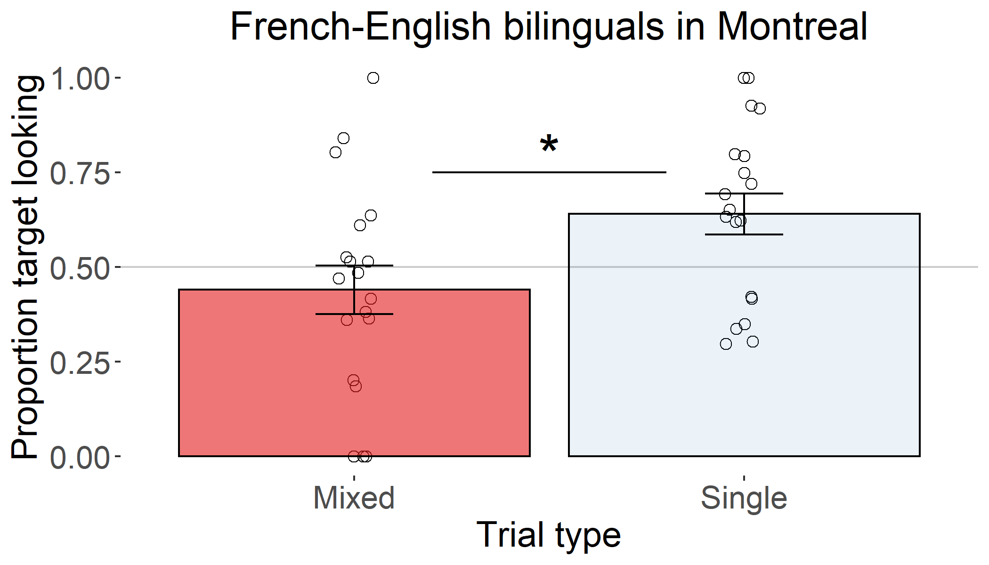

Figure 2: Proportion looking to target objects for French-English bilinguals.

We also investigated whether or not the direction of the language switch during training (e.g., dominant to non-dominant language, or vice-versa) affected children’s performance at test. Thus, we compared groups of children who heard the main carrier phrase in their dominant versus non-dominant language. Note that this analysis was exploratory, given the reduced sample size of the subgroups (dominant: *n* = 9; non-dominant: *n* = 10). A 2 (sentence type: single, mixed) x 2 (carrier language: dominant, non-dominant) mixed ANOVA confirmed the significant main effect of sentence type, but there was no significant main effect or interaction with the carrier language (Table 1). However, follow-up *t*-tests indicated that the main effect of sentence type was statistically significant for the subgroup of children who heard the carrier phrase in their dominant language [*M*diff = 0.24, *t*(8) = -4.87, *p* = 0, *d* = -1.62], but not for the subgroup of children who heard the carrier phrase in their non-dominant language [*M*diff = 0.18, *t*(9) = -1.40, *p* = 0.19, *d* = 0.44]. This provides tentative evidence that word learning was less successful when children had heard a non-dominant word embedded in an otherwise dominant-language sentence, relative to the opposite. That is, hearing a brief switch into the dominant language may not impact subsequent encoding of new words to the same extent as a brief switch into the non-dominant language.

Table 1:

*French-English bilinguals: ANOVA for test trials by dominance*

|  |  |  |  |  |  |  |  |
| --- | --- | --- | --- | --- | --- | --- | --- |
|  | Effect | DFn | DFd | F | p | p<.05 | ges |
| 2 | carrier.dominant | 1.00 | 17.00 | 0.07 | 0.79 |  | 0.00 |
| 3 | sentence.type | 1.00 | 17.00 | 8.80 | 0.01 | * | 0.15 |
| 4 | carrier.dominant:sentence.type | 1.00 | 17.00 | 0.22 | 0.65 |  | 0.00 |

### Learning phase

To better understand children’s overall unsuccessful learning of the word presented in mixed-language sentences, we investigated their looking patterns during the learning phase. We expected that language mixing would affect learning in this study by slowing children’s processing of the familiar word, which, in turn, would block children from having sufficient time to encode the novel word/object pair. If correct, this would manifest as less looking to the labeled objects (both familiar and novel) during mixed-language sentences than during single-language sentences.

We computed the proportion of time that children looked towards each of the four objects onscreen: the familiar target, the novel target, the familiar distractor, and the novel distractor. As during the test phase, data for each trial were collapsed across a time window 360–2000 ms after the familiar word onset. We note that while it is possible that children would need additional time to process the novel word that followed the familiar word, this time window afforded maximum sensitivity for detecting potential differences in the single-language versus mixed-language contexts (Swingley, 2012). Trials where the child was inattentive were excluded from these analyses (i.e., when they looked at the four objects on the screen for less than 750 ms total). Children contributed data for an average of 5.53 single-language trials (range: 3 – 6) and 5.63 mixed-language trials (range: 4 – 6) out of 6 possible trials per type. As preliminary analyses found no effects of language dominance on the patterns of looking to the target, this factor was not included in these analyses. Means and standard deviations of proportion looking to each object type (target familiar, target novel, distractor familiar, distractor novel) during single-language and mixed-language sentences are displayed in Table 2.

Table 2:

*Descriptive statistics for looking times during training phase: French–English bilinguals.*

|  |  |  |  |  |
| --- | --- | --- | --- | --- |
| target.type | sentence.type | familiarity | mean | sd |
| target | Single | familiar | 0.31 | 0.15 |
| target | Single | novel | 0.44 | 0.18 |
| target | Mixed | familiar | 0.32 | 0.12 |
| target | Mixed | novel | 0.47 | 0.18 |
| distractor | Single | familiar | 0.08 | 0.07 |
| distractor | Single | novel | 0.09 | 0.09 |
| distractor | Mixed | familiar | 0.10 | 0.08 |
| distractor | Mixed | novel | 0.07 | 0.05 |

Proportion looking to the objects was analyzed with a 2 (target type: target, distractor) x 2 (familiarity: familiar, novel) x 2 (trial type: single-language, mixed-language) repeated measures ANOVA. Statistics are displayed in Table 3; note that chance looking is not 0.5, as there were two groups of two objects on the screen. There were significant main effects of familiarity (greater looking at novel than familiar objects) and target type (greater looking at target than distractor objects). There was also a significant interaction between familiarity and target type: looking times to target objects were higher overall, with significantly greater looking to novel than to familiar targets, and looking times to distractor objects were lower overall, with no significant difference in looking to novel vs. familiar distractors. Critically, there were no effects or interactions with trial type, indicating similar patterns of looking across single-language and mixed-language sentences. Across both single-language and mixed-language sentences, children looked significantly longer at the target objects than the distractor objects after hearing the label (*p*s < .05). Visual inspection of time course plots (Figure 3) confirms that on both single-language and mixed-language sentences, children showed similar increases in looking to the labeled objects after naming. These analyses suggest that language mixing did not affect children’s accuracy in looking to the labeled targets during the training phase.

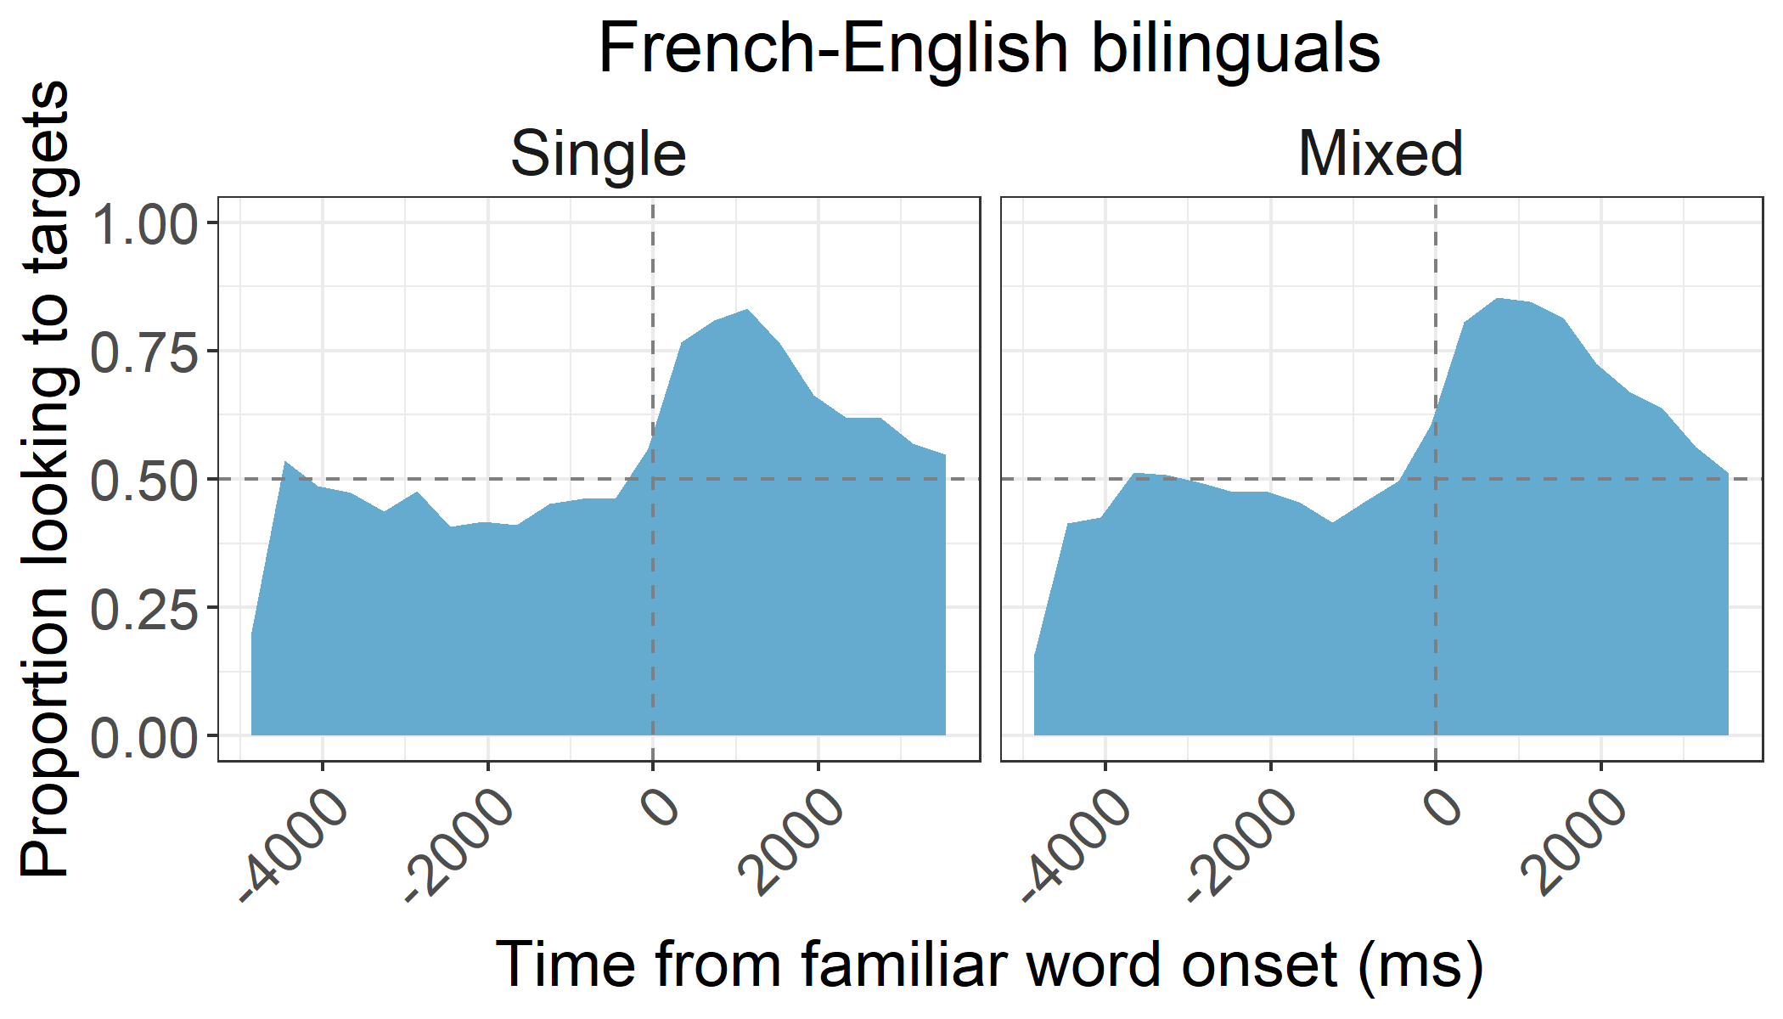

Figure 3: Timecourse of looking to labeled target for French-English bilinguals (Experiment 1).

Table 3:

*ANOVA for training trials.*

|  |  |  |  |  |  |  |  |
| --- | --- | --- | --- | --- | --- | --- | --- |
|  | Effect | DFn | DFd | F | p | p<.05 | ges |
| 2 | sentence.type | 1.00 | 18.00 | 0.76 | 0.39 |  | 0.00 |
| 3 | familiarity | 1.00 | 18.00 | 5.05 | 0.04 | * | 0.07 |
| 4 | target.type | 1.00 | 18.00 | 141.90 | 0.00 | * | 0.62 |
| 5 | sentence.type:familiarity | 1.00 | 18.00 | 0.06 | 0.81 |  | 0.00 |
| 6 | sentence.type:target.type | 1.00 | 18.00 | 0.49 | 0.49 |  | 0.00 |
| 7 | familiarity:target.type | 1.00 | 18.00 | 9.94 | 0.01 | * | 0.09 |
| 8 | sentence.type:familiarity:target.type | 1.00 | 18.00 | 0.56 | 0.47 |  | 0.00 |

# Experiment 2: Spanish–English bilinguals in [omitted]

In Experiment 1, we found that mid-sentence language mixing reduced French–English bilingual children’s abilities to encode a sentence-final novel word. Instead of using these findings to draw conclusions about the nature of bilingual development, we examined their generalizability to a different bilingual population. The purpose of Experiment 2 was to study how language mixing affects word learning among Spanish–English bilingual 3-year-olds in [omitted].

## Method

The method of Experiment 2 was approved by the [omitted] Institutional Review Board. Data were collected between March 2017 and January 2018, and parents provided informed consent prior to their child’s participation. As in Experiment 1, participants in Experiment 2 participated in an additional experiment either prior to or after participating in this experiment. Stimuli, data, and analysis scripts are available via the Open Science Framework at <https://osf.io/q2nzr/?view_only=51145827989c44eaae3d1d6a659f6ebf> (Anonymized link for peer review).

### Participants

A total of 21 healthy Spanish–English bilingual children were included in the final sample. All children were growing up in [omitted]. English is the majority language and Spanish is the minority language in this region. Participants were primarily recruited via various nonprofit organizations in the region.

Children had an average age of 3.70 years (range: 3.20 – 4.10). There were 9 males and 12 females. As in Experiment 1, a modified version of the Language Experience and Proficiency Questionnaire (Marian et al., 2007) was used to assess the children’s language background and proficiency. Inclusion criteria and definitions of language dominance were the same as in Experiment 1. There were 8 English-dominant children and 13 Spanish-dominant children. For Spanish, all children were exposed regularly from birth. For English, 8 were exposed regularly from birth (i.e., were simultaneous bilinguals), 9 were exposed after birth but within the first year of life, and 4 were exposed between 12 and 36 months. Another 5 children were tested but not included in the final sample due to not meeting pre-established inclusion criteria for bilingual exposure (*n* = 4) or reported language delay (*n* = 1).

As in Experiment 1, children’s exposure to parental language mixing was measured via the Language Mixing Scale Score (Byers-Heinlein, 2013). The average score in this sample was 16.50 (range: 0 – 30. This was not statistically different from the amount of mixing reported by parents in Experiment 1 [$t(38)=1.18$, $p=.244$, *d* = 0.37].

Socioeconomic status was assessed via mothers’ highest educational attainment: 7 had completed a graduate degree, 4 had completed some university, 5 had completed high school, 3 had not completed high school, and 2 did not report. That is, among those reporting, 56% of mothers of Spanish–English bilingual children had completed education beyond high school; in contrast, 95% of mothers of French–English bilingual children had done so. Thus, we infer that the sample of Spanish–English bilingual children was of lower socioeconomic status than the sample of French–English bilingual children.

As in Experiment 1, children’s productive vocabulary size in English was assessed using the Developmental Vocabulary Assessment for Parents (DVAP; Libertus et al., 2015), and using a Spanish adaptation we created for the purposes of this study based on the Spanish version of the PPVT (Test de Vocabulario en Imagenes Peabody; Dunn, Padilla, Lugo, & Dunn, 1986). Data were missing for one language for 1 participant. Of the words on the DVAP, toddlers produced an average of 54 words in their dominant language (range: 3 – 105) and 41 words in their non-dominant language (range: 1 – 107), a difference which was not statistically reliable, [$t(19)=0.90$, $p=.380$, *d* = 0.20]. The total number of words produced across both languages was 93 words on average (range: 31 – 155). This was significantly fewer than French–English bilinguals, who produced an average of 125 words, [$t(36)=2.05$, $p=.047$, *d* = 0.67]. This difference in vocabulary size is likely related to differences in average socioeconomic status between the two samples (e.g., Hart & Risley, 1995).

### Stimuli

Auditory stimuli for Experiment 2 were equivalently structured to those used in Experiment 1. Sentences were produced by a female Spanish–English bilingual speaker (e.g., “Look! Do you see the dog/*perro* on the teelo?” / *“¡Mira! ¿Puedes ver el perro/dog encima del tilo?”*). All other aspects of the stimuli were identical to Experiment 1. As in Experiment 1, the language of the carrier phrase was consistent for each child (e.g., always in Spanish or always in English). Children were randomly assigned to the language of testing: 10 children were tested in their dominant language, and 11 were tested in their non-dominant language.

### Procedure and Reliability Coding

The procedure was similar to Experiment 1. Children sat on their parent’s lap, and caregivers wore occluded glasses and headphones with music to blind them to trial type. Children viewed stimuli approximately 70 cm from a large, flat-screen television monitor (68 x 122 cm). The experimenter recorded infants’ eye movements via a video camera below the screen. After testing, a researcher who was blind to condition coded eye movements, indicating the direction of looks as: left, right, shifting, or away. Another researcher also coded 25% of the videos. Inter-coder reliability was 98.7% across all video frames, and 97.5% for video frames surrounding only shift events.

## Results

### Test phase

Analyses for Experiment 2 were similar to those for Experiment 1, focusing on children’s looking patterns during the 360–2000 ms time window after the object was labeled during the test phase, again excluding trials with less than 750 ms of overall looking during this time window. Children’s proportion of looking to target was averaged across the two test trials of each type. Children completed an average of 1.68 out of 2 trials testing the novel word that was encountered during single-language sentences in the learning phase (range: 1 – 2) and 1.58 out of 2 trials testing the novel word that was encountered during mixed-language sentences (range: 1 – 2). Preliminary analyses found no effects of language dominance on the patterns of looking to the target, this factor was not included in subsequent analyses.

Overall, children in Experiment 2 appeared unsuccessful at learning either word, as displayed in Figure 4. Two-tailed single-samples *t*-tests showed that children’s looking to the target object was not significantly different from chance (.5) for the novel object heard in single-language sentences, [*M* = 0.51, *SD* = 0.30, *t*(18) = 0.10, *p* = 0.92, *d* = 0.02] or in mixed-language sentences, [*M* = 0.53, *SD* = 0.28, *t*(18) = 0.43, *p* = 0.67, *d* = 0.10]. A two-tailed paired-samples *t*-test confirmed that children showed similar looking to the target novel objects heard in the single-language and mixed-language sentences,[*t*(18) = 1.45, *p* = 0.16, *d* = 0.33].

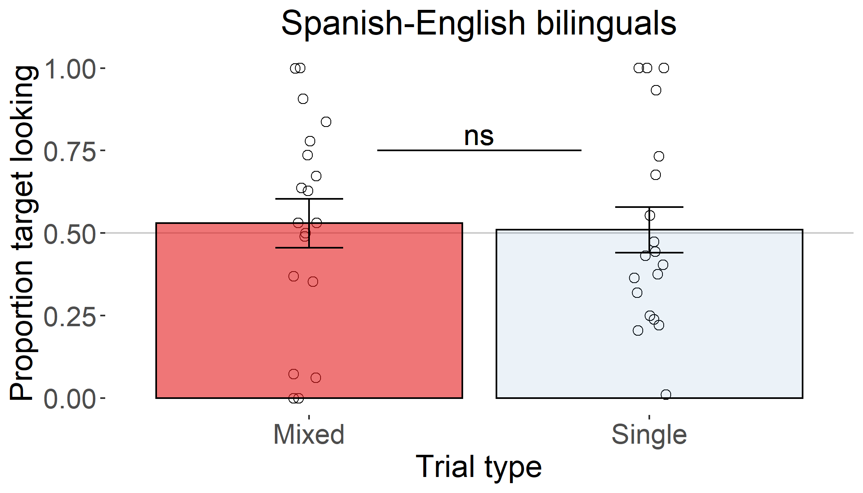

Figure 4: Proportion looking to target object for Spanish–English bilinguals (Experiment 2). Bars represent standard error of the mean.

### Learning phase

In these analyses, we investigated whether children’s apparently unsuccessful learning of the novel words was due to difficulty locating the labeled referent. Because data in Experiment 2 were coded by humans rather than an eye tracker, children’s looks were coded in terms of whether looking was at the target familiar–novel combination of objects or at the distractor familiar–novel combination of objects; finer resolution to the area of interest surrounding each familiar and novel object was not possible. Children contributed an average of 5.53 single-language trials (range: 2 – 6) and 5.05 mixed-language trials (range: 3 – 6) out of 6 possible trials per type. Preliminary analyses found no effects of language dominance on the patterns of looking to the target, thus this factor was not included in subsequent analyses. Means and standard deviations of proportion looking to each object type (target familiar, target novel, distractor familiar, distractor novel) during single-language and mixed-language sentences are displayed in Table 4.

Table 4:

*Descriptive statistics for looking times during training phase: Spanish–English bilinguals.*

|  |  |  |  |  |
| --- | --- | --- | --- | --- |
| target.type | sentence.type | familiarity | mean | sd |
| target | Single | familiar + novel | 0.72 | 0.23 |
| target | Mixed | familiar + novel | 0.67 | 0.25 |
| distractor | Single | familiar + novel | 0.28 | 0.23 |
| distractor | Mixed | familiar + novel | 0.33 | 0.25 |

A two-tailed, paired-samples *t*-test showed that children’s attention to the target was similar for the single-language and mixed-language sentences, [$t(18)=-0.97$, $p=.344$, *d* = -0.22]. Children’s looking to the target side was significantly above chance during both single-language sentences [M = 0.72, SD = 0.23, $t(18)=4.10$, $p=.001$, *d* = 0.94] and mixed-language sentences [M = 0.67, SD = 0.25, $t(18)=2.86$, $p=.010$, *d* = 0.66]. Time course plots shown in Figure 5 confirm that children showed similar increases in looking to the labeled objects after naming for both trial types. This indicated that language mixing did not affect children’s success in orienting to the labeled object during the learning phase.

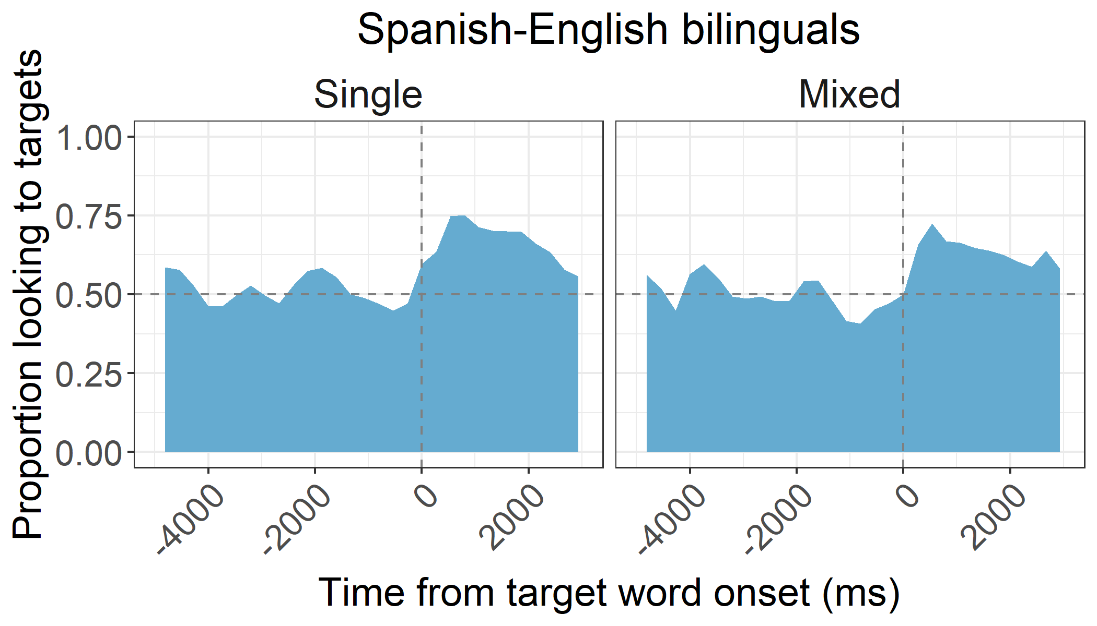

Figure 5: Timecourse of looking to target during training trials for Spanish–English bilinguals

### Comparison of French–English (Experiment 1) and Spanish–English (Experiment 2) bilinguals

Our final set of analyses compared the French–English (Experiment 1) and Spanish–English (Experiment 2) bilingual children directly. First, we examined performance during the test phase in a 2 (population: French–English, Spanish–English) x 2 (sentence type: single-language, mixed-language) mixed ANOVA. The largest observed effect was an interaction of population and sentence type, which was expected as French–English bilinguals looked longer at the novel target that had been encountered in single-language trials than in mixed-language trials, but Spanish–English bilinguals showed similar looking to the targets regardless of the presence or absence of mixing. However, this interaction failed to achieve statistical significance.

Table 5:

*Comparison of French–English (Experiment 1) and Spanish–English (Experiment 2) bilinguals’ performance during the test phase.*

|  |  |  |  |  |  |  |  |  |
| --- | --- | --- | --- | --- | --- | --- | --- | --- |
| Effect | DFn | DFd | SSn | SSd | F | p | p<.05 | ges |
| (Intercept) | 1.00 | 36.00 | 21.39 | 3.49 | 220.47 | 0.00 | * | 0.78 |
| population | 1.00 | 36.00 | 0.01 | 3.49 | 0.09 | 0.76 |  | 0.00 |
| sentence.type | 1.00 | 36.00 | 0.16 | 2.43 | 2.34 | 0.13 |  | 0.03 |
| population:sentence.type | 1.00 | 36.00 | 0.26 | 2.43 | 3.80 | 0.06 |  | 0.04 |

Second, we examined performance during the training phase. A 2 (population: French–English, Spanish–English) x 2 (sentence type: single-language, mixed-language) mixed ANOVA revealed a statistically significant main effect of population, whereby the French–English bilinguals looked to the labeled target with greater accuracy than did the Spanish–English bilinguals (Table 6). The main effect of sentence type and the interaction between sentence type and population were not statistically significant. Thus, although both groups did look more to the target objects than the distractor objects during the learning phase, the French–English bilinguals did so more reliably.

Table 6:

*Comparison of French–English (Experiment 1) and Spanish–English (Experiment 2) bilinguals’ performance during the learning phase.*

|  |  |  |  |  |  |  |  |  |
| --- | --- | --- | --- | --- | --- | --- | --- | --- |
| Effect | DFn | DFd | SSn | SSd | F | p | p<.05 | ges |
| (Intercept) | 1.00 | 36.00 | 16.33 | 1.67 | 352.05 | 0.00 | * | 0.88 |
| population | 1.00 | 36.00 | 3.97 | 1.67 | 85.61 | 0.00 | * | 0.65 |
| sentence.type | 1.00 | 36.00 | 0.01 | 0.48 | 0.71 | 0.40 |  | 0.00 |
| population:sentence.type | 1.00 | 36.00 | 0.02 | 0.48 | 1.17 | 0.29 |  | 0.01 |

# General discussion

We tested whether and how language mixing affects novel word learning in 3-year-old bilingual children from two language communities: French–English bilinguals in [omitted], and Spanish–English bilinguals in [omitted]. Children viewed pairs of familiar animals, each perched atop different novel objects, and had the opportunity to learn two novel words. One novel word was consistently encountered within single-language sentences (e.g., “Look! Do you see the dog on the teelo?”), and one was consistently encountered within mixed-language sentences (e.g., “Look! Do you see the *chien/perro* on the teelo?”). This design required children to first identify the familiar referent in order to then locate the referent of the target novel noun. At test, children saw the two novel objects without the familiar objects, and a sentence directed their attention to the target.

Children’s accuracy in learning novel words differed across the two language communities. French–English bilingual children successfully recognized the word that had been encountered in single-language sentences, but not the word encountered in mixed-language sentences. However, Spanish–English bilingual children did not recognize the word encountered in either context. Results from French–English bilinguals support the hypothesis that language mixing can disrupt initial encoding of novel words. Moreover, for the French–English bilinguals, we found evidence that word learning in the mixed-language context was especially reduced for children who heard the familiar word in their non-dominant language. This is consistent with dominance asymmetries reported in previous word comprehension paradigms (Byers-Heinlein et al., 2017; Potter et al., 2019). However, no effects of mixing or dominance were observed among Spanish–English bilinguals, and in fact no successful word learning was observed, suggesting that the task demands were more challenging for this population than for the French–English bilinguals.

Our investigation was motivated by the idea that language mixing can sometimes derail children’s recognition of a familiar word, which in turn could derail learning of a novel word that occurs moments later. Indeed, substantial previous work has demonstrated that both children and adults experience processing costs for language mixing in a range of paradigms including eye tracking and speech production (Altarriba, Kroll, Sholl, & Rayner, 1996; Byers-Heinlein et al., 2017; Chan, Chau, & Hoosain, 1983; Grainger & Beauvillain, 1988; Macnamara & Kushnir, 1971; Meuter & Allport, 1999; Moreno, Federmeier, & Kutas, 2002; Potter et al., 2019; Price, Green, & von Studnitz, 1999; Proverbio, Leoni, & Zani, 2004; Soares & Grosjean, 1984; Thomas & Allport, 2000). However, our analyses of children’s looking behavior during the learning phase did not necessarily converge with these findings. We found that children in both groups did successfully identify the familiar object—and in turn, the target novel object—during the learning phase, regardless of whether they encountered its label in a single-language or a mixed-language sentence. That is, children shifted their eyes to the ‘correct’ location independent of sentence type or population. This presents a key problem: despite consistently successful looking toward the correct referents, Spanish–English bilinguals did not appear to successfully learn the novel word-object mappings (perhaps because they were less efficient overall in orienting to targets), and French–English bilinguals showed asymmetry in doing so across the two sentence types.

Samuelson and colleagues (2017; Horst & Samuelson, 2008) make an important distinction between two phases in word learning. The first phase is referent selection: determining the likely referent of a novel word. The second phase is retention: linking the sound of the novel word to its meaning. A number of recent studies have shown that these are dissociable processes in word learning, as children sometimes look toward the correct referent without recognizing the word later (Bion, Borovsky, & Fernald, 2013; Horst & Samuelson, 2008; O’Connell, Poulin-Dubois, Demke, & Guay, 2009). Our findings—using the quite distinct domain of language mixing—confirm the dissociable nature of these two components of word learning. That is, during the learning phase, children looked toward the labeled object in all contexts, but only French–English bilinguals showed successful word learning, and only in the single-language context.

The cognitive demands of our word learning task might have contributed to children’s overall difficulty with word learning. First, our learning phase presented children with complex visual scenes involving two familiar and two novel objects. Some studies have suggested that the presence of multiple objects can make word learning challenging. For example, Horst and Samuelson (2008) presented 24-month-old monolingual children with three objects: two familiar objects (e.g., car, cow) and one novel object (e.g., ‘splicket’). They instructed children to “Look at the splicket! Which one is the splicket?” Children’s knowledge of the familiar objects helped them identify the novel object as the referent of the novel word (i.e., referent selection), yet when tested they did not appear to retain this link (i.e., retention). Only when provided with additional cues that heightened the novel object’s salience, such as ostensive naming, did infants retain the label. The authors suggested that although the familiar objects helped children identify the novel object, they also competed as possible referents for the novel word. Such complexity was also present in our design. On each learning trial, infants not only encountered the target referent (e.g., teelo), but also three other competitors: the familiar target (e.g., dog), the familiar distractor (e.g., bunny), and the novel distractor (e.g., walem). Moreover, when children heard “Look! Do you see the dog on the teelo?”, they had to infer that the teelo was the object underneath the dog—an additional processing step that might have made the task especially challenging for some children (see Bion et al., 2013; Carey & Bartlett, 1978; Goodman et al., 1998; and Horst & Samuelson, 2008; for studies that required children to make comparable inferences).

In light of these design-related complexities, the data for Spanish–English versus French–English bilingual children merit special attention. Spanish–English bilinguals did not learn words in single- or mixed-language sentences, yet it appears that French–English bilingual children were able to learn in the single-language condition. While both groups showed above-chance looking toward the target side during the learning phase, French–English bilinguals were more efficient in doing so. This likely gave French–English bilinguals more time to encode the word-referent link. However, we do not currently know why the two groups differed in their orientation behaviors during the learning phase. This could be attributable to a variety of differences between our two groups of learners, including their existing language knowledge (French–English bilinguals had larger reported productive vocabularies than Spanish–English bilinguals), how typical our chosen novel words were of other words in their vocabularies (even though novel words were always pronounced with language-specific phonology), their socioeconomic status (French–English bilinguals came from families of higher socioeconomic status than Spanish–English bilinguals), community-specific differences in patterns of bilingual language use, and family-level or society-level differences in language attitudes. Each of these factors could account for the observed population differences; previous research points to socioeconomic status as an important influence on early language processing and vocabulary growth (e.g., Fernald, Marchman, & Weisleder, 2013), but it is safe to assume that these other dimensions of language experience also play a role in shaping bilingual learning. Research is needed to better understand the microstructure of language use in different bilingual households and different bilingual communities, and how these in turn affect children’s language processing and vocabulary growth over time.

Regarding the findings for French–English bilingual children, it is important to consider why the single-language sentences (relative to the mixed-language sentences) enabled encoding of the link between the novel word and its referent. In addition to children’s equal gaze to target referents during the learning phase, many factors were identical across these sentence contexts: the same number of objects was visible, the same competition between objects was at play, the same inferences were required in both cases, and the same word–object association demands were required. What differed was whether the label for the mid-sentence familiar animal did or did not match the language used in the rest of the sentence, and possibly whether that word appeared in the child’s dominant or non-dominant language. Why were French–English bilinguals unable to encode the word–referent link in the mixed-language condition?

One broad possibility is that bilingual children learn over time that language mixing does not offer an optimal moment for learning, and thus they either implicitly or explicitly do not encode novel words that appear in mixed-language sentences. Toddlers have been shown to apply at least some selectivity when learning words; for example, they prefer word labels that come from reliable over unreliable speakers (Mangardich & Sabbagh, 2018). It is possible that children interpret language mixing as a signal of a speaker’s uncertainty or unreliability in that moment, which may block encoding of novel information.

A second possibility is that language mixing could present ambiguity or confusion about what language the to-be-learned word is in. Some theories of bilingual language acquisition posit that even young bilingual learners do encode the language of a word (Byers-Heinlein, 2014; Curtin, Byers-Heinlein, & Werker, 2011). But in contexts with language mixing, the language of a word is incrementally less clear, as the preceding sentence suddenly includes sounds, syllables, words, and/or phrases from both languages. Although our target novel words had clear phonological characteristics of one language or the other (i.e., words were pronounced either in an English-like or French/Spanish-like accent), these cues might have been insufficient or too fleeting.

To further evaluate these contrasting—but complementary—ideas, future investigations could teach children words in language-mixing contexts with simpler visuals than those used in the current design. For example, an experiment could display only one familiar–novel object pair at a time (e.g., a dog on a teelo, with no distractor), or only one novel object at a time, in isolation (e.g., only the teelo). Any heightened success in learning words under these simpler task demands would indicate that the cognitive load of the current design was too high. However, if language mixing is implicitly or explicitly perceived as a sub-optimal learning opportunity, children would avoid and/or show failure in learning a novel word that is presented in a mixed-language sentence, regardless of task complexity. Indeed, there is some evidence to support this possibility: in a study of Mandarin–English bilingual 18-month-olds using the Switch task (which presents one novel object at a time accompanied by an isolated label), children readily encoded words with full phonetic detail in a single-language context, but not in a switched-language context (Singh, Fu, Tay, & Michnick Golinkoff, 2018).

To conclude, the current experiments provide two main contributions to existing research. First, they demonstrate that language mixing can sometimes hinder bilingual children’s learning of new words that occur downstream, but leave open important questions as to why. Second, they show that different populations of bilingual children sometimes perform differently on equivalent language tasks. This highlights the need for caution in generalizing findings to bilinguals in general, and calls for an increased practice of comparing multiple populations of bilingual learners.

## References

Altarriba, J., Kroll, J. F., Sholl, A., & Rayner, K. (1996). The influence of lexical and conceptual constraints on reading mixed-language sentences: Evidence from eye fixations and naming times. *Memory & Cognition*, *24*(4), 477–492. doi:[10.3758/BF03200936](https://doi.org/10.3758/BF03200936)

Bail, A., Morini, G., & Newman, R. S. (2015). Look at the gato! Code-switching in speech to toddlers. *Journal of Child Language*, *42*(5), 1073–1101. doi:[10.1017/S0305000914000695](https://doi.org/10.1017/S0305000914000695)

Bergmann, C., Tsuji, S., Piccinini, P. E., Lewis, M. L., Braginsky, M., Frank, M. C., & Cristia, A. (2018). Promoting replicability in developmental research through meta-analyses: Insights from language acquisition research. *Child Development*, *89*(6), 1996–2009. doi:[10.1111/cdev.13079](https://doi.org/10.1111/cdev.13079)

Bion, R. A., Borovsky, A., & Fernald, A. (2013). Fast mapping, slow learning: Disambiguation of novel word–object mappings in relation to vocabulary learning at 18, 24, and 30 months. *Cognition*, *126*(1), 39–53. doi:[10.1016/j.cognition.2012.08.008](https://doi.org/10.1016/j.cognition.2012.08.008)

Boudreault, M.-C., Cabirol, É.-A., Trudeau, N., Poulin-Dubois, D., & Sutton, A. (2007). Les inventaires MacArthur du développement de la communication: Validité et données normatives préliminaires. / MacArthur communicative development inventories: Validity and preliminary normative data. *Canadian Journal of Speech-Language Pathology and Audiology*, *31*(1), 27–37.

Byers-Heinlein, K. (2013). Parental language mixing: Its measurement and the relation of mixed input to young bilingual children’s vocabulary size. *Bilingualism: Language and Cognition*, *16*(1), 32–48. doi:[10.1017/S1366728912000120](https://doi.org/10.1017/S1366728912000120)

Byers-Heinlein, K. (2014). Languages as categories: Reframing the “one language or two” question in early bilingual development. *Language Learning*, *64*(s2), 184–201. doi:[10.1111/lang.12055](https://doi.org/10.1111/lang.12055)

Byers-Heinlein, K., Morin-Lessard, E., & Lew-Williams, C. (2017). Bilingual infants control their languages as they listen. *Proceedings of the National Academy of Sciences*, *114*(34), 9032–9037. doi:[10.1073/pnas.1703220114](https://doi.org/10.1073/pnas.1703220114)

Carey, & Bartlett. (1978). Acquiring a single new word. *Proceedings of the Stanford Child Language Conference*, *15*, 17–29.

Chan, M.-C., Chau, H. L. H., & Hoosain, R. (1983). Input/output switch in bilingual code switching. *Journal of Psycholinguistic Research*, *12*(4), 407–416. doi:[10.1007/BF01067622](https://doi.org/10.1007/BF01067622)

Curtin, S., Byers-Heinlein, K., & Werker, J. F. (2011). Bilingual beginnings as a lens for theory development: PRIMIR in focus. *Journal of Phonetics*, *39*(4), 492–504. doi:[10.1016/j.wocn.2010.12.002](https://doi.org/10.1016/j.wocn.2010.12.002)

DeAnda, S., Hendrickson, K., Zesiger, P., Poulin-dubois, D., & Friend, M. (2018). Lexical access in the second year: A study of monolingual and bilingual vocabulary development. *Bilingualism: Language and Cognition*, *21*(2), 314–327. doi:[10.1017/S1366728917000220](https://doi.org/10.1017/S1366728917000220)

Dink, J., & Ferguson, B. (2015). eyetrackingR: An R Library for Eye-tracking Data Analysis. Retrieved from <http://www.eyetrackingr.com>

Dunn, L. M., & Dunn, D. M. (2007). *Peabody Picture Vocabulary Test-IV*. Circle Pines, MN: American Guidance Service.

Dunn, L. M., Dunn, L. M., & Thériault-Whalen, C. M. (1993). *Échelle de vocabulaire en images Peabody (EVIP)*. Toronto: Psycan.

Dunn, L. M., Padilla, E. R., Lugo, D. E., & Dunn, L. M. (1986). *Test de vocabulario en imagenes Peabody: TVIP: Adaptacion hispanoamericana (Peabody Picture Vocabulary Test: PPVT: Hispanic-American Adaptation)*. Circle Pines, MN: American Guidance Service (AGS), Inc.

Fenson, L., Marchman, V. A., Thal, D. J., Dale, P. S., Steven Reznick, J., & Bates, E. (2007). *MacArthur-Bates Communicative Development Inventories* (2nd ed.). Baltimore, MD: Brookes.

Fernald, A., & Marchman, V. A. (2012). Individual differences in lexical processing at 18 months predict vocabulary growth in typically developing and late-talking toddlers. *Child Development*, *83*(1), 203–222. doi:[10.1111/j.1467-8624.2011.01692.x](https://doi.org/10.1111/j.1467-8624.2011.01692.x)

Fernald, A., Marchman, V. A., & Weisleder, A. (2013). SES differences in language processing skill and vocabulary are evident at 18 months. *Developmental Science*, *16*(2), 234–248. doi:[10.1111/desc.12019](https://doi.org/10.1111/desc.12019)

Fernald, A., Perfors, A., & Marchman, V. A. (2006). Picking up speed in understanding: Speech processing efficiency and vocabulary growth across the 2nd year. *Developmental Psychology*, *42*(1), 98–116. doi:[10.1037/0012-1649.42.1.98](https://doi.org/10.1037/0012-1649.42.1.98)

Frank, M. C., Braginsky, M., Yurovsky, D., & Marchman, V. A. (2017). Wordbank: An open repository for developmental vocabulary data. *Journal of Child Language*, *44*(3), 677–694. doi:[10.1017/S0305000916000209](https://doi.org/10.1017/S0305000916000209)

Goodman, J. C., McDonough, L., & Brown, N. B. (1998). The role of semantic context and memory in the acquisition of novel nouns. *Child Development*, *69*(5), 1330–1344. doi:[10.1111/j.1467-8624.1998.tb06215.x](https://doi.org/10.1111/j.1467-8624.1998.tb06215.x)

Goodz, N. S. (1989). Parental language mixing in bilingual families. *Infant Mental Health Journal*, *10*(1), 25–44. doi:[10.1002/1097-0355(198921)10:1<25::AID-IMHJ2280100104>3.0.CO;2-R](https://doi.org/10.1002/1097-0355(198921)10:1%3c25::AID-IMHJ2280100104%3e3.0.CO;2-R)

Grainger, J., & Beauvillain, C. (1988). Associative priming in bilinguals: Some limits of interlingual facilitation effects. *Canadian Journal of Psychology/Revue Canadienne de Psychologie*, *42*(3), 261–273. doi:[10.1037/h0084193](https://doi.org/10.1037/h0084193)

Hart, B., & Risley, T. (1995). *Meaningful differences in the everyday experience of young American children*. Baltimore, MD: Paul H. Brookes Publishing Company.

Horst, J. S., & Samuelson, L. K. (2008). Fast mapping but poor retention by 24-month-old infants. *Infancy*, *13*(2), 128–157. doi:[10.1080/15250000701795598](https://doi.org/10.1080/15250000701795598)

Hurtado, N., Grüter, T., Marchman, V. A., & Fernald, A. (2014). Relative language exposure, processing efficiency and vocabulary in Spanish–English bilingual toddlers. *Bilingualism: Language and Cognition*, *17*(1), 189–202. doi:[10.1017/S136672891300014X](https://doi.org/10.1017/S136672891300014X)

Kircher, R. (2014). Thirty years after Bill 101: A contemporary perspective on attitudes towards English and French in Montreal. *Canadian Journal of Applied Linguistics*, *17*(1), 20–50.

Lany, J. (2018). Lexical-processing efficiency leverages novel word learning in infants and toddlers. *Developmental Science*, *21*(3), e12569. doi:[10.1111/desc.12569](https://doi.org/10.1111/desc.12569)

Legacy, J., Zesiger, P., Friend, M., & Poulin-Dubois, D. (2016). Vocabulary size and speed of word recognition in very young French–English bilinguals: A longitudinal study. *Bilingualism: Language and Cognition*, *21*(1), 1–13. doi:[10.1017/S1366728916000833](https://doi.org/10.1017/S1366728916000833)

Lew-Williams, C., & Fernald, A. (2007). Young children learning Spanish make rapid use of grammatical gender in spoken word recognition. *Psychological Science*, *18*(3), 193–198. doi:[10.1111/j.1467-9280.2007.01871.x](https://doi.org/10.1111/j.1467-9280.2007.01871.x)

Libertus, M. E., Odic, D., Feigenson, L., & Halberda, J. (2015). A developmental vocabulary assessment for parents (DVAP): Validating parental report of vocabulary size in 2- to 7-year-old children. *Journal of Cognition and Development*, *16*(3), 442–454. doi:[10.1080/15248372.2013.835312](https://doi.org/10.1080/15248372.2013.835312)

Macnamara, J., & Kushnir, S. L. (1971). Linguistic independence of bilinguals: The input switch. *Journal of Verbal Learning and Verbal Behavior*, *10*(5), 480–487. doi:[10.1016/S0022-5371(71)80018-X](https://doi.org/10.1016/S0022-5371(71)80018-X)

Mangardich, H., & Sabbagh, M. A. (2018). Children remember words from ignorant speakers but do not attach meaning: Evidence from event-related potentials. *Developmental Science*, *21*(2), e12544. doi:[10.1111/desc.12544](https://doi.org/10.1111/desc.12544)

Marchman, V. A., Fernald, A., & Hurtado, N. (2010). How vocabulary size in two languages relates to efficiency in spoken word recognition by young Spanish–English bilinguals. *Journal of Child Language*, *37*(4), 817–840. doi:[10.1017/S0305000909990055](https://doi.org/10.1017/S0305000909990055)

Marian, V., Blumenfeld, H. K., & Kaushanskaya, M. (2007). The language experience and proficiency questionnaire (LEAP-Q): Assessing language profiles in bilinguals and multilinguals. *Journal of Speech, Language, and Hearing Research*, *50*(4), 940–967. doi:[10.1044/1092-4388(2007/067)](https://doi.org/10.1044/1092-4388(2007/067))

Meuter, R. F., & Allport, A. (1999). Bilingual language switching in naming: Asymmetrical costs of language selection. *Journal of Memory and Language*, *40*(1), 25–40. doi:[10.1006/jmla.1998.2602](https://doi.org/10.1006/jmla.1998.2602)

Moreno, E. M., Federmeier, K. D., & Kutas, M. (2002). Switching languages, switching palabras (words): An electrophysiological study of code switching. *Brain and Language*, *80*(2), 188–207. doi:[10.1006/brln.2001.2588](https://doi.org/10.1006/brln.2001.2588)

O’Connell, L., Poulin-Dubois, D., Demke, T., & Guay, A. (2009). Can infants use a nonhuman agent’s gaze direction to establish word–Object relations? *Infancy*, *14*(4), 414–438. doi:[10.1080/15250000902994073](https://doi.org/10.1080/15250000902994073)

Place, S., & Hoff, E. (2011). Properties of dual language exposure that influence 2-year-olds’ bilingual proficiency. *Child Development*, *82*(6), 1834–1849. doi:[10.1111/j.1467-8624.2011.01660.x](https://doi.org/10.1111/j.1467-8624.2011.01660.x)

Place, S., & Hoff, E. (2016). Effects and noneffects of input in bilingual environments on dual language skills in 2 ½-year-olds. *Bilingualism: Language and Cognition*, *19*(5), 1023–1041. doi:[10.1017/S1366728915000322](https://doi.org/10.1017/S1366728915000322)

Potter, C. E., Fourakis, E., Morin-Lessard, E., Byers-Heinlein, K., & Lew-Williams, C. (2018). Bilingual infants process mixed sentences differently in their two languages. In N. Miyake, D. Peebles, & R. Cooper (Eds.), *Proceedings of the 40th Annual Meeting of the Cognitive Science Society* (pp. 900–905). Madison, WI: Cognitive Science Society.

Potter, C. E., Fourakis, E., Morin-Lessard, E., Byers-Heinlein, K., & Lew-Williams, C. (2019). Bilingual toddlers’ comprehension of mixed sentences is asymmetrical across their two languages. *Developmental Science*, *22*(4), e12794. doi:[10.1111/desc.12794](https://doi.org/10.1111/desc.12794)

Price, C. J., Green, D. W., & von Studnitz, R. (1999). A functional imaging study of translation and language switching. *Brain*, *122*(12), 2221–2235. doi:[10.1093/brain/122.12.2221](https://doi.org/10.1093/brain/122.12.2221)

Proverbio, A. M., Leoni, G., & Zani, A. (2004). Language switching mechanisms in simultaneous interpreters: An ERP study. *Neuropsychologia*, *42*(12), 1636–1656. doi:[10.1016/j.neuropsychologia.2004.04.013](https://doi.org/10.1016/j.neuropsychologia.2004.04.013)

R Core Team. (2018). R: A language and environment for statistical computing. Vienna, Austria: R Foundation for Statistical Computing. Retrieved from <https://www.R-project.org/>

Singh, L., Fu, C., Tay, Z., & Michnick Golinkoff, R. (2018). Novel word learning in bilingual and monolingual infants: Evidence for a bilingual advantage. *Child Development*, *89*, e183–e198. doi:[10.1111/cdev.12747](https://doi.org/10.1111/cdev.12747)

Soares, C., & Grosjean, F. (1984). Bilinguals in a monolingual and a bilingual speech mode: The effect on lexical access. *Memory & Cognition*, *12*(4), 380–386. doi:[10.3758/BF03198298](https://doi.org/10.3758/BF03198298)

Swingley, D. (2012). The looking-while-listening procedure. *Research Methods in Child Language: A Practical Guide*, 29–42. doi:[10.1002/9781444344035.ch3](https://doi.org/10.1002/9781444344035.ch3)

Thomas, M. S., & Allport, A. (2000). Language switching costs in bilingual visual word recognition. *Journal of Memory and Language*, *43*(1), 44–66. doi:[10.1006/jmla.1999.2700](https://doi.org/10.1006/jmla.1999.2700)

## Appendix

Table 7:

*Sample trial order for Experiment 1.*

|  |  |  |  |  |  |  |  |
| --- | --- | --- | --- | --- | --- | --- | --- |
| Study phase | Trial # | Auditory stimulus | Trial type | Left familiar object | Left novel object | Right familiar object | Right novel object |
| Learning | 1.00 | Look! Do you see the *chien* on the walem? | mixed | bunny | teelo | dog | walem |
| Learning | 2.00 | Look! Do you see the bunny on the teelo? | single | bunny | teelo | fish | walem |
| Learning | 3.00 | Look! Do you see the fish on the teelo? | single | dog | walem | fish | teelo |
| Learning | 4.00 | Look! Do you see the *lapin* on the walem? | mixed | bunny | walem | dog | teelo |
| Learning | 5.00 | Look! Do you see the *poisson* on the walem? | mixed | bunny | teelo | fish | walem |
| Learning | 6.00 | Look! Do you see the dog on the teelo? | single | dog | teelo | bunny | walem |
| Learning | 7.00 | Look! Do you see the *poisson* on the walem? | mixed | fish | walem | dog | teelo |
| Learning | 8.00 | Look! Do you see the dog on the teelo? | single | fish | walem | dog | teelo |
| Learning | 9.00 | Look! Do you see the *lapin* on the walem? | mixed | fish | teelo | bunny | walem |
| Learning | 10.00 | Look! Do you see the fish on the teelo? | single | fish | teelo | bunny | walem |
| Learning | 11.00 | Look! Do you see the *chien* on the walem? | mixed | dog | walem | fish | teelo |
| Learning | 12.00 | Look! Do you see the bunny on the teelo? | single | dog | walem | bunny | teelo |
| Test | 13.00 | Can you find the walem? | encountered in mixed | NA | teelo | NA | walem |
| Test | 14.00 | Can you find the teelo? | encountered in single | NA | teelo | NA | walem |
| Test | 15.00 | Can you find the walem? | encountered in mixed | NA | walem | NA | teelo |
| Test | 16.00 | Can you find the teelo? | encountered in single | NA | walem | NA | teelo |