Brandon Jones

ISYE 6644

7/22/2023

Simulation of Yahtzee Games

**Game Play Description**

Yahtzee is a game played with 5 typical 6-sided dice. A game of Yahtzee lasts 13 rounds. In each round each player takes a turn at the dice. In a turn of Yahtzee, the player begins by rolling all 5 dice. Then then player has the option of keeping any of the dice as they landed, or picking them up and rolling a second time. Then, the same choice once again. So, a player can roll each die up to three times. Once a player has finished all desired rolls, the player will choose a category on the score card to enter the number of points the final set of dice are worth.

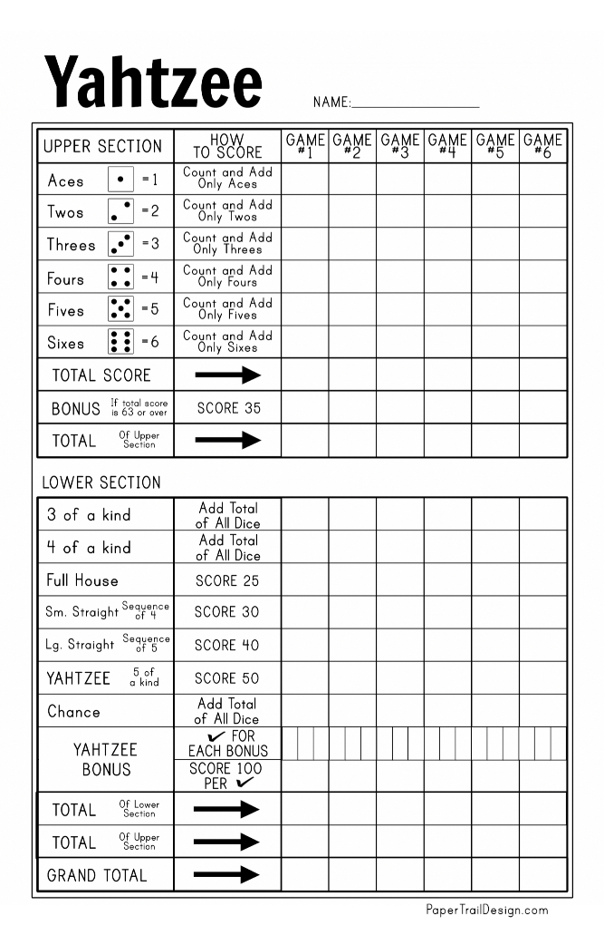

Points are scored according to the score card shown above. The score card has two distinct sections. In the upper section, points are scores as the sum of a Aces, Twos, Threes, etc. So the same roll would be worth different points depending on which section a player selected. For example, a roll of  would be worth 2 in the Twos category, but 24 in the Sixes category. A key thing to note from the Upper Section is the availability of an Upper Bonus, which is 35 points, awarded when the sum total of Upper Section points meets or exceeds 63. A quick inspection will show that this is achieved when a player scores three Aces in the Aces section (worth three points), three Twos in the Twos section (worth 6 points), etc. Of course, if a player were to score, say, 4 Fours, that would be worth 16 points, and they would be able to offset a lower score in the Aces, Twos, or Threes.

The Lower Section has Three of a Kind and Four of a Kind, which sum all the dice for eligible hands, as well as Small/Large Straight, and Full House. A Full House necessarily also qualifies for Three of a Kind, so the player will have to make a strategic decision for placement in the category.

Most notable is the namesake Yahtzee, when the player ends up with 5 of the same dice. In this case, 50 points are scored regardless of which of Aces, Twos, etc. are showing on the dice. Additionally, once a Yahtzee has been scored, and additional Yahtzee in the same game is worth 100 points, in addition to the roll being counted elsewhere in the score card. (For the purposes of this exercise we are using the Original Joker rule, which states that the Bonus Yahtzee can be used for any of the Lower Section categories, e.g., scoring 40 for Large Straight when not technically a Large Straight).

Each roll must be placed in a category, so that all categories are full at the end of a game. Once filled, a category is no longer available, so if a player elects to put a non-Yahtzee roll into Yahtzee, the player scores 0 points, and any subsequent actual Yahtzee is not eligible for the 50 points (nor are any further Bonus Yahtzees).

**Previous Optimization Work and Project Implementation / Strategy**

Strategies for Yahtzee vary for human players, and given the larger scores of the Lower Section beginner players often focus on those categories first. However, the Upper Bonus is an important element of maximizing score, so most experienced players will focus on the Upper Section first, and, for example, a roll of four 6’s would be put in the Upper Section even though it qualifies as a fairly good Four of a Kind as well.

In fact, the optimal Yahtzee strategy is known[1], though it is a little complicated. For the purposes of this project, I purposefully did not look for details on the strategy, though I did observe that the average Yahtzee score for the optimal algorithm was 254.

This project was implemented in Jupyter notebook using python. The dice were simulated by using a the package **random**, which uses a “discrete uniform” distribution, equivalent to a celing(6*uniform random(0,1)). For each round the dice are rolled. They are evaluated, in order to determine what time of results we have, and to decide which, if any, dice to re-roll. Then finally after the third roll a decision has to be made into which category to place the points. For the decision on which dice to re-roll and the decision for final category placement a logical prioritization of possibilities takes place in a waterfall logic.

I attempted four different iterations of strategies, mostly based on my experience as a Yahtzee player and intuition. I prefer Upper Section scoring to Lower Section scoring, and prefer scratching small and large straights to Yahtzee. Each iteration ran 250,000 trials, in order to converge on representative results. Iterations 2 and 3 are simple tweaks of the first iteration. But Iteration 4 was an all-out Yahtzee-or-nothing affair.

**Results**

For Iteration 1, the average score was 200, with a standard deviation of 63. The distribution is heavily skewed to the right, as the Yahtzee Bonuses pull the average up significantly. Given the large bump in score a Yahtzee provides, there is no expectation of normality in the results, though if filtered to only non-Yahtzee games the distribution, if not actually normal, is at least more symmetric. The average score seems to converge to around 200 by around 30-40k trials.

**Iteration 1: Histogram of Scores (All Games)**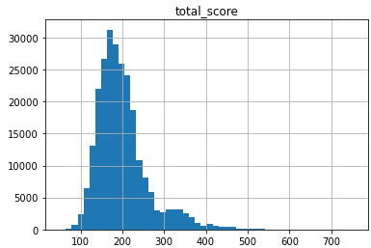

**Iteration 1: Histogram of Scores (non-Yahtzee Games)**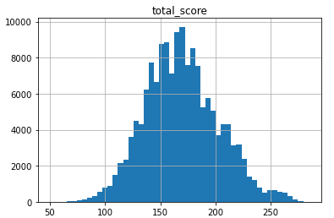

Iteration 1: Convergence of Average(Score)  
All 250 Trials (Left) – First 50k Trials (Right)

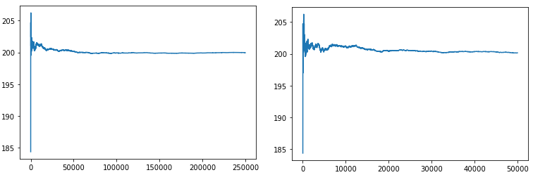

For Iteration 2, there was only one change made which pertained to Full Houses and the case when a Yahtzee roll resulted in two sets of “doubles”, e.g., . In Iteration 1 we kept the two sets of doubles and proceeded to aim for a Full House. Now in my personal experience I almost never try for a Full House, though I seem to nearly always get one along the way anyway. So, for Iteration 2, in the case of two sets of doubles, we simply keep the higher value, e.g., 5’s in the example above.

For Iteration 3, the change from Iteration 2 was kept, and the scoring of Four of a Kind was changed. In Iteration 3, an Upper Section score was preferred to Lower Section scoring. This was an attempt to increase the frequency of achieving the 35-point Upper Bonus.

For Iteration 4, most of the prior logic was discarded, and Yahtzee was the only goal.

**Table of Score Stats**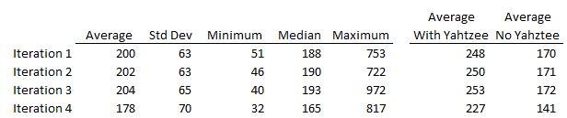

**Table of Categories Achieved** 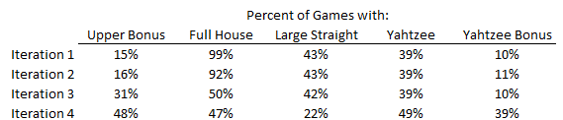

The above results basically show the intended impact of the changes made. Our baseline Iteration 1 average was 200, as mentioned. We notice that Full House is achieved 99% of the time, but the Upper Bonus is only achieved 15% of the time, with Yahtzee achieved 39% of games. The goal of Iteration two was to remove the logical statement of trying for Full Houses, which is represented in a lower achievement rate, 92%. However, as hoped, the overall average increased, though not by much. For Iteration 3, the goal was to increase the frequency of obtaining the Upper Bonus, by putting Four of a Kind in Upper Section over the Lower Section. Indeed, this was seen in the results, though the average score was not greatly moved. Interestingly, Iteration 4 did see many more Yahtzee’s. However, based on the average score for this iteration is would seem to be a decidedly worse strategy.

**Summary and Further Refinement**

Overall, the logic and simulation were successful, but fell short of nearing the optimal reported average of 254. It is unclear of the exact “Joker” rule used for Bonus Yahtzee by the optimal solution, but in any case, it does seem like refinement is needed. One clear area when the simulation code needs to improve is treating the decision of which dice to keep and which to roll again depend on which roll number is being considered. In the current state, the decision on which dice to keep depends only on the dice, and not on if the next roll is the second or third.

1. http://gunpowder.cs.loyola.edu/~jglenn/research/optimal_yahtzee.pdf