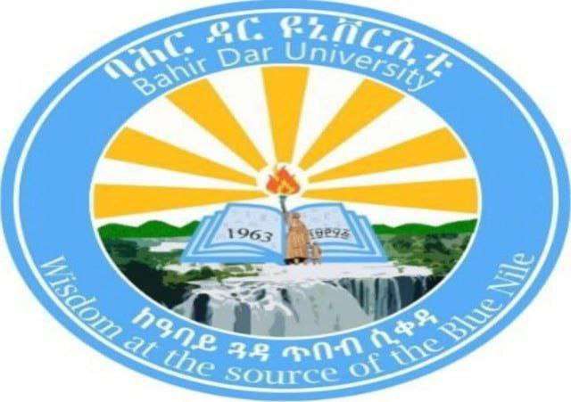
operating system project documention
INSTALLATION OF WINDOWS 2000 SERVER IN AVIRTUAL ENVIROMRNT

Name: Hilawit Assefa
Id :1601789
University: Bahir Dar University
Institute: Bahir Dar Institute of Technology
Department: Information Systems
Course: Operating Systems
Summited to:lec alemit
Summited date:06/05/17

1. Introduction

Background
An operating system (OS) is the core software that manages computer hardware and provides services for application programs. Windows 2000 Server is a network-oriented operating system developed by Microsoft, mainly used for server administration, file sharing, and domain services in earlier enterprise environments.

Motivation
Although Windows 2000 Server is outdated and no longer supported, installing it in a virtual environment helps students understand:
- Legacy operating systems
- Server-based OS architecture
- Virtualization concepts without damaging physical hardware
Using virtualization avoids hardware compatibility issues and allows safe experimentation.

2. Objectives
The objectives of this project are:
- To understand server-based operating systems
- To learn how to install an OS using virtualization tools
- To gain experience with Windows 2000 Server features
- To understand filesystem support in Windows
- To identify issues during installation and their solutions

3. Requirements

i. Hardware Requirements (Host Machine)
Component | Requirement
Processor | Intel/AMD with virtualization support
RAM | Minimum 4 GB (8 GB recommended)
Storage | At least 20 GB free disk space
System Type | 64-bit system

ii. Software Requirements
Software | Description
VMware Workstation | Virtualization tool
Windows 2000 Server ISO | Installation image
Host OS | Windows 10/11
Internet | Optional (for VMware download)

4. Installation Steps

Step 1: downloading VMware Workstation
- Go to vmware website

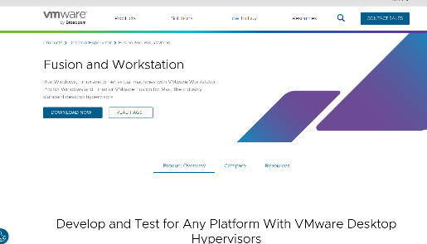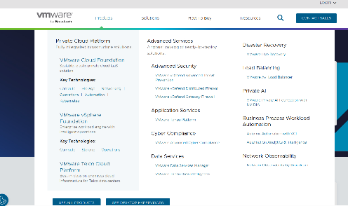

- Sign into Broadcom Account(choose Broadcom login

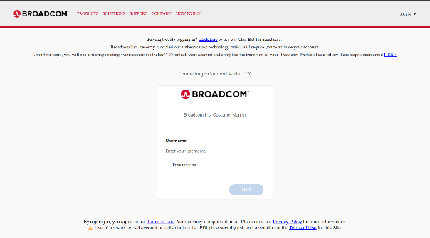

- If we don’t have an account (Sign in or register

t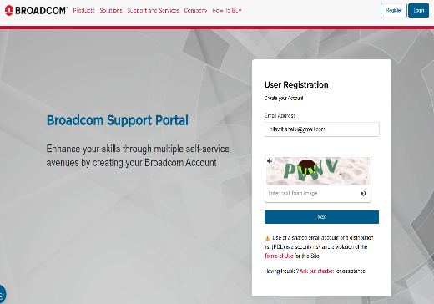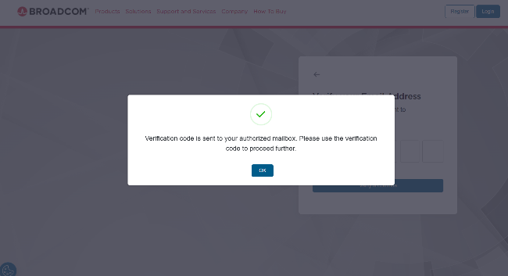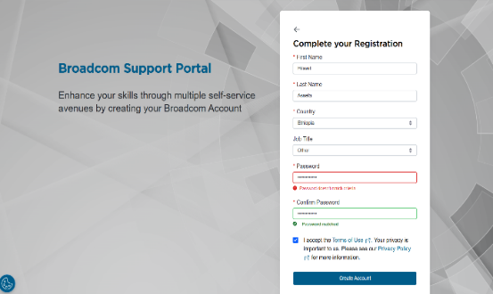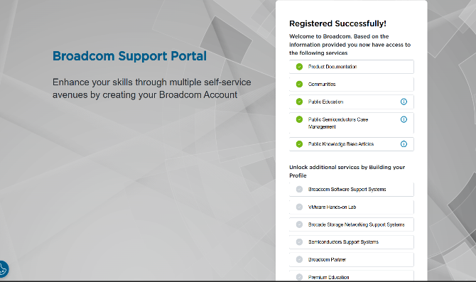

- Go to downloads (select vmware desktop hypervisor

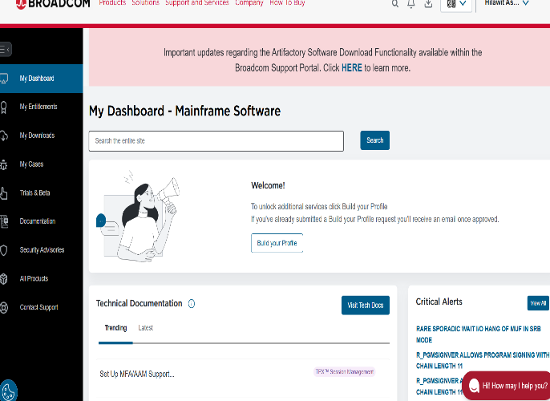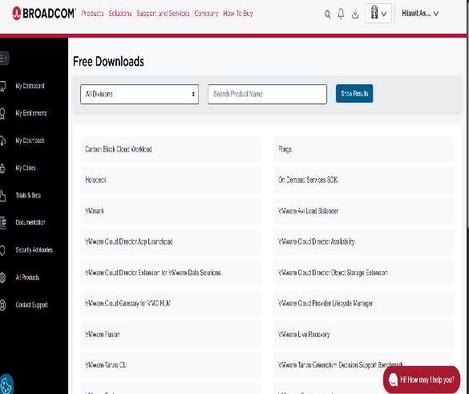

- Choose your operating system(vmware workstation pro for windows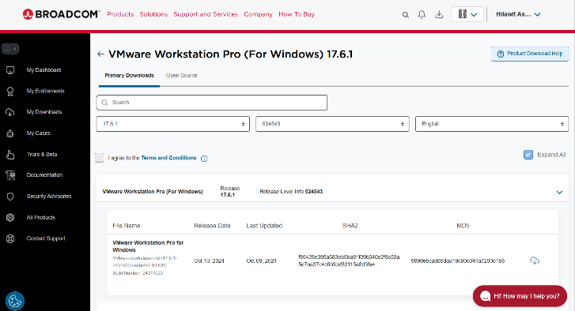

- Accept license agreements and click download button

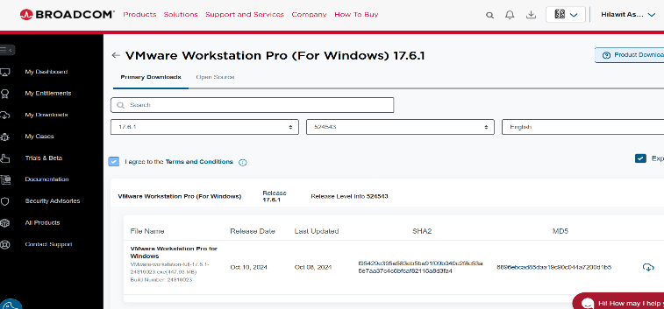

- Download start

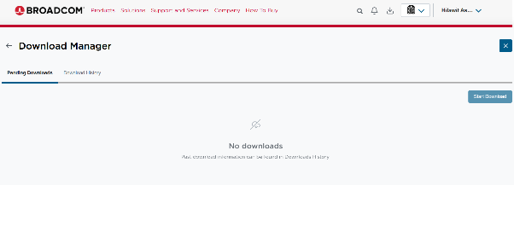

- This is all over step downloaded vmware workstation after this there is no window 2000 server file but we can assum we found it and continue this steps

Step 2: Create a New Virtual Machine
- Open VMware Workstation
- Click Create New Virtual Machine
- Choose Typical
- Select Installer disc image (ISO)
- Browse and select Windows 2000 Server ISO

Step 3: Configure Virtual Machine
- Guest OS: Microsoft Windows
- Version: Windows 2000 Server
- Name the virtual machine using your full name
- Allocate:
  - RAM: 512 MB – 1 GB
  - Disk: 10–20 GB (IDE)

Step 4: Start Installation
- Power on the virtual machine
- Windows 2000 setup loads
- Choose:
  - New installation
  - NTFS filesystem
- Follow on-screen instructions

Step 5: Complete Installation
- System restarts automatically
- Set Administrator password
- Windows 2000 Server desktop appears

- Finally this is the over all step to installing window 2000 server in vmware workstation when we find official page for downloading window 2000 server but we can’t find because of the below reason

Windows 2000 Server (and the entire Windows 2000 family) reached end of support on July 13, 2010 — over 15 years ago.
Microsoft's policy for retired products removes official downloads, ISOs, and dedicated product pages to encourage migration to supported versions and avoid security risks from unsupported software. As a result, no official Microsoft page provides installation media or direct downloads today.
For VMware installation, users typically rely on archived ISOs from community sources (like WinWorld or Internet Archive), but these are unofficial — ensure you have a valid license key if required.

5. Issues (Problems Faced)
- ISO not detected by VMware
- Black screen during boot
- Unsupported hardware warning
- Mouse and display lag
- There is no official page for installation window 2000 server

6. Solutions
Problem | Solution
ISO not detected | Re-select ISO file correctly
Black screen | Use IDE disk instead of SATA
Hardware warning | Ignore and continue installation
Mouse lag  There is no official page | Install VMware Tools  Use another version to replace this(like window 2022 server)

7. Filesystem Support

Supported Filesystems in Windows 2000 Server
Filesystem | Supported | Reason
NTFS | ✅ Yes | Secure, journaling, permissions
FAT32 | ✅ Yes | Compatibility
exFAT | ❌ No | Introduced later
ext4 | ❌ No | Linux filesystem
Btrfs | ❌ No | Not Windows-based
ZFS | ❌ No | Unix-based
HFS+ | ❌ No | Apple filesystem
APFS | ❌ No | Apple filesystem
Preferred Filesystem: NTFS
Reason: Supports security, encryption, large files, and stability.

8. Advantages and Disadvantages

Advantages
- Stable server OS
- Supports Active Directory
- Good for learning legacy systems
- Lightweight compared to modern OS

Disadvantages
- No longer supported (No LTS)
- Security vulnerabilities
- No modern hardware support
- Limited software compatibility

9. Conclusion
In this project, Windows 2000 Server was successfully installed using VMware Workstation. But we not found the official page to download window 2000 server so I can’t put it practical installation step but put it theoretically .The project helped in understanding virtualization, server OS installation, filesystem concepts, and troubleshooting installation issues. Despite being outdated, Windows 2000 Server remains useful for educational purposes.

10. Future Outlook / Recommendation
- Use modern server OS like Windows Server 2019 or Linux Server
- Avoid using Windows 2000 in real environments
- Use virtualization for learning and testing legacy systems
- Focus on security-supported operating systems

11. Virtualization in Modern Operating Systems

What is Virtualization?
Virtualization is the process of running multiple operating systems on a single physical machine using virtual machines.

Why Virtualization?
- Saves hardware cost
- Safe testing environment
- Easy backup and recovery
- Supports legacy OS installation

How Virtualization Works
A hypervisor (like VMware) sits between hardware and OS, allocating resources to virtual machines.

REFERENCE
1.Chatgpt.com
2.google
3.Grok.com

