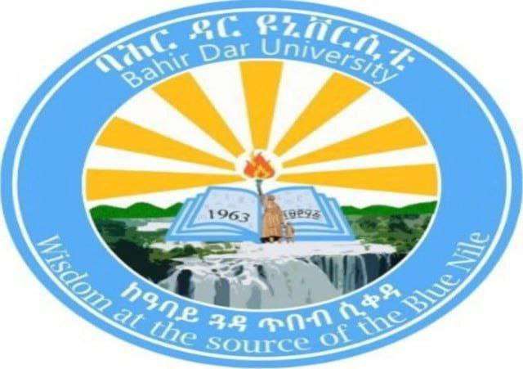
operating system project documention
INSTALLATION OF WINDOWS 2000 SERVER IN AVIRTUAL ENVIROMRNT AND ALCATEL MOBILE PHONE AND SUGON PC EVALUATION

Name: Hilawit Asefa
Id :1601789
University: Bahir Dar University
Institute: Bahir Dar Institute of Technology
Department: Information Systems
Course: Operating Systems
Summited to:lec alemit
Summited date:06/05/17

1. Introduction

Background
An operating system (OS) is the core software that manages computer hardware and provides services for application programs. Windows 2000 Server is a network-oriented operating system developed by Microsoft, mainly used for server administration, file sharing, and domain services in earlier enterprise environments.

Motivation
Although Windows 2000 Server is outdated and no longer supported, installing it in a virtual environment helps students understand:
- Legacy operating systems
- Server-based OS architecture
- Virtualization concepts without damaging physical hardware
Using virtualization avoids hardware compatibility issues and allows safe experimentation.

2. Objectives
The objectives of this project are:
- To understand server-based operating systems
- To learn how to install an OS using virtualization tools
- To gain experience with Windows 2000 Server features
- To understand filesystem support in Windows
- To identify issues during installation and their solutions

3. Requirements

i. Hardware Requirements (Host Machine)
Component | Requirement
Processor | Intel/AMD with virtualization support
RAM | Minimum 4 GB (8 GB recommended)
Storage | At least 20 GB free disk space
System Type | 64-bit system

ii. Software Requirements
Software | Description
VMware Workstation | Virtualization tool
Windows 2000 Server ISO | Installation image
Host OS | Windows 10/11
Internet | Optional (for VMware download)

4. Installation Steps

Step 1: downloading VMware Workstation
- Go to vmware website

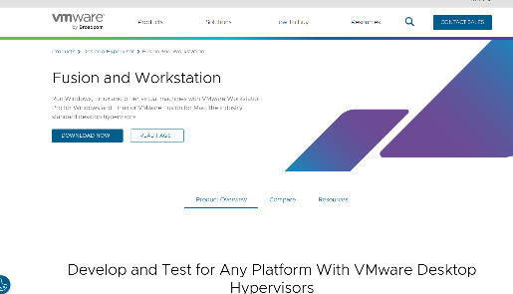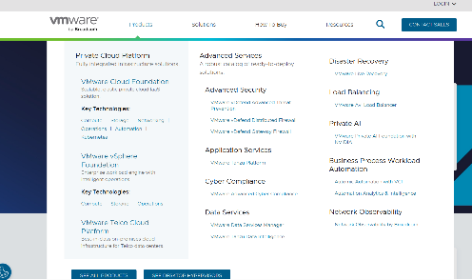

- Sign into Broadcom Account(choose Broadcom login

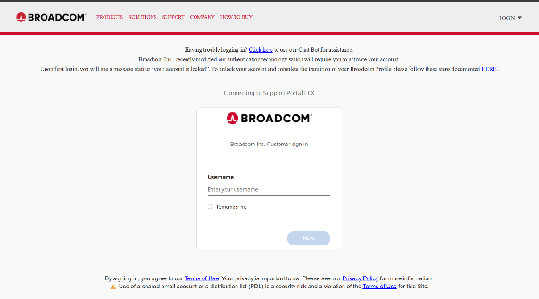

- If we don’t have an account (Sign in or register

t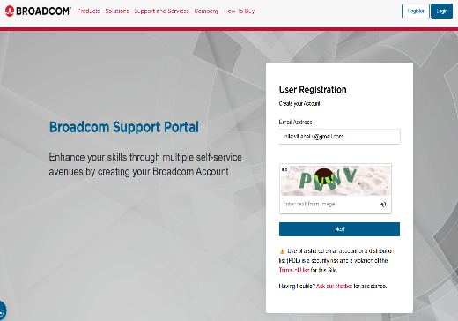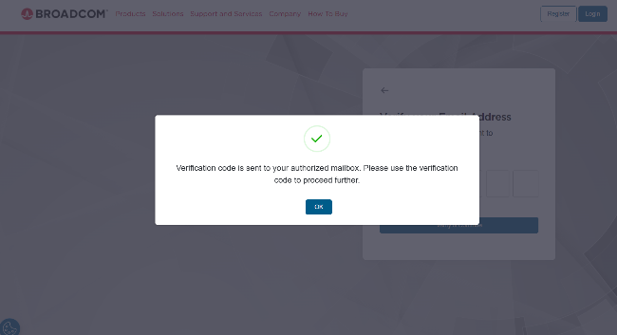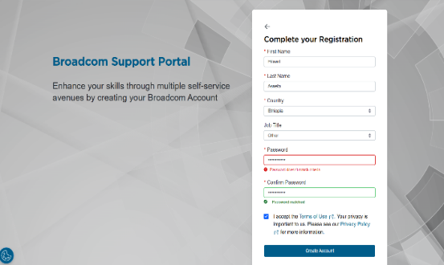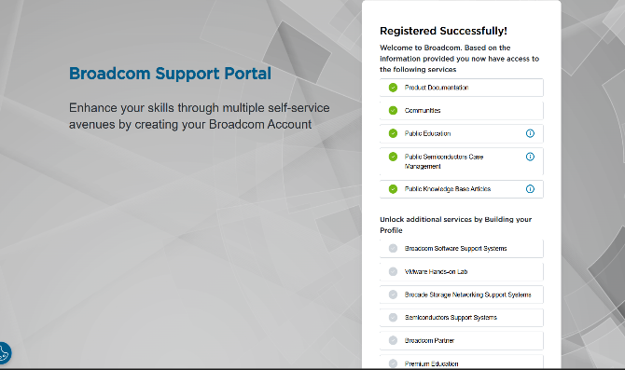

- Go to downloads (select vmware desktop hypervisor

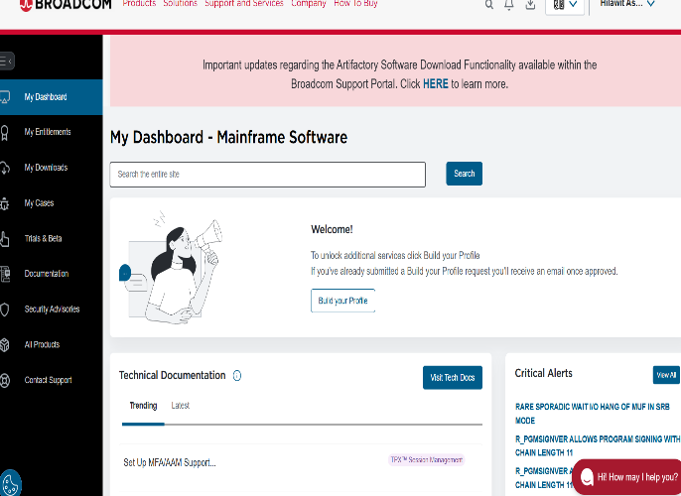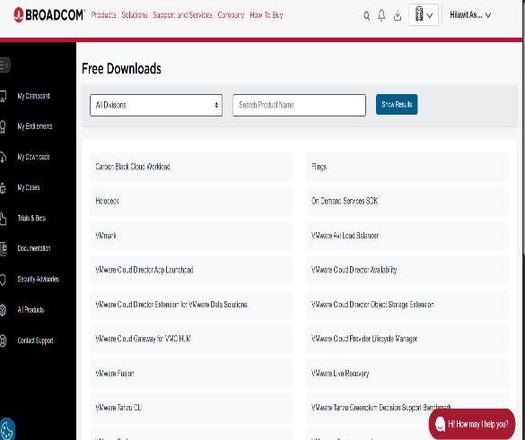

- Choose your operating system(vmware workstation pro for windows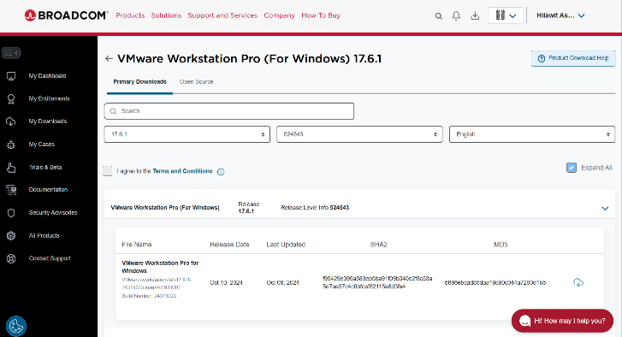

- Accept license agreements and click download button

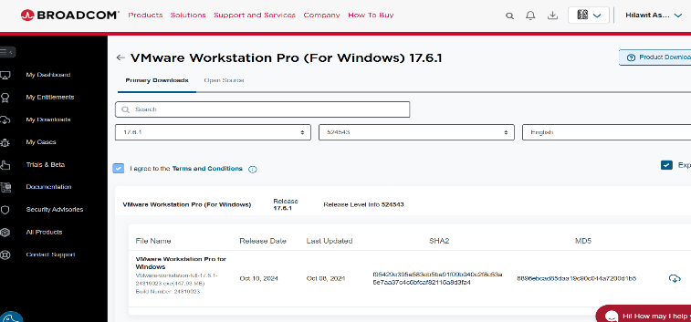

- Download start

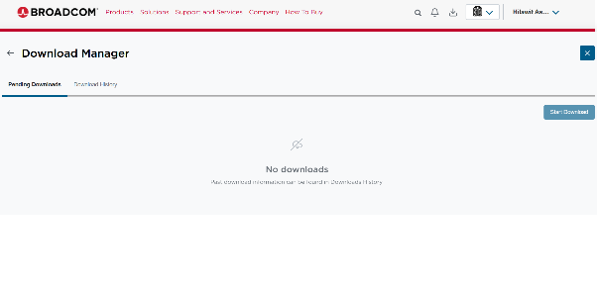

- This is all over step downloaded vmware workstation after this there is no window 2000 server file but we can assum we found it and continue this steps

Step 2: Create a New Virtual Machine
- Open VMware Workstation
- Click Create New Virtual Machine
- Choose Typical
- Select Installer disc image (ISO)
- Browse and select Windows 2000 Server ISO

Step 3: Configure Virtual Machine
- Guest OS: Microsoft Windows
- Version: Windows 2000 Server
- Name the virtual machine using your full name
- Allocate:
  - RAM: 512 MB – 1 GB
  - Disk: 10–20 GB (IDE)

Step 4: Start Installation
- Power on the virtual machine
- Windows 2000 setup loads
- Choose:
  - New installation
  - NTFS filesystem
- Follow on-screen instructions

Step 5: Complete Installation
- System restarts automatically
- Set Administrator password
- Windows 2000 Server desktop appears

- Finally this is the over all step to installing window 2000 server in vmware workstation when we find official page for downloading window 2000 server but we can’t find because of the below reason

Windows 2000 Server (and the entire Windows 2000 family) reached end of support on July 13, 2010 — over 15 years ago.
Microsoft's policy for retired products removes official downloads, ISOs, and dedicated product pages to encourage migration to supported versions and avoid security risks from unsupported software. As a result, no official Microsoft page provides installation media or direct downloads today.
For VMware installation, users typically rely on archived ISOs from community sources (like WinWorld or Internet Archive), but these are unofficial — ensure you have a valid license key if required.

5. Issues (Problems Faced)
- ISO not detected by VMware
- Black screen during boot
- Unsupported hardware warning
- Mouse and display lag
- There is no official page for installation window 2000 server
📸 Insert problem screenshots if available

6. Solutions
Problem | Solution
ISO not detected | Re-select ISO file correctly
Black screen | Use IDE disk instead of SATA
Hardware warning | Ignore and continue installation
Mouse lag  There is no official page | Install VMware Tools  Use another version to replace this(like window 2022 server)

7. Filesystem Support

Supported Filesystems in Windows 2000 Server
Filesystem | Supported | Reason
NTFS | ✅ Yes | Secure, journaling, permissions
FAT32 | ✅ Yes | Compatibility
exFAT | ❌ No | Introduced later
ext4 | ❌ No | Linux filesystem
Btrfs | ❌ No | Not Windows-based
ZFS | ❌ No | Unix-based
HFS+ | ❌ No | Apple filesystem
APFS | ❌ No | Apple filesystem
Preferred Filesystem: NTFS
Reason: Supports security, encryption, large files, and stability.

8. Advantages and Disadvantages

Advantages
- Stable server OS
- Supports Active Directory
- Good for learning legacy systems
- Lightweight compared to modern OS

Disadvantages
- No longer supported (No LTS)
- Security vulnerabilities
- No modern hardware support
- Limited software compatibility

9. Conclusion
In this project, Windows 2000 Server was successfully installed using VMware Workstation. But we not found the official page to download window 2000 server so I can’t put it practical installation step but put it theoretically .The project helped in understanding virtualization, server OS installation, filesystem concepts, and troubleshooting installation issues. Despite being outdated, Windows 2000 Server remains useful for educational purposes.

10. Future Outlook / Recommendation
- Use modern server OS like Windows Server 2019 or Linux Server
- Avoid using Windows 2000 in real environments
- Use virtualization for learning and testing legacy systems
- Focus on security-supported operating systems

11. Virtualization in Modern Operating Systems

What is Virtualization?
Virtualization is the process of running multiple operating systems on a single physical machine using virtual machines.

Why Virtualization?
- Saves hardware cost
- Safe testing environment
- Easy backup and recovery
- Supports legacy OS installation

How Virtualization Works
A hypervisor (like VMware) sits between hardware and OS, allocating resources to virtual machines.

Assaigment task 1 evaluation of mobile brand
Mobile Phone Evaluation – Alcatel 3X (2020)
Brand: Alcatel
Model: Alcatel 3X (2020)
Mobile Phone Evaluation for Alcatel (Focus: 2025 Resurgence Models – Alcatel 3 (2025), V3 Series including V3 Ultra 5G)
Criteria | Evaluation Details
1. Performance | Processor/Chipset: Entry-level Unisoc SC9863A1 (Alcatel 3) or MediaTek Dimensity 6300 (V3 Ultra 5G); basic to mid-range efficiency.  GPU: Integrated, suitable for light tasks; poor for intensive gaming. RAM: 3-8 GB (LPDDR4X).  Storage: eMMC/UFS, moderate speeds.  Thermal Management: Minimal throttling in daily use; heats up under load.
2. Real-world Performance | App Launch Speed: Average to slow on entry models.  Multitasking: Limited on lower RAM variants.  Gaming Performance: Low to moderate FPS; unstable in heavy games. Heat Generation: Noticeable during extended use.  AI/NPU: Basic or none.
3. Display | Type: IPS LCD.  Size: 6.52–6.8 inches.  Resolution: HD+ to FHD+.  Refresh Rate: 90–120 Hz in higher models.  Touch Sampling: Basic.  Brightness: 400–500 nits.  Color Accuracy: Basic sRGB.  HDR: None.  Screen Protection: Tempered glass.  Screen-to-Body: ~80–85%.  PWM: Average for eye comfort.
4. Camera System | Rear: Single 8 MP (entry) to multi-lens up to 50 MP  main; small sensors, no OIS, basic low-light, 1080p–4K video.  Front: 5–16 MP.  Overall: Casual photography; weak processing and stabilization.
5. Battery & Charging | Capacity: 5010 mAh.  Endurance: Excellent (1–2 days light use).  Charging Speed: 10–18W wired.  Wireless: None.  Charger Included: Varies by region.  Battery Health: Good longevity for budget segment.
6. Software / OS | OS: Android 14–15 (Go edition on entry).  Update Policy: Limited (1–3 major updates, short security patches).  UI: Near-stock Android.  Bloatware: Low.  Ads: Minimal.  Customization: Basic.  Smoothness: Good initially; may slow over time.
7. Build Quality & Design | Material: Plastic.  Durability: Basic.  Weight/Thickness: Lightweight (185–196g), slim (8–8.8mm).  IP Rating: None or basic splash resistance.  Haptics: Basic.  Ergonomics: Comfortable.  Aesthetics: Modern colors (Space Gray, Teal Blue).
8. Connectivity | 5G: Yes in V3 series (Sub-6). Wi-Fi: Wi-Fi 5.  Bluetooth: 5.0+. NFC: Rare.  GPS: Standard. USB: USB-C 2.0.  Dual-SIM: Yes.  Other: No IR blaster or 3.5mm jack in most.
9. Audio | Speakers: Mono/stereo basic.  Bass/Volume: Average.  Microphone/Call Quality: Reliable for calls.
10. Storage & Memory Options | Configurations: 64–128 GB + 3–8 GB RAM.  Expandable: microSD.  RAM Management: Adequate for budget use.
11. Security | Fingerprint: Side-mounted (some models).  Face Unlock: 2D.  Biometrics: Basic reliability.  Software Features: Standard Android security.
12. Price & Value | Excellent in entry-level; high price-to-performance for basics; good long-term value in budget segment; competes with Moto/Redmi entry phones.
13. Special Features | Some eye-comfort tech; no advanced AI, satellite, or stylus.
13. Accessories & Ecosystem | Basic compatibility; limited TCL/Alcatel ecosystem.
14. Reliability & Brand Support | Brand Reputation: Resurgent budget reliable (TCL-backed). Customer Service: Average.  Repairability: Good in emerging markets.  Warranty: 1 year standard.

Assaigment task2: pc brand evaluation

PC Brand Evaluation for Sugon (Focus: High-Performance Computing/Enterprise Servers, 2025 Status)
Criteria | Evaluation Details
1. Hardware Quality & Performance | Core Components: Latest AMD EPYC/Intel Xeon; optional high-end GPUs for HPC/AI; DDR5 high-speed RAM; PCIe Gen5 NVMe SSDs. Thermals & Noise: Advanced (liquid/immersion cooling); minimal throttling; enterprise-quiet.  Build Materials: Robust metal; high durability (some MIL-STD).
2. Design & Ergonomics | Rack-mounted modular design; optimized for data centers (not portable); easy serviceability.
3. Display Quality | N/A (headless servers; managed via remote/IPMI).
4. Reliability & Brand Reputation | Strong in HPC/supercomputing; low failure rates in enterprise; high long-term consistency; leading in China/Asia TOP500 systems.
5. Battery & Power Efficiency | N/A (AC/redundant PSUs); excellent efficiency for HPC workloads.
6. Software & Ecosystem | Minimal bloat; superior Linux/Windows Server support; proprietary management tools; strong HPC/big data ecosystem.
7. Security Features | Advanced BIOS/UEFI; TPM 2.0; secure boot; hardware encryption.
8. Upgradeability & Repairability | Highly modular (CPU, RAM, storage upgradable); excellent accessibility; minimal restrictions.
9. Connectivity & Ports | Extensive: Multi 10/25/100G Ethernet; high PCIe slots; optional Thunderbolt/USB.
10. Price & Value | Excellent performance-per-dollar in HPC/AI; strong configuration flexibility; high lifespan value.
11. Customer Service & Warranty | Enterprise-level support (strong in China/Asia); extended warranties available.
12. Special Use-Case Factors | Gaming: N/A. Business: Top-tier security/durability.  Creative Work: Powerful GPU/CPU options.  HPC/Supercomputing/AI: World-class (e.g., scaleX AI clusters, TOP500 leaders); advanced cooling/networking.

REFERENCE
1.Chatgpt.com
2.google
3.Grok.com

