


Grant Agreement number: 233758
Project acronym: e-Freight
Project title: European e-Freight capabilities for Co-modal transport
Funding Scheme: Sustainable surface transport, Large-scale integrating project

D2.4/D2.5 - e-Freight Semantic Registry and Repository / e-Freight SESA Platform

Due date of deliverable: 31/07/11
Actual submission date: DD/MM/YY

Start date of project: 01/01/2010 Duration: 42M

Organisation name of lead contractor for this deliverable: UIBK

Revision [draft, v0.2]
Project co-funded by the European Commission within the Seventh Framework Programme (2007-2013)
Dissemination Level
PU | Public | ☑
PP | Restricted to other programme participants (including the Commission Services)
RE | Restricted to a group specified by the consortium (including the Commission Services)
CO | Confidential, only for members of the consortium (including the Commission Services)

Contents
1. Executive Summary 3
2. Introduction 4
3. Semantic Web Services 5
3.1 Goals and Approaches 5
3.2 SAWSDL 5
3.3 WSMO-Lite 6
4. e-Freight Service Model 8
5. e-Freight SESA Architecture Design 16
5.1 Overview 16
5.2 Repository 16
5.3 Management Component 17
5.4 Registration Component 17
5.5 Discovery Component 17
5.6 Invocation Component (Invoker) 17
5.7 Evolution 18
6. Prototype Implementation 19
7. Conclusions 20
8. References 21

Executive Summary
Davide

Introduction
Davide

Semantic Web Services

Goals and Approaches
The Web service technology stack allows exchanging messages between Web services (SOAP), describing the technical interface for consuming a Web service (WSDL), and advertising Web services in registries (UDDI). However, in traditional Web service implementations, the lack of information to express the meaning of the data and of the vocabulary referenced by the interface, as well as the lack of formalisation of the Web service behaviour, implies the requirement of human intervention in tasks such as Web service discovery, composition, ranking and selection, thus severely hindering the automation of the envisioned tasks.

The emergence of the semantic Web envisions an extension of the current Web in which information is given well defined meaning, thus better enabling computers and people to work in cooperation. This meaning is represented by the structured collections of information and sets of inference rules that can be used by machines to conduct automated reasoning. The same formalisation techniques can form a foundation to introduce semantics to Web service architectures.

Semantic Web services (SWS) aim at providing more sophisticated Web service technologies along with support for the semantic Web. SWS utilise ontologies as the underlying data model in order to support semantic interoperability between Web services and clients, and apply semantically enabled automated mechanisms that span the whole SWS usage lifecycle, comprising discovery, selection, composition, mediation, negotiation, and execution of Web services. More generally, the introduction of semantics as an extension of Service-Oriented Architectures, and thus the creation of Semantically Enabled Service Oriented Architectures (SESAs), provides for next generation of service-oriented computing based on machine-processable semantics. The advantages of SWS stem from the fact that explicit, formal semantics is associated with the Web service description, and that the execution environment for SWS is able to interpret and use this semantics appropriately. This supports direct understanding of the Web service functionality at design as well as at run time.

The earliest approaches to SWS are the so-called top-down approaches, such as OWL-S [OWL-S] and WSMO [WSMO]. Following these approaches, the designer starts with a high-level conceptualisation of all the knowledge related to the services (using ontologies), and then “grounds” it down to actual services. These are also called “heavyweight” approaches, as they provide powerful but very complex frameworks, based on logics, to describe Web services. Such complexity, however, proved to be too high and often unneeded, and together with the difficulty of applying a top-down design to real Web service usage scenarios determined the failure of such approaches. To address these issues, “lightweight” approaches emerged, based on more lightweight semantics, which provide less ambitious automation capabilities but offer a simpler, bottom-up, approach based on semantically annotating current Web service descriptions (i.e. WSDL). In e-Freight we follow a lightweight approach based on SAWSDL and WSMO-Lite, which we briefly introduce in the next sections.

SAWSDL
The Web Services Description Language (WSDL) [WSDL-core][WSDL-adj] specifies a way to describe the abstract functionalities of a Web service, and concretely how and where to invoke it. WSDL descriptions do not however include any semantics; therefore, two services can have similar descriptions while meaning different things, or very different descriptions yet similar meaning. Resolving such ambiguities in Web service descriptions is a fundamental step towards automating the discovery and composition of Web services.

SAWSDL (Semantic Annotations for WSDL and XML Schema) [SAWSDL] is a W3C Recommendation that defines mechanisms using which semantic annotations can be added to WSDL descriptions, referencing concepts in semantic models (e.g. ontologies). SAWSDL enables semantic annotations for Web services not only for discovering Web services but also for invoking them, giving the possibility to reference lifting and lowering schema mappings (i.e. transformations between the conceptual representation and the syntactical representation). SAWSDL does not specify or mandate a specific language for representing semantic models, so any suitable language could be used (e.g. OWL, RDFS).

In order to enable semantic annotations of WSDL components, SAWSDL defines three new attributes that can be added to WSDL elements:
one attribute, named modelReference, to specify the association between a WSDL component and a concept in some semantic model. This modelReference attribute can be used especially to annotate XML Schema type definitions, element declarations, and attribute declarations as well as WSDL interfaces, operations, and faults.
two attributes, named liftingSchemaMapping and loweringSchemaMapping, that are added to XML Schema element declarations and type definitions for specifying mappings between semantic data and XML. These mappings can be used during service invocation.

WSMO-Lite
SAWSDL provides the grounds for a bottom-up approach to semantic Web service modelling: it supports the idea of adding small increments (and complexity) on top of WSDL, allowing results from various existing approaches to be adopted. As the basis for bottom-up modelling, SAWSDL is independent of any particular semantic technology, i.e., it does not define any types, forms or languages for semantic descriptions. The WSMO-Lite service ontology [WSMO-Lite] fills the SAWSDL annotations with concrete semantic Web service descriptions.

A WSMO-Lite description contains three parts:
the information model, represented using a domain ontology;
functional descriptions, which can have two components: classifications, which link to a functional taxonomy via a concrete root class, and capabilities, which express the (pre)conditions and effects of the services and of their operations;
non-functional descriptions, used to formalise non-functional properties (e.g. policies).

WSMO-Lite descriptions are serialised in RDF [RDF], and can thus be stored in RDF repositories (triplestores). Figure 1 shows the relationship between WSDL, SAWSDL, and WSMO-Lite.

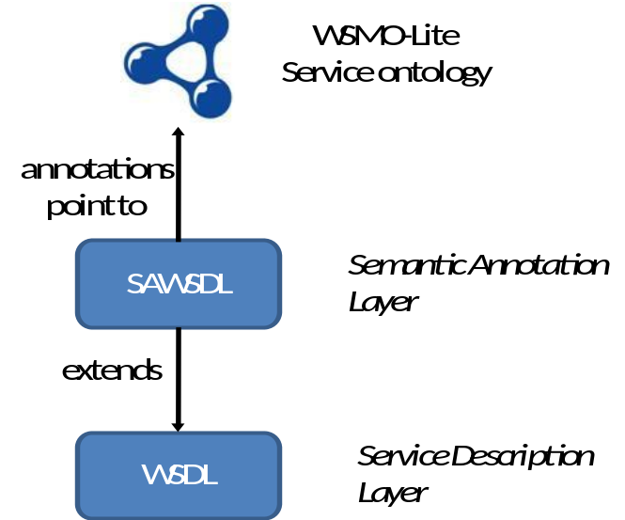

Figure 1: Relationship between WSDL, SAWSDL, and WSMO-Lite

e-Freight Service Model

The SESA platform is used in combination with a service model that enables the semantic representation of Web Services. As the framework deals with a variety of services offered by different authorities all over Europe, the model has to support various types of services (e.g. WSDL) as well as different levels of abstraction. Rather than building such a model from scratch, major components of two already in-use models, that serve as quasi standards, can be reused and combined in a fruitful and consistent manner.

The remainder of this section is organized as follows: In section 4.1 and 4.2, we introduce two state-of-the-art service models of which both are widely in use and suit the complexity of the task to integrate a variety of e-Freight authority services. In section 4.3 it is shown how both of these models can be used by combining them taking into account minor modifications. As explained in section 3, we use annotated service descriptions in order to align the different inputs and outputs of the authorities’ services with our data model (the domain ontology). These annotations also need to be considered by our service model. Therefore, in section 4.4, we provide an example of how an e-Freight service can be annotated with the domain ontology.

WSDL RDF Mapping (WSDL-RDF)

The WSDL 2.0 RDF Mapping is a W3C Working Group Note of 26th of June 2007. The document can generally be understood as a guide on how to transform a WSDL file into a predefined vocabulary. The creation of this vocabulary was aligned with the definitions of the WSDL 2.0 specification and can therefore be considered as a one to one match between the WSDL XML definitions. In the following example, we demonstrate this match on the WSDL Interface Operation Component:

<description>
....
<interface name="ngsw:submissionInterface">
....
<operation>
name="ngsw:submitInformation">
<input messageLabel="ngsw:information">
</input>
</operation>
....
</interface>
....
</description>
Listing 1: Example for a WSDL Interface Operation.

The transformation to WSDL-RDF results in the following triples:

<#wsdl.description()> a wsdl:Description ;
wsdl:interface <#wsdl.interface(submissionInterface)> .

<#wsdl.interface(submissionInterface)> a wsdl:Interface ;
rdfs:label “submissionInterface” ;
wsdl:interfaceOperation <#wsdl.interfaceOperation(submitInformation)> .

< #wsdl.interfaceOperation(submitInformation)> a wsdl:InterfaceOperation ;
rdfs:label "submitInformation" ;
wsdl:interfaceMessageReference <#wsdl.interfaceMessageReference(information)> .

<#wsdl.interfaceMessageReference(information)> a
wsdl:InterfaceMessageReference ,
wsdl:InputMessage ;
wsdl:messageLabel <ngsw:information> .

Listing 2: RDF representation of the example shown in Listing 1.

The WSDL-RDF model reflects each component of WSDL 2.0 either as a class or a property. The source of the ontology can be found in the appendix A of the WSDL-RDF specification.

WSDL-RDF can be considered as a candidate for the SESA implementation as it maps all relevant WSDL specific details to RDF. This enables WSDL service management, registration, discovery, and invocation with only making this one transformation. A drawback of WSDL-RDF is that it only supports WSDL services.

Minimal Service Model (MSM)

The Minimal Service Model (MSM) is best introduced by citing its developers:

“The Minimal Service Model provides a simple common ground for describing both WSDL services and Web APIs in RDF in a way such that it can be directly used by developers for simple service matchmaking based on SPARQL.”

The ability to handle services that work on a Web API basis (such as RESTful Web services) as well as services specified in WSDL files provides high interoperability through abstraction. The model, shown in Figure 2, includes several semantic web service vocabularies that are explained in section 3 (i.e. SAWSDL and WSMO-Lite). Each service description in MSM also includes a link to the actual Web service (rdfs:isDefinedBy, rdfs:seeAlso) that enables access and invocation. MSM has been developed for the service platform iServe that publishes different kinds of service descriptions publically and unified through MSM RDF descriptions. The published data is added to the Linking Open Data Cloud. This service platform increases the visibility of different Web services and can also help to position the e-Freight services in public.

Unfortunately, the earlier mentioned abstraction of MSM also comes with losing the capability to search for service-type-specific features. In the case of having mostly WSDL services, employing only the MSM model obviates the search for invocation specific attributes of WSDL services. Therefore, in the next section we introduce a merging of the MSM and WSDL-RDF (cf. section 4.1).

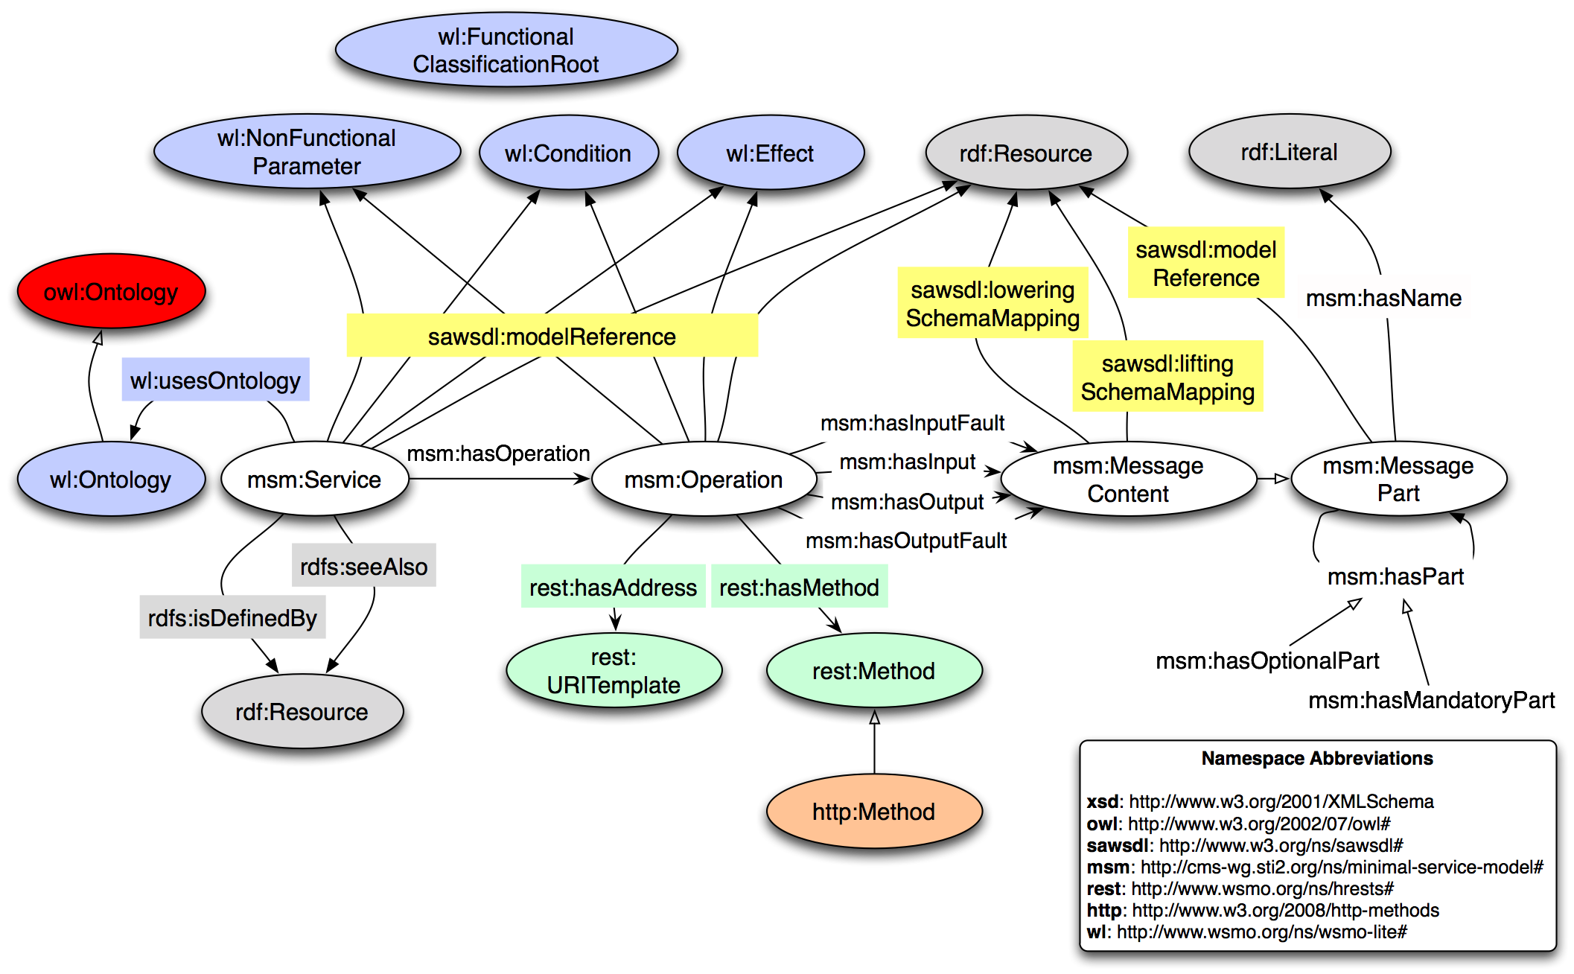
Figure 2: Diagram visualizing the Minimal Service Model.

Merging WSDL-RDF and MSM

Both, WSDL-RDF and MSM support modelling of annotated e-Freight authority services in RDF. In both models, there are concepts for services, operations and messages. It is possible to introduce a subclass relationship between different components of WSDL-RDF and MSM as the latter refers to the parts of a Web service on a more abstract level. Subclassing with RDFS means that every instance of the more special class is also an instance of the more general class. Applied to our case, where wsdl-rdf:interfaceOperation is a subclass of msm:Operation, this means that every instance of wsdl-rdf:interfaceOperation is also an instance of msm:Operation.

In the MSM, the distinction between input and output messages is modelled as properties. In WSDL-RDF this is done by using classes instead of properties. Therefore, the mapping of the property wsdl-rdf:interfaceMessageReference to msm:hasInput and msm:hasOutput as well as the relation of wsdl-rdf:interfaceFaultReference to msm:hasInputFault and msm:hasOutputFault imply minor modifications on MSM: For our purposes, we omit the four properties msm:hasInput, msm:hasOutput, msm:hasInputFault, and msm:hasOutputFault and use two new classes, #Input and #Output instead. Moreover, we introduce a new property called #hasMessageContent. To these classes and properties, we draw subclass/subproperty relationships from the relevant classes of WSDL-RDF as shown in Figure 3.

For the full RDF-XML representation of this service model and its extensions/modifications, the interested reader is referred to section 8 (appendix).

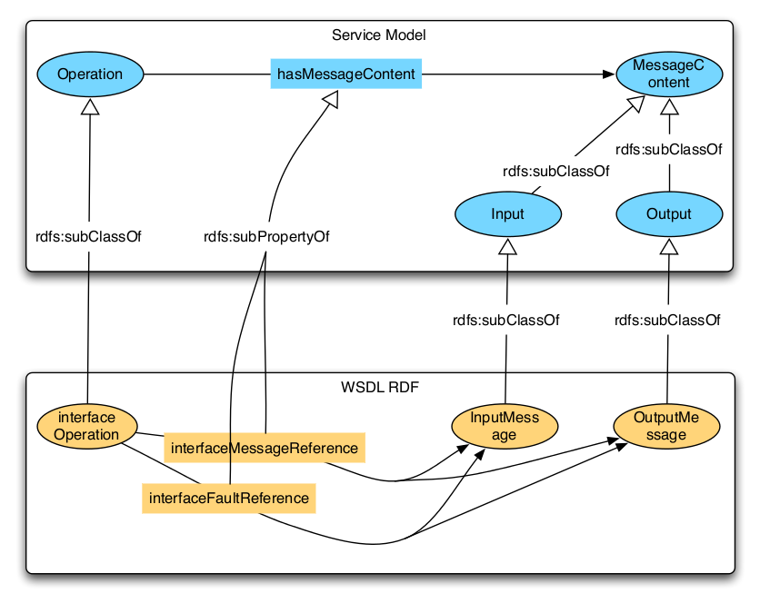
Figure 3: The match between the WSDL RDF mapping and the Minimum Service Model.

Example: Service Annotation

In the following, you can find an example for the annotation of an e-Freight service. For the annotation we used an ontology that was automatically extracted from the FAL forms, as the extracted version of the Single Window Datamodel was not available at the date of writing.

...
<wsdl:portType name="ISubmissionService" sawsdl:modelReference="http://efreightproject.eu/ontologies/ServiceCategories#Maritime">
...
Listing 3: Category annotation for a e-Freight WSDL 1.1 service.

...
<xs:element name="GetPendingBerthAuthorisations" sawsdl:modelReference="http://efreightproject.eu/ontologies/FAL.owl#Port" sawsdl:loweringSchemaMapping="PortLowering.xml">
<xs:complexType>
<xs:sequence>
<xs:element minOccurs="0" name="portCode" nillable="true" type="xs:string"/>
</xs:sequence>
</xs:complexType>
</xs:element>
<xs:element name="GetPendingBerthAuthorisationsResponse" sawsdl:modelReference="http://efreightproject.eu/ontologies/FAL.owl#WorkItem" sawsdl:liftingSchemaMapping="WorkItemLifting.xslt">
<xs:complexType>
<xs:sequence>
<xs:element minOccurs="0" name="GetPendingBerthAuthorisationsResult" nillable="true" type="q2:ArrayOfF1forBerthAuthorisationListItem" xmlns:q2="http://schemas.datacontract.org/2004/07/MSW.DAL"/>
</xs:sequence>
</xs:complexType>
</xs:element>
...
Listing 4: Annotated e-Freight WSDL messages.

PortLowering.xml
<lowering>
<sparqlQuery>
PREFIX fal: &lt;http://efreightproject.eu/ontologies/FAL.owl#&gt;
SELECT ?portCode
WHERE {
?port a fal:Port ;
fal:hasPortCode ?portCode.
}
</sparqlQuery>
<xsl:transform version="2.0"
xmlns:po="http://www.w3.org/2002/ws/sawsdl/spec/wsdl/order#"
xmlns:xsl="http://www.w3.org/1999/XSL/Transform"
xmlns:sp="http://www.w3.org/2005/sparql-results#"
xmlns:tns="http://tempuri.org/">
<xsl:output method="xml" version="1.0" encoding="iso-8859-1" indent="yes" />
<xsl:template match="/sp:sparql">
<tns:GetPendingBerthAuthorisations>
<xsl:apply-templates select="sp:results/sp:result" />
</tns:GetPendingBerthAuthorisations>
</xsl:template>
<xsl:template match="sp:result">
<tns:portCode><xsl:value-of select="sp:binding[@name='portCode']" /></tns:portCode>
</xsl:template>
</xsl:transform>
</lowering>
Listing 5: Lowering of “GetPendingBerthAuthorisations”.

WorkItemLifting.xslt
<?xml version='1.0' ?>
<xsl:transform version="2.0"
xmlns:xsl="http://www.w3.org/1999/XSL/Transform"
xmlns:rdf="http://www.w3.org/1999/02/22-rdf-syntax-ns#"
xmlns:fal="http://efreightproject.eu/ontologies/FAL.owl#"
xmlns:tns="http://tempuri.org/">
<xsl:output method="xml" version="1.0" encoding="iso-8859-1" indent="yes" />
<xsl:template match="tns:GetPendingBerthAuthorisationsResponse">
<rdf:RDF>
<xsl:apply-templates select="tns:GetPendingBerthAuthorisationsResult" />
</rdf:RDF>
</xsl:template>
<xsl:template match="tns:GetPendingBerthAuthorisationsResult">
<fal:WorkItem>
<fal:hasWorkItemId rdf:datatype="http://www.w3.org/2001/XMLSchema#string">
<xsl:value-of select="tns:workItemId" />
</fal:hasWorkItemId>
<fal:hasCreationTime rdf:datatype="http://www.w3.org/2001/XMLSchema#dateTime">
<xsl:value-of select="tns:fALForm1Id" />
</fal:hasCreationTime>
<fal:isInWork rdf:datatype="http://www.w3.org/2001/XMLSchema#boolean">
<xsl:value-of select="tns:isInWork" />
</fal:isInWork>
<fal:hasForm>
<fal:GeneralDeclarationF1>
<fal:hasGeneralDeclarationId rdf:datatype="http://www.w3.org/2001/XMLSchema#int">
<xsl:value-of select="tns:ReceiveSubmissionResponse" />
</fal:hasGeneralDeclarationId>
<fal:hasArrivalOrDepartureDateTime rdf:datatype="http://www.w3.org/2001/XMLSchema#dateTime">
<xsl:value-of select="tns:ReceiveSubmissionResponse" />
</fal:hasArrivalOrDepartureDateTime>
<fal:hasNumberOfCrew rdf:datatype="http://www.w3.org/2001/XMLSchema#int">
<xsl:value-of select="tns:numberOfCrew" />
</fal:hasNumberOfCrew>
<fal:hasNumberOfPassengers rdf:datatype="http://www.w3.org/2001/XMLSchema#int">
<xsl:value-of select="tns:numberOfPassengers" />
</fal:hasNumberOfPassengers>
<fal:hasSubmission>
<fal:Submission>
<fal:hasSubmissionId rdf:datatype="http://www.w3.org/2001/XMLSchema#string">
<xsl:value-of select="tns:submissionId" />
</fal:hasSubmissionId>
</fal:Submission>
</fal:hasSubmission>
<fal:hasShip>
<fal:hasCallSign rdf:datatype="http://www.w3.org/2001/XMLSchema#string">
<xsl:value-of select="tns:callSign" />
</fal:hasCallSign>
</fal:hasShip>
</fal:GeneralDeclarationF1>
</fal:hasForm>
</fal:Submission>
</xsl:template>
</xsl:transform>
Listing 6: Lifting of “GetPendingBerthAuthorisationsResult” to an instance of “WorkItem”.

e-Freight SESA Architecture Design

Overview
The SESA architecture provides facilities to register, discover and invoke Web services, automating some of the Web service usage tasks and dealing with some heterogeneities in the services (e.g., by taking care of data mediation).

Figure 4 gives an overview of e-Freight SESA architecture. The core of the SESA is the repository, which stores Web service descriptions and all related knowledge (notably, ontologies). Different components, exposed as Web services, exploit the knowledge in the repository to provide automated discovery and invocation of external Web services. The different components of the SESA architecture will be described in the next sections.

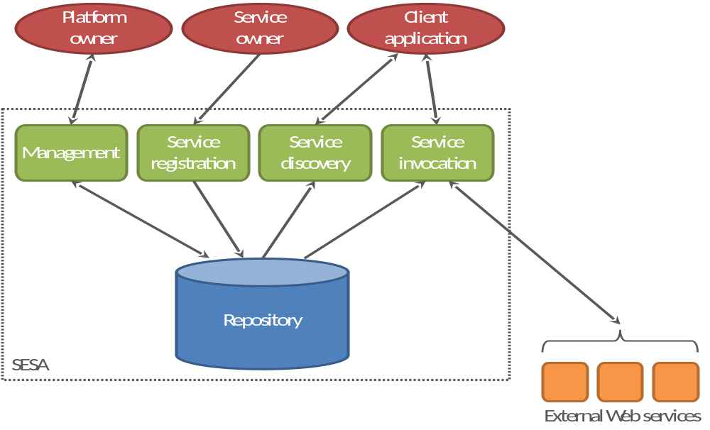
Figure 4: Overview of e-Freight SESA architecture

Repository
The repository stores the metadata about services which are needed by the other components of the SESA architecture. The semantic descriptions of the Web services registered in the platform are stored here and can be queried, so that the repository can be used in the SESA architecture also as a service registry.

The repository is an RDF triplestore, which can be queried via SPARQL [SPARQL]. It is however not intended to be directly accessible from outside the SESA architecture.

Management Component
The management component allows administering the data stored in the repository, and in particular it allows storing and updating ontologies. These data are not used to describe a single Web service; therefore they are administered by the platform owner/administrator through this component, and not by single Web service owners through the registration component. The management component also allows administering permissions related to service registration for service owners.

The management component is envisioned, but not yet implemented in the first release.

Registration Component
The registration component allows service owners to register their services in the platform, by storing the relevant information in the repository. Basically, service owners need to submit semantically annotated WSDL descriptions of their services; the registration component extracts relevant metadata and stores it in the repository as RDF triples.

In the future, the service registration component may be enriched with extra validation and checking functionalities with respect to some policy. Using the e-Freight ontology, for example, the platform administrator may specify that a service belonging to category A can or cannot request as input data of type X (where X is a concept in the e-Freight ontology, not a syntactic datatype). By checking the SAWSDL annotations (model references for service category and input/output data), the registration component can check compliance to such policy when a service is registered (or the description is updated).

Discovery Component
The discovery component allows client applications to discover services that can fulfil their goals. In its simplest form, implemented in the first release, the discovery is based on functional categories (classifications) defined in the e-Freight ontologies. In the future, we will consider the possibility to extend the discovery component in order to take into account functional capabilities (condition/effect) and/or non-functional properties, depending on complexity and e-Freight applications requirements.

Invocation Component (Invoker)
The invoker allows client applications to invoke external Web services without having to deal with their specific data schema. The client asks the invoker to invoke a certain Web service (which may have been previously identified through service discovery), passing to the invoker the input data in RDF format, according to the e-Freight ontology. The invoker retrieves from the repository the metadata which is needed to invoke that service, and in particular the ones about lifting and lowering transformations. The input data is lowered to the specific XML schema used by the requested Web service, which is then invoked. The data returned by the Web service is then lifted to RDF, and returned back to the client application.

In its simplest form, implemented in the first release, the invoker basically deals with data mediation, so that client applications can deal with just RDF data according to the e-Freight ontology, without having to worry about schema heterogeneities when invoking external Web services. Besides this, the invoker is transparent in the communication between client applications and external Web services. In a subsequent release, we may take into account also message exchange patterns.

In the first release, the invoker is able to invoke WSDL-based services. We will consider the possibility of adding other types of services, notably REST services, in a subsequent release. In the first release, only XSLT scripts are supported as lifting and lowering transformations.

Evolution
Besides some extensions of features of each component as sketched in the previous sections, there are other extra functionalities that we will consider for inclusion in future releases of the SESA architecture:
Service ranking: the ranking functionality (which can be integrated in the discovery component or realised as a separate component) allows client applications to receive an ordered list out of the set of services resulting from the discovery process. The ranking criteria can be various non-functional properties specified by the client application.
Platform federation: the federation functionality allows moving from a centralised architecture (with a central registry of services, as described in the previous sections) to a federated architecture, with multiple, federated, instances of the platform.

Prototype Implementation
The following chapter describes the implementation (version 1) of the eFreight SESA platform, the components and the corresponding interfaces. In this release the registration, invocation and discovery components are implemented, as these serve as a basis for the platform. All components are exposed as SOAP/WSDL web services.
Please note that currently only (SA)WSDL for service descriptions and XSLT for lowering/lifting transformations are supported. A future release might add support for other service architectures (e.g. REST) and lowering/lifting transformations (e.g. XSPARQL).

Registration Component
As described in the Section 5.4, the registration component in its first version allows the client to register (SA)WSDL service descriptions and making them available for discovery and invocation.

The register operation transforms relevant parts from (SA)WSDL service description into RDF triples and stores them in the repository. For a proper discovery the service must be semantically annotated, as also for invocation the operations inputs and outputs using annotations.

serviceID register(SAWSDL)

[IN] SAWSDL | The SAWSDL input is an URL pointing to the SAWSDL description.
[OUT] serviceID | The serviceID for the registered service or a fault will be returned.

The semantic annotation for categorisation of services is using sawsdl:modelReference attribute, which will include one or more URIs, pointed to concepts in the ontology. Below is given an example of how to annotate the service description for categorisation.

…
<wsdl:service name="SubmissionService"
sawsdl:modelReference=”http://www.sti2.at/E-Freight/ServiceCategories#SubmitEntrySummaryDeclaration http:/www.sti2.at/E-Freight/ServiceCategories#SubmitEntrySummaryDeclarationAmendment”>
<wsdl:port name="BasicHttpBinding_ISubmissionService"
binding="tns:BasicHttpBinding_ISubmissionService">
<soap:address
location="http://localhost/CLMS_SpainMSW_1_0_pda_EFreight/Services/SubmissionService.svc" />
</wsdl:port>
</wsdl:service>
Listing 7: WSDL service annotation.

The semantic annotations added to global element declarations are sawsdl:liftingSchemaMapping and sawsdl:loweringSchemaMapping. Both values of them can have one or more URIs referencing mapping definitions. When multiple URIs are specified on sawsdl:liftingSchemaMapping or sawsdl:loweringSchemaMapping, the schema mappings they reference are to be treated as alternatives. Below is given an example of how to annotate the element declaration.

<xs:element name="ReceiveSubmission"
sawsdl:loweringSchemaMapping=”http://www.sti2.at/E-Freight/xslt/submision-lowering.xslt”>
<xs:complexType>
<xs:sequence>
<xs:element minOccurs="0" name="submissionD" nillable="true"
type="q1:Submission" xmlns:q1="http://schemas.datacontract.org/2004/07/MSW.BO" />
</xs:sequence>
</xs:complexType>
</xs:element>
Listing 8: Example for loweringSchemaMapping.

<xs:element name="ReceiveSubmissionResponse"
sawsdl:liftingSchemaMapping=”http://www.sti2.at/E-Freight/xslt/submision-lifting.xslt”>
<xs:complexType>
<xs:sequence>
<xs:element minOccurs="0" name="ReceiveSubmissionResult"
nillable="true" type="xs:string" />
</xs:sequence>
</xs:complexType>
</xs:element>
Listing 9: Example for liftingSchemaMapping.

Discovery Component
As described in Section 4.9, the discovery component in its first version discovers services and corresponding operations based on their semantic annotations.

The discover operation performs a matching process between the provided input categories and the registered/categorized service descriptions (please refer to Section 5.1 for details about how services can be categorized using annotations). The matching process returns all registered service descriptions that match to all input categories; sub-categories (in the taxonomy denoted as subClassOf) are also a valid match.

“match” if categories ⊆ C_{n} ∪ IC_{n}
“no_match” if categories ⊈ C_{n} ∪ IC_{n}

categories… input categories
C_{n}… categories of service n
IC_{n}… inferred categories of service n

Note that the discovered service descriptions (and their corresponding operations) are not ranked (see Evolution 4.11).

discoveredServices discover(categoryList)

[IN] categoryList | The categoryList is a list of URIs. These URIs are concepts from the domain taxonomy. Other taxonomies, e.g. for non-functional properties, can be added.
[OUT] discoveredServices | The discoveredServices are RDF triples containing the discovered serviceIDs and the corresponding operationNames. Using the serviceID and operationName one can call the invocation interface (see Section 5.3).

Example
In Figure Figure 5 a subset of the e-Freight service categories (taxonomy) is visualized. Imagine the platform has registered 3 services and a client application calls the discover operation giving as input a list of service categories, e.g. discover(InlandWaterway, GoodsDeclaration).

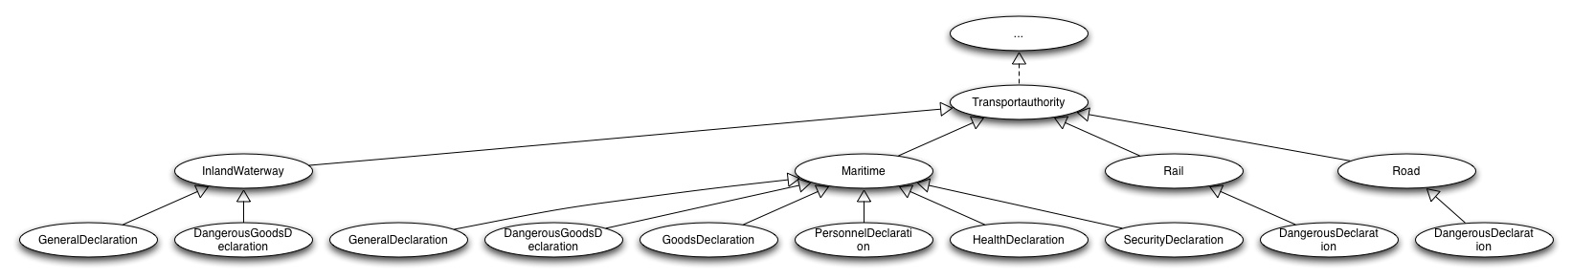
Figure 5: Service Category Subset

{InlandWaterway, GoodsDeclaration} ∈ categories

Service1: categories ⊆ {InlandWaterway, GeneralDeclaration, GoodsDeclaration} ∪ {Maritime, TransportAuthoritiy}
match

Service2: categories ⊈ {Maritime, GoodsDeclaration} ∪ {TransportAuthority}
no match

Service3: categories ⊆ {GeneralDeclaration, GoodsDeclaration} ∪ {InlandWaterway, Maritime, TransportAuthority}
match

In this example the discovery process returns service1 and service3 for input categories InlandWaterway and GoodsDeclaration as matching services.

Please note: We are aware of the fact that a serviceID and operationName is not enough to invoke the invocation component, furthermore the client needs input data (rdf triples) that can be lowered in order to invoke the external service. To address this problem of the structure of the input data we envision a “lookup” operation, which allows the client application to get the full description of a single service, given the respective serviceID. This full description contains also the pointers (modelReference) to semantically concepts, knowing the semantic concepts enables to generate the required input data for invocation.

Invocation Component
As described in Section 4.10 the invocation component in its first version allows the client application to invoke external Web services without having to deal with their specific data schema. In other words the invocation component functions as a transparent proxy and does data mediation. In order to invoke external web services, they need to be registered first (see Section 5.1). Service discovery (see Section 5.2) can be used to find appropriate services for invocation.

The invoke operation calls the registered web service (identified by serviceID) using the operation and RDF triples as input data. The data needed for the actual invocation (endpoint, binding, lifting/lowering …) is extracted from (SA)WSDL and stored in the repository already at registration time, the client application has not to deal with this specific parameters. When the invoke process starts the service description is loaded from the repository, the input data (in form of RDF triples) is lowered (using XSLT transformations). After this step the external web service is called using the previously lowered data. After the execution the returned data is lifted (using XSLT transformations) and returned to the calling client application.

outputData invoke(serviceID, operationName, inputData)

[IN] serviceID | The serviceID consists of the concatenation of service namespace and service name. In our example service the serviceID is http://www.efreightproject.eu/ValenciaPortWebService  (see targetNamespace in wsdl:definitions and name attributes in wsdl:service node)
[IN] operationName | The second parameter is the operation name; it is returned by the discovery process. In our example operationName is submitFALForm (see name attribute in wsdl:operation)
[IN] inputData | The last parameter is the input data described as RDF instances. The input data is described in section “Example Input Data – FAL Form”  Limitation: Currently only xml/rdf is supported. Other serializations might be supported in later releases.
[OUT] ouputData | The output data consists also of triples that are described in the domain ontology.

Example
The following example is based on the example in Section 4.4. Please refer to Listings 8,9 for the according lowering/lifting transformation scripts.

[IN] serviceID | http://tempuri.org/SubmissionService
[IN] operationName | GetPendingBerthAuthorizations
[IN] inputData | see Listing 10
[OUT] ouputData | see Listing 11

<?xml version="1.0"?>
<rdf:RDF xmlns:fal="http://efreightproject.eu/ontologies/FAL.owl#"
xmlns:rdf="http://www.w3.org/1999/02/22-rdf-syntax-ns#">
<fal:Port rdf:about="http://sti2.at/">
<fal:hasPortCode>ESVLC</fal:hasPortCode>
</fal:Port>
</rdf:RDF>

Listing 10: RDF input data.

<?xml version="1.0"?>
<rdf:RDF xmlns:fal="http://efreightproject.eu/ontologies/FAL.owl#"
xmlns:rdf="http://www.w3.org/1999/02/22-rdf-syntax-ns#">
<fal:WorkItem rdf:about="http://sti2.at/WorkItem_3f8b09d5">
<fal:hasWorkItemId>3f8b09d5</fal:hasWorkItemId>
<fal:hasCreationTime>2011-07-23T00:00:00</fal:hasCreationTime>
<fal:isInWork>true</fal:isInWork>
<fal:hasForm>
<fal:GeneralDeclarationF1 rdf:about="http://sti2.at/Declaration_934b">
<fal:hasGeneralDeclarationId>934b</fal:hasGeneralDeclarationId>
<fal:hasArrivalOrDepartureDateTime>2011-07-23T00:00:00
</fal:hasArrivalOrDepartureDateTime>
<fal:hasNumberOfCrew>14</fal:hasNumberOfCrew>
<fal:hasNumberOfPassengers>2</fal:hasNumberOfPassengers>
<fal:hasSubmission>
<fal:Submission rdf:about="http://sti2.at/Submission_C430">
<fal:hasSubmissionId>c430</fal:hasSubmissionId>
</fal:Submission>
</fal:hasSubmission>
<fal:hasShip>
<fal:Ship rdf:about="http://sti2.at/Ship_9HVG8">
<fal:hasCallSign>9HVG8</fal:hasCallSign>
</fal:Ship>
</fal:hasShip>
</fal:GeneralDeclarationF1>
</fal:hasForm>
</fal:WorkItem>
</rdf:RDF>

Listing 11: RDF output data.

Conclusions
Davide

References
[OWL-S] OWL-S: Semantic Markup for Web Services.
W3C Member Submission 22 November 2004.
http://www.w3.org/Submission/2004/SUBM-OWL-S-20041122/

[RDF] RDF Primer.
W3C Recommendation 10 February 2004.
http://www.w3.org/TR/2004/REC-rdf-primer-20040210/

[SAWSDL] Semantic Annotations for WSDL and XML Schema.
W3C Recommendation 28 August 2007.
http://www.w3.org/TR/2007/REC-sawsdl-20070828/

[SPARQL] SPARQL Query Language for RDF.
W3C Recommendation 15 January 2008.
http://www.w3.org/TR/2008/REC-rdf-sparql-query-20080115/

[WSDL-adj] Web Services Description Language (WSDL) Version 2.0 Part 2: Adjuncts.
W3C Recommendation 26 June 2007.
http://www.w3.org/TR/2007/REC-wsdl20-adjuncts-20070626

[WSDL-core] Web Services Description Language (WSDL) Version 2.0 Part 1: Core
Language.
W3C Recommendation 26 June 2007.
http://www.w3.org/TR/2007/REC-wsdl20-20070626

[WSMO] Web Service Modeling Ontology (WSMO).
W3C Member Submission 3 June 2005.
http://www.w3.org/Submission/2005/SUBM-WSMO-20050603/

[WSMO-Lite] WSMO-Lite: Lightweight Semantic Descriptions for Services on the Web.
W3C Member Submission 23 August 2010.
http://www.w3.org/Submission/2010/SUBM-WSMO-Lite-20100823/

Appendix

The e-Freight Service Model:

<?xml version="1.0"?>

<!DOCTYPE rdf:RDF [
<!ENTITY msm "http://cms-wg.sti2.org/ns/minimal-service-model#">
<!ENTITY wl "http://www.wsmo.org/ns/wsmo-lite#">
<!ENTITY sawsdl "http://www.w3.org/ns/sawsdl#">
<!ENTITY rest "http://www.wsmo.org/ns/hrests#">
<!ENTITY wsdl "http://www.w3.org/ns/wsdl-rdf#" >
]>
<rdf:RDF xmlns:rdf="http://www.w3.org/1999/02/22-rdf-syntax-ns#"
xmlns:rdfs="http://www.w3.org/2000/01/rdf-schema#"
xmlns:owl="http://www.w3.org/2002/07/owl#"
xmlns:sawsdl="&sawsdl;"
xmlns:http="http://www.w3.org/2008/http-methods#"
xmlns:vs="http://www.w4.org/2003/06/sw-vocab-status/ns#"
xmlns:wl="&wl;"
xmlns:rest="&rest;">

<rdfs:Class rdf:about="http://www.wsmo.org/ns/wsmo-lite#Ontology">
<rdfs:subClassOf rdf:resource="http://www.w3.org/2002/07/owl#Ontology" />
</rdfs:Class>

<rdf:Description rdf:about="http://www.wsmo.org/ns/wsmo-lite#FunctionalClassificationRoot">
<rdfs:subClassOf rdf:resource="http://www.w3.org/2000/01/rdf-schema#Class" />
</rdf:Description>

<rdfs:Class rdf:about="http://www.wsmo.org/ns/wsmo-lite#NonFunctionalParameter" />
<rdfs:Class rdf:about="http://www.wsmo.org/ns/wsmo-lite#Condition" />
<rdfs:Class rdf:about="http://www.wsmo.org/ns/wsmo-lite#Effect" />

<rdfs:Class rdf:about="http://www.w3.org/2008/http-methods#Method">
<rdfs:subClassOf rdf:resource="http://www.wsmo.org/ns/hrests#Method" />
</rdfs:Class>

<rdfs:Class rdf:about="#Service" />

<rdfs:Class rdf:about="#Operation" />

<rdfs:Class rdf:about="#MessagePart" />

<rdfs:Class rdf:about="#MessageContent">
<rdfs:subClassOf rdf:resource="#MessagePart" />
</rdfs:Class>

<rdfs:Class rdf:about="http://www.wsmo.org/ns/hrests#URITemplate" />

<rdf:Property rdf:about="http://www.wsmo.org/ns/wsmo-lite#usesOntology">
<rdfs:domain rdf:resource="#Service" />
<rdfs:subPropertyOf rdf:resource="http://www.w3.org/2000/01/rdf-schema#seeAlso" />
</rdf:Property>

<rdf:Property rdf:about="#hasOperation">
<rdfs:domain rdf:resource="#Service" />
<rdfs:range rdf:resource="#Operation" />
</rdf:Property>

<!--
- Substitution for hasInput, hasOutput, hasInputFault and hasOutputFault
-->
<rdf:Property rdf:about="#hasMessageContent">
<rdfs:domain rdf:resource="#Operation" />
<rdfs:range rdf:resource="#MessageContent" />
</rdf:Property>

<rdf:Property rdf:about="http://www.wsmo.org/ns/hrests#hasAddress">
<rdfs:domain rdf:resource="#Operation" />
<rdfs:range rdf:resource="http://www.wsmo.org/ns/hrests#URITemplate" />
</rdf:Property>

<rdf:Property rdf:about="http://www.wsmo.org/ns/hrests#hasMethod">
<rdfs:domain rdf:resource="#Operation" />
<rdfs:range rdf:resource="http://www.wsmo.org/ns/hrests#Method" />
</rdf:Property>

<rdf:Property rdf:about="http://www.w3.org/ns/sawsdl#modelReference" />

<rdf:Property rdf:about="http://www.w3.org/ns/sawsdl#liftingSchemaMapping" />

<rdf:Property rdf:about="http://www.w3.org/ns/sawsdl#loweringSchemaMapping" />

<rdf:Property rdf:about="#hasPart">
<rdfs:domain rdf:resource="#MessagePart" />
<rdfs:range rdf:resource="#MessagePart" />
</rdf:Property>

<rdf:Property rdf:about="#hasName">
<rdfs:domain rdf:resource="#MessagePart" />
<rdfs:range rdf:resource="http://www.w3.org/1999/02/22-rdf-syntax-ns#Literal" />
</rdf:Property>

<rdf:Property rdf:about="#hasOptionalPart">
<rdfs:subPropertyOf rdf:resource="#hasPart" />
</rdf:Property>

<rdf:Property rdf:about="#hasMandatoryPart">
<rdfs:subPropertyOf rdf:resource="#hasPart" />
</rdf:Property>

<!--
- Start Extensions
-->
<rdfs:Class rdf:about="#Input">
<rdfs:subClassOf rdf:resource="#MessageContent"/>
</rdfs:Class>

<rdfs:Class rdf:about="#Output">
<rdfs:subClassOf rdf:resource="#MessageContent"/>
</rdfs:Class>

<rdfs:Class rdf:about="&wsdl;InterfaceOperation">
<rdfs:subClassOf rdf:resource="&msm;Operation" />
</rdfs:Class>

<rdfs:Class rdf:about="&wsdl;InputMessage">
<rdfs:subClassOf rdf:resource="&msm;Input" />
</rdfs:Class>

<rdfs:Class rdf:about="&wsdl;OutputMessage">
<rdfs:subClassOf rdf:resource="&msm;Output" />
</rdfs:Class>

<rdfs:Class rdf:about="&wsdl;QName">
<rdfs:subClassOf rdf:resource="&msm;MessagePart" />
</rdfs:Class>

<rdfs:Property rdf:about="&wsdl;interfaceMessageReference">
<rdfs:subPropertyOf rdf:resource="&msm;hasInput" />
</rdfs:Property>

<rdfs:Property rdf:about="&wsdl;interfaceMessageReference">
<rdfs:subPropertyOf rdf:resource="&msm;hasMessageContent" />
</rdfs:Property>

<rdfs:Property rdf:about="&wsdl;interfaceFaultReference">
<rdfs:subPropertyOf rdf:resource="&msm;hasMessageContent" />
</rdfs:Property>

<rdfs:Property rdf:about="#wsdlDescription">
<rdfs:label>wsdl Description</rdfs:label>
<vs:term_status>testing</vs:term_status>
<rdfs:domain rdf:resource="&msm;Service" />
<rdfs:range rdf:resource="&msm;Description" />
</rdfs:Property>

</rdf:RDF>

http://www.w3.org/TR/wsdl20-rdf/
http://www.w3.org/TR/wsdl20/
http://www.w3.org/TR/wsdl20/#InterfaceOperation
http://www.w3.org/TR/wsdl20-rdf/#ontologysource
http://iserve.kmi.open.ac.uk/wiki/index.php/Simple_vocabulary
http://iserve.kmi.open.ac.uk/ (last access on 2011-07-23)
Pedrinaci, C.; Liu, D.; Maleshkova, M.; Lambert, D.; Kopecky, J. and Domingue, J. (2010). iServe: a linked services publishing platform. In: Ontology Repositories and Editors for the Semantic Web Workshop at The 7th Extended Semantic Web, 30 May - 03 Jun 2010, Heraklion, Greece.
http://lod-cloud.net
Source: http://iserve.kmi.open.ac.uk/wiki/images/8/85/Minimal_Service_Model-v5.png
http://www.w3.org/TR/rdf-schema/
http://82.138.229.181/CLMS_SpainMSW_1_0_pda_EFreight/Services/SubmissionService.svc?wsdl
At least not for writing operations, which should go through the registration and management components. Other components of the e-Freight platform could be allowed to directly query the repository.

