ELI-triscope-StageController-V1.0.0

This version of the program has been tested on Windows 7 operating system.

This program can control the Newport Open Loop [Picomotor Actuator by 8742 Motion Controller](https://www.newport.com.cn/t/how-the-picomotor-actuator-works) for XYZ movement and drive maxon brushless motor by EPOS2 EPOS2 Positioning Controller for tilt.

The program was written by LabVIEW 2011.

Before running this program, the hardware should be mounted well and the driver should be installed. And the corresponding LabVIEW subprogram of the hardware should be downloaded and installed.

The following is the interface of the program.

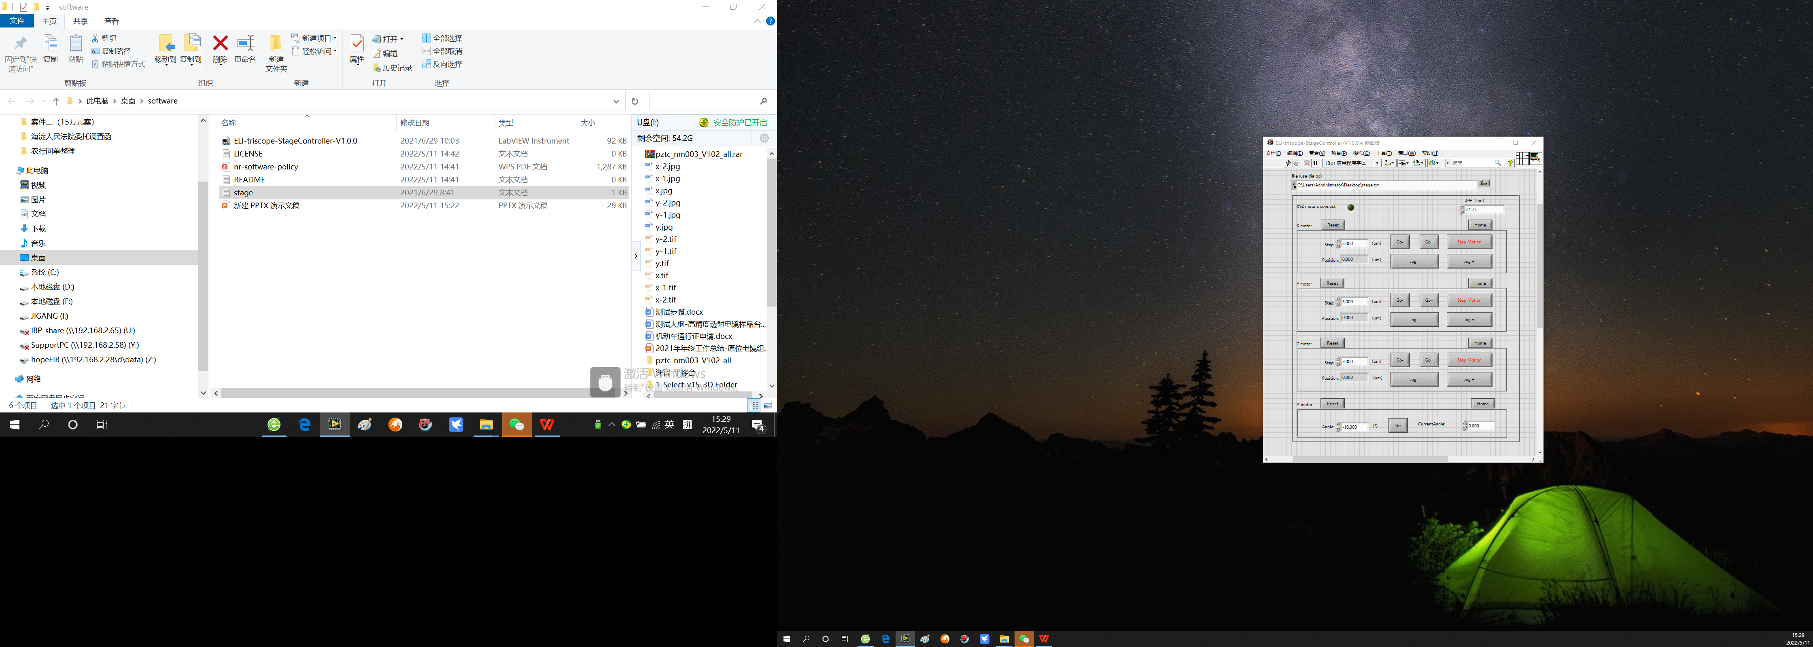

The file address is for a text file stage.txt to save the position of the stage.

When the program runs, XYZ motors connection light become on station, indicating the program has connected with the hardware.

Each motor can have “Reset”, “Home”, “Go-”, “Go+”, “Jog-”, “Jog+”, “Stop Motion”, “Step”, “Position”. You can set the step and put the “Go-”, “Go+” buttons for step motion. The “Jog-”, “Jog+” buttons for continuous movement. The “Position” shows the current position of the corresponding motor.

Put “Reset” button can set the current position to 0.

Put “Home” button can move the stage to the 0 position.

The “Stop” Motion can stop the motor movement anytime.

The last one is A motor for tilt stage. First, set the angle in the “Angle” blank. Then put the “Go” button to tilt the stage. The “CurrentAngle” indicates the real tilt angle.