1. Description 2
2. Disclaimer 2
3. Installation 2
4. Settings 3
5. Scan for PLCs on a TCP/IP network 4
6. Scanning for process variables and Watch them (PVs) 5
7. Logging PVs to a CSV- File 7
8. Starting and Stopping the Logger 8

1. Description
BRWATCH ist a small B&R PVI- based debugging tool for Microsoft Windows to watch process variables („PV“) on B&R PLCs. Furthermore, it enables to log the contents to CSV- Files.
As PVI itself is not able read and write PV in a ‘real time context’ (e.g. no warranty of exact timing), BRWATCH miss the same capabilities of course.

2. Disclaimer
BRWATCH comes „as is“, e.g. without support and warranty.
You can freely copy it but use it at your own risk.

3. Installation
There is no “classical” installation required.
At first download an actual “PVI development setup” from www.br-automation.com, install it.
After installation of PVI just copy BRWATCH.exe to any folder.
If you plan to use it twice or more with different settings must copy the EXE into separate folders.
If you don‘t run PVI on a B&R- PC or on a PC without a PVI Dongle installed, PVI runs at maximum duration of 2 hours. If you plan to run it longer, buy a valid license from B&R.
BRWATCH.exe only depends on Windows system libraries and B&R PVI

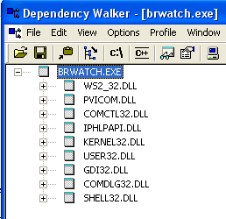

4. Settings
After first start, BRWATCH creates a ‘BRWATCH.ini’ file in the current folder.
To edit these settings use an external editor or the built-in one in menu Options/Settings.
Refer to the comments in this file and the PVI- documentation that comes with the installation package of “PVI development setup”.

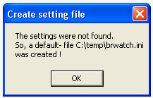

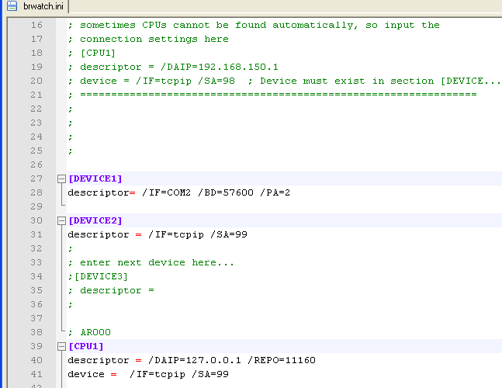

5. Scan for PLCs on a TCP/IP network
Right clicking with your mouse on an Ethernet device (“/IF=tcpip”) enables to search a PLC on a connected network. As this service uses UDP, some network settings disable this feature. In this case, you have to enter the settings in the BRWATCH.ini file manually :-(.
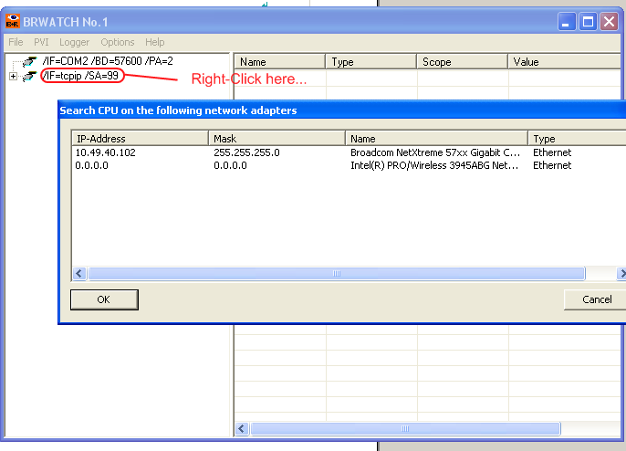

If you mark an Ethernet adapter in this list and press ‘OK’ BRWATCH will list the found CPUs after a short while.
(This service will also find ‘normal’ PCs running PVI, please ignore them)
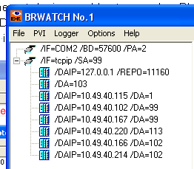

(Starting with PVI 3.x. there is a more reliable SNMP based search available, but BRWATCH currently makes no use of it).

6. Scanning for process variables and Watch them (PVs)
To scan variables, left-click on each node-entry of the tree view control.
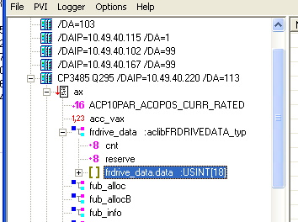

To watch a selected variable just drag it to the list view control at the right. The entries can be freely arranged by drag and drop operations. If you drag an entry outside BRWATCH, it will removed from the list view.

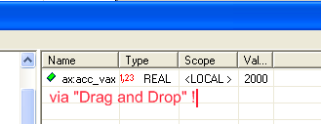

Right-Click on an entry in the list view opens a context menu for further settings (e.g.
Representation of integer variables and strings).

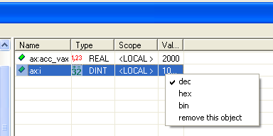

To change a value double click the entry in the list view. The following dialog window enables to enter a new value.
If option ‘write once’ is enabled this dialog will close after pressing „OK“. If not, this dialog remains open (e.g. ‘apply’ instead of ‘confirm’).

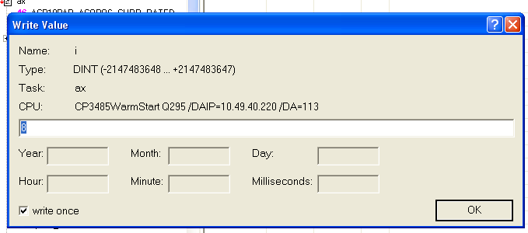

You can save the watch configuration (or load an existing configuration) in menu „File“.

7. Log PV to a CSV- File
If the list view contains one or more PV you can write the values into a CSV- File. ‘Microsoft Excel’ or ‘Libre Office Calc’ can open this file type for example (or an ordinary text editor of course).

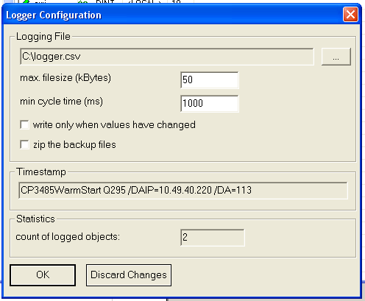

The CSV- file size can be limited. If the entries exceeds this size, the earlier file is renamed (extended with date and time settings) and a new file will be written.
If option ‘write only when values have changed’ is checked, a row is written if at least one variable in the list view has changed its content (minimize size).

Otherwise, the entered cycle time is for each row no matter if values have changed in a new cycle.

Each row in the CSV- file will contain a timestamp. This will come from the first CPU listed in the list view.

Furthermore, the CSV- files can compressed via ZIP- algorithm. Extract these files later on by BRWATCH (Menu File) or with a separate tool (WinZIP, 7zip e.g.)

Pressing ‘OK’ will save these settings in the BRWATCH.ini file.

8. Starting and Stopping the Logger
Menu Logger enables to start the logger or to stop a started logging. If logging has started, the BRWATCH main window is grey colored to signal this state.
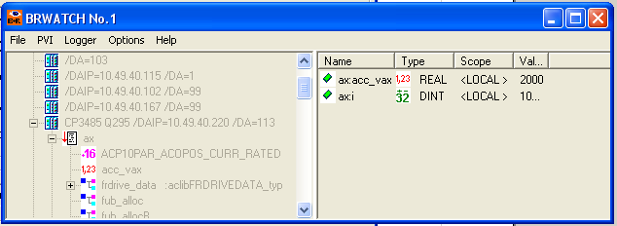

You can save space on your Window desktop by minimizing the window. BRWATCH will then be visible only as an icon in the taskbar. Moving the mouse over this icon gives the option to maximize the main window again.
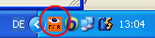

If you close BRWATCH in this state (e.g. power down your PC) the logger will start in this state again after power up (for long term logging capabilities).
Beware; the minimized window state is be saved, too.
So if you don‘t see the main window after starting the .exe just have a look at the windows taskbar.

