
Front End Technologies Week 5 Coding Assignment
Points possible: 70
Category | Criteria | % of Grade
Functionality | Does the code work? | 25
Organization | Is the code clean and organized? Proper use of white space, syntax, and consistency are utilized. Names and comments are concise and clear. | 25
Creativity | Student solved the problems presented in the assignment using creativity and out of the box thinking. | 25
Completeness | All requirements of the assignment are complete. | 25

Instructions: In VS Code, or an IDE of your choice, write the code that accomplishes the objectives listed below. Ensure that the code compiles and runs as directed. Take screenshots of the code and of the running program (make sure to get screenshots of all required functionality) and paste them in this document where instructed below. Create a new repository on GitHub for this week’s assignments and push this document, with your JavaScript project code, to the repository. Add the URL for this week’s repository to this document where instructed and submit this document to your instructor when complete.
Coding Steps:
- Using any of the tools you’ve worked with so far, create a game of tic-tac-toe.
  - A heading should say whether it is X’s or O’s turn and change with each move made.
  - Create a tic-tac-toe grid using your HTML element of choice. When a cell in the grid is clicked, an X or O should appear in that spot depending on whose turn it is.
  - A button should be available to clear the grid and restart the game.
  - When a player has won, or the board is full and the game results in a draw, a Bootstrap alert or similar Bootstrap component should appear across the screen announcing the winner.

Screenshots of Code:
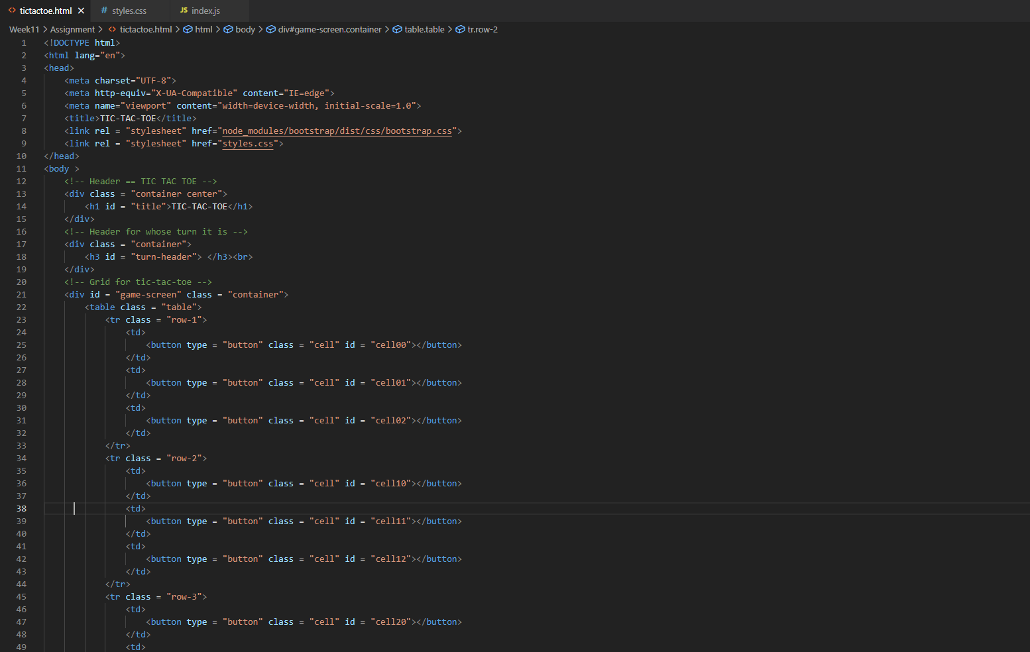
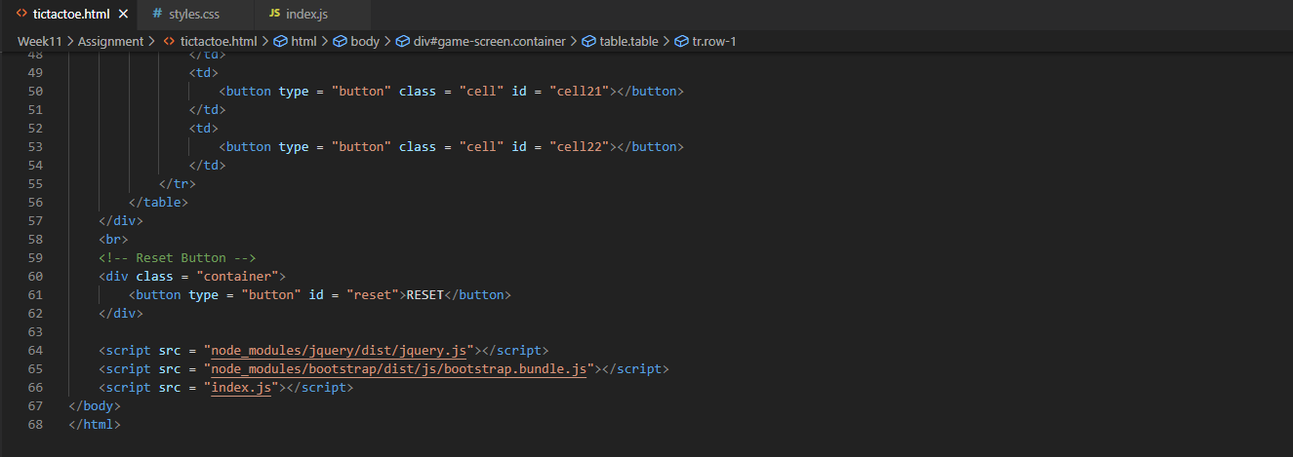
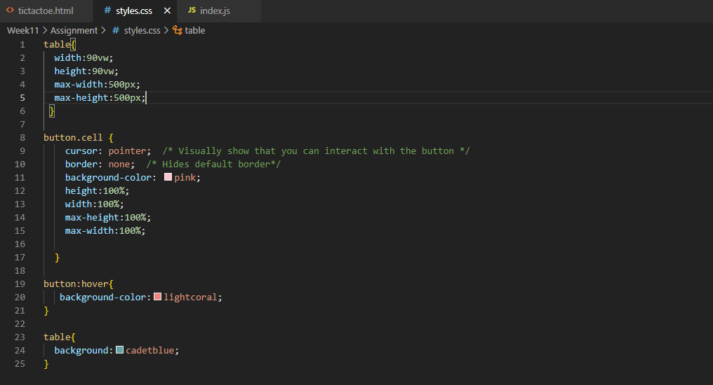
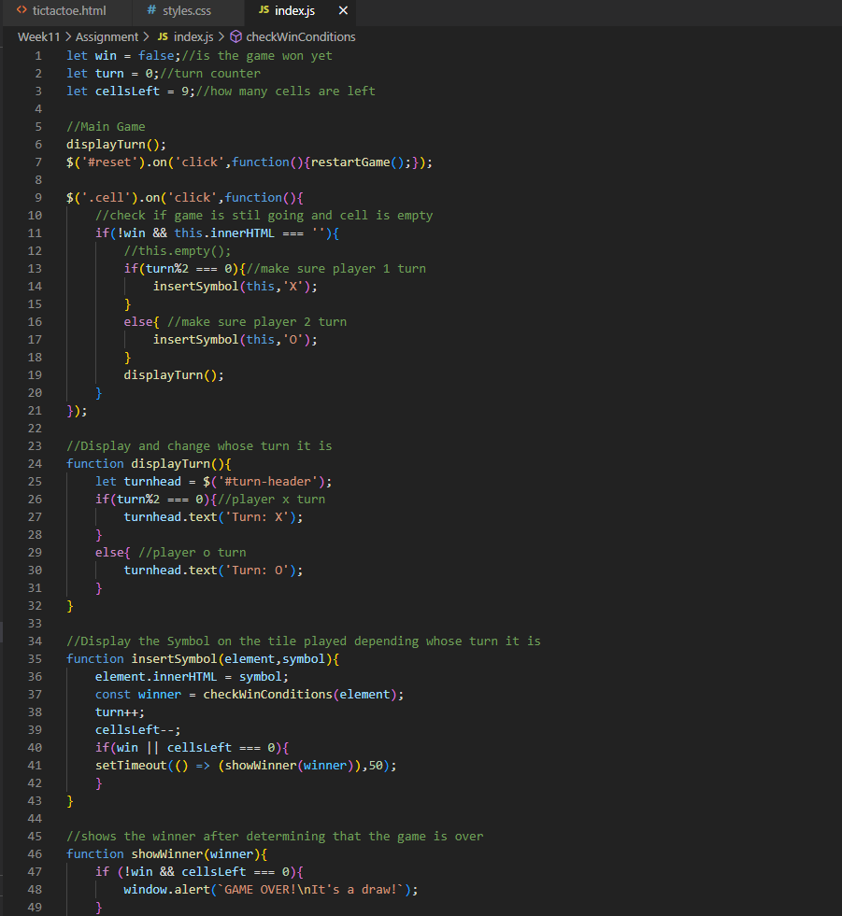
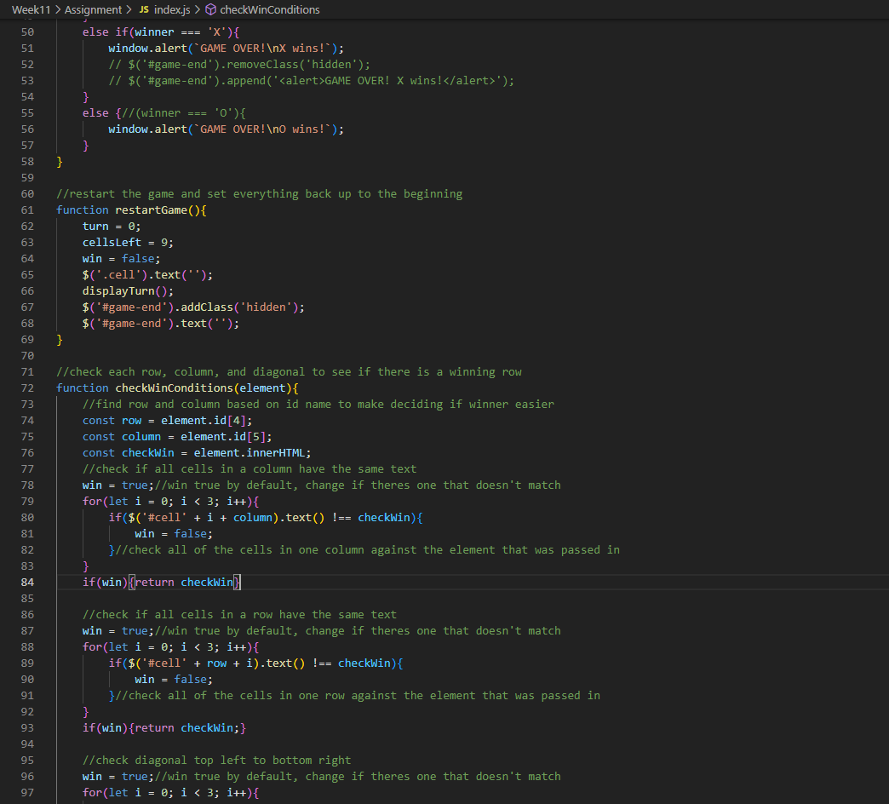
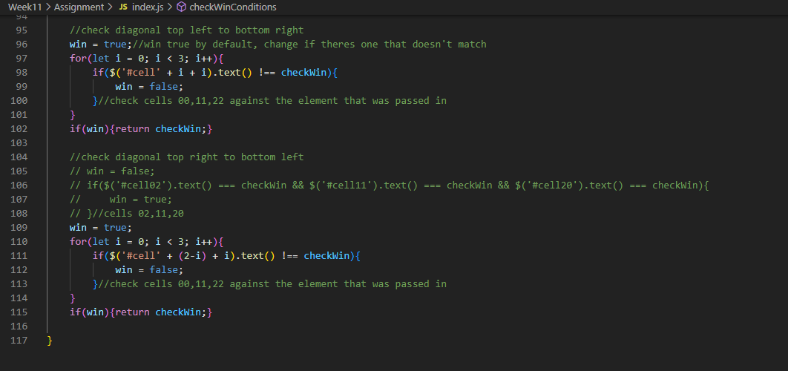

Screenshots of Running Application:
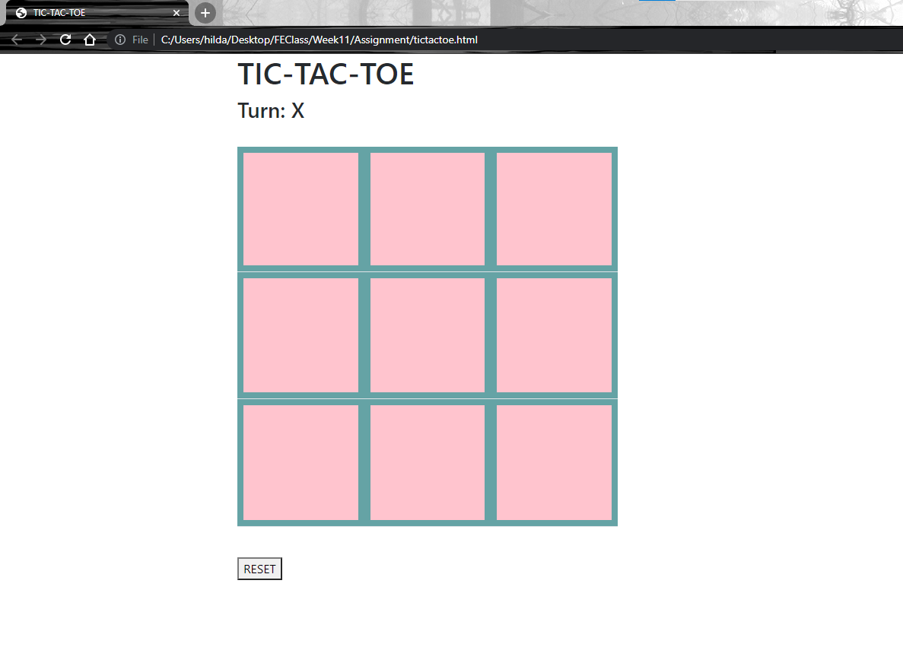
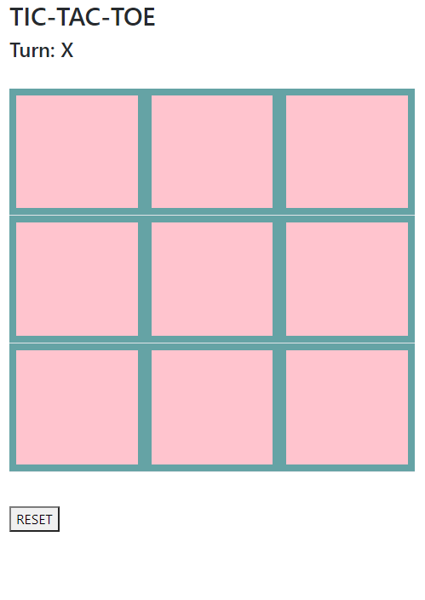
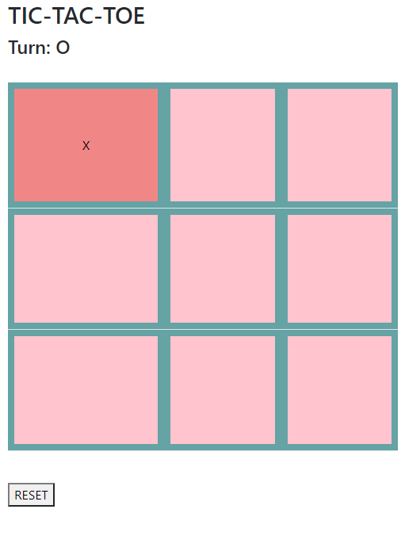
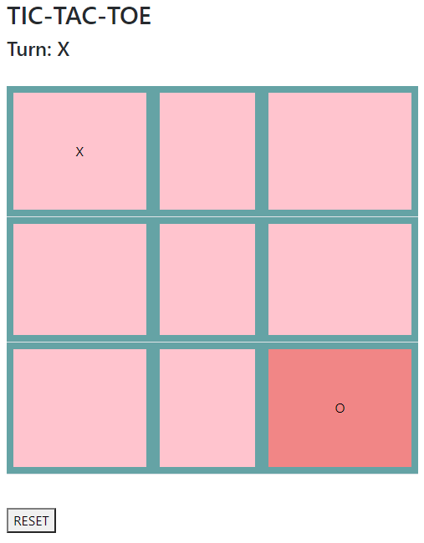
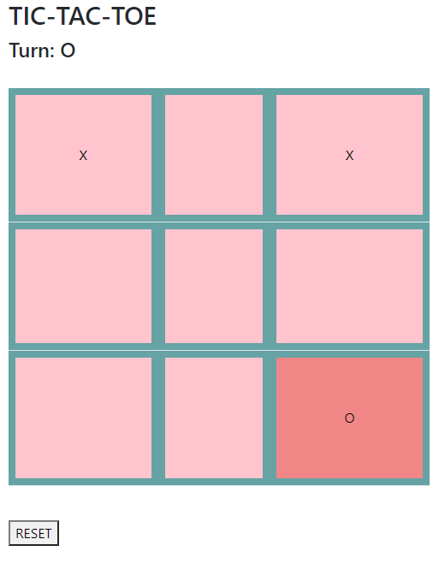
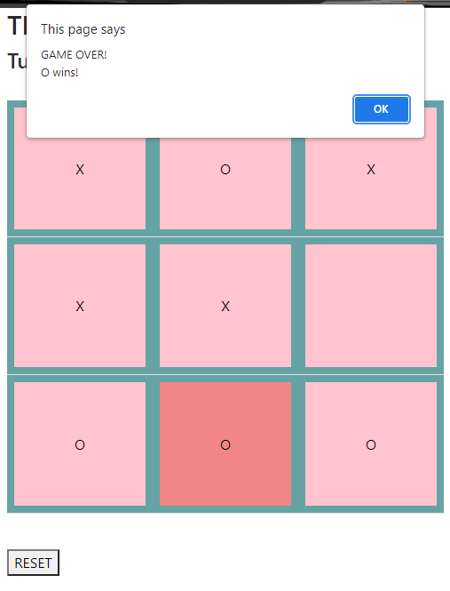
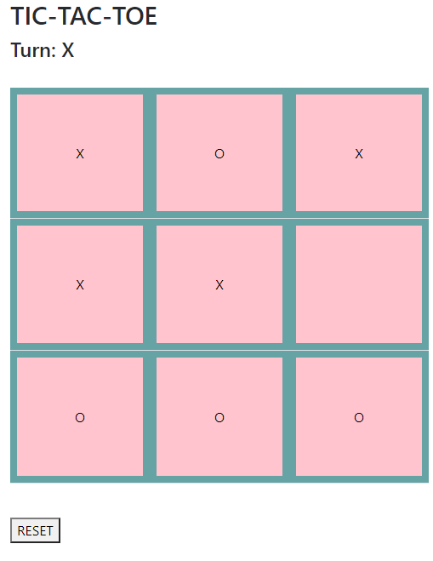
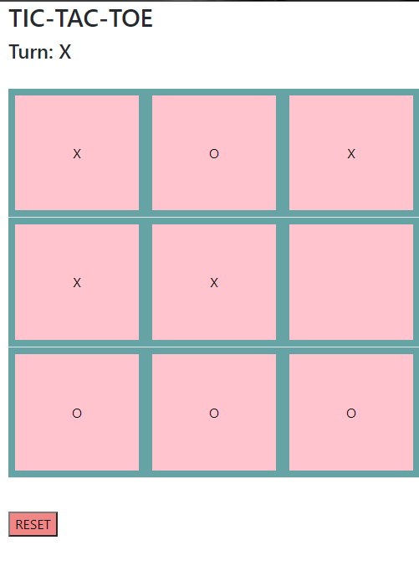
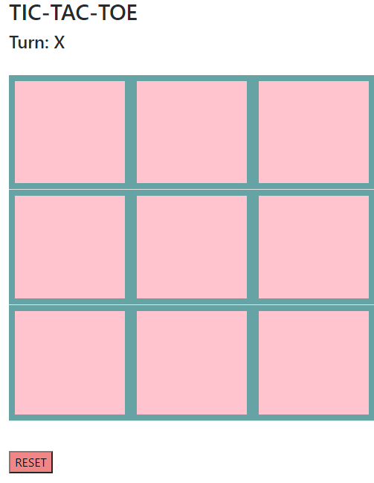
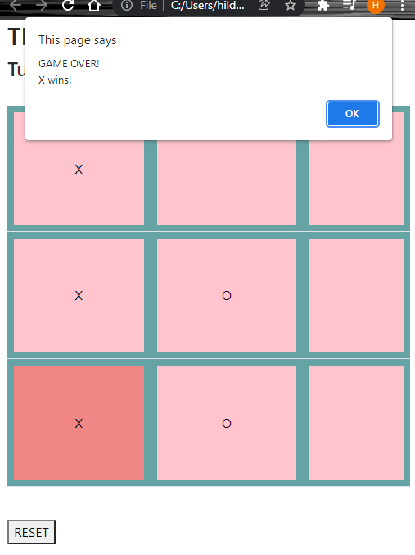
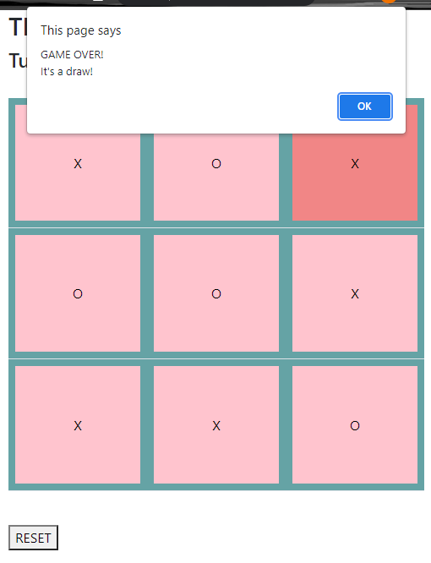

URL to GitHub Repository:
https://github.com/hildadahlstrom/Week11Assignment

