
Front End Technologies Week 1 Coding Assignment
Points possible: 70
Category | Criteria | % of Grade
Functionality | Does the code work? | 25
Organization | Is the code clean and organized? Proper use of white space, syntax, and consistency are utilized. Names and comments are concise and clear. | 25
Creativity | Student solved the problems presented in the assignment using creativity and out of the box thinking. | 25
Completeness | All requirements of the assignment are complete. | 25

Instructions: In VS Code, or an IDE of your choice, write the code that accomplishes the objectives listed below. Ensure that the code compiles and runs as directed. Take screenshots of the code and of the running program (make sure to get screenshots of all required functionality) and paste them in this document where instructed below. Create a new repository on GitHub for this week’s assignments and push this document, with your project code, to the repository. Add the URL for this week’s repository to this document where instructed and submit this document to your instructor when complete.
Coding Steps:
- Create a website using only HTML. The website can be anything you like (within school guidelines) as long as it meets the following criteria – website must contain:
  - At least 3 pages
  - Links to navigate between all pages present on each page
  - A list
  - 3 images
  - 2 different size headers
  - A table
  - A form
Screenshots of Code:
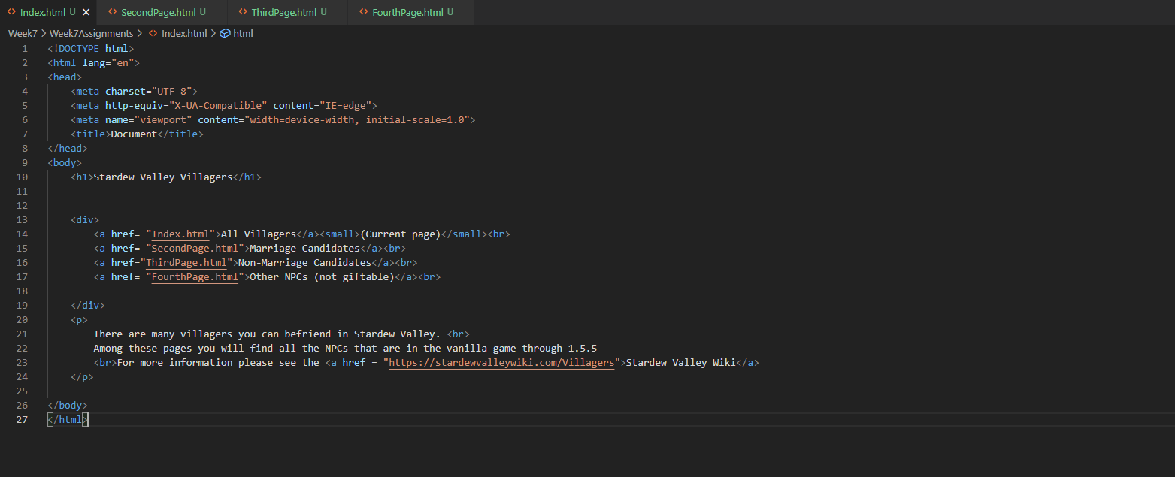
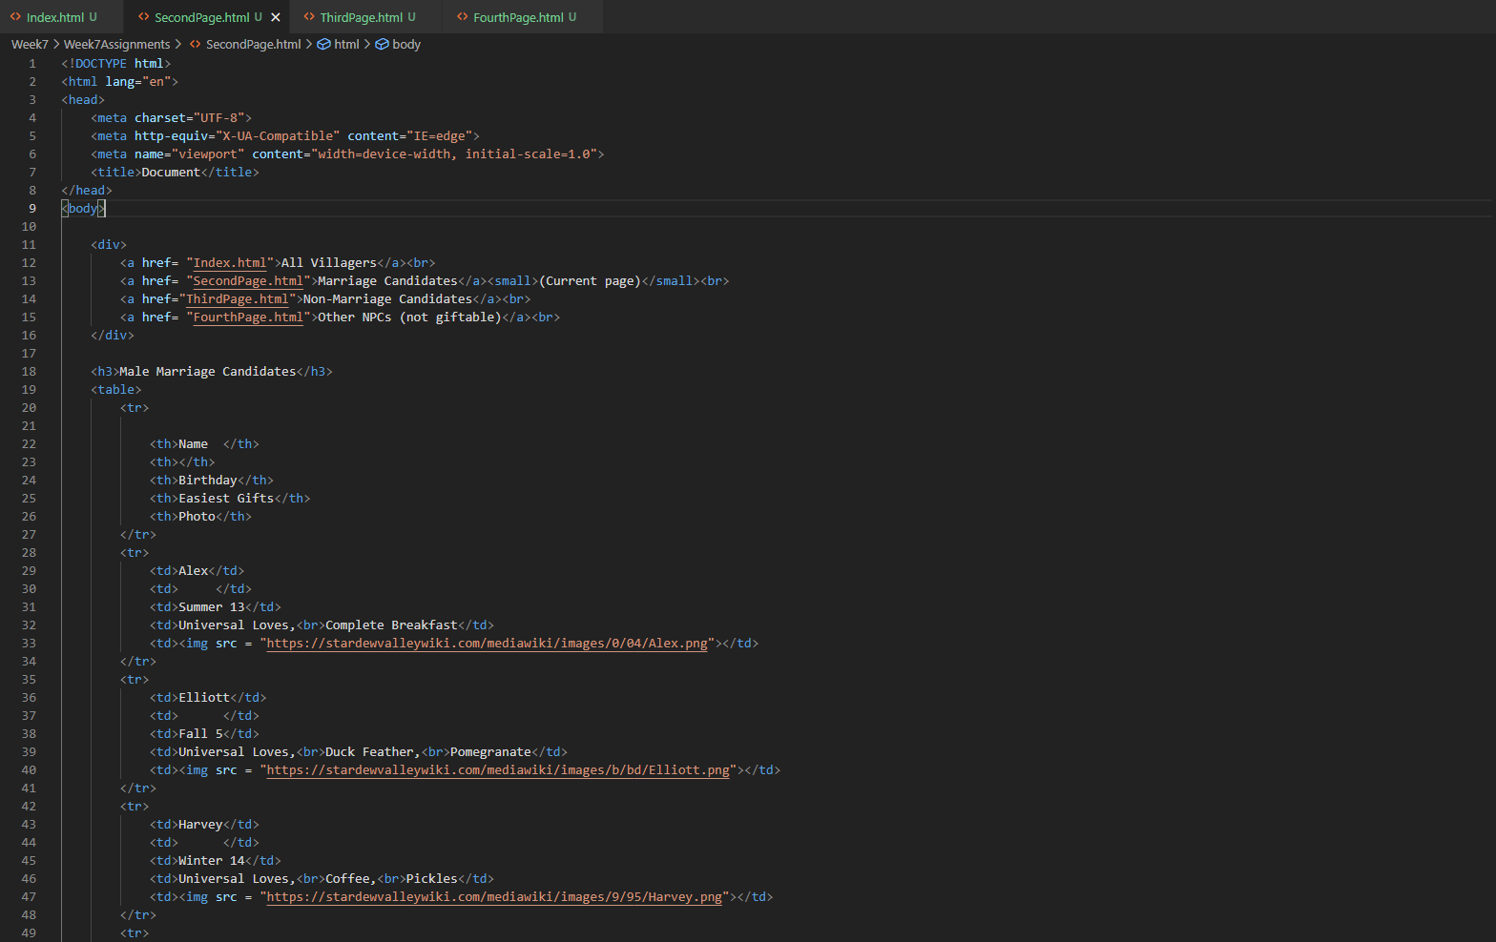
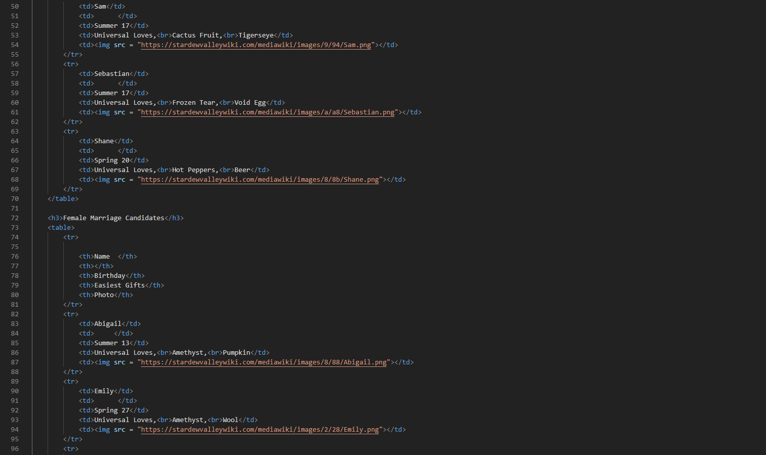
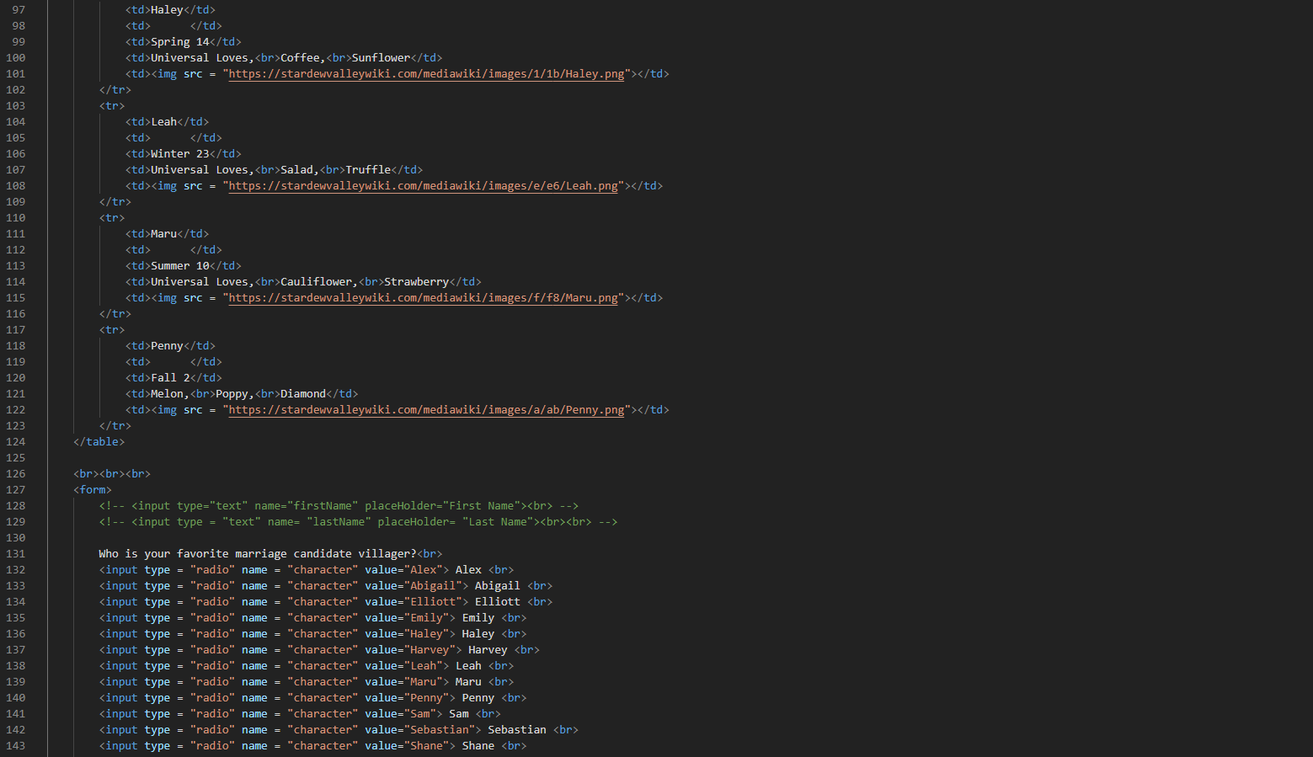
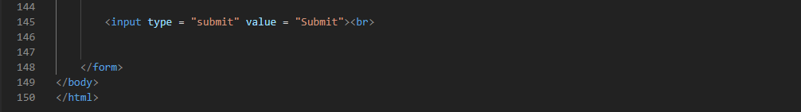
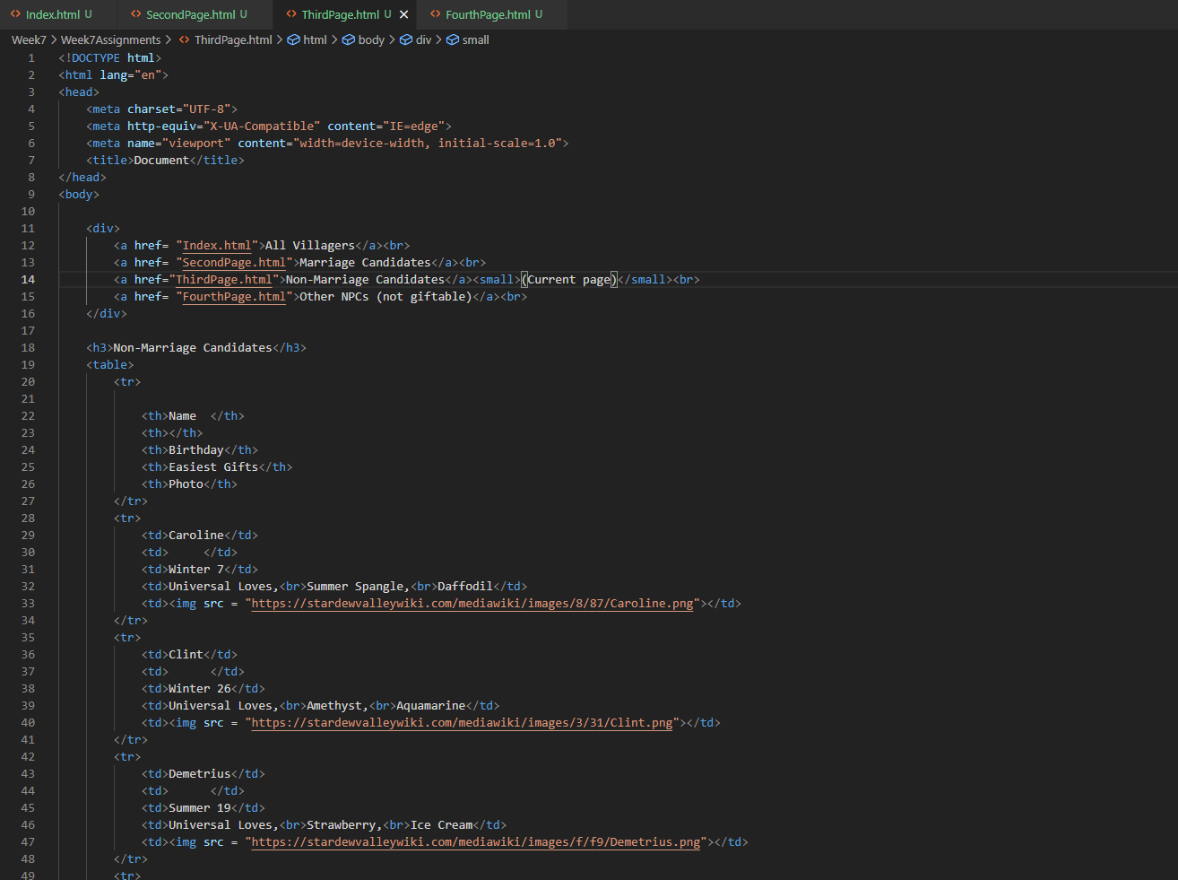
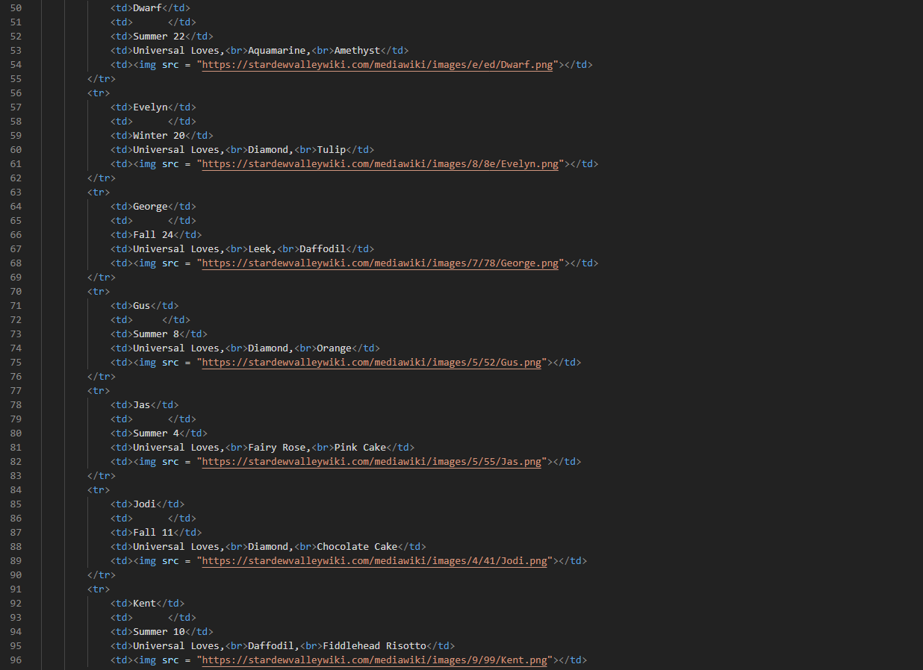
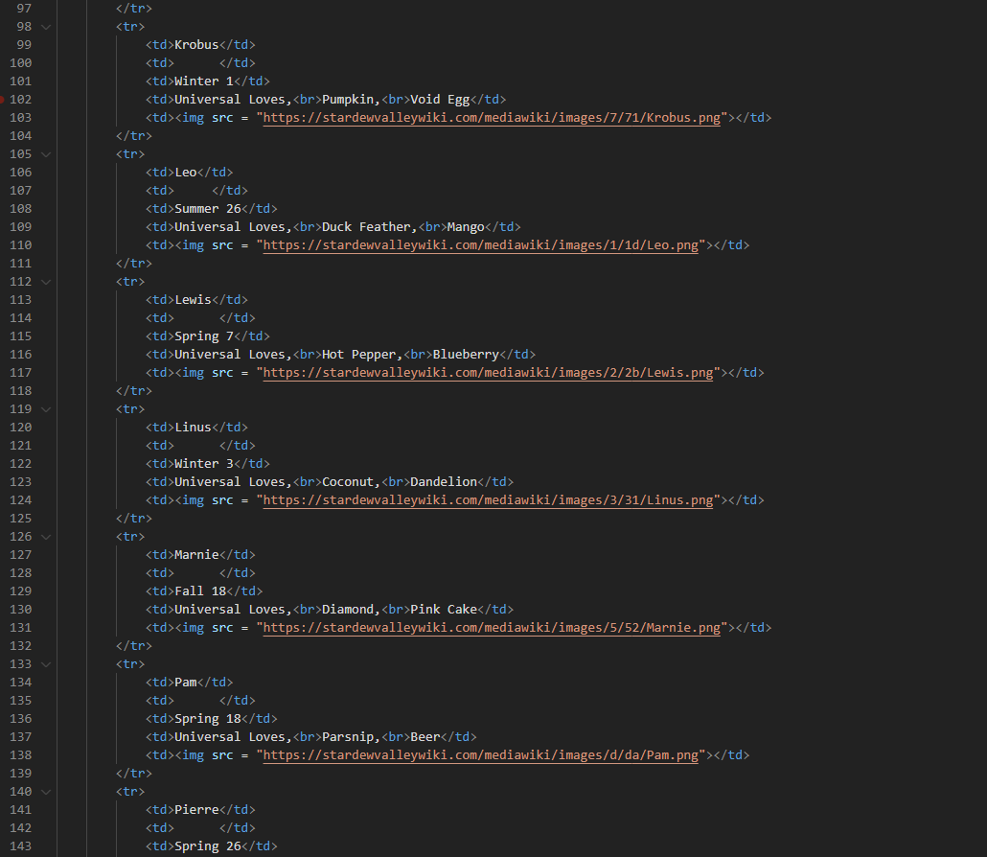
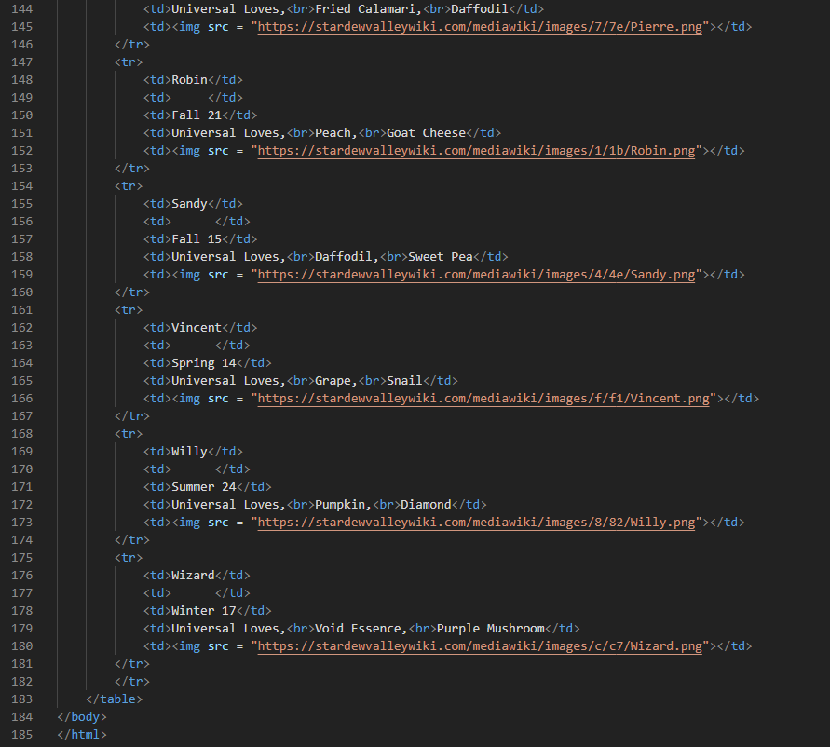
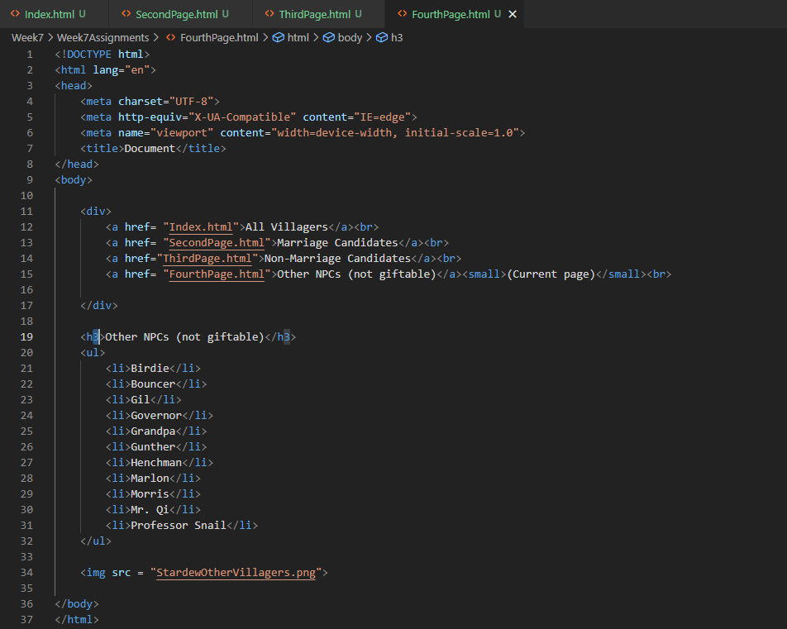
Screenshots of Running Application:
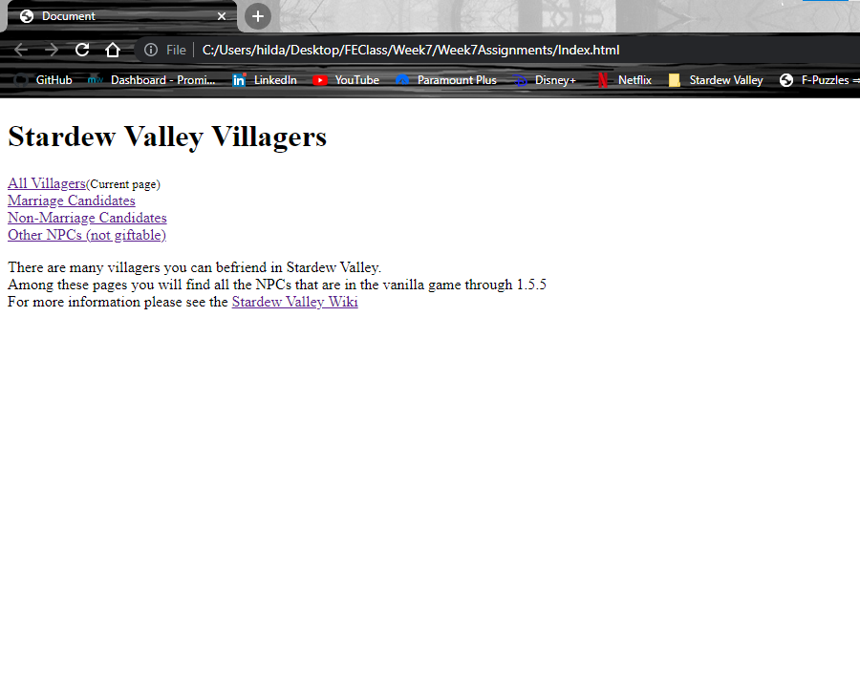
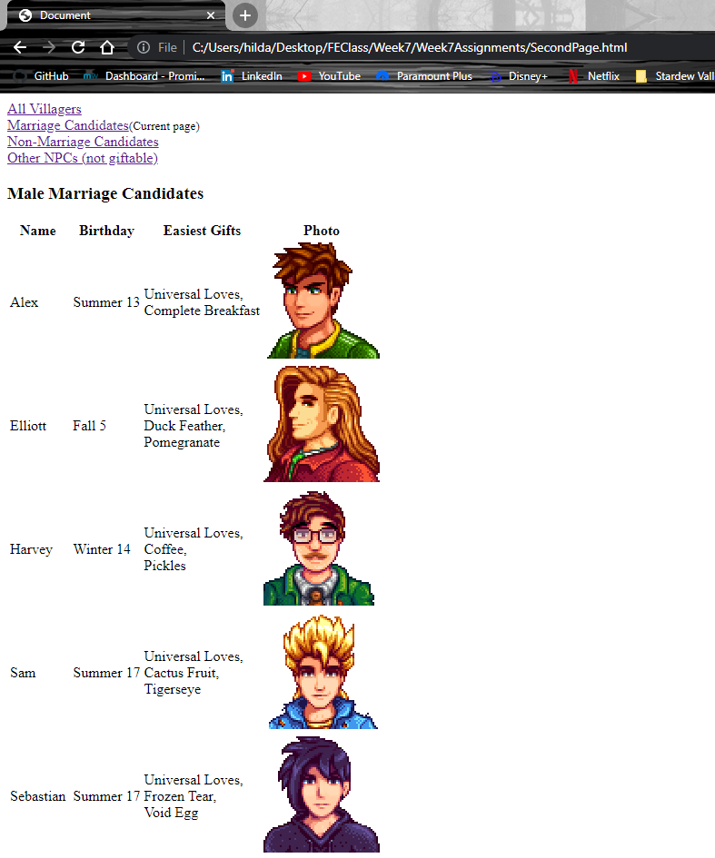
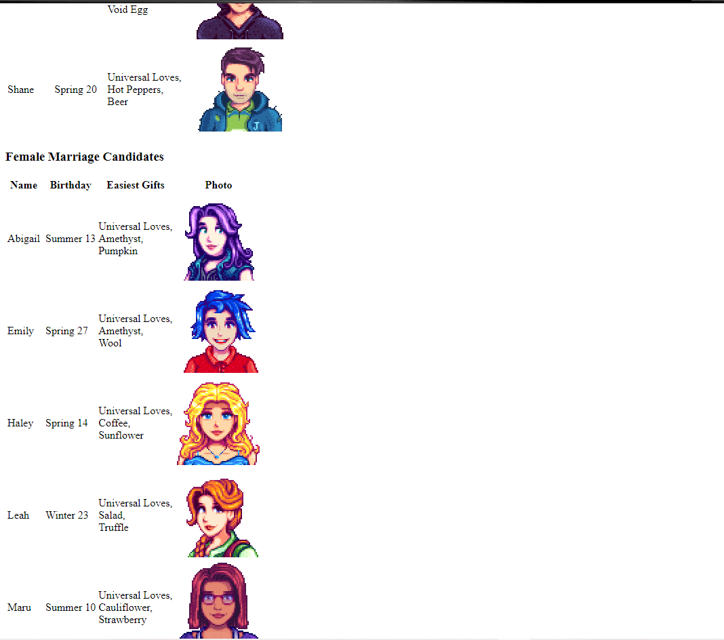
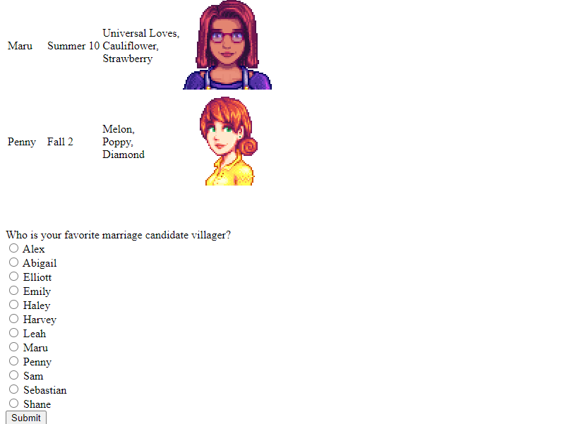
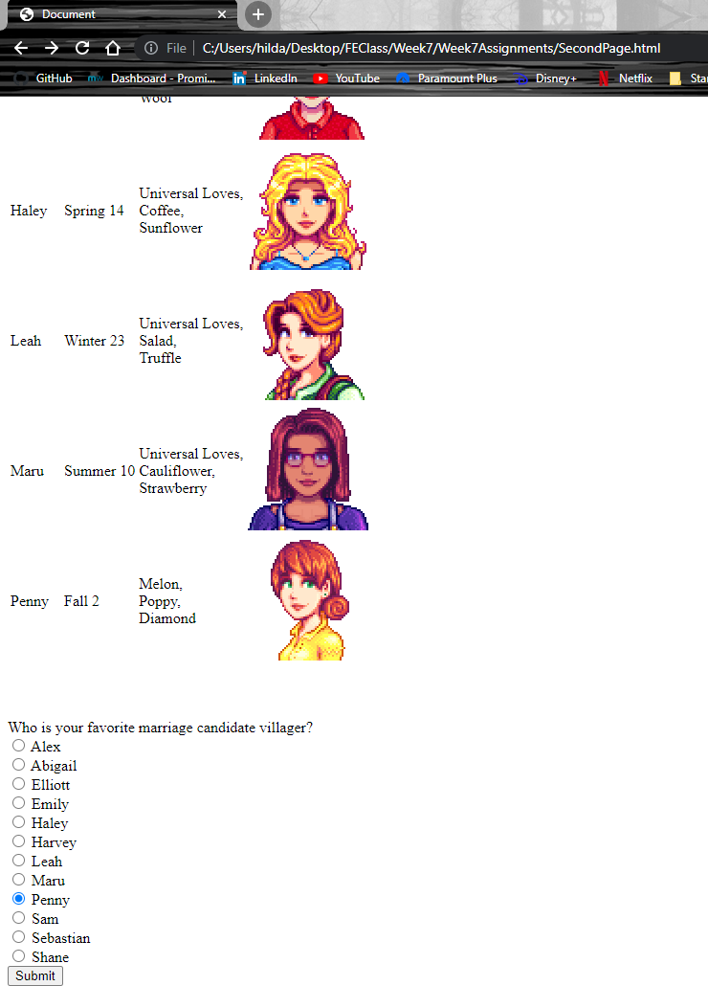
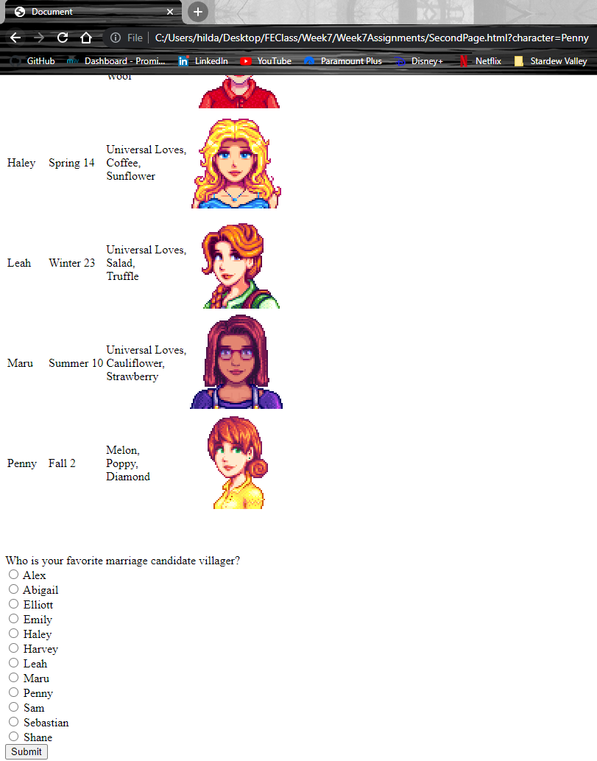
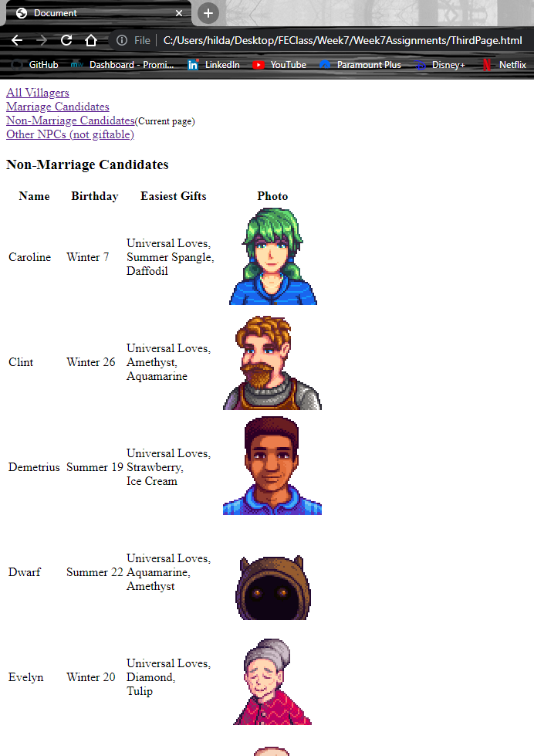
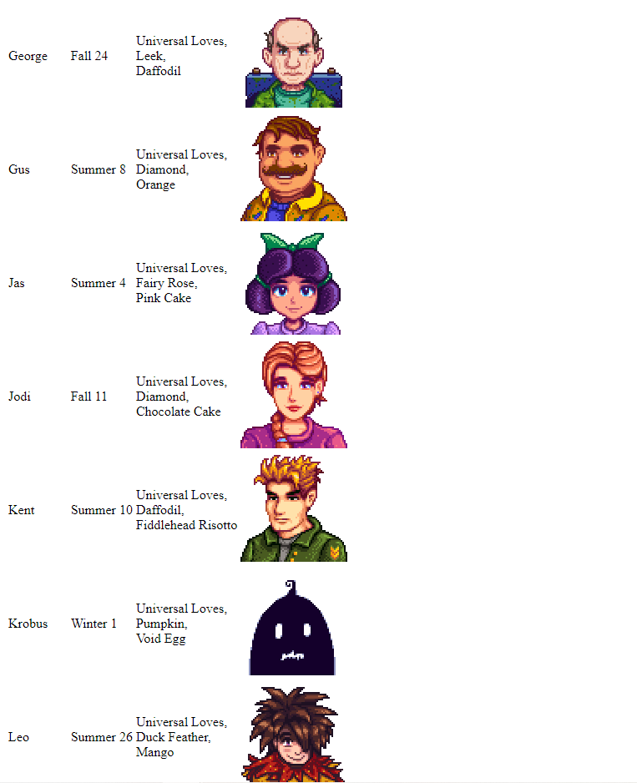
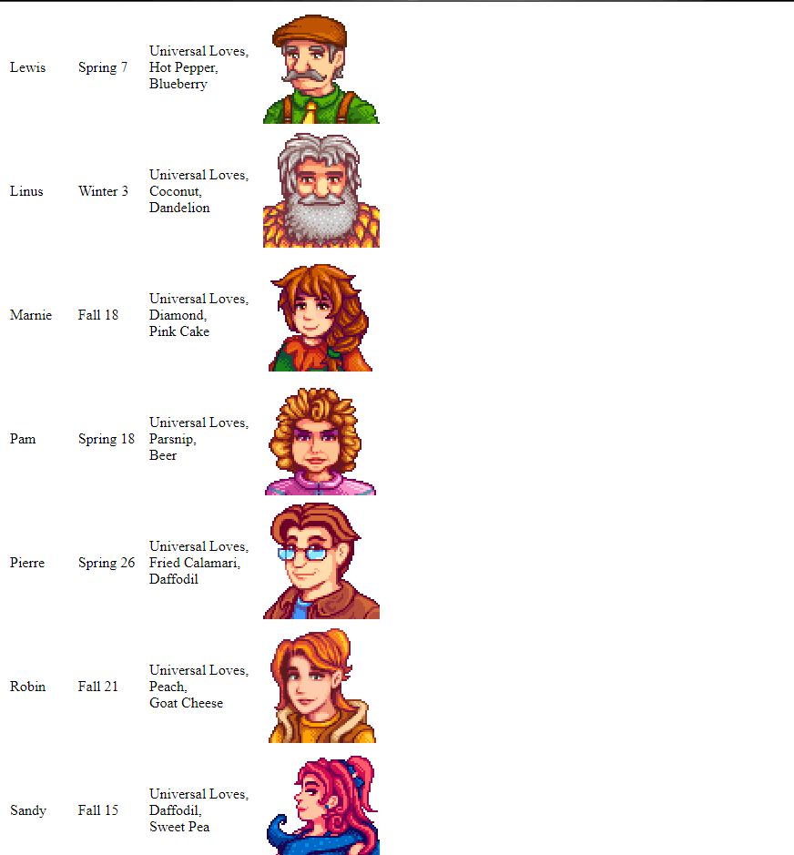
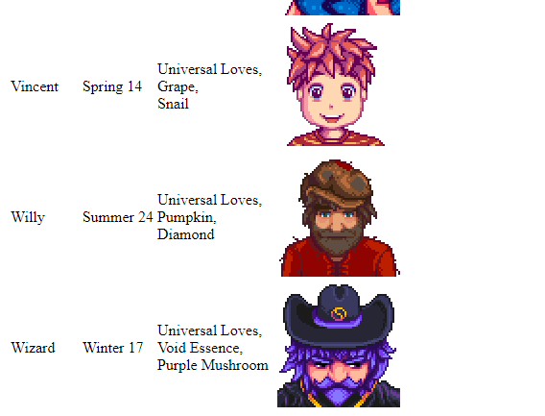
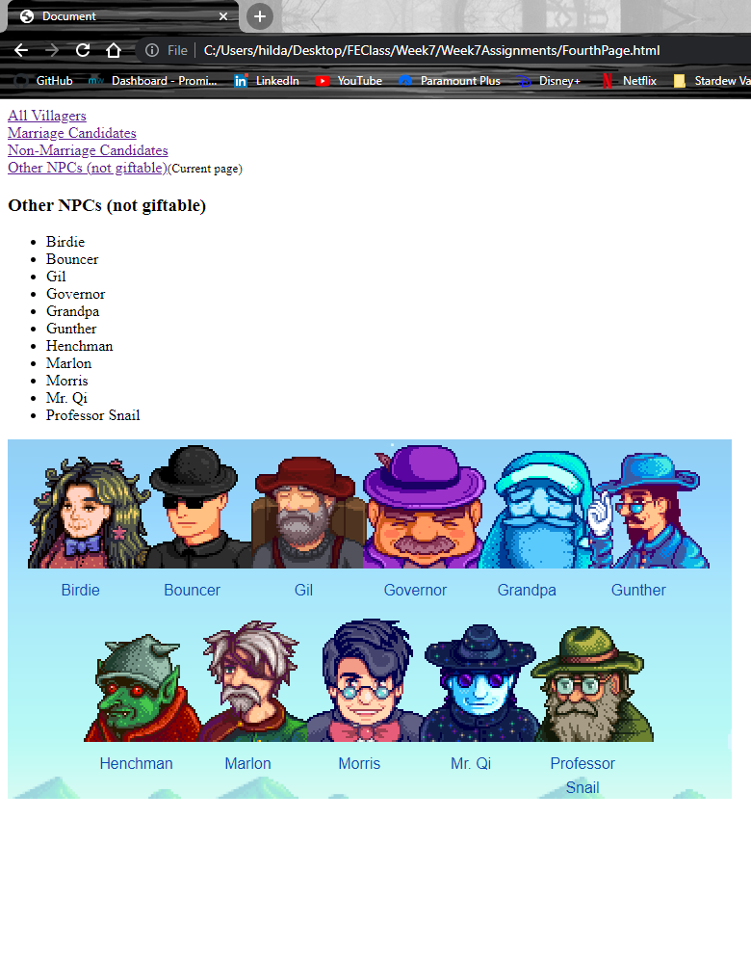

URL to GitHub Repository:
https://github.com/hildadahlstrom/Week7Assignment

