
Front End Technologies Week 2 Coding Assignment
Points possible: 70
Category | Criteria | % of Grade
Functionality | Does the code work? | 25
Organization | Is the code clean and organized? Proper use of white space, syntax, and consistency are utilized. Names and comments are concise and clear. | 25
Creativity | Student solved the problems presented in the assignment using creativity and out of the box thinking. | 25
Completeness | All requirements of the assignment are complete. | 25

Instructions: In VS Code, or an IDE of your choice, write the code that accomplishes the objectives listed below. Ensure that the code compiles and runs as directed. Take screenshots of the code and of the running program (make sure to get screenshots of all required functionality) and paste them in this document where instructed below. Create a new repository on GitHub for this week’s assignments and push this document, with your JavaScript project code, to the repository. Add the URL for this week’s repository to this document where instructed and submit this document to your instructor when complete.
Coding Steps:
- Style the website you made last week using CSS. Below are the requirements:
  - Use only external CSS file (no internal or inline styling)
  - Every element must be styled
  - Create style rules using class, id, and element selectors
Screenshots of Code:
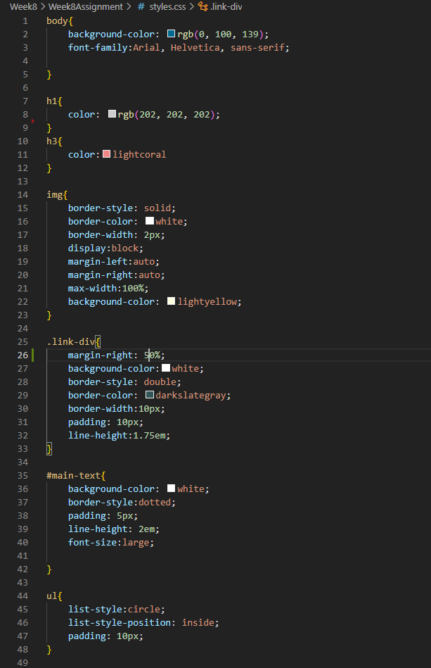
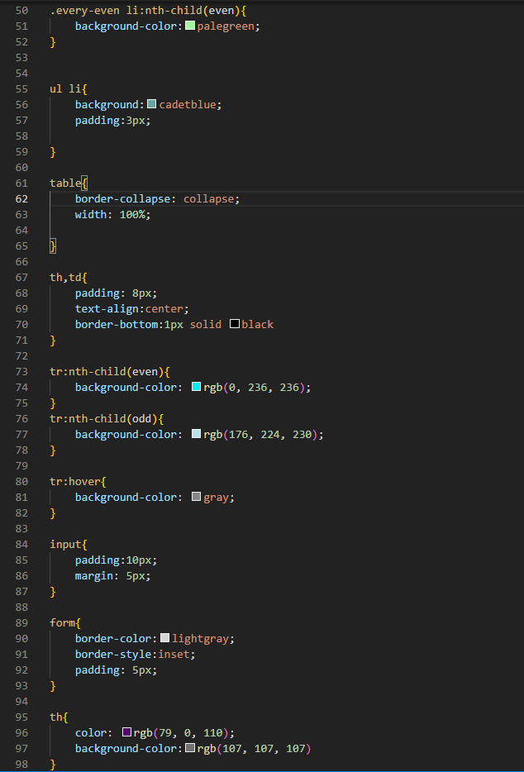
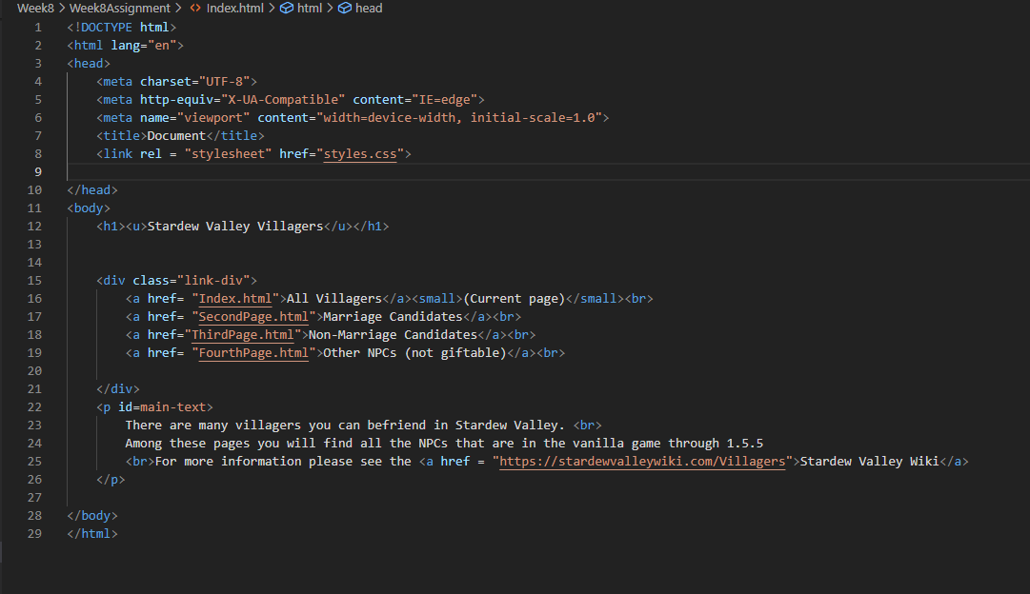
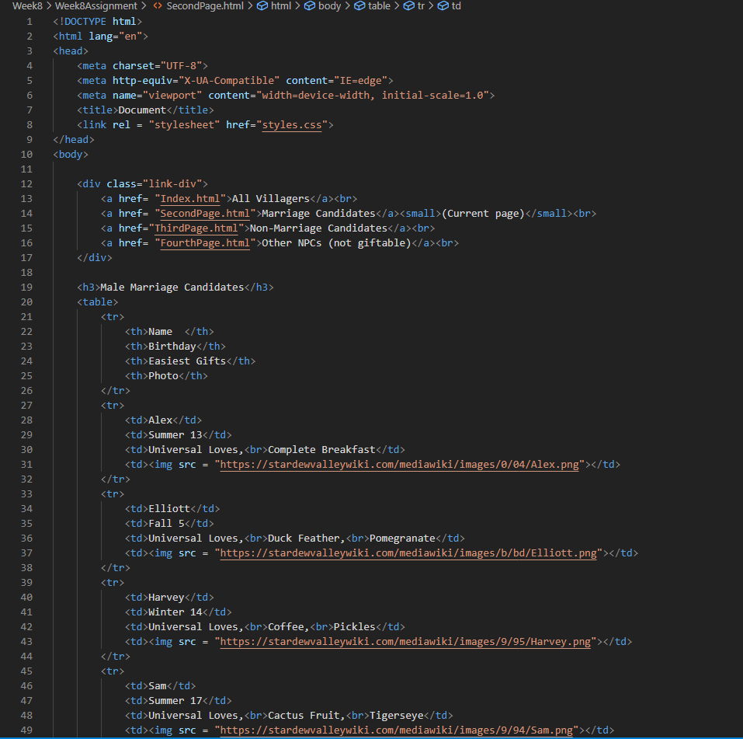
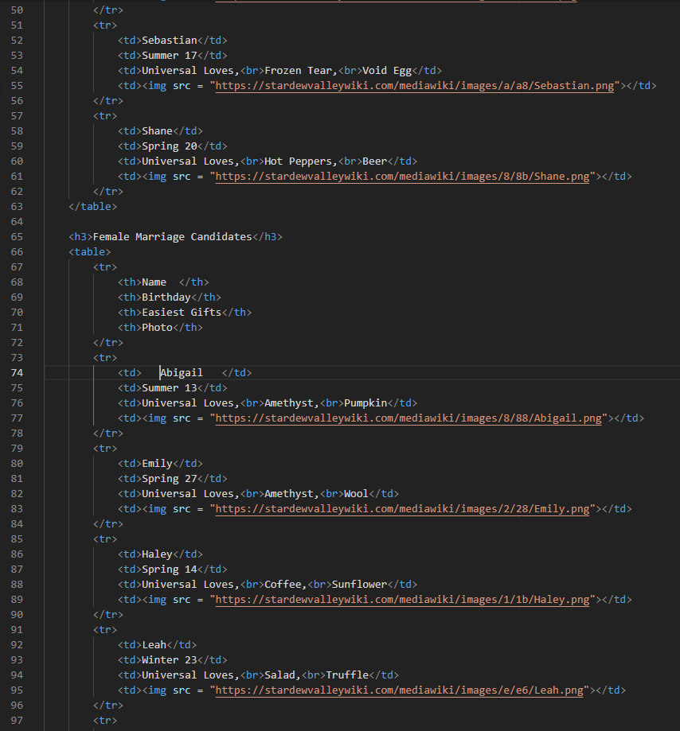
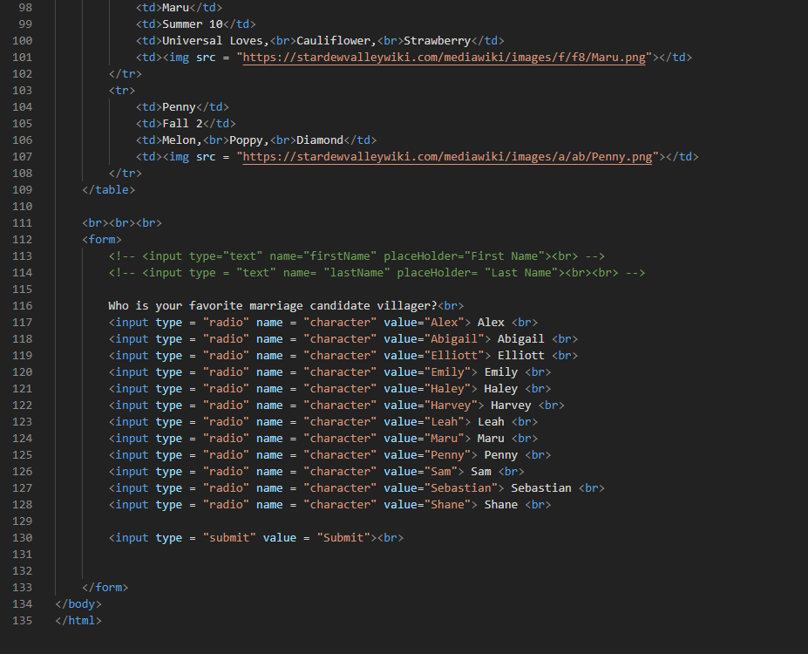
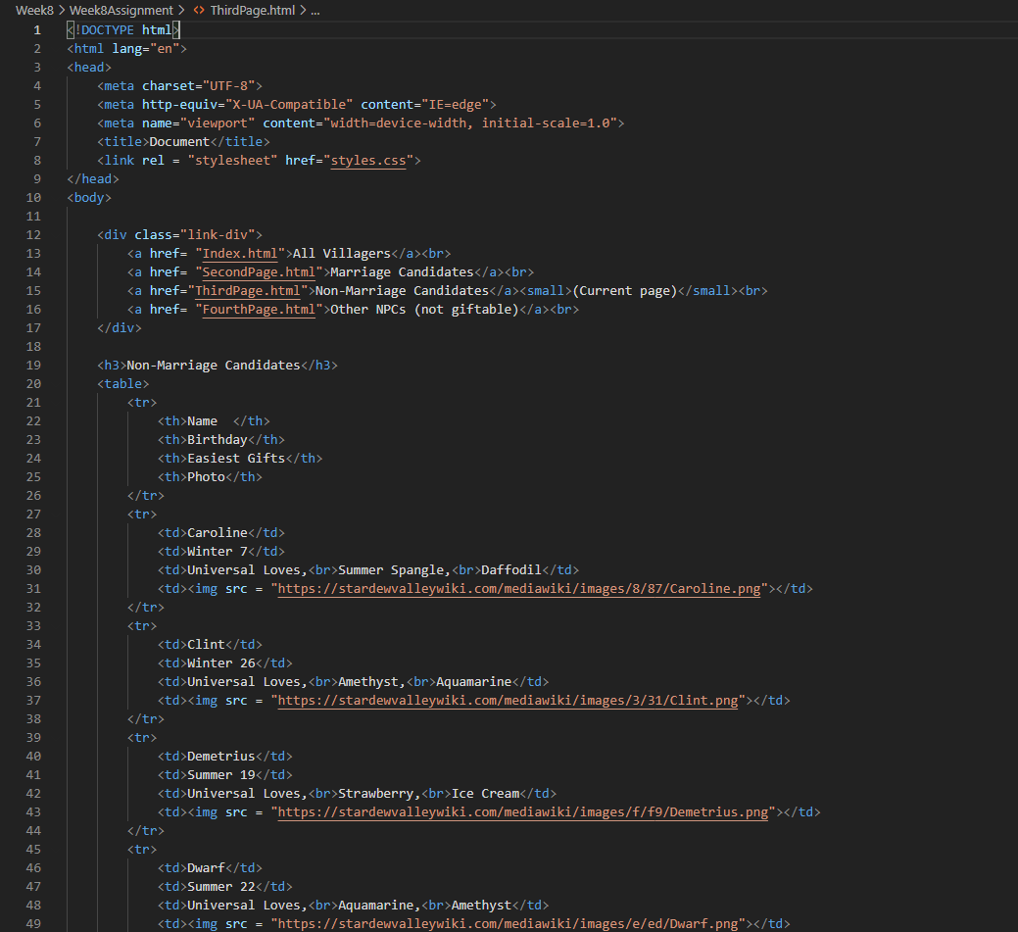
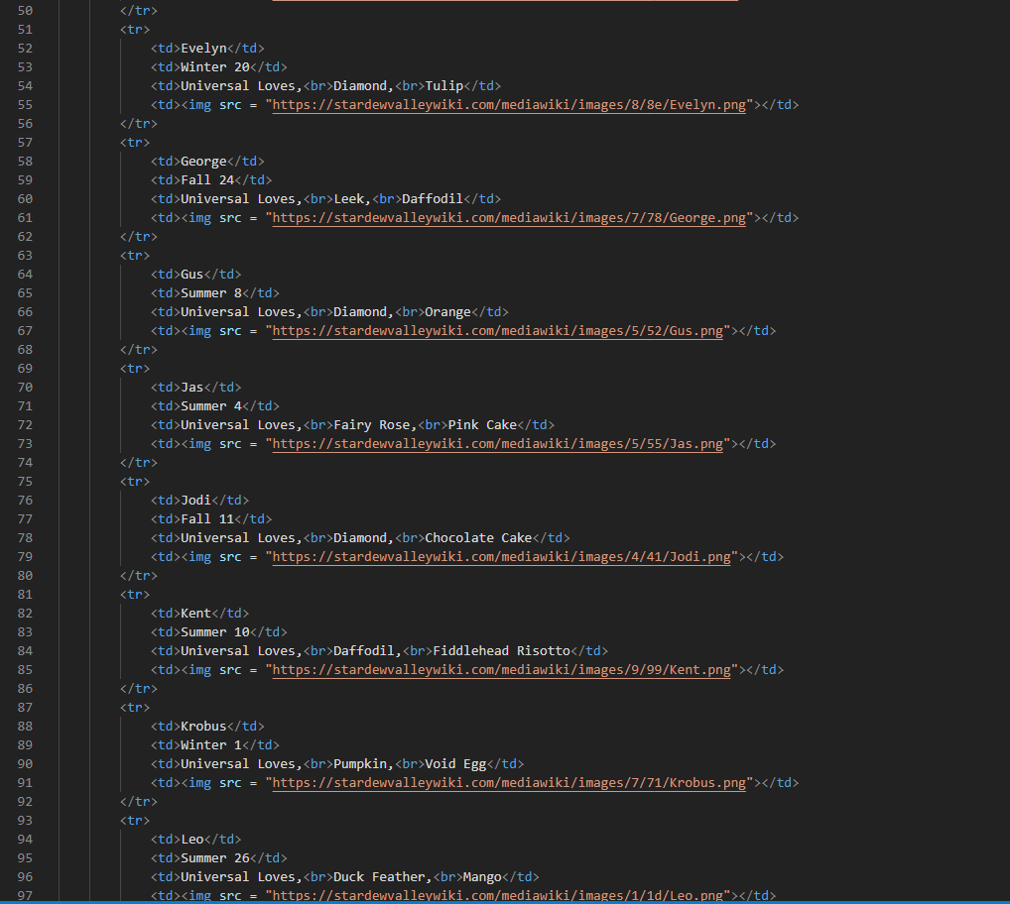
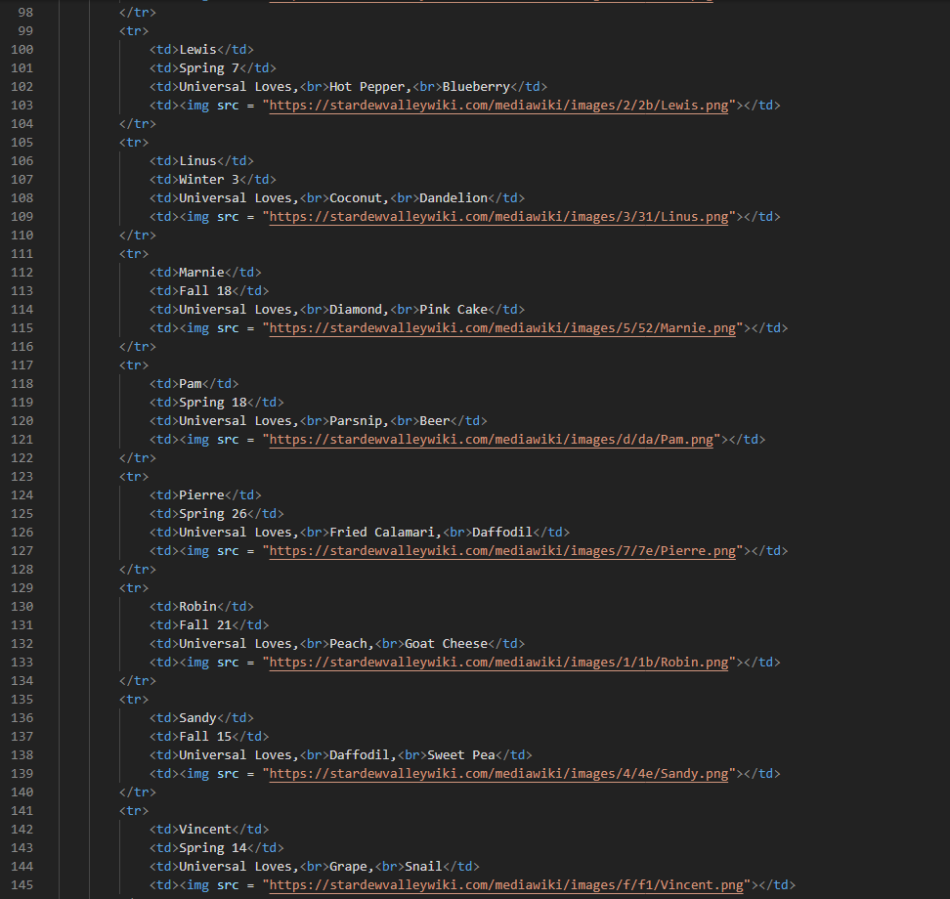
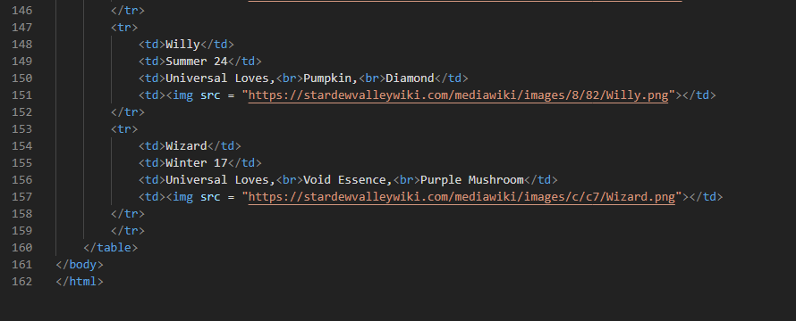
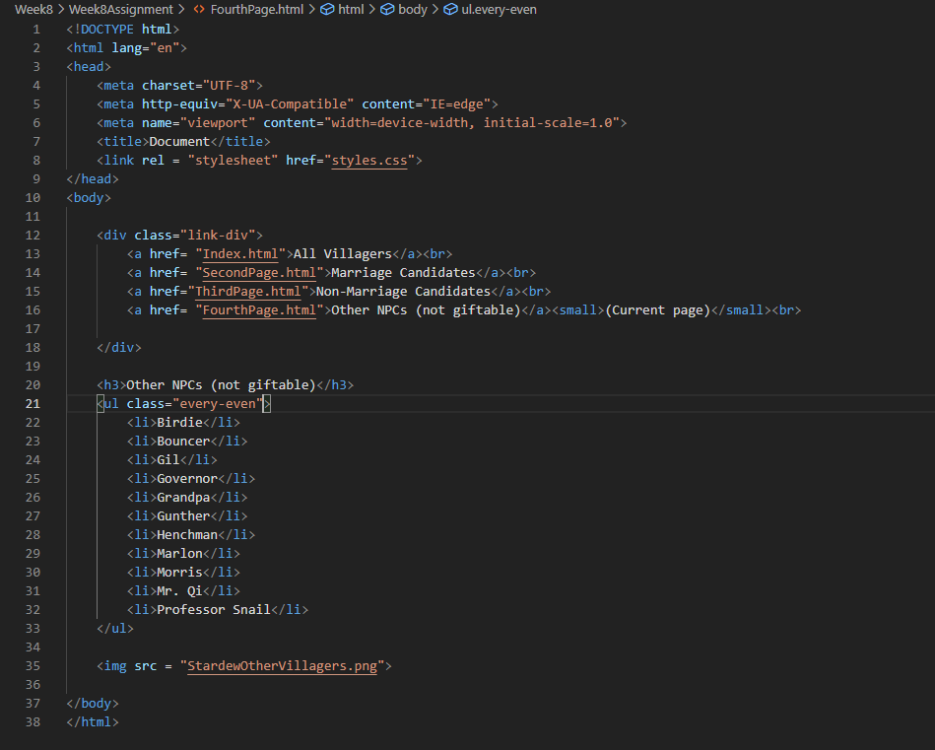

Screenshots of Running Application:
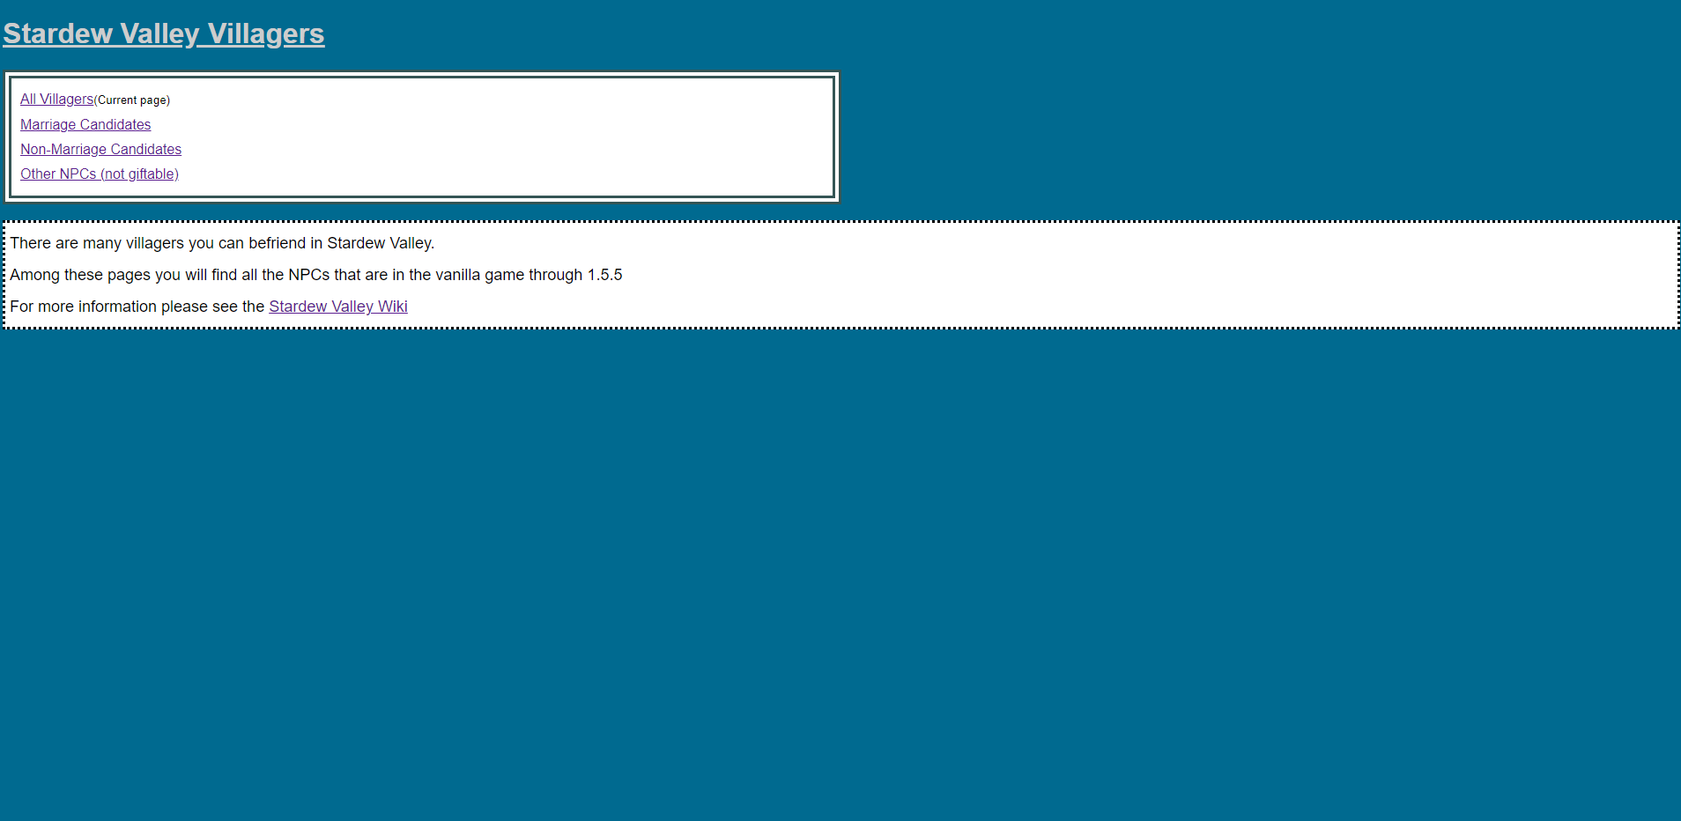
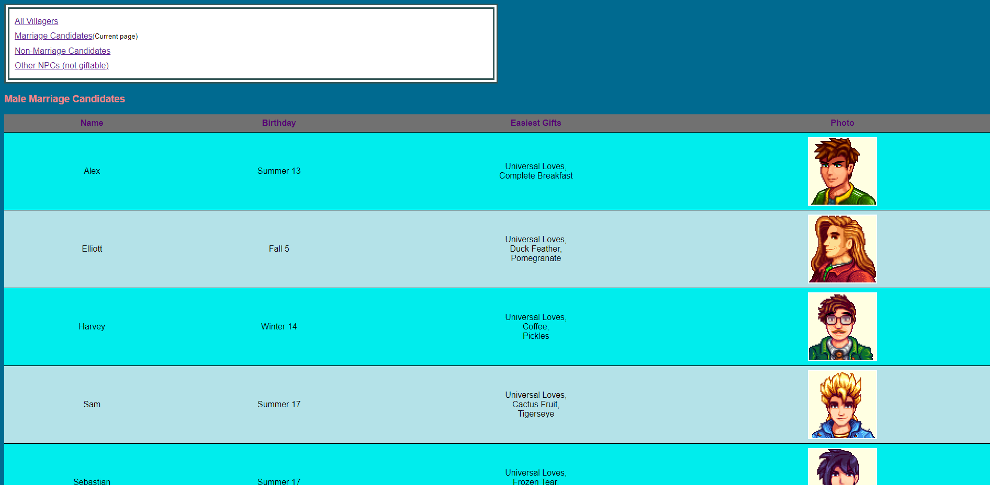
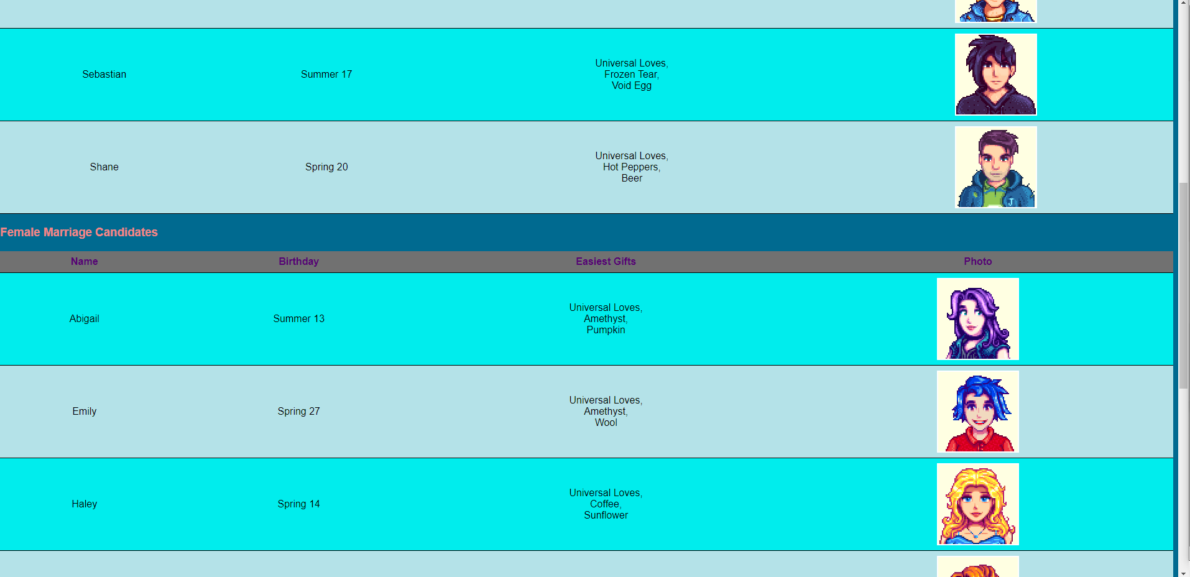
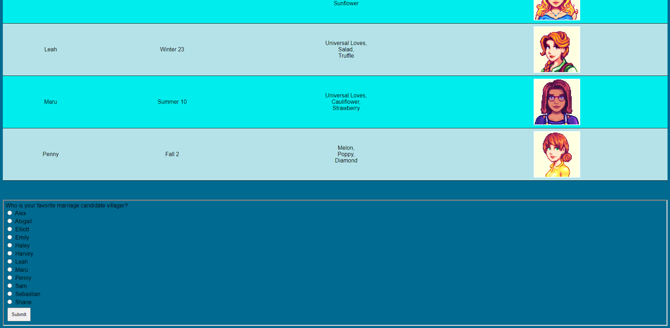
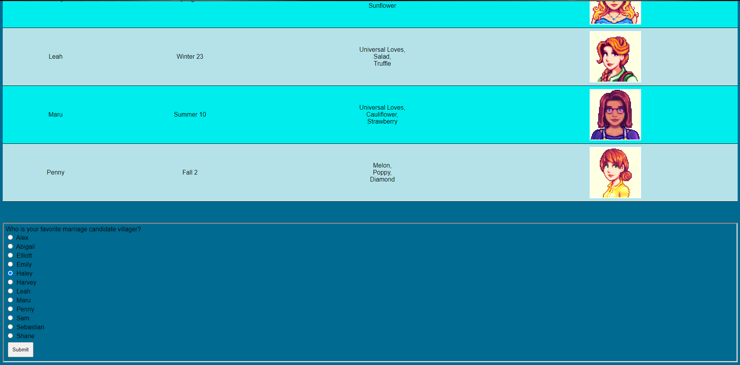
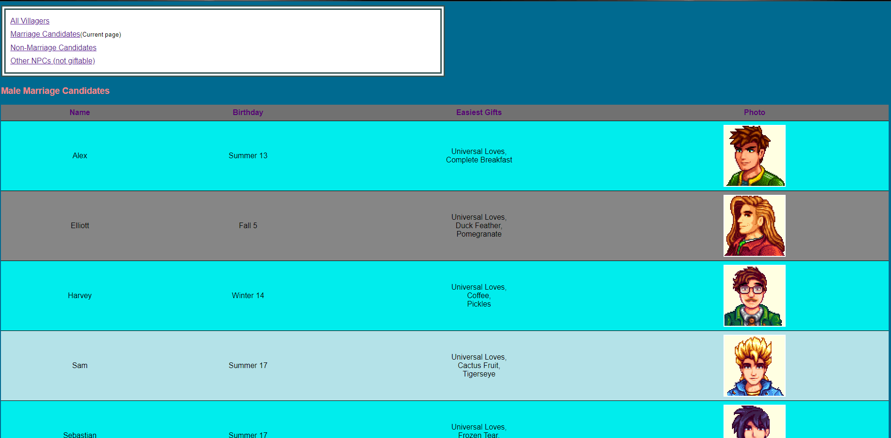
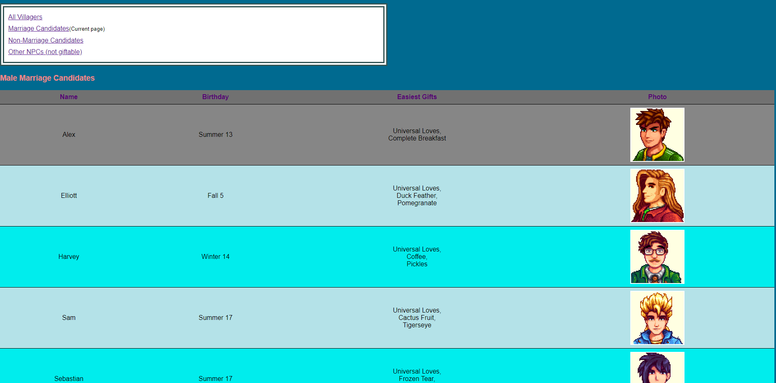
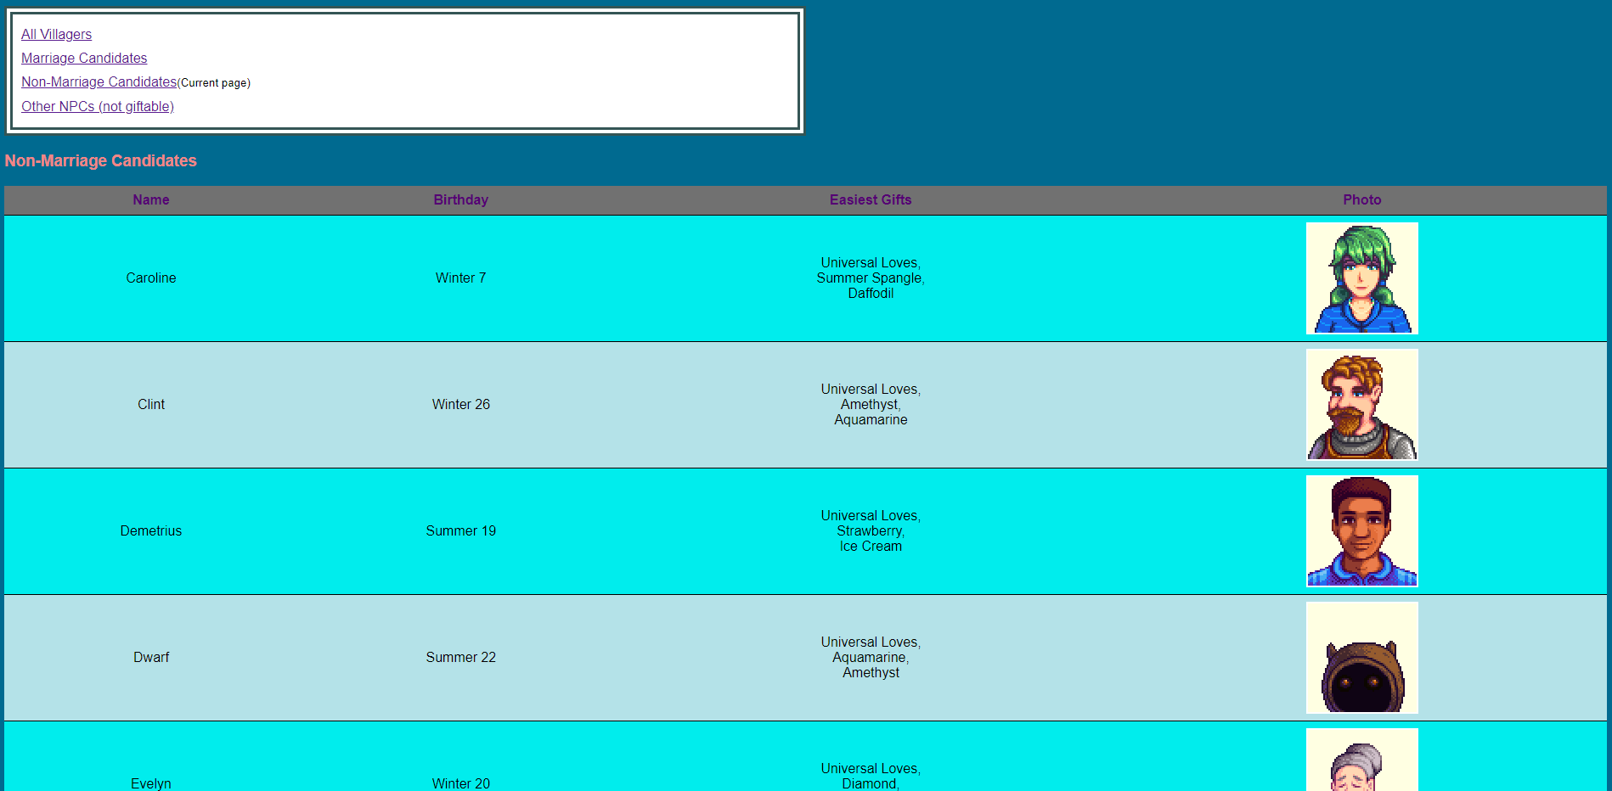
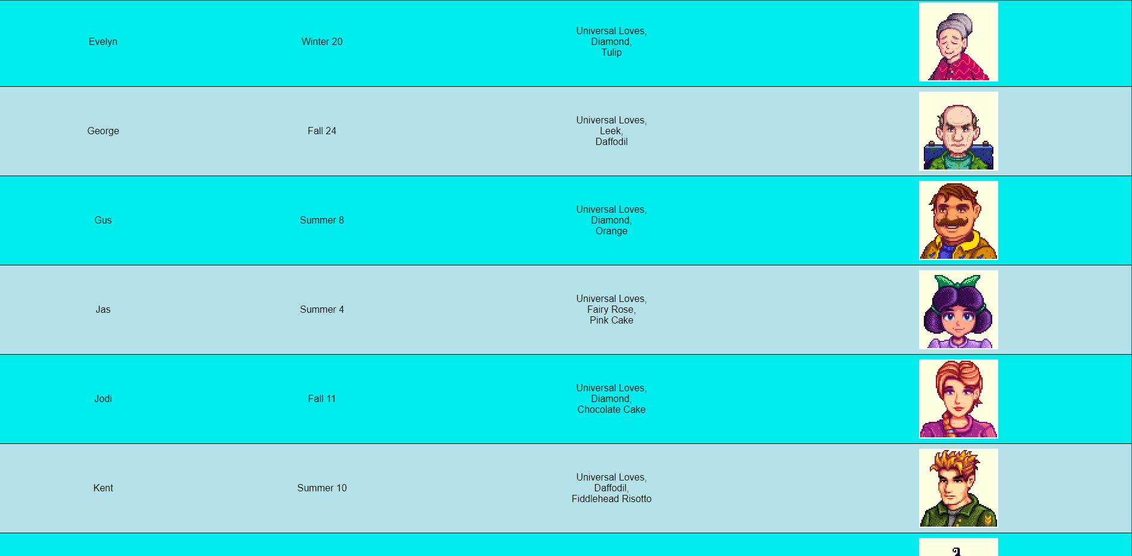
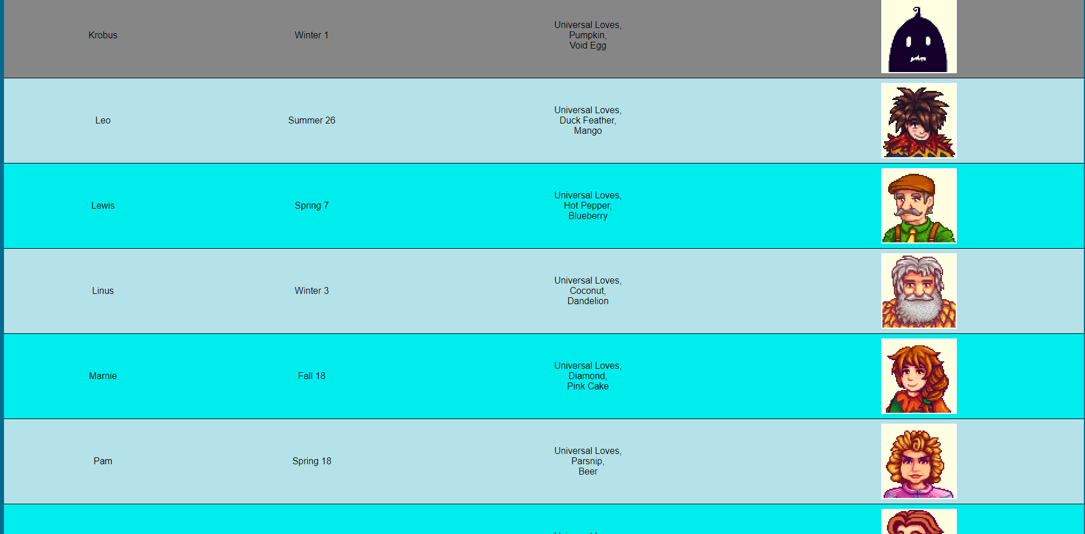
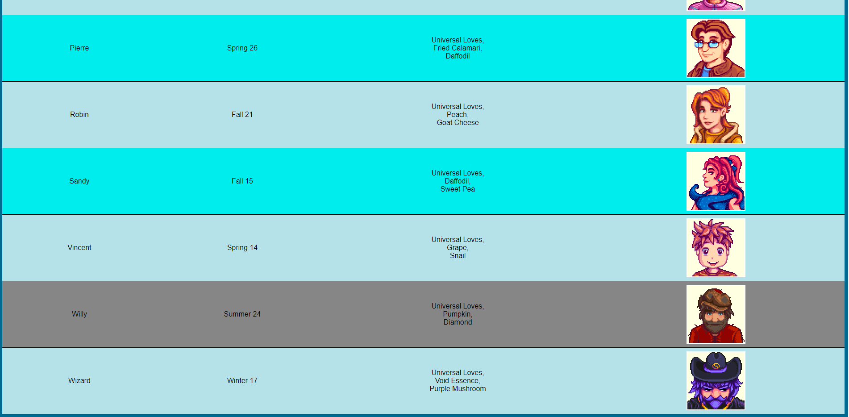
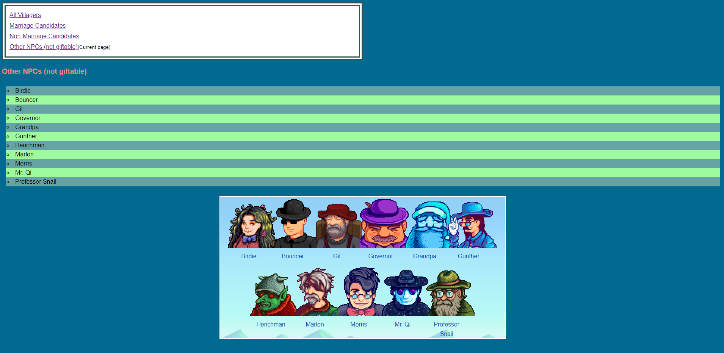

URL to GitHub Repository:
https://github.com/hildadahlstrom/Week8Assignment

