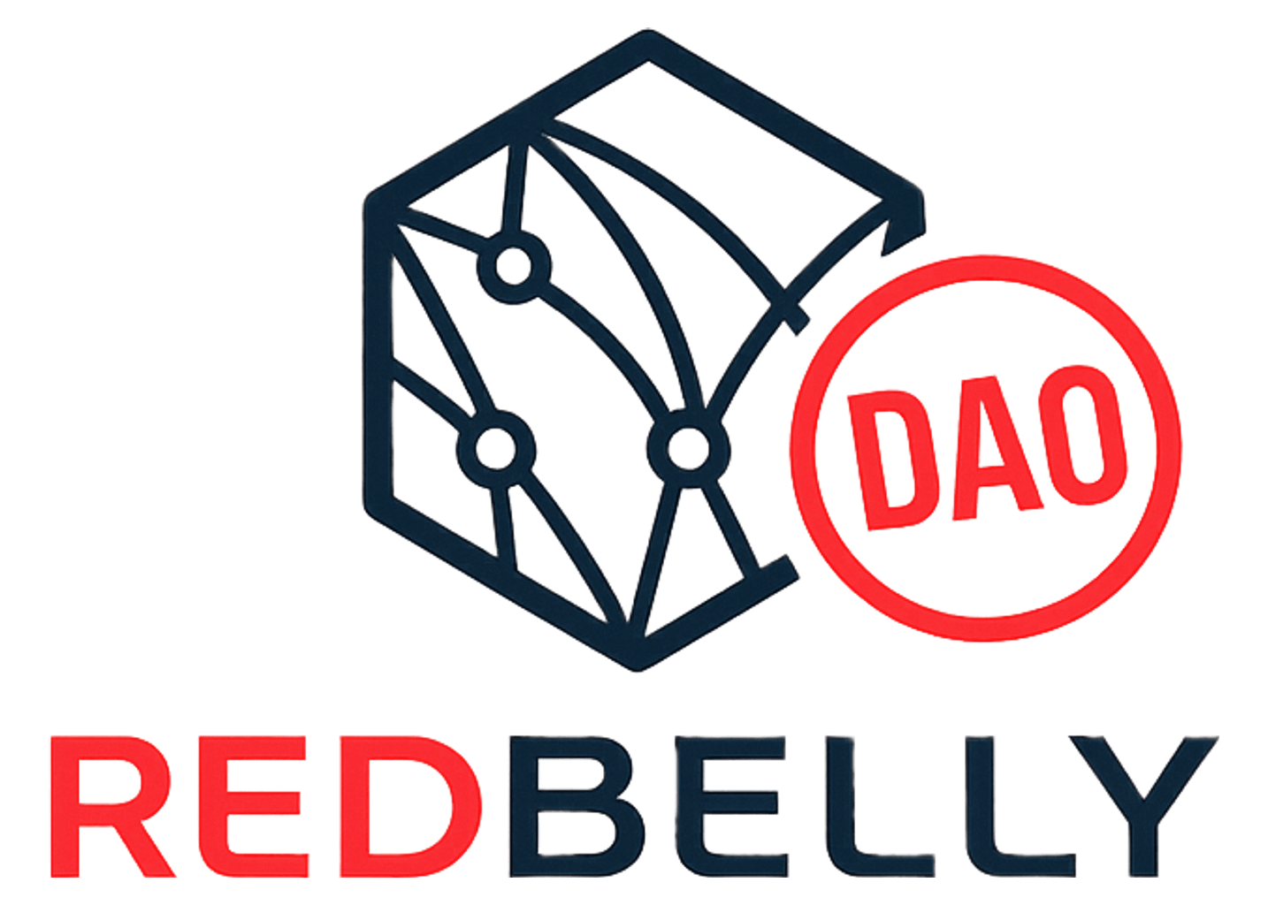
TASK-25
Proposal Evaluation Rubric
Criteria-to-Constitution mapping for automated pre-screening
Sources
Task: TASK-25, Proposal Evaluation Framework with Automated Pre-Screening.
Checklist: “Adoption of Standardised Proposal Evaluation Criteria,” Snapshot proposal #7, moderator CaptDeFi. Passed, ratified 6 Oct 2025.
https://snapshot.box/#/s:rbnt.eth/proposal/0xf2a05384e37a710c1600db1abbac9b4dc66444a56a1ed49df7f0e3dbfd7570e7
Constitution: Redbelly Community DAO Constitution v1.3, current. Supersedes v1.2 (ratified via Snapshot vote 20 Sep 2025). Version history: governance consolidation incorporating ratified constitutional questionnaire and meeting clarifications.
https://cdn.jsdelivr.net/gh/hildecorp/redbellydaotask25@main/website/constitutionv1.3.pdf
Code of Conduct: Redbelly Community DAO Code of Conduct v1.0, ratified via Snapshot vote 6 Oct 2025.
https://firebasestorage.googleapis.com/v0/b/redbelly-community-dao.firebasestorage.app/o/resources%2F1762476540292-Redbelly%20Community%20DAO%20Code%20of%20Conduct%20-%20Ratified.pdf?alt=media&token=84ca2c33-a502-4991-9720-4e6154847416
How to read this
Each of the 11 criteria below carries the pass conditions and flag condition exactly as ratified, with no rewording. Below that, this rubric adds a Constitution anchor: the section of Constitution v1.3 (or the Code of Conduct) that grounds the criterion in DAO governance text, so a flag can cite a rule number instead of a reviewer's opinion. Four criteria have never had a clean anchor. That is stated plainly rather than forced. A fifth, Strategic Fit, lost its anchor when Constitution v1.3 retired the pod structure section entirely. That history, and one other ratified-text gap, are named in Known Discrepancies at the end rather than silently resolved.

1. Budget Alignment & Limits
PASS WHEN
- Clear separation of USDT (external spend) and RBNT (internal rewards).
- Cost breakdown or justification included.
FLAG WHEN
- Flag if missing USDT/RBNT split, excessive allocation, or weak justification.
CLEAN MATCH Constitution anchor: Section 5.7, Budgeting.
Annual cap 100,000 USDT. RBNT: 10,000,000 total available for DAO incentives. 10% minimum allocation reserved for Open Innovation.

2. Payment & Payout Structure
PASS WHEN
- Payouts milestone-based or post-completion.
- Upfront requests require clear justification.
- Milestones tied to deliverables.
FLAG WHEN
- Flag if large upfront payments lack justification or no milestone structure provided.
CLEAN MATCH Constitution anchor: Section 6, Contributor Expectations.
Tasks and grants must define clear KPIs, a timeline and milestones, and a reward structure. Section 3.2 step 7, Payment + Archive, applies loosely too.

3. Strategic Fit
PASS WHEN
- Alignment with one of the three working groups (Community, Marketing, Developers/Builders).
- Clear link to DAO-wide goals (adoption, awareness, infrastructure growth).
FLAG WHEN
- Flag if alignment unclear or goals vague.
ANCHOR RETIRED Constitution anchor: No Constitution anchor.
The ratified checklist names three working groups. Constitution v1.2 named five pods for this. The DAO Guild Structure Consolidation vote, passed 20 September 2025, merged two of those five into the other three. Constitution v1.3 then removed the pod structure from the Constitution entirely. The three groups the checklist names are still the ones in practice; nothing in the current Constitution defines or anchors them. See Known Discrepancies, item 1.

4. Feasibility & Timeline
PASS WHEN
- Timeline with milestones/deliverables provided.
- Scope achievable with proposed budget/resources.
- No duplication of existing efforts.
FLAG WHEN
- Flag if timeline absent, milestones vague, or scope unrealistic.
NO CLEAN ANCHOR Constitution anchor: No Constitution section sets a feasibility standard.
Section 3.2, Process Overview, describes the review pipeline, not a feasibility test. This criterion stays a reviewer judgment call, not a text lookup.

5. Oversight & Accountability
PASS WHEN
- Independent reviewer/oversight lead nominated.
- Monthly updates planned in DAO channels.
FLAG WHEN
- Flag if oversight or communication plan missing.
CLEAN MATCH Constitution anchor: Section 5.6, Transparency and Accountability.
Monthly treasury and revenue dashboards, quarterly reporting required by each working group. Section 7's weekly and monthly governance calls, with notes published publicly, add further support.

6. Impact & Measurement
PASS WHEN
- KPIs or measurable success criteria included.
- Midpoint and final review methods defined.
- Long-term/community value identified.
FLAG WHEN
- Flag if no success criteria or only short-term focus.
NO CLEAN ANCHOR Constitution anchor: No Constitution section sets a KPI or review-cadence standard.
Section 5.6 covers DAO-level treasury reporting. That is not the same as project-level success metrics on one proposal, so it is not treated as a match here.

7. Risk & Mitigation
PASS WHEN
- Key risks identified.
- Mitigation strategies outlined.
FLAG WHEN
- Flag if no risks or mitigation described.
NO CLEAN ANCHOR Constitution anchor: The Constitution does not require a risk section on proposals.
No section addresses risk disclosure or mitigation planning at the individual-proposal level.

8. Co-Funding & Leverage
PASS WHEN
- Matching funds, sponsorships, or in-kind contributions noted.
FLAG WHEN
- Flag if no leverage (not a dealbreaker, but relevant).
NO CLEAN ANCHOR Constitution anchor: Co-funding is not addressed anywhere in the Constitution.
Treat this criterion as a reviewer note, not a constitutional test.

9. Contribution Equity
PASS WHEN
- No single contributor dominating payouts.
- Proposer not holding multiple paid lead roles without justification.
FLAG WHEN
- Flag if payouts concentrated with same individual(s).
CLEAN MATCH Constitution anchor: Section 4, Conflict of Interest Policy.
“One paid role per individual per quarter” maps directly to this criterion's payout-concentration test.

10. Compliance & Ethical Standards
PASS WHEN
- No regulatory/reputational risks.
- Consistency with DAO's code of conduct.
FLAG WHEN
- Flag if unclear or non-compliant activities proposed.
PRIMARY ANCHOR Constitution anchor: Code of Conduct v1.0 (Core Principles, Expected/Unacceptable Behaviors, Enforcement).
Constitution Section 4 applies loosely as a conflict-of-interest-adjacent backstop, but the Code of Conduct is the direct source for this criterion.

11. Community Involvement
PASS WHEN
- Evidence of discussion with community members.
FLAG WHEN
No flag condition given in the ratified text. This is the only criterion of the 11 without one. See Known Discrepancies, item 2.
CLEAN MATCH Constitution anchor: Section 7, Community Involvement.
Section 3.2 step 3, Feedback via Discord with a 3-day window, is the process this criterion checks for evidence of.

Known Discrepancies
1. Three working groups, five pods, then none. Criterion 3 (Strategic Fit) checks alignment with “one of the three working groups (Community, Marketing, Developers/Builders).” Constitution v1.2 ratified five pods for this: Marketing, Builder/Develop, Researcher, Community, Partnerships. The DAO Guild Structure Consolidation vote, passed 20 September 2025, about 3 hours after v1.2 itself, merged Partnerships and Research into the other three, leaving the same three the checklist names. Constitution v1.3 then removed the pod structure section outright; no section defines working groups or pods anymore. Pre-screening still checks alignment against the three named groups, since that is the ratified checklist text; it just has no Constitution section left to cite.
2. Criterion 11 has no flag condition. Every other criterion (1 through 10) pairs its pass condition with an explicit “Flag if…” line. Criterion 11 (Community Involvement) ends after “Evidence of discussion with community members.” This was checked against the full ratified text; it is not a capture gap. Until pod leaders add a flag condition, this criterion cannot fail a proposal on its own, and the pre-screening flow treats it as informational only.


End of TASK-25 Proposal Evaluation Rubric

