Choosing the Number of Segments
Silhouette scores for two to five clusters, using KMeans and hierarchical clustering
Prepared by Hilda Mukonyora | 14 October 2026

1. Executive summary
The chart compares how cleanly the investor rankings divide into two, three, four or five clusters. The measure is the silhouette score, which runs from -1 to 1 and rewards clusters that are tight and well separated from each other. Two clustering methods were tested at each size.
- Three clusters score best. Both methods reach about 0.455 at k=3, the highest value on the chart. This supports the three-segment solution used in the earlier reports.
- Two clusters are a close second. At about 0.427 for both methods, k=2 trails k=3 by only 0.028, so a two-group solution cannot be ruled out.
- Four and five clusters are clearly worse. Scores drop to about 0.35 at k=4 and recover only to about 0.36 at k=5.
- The two methods agree. KMeans and hierarchical clustering differ by 0.005 at most, so the preference for k=3 does not depend on the algorithm.
- The structure is moderate, not strong. A score of 0.455 sits in the band that a commonly cited rule of thumb (Kaufman and Rousseeuw) labels weak-to-moderate structure, so the segments should be treated as useful groupings and not sharply separated types.

2. The chart
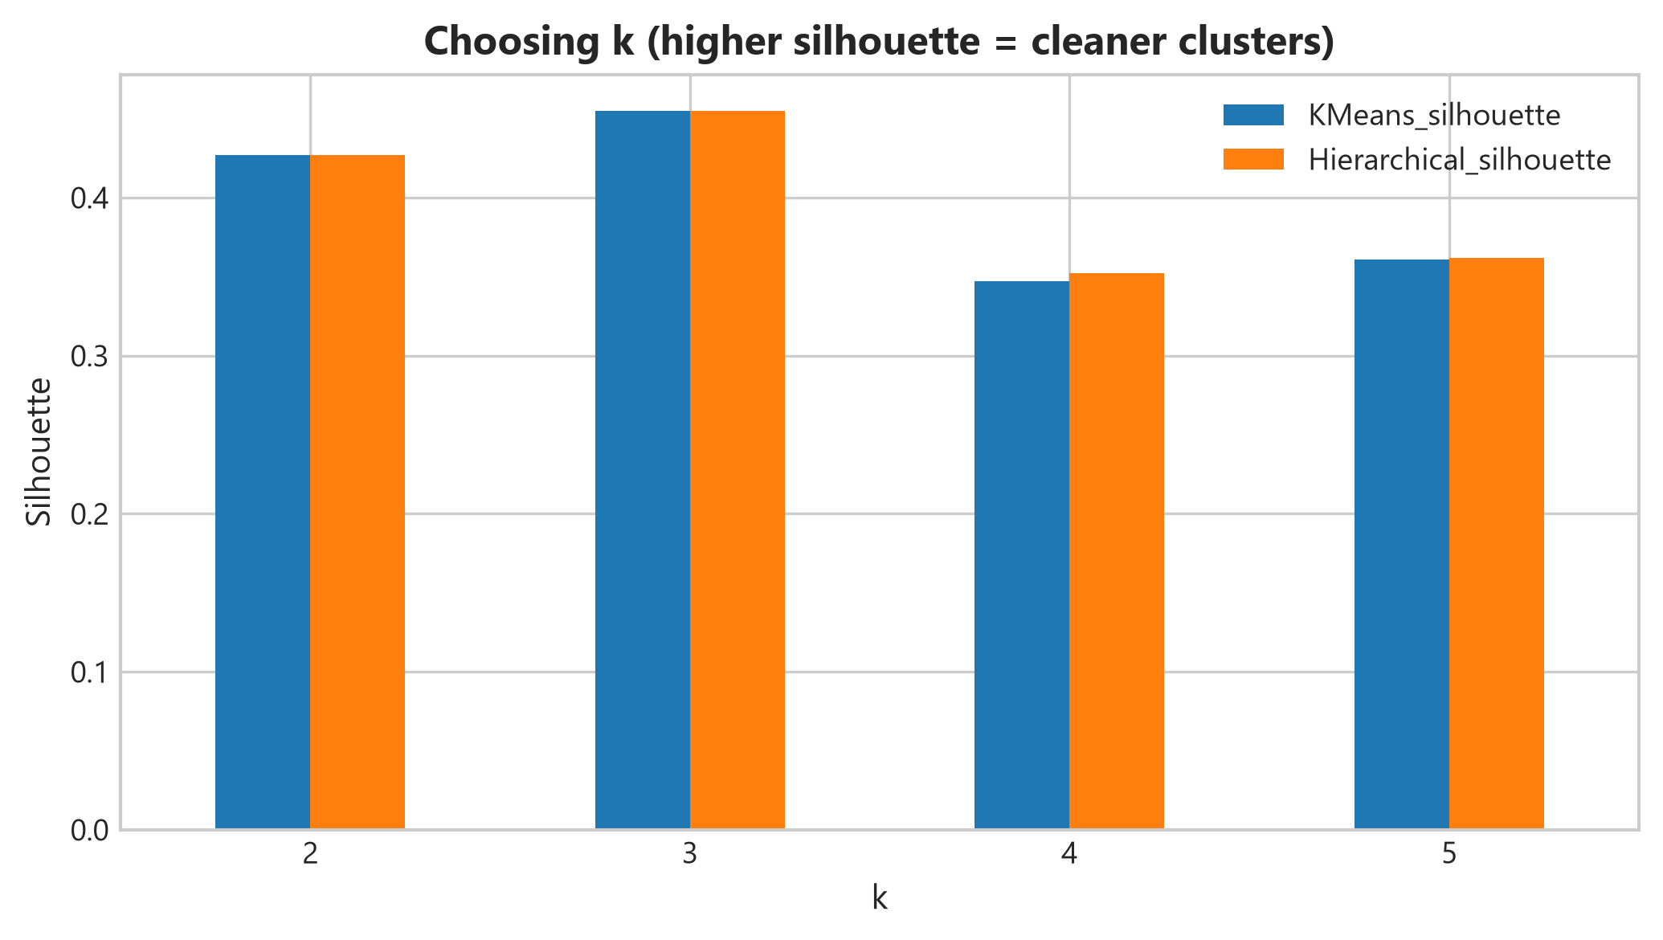
Figure 1. Silhouette score by number of clusters for KMeans and hierarchical clustering (higher is better).
Each pair of bars shows one value of k. Blue bars are KMeans and orange bars are hierarchical clustering. Values below were read from the chart and are accurate to about 0.003.

3. Scores by number of clusters
Number of clusters (k) | KMeans silhouette | Hierarchical silhouette | Gap between methods
2 | 0.427 | 0.427 | 0.000
3 | 0.455 | 0.455 | 0.000
4 | 0.347 | 0.352 | 0.005
5 | 0.361 | 0.362 | 0.001

The highlighted row is the best score. The gap column shows how closely the two methods agree: at k=2 and k=3 the bars are indistinguishable, and at k=4 and k=5 the hierarchical method is marginally higher.

4. How much better is k=3?
Comparison (KMeans) | k=3 minus other k | Other k is lower by | Reading
k=3 vs k=2 | +0.028 | 6% (of the k=3 score) | Small edge
k=3 vs k=4 | +0.108 | 24% (of the k=3 score) | Clear edge
k=3 vs k=5 | +0.094 | 21% (of the k=3 score) | Clear edge

The edge over k=4 and k=5 is substantial, with scores about a fifth to a quarter lower for those sizes. The edge over k=2 is much smaller. With only 40 respondents, a difference of 0.028 is within what could change if a few people were ranked differently, so k=2 and k=3 should be seen as competing candidates.

5. Interpretation
- k=3 is supported but not decisive. It has the top score and matches the segments already profiled, so it is a sound working choice.
- k=2 deserves a place in the discussion. The earlier two-dimensional plot showed one dense group of 31 respondents separated from the rest by a clear gap. A two-cluster split would probably follow that boundary, although the chart does not show how the clusters are formed.
- The dip at k=4 suggests over-splitting. Adding a fourth cluster divides groups that are not naturally separate, and the small recovery at k=5 does not change that.
- Method agreement is a good sign. Two quite different algorithms producing almost the same scores suggests the patterns come from the data and not from one algorithm's quirks.

6. Limitations
- Small sample. The earlier results indicate 40 respondents, and the three segments contain 31, 5 and 4 of them. Silhouette scores for clusters this small are volatile.
- Silhouette is one criterion. It favours compact, evenly sized clusters and says nothing about whether the segments are useful for the business.
- Only k=2 to 5 were tested. Larger values were not shown, and k=1 (no meaningful segments) cannot be scored by this measure.
- No per-cluster detail. The chart gives an average. It does not show whether one of the small segments contains poorly fitting respondents, which a per-cluster breakdown would reveal.
- No stability check. A single run says nothing about whether the same groups would appear after resampling the respondents.

7. Recommendations
- Keep three segments as the working solution, and state that two segments is a nearly equal alternative.
- Report silhouette scores for each cluster and list any respondents with negative scores, since they sit closer to another cluster than to their own.
- Check stability by repeating the clustering on resampled data and comparing the groups (for example with the adjusted Rand index).
- Confirm the choice with a second criterion, such as the elbow in within-cluster variation or the gap statistic, and with the business meaning of the segments.
- Compare the k=2 and k=3 solutions directly, looking at whether Segments 1 and 3 behave differently enough to justify keeping them apart.
- Collect more respondents so that the smaller segments can be assessed reliably.

