Confusion Matrix Analysis by Prediction Target
Where the models get respondents right and wrong | 13 October 2026

1. Purpose
This report reads four confusion matrices to show not just how often the predictions are right, but which classes are predicted well and which are confused with one another. Each matrix covers 40 respondents, with true labels in rows and predicted labels in columns.
Note: the counts were read from the figure, and the figure does not say which model produced them. Accuracy, recall, precision and F1 below are calculated from those counts. The baseline is the share of the largest true class on the same 40 respondents.

2. The matrices
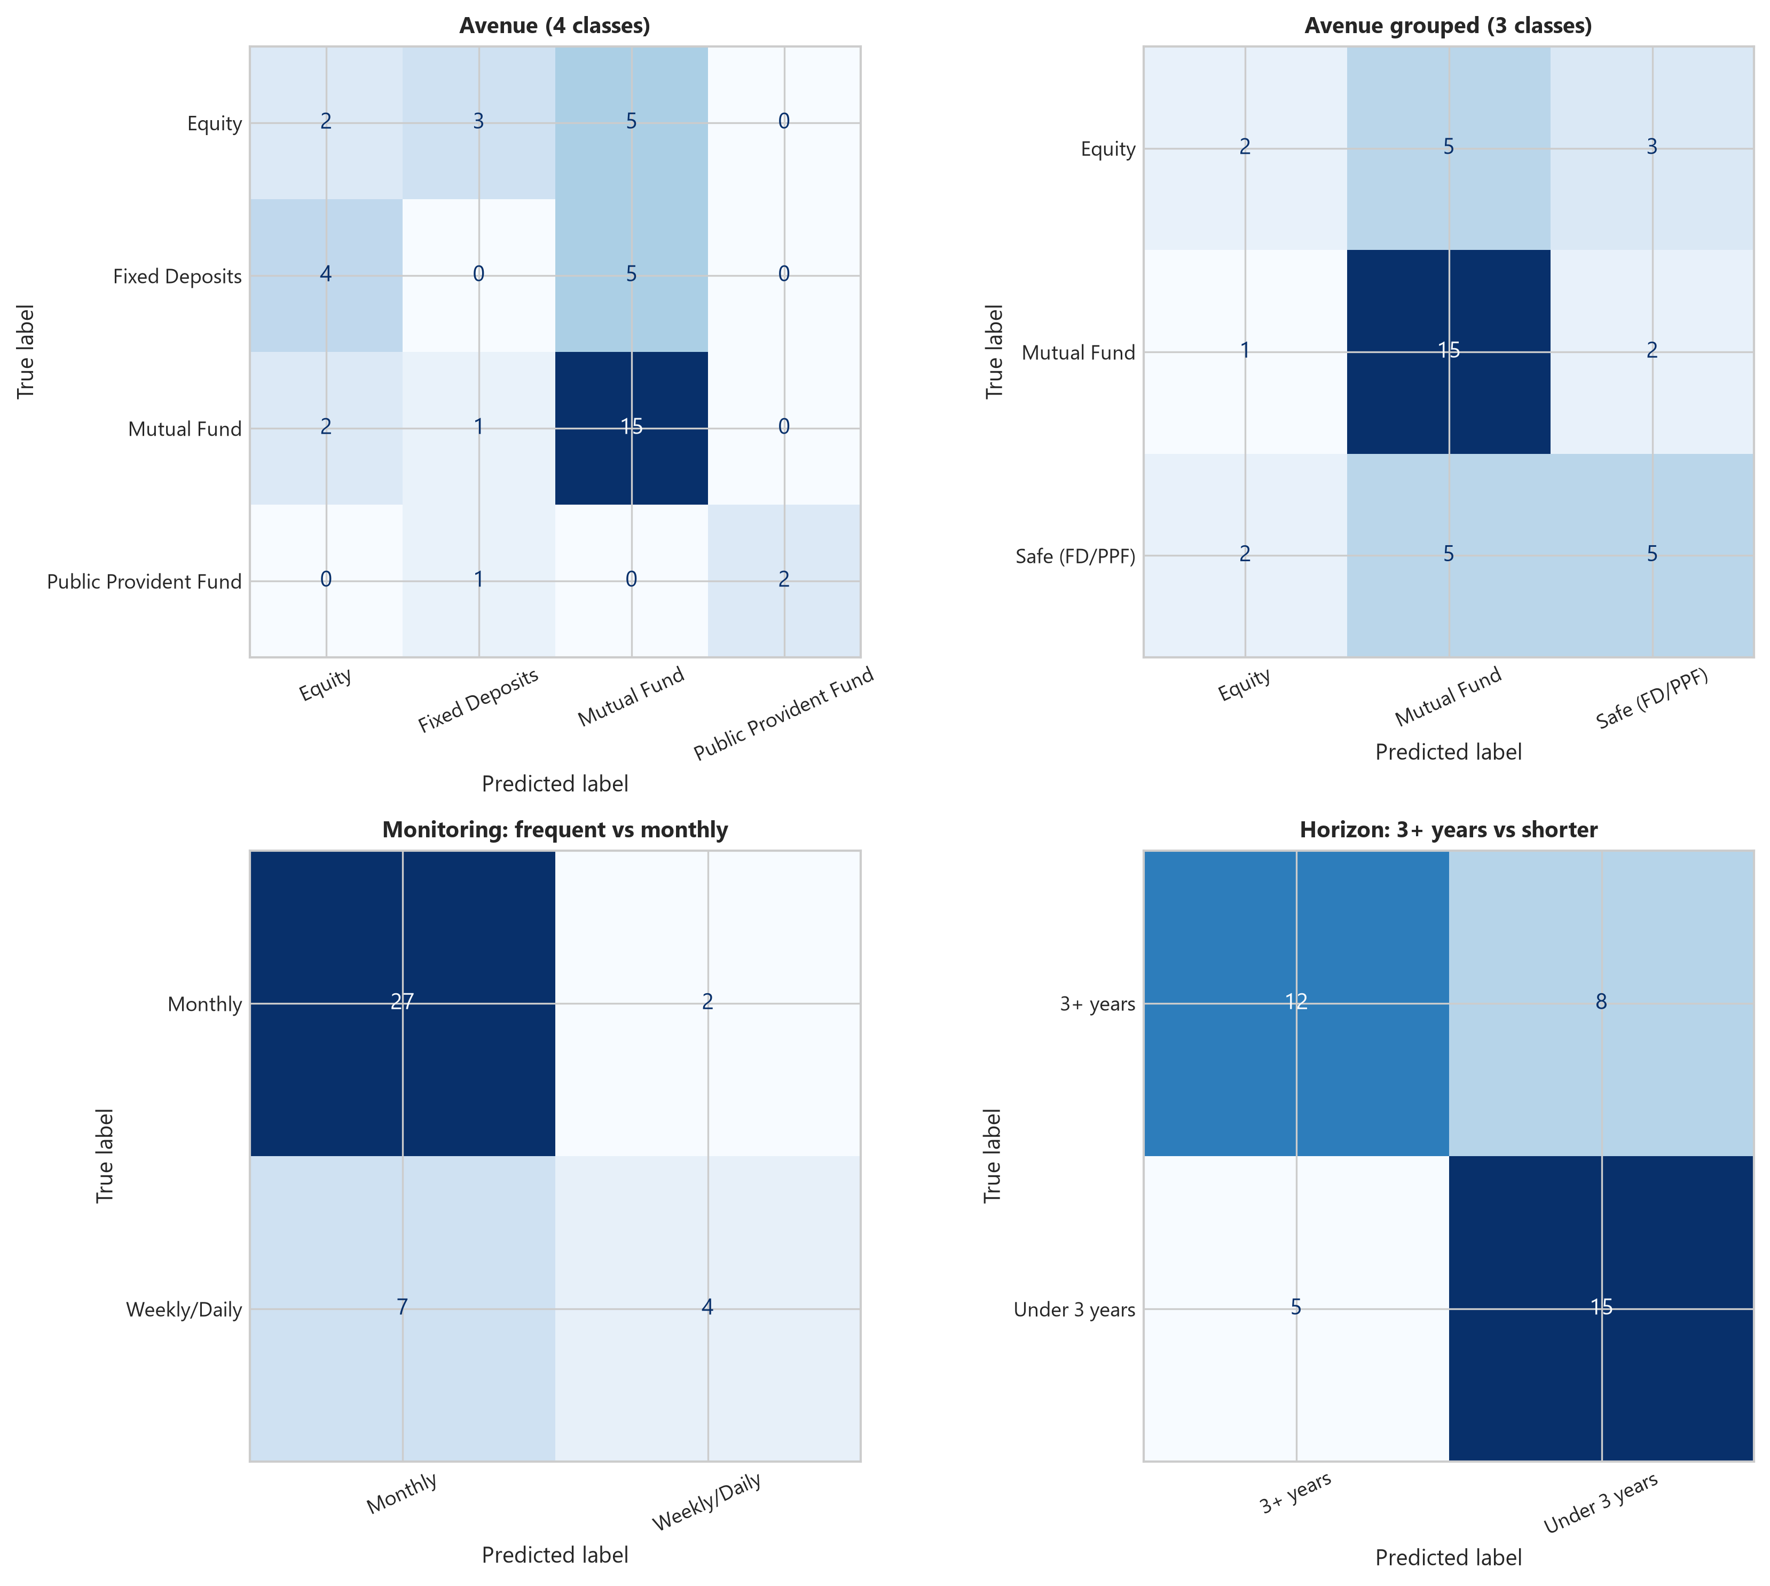
Figure 1: Confusion matrices for the four prediction targets.

3. Summary of results
Horizon is the only target with a substantial gain over the baseline. Grouping the avenue classes lifts accuracy by 10 points, while Monitoring and the four-class Avenue target improve only slightly.
Target | Test size | Accuracy | Majority baseline | Gain vs baseline | Macro F1
Horizon: 3+ years vs shorter | 40 | 67.5% | 50.0% | +17.5 pts | 0.67
Avenue grouped (3 classes) | 40 | 55.0% | 45.0% | +10.0 pts | 0.47
Monitoring: frequent vs monthly | 40 | 77.5% | 72.5% | +5.0 pts | 0.66
Avenue (4 classes) | 40 | 47.5% | 45.0% | +2.5 pts | 0.43
Gain is measured in percentage points. With 40 respondents, one extra correct prediction equals 2.5 points.

4. Results by target
4.1 Avenue (4 classes)
The model gets 19 of 40 right (47.5%), only one respondent better than always predicting Mutual Fund (45%). It predicts Mutual Fund 25 times although only 18 respondents truly prefer it, so the other classes lose out.
Class (true) | Recall | Precision | Correct / total | Most common error
Mutual Fund | 83.3% | 60.0% | 15 / 18 | 2 to Equity, 1 to FD
Public Provident Fund | 66.7% | 100% | 2 / 3 | 1 to Fixed Deposits
Equity | 20.0% | 25.0% | 2 / 10 | 5 to Mutual Fund
Fixed Deposits | 0.0% | 0.0% | 0 / 9 | 5 to MF, 4 to Equity

- Fixed Deposits are never identified. None of the 9 respondents who prefer them is classified correctly; 5 are labelled Mutual Fund and 4 Equity.
- Equity is mostly mistaken for Mutual Fund. Only 2 of 10 are correct, with 5 sent to Mutual Fund and 3 to Fixed Deposits.
- Public Provident Fund looks good but rests on 3 respondents. Both predictions of this class were right, but with so few cases this is not reliable.
4.2 Avenue grouped (3 classes)
Merging Fixed Deposits and Public Provident Fund into a “Safe” class raises accuracy to 55.0% (22 of 40), 10 points above the 45% baseline. The model still leans on Mutual Fund (25 predictions).
Class (true) | Recall | Precision | Correct / total | Most common error
Mutual Fund | 83.3% | 60.0% | 15 / 18 | 2 to Safe, 1 to Equity
Safe (FD/PPF) | 41.7% | 50.0% | 5 / 12 | 5 to Mutual Fund
Equity | 20.0% | 40.0% | 2 / 10 | 5 to Mutual Fund

- Safe is now partly recognised. 5 of 12 are correct, against 0 of 9 for Fixed Deposits alone, although 5 more are labelled Mutual Fund.
- Equity remains the hardest class. Only 2 of 10 are correct, and half are labelled Mutual Fund.
4.3 Monitoring: frequent vs monthly
Accuracy is 77.5% (31 of 40) against a 72.5% baseline, a gain of two respondents. The model leans heavily toward Monthly, predicting it 34 times.
Class (true) | Recall | Precision | Correct / total | Most common error
Monthly | 93.1% | 79.4% | 27 / 29 | 2 to Weekly/Daily
Weekly/Daily | 36.4% | 66.7% | 4 / 11 | 7 to Monthly

- Frequent monitors are mostly missed. Only 4 of 11 Weekly/Daily respondents are found; 7 are labelled Monthly.
- Accuracy overstates the result. Macro F1 of 0.66 is lower than accuracy, because the majority class dominates the score.
4.4 Horizon: 3+ years vs shorter
This is the strongest result. The classes are balanced (20 each), the baseline is 50%, and the model reaches 67.5% (27 of 40), a gain of 7 respondents.
Class (true) | Recall | Precision | Correct / total | Most common error
Under 3 years | 75.0% | 65.2% | 15 / 20 | 5 to 3+ years
3+ years | 60.0% | 70.6% | 12 / 20 | 8 to Under 3 years

- Errors are fairly even. 8 long-horizon respondents are labelled Under 3 years and 5 short-horizon respondents are labelled 3+ years.
- Both classes are usable. Recall is 60% to 75% and precision 65% to 71%, so neither class is ignored.

5. Interpretation
The pattern across the four matrices is consistent: the models rely on the largest class. This is clearest for the avenue targets, where Mutual Fund is over-predicted and the smaller classes are under-identified, and for Monitoring, where Monthly dominates. Horizon is the exception because its classes are balanced, so the model has to learn something real to score above 50%.
Grouping avenues helps because it replaces two tiny, hard-to-separate classes with one larger one, but Equity still cannot be separated from Mutual Fund. This suggests the available features say little about the difference between those two choices.

6. Limitations
- Each matrix covers only 40 respondents. Classes such as Public Provident Fund (3 respondents) are too small for stable percentages, and a single respondent moves accuracy by 2.5 points.
- The figure does not say which model produced the matrices or whether the predictions come from cross-validation or a single split. Results may therefore differ from the model comparison chart.
- No confidence intervals are given, so the gains for Monitoring (+5 points) and four-class Avenue (+2.5 points) cannot be told apart from chance.

7. Recommendations
- Use Horizon as the main practical prediction target, and the grouped three-class avenue target in place of the four-class version.
- Do not use the four-class Avenue or Monitoring predictions for decisions until they clearly beat the baseline; for Monitoring, assess performance with recall on the Weekly/Daily class.
- Report macro F1 or per-class recall alongside accuracy, since accuracy hides the weak classes.
- Collect more respondents, or features that separate Equity from Mutual Fund, before refining the models further.

8. Conclusion
The confusion matrices show that predictive value is concentrated in the Horizon target (67.5% against 50%) and, to a lesser extent, the grouped avenue target (55% against 45%). For the other two targets the models mostly repeat the majority class, and Fixed Deposits and Weekly/Daily monitors are rarely identified. A larger sample would be needed to confirm these patterns.

