Feature Importance Report
Which inputs drive each prediction, based on accuracy lost when a feature is shuffled
Prepared by Hilda Mukonyora | 14 October 2026

1. Executive summary
The chart shows permutation importance for the four prediction targets in the model comparison: how far accuracy falls when the values of one feature are randomly shuffled. A larger drop means the model relies on that feature more. Each panel lists the six most influential features for its target.
- Savings_Objective dominates Avenue. Shuffling it costs 13.4 points on the 4-class target and 18.9 points on the 3-class target, about 2.5 to 2.8 times the next feature.
- Horizon depends on market and source variables. Source (12.3 points), Equity_Market (12.1) and Gold (9.3) lead, with Savings_Objective fourth at 8.3.
- Monitoring has no standout feature. The top three (Stock_Market, Equity_Market, Source) are all about 3 points and effectively tied, consistent with the models barely beating the baseline on this target.
- Source and Savings_Objective recur. Source ranks in the top three for Avenue grouped, Monitoring and Horizon, and Savings_Objective appears in the top six for every target.
- Read with care. These are model-reliance scores, not causal effects, and several features are likely correlated (see Section 5).

2. The chart
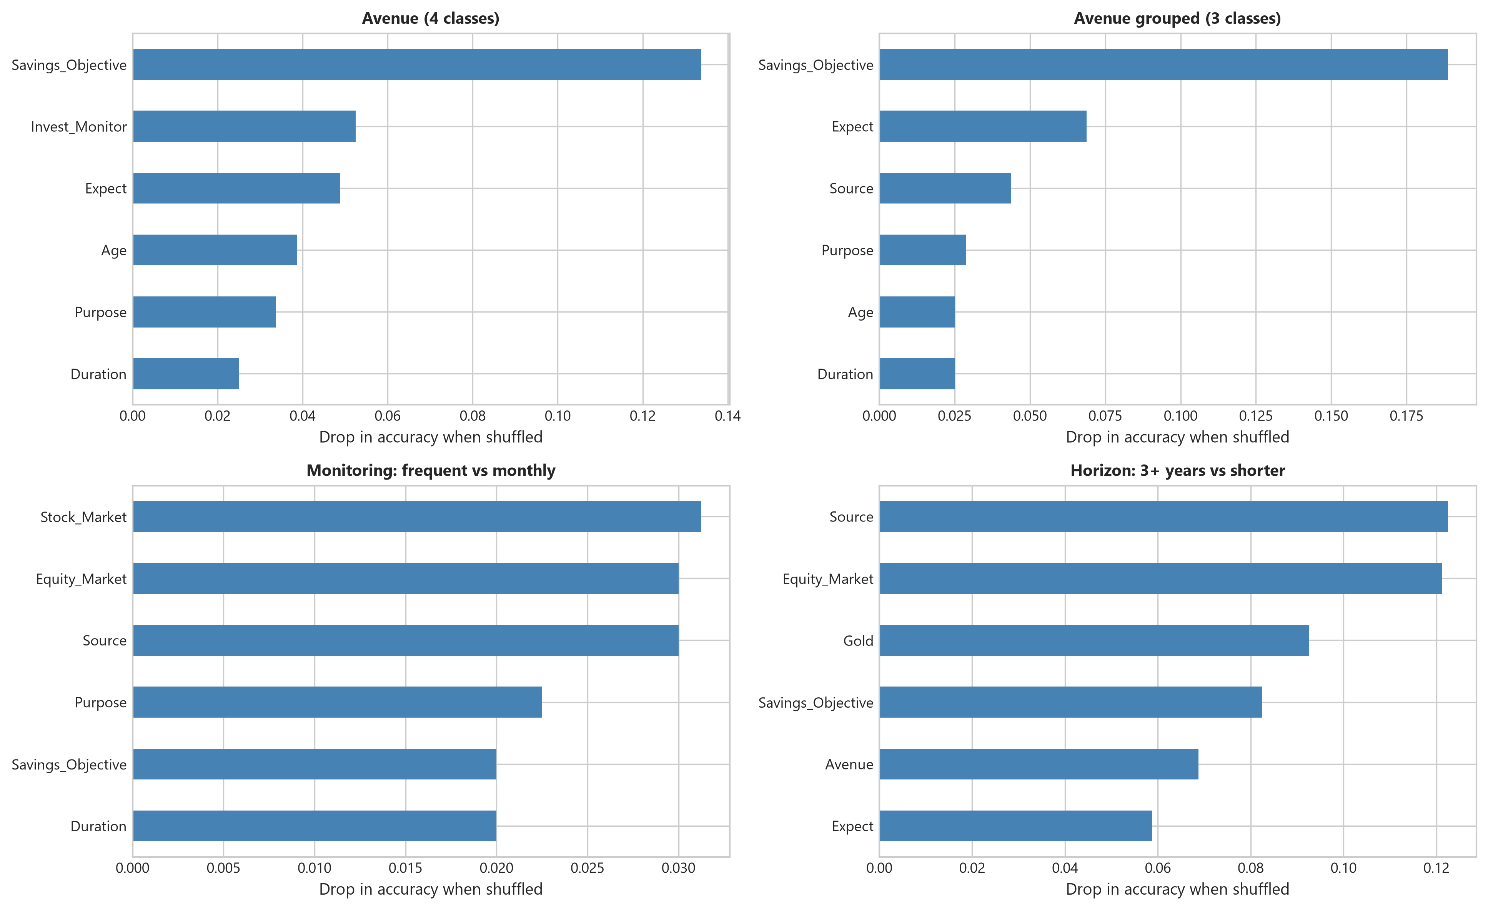
Figure 1. Drop in accuracy when each feature is shuffled (permutation importance), by prediction target.
The horizontal axis differs between panels, from 0 to 0.14 for Avenue, 0 to 0.18 for Avenue grouped, 0 to 0.03 for Monitoring and 0 to 0.12 for Horizon. Bar lengths should therefore be compared within a panel, not across panels. Values below were read from the chart and are accurate to roughly 0.002.

3. Values by target
Target | Feature (ranked) | Drop in accuracy | In percentage points
Avenue (4 classes) | 1. Savings_Objective | 0.134 | 13.4 pp
 | 2. Invest_Monitor | 0.052 | 5.2 pp
 | 3. Expect | 0.049 | 4.9 pp
 | 4. Age | 0.039 | 3.9 pp
 | 5. Purpose | 0.034 | 3.4 pp
 | 6. Duration | 0.025 | 2.5 pp
Avenue grouped (3 classes) | 1. Savings_Objective | 0.189 | 18.9 pp
 | 2. Expect | 0.069 | 6.9 pp
 | 3. Source | 0.044 | 4.4 pp
 | 4. Purpose | 0.029 | 2.9 pp
 | 5. Age | 0.025 | 2.5 pp
 | 6. Duration | 0.025 | 2.5 pp
Monitoring: frequent vs monthly | 1. Stock_Market | 0.031 | 3.1 pp
 | 2. Equity_Market | 0.030 | 3.0 pp
 | 3. Source | 0.030 | 3.0 pp
 | 4. Purpose | 0.023 | 2.3 pp
 | 5. Savings_Objective | 0.020 | 2.0 pp
 | 6. Duration | 0.020 | 2.0 pp
Horizon: 3+ years vs shorter | 1. Source | 0.123 | 12.3 pp
 | 2. Equity_Market | 0.121 | 12.1 pp
 | 3. Gold | 0.093 | 9.3 pp
 | 4. Savings_Objective | 0.083 | 8.3 pp
 | 5. Avenue | 0.069 | 6.9 pp
 | 6. Expect | 0.059 | 5.9 pp

4. Findings by target

Avenue (4 classes)
Savings_Objective is the clear leader at 0.134. The next features, Invest_Monitor (0.052) and Expect (0.049), are less than half as influential, followed by Age (0.039), Purpose (0.034) and Duration (0.025). The model is relying heavily on one input. Since this target's accuracy (about 46%) barely beats the 45% baseline, the strong reliance does not translate into reliable predictions.

Avenue grouped (3 classes)
The pattern sharpens after grouping. Savings_Objective reaches 0.189, followed by Expect (0.069) and Source (0.044). Age and Duration tie at the bottom of the top six (0.025). Grouping appears to concentrate the useful signal in the savings objective, which matches the improvement seen when the classes were merged (best accuracy 53.8%).

Monitoring: frequent vs monthly
Importances are small. The largest is 0.031 for Stock_Market, with Equity_Market and Source at 0.030, Purpose at 0.023, and Savings_Objective and Duration at 0.020. These gaps are one or two predictions in a small sample, so the ranking among the top three is not meaningful. The model has not found a dependable driver of how often people monitor their investments, which fits its 73.8% accuracy against a 72.5% baseline.

Horizon: 3+ years vs shorter
This target shows the strongest and most varied signal. Source (0.123) and Equity_Market (0.121) are nearly tied at the top, followed by Gold (0.093), Savings_Objective (0.083), Avenue (0.069) and Expect (0.059). Market-related variables and the information source drive the prediction, and the chosen Avenue itself carries information about the time horizon. This is the target where the models showed a clear gain over the baseline.

5. Interpretation and caveats
- Importance is not effect. Permutation importance shows what the fitted model uses, not what causes the outcome.
- Correlated features share credit. Stock_Market, Equity_Market and Gold are plausibly related, so shuffling one while the others stay intact can understate its value, and the ranking among them may be unstable.
- Only the top six are shown. Features outside each panel are less important, which is why the feature lists differ between panels. A feature missing from a panel is not necessarily unimportant for that target.
- Small differences are noisy. Several bar lengths sit on a grid of about 0.0125, consistent with a small test set where one prediction moves the score by roughly one point. No error bars are shown, so gaps under about 0.02 should not be interpreted.
- The model and data split are not stated. The chart does not say which model was used or whether scores come from training or held-out data. Importances computed on training data tend to be inflated, especially for flexible models.

6. Recommendations
- Treat Savings_Objective as the primary input when explaining or guiding the Avenue recommendation, and confirm with advisors that it is captured consistently.
- For Horizon, focus on Source and the market variables (Equity_Market, Gold), and investigate why the information source is so predictive before relying on it.
- Recompute importance on held-out data with repeated shuffles, and show the spread as error bars so that ties can be separated from real differences.
- Test grouped permutation (shuffling Stock_Market, Equity_Market and Gold together) to measure the combined contribution of market awareness.
- Do not build decisions on Monitoring importances, since the model barely beats the baseline there.
- Consider removing consistently weak features such as Duration and Age from the Avenue models and checking whether accuracy holds.

