Investor Segments Report
How three groups of investors rank seven investment avenues
Prepared by Hilda Mukonyora | 14 October 2026

1. Executive summary
The heatmap shows the average rank that each of three investor segments gave to seven investment avenues, where 1 is the most preferred and 7 the least. The 40 respondents split very unevenly: 31 in Segment 2, 5 in Segment 3 and 4 in Segment 1.
- One segment is the market. Segment 2 holds 77.5% of respondents. It puts PPF first (mean rank 1.6), followed by Mutual Funds (2.5) and Fixed Deposits (3.0).
- Preferences differ sharply between segments. Segment 1 favours Mutual Funds and Equity Market equally (1.5), while Segment 3 favours Government Bonds (1.8) and PPF (2.4).
- Debentures split the segments most. They rank 2.8 for Segment 3 and 3.5 for Segment 1, but 6.5 for Segment 2, a gap of 3.7 ranks.
- Gold is last or near last for everyone. Mean ranks are 5.8, 5.9 and 6.6, the narrowest spread of any avenue (0.8).
- Treat the small segments cautiously. Segments 1 and 3 contain only 4 and 5 people, so their averages can move a lot with one respondent.

2. The heatmap
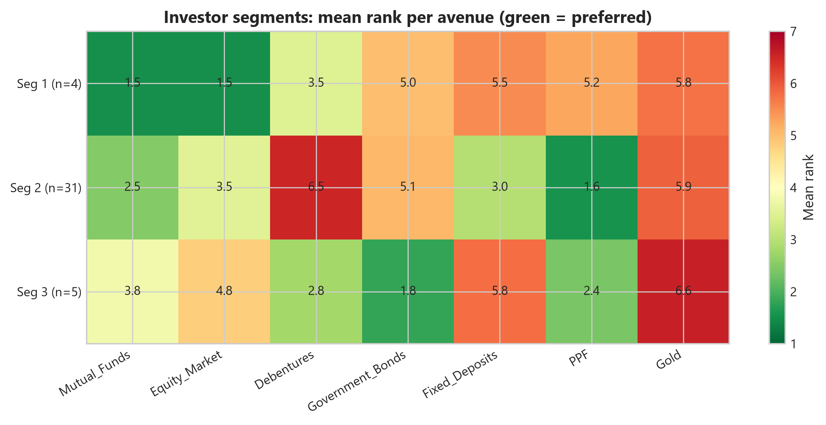
Figure 1. Mean rank of each investment avenue by investor segment (1 = most preferred, 7 = least preferred).
Green cells are preferred avenues and red cells are disliked ones. The values printed in the cells are mean ranks, and a rank is the position a respondent gave an avenue when ordering all seven. As a consistency check, each segment's seven means add up to about 28, which is what complete rankings from 1 to 7 must produce.

3. Mean ranks by segment
The table repeats the chart values with the same colour scale. The last row shows how much each avenue's rank varies across the three segments.
Segment | Mutual Funds | Equity Market | Debentures | Government Bonds | Fixed Deposits | PPF | Gold
Segment 1 (n=4) | 1.5 | 1.5 | 3.5 | 5.0 | 5.5 | 5.2 | 5.8
Segment 2 (n=31) | 2.5 | 3.5 | 6.5 | 5.1 | 3.0 | 1.6 | 5.9
Segment 3 (n=5) | 3.8 | 4.8 | 2.8 | 1.8 | 5.8 | 2.4 | 6.6
Spread (max - min) | 2.3 | 3.3 | 3.7 | 3.3 | 2.8 | 3.6 | 0.8

4. Segment profiles
Segment | Size | Most preferred | Middle | Least preferred | Working label
Segment 1 | 4 (10%) | Mutual Funds and Equity Market (1.5 each) | Debentures (3.5) | Fixed Deposits (5.5), Gold (5.8) | Growth-oriented, market-linked
Segment 2 | 31 (77.5%) | PPF (1.6), Mutual Funds (2.5) | Fixed Deposits (3.0), Equity Market (3.5) | Debentures (6.5), Gold (5.9) | Safety-first with a mutual fund tilt
Segment 3 | 5 (12.5%) | Government Bonds (1.8), PPF (2.4) | Debentures (2.8), Mutual Funds (3.8) | Gold (6.6), Fixed Deposits (5.8) | Bond and fixed-income oriented

The working labels in the last column are descriptive names chosen for this report. They were not provided with the data.

Segment 1: growth-oriented (n=4)
These investors give their top two ranks to Mutual Funds and Equity Market (1.5 each), with Debentures a distant third (3.5). They rank every safer option below the middle: Government Bonds 5.0, PPF 5.2, Fixed Deposits 5.5 and Gold 5.8. This is the only group that actively prefers market-linked products, but with four respondents it is a very thin base.

Segment 2: safety-first with a mutual fund tilt (n=31)
The dominant group prefers PPF (1.6) clearly over everything else, with Mutual Funds (2.5), Fixed Deposits (3.0) and Equity Market (3.5) following. It rejects Debentures strongly (6.5), the second-worst score in the chart after Segment 3's Gold (6.6), and also ranks Gold (5.9) and Government Bonds (5.1) low. Their mix of PPF, mutual funds and fixed deposits suggests tax-efficient, steady-growth saving, though the data do not state their motives.

Segment 3: bond and fixed-income oriented (n=5)
Government Bonds (1.8) lead for this group, followed by PPF (2.4) and Debentures (2.8). Mutual Funds sit in the middle (3.8), Equity Market is below it (4.8), and Fixed Deposits (5.8) and Gold (6.6) are the least liked. Gold at 6.6 is the lowest preference score in the whole chart.

5. Patterns across segments
- PPF and Mutual Funds are the most broadly accepted. Both rank in the top three for at least two segments. PPF has the best score for Segment 2 and is second for Segment 3, but is poorly ranked by Segment 1 (5.2).
- Equity Market is polarising. It is joint first for Segment 1 (1.5) but fourth for Segment 2 (3.5) and fifth for Segment 3 (4.8).
- Fixed Deposits and Government Bonds separate Segments 2 and 3. Segment 2 likes Fixed Deposits (3.0) and is lukewarm on Government Bonds (5.1), while Segment 3 shows the opposite (5.8 and 1.8).
- Gold is not a core holding for anyone. All three segments rank it sixth or seventh, so it is better treated as a niche or diversifying option than a headline product.

6. Caveats
- Very small groups. With 4 and 5 respondents, Segments 1 and 3 are fragile. A mean rank of 1.5 with n=4 can come from just two different orderings.
- Means hide the spread. A mean rank does not show whether a segment agrees internally. Segment 2 is large enough that its mean probably hides several sub-preferences.
- Ranks are linked. Ranking one avenue higher pushes the others down, so the columns are not independent measures of liking.
- Unknown segmentation method. The chart does not say how respondents were assigned to segments, nor how stable the groups are if the method is rerun.
- A possible mismatch with the Avenue target. In the earlier classification results only 3 of 40 respondents had PPF as their Avenue, yet Segment 2 (31 people) ranks PPF first on average. The Avenue target may record a different thing from the preference ranking, such as current holdings, and that should be confirmed before the two are combined.

7. Recommendations
- Lead product messaging for the majority (Segment 2) with PPF, supported by mutual funds and fixed deposits, and avoid pushing debentures to this group.
- Offer Segment 1 equity and mutual fund content, and Segment 3 a government bond and debenture focus, while recognising how small these groups are.
- Collect more respondents, especially for Segments 1 and 3, before building separate strategies on them.
- Report the spread of ranks (standard deviation or the share ranking each avenue first) alongside the means.
- Test segment membership as an input to the earlier prediction models, for example for the Horizon target, and reconcile the Avenue label with these preference ranks.
- Describe how segments were derived and check their stability by repeating the clustering.

