REPORT
Age and Gender Profile of Survey Respondents
Demographic summary of 40 respondents | 16 October 2026

1. Introduction
This report summarises the demographic profile of the survey respondents, based on two charts: the age distribution (histogram) and the gender split (bar chart). Both charts cover the same 40 respondents.
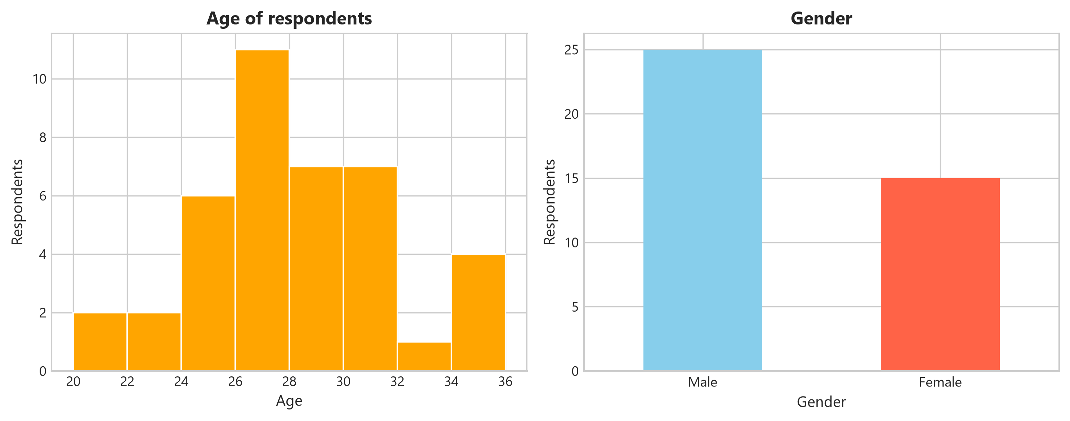
Figure 1: Age of respondents (left) and gender of respondents (right)

2. Age distribution
Respondents' ages range from 20 to 36 and are grouped into two-year bands.
Age band (years) | Respondents | Share of total
20-22 | 2 | 5.0%
22-24 | 2 | 5.0%
24-26 | 6 | 15.0%
26-28 | 11 | 27.5%
28-30 | 7 | 17.5%
30-32 | 7 | 17.5%
32-34 | 1 | 2.5%
34-36 | 4 | 10.0%
Total | 40 | 100.0%
Table 1: Respondents by age band
Key observations
- Largest group: respondents aged 26-28 form the largest band, with 11 people (27.5%).
- Concentration: the sample clusters in the mid-to-late twenties and early thirties. The 24-32 range accounts for 31 of 40 respondents (about 78%).
- Younger respondents: those under 24 are few, at 4 respondents (10%).
- Central tendency: the median age falls in the 26-28 band, and the estimated mean is about 28 years, using band midpoints.
- Upper end: there is a small uptick in the 34-36 band (4 respondents) after a dip at 32-34 (1 respondent). With a sample this small, this may be noise rather than a real pattern.

3. Gender distribution
Gender | Respondents | Share of total
Male | 25 | 62.5%
Female | 15 | 37.5%
Total | 40 | 100.0%
Table 2: Respondents by gender
Men outnumber women by roughly 5 to 3, a gap of 10 respondents. Male respondents make up 62.5% of the sample and female respondents 37.5%.

4. Discussion
The sample is predominantly young adults in their late twenties and is male-skewed. This has implications for how far the findings can be generalised:
- Results may best reflect the views or behaviours of men aged roughly 24-32.
- Women, and respondents under 24 or over 32, are under-represented, so conclusions about these groups should be treated with caution.
- With only 40 respondents, each person shifts the percentages noticeably (one respondent is 2.5%), so small differences between bands should not be over-interpreted.

5. Conclusion and recommendations
The respondent group is relatively homogeneous in age but unbalanced in gender. If the study aims to represent a wider population, consider the following:
- Increase the sample size.
- Target recruitment toward women and toward the youngest and oldest age bands.
- Weight results by gender and age in any further analysis, or analyse the groups separately.

