Segment Separation Report
A two-dimensional view of the three investor segments (PCA of the rankings)
Prepared by Hilda Mukonyora | 14 October 2026

1. Executive summary
The scatter plot projects each of the 40 respondents' rankings of seven investment avenues onto two principal components (PC1 and PC2), the two directions that capture the most variation. Points are coloured by the segment they were assigned to. The plot is a check on whether the segments shown in the earlier heatmap are visibly distinct.
- The segments are visibly separate. Segments 1 and 3 sit on the far left (PC1 below about -2.3), while every Segment 2 respondent lies to the right of about -0.5.
- PC1 splits Segment 2 from the other two. There is an empty band roughly 2 units wide between the left-hand groups and the Segment 2 cloud.
- PC2 splits Segment 1 from Segment 3. Segment 1 is entirely above 1.7, and four of the five Segment 3 points are below -2.1.
- Segment 2 is one dense core with a few stragglers. Most of its 31 points fall in a compact region, but a handful stretch to the top and bottom edges.
- Do not over-read this as proof. Segments built from the rankings will naturally look separate in a projection of the same rankings, and Segments 1 and 3 are very small.

2. The plot
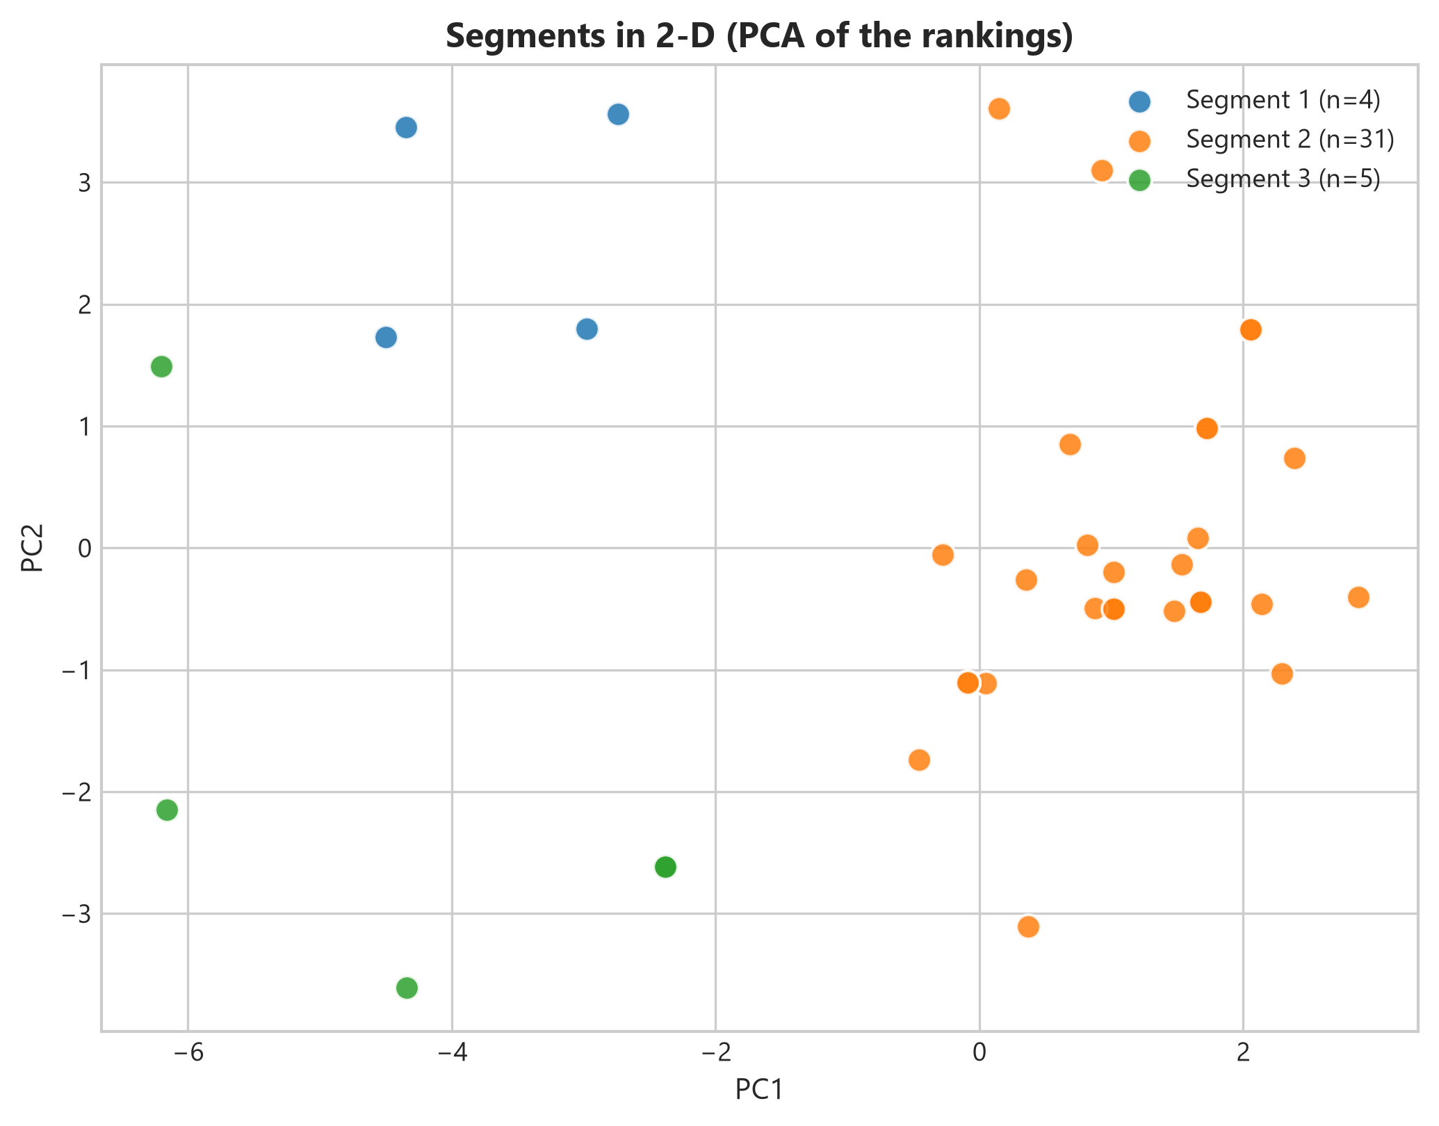
Figure 1. Respondents plotted on the first two principal components of their rankings, coloured by segment.
Darker points are places where two or more respondents have the same position, meaning identical or nearly identical rankings. Several of these appear in Segment 2 and one in Segment 3. The plot does not show how much of the total variation the two axes explain, so the distances should be read as indicative.

3. Where each segment sits
Coordinates were read from the chart and are approximate.
Segment | n | PC1 range (approx.) | PC2 range (approx.) | Shape in the plot
Segment 1 (blue) | 4 | -4.5 to -2.7 | 1.7 to 3.6 | Tight group, upper left
Segment 2 (orange) | 31 | -0.5 to 2.9 | -3.1 to 3.6 | Dense core, right of centre, with a few points stretched up and down
Segment 3 (green) | 5 | -6.2 to -2.4 | -3.6 to 1.5 | Loosest group, far left, spread top to bottom

Segment 1 (n=4)
The four blue points form the most compact group, with two near PC2 3.5 and two near PC2 1.8, all between PC1 -4.5 and -2.7. They are clearly set apart from Segment 2. This matches their heatmap profile, where Mutual Funds and Equity Market rank first and nearly every other avenue ranks poorly.

Segment 2 (n=31)
This is the main cloud, centred around PC1 1 and PC2 0, and it holds 77.5% of respondents. Its core is tight, but three points lie well outside it: two at the top (about 0.2 and 0.9 on PC1, with PC2 above 3) and one at the bottom (PC1 about 0.4, PC2 about -3.1). They share the vertical positions of Segment 1 and Segment 3 but remain on the Segment 2 side of PC1, which hints at sub-groups with a slight growth lean or a slight bond lean inside the majority segment.

Segment 3 (n=5)
The green points are the most spread out. Two sit at the extreme left (PC1 about -6.2), one at PC2 1.5 and one at -2.15, and the other three are in the lower half near PC2 -2.6 and -3.6 (one visible point is darker, indicating two respondents in the same spot). The upper left point at (-6.2, 1.5) is about 1.7 units from the nearest Segment 1 point, so it is the closest thing to a borderline case between the two small segments.

4. What the axes may represent
The chart does not give the loadings, so the meaning of each axis has to be inferred. Using the mean ranks from the heatmap report, the avenues that differ most between segments are the likely drivers:
- PC1 probably reflects Debentures versus Fixed Deposits. Segment 2 ranks Debentures last (6.5) and Fixed Deposits third (3.0), while Segments 1 and 3 do the reverse (Debentures 3.5 and 2.8, Fixed Deposits 5.5 and 5.8).
- PC2 probably separates market-linked from bond-type preferences. Segment 1 prefers Mutual Funds and Equity Market, whereas Segment 3 prefers Government Bonds and PPF.
These are hypotheses, and they should be confirmed against the component loadings before being stated as findings.

5. Caveats
- Circular validation. If the segments were produced by clustering the same rankings, they are expected to look separated here. The plot shows the clustering is coherent, not that the groups are real.
- Tiny segments. With 4 and 5 points, Segments 1 and 3 cannot support strong conclusions, and removing one respondent would change their shape.
- Two dimensions only. The rankings have seven dimensions, effectively six because each respondent's ranks must sum to 28. Overlaps or gaps in two dimensions may differ in the full space.
- Explained variance not shown. Without the percentage of variance on PC1 and PC2, we cannot tell how faithfully the plot represents the data.
- No respondent identifiers. Individual points cannot be traced back to people, so outliers and borderline cases cannot yet be investigated.

6. Recommendations
- Add the explained variance to the axis labels and publish the loadings so that PC1 and PC2 can be interpreted rather than guessed.
- Test a two-group solution (Segment 2 versus everyone else). The plot suggests that is the clearest boundary, and Segments 1 and 3 may be better treated as one group or as a long-tail of minority preferences.
- Measure cluster quality with silhouette scores and repeat the clustering on resampled data to check that the three segments are stable.
- Label the outliers (the three stretched Segment 2 points and the upper-left Segment 3 point) and review their full rankings.
- Look inside Segment 2 for the upper and lower sub-groups, since it holds most respondents and its mean profile may hide different preferences.
- Collect more respondents so that the minority segments can be profiled with confidence.

