AWS Cost Optimization Case Study: Reducing NAT Gateway Data Transfer Costs
Overview
This project involved investigating an unexpected increase in AWS networking costs and implementing an architecture improvement to reduce recurring charges. The primary objective was to identify the source of the traffic and optimize the network path without changing application behavior.

Problem Statement
An AWS environment experienced a significant increase in networking costs. Cost analysis showed that the majority of the charges were associated with a NAT Gateway.
Initial Environment
- Internet Gateway attached to the VPC
- Private subnets routing outbound traffic through a NAT Gateway
- No VPC endpoints configured
- No VPC peering connections
The goal was to determine which workloads were generating the traffic and whether the NAT Gateway was the appropriate path for that communication.

Investigation
VPC Flow Log Analysis
To identify the largest traffic sources and destinations, VPC Flow Logs were queried using CloudWatch Logs Insights.
fields srcAddr, dstAddr, bytes
| stats sum(bytes) as totalBytes by srcAddr, dstAddr
| sort totalBytes desc
| limit 20
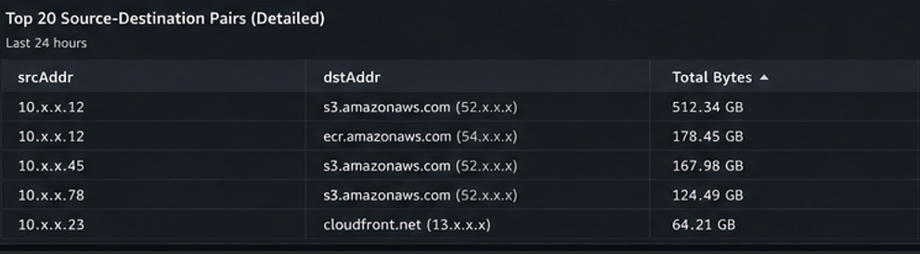

Findings
The analysis showed that traffic from workloads in private subnets was communicating with AWS public service endpoints. Because the workloads did not have private connectivity to those services, the traffic was routed through the NAT Gateway.
Key observation:
- Traffic destined for AWS public endpoints was contributing to NAT Gateway data processing charges.
- Private-to-private traffic within RFC1918 address ranges did not incur NAT Gateway processing charges.

Additional Traffic Analysis
NAT Gateway CloudWatch metrics were reviewed to validate the traffic pattern.
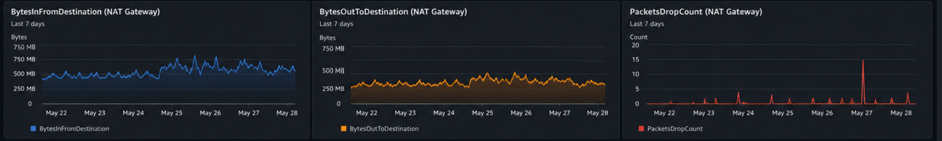
Observations
- Inbound and outbound throughput remained consistently high.
- Traffic was sustained continuously over an extended period.
- Outbound traffic increased during a later period, indicating a workload or deployment pattern change.
- Packet drops were negligible, suggesting the gateway was functioning normally.
Likely Cause
The traffic profile was consistent with workloads repeatedly accessing AWS services such as object storage or container image repositories from private subnets.

Root Cause
Private subnet workloads were accessing AWS public service endpoints through the NAT Gateway because no private connectivity mechanism was configured.
This caused:
- All service traffic to traverse the NAT Gateway.
- Data processing charges to accumulate continuously.
- Monthly networking costs to increase significantly.

Solution
Implemented Optimization
Created a Gateway VPC Endpoint for Amazon S3 and associated it with the private subnet route tables.
Resulting Traffic Flow
Before
Private Subnet → NAT Gateway → Internet → S3 Public Endpoint
After
Private Subnet → S3 Gateway Endpoint → S3
This change allows S3 traffic to remain on the AWS private network and bypass the NAT Gateway entirely.

Implementation Steps
- Open VPC Console
- Navigate to Endpoints
- Select Create Endpoint
- Choose AWS services
- Select the Amazon S3 service
- Choose Gateway endpoint type
- Associate the endpoint with the private subnet route tables
- Create the endpoint

Cost Impact
Amazon S3 Gateway Endpoints have no hourly charge and no data processing charge. Redirecting S3 traffic away from the NAT Gateway can substantially reduce networking costs in environments that store backups, artifacts, logs, packages, or application assets in S3.

Outcome
- Reduced NAT Gateway data processing traffic
- Lowered recurring networking costs
- Maintained existing application functionality
- Improved overall network architecture by using private AWS service connectivity

Key Takeaways
- VPC Flow Logs are highly effective for identifying unexpected traffic patterns.
- NAT Gateway charges can grow quickly when private workloads access AWS public service endpoints.
- S3 Gateway Endpoints are a low-effort, high-impact optimization for private subnet architectures.
- Reviewing CloudWatch NAT Gateway metrics helps distinguish between transient spikes and sustained traffic patterns.

Skills Demonstrated
- AWS networking
- VPC architecture
- NAT Gateway troubleshooting
- VPC Flow Log analysis
- CloudWatch Logs Insights
- Cost optimization
- Root cause analysis
- Infrastructure improvement planning

