**COMPLETED PROJECT 5 REVIEWED**

**Task:** Implement a Client Server Architecture using MySQL Database Management System (DBMS).

**Goal/Aim:** To deploy a fully functional mysql client-server set up.

**Step1**: Create and configure two Linux-based virtual servers (EC2 instances in AWS).

* Installing mysql server:

Sudo apt update and sudo apt install mysql-server

* Installing mysql client:

Sudo apt update and sudo apt install mysql-client

**Step2**: Open port 3306 on mysql server:

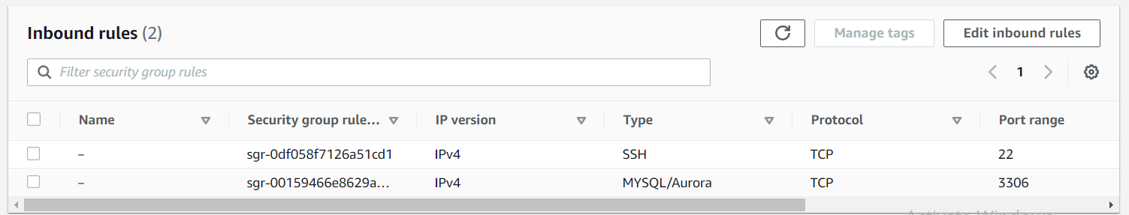

**Step3:** Configure MySQL server to allow connections from remote hosts.

* Open the mysql server daemon configuration file and replace 127.0.0.1 to 0.0.0.0

Sudo vi /etc/mysql/mysql.conf.d/mysqld.cnf

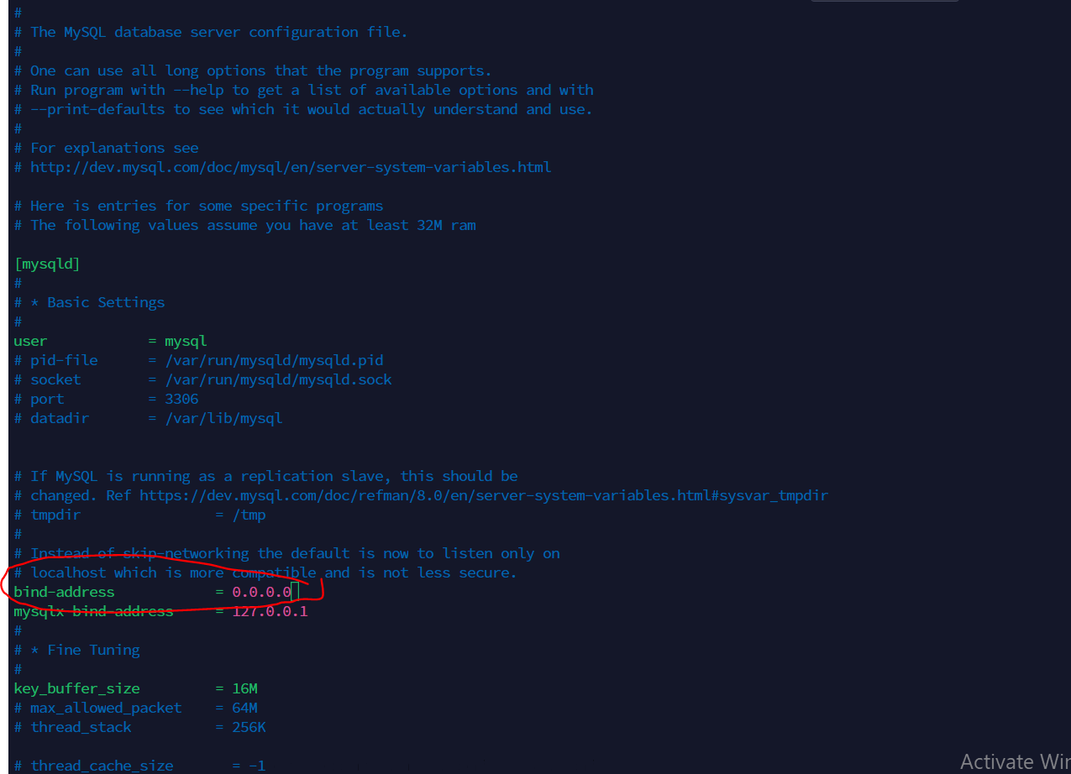

**CONFIGURING MYSQL SERVER**

**Step1:**

* **Login to mysql server**

sudo mysql

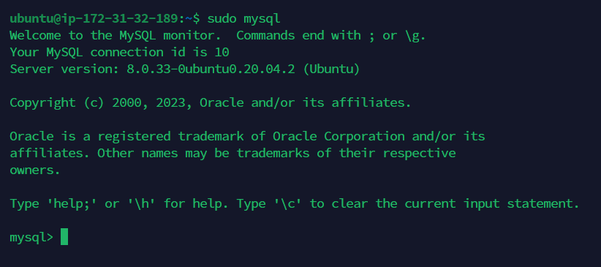

* Then run the following ALTER USER command to change the root user’s authentication method to one that uses a password. The following example changes the authentication method to mysql_native_password:

ALTER USER 'root'@'localhost' IDENTIFIED WITH mysql_native_password BY 'password';

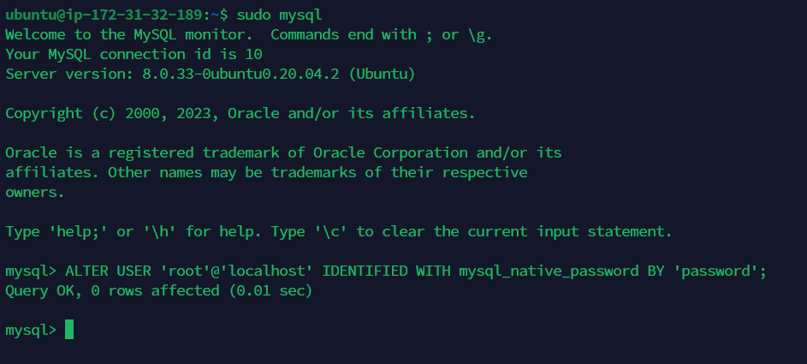

* After making this change exit the mysql prompt:

exit

Now you can run secure_installation_mysql without issue

sudo mysql_secure_installation

**This will take you through a series of prompts where you can make some changes to your MySQL installation’s security options. The first prompt will ask whether you’d like to set up the Validate Password Plugin, which can be used to test the password strength of new MySQL users before deeming them valid.**

**If you elect to set up the Validate Password Plugin, any MySQL user you create that authenticates with a password will be required to have a password that satisfies the policy you select:**

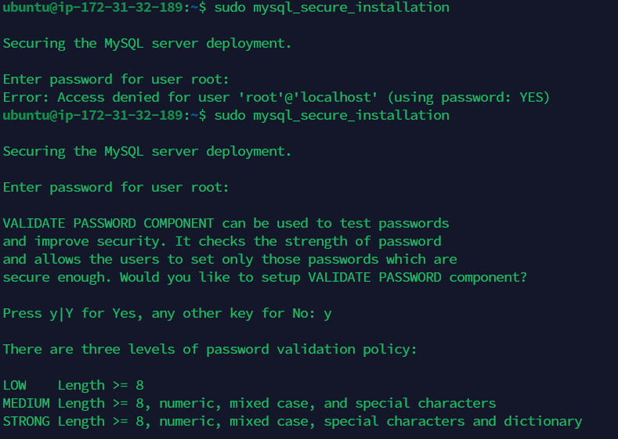

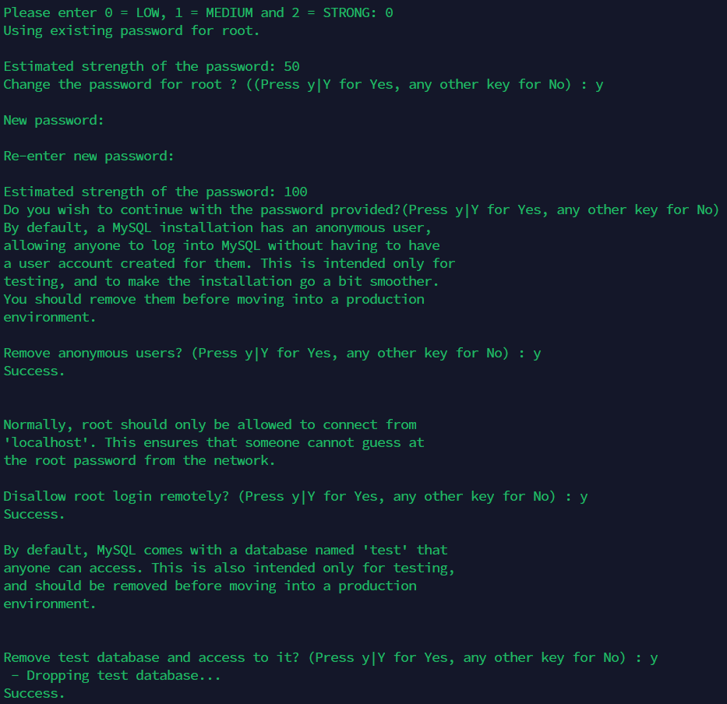

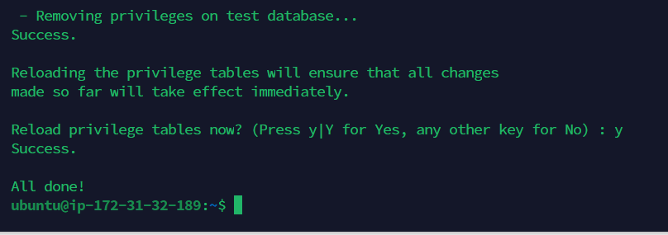

**Once the script completes, your MySQL installation will be secured. You can now move on to creating a dedicated database user with the MySQL client.**

**CREATE A DEDICATED MYSQL USER AND GRANT PRIVILEGES**

**Step1:**

* **Login to Mysql Server**

**mysql -u root -p**

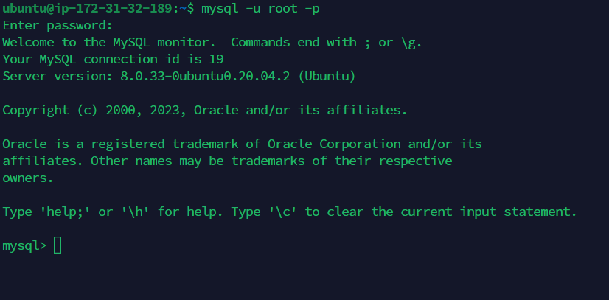

**Step2:**

**Create a new user:**

**CREATE USER 'jude'@'%' IDENTIFIED WITH mysql_native_password BY 'password';**



**After creating your new user (jude), you can grant jude the appropriate privileges. The general syntax for granting user privileges is as follows:**

**GRANT ALL PRIVILEGES ON *.* TO 'jude'@'%' WITH GRANT OPTION;**



**Following this, it’s good practice to run the FLUSH PRIVILEGES command. This will free up any memory that the server cached as a result of the preceding CREATE USER and GRANT statements:**

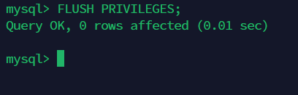

**Now Create database:**



**exit**

**Now go to the mysql client server and run this command:**

**sudo mysql -u jude -h 172.31.32.189 -p**

**The IP address there is the IP address of the database server (mysqlserve)**

**And then type the user jude password:**

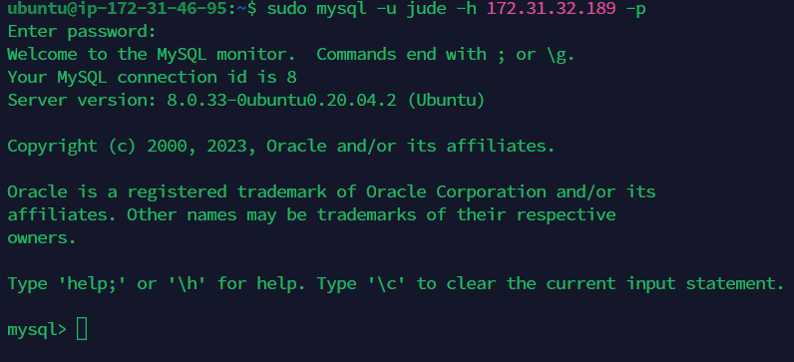

**To confirm check to see the database test_db that was created before:**

